Supplementary information includes four Figures

NAMPT deficiency triggers dopaminergic neurodegeneration in the substantia nigra of mouse

Cong Chen¹, Tong-Yao Gao¹, Tong Wang¹, Ya-Ling Chen¹, Yun-Bi Lu¹, Wei-Ping Zhang^{1,2,*}
¹Department of Pharmacology, Zhejiang University School of Medicine, Hangzhou 310058, Zhejiang, China
²Zhejiang Province Key Laboratory of Mental Disorder’s Management, Zhejiang University School of Medicine, Zhejiang 310058, Hangzhou, China
*Corresponding author, Wei-Ping Zhang, email: weiping601@zju.edu.cn

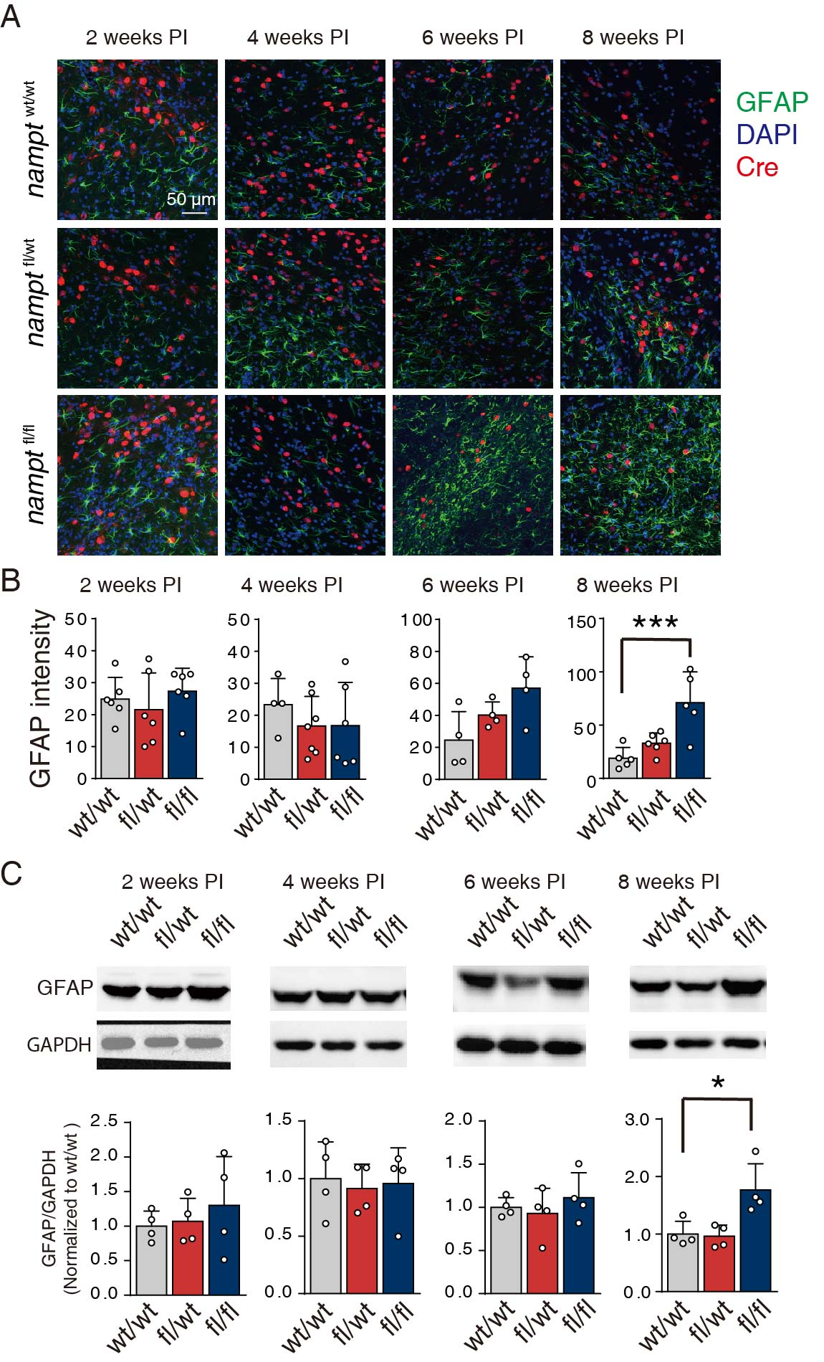

Supplementary Fig. 1 The knockout of nampt in the substantia nigra of mouse brain increased astrocyte responses. (A) Representative immunofluorescence images of GFAP and Cre recombinase in the substantia nigra of mouse brain from nampt^{wt/wt}, nampt^{fl/wt} and nampt^{fl/fl} on 2-, 4-, 6- and 8-weeks post-injection (PI) of rAAV. (B) Statistical analysis of GFAP intensity in the SN of mouse brain from nampt^{wt/wt}, nampt^{fl/wt} and nampt^{fl/fl} on 2-, 4-, 6- and 8-weeks post-injection of rAAV. N=4-6. Mean ± SD. ***P < 0.001 one-way ANOVA. (C) Western blot analysis of GFAP in the SN of mouse brain on 2-, 4-, 6-, and 8-weeks post-injection of rAAV. N=4. Mean ± SD. *P < 0.05, one-way ANOVA.

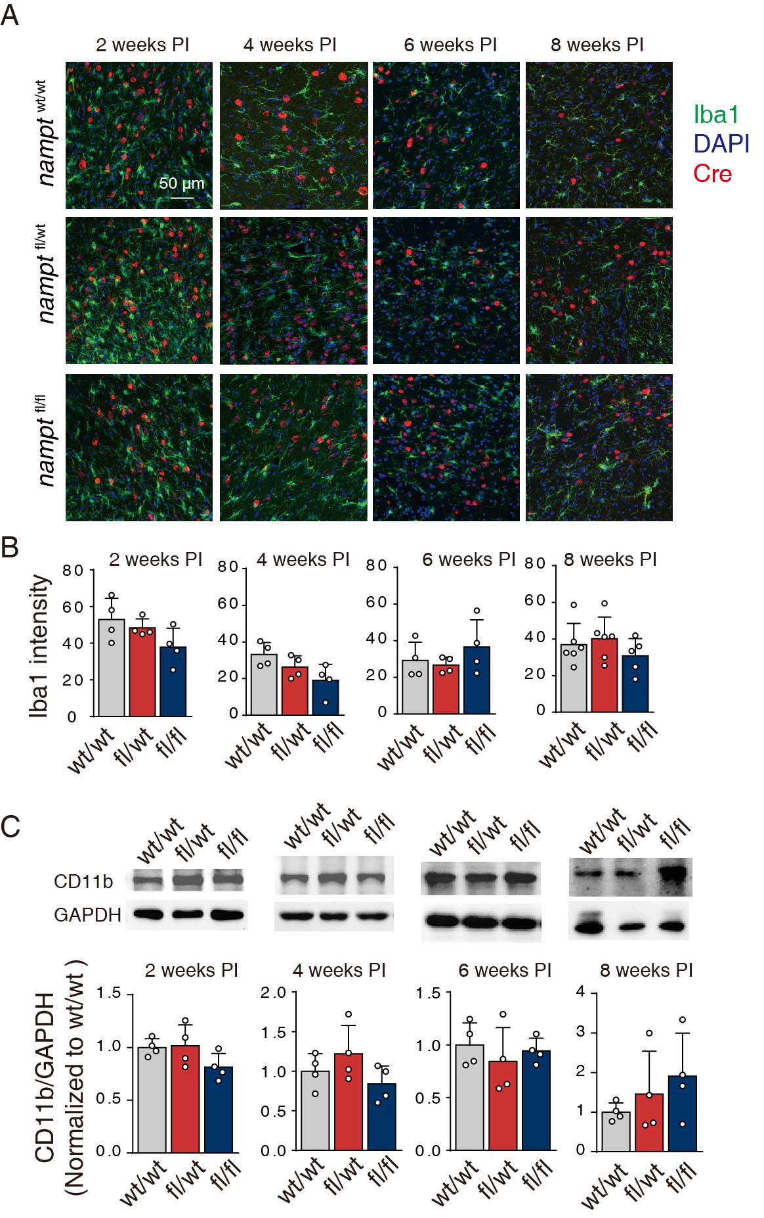

Supplementary Fig. 2 The knockout of nampt in the substantia nigra of mouse brain increased microglia responses. (A) Representative immunofluorescence images of Iba1 and Cre recombinase in the substantia nigra of mouse brain from nampt^{wt/wt}, nampt^{fl/wt} and nampt^{fl/fl} on 2-, 4-, 6- and 8-weeks post-injection (PI) of rAAV. (B) Statistical analysis of Iba1 intensity in the SN of mouse brain from nampt^{wt/wt}, nampt^{fl/wt} and nampt^{fl/fl} on 2-, 4-, 6- and 8-weeks post-injection of rAAV. N=4-6. Mean ± SD. (C) Western blot analysis of CD11b in the SN of mouse brain on 2-, 4-, 6-, and 8-weeks post-injection of rAAV. N=4. Mean ± SD.

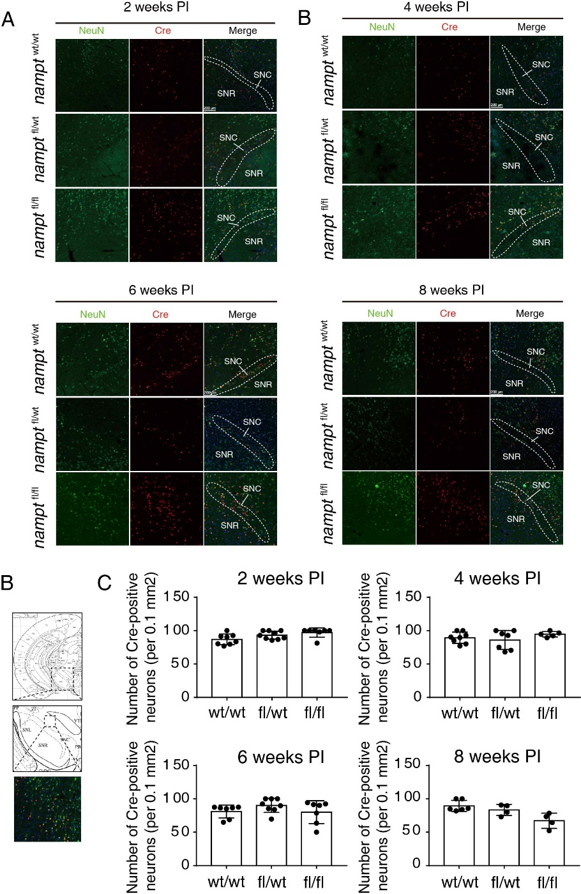

Supplementary Fig. 3 The knockout of nampt in non-dopaminergic neuron did not induce neuronal loss in the substantia nigra of mouse brain on 2 to 8-weeks post rAAV-hSyn-Cre-WPRE-pA injection. (A) Representative immunofluorescence images of NeuN and Cre recombinase in the substantia nigra of mouse brain from nampt^{wt/wt}, nampt^{fl/wt} and nampt^{fl/fl} on 2-, 4-, 6- and 8-weeks post-injection (PI) of rAAV. (B) Illustration of the region for the statistical analysis of Cre-positive neurons. (C) Statistical analysis of Cre-positive neurons intensity in the SN of mouse brain from nampt^{wt/wt}, nampt^{fl/wt} and nampt^{fl/fl} on 2-, 4-, 6- and 8-weeks post-injection of rAAV. N=4-9. Mean ± SD.
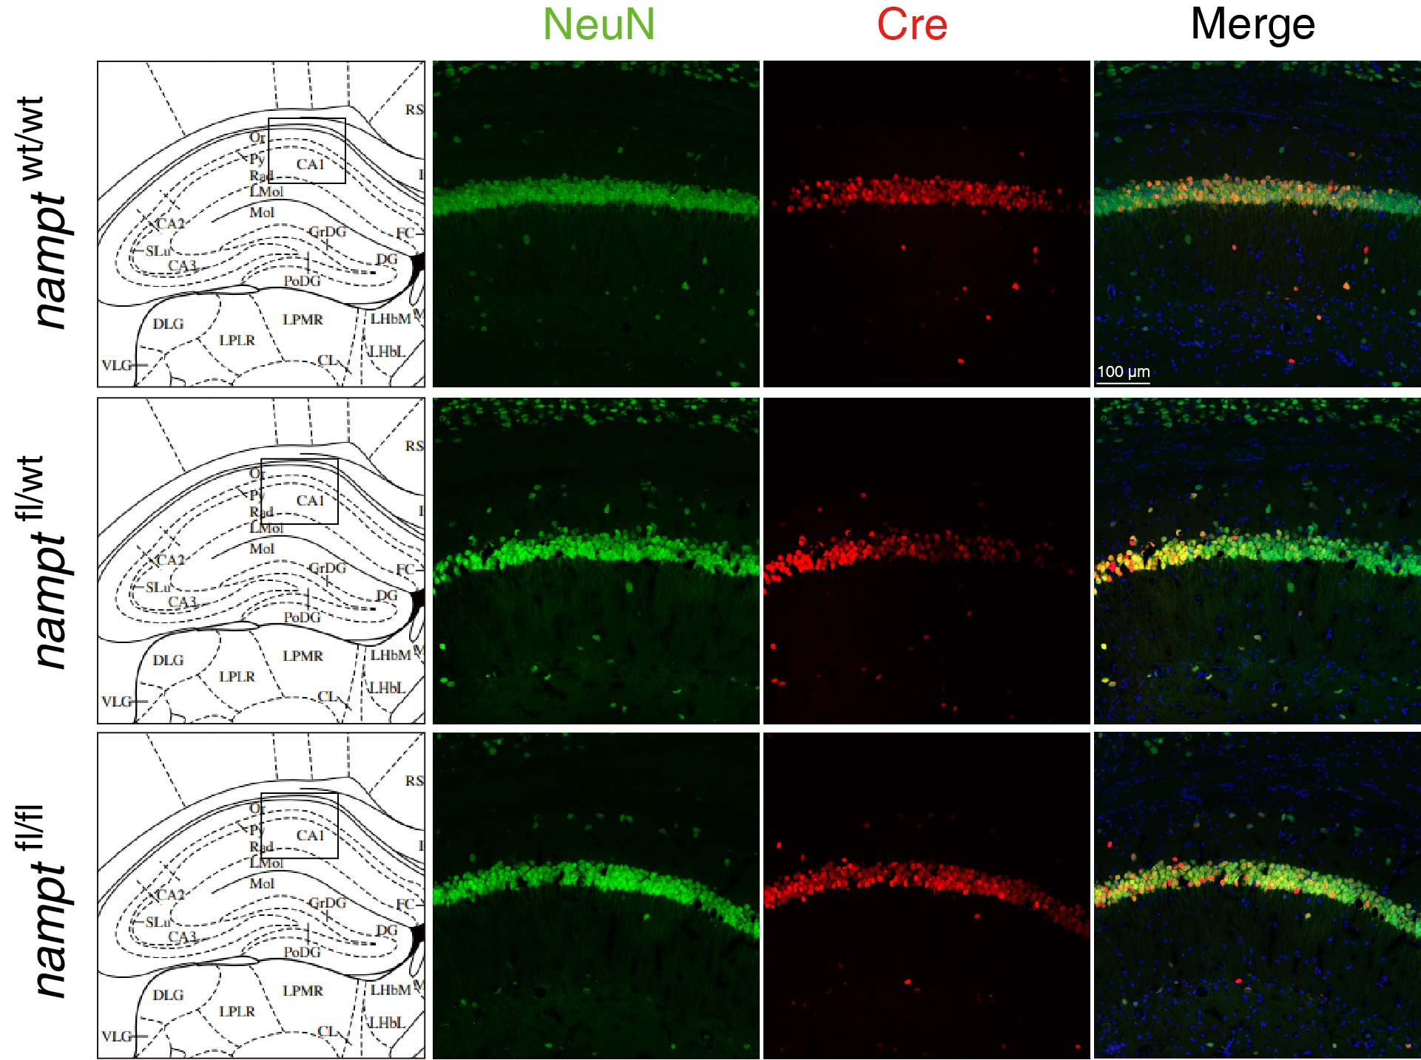

Supplementary Fig. 4 The knockout of nampt did not induce neuronal loss in the hippocampus CA1 region of mouse brain. The brain samples were collected on 4-weeks post rAAV-hSyn-Cre-WPRE-pA injection. Three individual mice were analyzed for each group.

