Revealing the mechanism of charge storage induced hole catalysis
Fang Li, ª Chen Guan,ª Zhihan Yu,ª Quanjun Xiangª*
a State Key Laboratory of Electronic Thin Film and Integrated Devices, School of Electronic Science and Engineering, University of Electronic Science and Technology of China, Chengdu 610054, P. R. China
^{E-mail: xiangqj@uestc.edu.cn;}

Table of contents
Table S1 Comparison of hole-releasing activity of prepared samples in light and dark-state conditions.
Table S2 Changes in hole concentration during charge storage and release.
Supplementary Fig. 1 (a) Photograph of PHI powder sample. (b) Photograph of blue radicals during charge storage process.
Supplementary Fig. 2 (a) Photograph of the blue radical after two hours of light exposure (b) Photograph of the blue radical being burst when the three-necked flask was not sealed in time after gas extraction.
Supplementary Fig. 3 Hydrogen production activity of PHI samples with co-catalyst.
Supplementary Fig. 4 (a) Dark-state oxygen production activities of PHI, PHI-KLi, and PHI-S. (b) Dark-state oxygen production activities of PHI without hole scavenger and co-catalyst.
Supplementary Fig. 5 Charge storage and release. (a) Photograph of the blue radical after one hour of light exposure (charge storage). (b) The blue radical is completely extinguished and the solution changes to its original yellow color (charge release).
Supplementary Fig. 6 Oxygen production activity of PHI under different conditions after electron release. (a) Dark-state oxygen-producing activity of PHI under light-only and heating-only conditions. (b) Effect of different hole scavengers on the dark state oxygen-producing activity of PHI.
Supplementary Fig. 7 Dark-state oxygen production activity of PHI under heating conditions.
Supplementary Fig. 8 Dark hydrogen production activity of PHI sample after heating and stirring.
Supplementary Fig. 9 (a, b) TEM images of PHI.
Supplementary Fig. 10 (a) TEM image of PHI, (b-e) corresponding elemental distribution images.
Supplementary Fig. 11 Proportion of elements in PHI.
Supplementary Fig. 12 The simulated STM image of PHI.
Supplementary Fig. 13 XPS survey Spectra of PHI.
Supplementary Fig. 14 (a) XPS C 1s and K 2P spectra of PHI. (b) XPS N 1s spectra of PHI. (c) XPS S 2p spectra of PHI.
Supplementary Fig. 15 DRS spectra of PHI, PHI-KLi, and PHI-S and (b) corresponding Kubelka-Monk transformation function.
Supplementary Fig. 16 FTIR spectra of PHI, PHI-KLi, and PHI-S.
Supplementary Fig. 17 (a, b) In-situ DRIFT spectra of PHI.
Supplementary Fig. 18 Schematic diagram of structural changes in PHI samples.
Supplementary Fig. 19 Electrochemical impedance curves of PHI samples in excited state and initial state.
Supplementary Fig. 20 (a, b) LSV curves of PHI samples in excited and initial states.
Supplementary Fig. 21 Structure of the geometrically optimized PHI. (a) Top view, and (b, e) side view.
Supplementary Fig. 22 Structure of the geometrically optimized PHI-CO. (a) Top view, and (b, e) side view.
Supplementary Fig. 23 (a) Charge density spectra of PHI and (b) PHI-CO. The isosurface level is 0.07 e/bohr³
Supplementary Fig. 24 TDOS plots for PHI and PHI-CO.
Supplementary Fig. 25 PDOS plots of the O atom of PHI-CO.

Table S1 Comparison of hole-releasing activity of prepared samples in light and dark-state conditions.
Samples | Scavenger | Heat | Hole release (μmol h-1 g-1)  Light Dark
PHI | MeOH | 25 ℃, 1h | 6.72 | 55.65
PHI-S | MeOH | 25 ℃, 1h | 45.42 | 30.90
PHI-KLi | MeOH | 25 ℃, 1h | 17.24 | 44.83
No catalytst | MeOH | 25 ℃, 1h |  | 3.85
PHI | No Scavenger | 25 ℃, 1h |  | 6.77
PHI1 | MeOH | 80 ℃, 1h |  | 75.90
PHI2 | AgNO₃ | 25 ℃, 1h | 3.89 | 45.15
PHI | MeOH | 80 ℃, 1h | 14.88 | 133.02
PHI | TEOA | 80 ℃, 1h | 17.61 | 63.14
PHI | Ethanol | 80 ℃, 1h | 20.15 | 22.02
PHI | Ethylene glycol | 80 ℃, 1h | 47.30 | 97.82

Table S2 Changes in hole concentration during charge storage and release.

Time | Spins/mm^³ | Concentration/M | Spins
Dark 0 min | 2.123*10¹⁵ | 3.525*10⁻³ | 3.335*10¹⁶
Light 15 min | 1.666*10¹⁵ | 2.767*10⁻³ | 2.617*10¹⁶
333 K dark 15 min | 1.553*10¹⁵ | 2.579*10⁻³ | 2.439*10¹⁶
Note: TEMPO is used as a hole trapping agent. the concentration of TEMPO is inversely proportional to the concentration of holes, and the amount of TEMPO reduced is equal to the amount of holes produced.

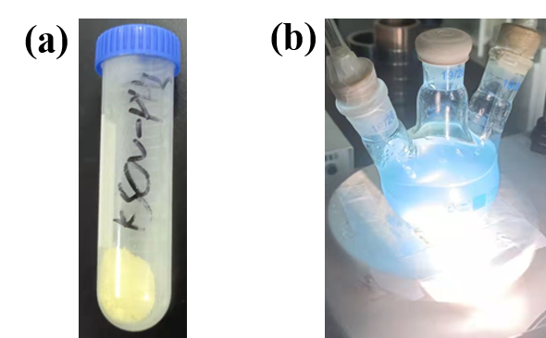
Supplementary Fig. 1 (a) Photograph of PHI powder sample. (b) Photograph of blue radicals during charge storage process.

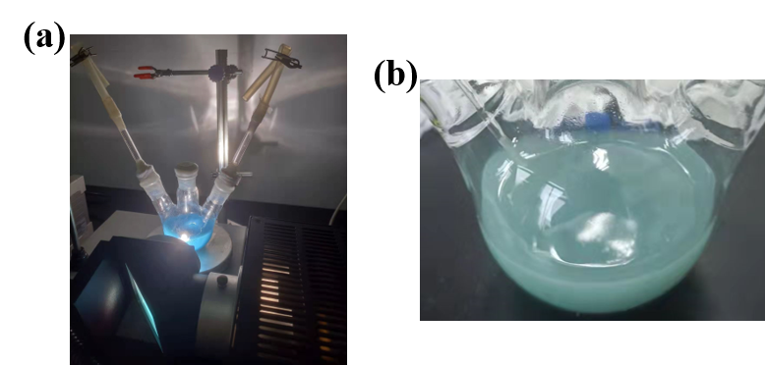
Supplementary Fig. 2 (a) Photograph of the blue radical after two hours of light exposure (b) Photograph of the blue radical being burst when the three-necked flask was not sealed in time after gas extraction.

Supplementary Fig. 3 Hydrogen production activity of PHI samples with co-catalyst.

Supplementary Fig. 4 (a) Dark-state oxygen production activities of PHI, PHI-KLi, and PHI-S. (b) Dark-state oxygen production activities of PHI without hole scavenger and co-catalyst.

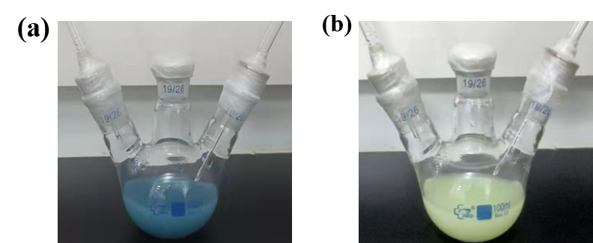
Supplementary Fig. 5 Charge storage and release. (a) Photograph of the blue radical after one hour of light exposure (charge storage). (b) The blue radical is completely extinguished and the solution changes to its original yellow color (charge release).

Supplementary Fig. 6 Oxygen production activity of PHI under different conditions after electron release. (a) Dark-state oxygen-producing activity of PHI under light-only and heating-only conditions. (b) Effect of different hole scavengers on the dark state oxygen-producing activity of PHI.

Supplementary Fig. 7 Dark-state oxygen production activity of PHI under heating conditions.

Supplementary Fig. 8 Dark hydrogen production activity of PHI sample after heating and stirring.

Supplementary Fig. 9 (a, b) TEM images of PHI.

Supplementary Fig. 10 (a) TEM image of PHI, (b-e) corresponding elemental distribution images.

Supplementary Fig. 11 Proportion of elements in PHI.

Supplementary Fig. 12 The simulated STM image of PHI.

Supplementary Fig. 13 XPS survey Spectra of PHI.

Supplementary Fig. 14 (a) XPS C 1s and K 2P spectra of PHI. (b) XPS N 1s spectra of PHI. (c) XPS S 2p spectra of PHI.

Supplementary Fig. 15 DRS spectra of PHI, PHI-KLi, and PHI-S and (b) corresponding Kubelka-Monk transformation function.

Supplementary Fig. 16 FTIR spectra of PHI, PHI-KLi, and PHI-S.

Supplementary Fig. 17 (a, b) In-situ DRIFT spectra of PHI.

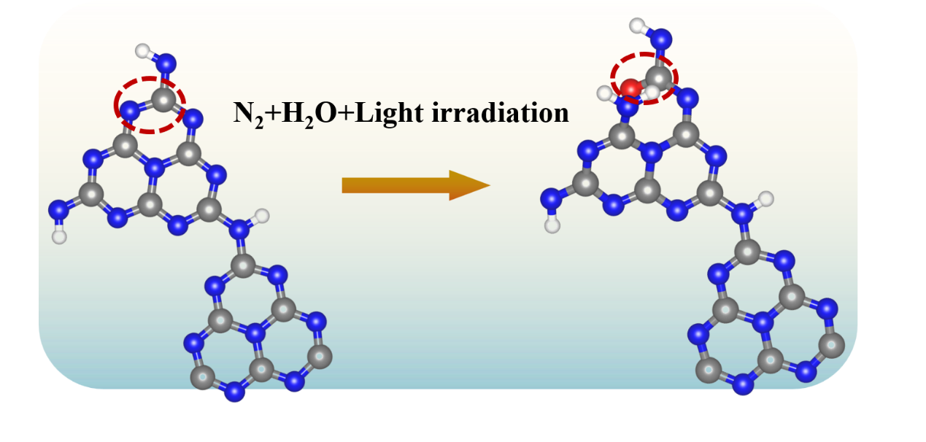
Supplementary Fig. 18 Schematic diagram of structural changes in PHI samples.

Supplementary Fig. 19 Electrochemical impedance curves of PHI samples in excited state and initial state.

Supplementary Fig. 20 (a, b) LSV curves of PHI samples in excited and initial states.

Supplementary Fig. 21 Structure of the geometrically optimized PHI. (a) Top view, and (b, e) side view.

Supplementary Fig. 22 Structure of the geometrically optimized PHI-CO. (a) Top view, and (b, e) side view.

Supplementary Fig. 23 (a) Charge density spectra of PHI and (b) PHI-CO. The isosurface level is 0.07 e/bohr³

Supplementary Fig. 24 TDOS plots for PHI and PHI-CO.

Supplementary Fig. 25 PDOS plots of the O atom of PHI-CO.

