2-Piperidone ,1 -(4-amino phenyl)-3-(4-morpholinyl): A new process related impurity of Apixaban-An anticoagulant drug

Vipin Kumar,ª Sachin Kumar Sharma,ª Govind Singh,ª Shyambaran Dhuriya,ª Lingaiah Balthu,ª Sushil Kumar,^{b} Rashmi Devi,^{b} Krishna Kumar Yadav,^{b} and Sumit S. Chourasiya*ª

ªDepartment of Process Research and Development,
IOL Chemicals and Pharmaceuticals Ltd, Barnala, Punjab-148101, India.
Department of Analytical Research and Development,
IOL Chemicals and Pharmaceuticals Ltd, Barnala, Punjab-14810, India.
E-mail:sumitchourasiya@iolcp.com
Table of Contents

- ¹H NMR, ¹³C NMR, IR and ESI-MS spectra scan copies of synthesized compounds
- ¹H NMR, ¹³C NMR, IR and LC-MS spectra scan copies of unknown impurity
- Details of HPLC method employed for analysis of Apixaban intermediate and Apixaban (API)
- HPLC chromatograph showing peak of impurity and APN-05
- Details of flash chromatography condition used for the isolation of impurity

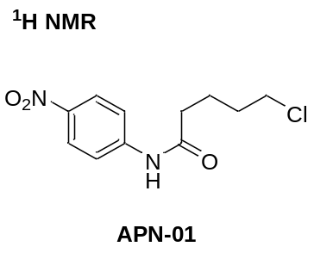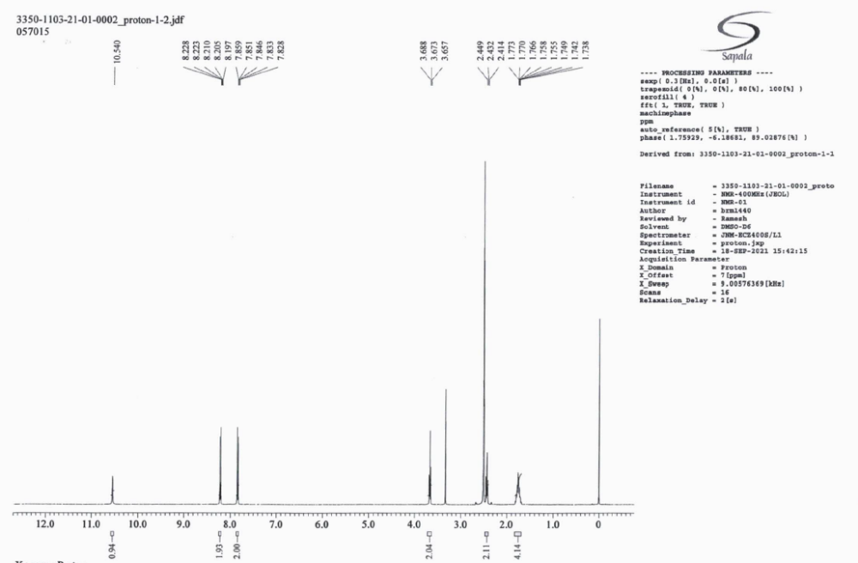
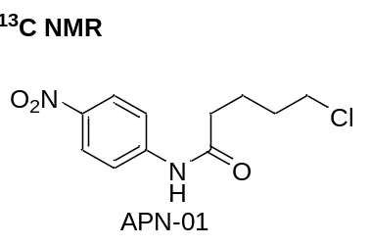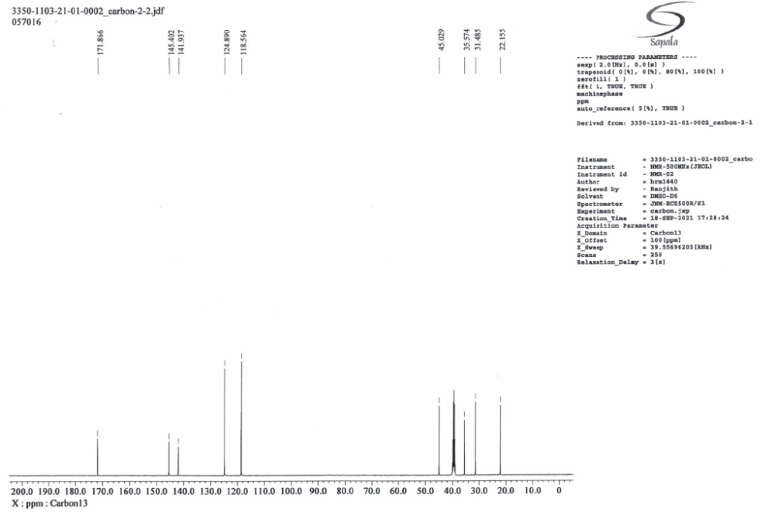
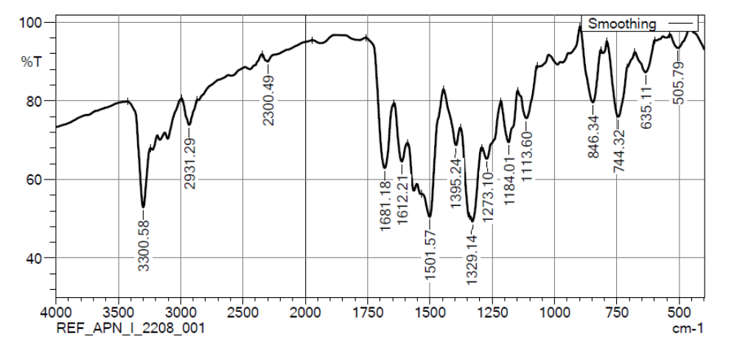
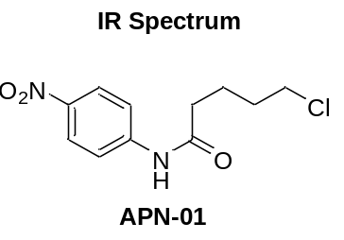

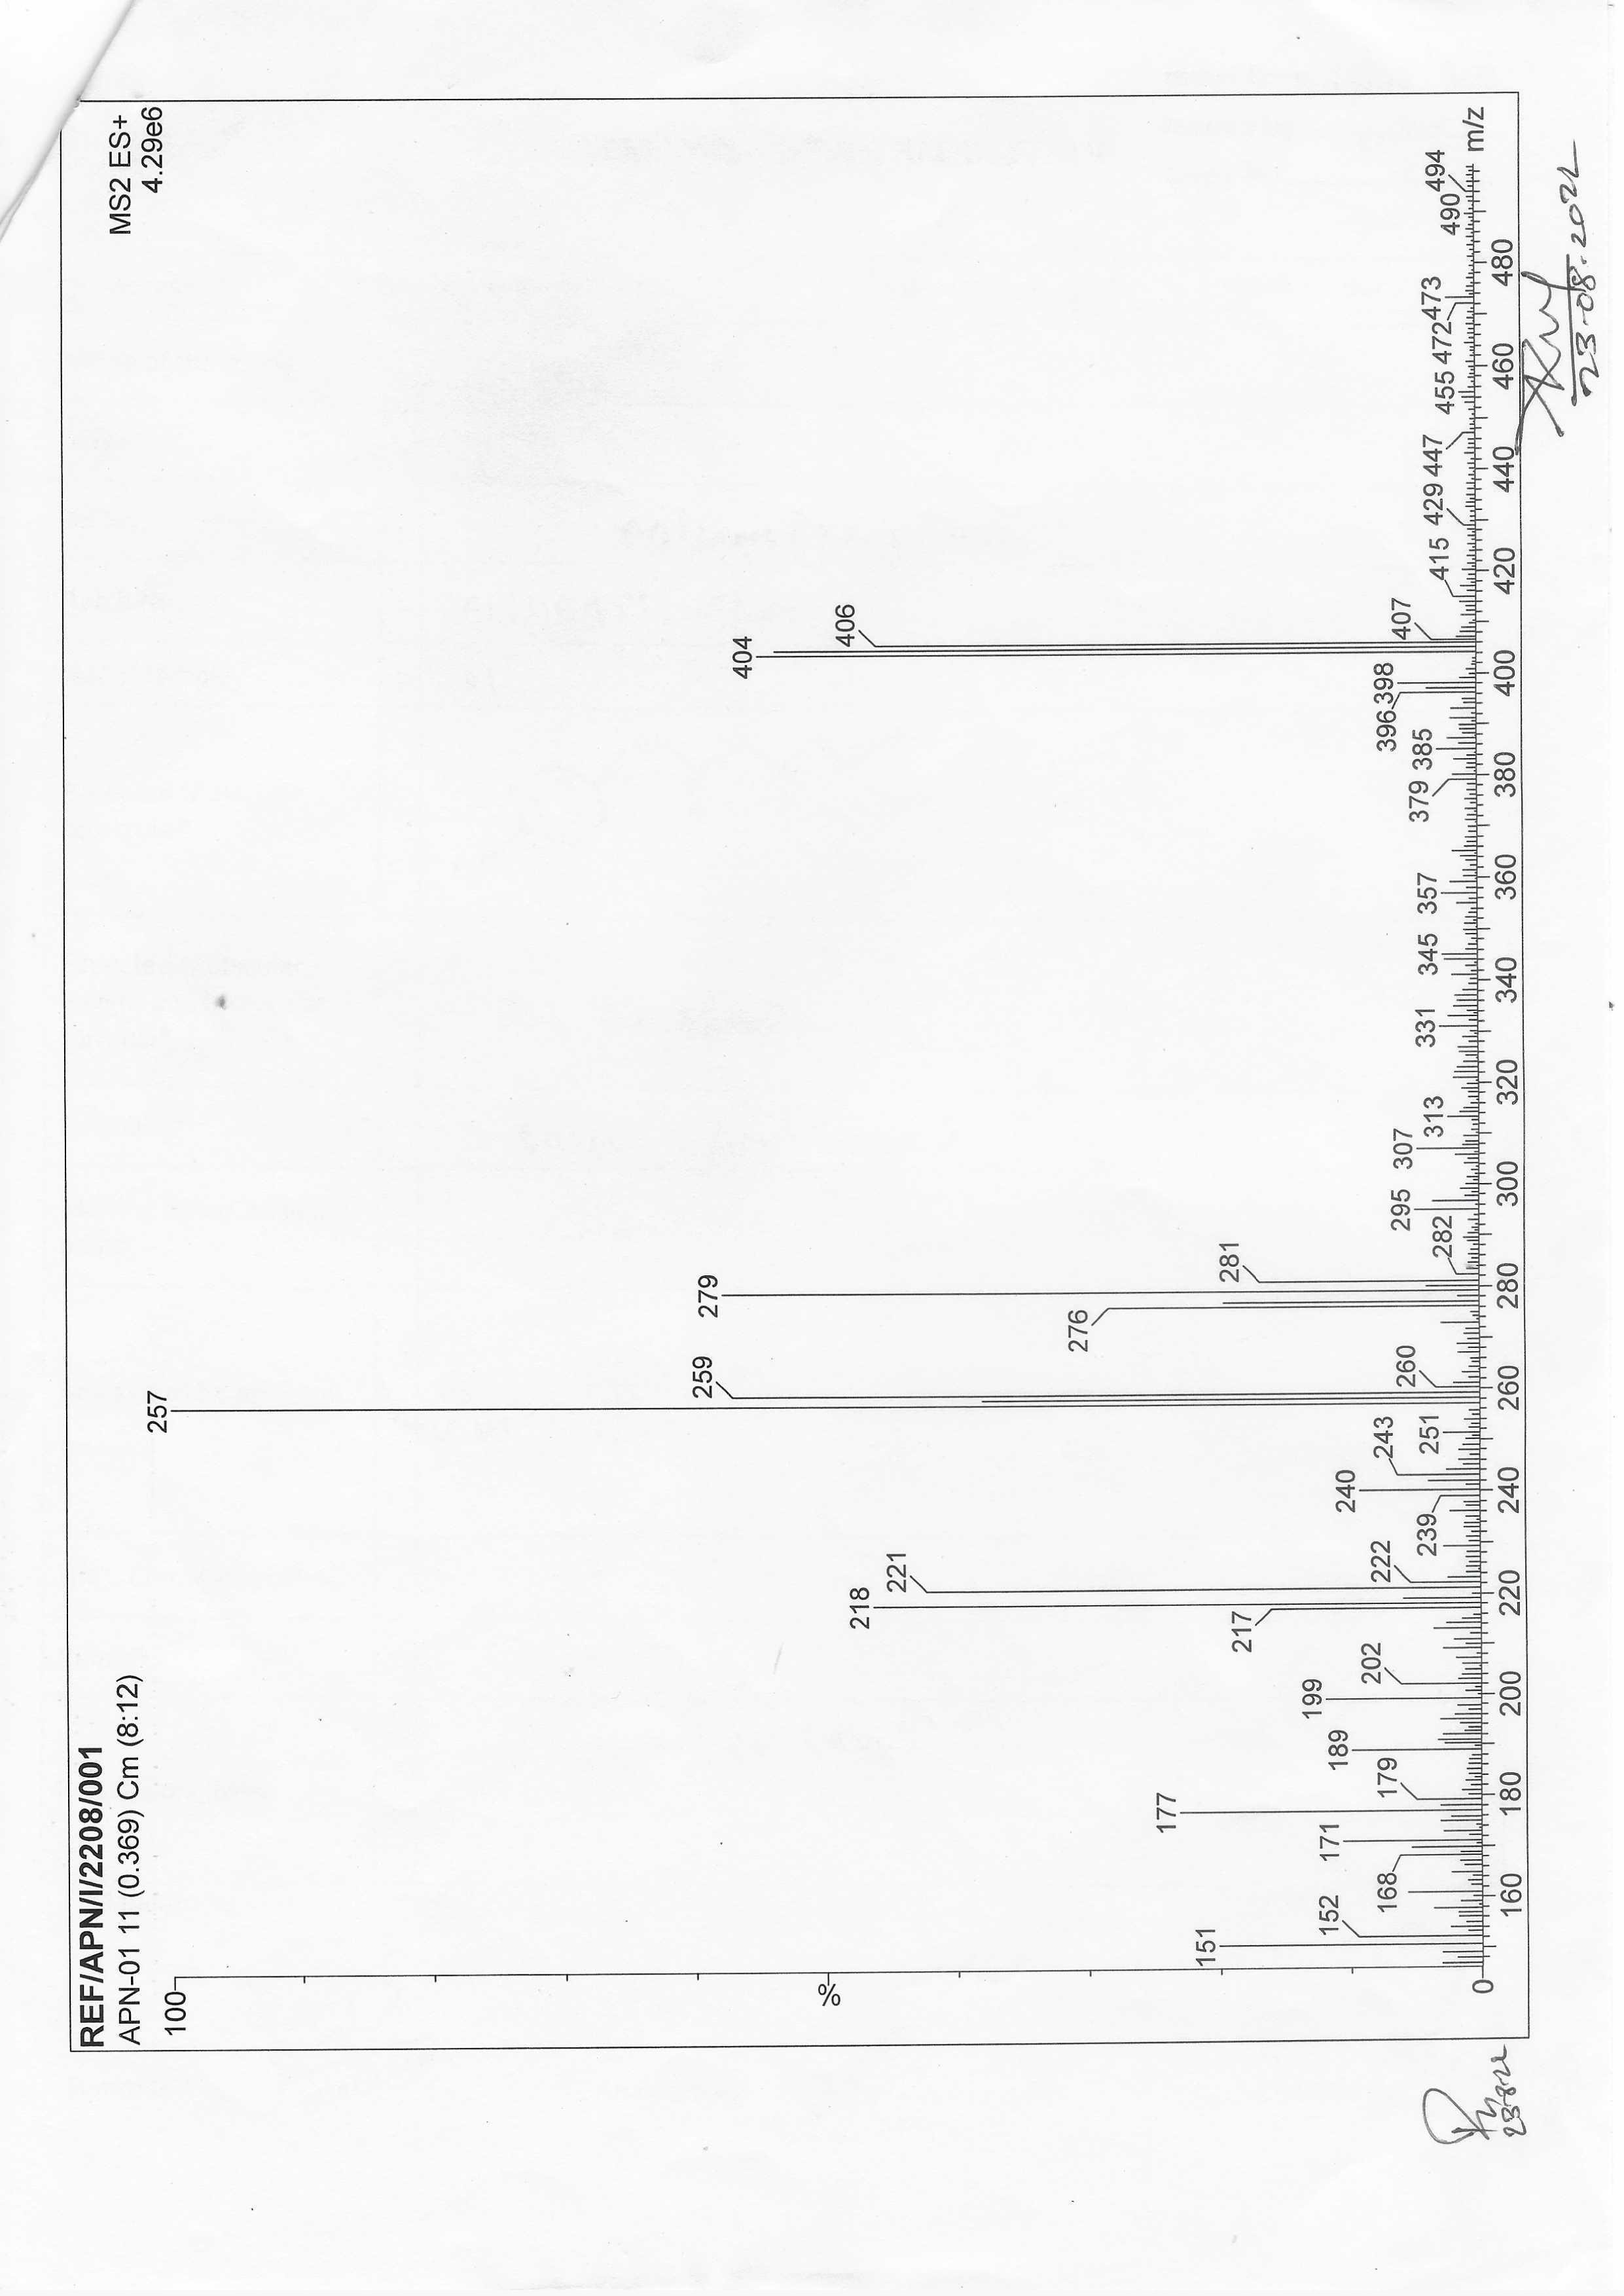
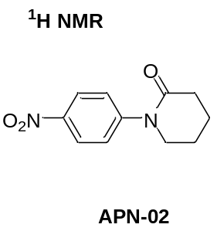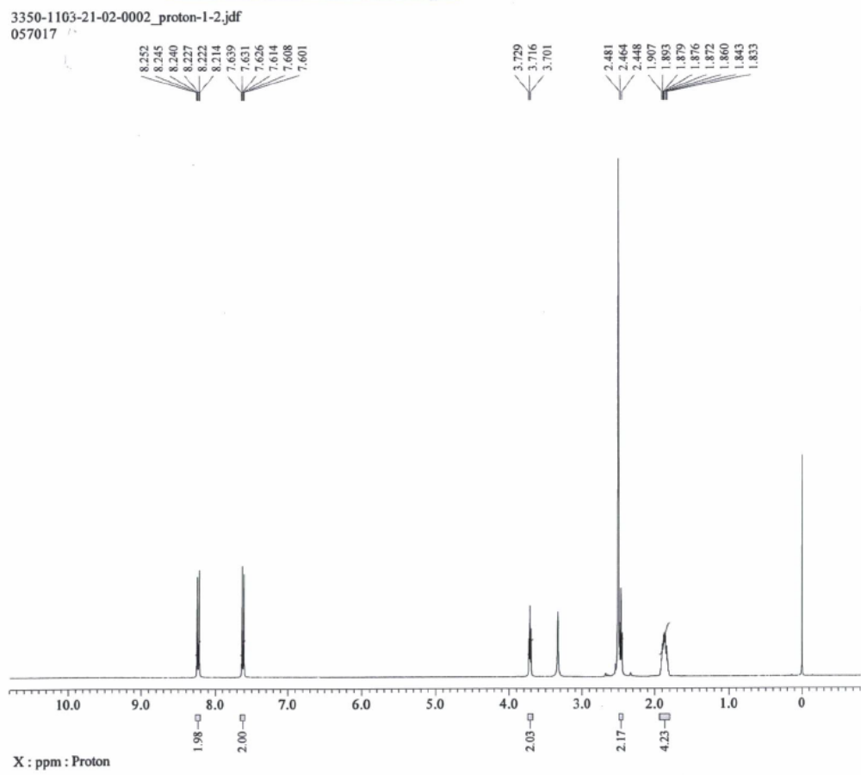
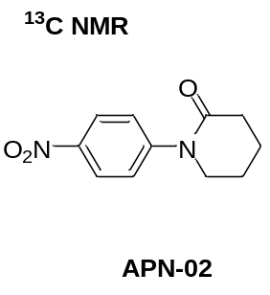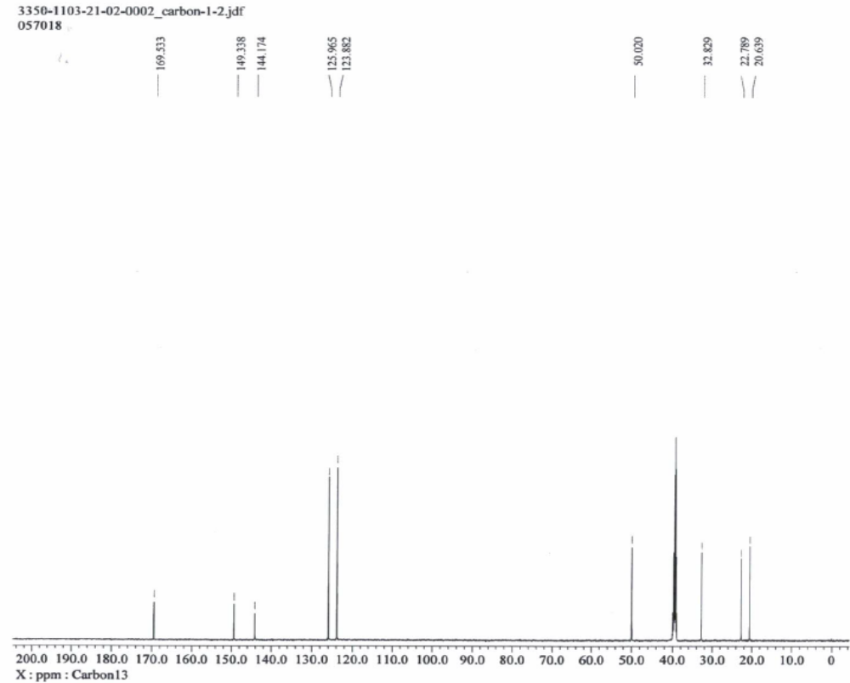
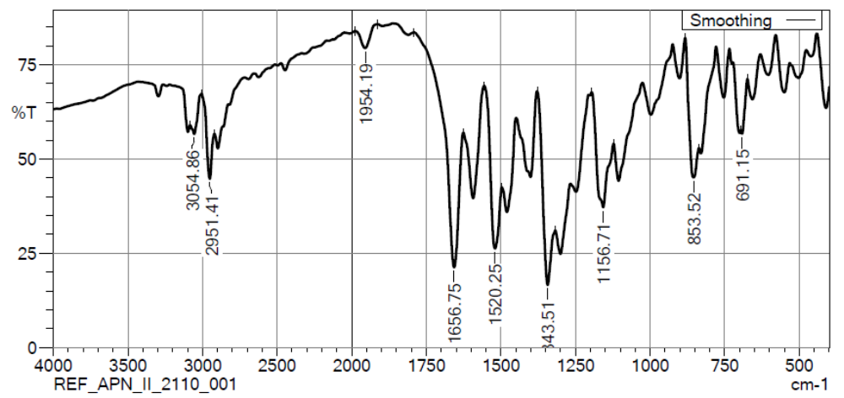
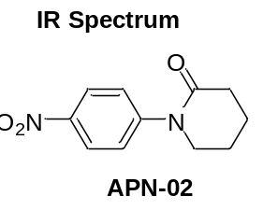

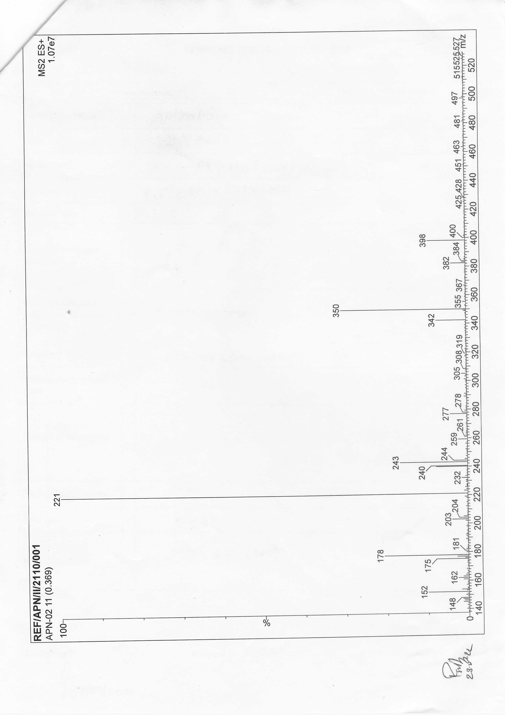

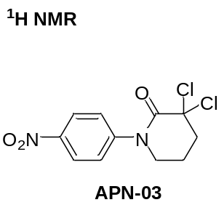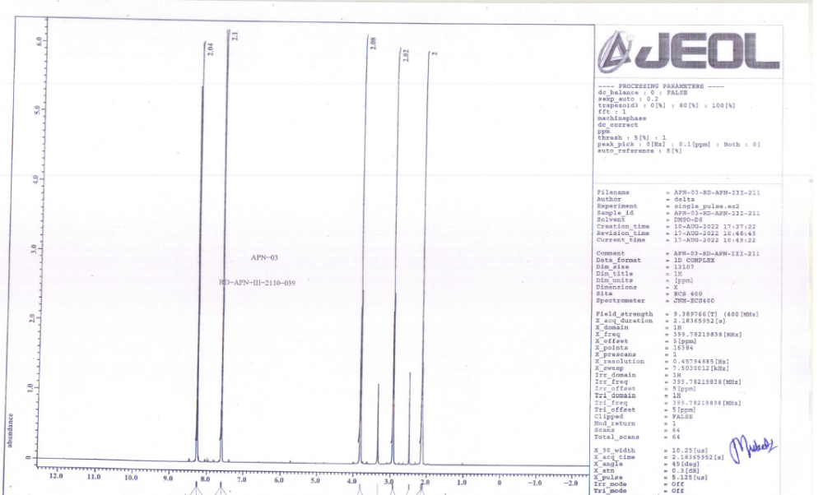
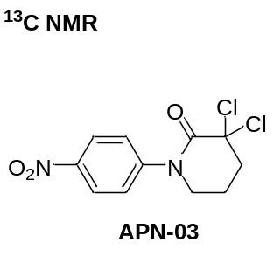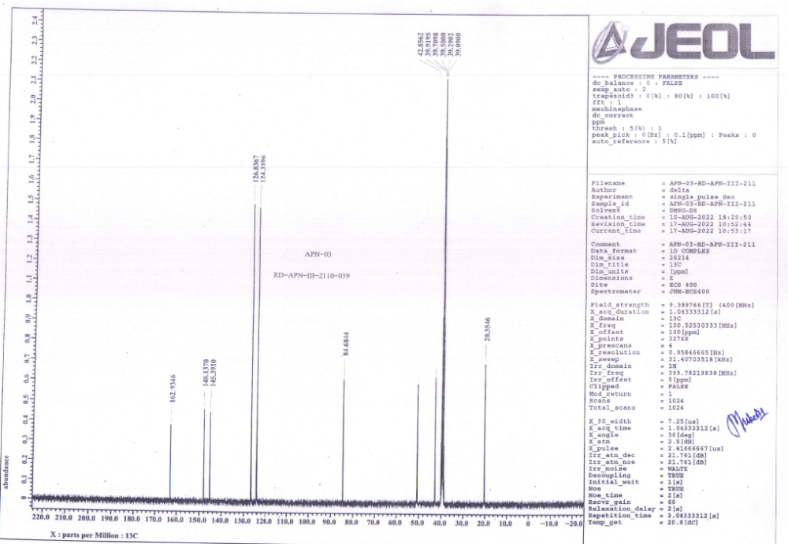

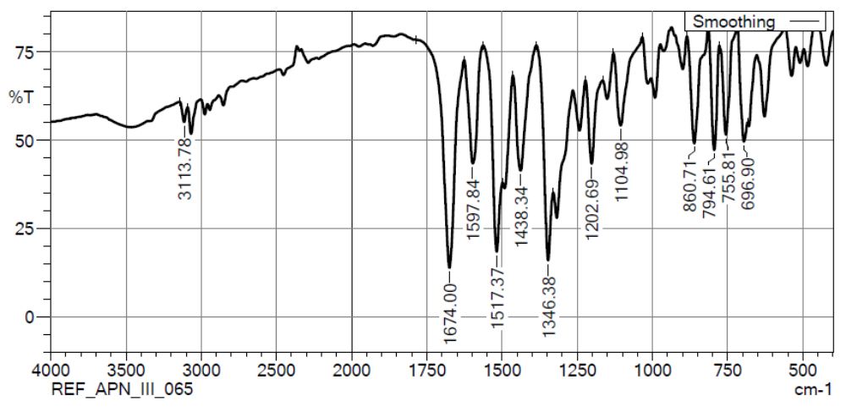
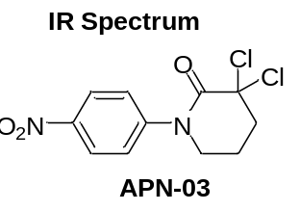

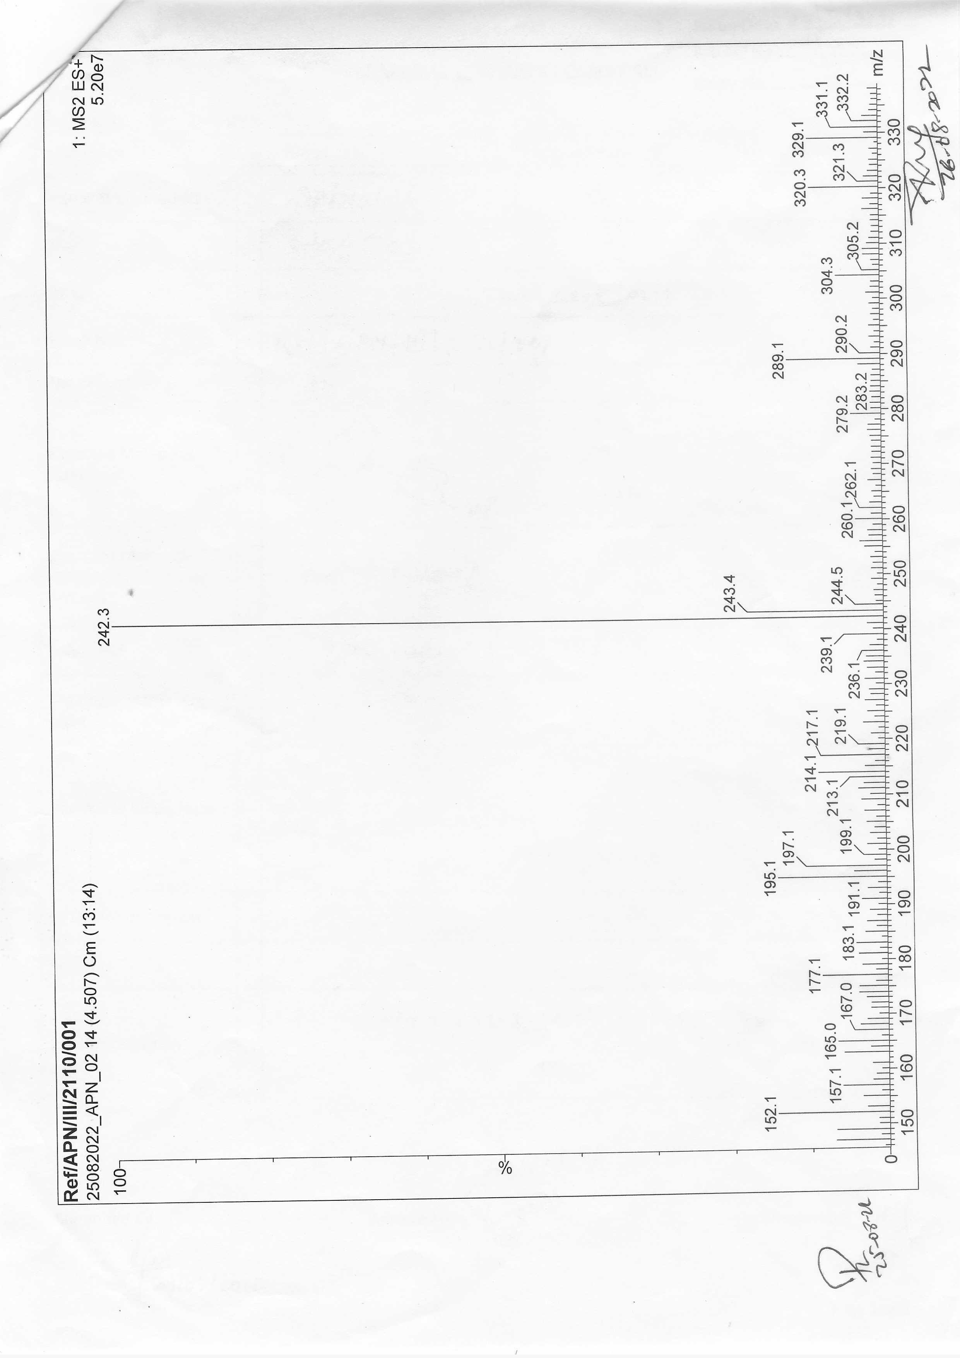
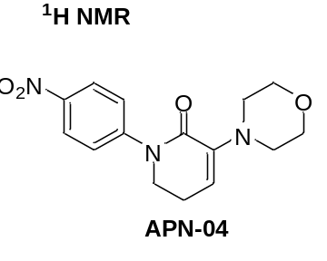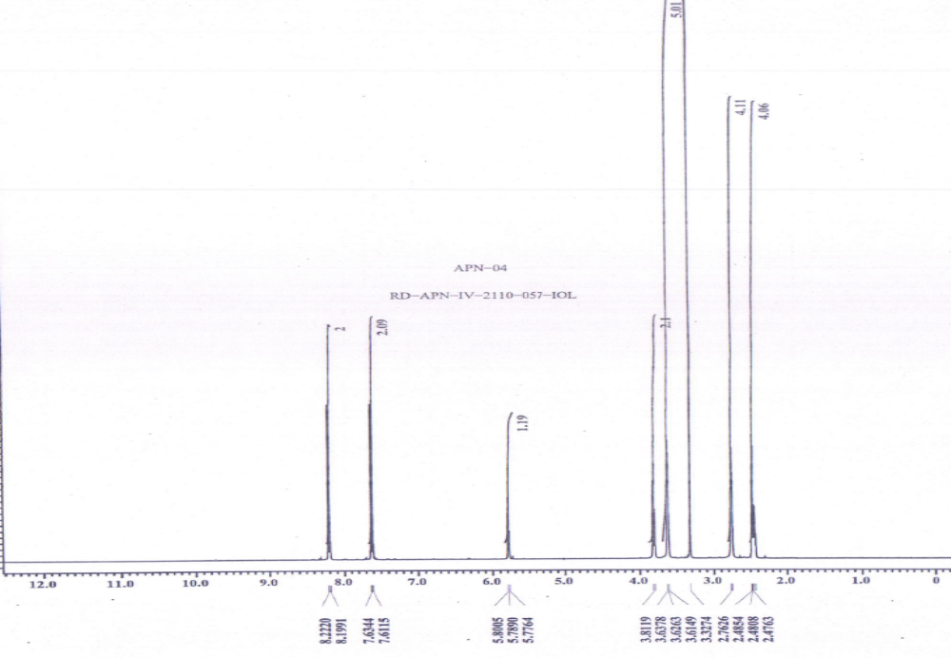
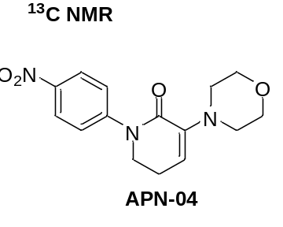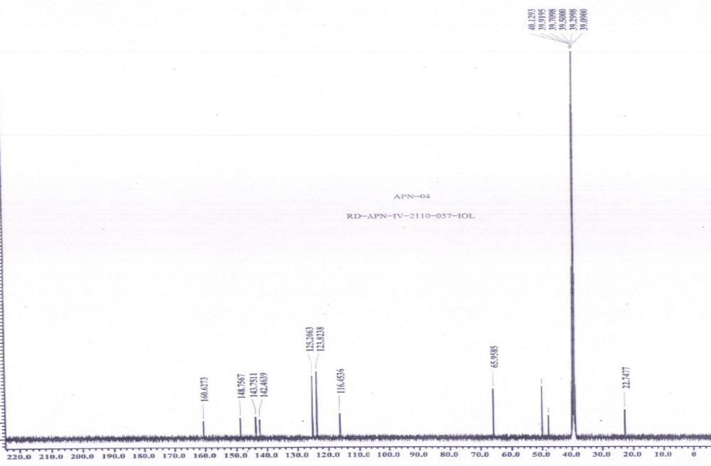
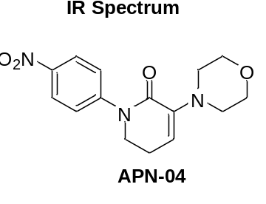

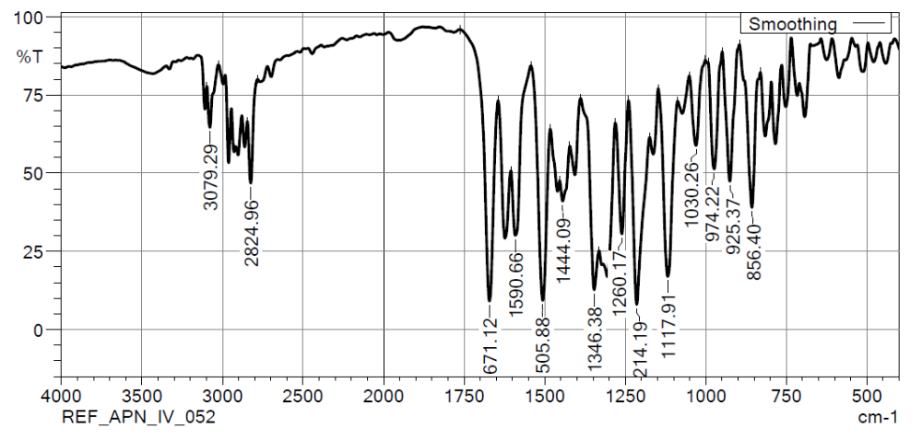
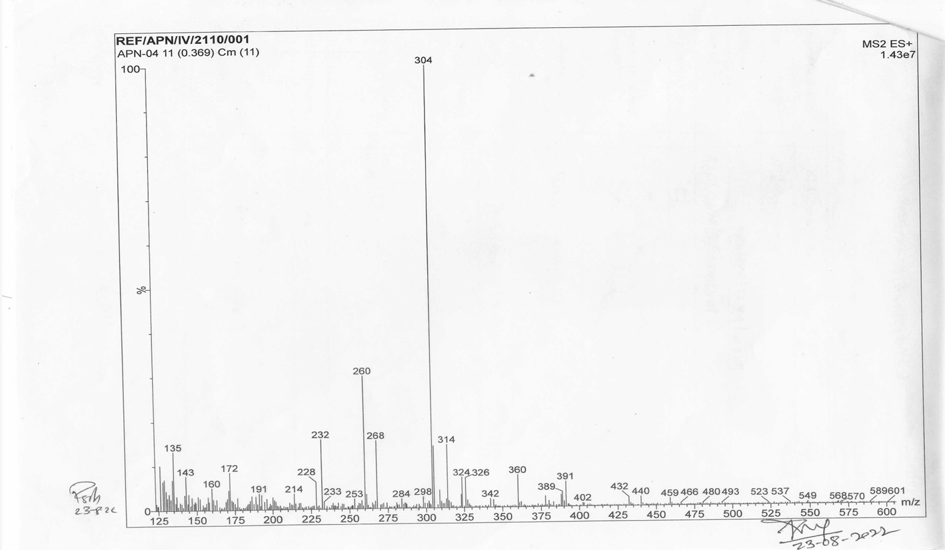
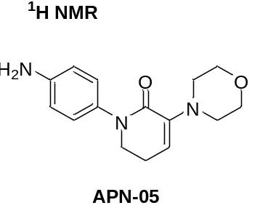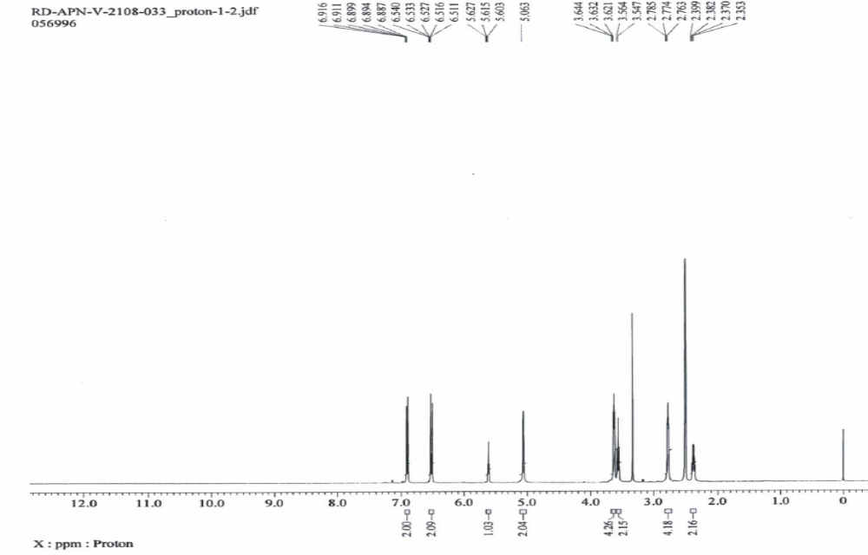
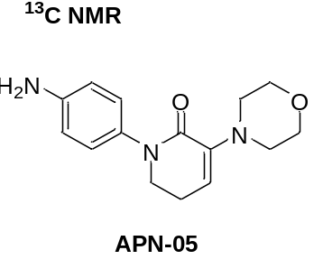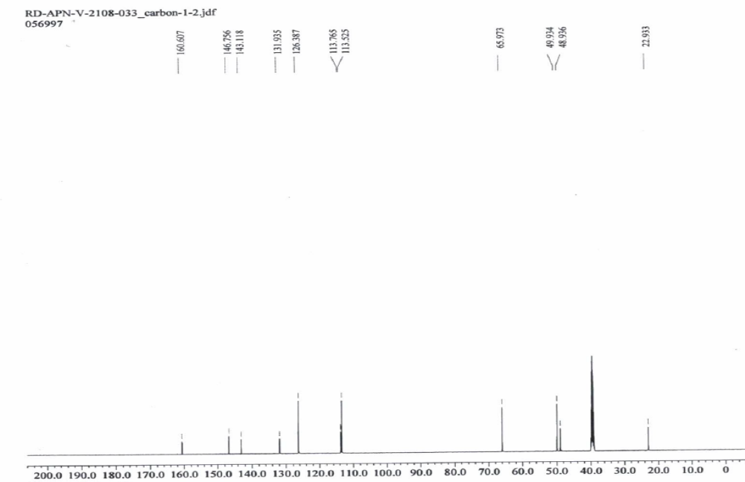
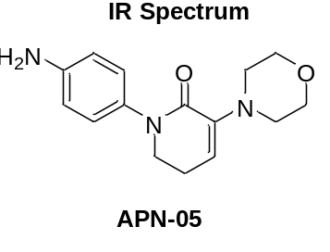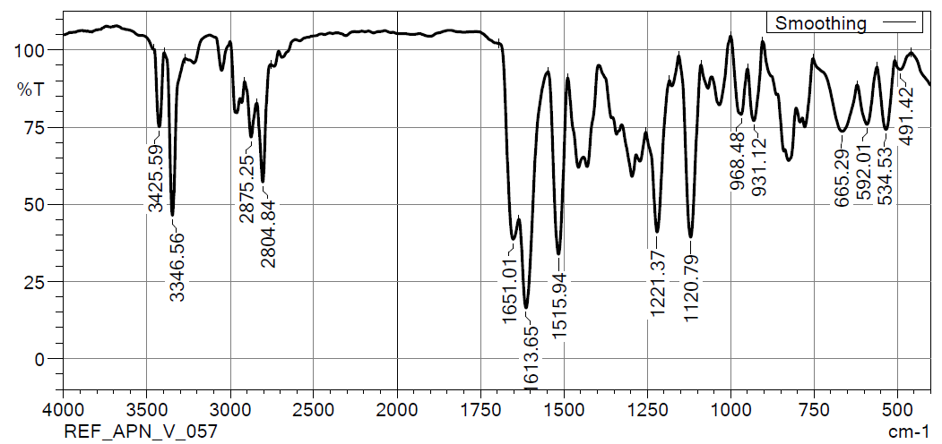
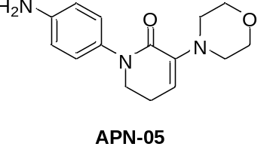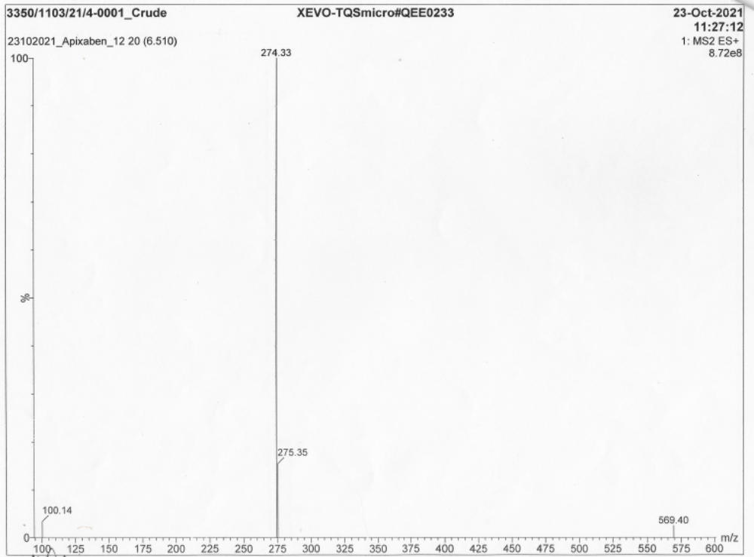
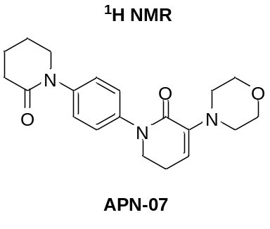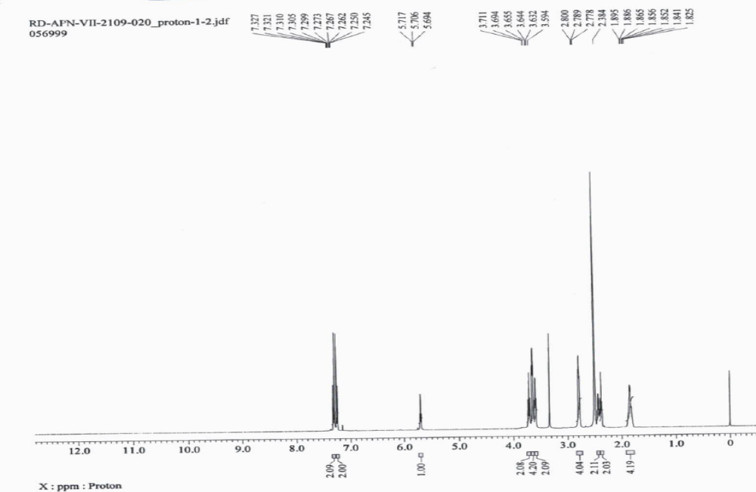
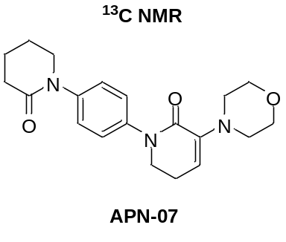
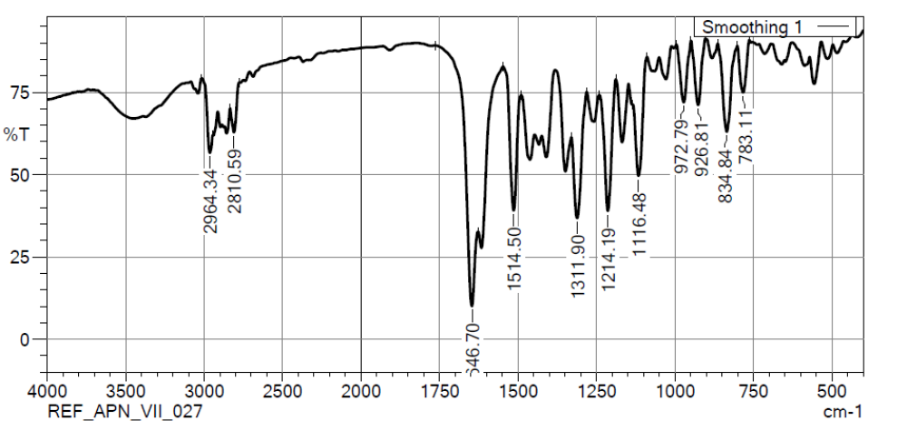
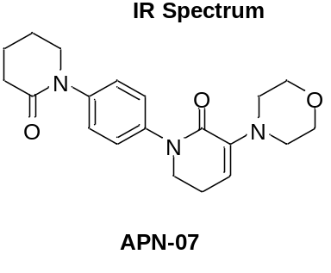
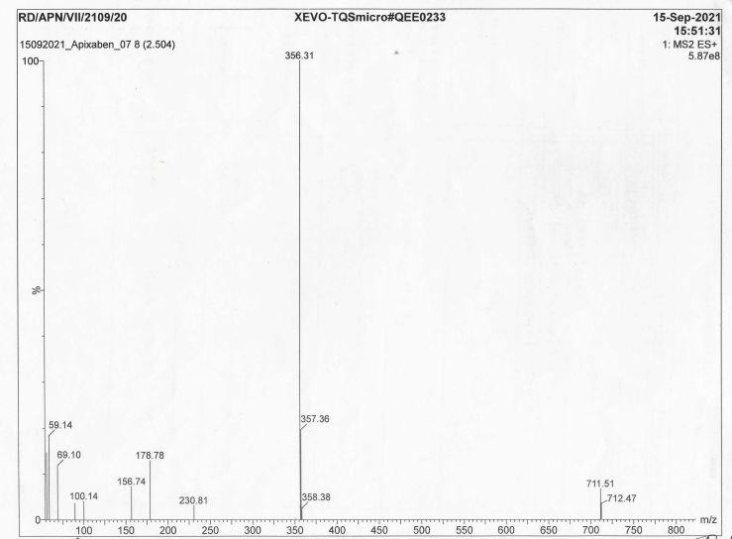
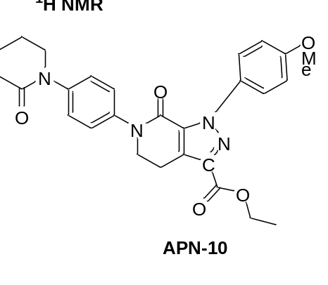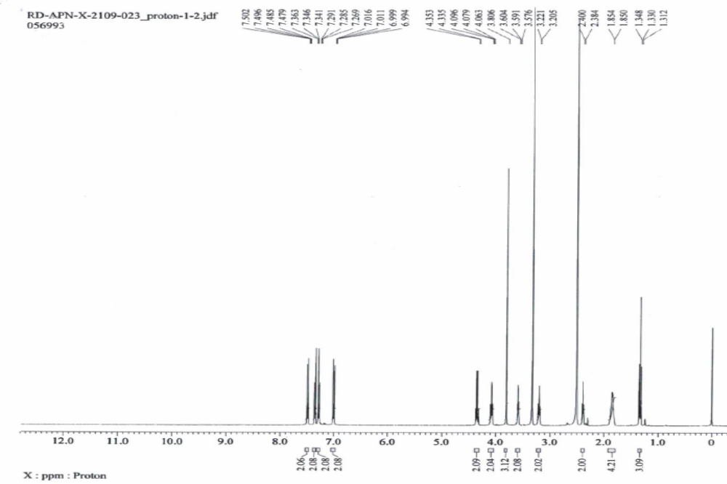
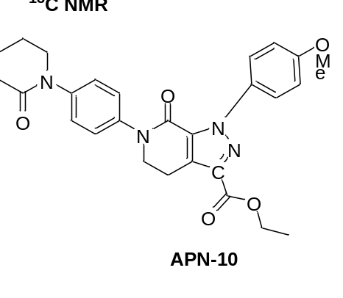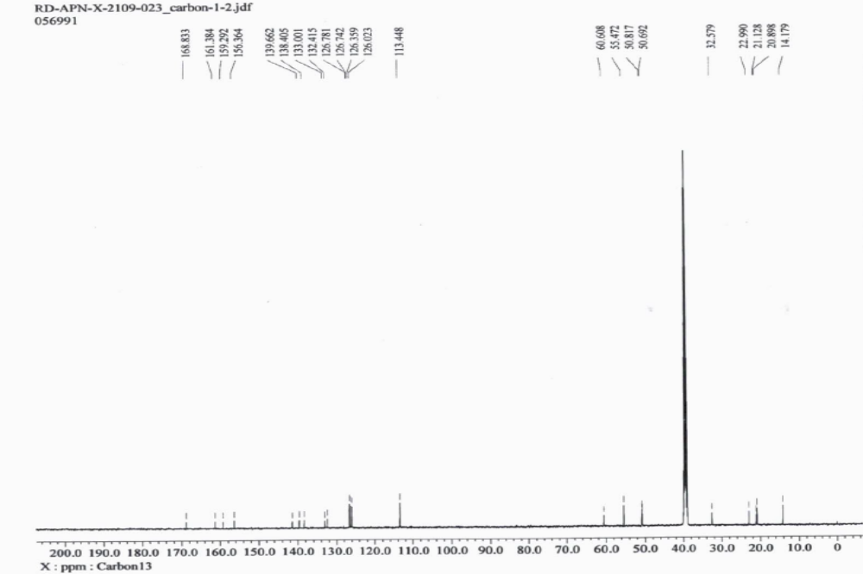
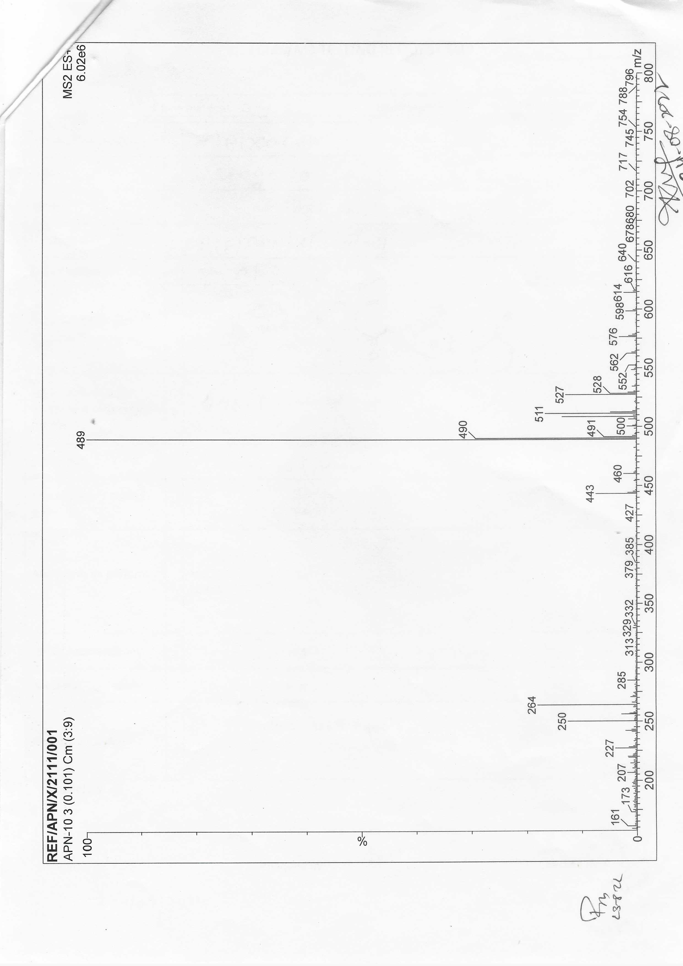
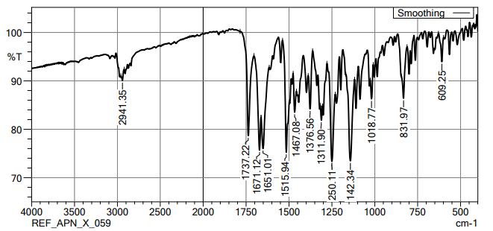
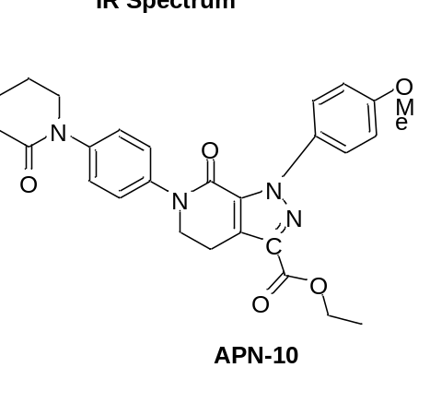
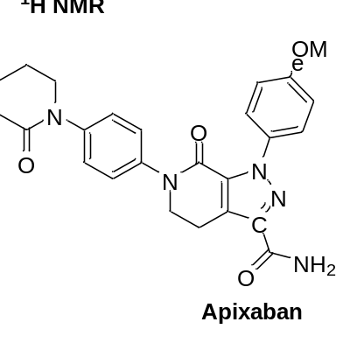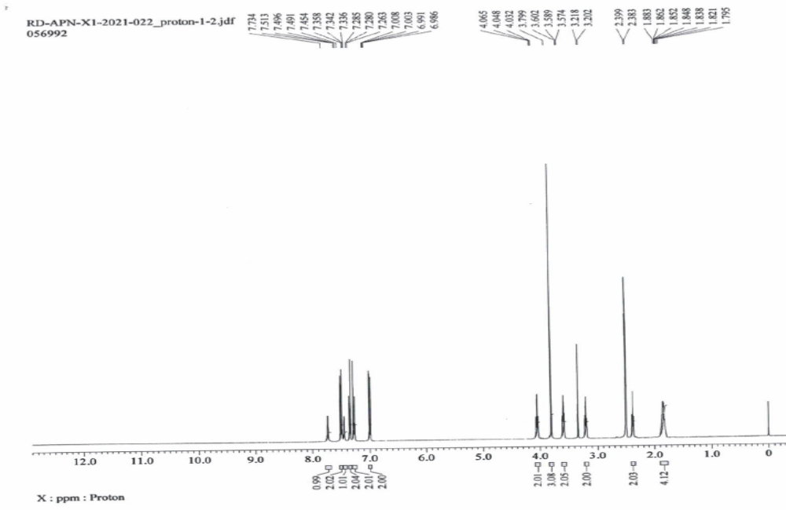
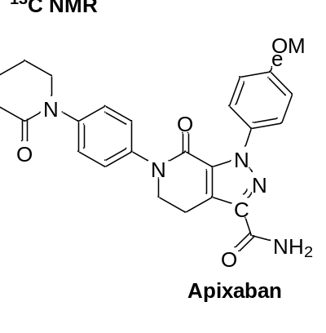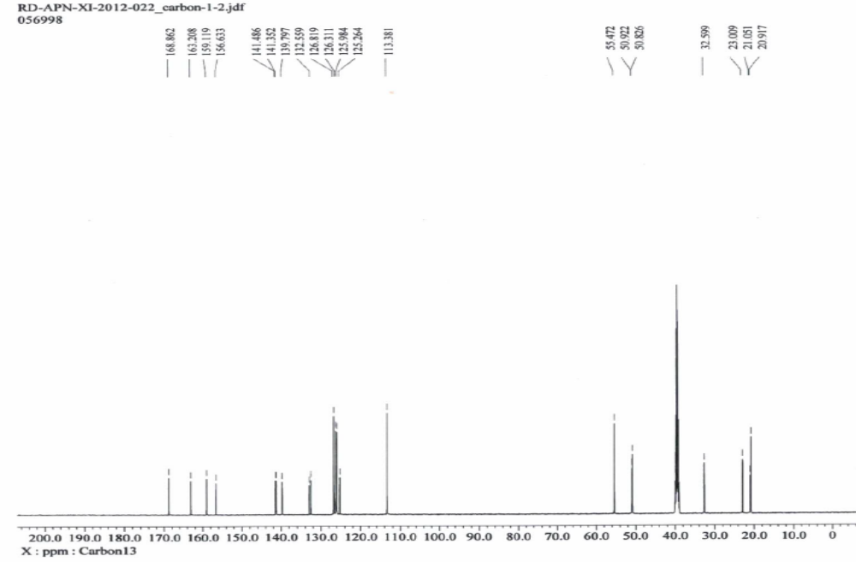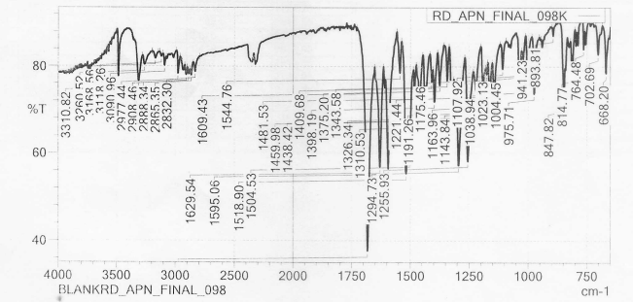

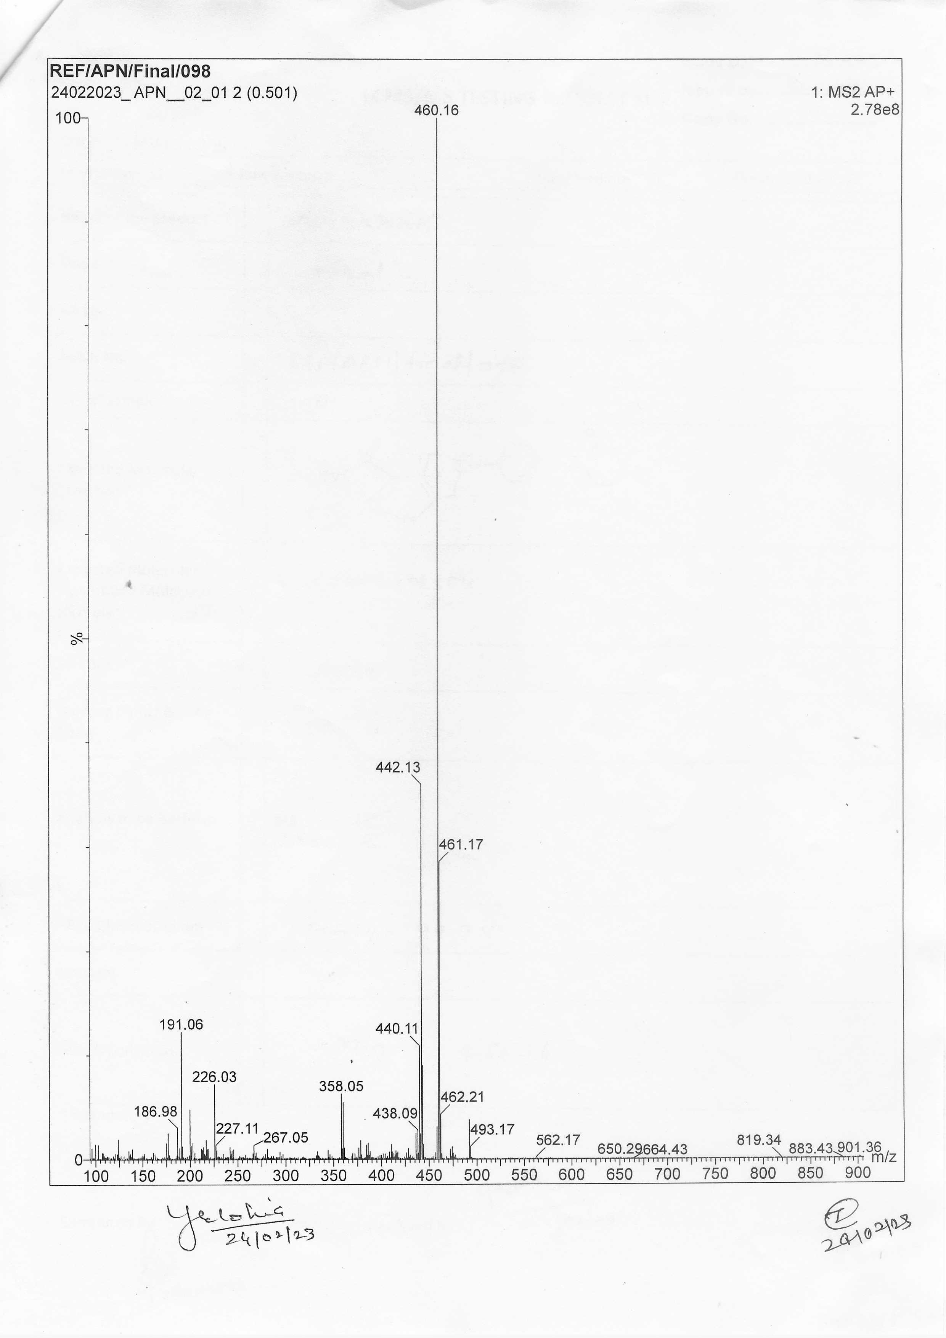

¹H NMR, ¹³C NMR, IR and LC-MS spectra scan copies of unknown impurity

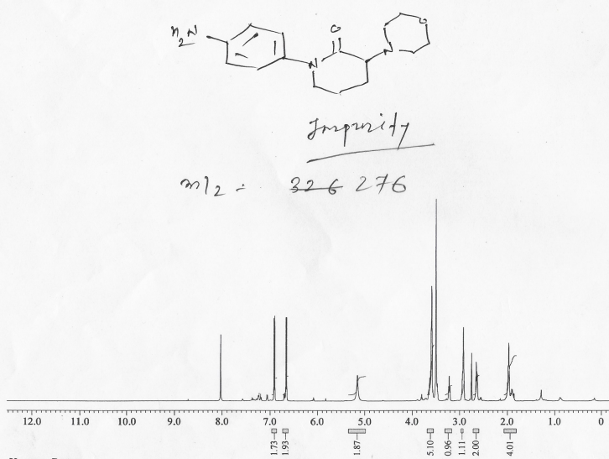

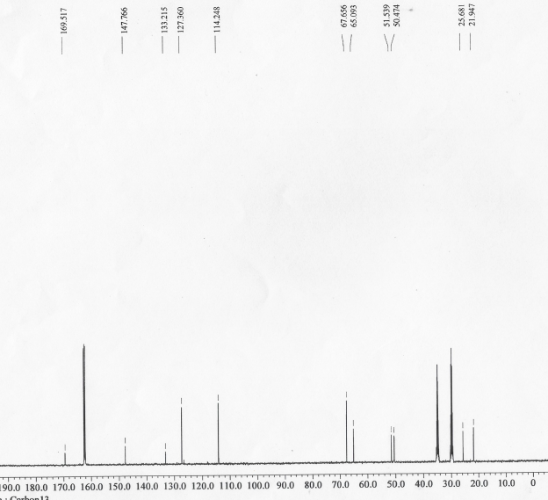
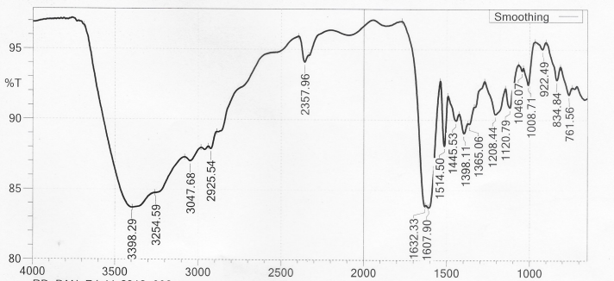
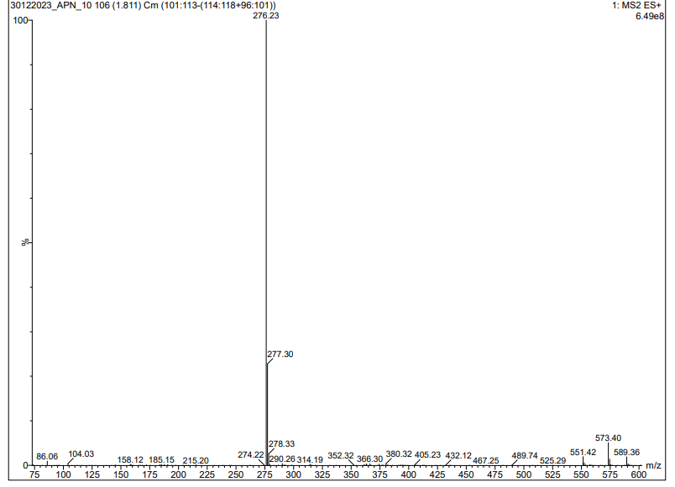
HPLC method employed for analysis
HPLC Method A: For analysis of APN-01, APN-02, APN-03 and APN-04
Column: Inertsil ODS 3V (250 mm x 4.6 mm,5µm); flow rate: 1.0 mL/min: eluent A: Aq. Solution of orthophosphoric acid in water prepared by dissolving 1.0 mL of orthophosphoric acid into 1000 mL milli-q water. eluent B: Methanol; Gradient: 0 min: 70% A, 30% B; 3 min: 70% A, 30% B; 15 min: 30% A, 70% B; 35 min: 30% A, 70% B; 36 min: 70% A, 30% B; 45 min: 70% A, 30% B. UV detection at 215 nm.
HPLC Method B: For analysis of APN-05, APN-06, APN-07
Column: Inertsil ODS 3V (250 mm x 4.6 mm,5µm); flow rate: 1.0 mL/min: eluent A: Aq. Solution of orthophosphoric acid in water prepared by dissolving 1.0 mL of orthophosphoric acid into 1000 mL milli-q water. eluent B: Methanol; Gradient: 0 min: 80% A, 20% B; 3 min: 80% A, 20% B; 15 min: 30% A, 70% B; 35 min: 30% A, 70% B; 36 min: 80% A, 20% B; 45 min: 80% A, 20% B. UV detection at 215 nm.
HPLC Method C: For reaction monitoring of APN-09 and APN-10
Column: Inertsil ODS 3V (250 mm x 4.6 mm,5µm); flow rate: 1.0 mL/min: eluent A: Aq. Solution of ammonium acetate in water with pH 4 prepared by dissolving 0.23g/L of ammonium acetate into 1000 mL milli-q water and adjusting pH 4.0 with Acetic acid: Acetonitrile (90/10 v/v). eluent B: Water: Acetonitrile (10:90 v/v); Gradient: 0 min: 75% A, 25% B; 20 min: 65% A, 35% B; 30 min: 40% A, 60% B; 35 min: 40% A, 60% B; 36 min: 75% A, 25% B; 45 min: 75% A, 25% B. UV detection at 280 nm.
HPLC Method D: For purity analysis of finished product i.e. Apixaban
Column: Zorbax Rx C8 (250 mm x 4.6 mm,5µm); flow rate: 1.0 mL/min: eluent A: Aq. Solution of trifluoroacetic acid in water prepared by dissolving 1.0 mL of Trifluoroacetic acid into 1000 mL milli-q water by shaking well to mix and sonicate to degas the solution. eluent B: Acetonitrile; Gradient: 0 min: 70% A, 30% B; 10 min: 70% A, 30% B; 30 min: 30% A, 70% B; 35 min: 30% A, 70% B; 40 min: 70% A, 30% B; 50 min: 70% A, 30% B. UV detection at 280 nm.

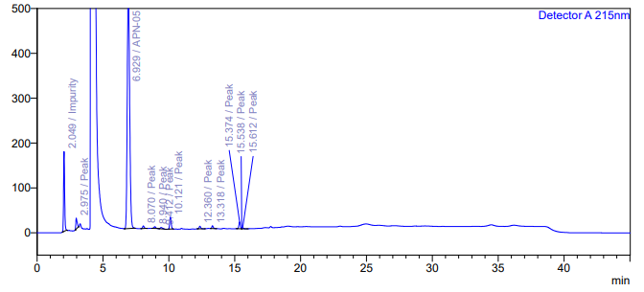
Figure 1: HPLC chromatograph showing unknown impurity eluting at 2.09 min whereas APN-05 eluting at 6.92 min.
Details of flash chromatography condition used for the isolation of impurity

