Supplemental Tab.1|C7 Length of nerve from dura mater to fusion (mm).
 | Left | Right
Specimen 1 | 9.5 | 9.0
Specimen 2 | 12.4 | 12.2
Specimen 3 | 11.3 | 11.6
Specimen 4 | 10.7 | 11.1

Supplemental Tab.2|Measuring data of left anterior root wire length (mm).
 | 1st bundle | 2nd bundle | 3rd bundle
Specimen 1 | 11.5 | 10.5 | 8.5
Specimen 2 | 13.0 | 12.1 | 11.2
Specimen 3 | 12.6 | 11.5 | 10.7
Specimen 4 | 11.9 | 10.3 | 8.6

Supplemental Tab.3|Measuring data of right anterior root wire length (mm).
 | 1st bundle | 2nd bundle | 3rd bundle
Specimen 1 | 12.1 | 11.5 | 9.1
Specimen 2 | 15.1 | 13.9 | 13.0
Specimen 3 | 11.8 | 10.7 | 9.0
Specimen 4 | 12.8 | 11.5 | 8.9

Supplemental Tab.4|Measuring data of left posterior root wire length (mm).
 | 1st bundle | 2nd bundle | 3rd bundle | 4th bundle | 5th bundle
Specimen 1 | 13.4 | 13.0 | 12.5 | 12.0 | 11.5
Specimen 2 | 17.0 | 16.5 | 15.2 | 14.5 | 13.0
Specimen 3 | 15.9 | 15.1 | 13.8 | 13.0 | 12.1
Specimen 4 | 16.2 | 15.4 | 14.2 | 13.8 | 12.9

Supplemental Tab.5|Measuring data of right posterior root wire length (mm).
 | 1st bundle | 2nd bundle | 3rd bundle | 4th bundle | 5th bundle
Specimen 1 | 15.1 | 14.5 | 14.1 | 13.4 | 12.8
Specimen 2 | 17.5 | 16.8 | 15.5 | 14.7 | 13.3
Specimen 3 | 14.8 | 14.3 | 13.7 | 12.5 | 11.7
Specimen 4 | 14.5 | 13.7 | 12.9 | 12.1 | 11.4

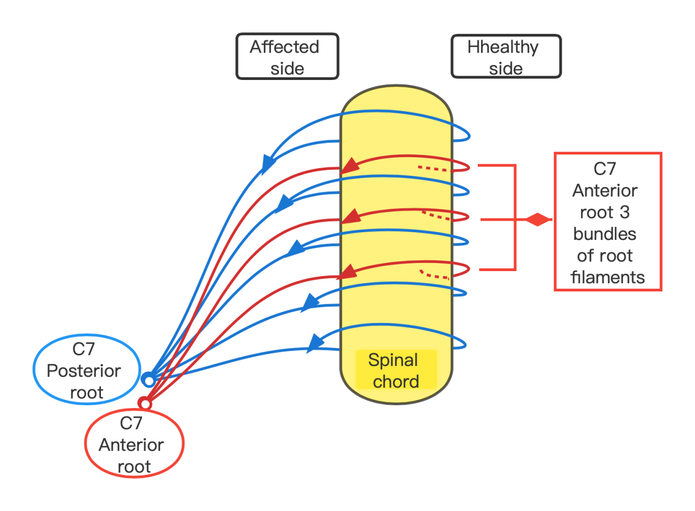
Supplemental Figure 1 After the healthy posterior root segment is cut, it is anastomosed with the affected posterior root. The red line represents the anterior root, the blue line represents the posterior root, and the yellow line represents the spinal cord.

