Supplementary Materials for

Revelation of new magnetic domain wall category in the itinerant antiferromagnet Chromium

Yining Hu†, Xu Wang†, Chen Chen†*, Qingle Zhang, Dongming Zhao, Tianzhen Zhang, Chenxi Wang, Donglai Feng*, Tong Zhang*

†These authors contributed equally to this work.
*Corresponding authors.
Email: cchen_physics@zjnu.edu.cn, dlfeng@ustc.edu.cn, tzhang18@fudan.edu.cn

Supplementary Text
I. Measurement of pure spin-contrast along X, Y, Z directions:
Using Fe-coated tip, we can measure dI/dV maps with spin sensitivity along X ([100]), Y ([010]) and Z ([001]) directions, which is achieved by polarizing the tip under a vector magnetic field along X, Y and Z, respectively. The pure spin contrast maps (S_{X}, S_{Y}, S_{Z}) can be obtained by the relative difference of dI/dV maps taken under ±B_{X}, ±B_{Y} and ±B_{Z}, respectively. For example, Figs. S1a and S1b show two dI/dV maps taken under B_{X} = 1T and B_{X} = -1T around Q_{1±}/Q_{2±} domain wall. The S_{X} map is obtained by $\frac{{dI/dV}_{B_{x} } {- dI/dV}_{B_{-x}}}{{dI/dV}_{B_{x} } + {dI/dV}_{B_{-x}}}$, which gives pure spin contrast along X direction (S_{X} map). Similarly, Figs. S1d, e show the dI/dV maps taken under ±B_{Z} around a Q_{1±}/Q₃ domain wall, and Fig. S1f is the corresponding S_{Z} map. We note that the spin sensitivity of Fe tip is energy (bias voltage) dependent, the spin-resolved maps were usually taken with V_{b} = -100 mV to -180 mV, which has relatively high spin sensitivity. We shall note that since the SDW of Cr (an AFM state in general) is quite robust against magnetic field (ref. 19), the applied field here (|B|<1.5T) does not affect the spin structure of Cr but only polarize the Fe tip.

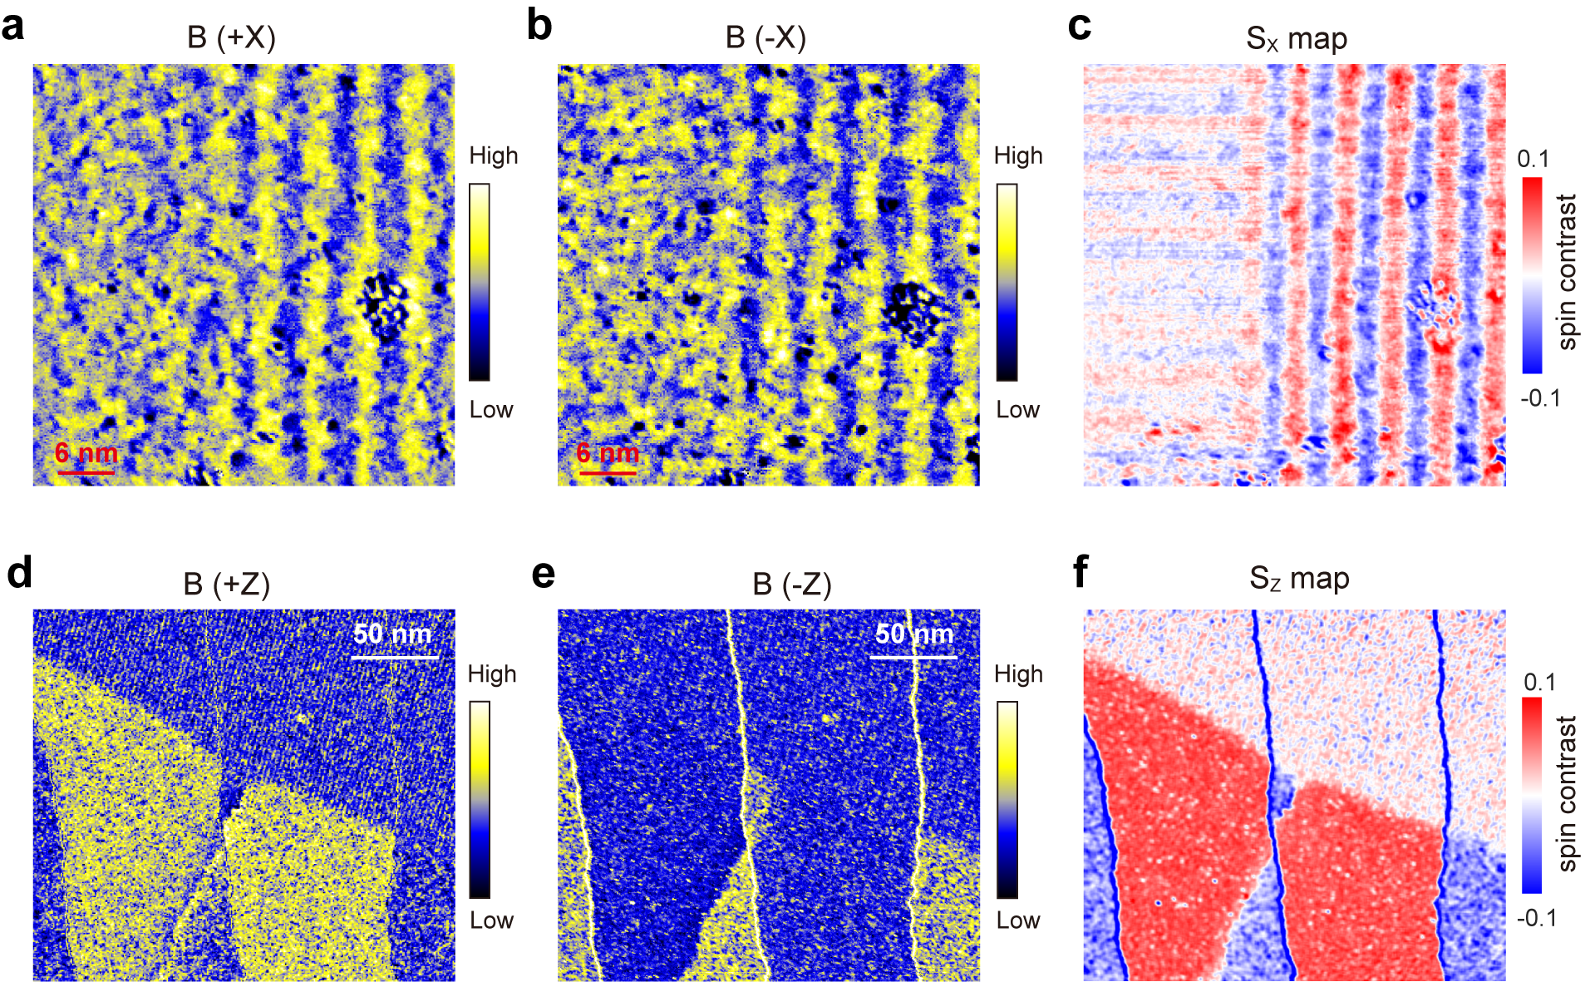

Fig. S1| a, b, dI/dV maps taken in the same area by Fe-coated tip under Bx = 1T and -1T, respectively (setpoint: I = 50 pA, V_{b} = -100 mV). c, Pure spin-contrast map (S_{X} map) obtained by calculating the relative difference of a and b. d, e, dI/dV maps taken in the same area by Fe-coated tip under Bz = 1.5T and -1T, respectively (setpoint: I = 50pA, V_{b} = -120mV). f, Pure spin-contrast map (S_{z} map) obtained by calculating the relative difference of dI/dV maps in (d) and (e).

II. Large scale spin maps of Q₃ domain:
Figs. S2a,b show the large scale topographic image and spin-resolved dI/dV map in Q₃ domain. The spin contrast is along Z direction, and panel b shows the adjacent terraces have opposite S_{Z} component. Fig. S2c shows the line profile along the arrow in panel b. We can see the spin contrast almost remains constant even over 17 terraces (~2.4nm), which means the long-period IC-SDW modulation is absent and evidences the SDW became commensurate in Q₃ domain.
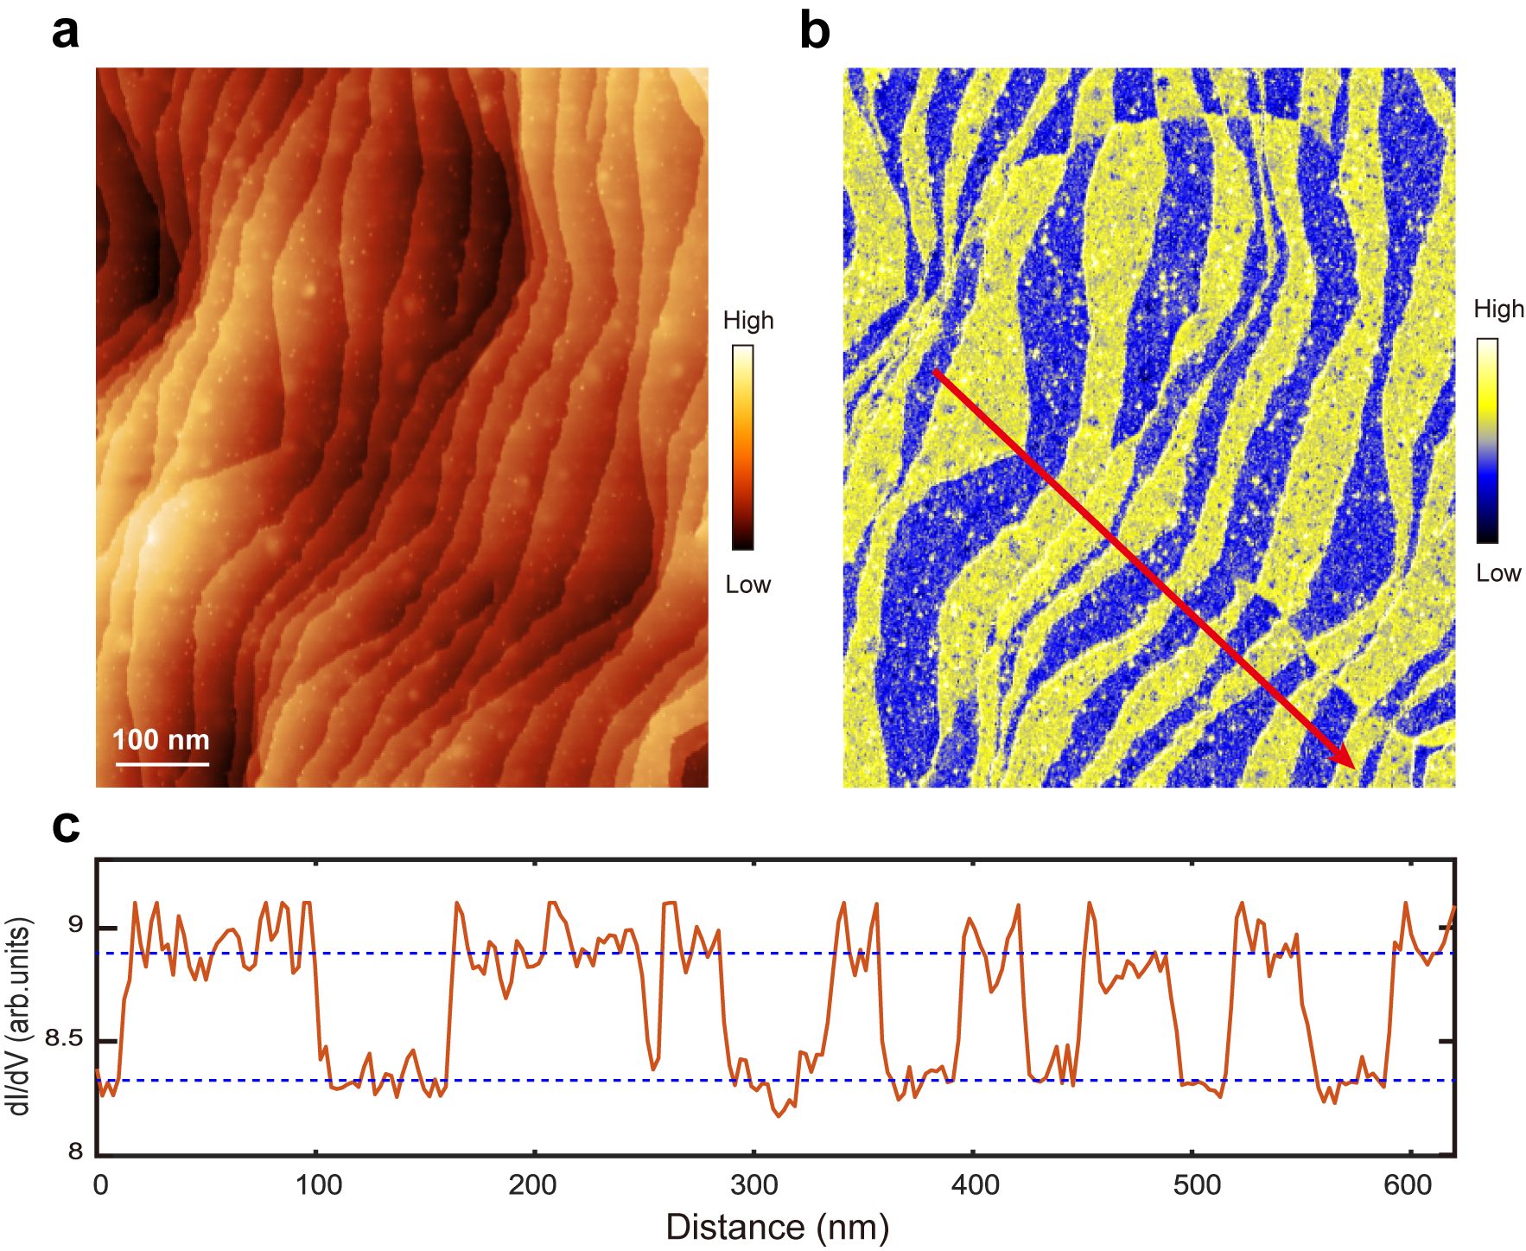
Fig. S2| a, Topographic image of Cr(001) surface in Q₃ domain (setpoint: I = 100pA, V_{b} = -120mV). b, Spin-resolved dI/dV map of the same region in (a), (Fe-coated tip, Bz = 1.5T). c, The line profile along the arrow in panel b, shows no long-period modulation over a series of terraces.

III. Large energy scale dI/dV spectra and electronic structure of Q_{1±} and Q₃ domains
Fig. S3a shows the spin-insensitive dI/dV map taken around Q_{1±}/Q₃ domain wall. In Q_{1±} domain, we can see clear in-plane incommensurate CDW with a period of 3.0 nm, and in Q₃ domain no IC-CDW observed. Fig. S3b shows the large energy scale dI/dV spectra taken on both domains. These spectra have very similar line shape with a pronounced DOS peak located at ≈ -70 mV, which is most likely from the surface state of Cr (ref. 21). The difference is that a C-SDW gap can be identified in Q₃ domain (indicated by black arrows) while it is absent Q_{1±} domain. The dI/dV spectra taken across the domain wall is shown in Fig. S3c. In the Q_{1±} domain, there is a dip feature near -22 mV in dI/dV which is related to the incommensurate CDW; while in the Q₃ domain the dip feature disappeared and a gap feature related to C-SDW appears between 0-50 mV, which is interpreted as the C-SDW gap.

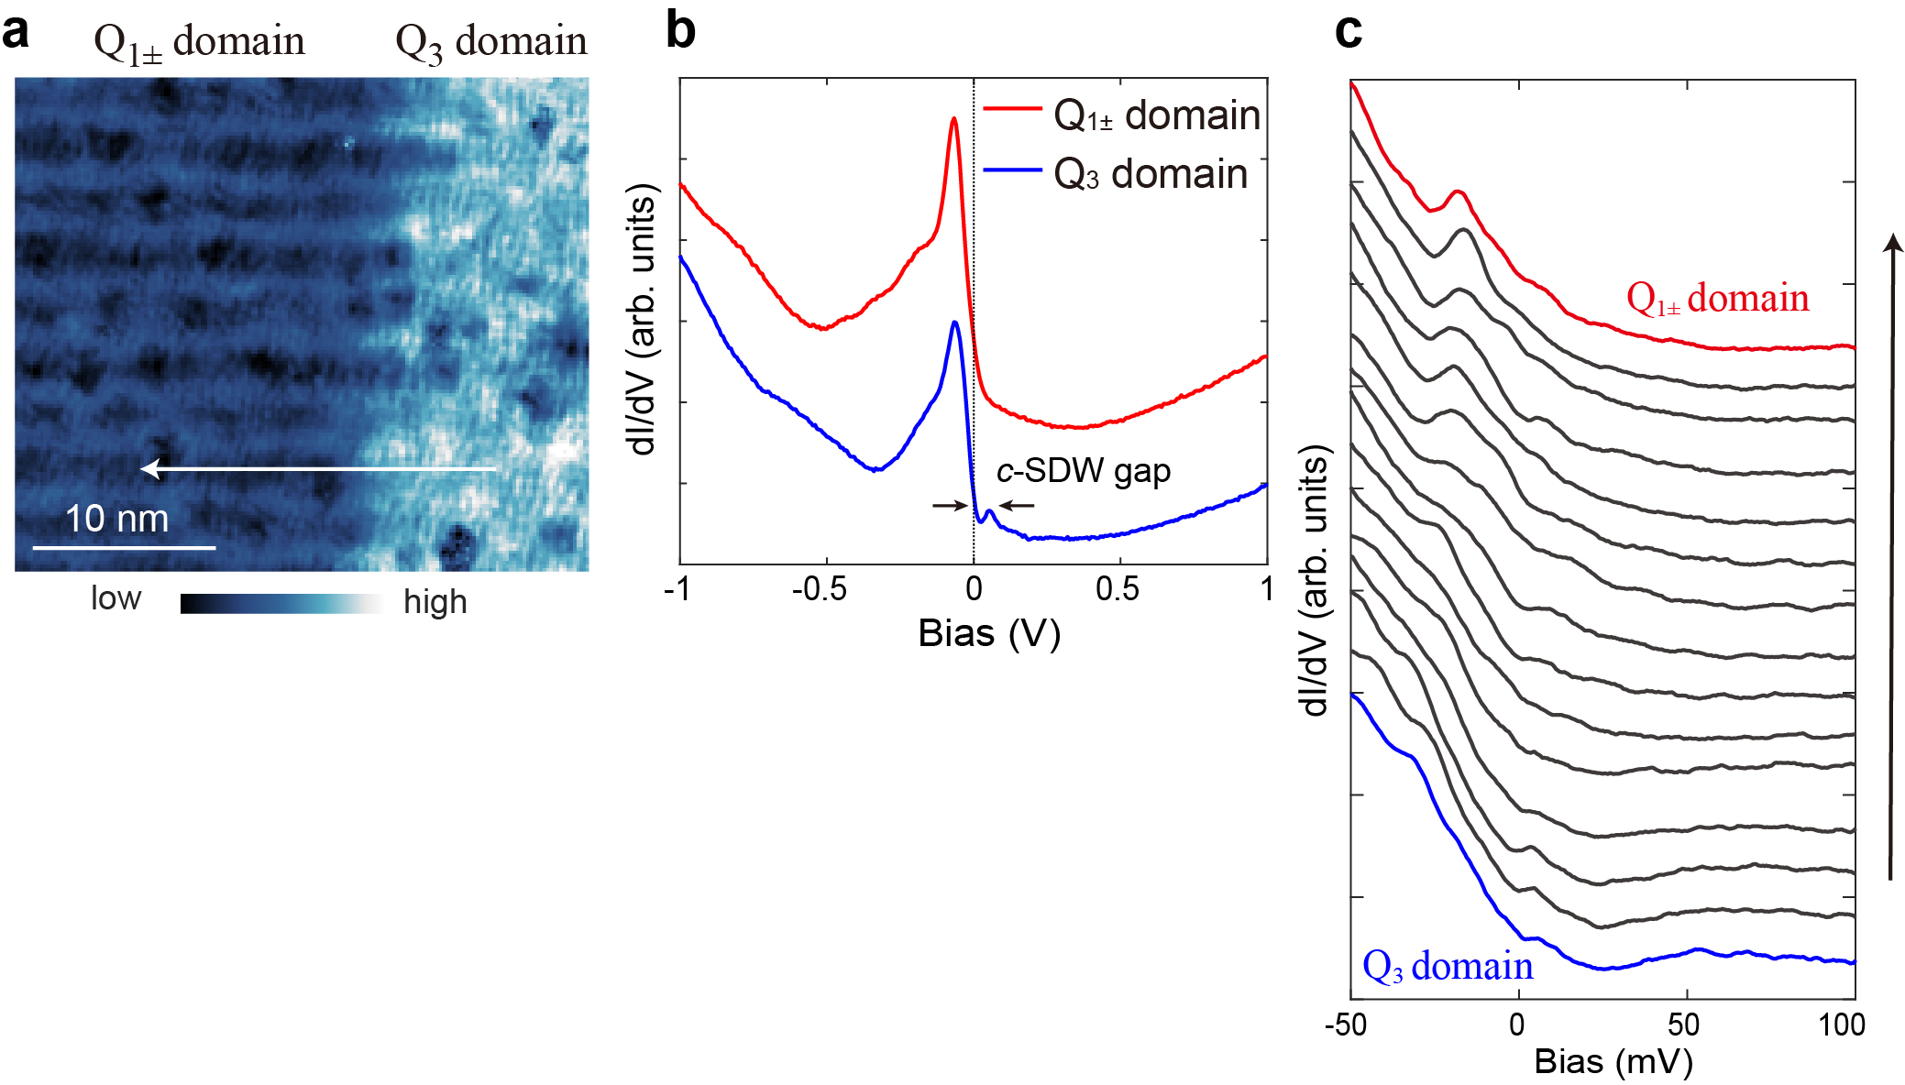
Fig. S3| a, Spin-insensitive dI/dV map taken around Q_{1±}/Q₃ domain wall (I = 50pA, V_{b} = -30 mV). b, Large energy scale dI/dV spectra taken on Q_{1±} and Q₃ domains (Setpoint: I = 60 pA, V_{b} = 1 V for Q_{1±} domain; I = 200 pA, V_{b} = -1 V for Q₃ domain). c, A series of dI/dV spectra taken along the arrow shown in panel (a) (setpoint: I = 40pA, V_{b} = -50 mV).

IV. The IC-SDW domain wall energy and width:
The domain wall energy and width of Q_{1±}/Q_{2±} IC-SDW should be determined by the condensation energy difference between single-Q and double-Q IC-SDW and the coherence length. Fig. S4 illustrates such domain wall structure along a line profile perpendicular to the wall. The IC-SDW amplitudes (A_{SDW}) in the Q_{1±}/Q_{2±} domains are normalized to 1 and they decay exponentially near the boundary. d is the distance between the two points where Q_{1±} and Q_{2±} start to decay. To simplify the calculation, we let Q_{1±} and Q_{2±} have the same decay length of ξ = 4.5 nm (obtained from the fitting in Fig. 2g), and assume the energies of single/double-Q SDW have a linear dependence with the area they occupied in Fig. S4. We define the energy without any SDW order is zero (U_{vac} = 0). The condensation energy of single-Q SDW is -U_{1Q} (per area in Fig. S4), and that of double-Q SDW is -U_{2Q}. Then the total energy of the system containing an IC-SDW domain wall is expressed as:
$$U= \int_{-∞}^{∞}{{-U}_{1Q}}A_{1Q}(x)dx+\int_{-∞}^{∞}{{-U}_{2Q}A_{2Q}(x)dx}$$
$$={-2U}_{1Q}\left(\int_{-∞}^{-\frac{d}{2}}{\left(1-e^{\frac{x-\frac{d}{2}}{ξ}}\right)dx}+\int_{-\frac{d}{2}}^{0}{\left(e^{-\frac{x+\frac{d}{2}}{ξ}}-e^{\frac{x-\frac{d}{2}}{ξ}}\right)dx}\right)-{2U}_{2Q}\int_{-∞}^{0}{e^{\frac{x-\frac{d}{2}}{ξ}}dx}$$
The distance of d reflects the domain wall width, which also determines the domain wall energy. If d is much larger than ξ, the decrease of d will lower system’s energy by forming single-Q SDW. However, the double-Q SDW region increases as d decreases, which will raise the energy. Therefore, at certain d the total energy shall reach a minimum. From the above expression, when $U$ reaches its minimum, the d value satisfies:
$$\frac{U_{2Q}}{U_{1Q}}=2-e^{\frac{d}{2ξ}} , d∈\left[0,∞\right)$$
By taking the measured value of d = 2.9 nm and ξ = 4.5 nm, we get $U_{2Q}=0.62 U_{1Q}$. This agrees with our assumption that single-Q state has larger condensation energy.

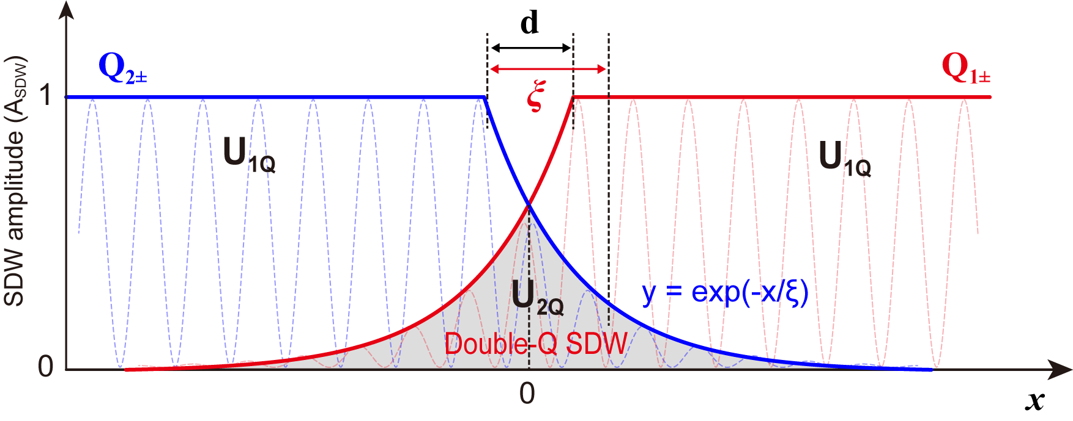
Fig. S4| Illustration of in-plane IC-SDW domain wall. The region with single-Q SDW has condensation energy of U_{1Q} (per length along x); while the double-Q SDW region (shaded region) has a condensation energy of U_{2Q} (per length along x).

V. Additional data about the CDW modulation on the IC-SDW domain wall.
In Fig. S5 we show additional CDW maps taken around IC-SDW domains wall and their FFT images. The Q_{DB-CDW} modulation are clearly seen in these maps (its unit cell is indicated by the dashed square). Figs. S5a-b are taken by W tip with magnetic coating, but under spin-insensitive bias voltage.
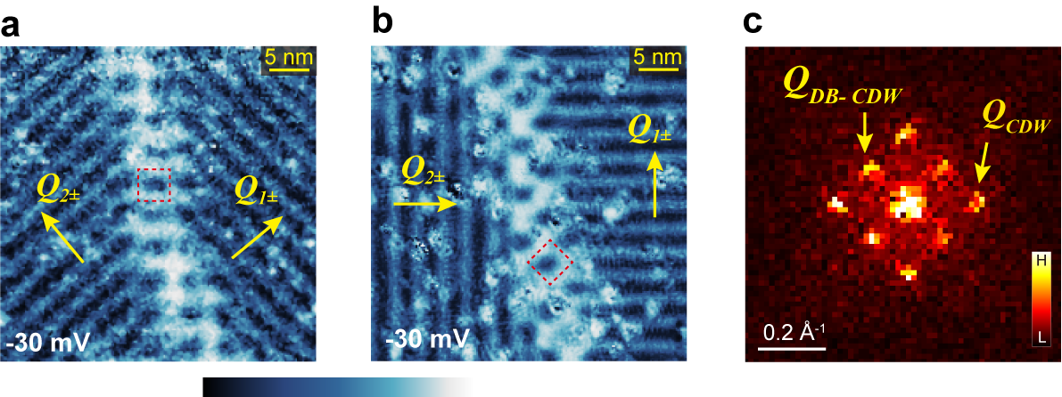
Fig. S5| a, b, spin-insensitive dI/dV maps taken near IC-SDW domain walls with different orientation, which all show the charge modulation of Q_{DB-CDW}. (Setpoint: I = 50 pA, V_{b} =-30 mV). c, FFT image of panel (a).

VI. The spatial lock-in method for extracting the amplitude of Q_{DB-CDW} modulation across the boundary
The spatial lock-in method is a technique which can visualize the amplitude of a specific modulation in real space (Fujita, K. et al., PNAS, 111, E3026 (2014)). To do that, we first generate a 2D Gaussian function $f\left(x,y\right)=exp(-\frac{{(x-x_{0})}^{2}+{(y-y_{0})}^{2}}{2σ^{2}})$ which reaches its maxima at the center position ($x_{0},y_{0}$) and decreases isotropically away from the center with the broadening of Gaussian peak determined by $σ$. Then, we do element-by-element multiplication of this 2D Gaussian matrix $f\left(x,y\right)$ and the data matrix $R\left(x,y\right)$ we want to analyze. This will return a matrix $R^{'}\left(x,y\right)=f\left(x,y\right).*R\left(x,y\right)$, whose data information is majorly preserved around position ($x_{0},y_{0}$) but mostly lost far away from position ($x_{0},y_{0}$). After applying 2D FFT transformation to the returned matrix $R'\left(x,y\right)$, we can extract the amplitude $A\left(x_{0},y_{0}\right)$ of the order with wave vector $Q$ from the absolute value at the corresponding $Q$ position in FFT. Here, since we want to extract the amplitude information for an order with bidirectional modulation, we take an average for the absolute value of two $Q_{DB-CDW}$ who are perpendicular to each other. If we do the above analysis for each pixel of $R\left(x,y\right)$ by changing the parameter $x_{0}$ and $y_{0}$ in $f\left(x,y\right)$, then we can obtain the amplitude distribution map $A\left(x,y\right)$ of the $Q$ order. By averaging elements in matrix $A\left(x,y\right)$ along the wall direction, we obtained the amplitude distribution of $Q_{DB-CDW}$ across the domain boundary as shown in Fig. 2h. Parameter $σ$ we used to obtain Fig 2h is 3.9 nm.

VII. The spin structure of Q_{1±}/Q₃ domain wall:
Fig. S6 shows the spin structure of the Q_{1±}/Q₃ domain wall, as well as the CDW feature and tunneling spectra across the domain wall. The spin contrast of Q_{1±} and Q₃ can be (and only be) visualized in S_{X} and S_{Z} maps, respectively. The amplitude of Q_{1±} (IC-SDW) and Q₃ (C-SDW) both decays exponentially at the boundary. Exponential fits to the decay yield ξ_{⊥Q1} = 3.6 nm and ξ_{⊥Q3} = 3.3 nm.
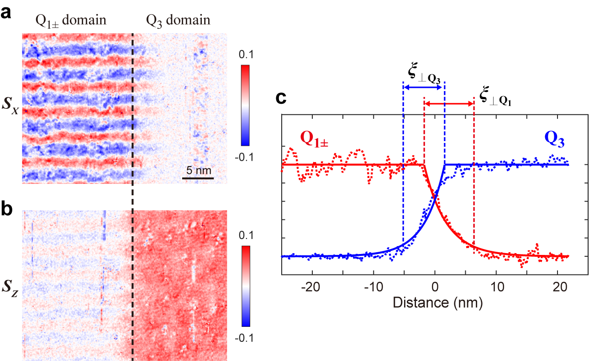
Fig. S6| a, b, S_{X} and S_{Z} maps taken around Q_{1±}/Q₃ domain wall (I = 50pA, V_{b} = -100 mV). c, Amplitude profile of the Q_{1±} (IC-SDW) and Q₃ (C-SDW) across the domain boundary.

