Supporting Information
©Wiley-VCH 2019
69451 Weinheim, Germany
Formation of atomically distributed Al-F3 nanoparticles towards precisely modulating pore size of carbon molecular sieve gas separation membranes

Xiuling Chen, Zhiguang Zhang, Shan Xu, Bin Zhang,* Yong Qin, Canghai Ma*, Gaohong He*, Nanwen Li*
Dr. Z. G. Zhang, S. Xu, Prof. B. Zhang, Prof. Y. Qin, Prof. N. W. Li, State Key Laboratory of Coal Conversion, Institute of Coal Chemistry
Chinese Academy of Sciences, Taiyuan 030001, China
E-mail: zhangbin2009@sxicc.ac.cn; linanwen@sxicc.ac.cn

Dr. X. L. Chen
Hubei Key Laboratory of Radiation Chemistry and Functional Materials, Hubei University of Science and Technology
Xianning 437100, China

Prof. C. Ma, Prof. G. H. He
State Key Laboratory of Fine Chemicals, Frontier Science Center for Smart Materials, School of Chemical Engineering, Dalian University of Technology
Dalian, Liaoning 116024, China
E-mail: cma@dlut.edu.cn; hgaohong@dlut.edu.cn

Table of Contents

1. Experimental Section.………………………………………………………………………..…………..4

1.1 materials………………………………………………………………………………………….…..4

1.2 Synthesis of 6FDA-TFDB……………………………………………………………………….…..4

1.3 Dense membrane preparation………………………………………………………………………..4

1.4 Preparation of 6FDA-TFDB-x…………………………………………………………………..…..5

1.5 Preparation of 6FDA-TFDB-x CMS membranes………………………………………….…….......6

1.6 Preparation of 6FDA-TFDB-Al₂O₃-x and 6FDA-TFDB-AlF₃-x MMMs…………………..……….7

2. Methods.…………………………………………………………………………………………………..7

2.1 Characterizations……………………………………………………………………………….…….7

2.2 Gas permeability testing………………………………………………………………………………7

2.3 Binary gas mixtures testing……………………………………………………………………….…..8

3. Physical characterization of 6FDA-TFDB-x precursor and 6FDA-TFDB-x CMS membranes……..9

Figure S2. TGA of 6FDA-TFDB and 6FDA-TFDB-x precursor under N₂ atmosphere………………......9

Figure S3. The surface SEM image of 6FDA-TFDB and 6FDA-TFDB-x………………………..............9

Figure S4. EDS mapping of Al and F distribution of CMS membrane…………………………………..10

Figure S5. Cross-sectional EDS mapping images of Al and F for 6FDA-TFDB-x CMS membranes at the red square of SEM image in figure……………………………………………………………………………10

Figure S6. XPS spectra of the F1s deconvoluted for 6FDA-TFDB-x precursor……………………….....11

Figure S7. XPS spectra of Al2p of precursor membranes………………………………………….…......12

Figure S8. XPS spectra of the deconvoluted N1s for 6FDA-TFDB-Al2O3-x CMS membranes…………13

Figure S9. XPS spectra of Al2p of (a) 6FDA-TFDB-x CMS membranes…………………………………14

Figure S10. Raman spectra of 6FDA-TFDB-x CMS membranes…………………………………………..15

Figure S11. XPS spectra of C1s for 6FDA-TFDB-x CMS and ATR-IR spectrum…………………….16

Figure S12. XPS spectra of Al2p of 6FDA-TFDB with different loadings of Al₂O₃………………....16

Figure S13. XPS spectra of F1s of 6FDA-TFDB with different loadings of Al₂O₃…………………...16

Figure S14. XPS spectra of C1s of 6FDA-TFDB with different loading of Al₂O₃…………………....17

Figure S15. XPS spectra of N1s of 6FDA-TFDB with different loading of Al₂O₃………….………...17

Figure S16. The upper bond of 6FDA-TFDB-x CMS……………………………………………........18

Figure S17. Optical images of precursors……………………………………………………..……….18

4. Comparison of gas permeability and selectivity with different polymers……………………..…….19

Table S1. BET surface area, gas permeability and selectivity of original 6FDA-TFDB and 6FDA-TFDB-x CMS membranes…………………………………………………………………………………………19

Table S2: Comparison of gas permeability and selectivity of different 6FDA-TFDB………………….20

Table S3. Gas permeability and selectivity of 6FDA-TFDB and 6FDA-TFDB-Al₂O₃-7 CMS membranes during aging……………………………………………………………………………………..….........20-21 Table S4. Comparison of CO₂ permeability and CO₂/CH₄ selectivity of polyimide-derived CMS membranes pyrolysis at 550 ºC

5. References……………………………………………………………………………..…………..…….21

- Experimental Procedures
1.1 Materials
The raw material 4,4’-(hexaﬂuoroisopropylidene)diphthalic anhydride (6FDA) and 2,2'-bis(trifluoromethyl)-[1,1'-biphenyl]-4,4'-diamine (TFDB) for the synthesis polyimide were obtained from Sigma-Aldrich and puriﬁed by sublimation prior to use. The solvent N-methylpyrrolidone (NMP) was dried by standard methods before using. Acetic anhydride, 2-methylpyridine, Al₂O₃, AlF₃ were obtained from Energy Chemical, and used without further purified.
1.2 Synthesis of 6FDA-TFDB
The 2,2'-bis(trifluoromethyl)-[1,1'-biphenyl]-4,4'-diamine (TFDB 10 mmol) was dissolved in NMP (15 mL) under a nitrogen atmosphere. The system was stirred at -5 ºC temperature for 30 min, 4,4’-(hexaﬂuoroisopropylidene)diphthalic anhydride (6FDA 10 mmol) was added (divided into two times) and stirred for 24 h to form a polyamic acid solution. Acetic anhydride (100 mmol) and 2-methylpyridine (10 mmol) were added to polyamic acid solution and stirred for 24 h. The resulting polyimide were precipitated with methanol and washed with methanol three times at 60 ºC, then dried at 80 ºC under vacuum for 24 h for using (Scheme 1). The molecular weight was estimated with the results of M_{w}=10.8×10⁴, PDI=3.4.
.
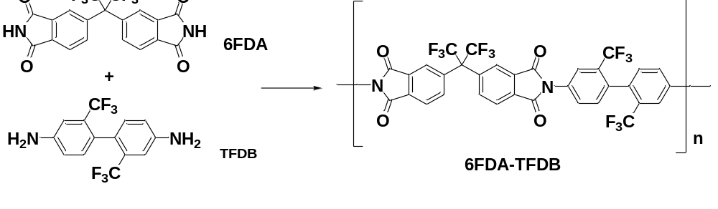
Scheme S1. Synthetic route for 6FDA-TFDB.

1.3 Dense membrane preparation
Dense membranes were prepared by solution casting of filtered 6FDA-TFDB in NMP on clean glass substrate inside a vacuum drying oven evaporate the solvent at 80 ºC for 12 h. After completion of the evaporation of NMP solvent, the membrane was soaked in methanol for overnight and further dried in a vacuum oven at 70 ºC for 24 h. The thickness of the 6FDA-TFDB membrane was about 60 μm (±10 um).
1.4 Preparation of 6FDA-TFDB-x
6FDA-TFDB-x was obtained by depositing Al₂O₃ on 6FDA-TFDB by ALD method in a custom-made hot-wall closed chamber-type ALD reactor, and the Al₂O₃ was deposited at 125 ºC using trimethylaluminium (TMA) and deionized H₂O as precursors, the mechanism and detailed set-up were shown in the below Figure S1. The detailed Al₂O₃ ALD process contains the following steps: (i) The 6FDA-TFDB membranes with diameter of ~7 cm and thickness of ~ 60 μm was attached to the sample holder by vacuum in the ALD chamber, which was then pumped down under an oil pump to the pressure ~20 Pa. (ii) TMA vapor pulse was introduced to the system by opening the valve A (Figure S1a) for 0.02 s, which was then exposed to 6FDA-TFDB membrane for 8 s to accommodate the TMA on the surface or inside the micropore of 6FDA-TFDB, and thereafter, the system was purged with inert N₂ for 25 s to get rid of the residual non-anchored TMA in the chamber. (iii) H₂O as the second precursor was then loaded following the same procedure as that of TMA with the pulse, exposure and purge time of 0.1, 8, and 25 s, respectively. (iv) The above (ii) and (iii) procedures were repeated for different cycles to get the resulting polymer membranes. Meanwhile, membrane with 1 cm² was cut by scissor for gas separation testing. Membrane with each ALD cycles was tested for three different samples, and the deviation of the results was less than 5%.

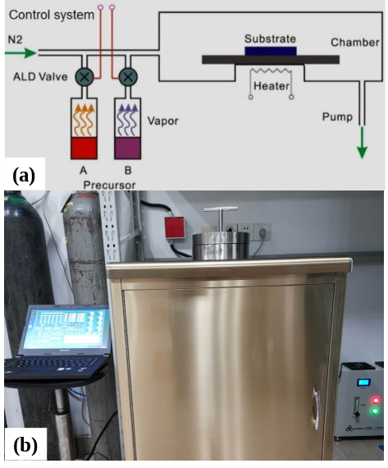
Figure S1. (a) Schematic set-up of ALD equipment and (b) picture of the home-made ALD instruments for Al ALD process.

  - Preparation of 6FDA-TFDB-x CMS membranes
The 6FDA-TFDB-x CMS membranes were obtained by pyrolyzing the6FDA-TFDB-x precursor membranes using the
following procedure. More specifically, the polymer films were cut into a rectangle of 1 cm × 5 cm, and placed into a tube furnace (Centurion NeytechQex). The tube furnace was blown via Ar for 2 h, while the oxygen level was kept to be below 10 ppm as detected by using an oxygen analyser (Cambridge Sensotec Ltd, Rapidox 2100 series, Cambridge, England).
1. Starting point at 30 °C;
2. from 30 °C to 250 °C at a ramp rate of 13.33 °C/min;
3. from 250 °C to 535 °C at a ramp rate of (3.85 °C /min);
4. from 535 °C to 550 °C at a ramp rate of (0.25 °C /min);
5. Soaked at 550 °C for 120 min;
6. cooled to the temperature of 20 ◦C for 180 min..
Finally, the obtained 6FDA-TFDB CMS dense membranes were carefully removed from the tube furnace to be tested
1.6 Preparation of 6FDA-TFDB-Al₂O₃-x and 6FDA-TFDB-AlF₃-x MMMs
Specifically, Al₂O₃ and AlF₃ were added to 6FDA-TFDB solution to form 2 wt% and 5 wt% solutions by physical blending and casting method. The casting solutions were stirred for 12 h and stood still for another 12 h for thorough dispersion and bubble removal before casting. Then, the solutions were cast on the glass support followed by being dried at 80 ◦C and for 24 h to obtain the 6FDA-TFDB-Al₂O₃-x and 6FDA-TFDB-AlF₃-x MMMs.
- Methods
2.1 Characterizations
Polymer thermal degradation curves were obtained from thermogravimetric analysis (TGA) (TA Instruments model 2950). Polymer samples for TGA were initially heated to 120 °C under nitrogen gas for 1 h and maintained for moisture removal, and then heated to 600 °C at 10 °C/min for degradation temperature measurements.
X-ray photoelectron spectrometer (XPS) was utilized to monitor the chemical changes of 6FDA-TFDB-Al₂O₃-x membranes. They were recorded in HSi spectrometer (Thermo Fisher ESCALAB 250 xi., England) using a monochromatic Al Kα X-ray source (1486.6 eV photons) at a constant dwell time of 100 ms and a pass energy of 40 eV under full vacuum. The anode voltage and anode current were 15 kV and 10 mA, respectively. All core-level spectra were obtained at a photoelectron takeoff angle of 90◦ with respect to the sample. To compensate for surface charging effects, all binding energies (BE’s) were referenced to the C1s hydrocarbon peak at 284.8 eV. Surface elemental stoichiometries were determined from the peak area ratios and were accurate to within ±5%.
Scanning electronic microscopy/Energy-dispersive X-ray spectroscopy mapping (SEM/EDS) was applied to analysis the surface morphology and elemental information and density of 6FDA-TFDB-x membranes by a Hitachi S5500 microscope. The polymer films were fractured and coated with a thin layer of gold. The surface and cross-section of the membrane was analyzed using x-ray as irradiate and the second electrons are collected to reflect the atom information. The EDS mapping with a scale of 10×10 μm² was selected for characterization.
The FTIR spectra were measured using an infrared spectrometer in transmission mode and an attenuated total reflectance cell. FT-Raman spectra are recorded on a HORIBA 100 FT-Raman spectrometer, are motivated by 532 nm. The scan frequency is 100 to 4000 cm⁻¹. The TGA-FTIR of 6FDA-TFDB-x precursor dense films was performed using a TA Q500 instrument under an inert argon atmosphere. The heating rate and argon flow rate were 10 °C min⁻¹ and 50 ml min⁻¹, respectively and collected at a resolution of 2 cm⁻¹ with a collection rate of 64 scans.
Nitrogen adsorption-desorption was performed using a Micromeritics ASAP 2020 instrument at pressures up to 1 bar. Dense polymer membranes (0.1 g) with thickness of 50 mm were cut into small pieces, loaded into the apparatus and degassed at 120 ºC under high vacuum (<10⁻⁶ bar). After the mass had been measured, the samples were further degassed under high vacuum for the gas sorption measurement. Nitrogen adsorption–desorption isotherms were measured at 77 K and 273 K, respectively. The specific surface area was calculated based on the Brunauer-Emmett-Teller model and the pore size distribution was derived from Horvath-Kawazoe method from N₂ isotherms at 77K.
2.2 Gas permeability testing
The pristine and Al₂O₃ ALD modified 6FDA-TFDB dense membranes were tested in pure gas systems. The pure gas permeation properties were evaluated by a constant-volume/variable-pressure method (constant downstream volume permeation apparatus). The downstream pressure was measured using an inficon transducer ranging from 0-10 torr, and the steady state pressure changing with time (dp/dt) was selected to calculate the permeability (P). Each pure gas was tested in the sequence of CH₄, N₂, O₂, CO₂ and H₂, at 35 °C and 100 psi. Membranes with each ALD cycles were tested for three different samples and the deviation was less than 5%. Permeability (P) was calculated using the following equation 1:
$P=\left(\frac{273}{T}\right)\left(\frac{dp}{dt}\right)\left(\frac{l}{∆pA}\right)$ …………………………………………………………………………………. (1)
where P is the permeability (Barrer) , 1 Barrer = 10 ^{–10} cm³(STP) cm cm⁻² s⁻¹ cmHg⁻¹, l is the membrane thickness (cm), A is the effective membrane area (cm²), T is the operating temperature (K), R is the gas constant (0.278 cm³ cmHg cm⁻³(STP) K⁻¹) and dp/dt is the steady-state downstream pressure increase rate (cmHgs⁻¹).
The ideal selectivity (α_{x/y}) for components x and y was defined as the ratio of gas permeability of the two components via equation 2.
$α_{x/y}=\frac{P_{x}}{P_{y}}$ …………………………………………………………………………………………………….(2)
Meanwhile, the diffusion coefficients (D) were obtained from the time-lag of the constant-volume/ variable-pressure method using the following equation 3:
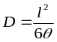………………………………………………………………………………….………………………(3)
where l is the membrane thickness and θ is the time lag in the permeability measurement.
The solubility coefficient S (cm³(STP)/cm³·cmHg⁻¹) was obtained from the equation 4:
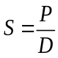……………………………………………………….………………………….………………......…(4)

2.3 Binary gas mixtures testing
The CO₂/CH₄ mixed-gas testing was performed at 35 ºC use a gas mixture as feed gas with component ratio of 50/50, and the upstream pressure ranging from 50 to 400 psi. The retention flow rate was controlled by MFC to be ~ 100 times higher than the permeate gas to keep the constant component ratio in the upstream. The permeated gas was collected in the downstream volume till the pressure reached more than 9 torr. The component ratio of the permeate gas was tested and confirmed by GC (GC-7820A, Agilent). The permeability in the mixed-gas separation was calculated from the steady state using the following equation:
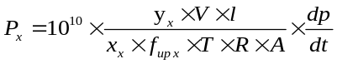……………………………………………………………………..……....(5)
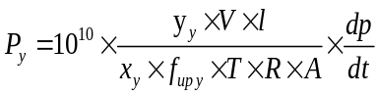………………….……...…………….……………………………………....(6)
Where x_{x} and x_{y} are the feeding component ratio of CO₂, CH₄, y_{x} and y_{y} are the permeate gas concentration of CO₂ and CH₄, respectively. f is the fugacity of the upstream partial pressure, and the dp/dt is the steady-state downstream pressure increase rate (cmHg s⁻¹). The selectivity of x/y can be calculated as follows:
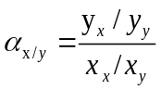……………………………………………………….…………......................................…......(7)
- Physical characterization of 6FDA-TFDB-x precursor and 6FDA-TFDB-x CMS membranes
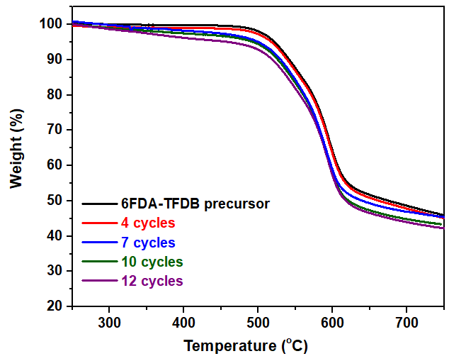
Figure S2. TGA of 6FDA-TFDB and 6FDA-TFDB-x precursor under N₂ atmosphere.

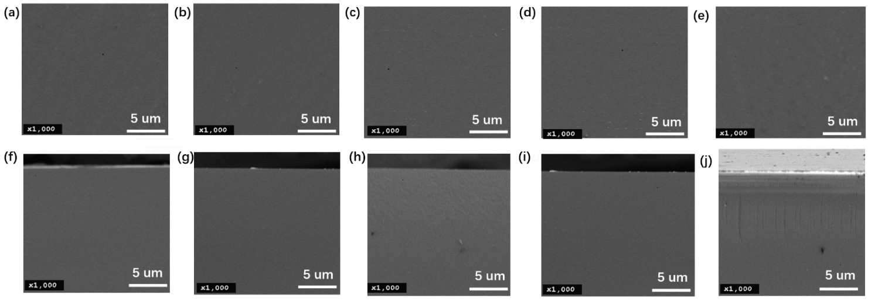

Figure S3. The surface SEM image of 6FDA-TFDB and 6FDA-TFDB-x: (a) 6FDA-TFDB precursor, (b) 4 cycles, (c) 7 cycles, (d) 10 cycles, (e) 12 ALD cycles ; Cross-sectional SEM image of (f) 6FDA-TFDB precursor, (g) 4 cycles, (h) 7 cycles, (i) 10 cycles, (j) 12 ALD cycles.

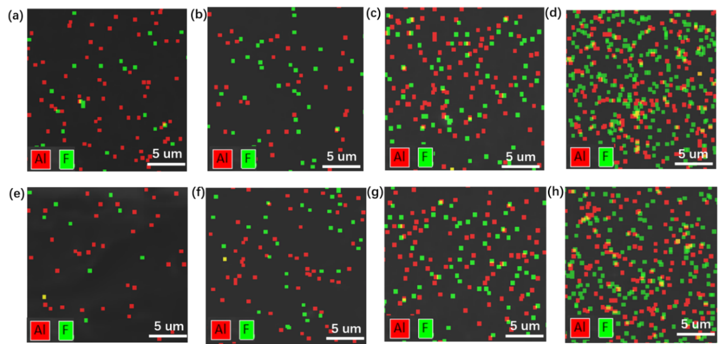

Figure S4.. EDS mapping of Al and F distribution of CMS membrane of 6FDA-TFDB-x on the surface (a) 4, (b) 7, (c) 10, (d) 12; cross section of (e) 4, (f) 7, (g) 10, (h) 12, Al2O3 ALD cycles.
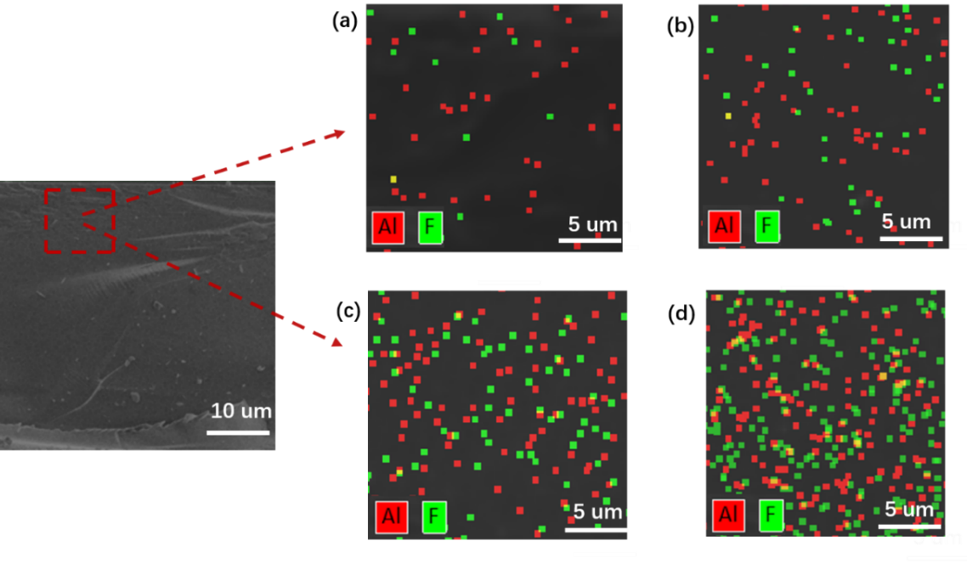

Figure S5. Cross-sectional EDS mapping images of Al and F for 6FDA-TFDB-x CMS membranes at the red square of SEM image in figure with (a) 4 cycles, (b) 7 cycles, (c) 10 cycles, (d) 12 ALD cycles.

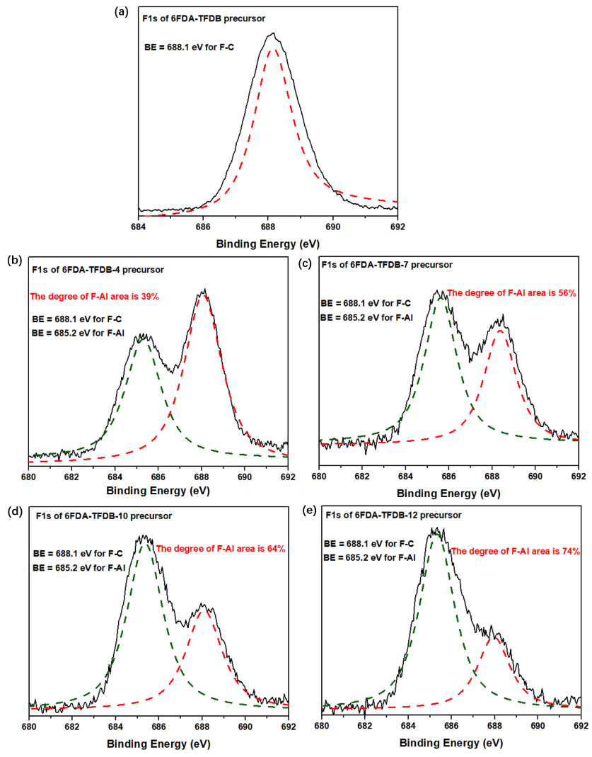

Figure S6. XPS spectra of the F_{1s} deconvoluted for 6FDA-TFDB-x precursor (a) 6FDA-TFDB (b) 4 cycles, (c) 7 cycles, (d) 10 cycles, (e) 12 ALD cycles.

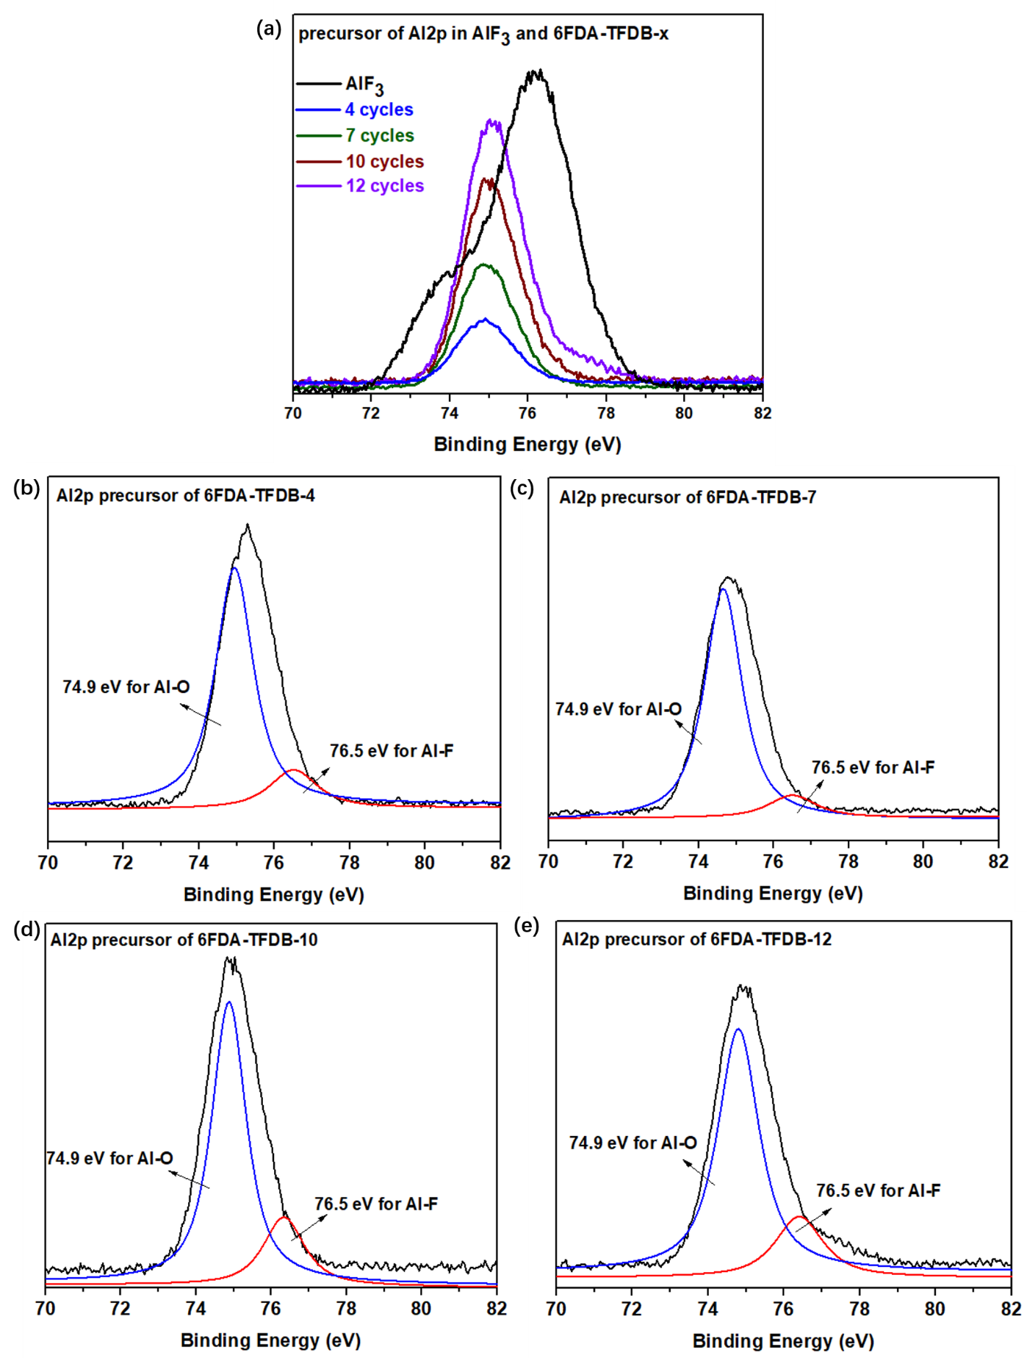
Figure S7. XPS spectra of Al_{2p} of precursor membranes (a) 6FDA-TFDB and 6FDA-TFDB-x, and the deconvoluted of (b) 4 cycles (c) 7 cycles (d) 10 cycles (e) 12 ALD cycles.

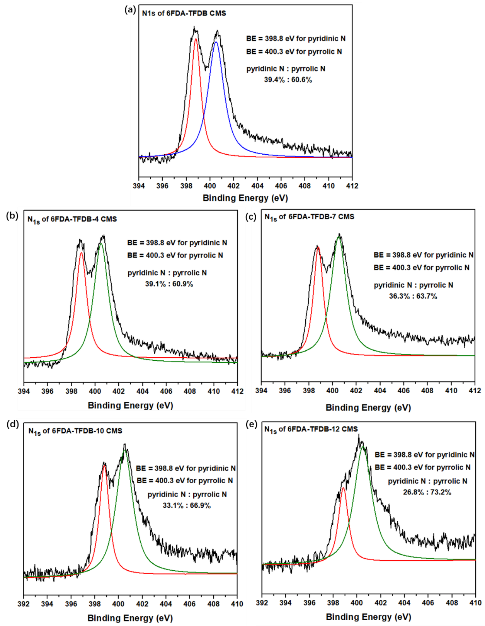

Figure S8. XPS spectra of the deconvoluted N_{1s} for 6FDA-TFDB-Al₂O₃-x CMS membranes (a) 6FDA-TFDB (b) 4 cycles, (c) 7 cycles, (d) 10 cycles, (e) ALD 12 cycles.

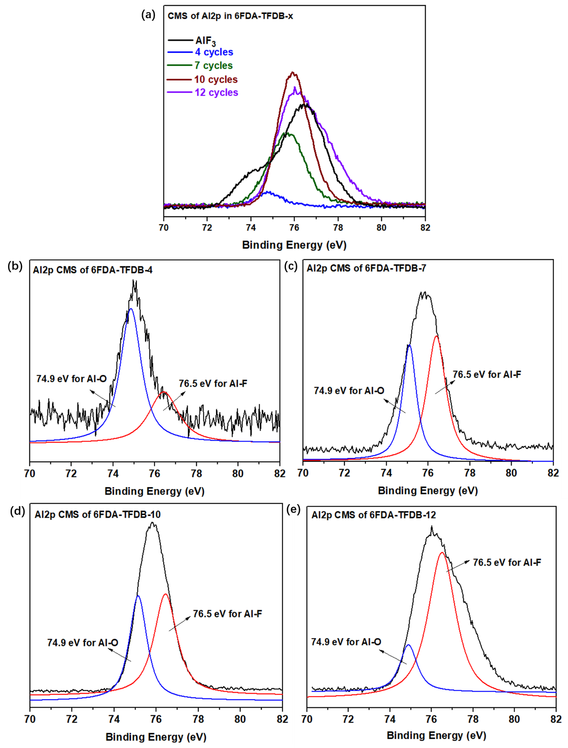

Figure S9. XPS spectra of Al2p of (a) 6FDA-TFDB-x CMS membranes, and the deconvoluted of (b) 4 cycles (c) 7 cycles (d) 10 cycles (e) ALD 12 cycles.
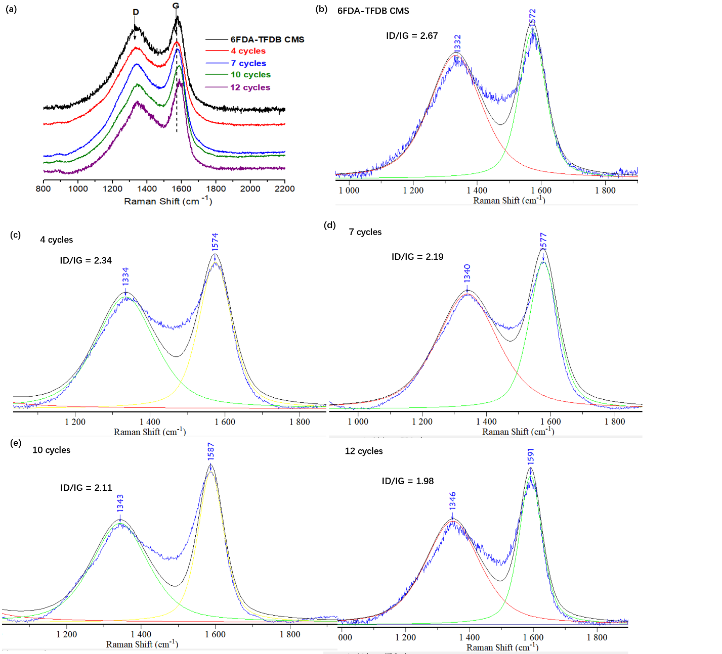

Figure S10. Raman spectra of 6FDA-TFDB-x CMS membranes.

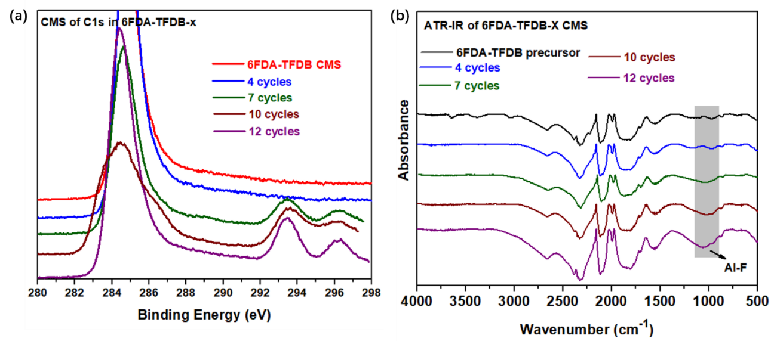

Figure S11. (a) XPS spectra of C_{1s} for 6FDA-TFDB-x CMS; (b) ATR-IR spectrum of 6FDA-TFDB-x CMS membranes.

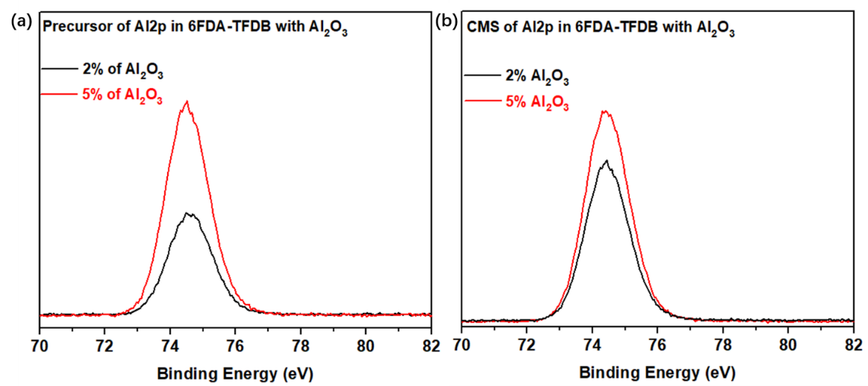

Figure S12. XPS spectra of Al_{2p} of 6FDA-TFDB with different loadings of Al₂O₃ (a) precursor (b) CMS membranes.

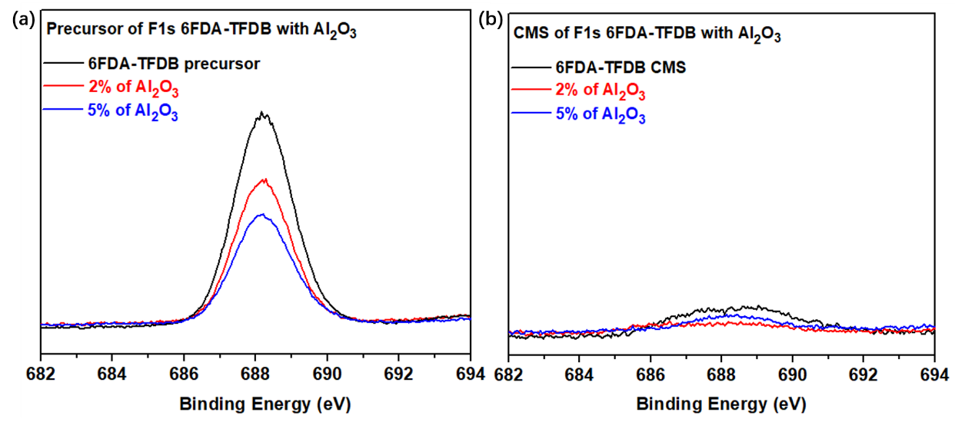

Figure S13. XPS spectra of F_{1s} of 6FDA-TFDB with different loadings of Al₂O₃ (a) precursor (b) CMS membranes.

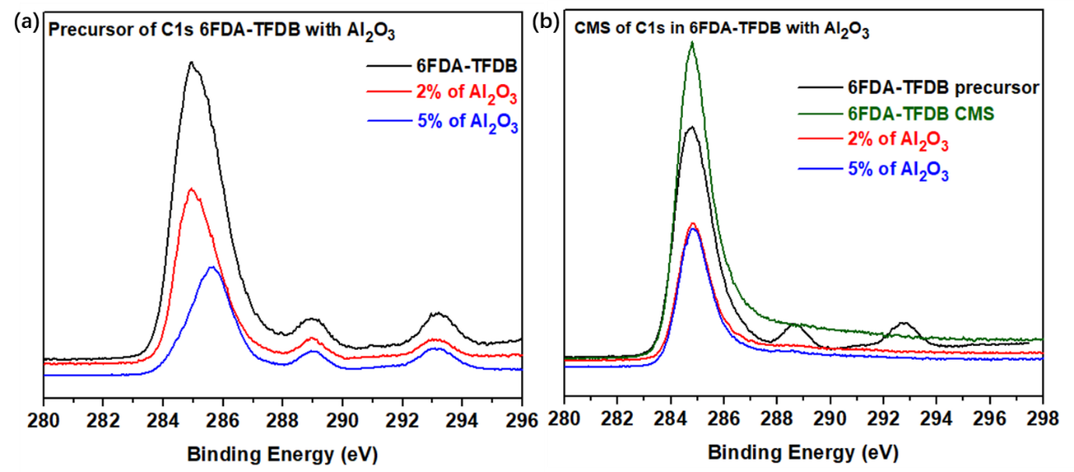

Figure S14. XPS spectra of C_{1s} of 6FDA-TFDB with different loading of Al₂O₃ (a) precursor (b) CMS membranes.

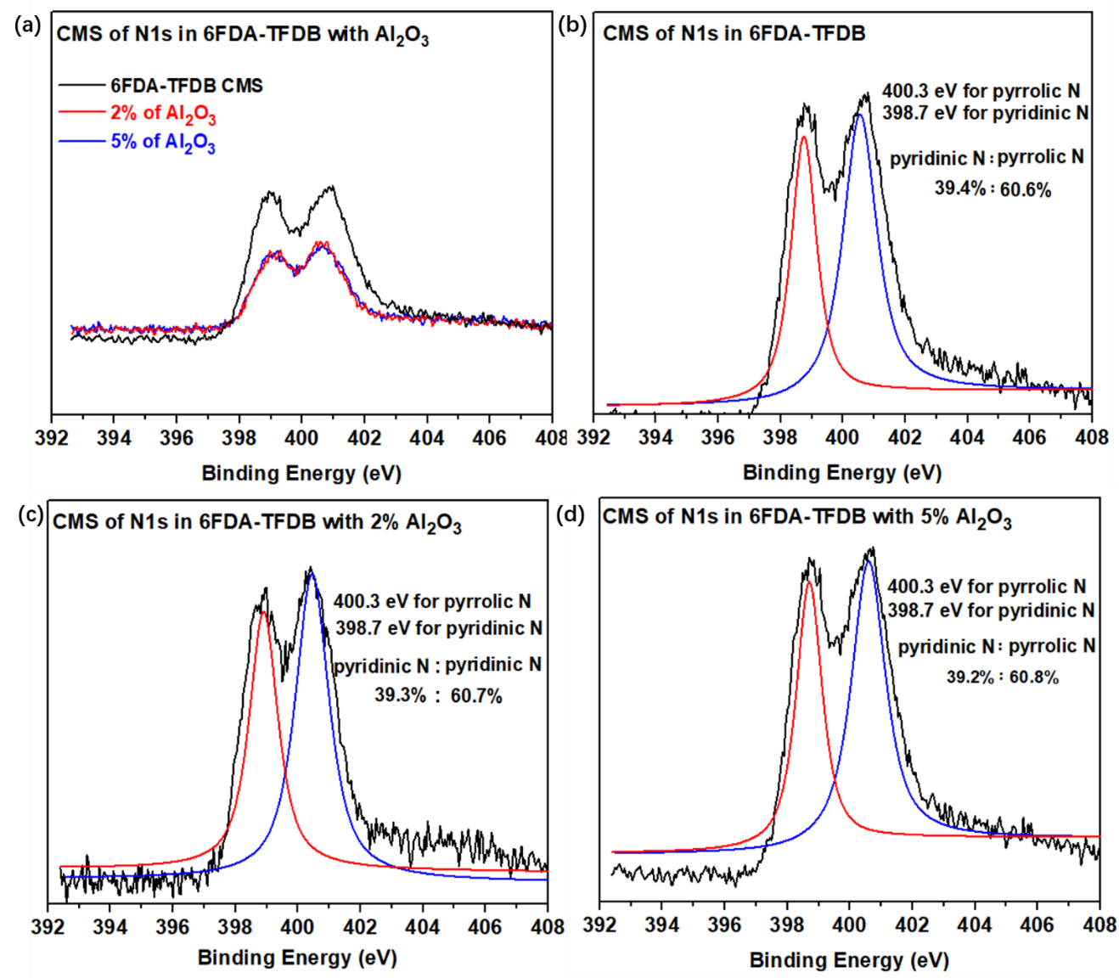

Figure S15. XPS spectra of N_{1s} of 6FDA-TFDB with different loading of Al₂O₃ (a) CMS membranes (b) the deconvoluted of 6FDA-TFDB (c) 6FDA-TFDB with 2% Al₂O₃ (d) 6FDA-TFDB with 5% Al₂O₃.

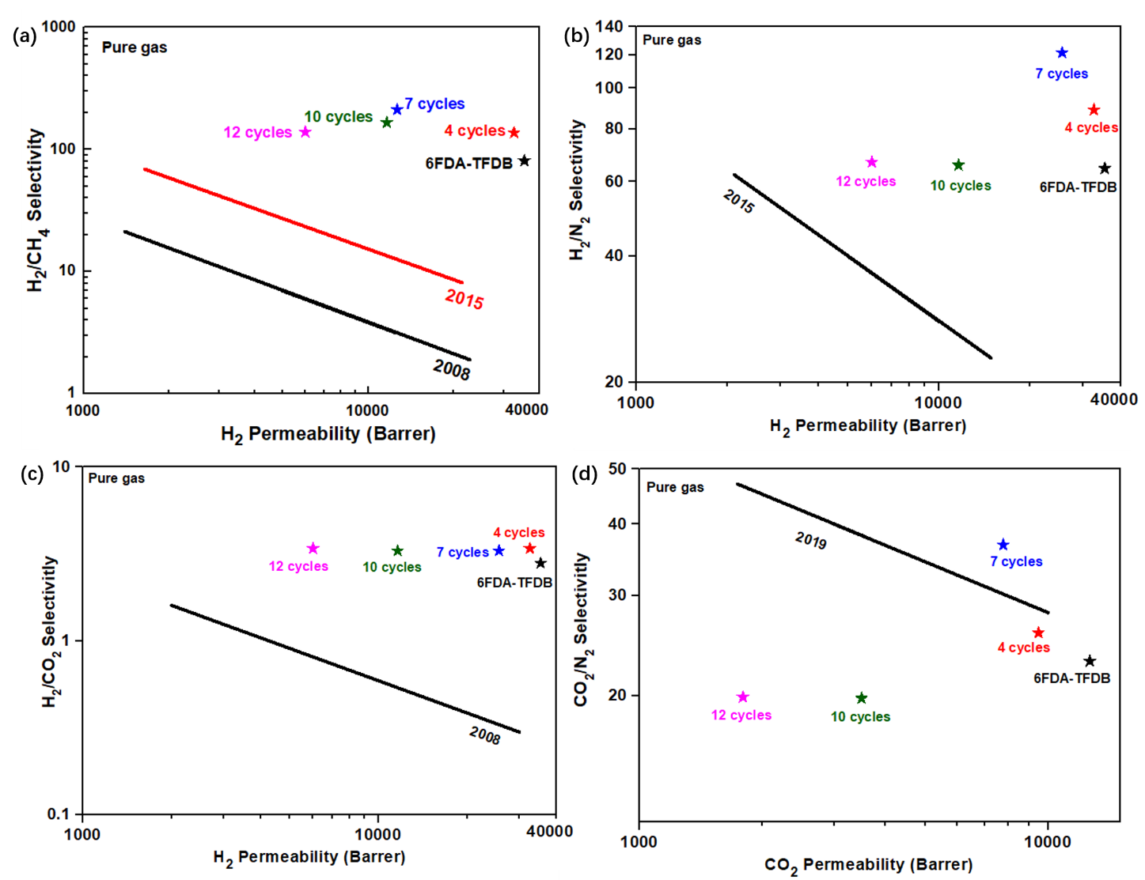
Figure S16. The upper bond of 6FDA-TFDB-x CMS (a) H₂/CH₄ selectivity (b) H₂/N₂ selectivity (c) H₂/CO₂ selectivity (d) CO₂/N₂ selectivity.
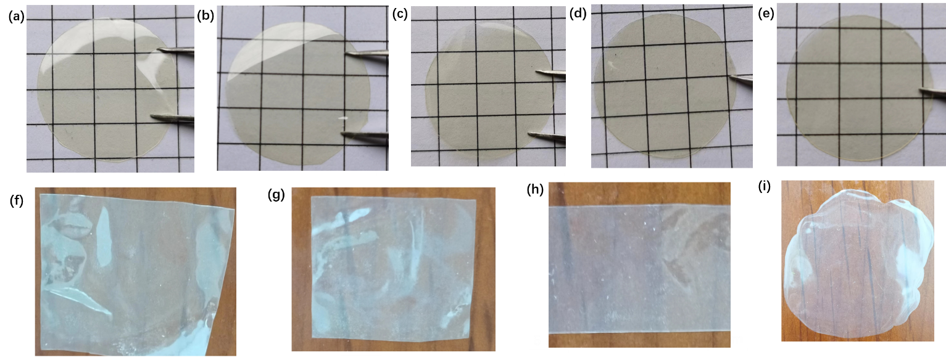
Figure S17. Optical images of precursors (a) 6FDA-TFDB (b) 4 cycles (c)7 cycles (d) 10 cycles (e) 12 cycles (f) 6FDA-TFDB-Al₂O₃-2% (g) 6FDA-TFDB-Al₂O₃-5% (h) 6FDA-TFDB-AlF₃-2% (i) 6FDA-TFDB-AlF₃-5%.
- Comparison of gas permeability and selectivity with different polymers
Table 1: BET surface area, gas permeability and selectivity of original 6FDA-TFDB and 6FDA-TFDB-x CMS membranes
Polymers | S_{BET}  [m²g⁻¹]^{[a]} | Permeability (Barrer) ^{[b]} |  |  |  |  |  | Selectivity ^{[c]}
Polymers | S_{BET}  [m²g⁻¹]^{[a]} | CH₄ | N₂ | O₂ | H₂ | CO₂ | CO₂/CH₄ |  | O₂/N₂ | H₂/CH₄ | H₂/CO₂
6FDA-TFDB | 949.8 | 419 | 549 | 2693 | 35428 | 12653 | 30.2 |  | 4.9 | 84.6 | 2.8
4 cycles | 938.6 | 243 | 367 | 2127 | 32610 | 9477 | 39.0 |  | 5.8 | 134.2 | 3.4
7 cycles | 921.2 | 133 | 211 | 1666 | 25622 | 7767 | 58.4 |  | 7.9 | 192.6 | 3.3
10 cycles | 870.6 | 70 | 177 | 905 | 11634 | 3496 | 49.9 |  | 5.1 | 166.2 | 3.3
12 cycles | 847.6. | 43 | 90 | 432 | 6015 | 1792 | 41.7 |  | 4.8 | 139.9 | 3.4

[a] BET surface area of CMS membranes was obtained by N₂ adsorption. [b] Permeability coefficients measured at 35 ºC and 100 psi feeding pressure. 1 Barrer = 10 ⁻¹⁰[cm³ (STP) cm]/(cm² s cmHg), [c] Ideal selectivity ɑ = P_{a}/P_{b}

Table S2: Comparison of gas permeability and selectivity of different 6FDA-TFDB
Polymers | Permeability (Barrer) ^{[a]} |  |  |  |  | Selectivity ^{[b]}
Polymers | CH₄ | N₂ | O₂ | H₂ | CO₂ |  | CO₂/CH₄ | O₂/N₂ | H₂/CH₄
6FDA-TFDB-fresh | 2.95 | 5.6 | 22.9 | 130.1 | 92.2 |  | 31.2 | 4.1 | 44.1
6FDA-TFDB-4 cycles | 1.62 | 2.6 | 13.3 | 93.1 | 42.3 |  | 26.1 | 5.1 | 57.5
6FDA-TFDB-7 cycles | 1.23 | 1.6 | 5.3 | 59.8 | 21.4 |  | 17.4 | 3.3 | 48.6
6FDA-TFDB-10 cycles | 1.09 | 1.2 | 2.5 | 28.1 | 9.7 |  | 8.9 | 2.1 | 25.8
6FDA-TFDB-12 cycles | 0.83 | 0.91 | 2.0 | 20.3 | 4.6 |  | 5.5 | 2.2 | 24.5
6FDA-TFDB-Al₂O₃-2 wt%-CMS | 455 | 534 | 2410 | 24441 | 12884 |  | 28.3 | 4.6 | 53.7
6FDA-TFDB-Al₂O₃-5 wt%-CMS | 560 | 660 | 2904 | 25799 | 14641 |  | 26.1 | 4.4 | 46.1
6FDA-TFDB-AlF₃-2 wt%-CMS | 330 | 351 | 1790 | 23242 | 10992 |  | 33.3 | 5.1 | 70.4
6FDA-TFDB-AlF₃-5 wt%-CMS | 196 | 262 | 1467 | 19804 | 8344 |  | 42.6 | 5.6 | 101.1
6FDA-TFDB-CMS | 419 | 549 | 2693 | 35428 | 12653 |  | 30.2 | 4.9 | 84.6
6FDA-TFDB-4 cycles-CMS | 243 | 367 | 2127 | 32610 | 9477 |  | 39.0 | 5.8 | 134.2
6FDA-TFDB-7 cycles-CMS | 133 | 211 | 1666 | 25622 | 7767 |  | 58.4 | 7.9 | 192.6
6FDA-TFDB-10 cycles-CMS | 70 | 177 | 905 | 11634 | 3496 |  | 49.9 | 5.1 | 166.2
6FDA-TFDB-12 cycles-CMS | 43 | 90 | 432 | 6015 | 1792 |  | 41.7 | 4.8 | 139.9
[a] Permeability coefficients measured at 35 ºC and 100 psi feeding pressure. 1 Barrer = 10 ⁻¹⁰[cm³ (STP) cm]/(cm² s cmHg), [b] Ideal selectivity ɑ = P_{a}/P_{b}.

Table S3. Gas permeability and selectivity of 6FDA-TFDB and 6FDA-TFDB-Al₂O₃-7 CMS membranes during aging
Age of time (h) | 6FDA-TFDB CMS membranes |  |  | 6FDA-TFDB-7 cycles CMS membranes
Age of time (h) | Permeability (Barrer) |  | Selectivity | Permeability (Barrer) |  | Selectivity
Age of time (h) | CH₄ | CO₂ | CO₂/CH₄ | CH₄ | CO₂ | CO₂/CH₄
0 h | 419 | 12653 | 30.2 | 133 | 7767 | 58.4
24 h | 294 | 10331 | 35.1 | 130 | 7721 | 59.4
48 h | 234 | 8412 | 35.9 | 119 | 7570 | 63.6
72 h | 174 | 6488 | 37.3 | 106 | 7374 | 69.5
96 h | 108 | 4201 | 38.9 | 97 | 7044 | 72.6
120 h | 93 | 3764 | 40.5 | 84 | 6709 | 79.8
240 h | 72 | 3099 | 43.1 | 77 | 6541 | 84.9
360 h | 60 | 2761 | 45.9 | 72 | 6318 | 87.7
480 h | 56 | 2566 | 45.8 | 59 | 6014 | 93.9

Table S4. Comparison of CO₂ permeability and CO₂/CH₄ selectivity of polyimide-derived CMS membranes pyrolysis at 550 ºC
Polymer | P_{CO2}(Barrer) | P_{CO2}/P_{CH4} | Ref.
6FDA-TFDB | 12653 | 30.2 | This work
6FDA-TFDB-4 cycles | 9477 | 39.0 | This work
6FDA-TFDB-7 cycles | 7767 | 58.4 | This work
6FDA-TFDB-10 cycles | 3496 | 49.9 | This work
6FDA-TFDB-12 cycles | 1792 | 41.7 | This work
Matrimid | 1264 | 65 | 1
Matrimid-Br | 2900 | 25 | 2
P84 | 1808 | 22 | 3
6FDA/BPDA-DAM (1:1) | 4864 | 54 | 1
6FDA/PMDA-TMMDA | 1300 | 28.9 | 4
6FDA-mPDA:DABA (3:2) | 14750 | 52 | 5
6FDA/DETDA | 2779 | 46.3 | 6
6FDA: BPDA/DETDA (1:1) | 4664 | 24 | 6
6FDA/DETDA:DABA (3:2) | 21740 | 30.1 | 7
6FDA/1,5-ND:ODA (1:1) | 9791 | 45.1 | 6
6FDA-Tröger base-PI | 16050 | 34 | 8
6FDA-PIM-OH | 4110 | 20 | 9
6FDA₂:BPDA₁:aBPDA₀/DAM₃ | 10195 | 40 | 10
6FDA₂:BPDA_{0.5}:aBPDA_{0.5}/DAM₃ | 13284 | 33 | 10
6FDA-DAM | 3465 | 21.1 | 11
6FDA-DAM-Br-60% | 5887 | 27 | 11
Cross-linked 6FDA-DAM-Br-60% (200 ºC) | 8863 | 26.3 | 11
Cross-linked 6FDA-DAM-Br-60% (350 ºC) | 11169 | 26.5 | 11
6FDA-DABA-50-Zn576 | 2284 | 55.1 | 12
6FDA-DABA-75-Zn576 | 1396 | 76.3 | 12

5. References
[1] K. M. Steel, W. J. Koros, Carbon 2005, 43, 1843-1856.
[2] Y. C. Xiao, Y. Dai, T. S. Chung, M. D. Guiver, Macromolecules 2005, 38, 10042-10049.
[3] P. S. Tin, T. S. Chung, Y. Liu, R. Wang, Carbon 2004, 42, 3123-3131.
[4] L. Shao, T. S. Chung, G. Wensley, S. H. Goh, K. P. Pramoda, J. Membr. Sci. 2004, 244, 77-87.
[5] W. Qiu, K. Zhang, F. S. Li, K. Zhang, W. J. Koros, ChemSusChem 2014, 7, 1186-1194.
[6] S. Fu, E.S. Sanders, S.S. Kulkarni, W.J. Koros, J. Membr. Sci. 2015, 487, 60-73.
[7] S. F. Hays, E. S. Sander, S. S. Kulkarni, W. J. Koros, J. Membr. Sci. 2015, 486, 60-73 .
[8] Z. Wang, H. Ren, S. Zhang, F. Zhang, J. Jin, ChemSusChem 2018, 11, 916-923.
[9] X. Ma, R. Swaidan, B. Teng, H. Tan, O. Salinas, E. Litwiller, Y. Han, I. Pinnau, Carbon 2013, 62, 88-96.
[10] W. Qiu, F. Stephanie Li, S. Fu, W.J. Koros, ChemSusChem. 2020, 13, 5318-5328.
[11] S. Xu, N. Zhao, L. Wu, S. Kang, Z. Zhang, G. Huo, Z. Dai, N. Li, J. Membr. Sci. 2022, 659, 120781.
[12] Q. Wang, F. Huang, C. J. Cornelius, Y. Fan, J. Membr. Sci. 2021, 621, 118785.

