Supporting Information

Piezo1 reduces inflammation regulatory ability of periodontal ligament cells to decelerate orthodontic tooth movement in response to heavy mechanical force
Ye Zhu¹, Xuehuan Meng¹, Qiming Zhai¹, Liangjing Xin¹, Hao Tan¹, Xinyi He¹, Xiang Li¹, Guoyin Yang¹, Jinlin Song ^{1*}, Leilei Zheng^{1*}
¹ College of Stomatology, Chongqing Medical University, Chongqing Key Laboratory for Oral Diseases and Biomedical Sciences, Chongqing Municipal Key Laboratory of Oral Biomedical Engineering of Higher Education, Chongqing, China.

*Corresponding author. Email: zhengleileicqmu@hospital.cqmu.edu.cn (Leilei Zheng), Songjinlin@hospital.cqmu.edu.cn. (Jinlin Song)

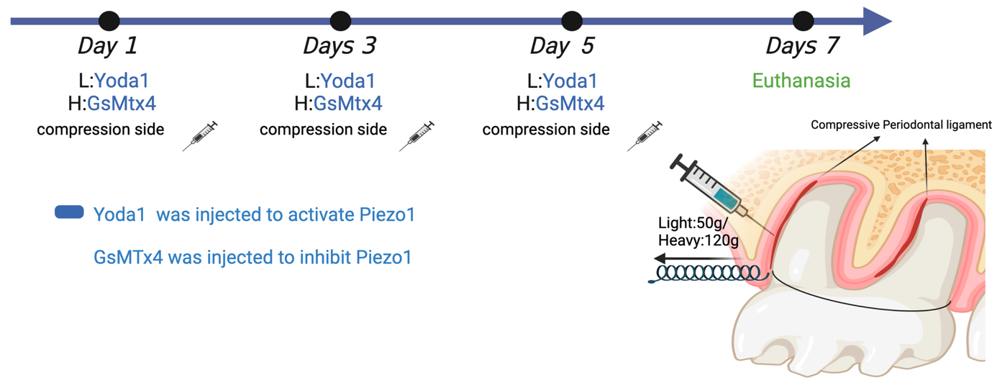
Fig S1. Schematic diagram of Piezo1 agonist and inhibitor intervention in OTM in Fig.4.

Figure S2. Micro-CT analysis of maxillary orthodontic tooth movement on days 1, 3, and 7 under the intervention of Piezo1 agonists and inhibitors in Fig.4 . N=3; Error bars, mean ± SD, * P<0.05, * * P<0.01.

Figure S3. Immunofluorescence of Piezo1 in 1, 3 and 7 days (scale bar:100μm) in Fig.4. N=3; Error bars, mean ± SD, * P<0.05, * * P<0.01. T: tooth, P: PDL, B: bone.
Figure S4. Immunofluorescence of IL-1β in 1, 3 and 7 days (scale bar:100μm) in Fig.4. N=3; Error bars, mean ± SD, * P<0.05, * * P<0.01.T: tooth, P: PDL, B: bone.
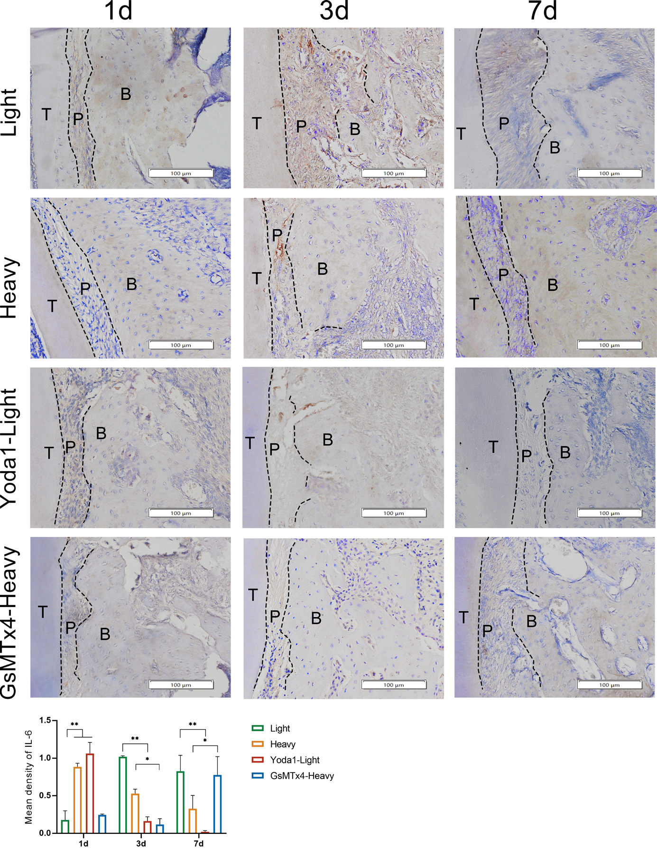
Figure S5. Immunofluorescence of IL-6 in 1, 3 and 7 days (scale bar:100μm) in Fig.4. N=3; Error bars, mean ± SD, * P<0.05, * * P<0.01.T: tooth, P: PDL, B: bone.
Figure S6. Tartrate-resistant acid phosphatase staining and analysis of maxillary orthodontic tooth movement on days 1, 3, and 7 under the intervention of Piezo1 agonists and inhibitors in Fig.4. N=3; Error bars, mean ± SD, * P<0.05, * * P<0.01.T: tooth, P: PDL, B: bone.

Figure S7. Immunofluorescence analysis of Fig.5. a. Immunofluorescence analysis of mtDNA. b. Immunofluorescence analysis of NF-κB. c. Immunofluorescence analysis of IRF3 in Fig.5. N=3; Error bars, mean ± SD, * P<0.05, * * P<0.01.

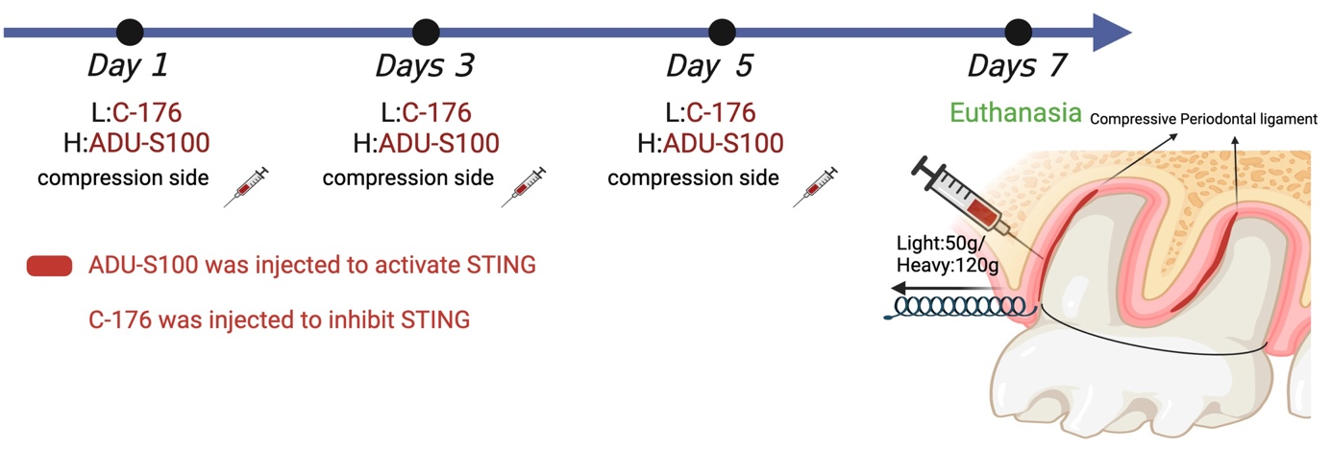
Figure S8. Schematic diagram of STING agonist and inhibitor intervention in OTM in Fig.6.
Figure S9. Micro-CT analysis of maxillary orthodontic tooth movement on days 1, 3, and 7 under the intervention of STING agonists and inhibitors in Fig.6. N=3; Error bars, mean ± SD, * P<0.05, * * P<0.01.
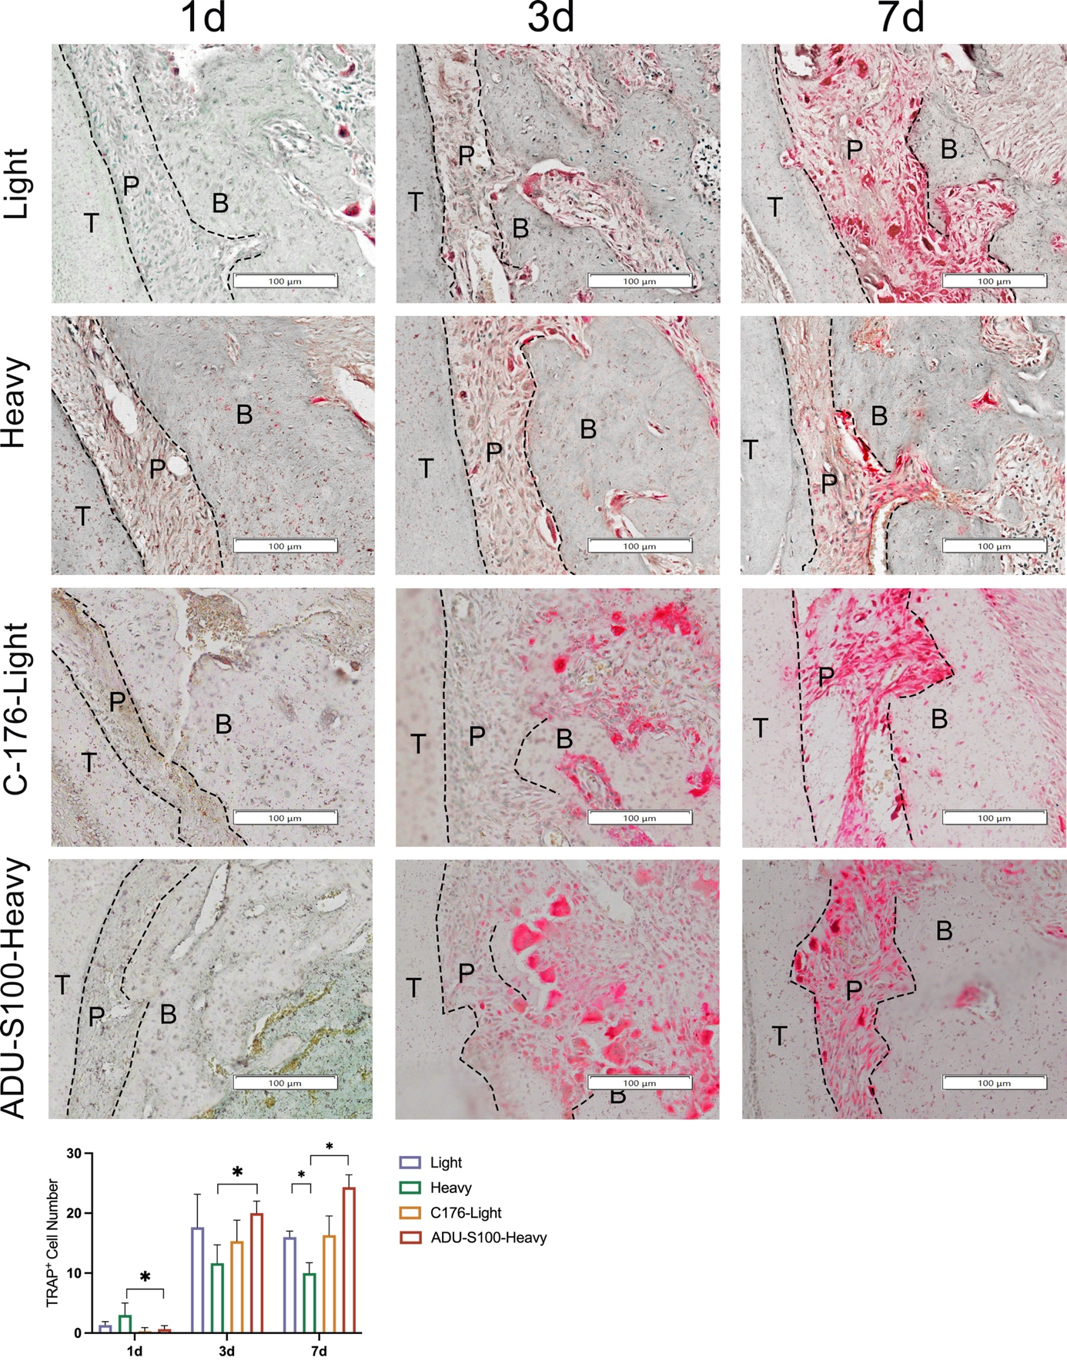
Figure S10. Tartrate-resistant acid phosphatase staining and analysis of maxillary orthodontic tooth movement on days 1, 3, and 7 under the intervention of STING agonists and inhibitors in Fig.6. N=3; Error bars, mean ± SD, * P<0.05, * * P<0.01.T: tooth, P: PDL, B: bone.
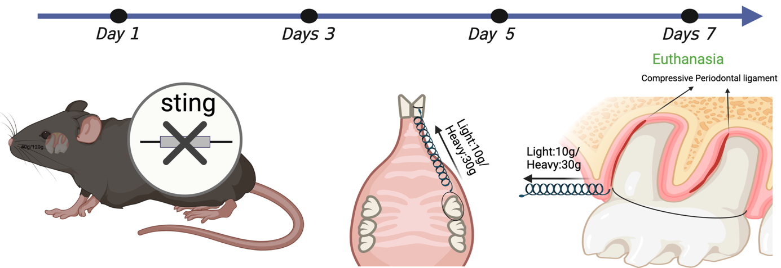
Figure S11. Schematic diagram of WT and sting^{-/-} mice in OTM in Fig.5.

Figure S12. Micro-CT analysis of maxillary OTM in WT and sting^{-/-} mice on days 1, 3, and 7 in Fig.6. N=3; Error bars, mean ± SD, * P<0.05, * * P<0.01.

Supplementary Table 1. List of reagents or resources used in the study.
REAGENT or RESOURCE | SOURCE | IDENTIFIER
Antibodies
Rabbit monoclonal anti – Piezo1 | Thermo Fisher Scientific | Cat# PA5-106296
Rabbit monoclonal anti- alpha Tubulin | Abcam | Cat# ab176560
Rabbit monoclonal anti - CDKN2A/p16^{INK4a} | Abcam | Cat# ab270058
Mouse monoclonal anti - IP3R-I/II/III | Santa Cruz | Cat# sc-377518
Rabbit monoclonal anti - VDAC1 | Affinity | Cat# AF4012
Mouse monoclonal anti - CBARA1/MICU1 | Santa Cruz | Cat# sc-518183
Rabbit monoclonal anti - Hexokinase II | Abcam | Cat# ab209847
Rabbit monoclonal anti - BAX | Abcam | Cat# ab32503
Mouse monoclonal anti - dsDNA | Progen | Cat# 61014
Rabbit monoclonal anti - TOMM20 | Abcam | Cat# ab186735
Rabbit monoclonal anti - cGAS | Abcam | Cat# ab302617
Rabbit monoclonal anti - STING | Abcam | Cat# ab288157
Rabbit monoclonal anti - TBK1 | Abcam | Cat# ab40676
Rabbit monoclonal anti - p-TBK1 | Abcam | Cat# ab109272
Rabbit monoclonal anti -IRF3 | Abcam | Cat# ab68481
Rabbit monoclonal anti - p-IRF3 | Abcam | Cat# ab76493
Rabbit monoclonal anti - NF-κB | Abcam | Cat# ab16502
Rabbit monoclonal anti - p-NF-κB | Abcam | Cat# ab109458
Rabbit monoclonal anti - IL-1β | Abcam | Cat# ab315084
Rabbit monoclonal anti - IL-6 | Abcam | Cat# ab9324

Supplementary Table 2. List of siRNAs used in the study.
Primer | Sequence (5'to3 ')
ITPR3(human)siRNA-2836 | CCAACGAGGAGAAGAACAATT
ITPR3(human)siRNA-2836 | UUGUUCUUCUCCUCGUUGGTT
ITPR3(human)siRNA-3709 | CGCCAAGGACAAGAAAGATT
ITPR3(human)siRNA-3709 | UCUUUCUUGUCCUUGGCGGTT
ITPR3(human)siRNA-3583 | CGCAGGACGUGGAGAACUATT
ITPR3(human)siRNA-3583 | UAGUUCUCCACGUCCUGCGTT
Negative control | UUCUCCGAACGUGUCACGUTT
Negative control | ACGUGACACGUUCGGAGAATT
FAM negative control | UUCUCCGAACGUGUCACGUTT
FAM negative control | ACGUGACACGUUCGGAGAATT
Positive control (human GAPDH) | GUAUGACAACAGCCUCAAGTT
Positive control (human GAPDH) | CUUGAGGCUGUUGUCAUACTT

Supplementary Table 3. List of primer used in the study
Primer | Sequence (5'to3 ')
Piezo1 | TGTTCCAGTTTGGGTTCTTCC
Piezo1 | ACAAGGTCAAACCCAAGAAGG
IL-1β | GAAATGATGGCTTATTACAGTGGC
IL-1β | TTGCTGTAGTGGTGGTCGGAG
IL-6 | GAGTAGTGAGGAACAAGCCAGAG
IL-6 | GGTCAGGGGTGGTTATTGC
MMP3 | CAATCCTACTGTTGCTGTGCG
MMP3 | CAAGGTTCATGCTGGTGTCC
MMP14 | GCCTGCGTCCATCAACACT
MMP14 | GCAGCATCAATCTTGTCGGT
CXCL3 | CCAAACCGAAGTCATAGCCAC
CXCL3 | GGTGCTCCCCTTGTTCAGTATC
CXCL10 | TGACTCTAAGTGGCATTCAAGGA
CXCL10 | TGGATTCAGACATCTCTTCTCACC
AREG | AGTGCTGATGGATTTGAGGTTAC
AREG | TAGCCAGGTATTTGTGGTTCG
EREG | GCCTGGGTTTCCATCTTCTAC
EREG | CACTTTGTTATTGACACTTGAGCC
CDKN2A(P16^{ink4a}) | GGCACCAGAGGCAGTAACCA
CDKN2A(P16^{ink4a}) | AATCGGGGATGTCTGAGGGA
ITPR3 | GACCTCCTGTTCTTCTTCATCG
ITPR3 | TGTCTTGTTATCAAACTTGTCCCTC
VDAC1 | TGACGGGCAGTCTGGAAAC
VDAC1 | ATCTCGGTGCCTAGTGTATTGTC
MICU1 | TGGCGAACTGAGCAATAAGG
MICU1 | GCATGAGGCGAGTGAAACC
BAX | CCTCCTCTCCTACTTTGGGAC
BAX | GAAAAACACAGTCCAAGGCAG
ACTB | AGAAAATCTGGCACCACACCT
ACTB | GATAGCACAGCCTGGATAGCA
18sRNA | GGACACGGACAGGATTGACAG
18sRNA | CCAGAGTCTCGTTCGTTATCGG
MT-COL1 | ACTAACAGACCGCAACCTCAAC
MT-COL1 | TCCGAAGCCTGGTAGGATAAG
MT-ND1 | CACCCTCACCACTACAATCTTCC
MT-ND1 | GGTGTATGAGTTGGTCGTAGCG
MT-ND2 | AACCCGTCATCTACTCTACCATC
MT-ND2 | GTTGCTTGCGTGAGGAAATAC
cGAS | CGTATGTACCCAGAACCCTCA
cGAS | TGTCACGCAGTTATCAAAGCAG
STING | TGATAACCTGAGTATGGCTGACC
STING | TGATAACCTGAGTATGGCTGACC
TBK1 | TCTCAGGGAACAATAGAAACCAG
TBK1 | GGATGAGTGCCTTCTTGATGTG
IRF3 | GGCTCGTGATGGTCAAGGT
IRF3 | CTTGTACTGGTCGGAGGTGAG
NFKB-RELA | TGGGGACTACGACCTGAATG
NFKB-RELA | AAGATGGGATGAGAAAGGACAG

