Supplementary data
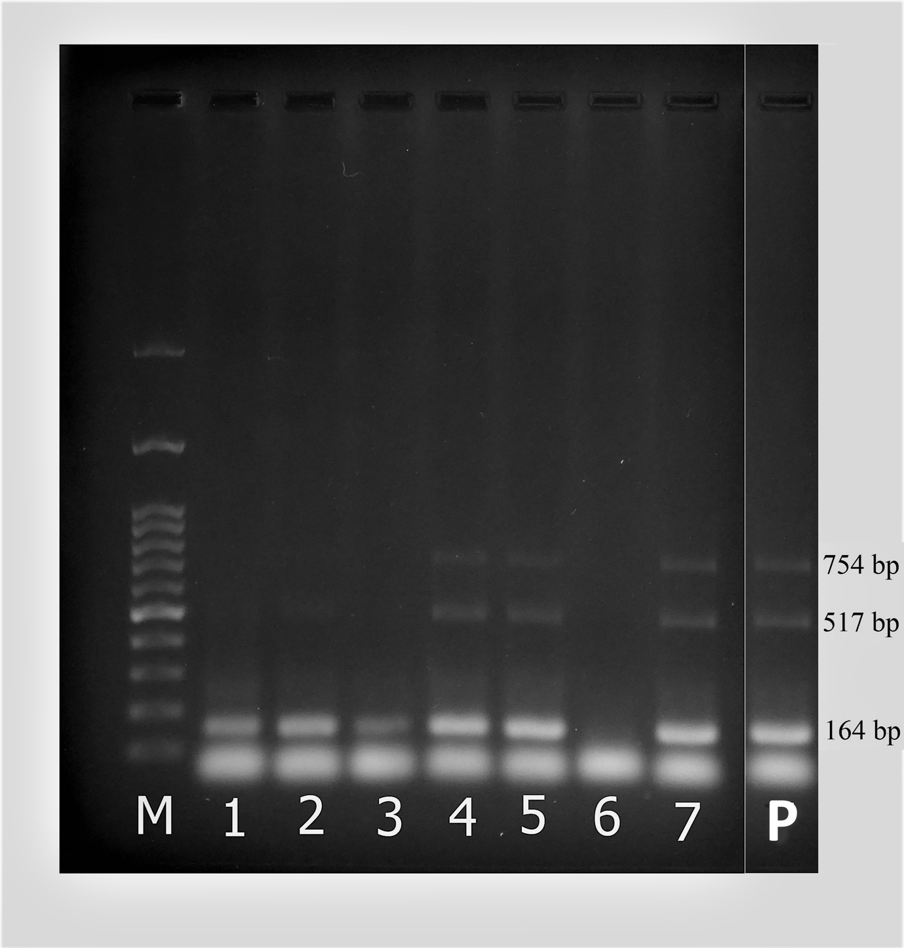
Figure S1 Agarose gel electrophoresis from one-tubed semi-nested PCR targeting MCP gene of ISKNV. The number of specific amplicons (164, 517, and 754bp) is correlated with the viral copy numbers presented in the DNA template. Each lane was a representative sample collected from the different farms (a total 7 farms). A relatively high degree of infection was observed in farm A, E and F (lane 4, 5 and 7). Lane 6, non-infected sample from farm B.
M; Marker 100 bp, P; Positive control.

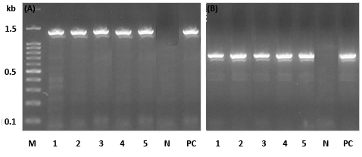
Figure S2 Amplification of full-length MCP and ATPase genes of ISKNV (A and B). A, lane A1-A5; B, lane B1-B5; M, 100 bp DNA marker, PC; positive control; N, negative control.
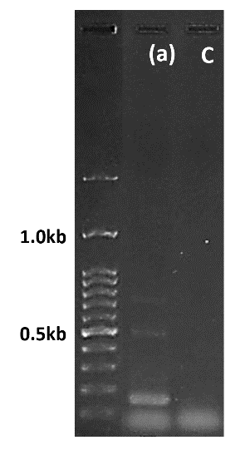
Figure S3 One-tubed semi-nested PCR from cell culture supernatant of GF cells infected with ISKNV. Specific amplification was found exclusively from virus-infected GF cell monolayer (a), whereas no amplification was observed from control GF cell (C).

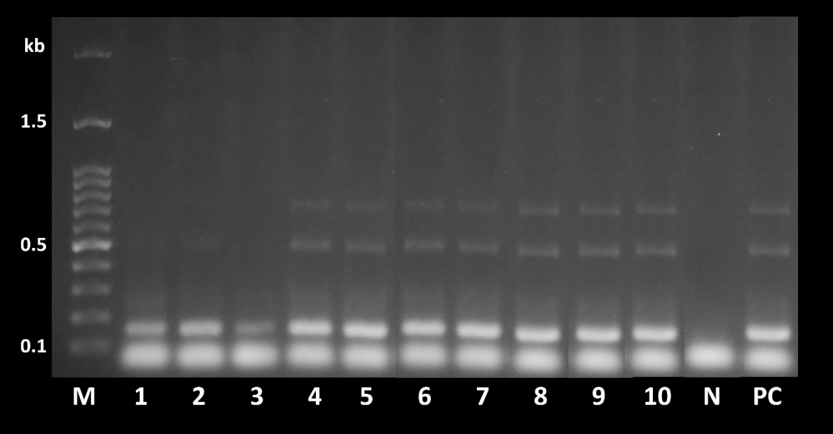
Figure S4 One-tubed semi-nested PCR from the liver of experimentally ISKNV-infected Asian sea bass indicated relatively high viral load as three specific PCR products were amplified. Control fish (fish inoculate with sterile L15 medium) yielded negative result for virus-specific snPCR. Marker (M), samples from experimental fish (1-10), Negative control (N) and Positive control (PC)

