Supplementary Information

Comparison of climate velocity algorithms
To illustrate the development of the climate zone velocity algorithm, we provide an example using the Selway-Bitterroot Wilderness (Fig. S1), located in western Montana/northeastern Idaho, USA and classified as IUCN category Ib (Fig. S1a). For each origin pixel, we find the nearest pixel with the same climate zone (i.e., the destination) based on a topographic least cost path. We then merge the paths from each of the four epochs (1970-2000, 2020-2049, 2040-2069, 2060-2089, and 2070-2099) to produce a single, continuous trajectory along which climate migrants will need to track climate conditions through space and time (Fig. S1b, solid line). The climate trajectory for the pixel (solid line, Fig. S1b) is compared to the simpler least cost path (dotted line) and a topographic least cost path that only uses the origin and final (last date) destination (dashed line) and does not consider intermediate time steps. The continuous climate trajectory developed in this paper offers a more realistic movement path that can account for finer temporal scale changes in climate over time. By incorporating multiple time steps (Fig. S1c), we are able to better capture the changing climate velocities that will characterize different areas of the globe. Our method also captures more realistic elevation changes of migration paths (Fig. S1d).

In the Selway-Bitterroot Wilderness, which is a mountainous region, the nearest destination pixel for a mountaintop pixel with the same climate class is often found on an adjacent mountain-top. The climate trajectory paths created using the traditional, single time-step method indicate migration will take place at lower elevations. However, our multi-temporal method indicates that migration will remain at higher elevations over time to track suitable climate. Fig. S1e shows all the trajectory paths (gray lines), origins, and destinations (black dots) in this protected area. Black dots that occur outside of the protected area boundary indicate that the closest suitable climate will not be in a protected area unless additional steps are taken to expand the boundaries. Over time, as the climate classes in the Selway-Bitterroot Wilderness shift, more of the trajectories have destinations outside of the protected area (Fig. S1e).
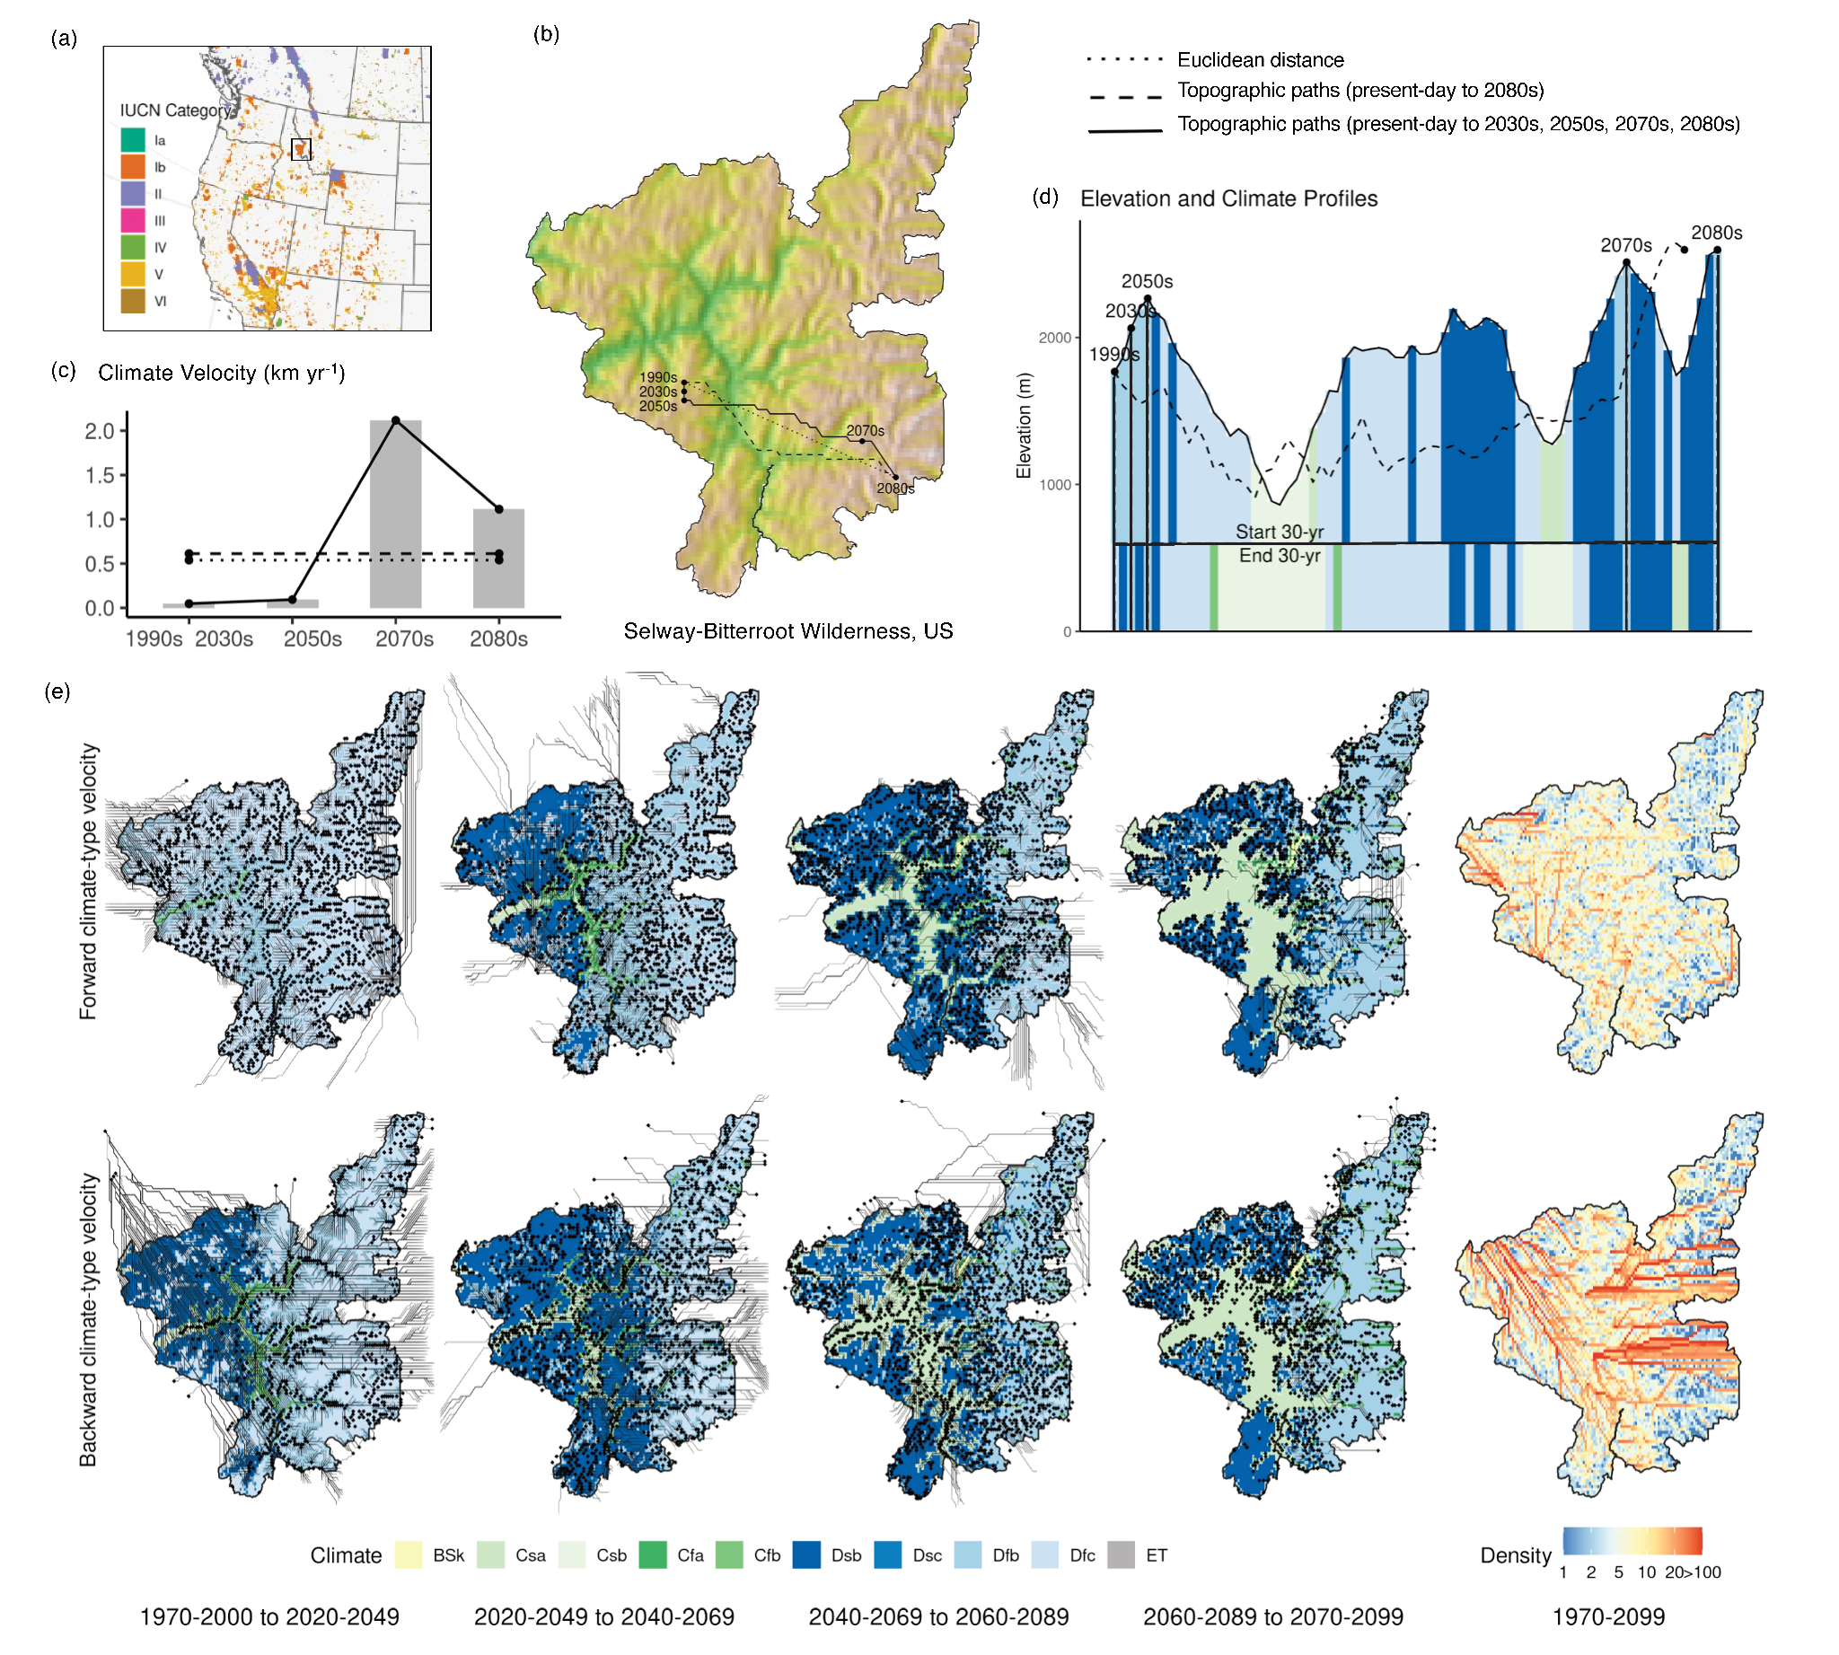Fig. S1 Comparison of velocity algorithms and example results of climate zone velocity. (a) Location and IUCN category of the Selway-Bitterroot Wilderness in the United States. (b) Climate velocities derived from three different approachesーdotted line showing climate velocity based on Euclidean distance and one future period, dashed line for climate velocity based on topographic paths, and solid line for climate velocity based on topographic paths and multiple future time frames, which is used in this study. (c) Temporal variations in climate velocities, which are largely overlooked by other velocity approaches. (d) Elevation and climate profiles of the climate velocities based on topographic paths focused on one period (1990s-2080s) and multiple periods (1990s, 2030s, 2050s, 2070s, and 2080s). The colors represent climate classes along the topographic paths for starting 30-year period (top) and ending 30-year period (bottom). The nearest pixel with the same climate class for a mountain-top is often found on an adjacent mountain-top. In mountainous regions like this, traditional climate velocities show a general pattern of low values. (e) Pixel-based trajectory results where each line indicates a topographic least cost path based on the merging of the multi-temporal climate velocities, with black dots marking the trajectory destination, which is the nearest pixel with the same climate in the future (forward velocity) and the past (backward velocity). The trajectory density map is created by overlaying all the climate trajectories of four future periods.

Timing of climate zone shifts
The time frame over which climates shift is critical in conservation planning and can determine the magnitude of ecological disruptions by climate change. To estimate the timing of projected climate zone shifts, for each PA, we identified a start 30-year period and an end 30-year period from future periods of 1970-2000 (1980s), 2020-2049 (2030s), 2040-2069 (2050s), 2060-2089 (2070s), and 2070-2099 (2080s) under alternative future scenarios (Fig. S11). If a PA has pixels changing across multiple periods and has no changing pixels in one of mid-century periods, then the time frame for the given PA is estimated as from the first period with changes to the last period in which changes occurred. Results show that more than half (52-55%) of global terrestrial protected areas (PAs) began to experience climate zone shifts starting in the 1980s (Table S3). Approximately 26-28% of global PAs are projected to undergo climate zone shifts over an extended time frame, starting from the 1980s and continuing until the end of this century. A smaller proportion of global terrestrial PAs (18%, 17%, 14%, and 13% under RCP2.6, 4.5, 6.0 and 8.5, respectively) will face near-term shifts in climate zones, with the timing estimated to occur within the first half of this century (Table S3). The protected areas that experience long-term climate zone shifts (from the 1980s to the 2080s) are primarily located in the western United States, northern and southern Europe, Australia, low latitudes of South America and Africa, central Asia, and eastern Russian (Fig. S11).

Correlations between metrics of climate zone shifts and PA characteristics
We conducted a correlation analysis to examine the relationship between metrics of climate zone shifts and characteristics of protected areas (PAs). The correlation results did not reveal significant differences among alternative scenarios. The following discussion will focus on the results obtained under the RCP8.5 scenario. This scenario represents a high greenhouse gas emissions pathway, assuming no significant mitigation efforts, and it represents a future with the most severe climate change impacts.

Correlations between climate zone shifts and PA characteristics suggest increased exposure for terrestrial PAs and that PAs in high latitudes and low elevations, with large sizes and low topographic heterogeneity are more likely to be exposed to high climate zone velocity shifts (Fig. S4). Positive relationships between climate zone velocity and species richness in Africa and Oceania, two areas with high biodiversity and biodiversity hotspots, are expected to experience higher rates of climate shifts (Fig. S4). We also find positive correlations between climate zone shifts and latitude and elevation, notably in Asia, North and South America, and Africa (Fig. S5), implying that PAs in high latitudes and high elevations are more likely to be exposed to larger magnitudes of climate zone shifts. Positive correlations between climate zone shifts and species richness are found in Europe and Oceania, indicating higher threats to biodiversity in PAs in these regions (Fig. S5). In addition, the first half of this century shows stronger correlations of climate zone shifts with examined PA attributes than the latter half of the century (Fig. S5).

Correlations between metrics of climate zone shifts
We examined correlations between the spatial patterns of climate zone shifts to investigate whether there are associations or connections between them. The metrics used in our analysis included forward and backward velocities of climate zone shifts, which represent the relocation rates of climates, and percentage of protected areas projected to undergo climate zone shifts, which describes the area changes in climate availability. The scatter charts and correlation coefficients showed that area metric has weak correlation with forward velocity and moderate correlation with backward velocity (Fig. S12). This suggests that PAs with more area projected to experience climate zone shifts are also more likely to be exposed to faster rates of climate zone shifts. Correlations between forward and backward velocity were observed to be relatively weak and exhibited a general decreasing trend.

- Additional Supplemental Figures and Tables

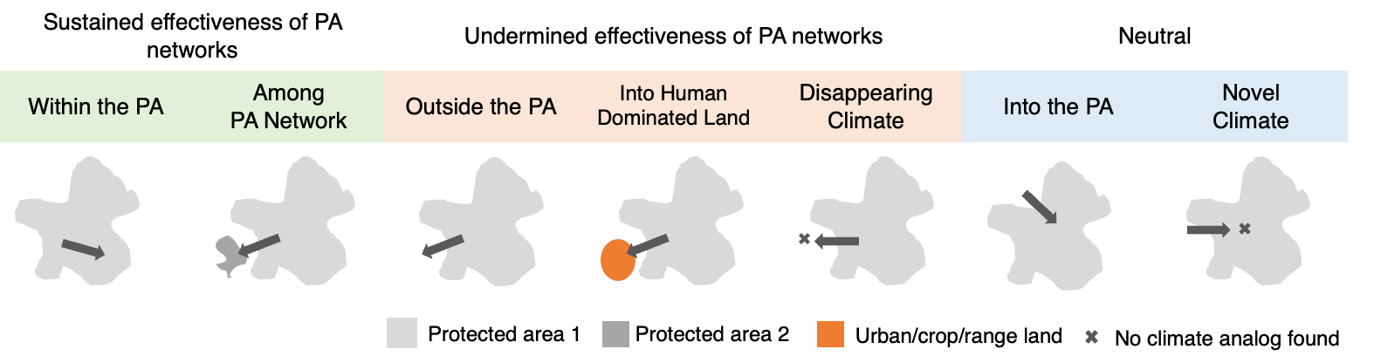Fig. S2 Conceptualization of the different spatial relationships that can characterize trajectories resulting from climate zone shifts in protected areas, adapted from Batllori et al. (2017). Shifts within, among, and into protected areas will be absorbed by the current PA network. Shifts outside, into disturbed areas, or disappearing climates will not be absorbed by the existing PA network. Novel climates may also appear in protected areas.
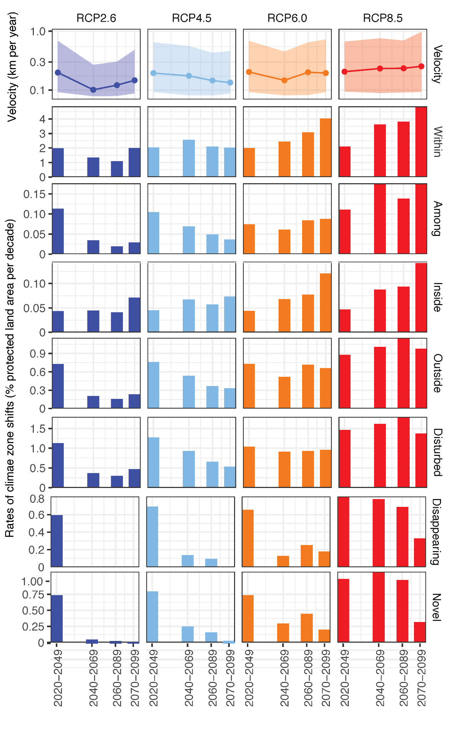
Fig. S3 Rates of climate zone shifts. Near-term (2020-2049), mid-term (2040-2069 and 2060-2089) and long-term (2080-2099) future climate zone velocities (top row) and rates of climate zone shifts (bar graphs) for protected areas under the four Representative Concentration Pathway (RCP) scenarios
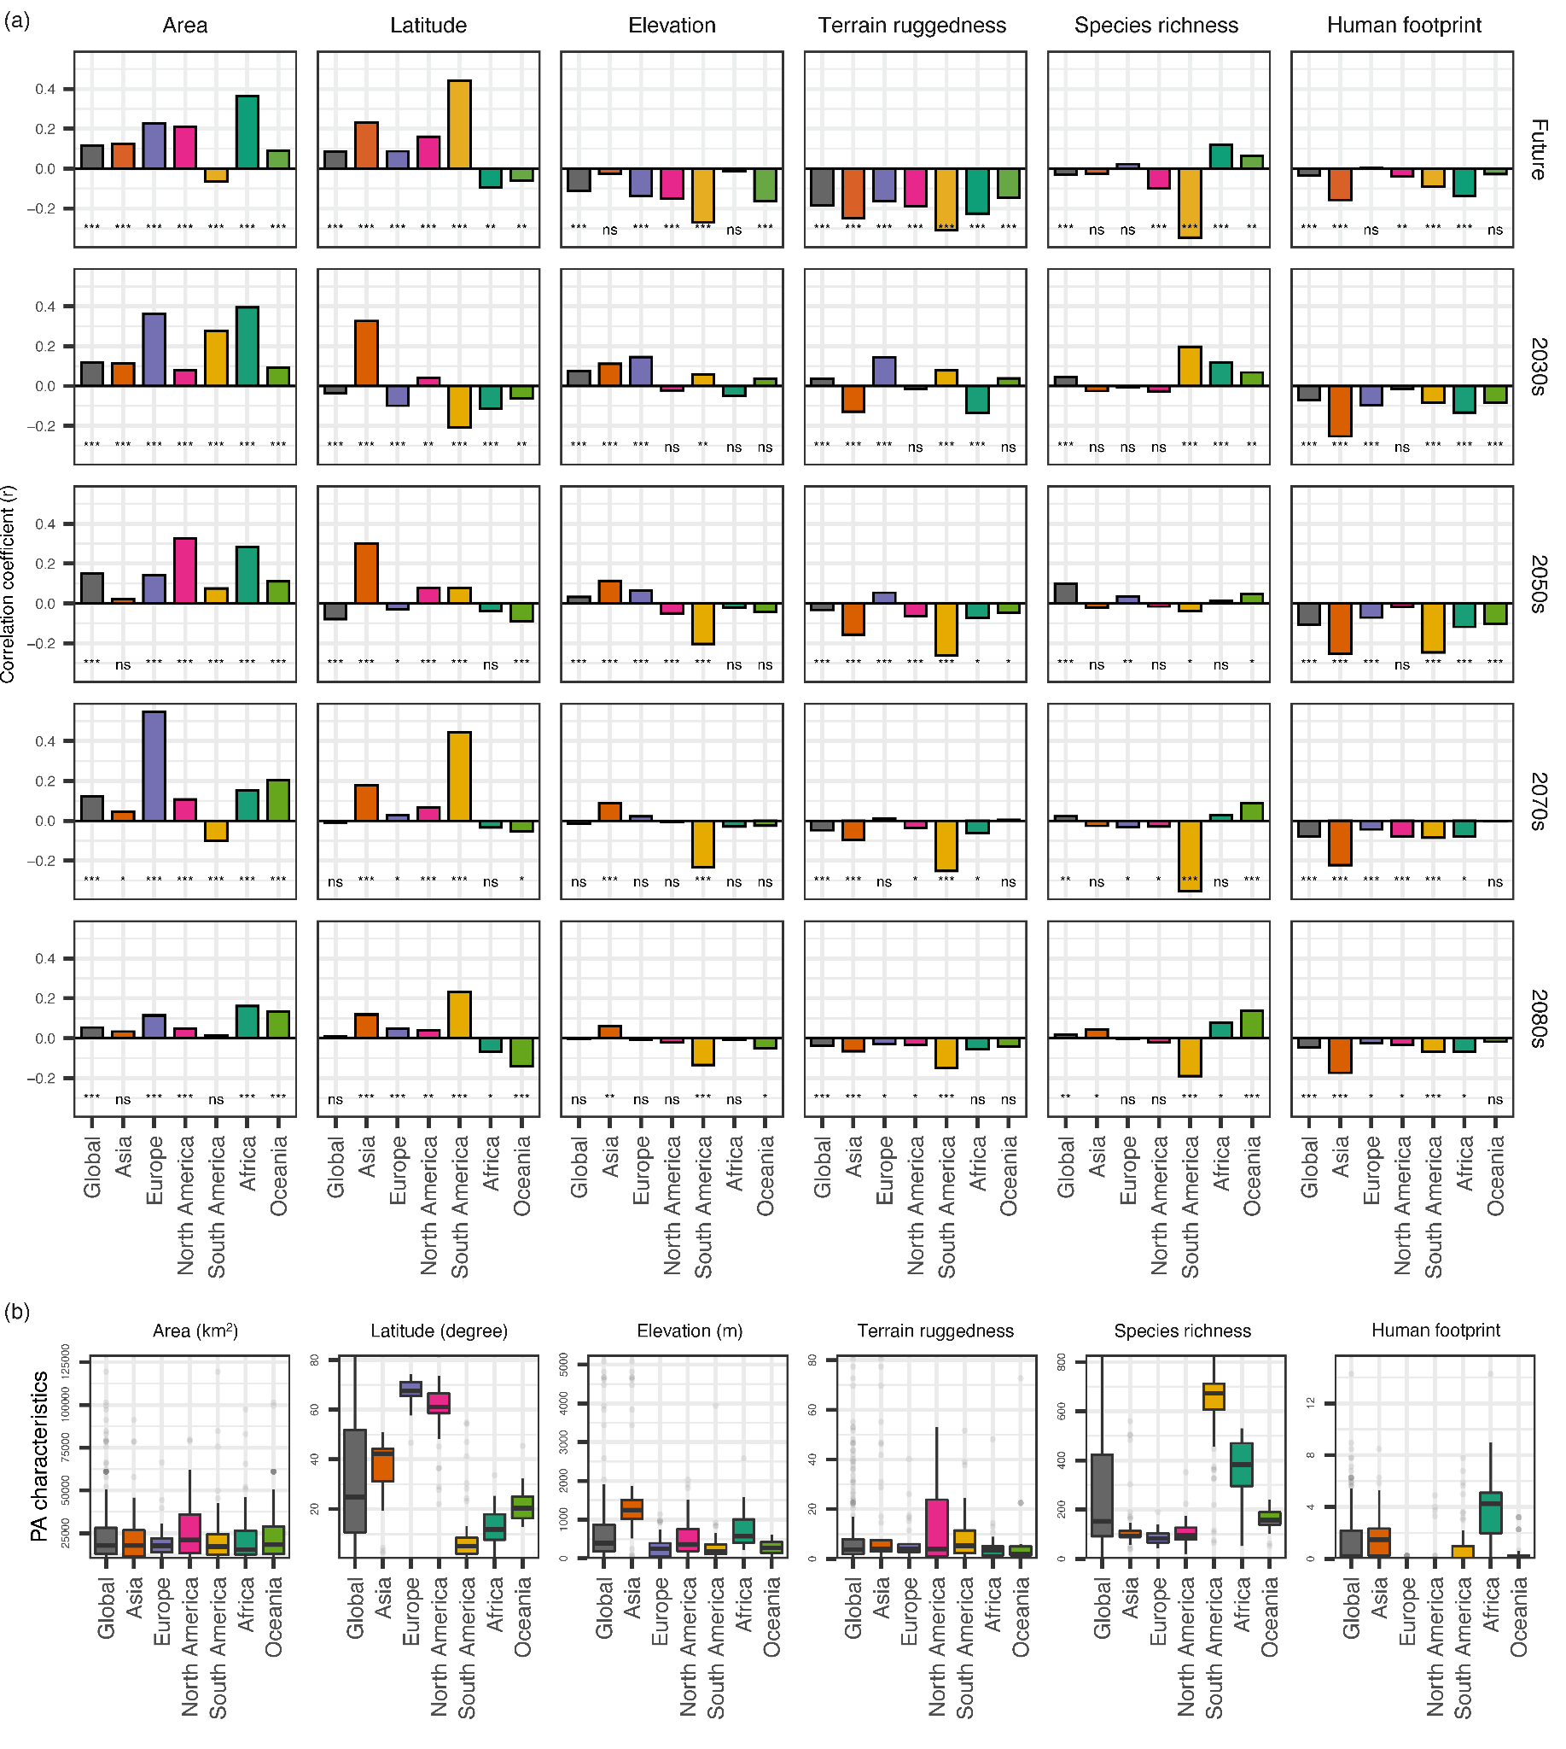Fig. S4 (a) Correlations between climate zone velocity and PA attributes (RCP8.5). Asterisks located beneath each bar represent the level of significance based on t-test accounting (*p ≤ 0.05, **p ≤ 0.01, ***p ≤ 0.001, “ns” for non-significant (p > 0.05) correlation). (b) Box and whisker plots of the actual values of each characteristic summarized by region and for the entire globe. Area is the total size of the PA. Latitude is the absolute mean latitude of the PA. Elevation, terrain ruggedness index (TRI), and human footprint (HFT) are averaged values within the PA. Species richness is estimated as cumulative species density for all animal species within the PA
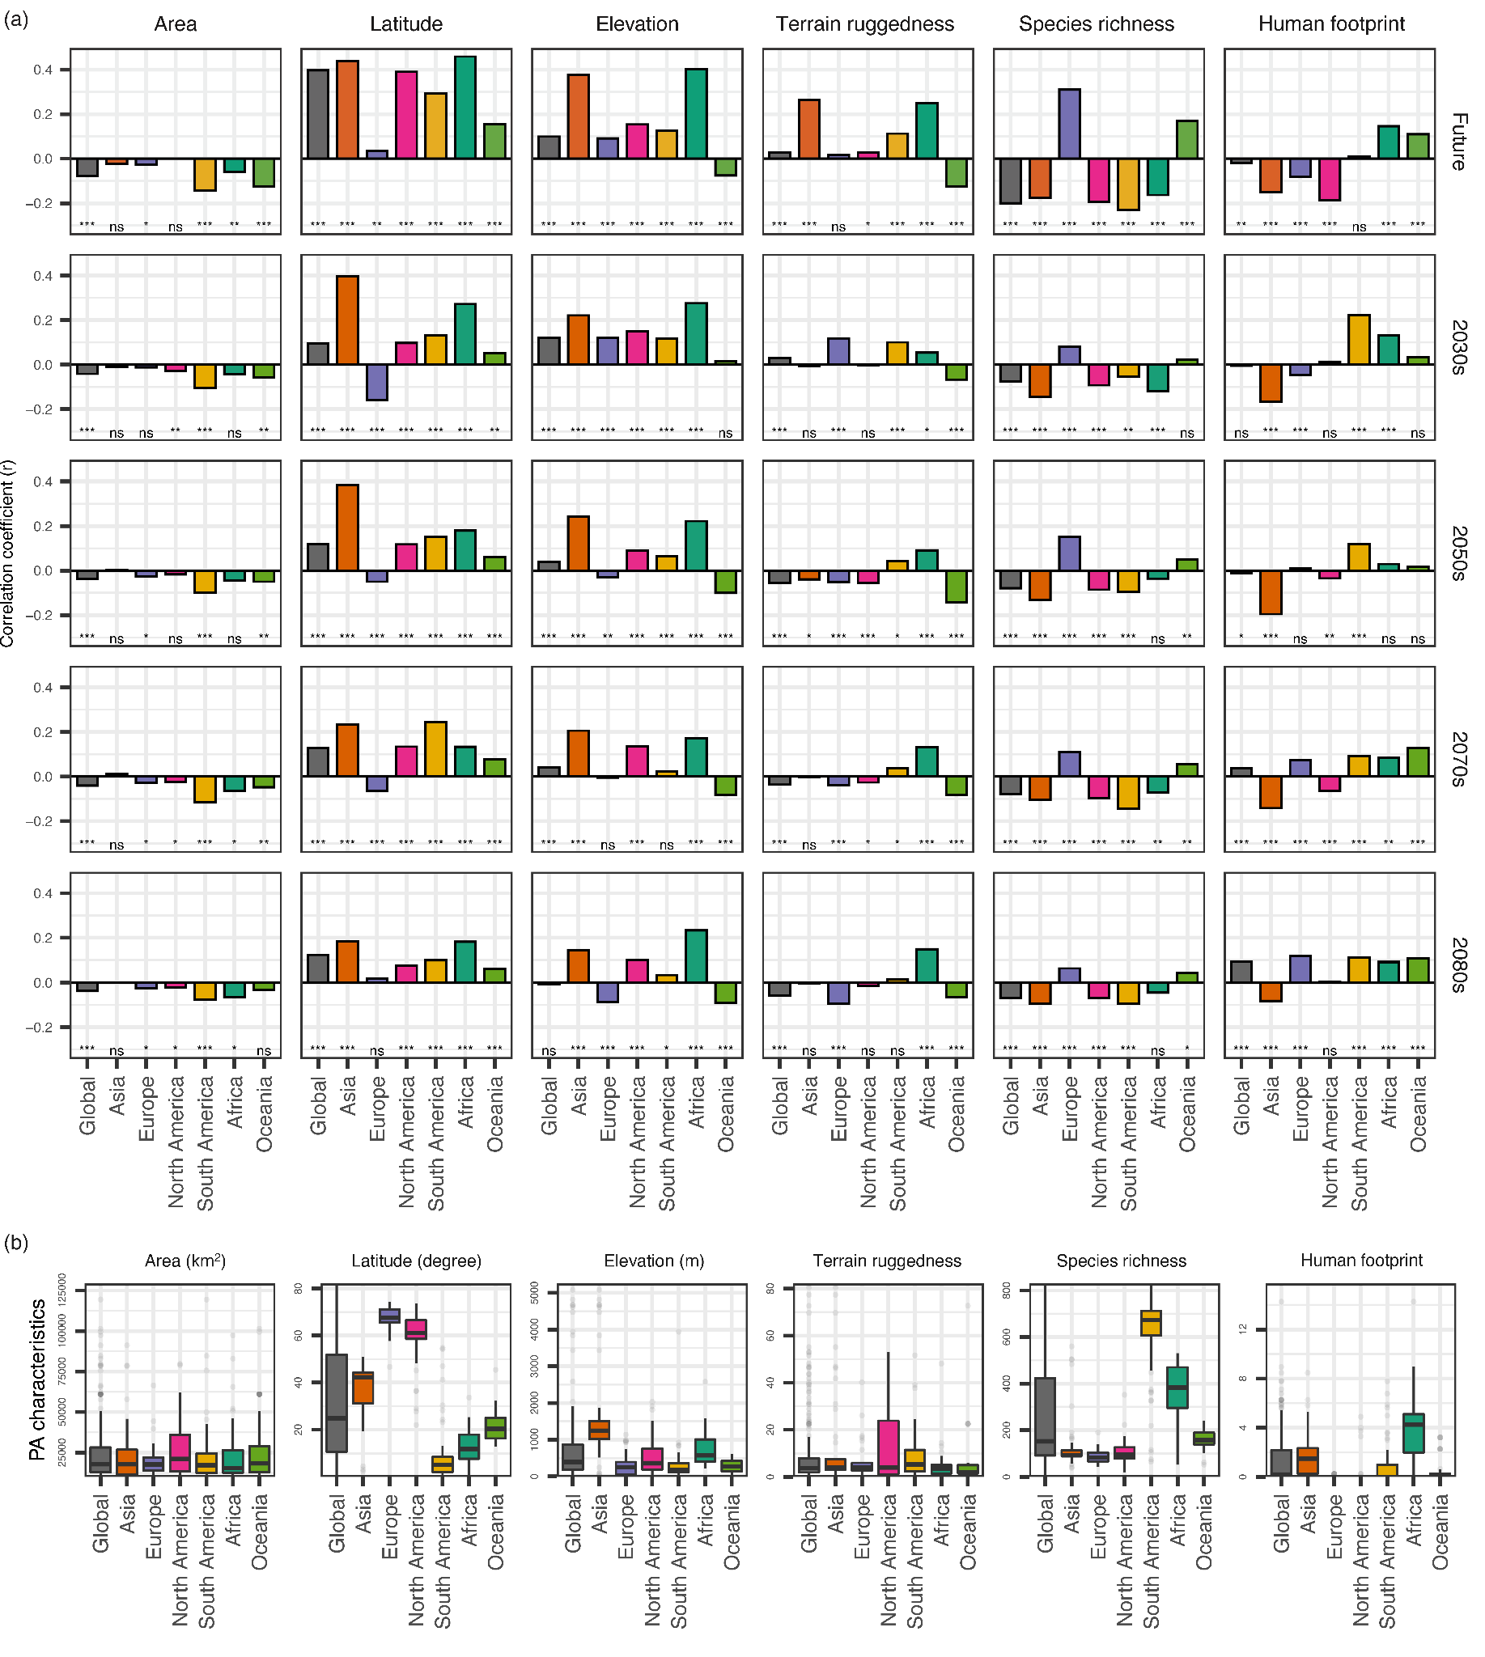Fig. S5 (a) Correlations between percent of PA expected to experience climate zone shifts and PA attributes (RCP8.5). Asterisks located beneath each bar represent the level of significance based on t-test accounting (*p ≤ 0.05, **p ≤ 0.01, ***p ≤ 0.001, “ns” for non-significant (p > 0.05) correlation). (b) Box and whisker plots of the actual values of each characteristic summarized by region and for the entire globe. Area is the total size of the PA. Latitude is the absolute mean latitude of the PA. Elevation, terrain ruggedness index (TRI), and human footprint (HFT) are averaged values within the PA. Species richness is estimated as cumulative species density for all animal species within the PA.
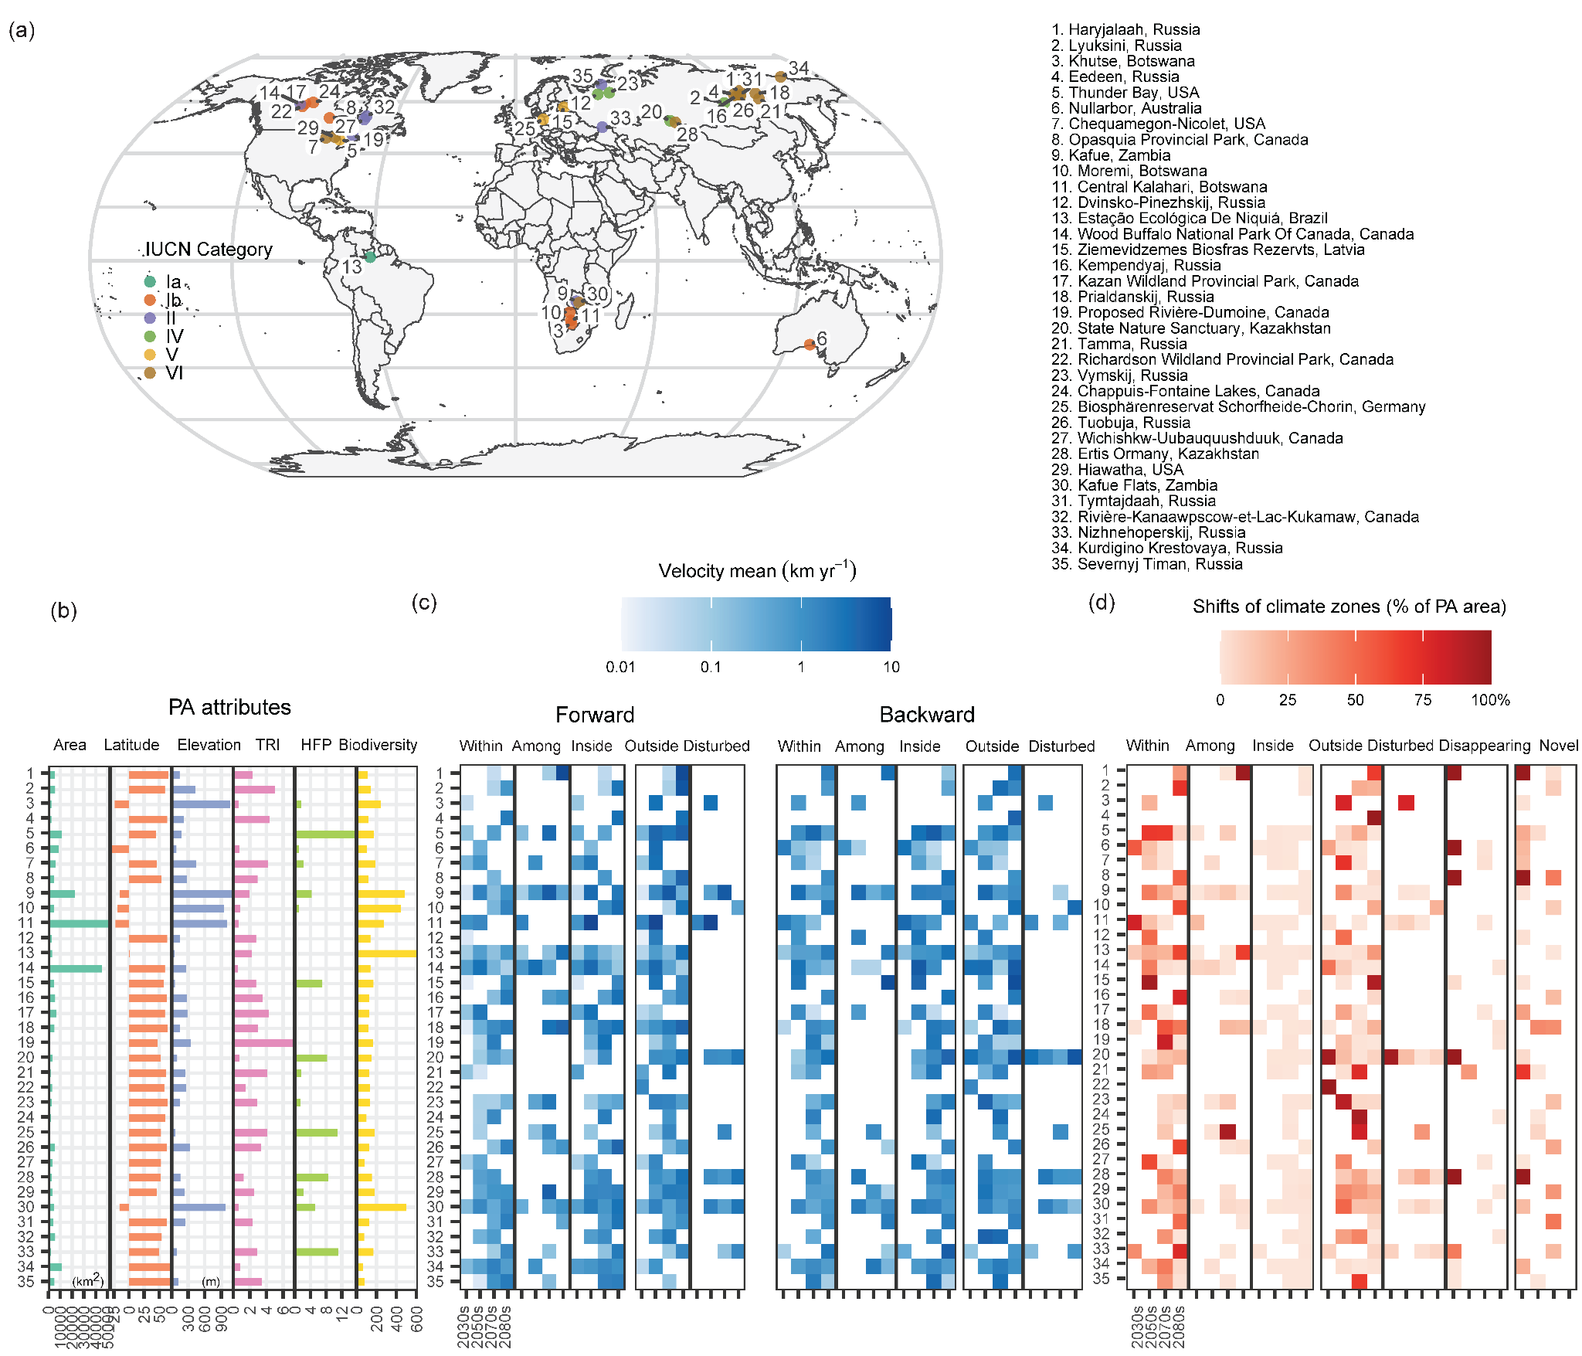
Fig. S6 PAs exposed to large proportions of climate zone shifts and high climate velocity. (a) Geographic locations of 35 terrestrial PAs projected to experience completely different climate zone distributions by the end of the century with mean estimated velocities greater than 1 km yr⁻¹. (b) Associated PA attributes including area, latitude, elevation, terrain ruggedness index (TRI), human footprint (HFP), and biodiversity. (c) Spatial and temporal patterns of the shifts in climate zone in terms of the mean velocity, both forward and backward, for five spatial relationship patterns. (d) Spatial and temporal patterns of percent change in area of the PA for the 35 PAs. The x axis indicates the four time periods, which repeat for each spatial relationship pattern.
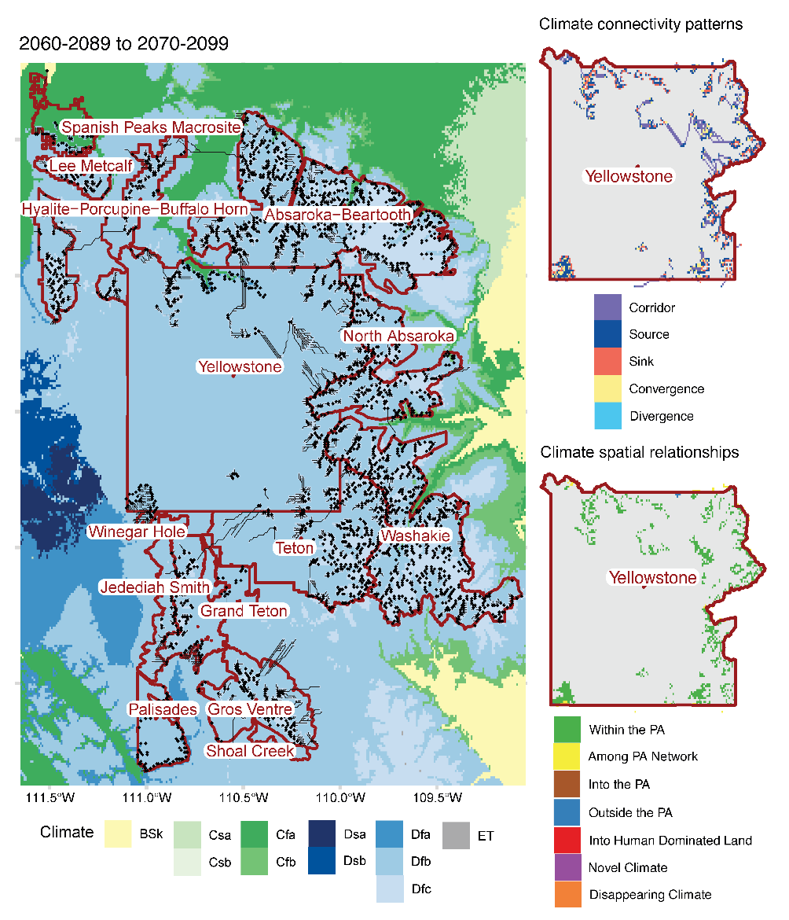
Fig. S7 Regional case study of the use of climate zone velocity results for conservation prioritization in the Yellowstone region of the USA for 2060-2089 to 2070-2099. Protected area boundaries are outlined in maroon. Black solid lines show climate zone velocities derived based on topographic paths, with black dots marking the destinations. Based on the 1-km climate zone velocity metric, we modify Batllori’s framework¹⁸ to categorize the climate spatial relationship patterns based on whether climates are relocated within, among, into or outside the PA networks (top thumbnails). We also identify climate connectivity based on the density and percentage of velocities starting in, ending in, and passing through the given cells (lower thumbnails). Gray indicates non-moving areas.
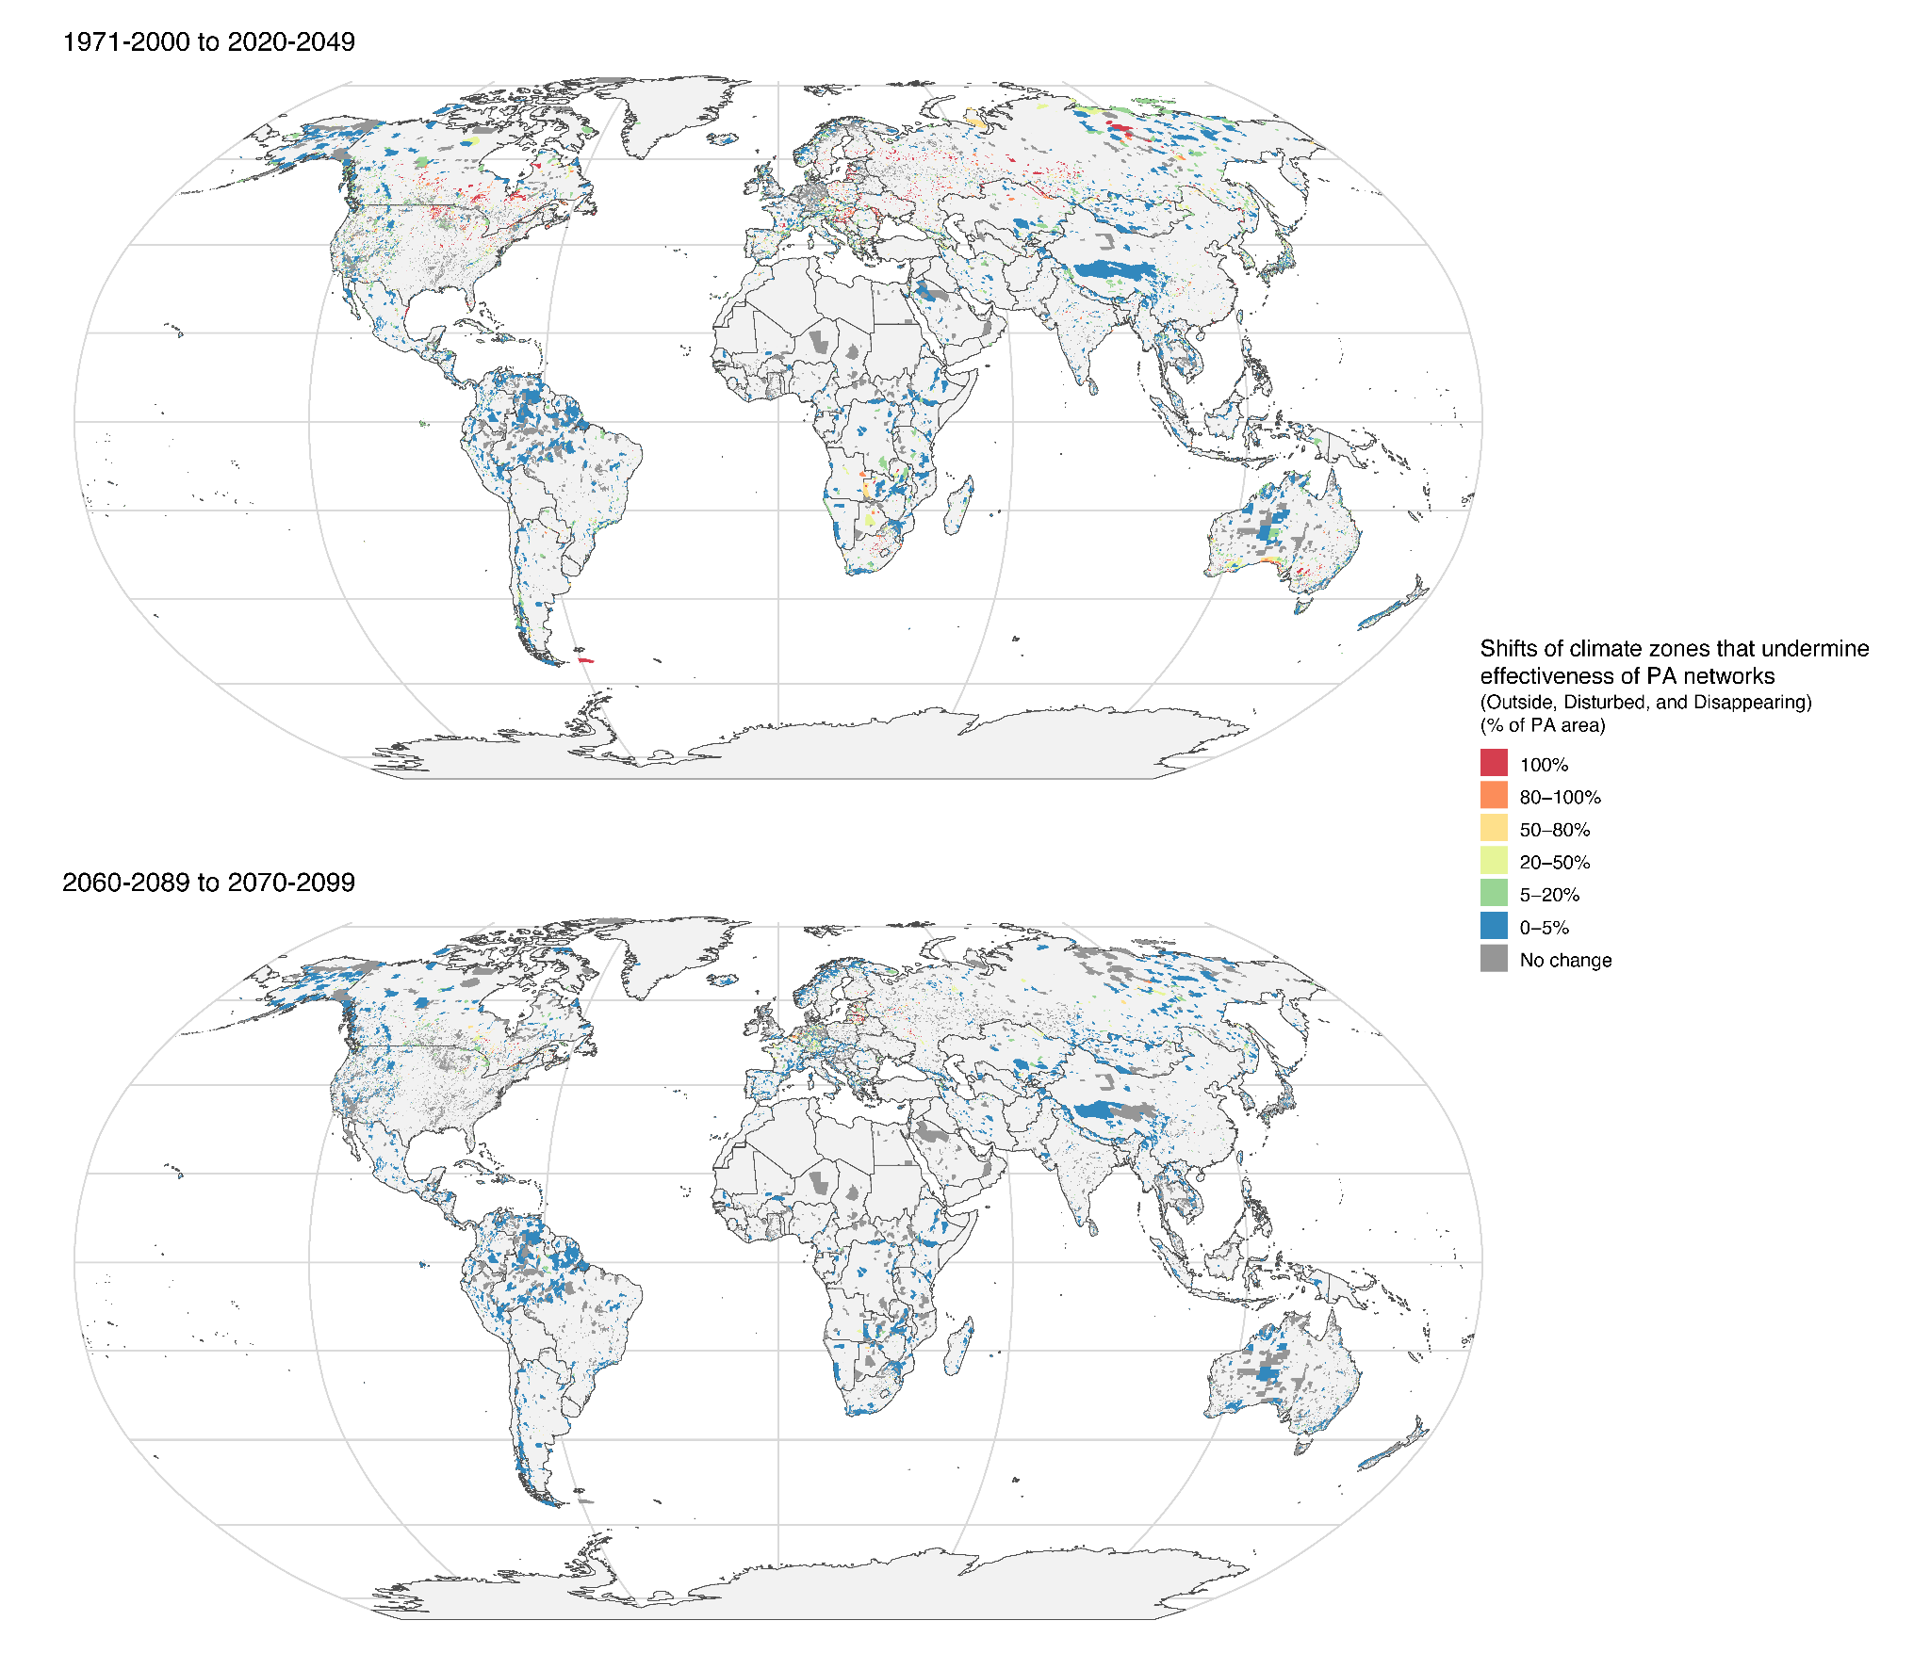
Fig. S8 Projected climate zone shifts that could potentially undermine the effectiveness of PA networks within each PA under RCP8.5 in the mid and late century. The maps show percent of PA area projected to shift outside the PA networks (Outside), into unprotected human dominated lands (Disturbed), or experience disappearing climates (Disappearing) for two future periods (1971-2000 to 2020-2049, and 2060-2089 to 2070-2099). Larger areas are more likely to absorb the changes.

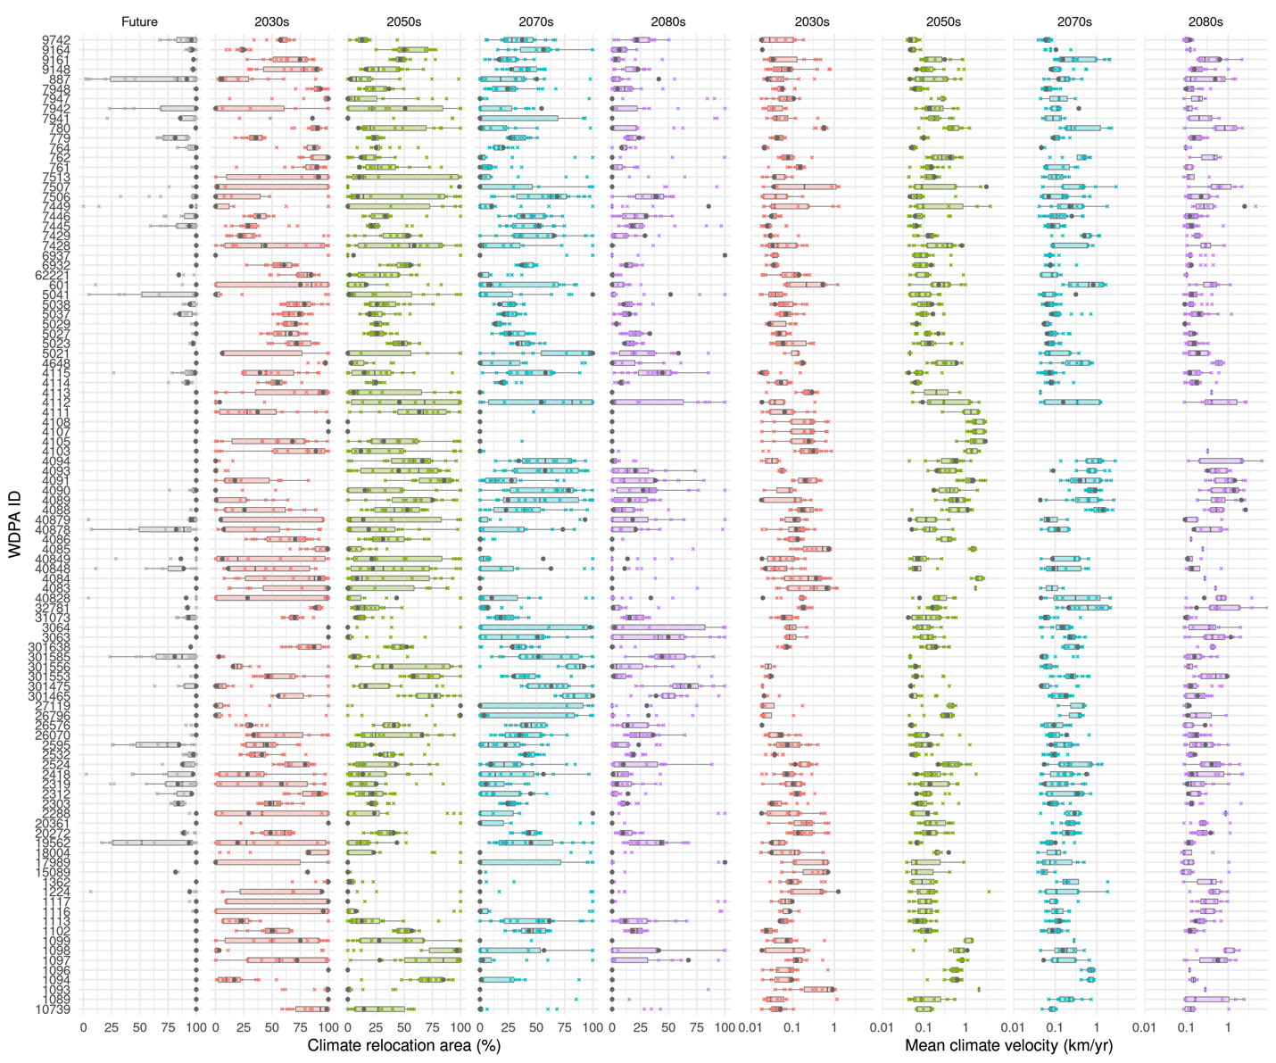
Fig. S9 Sensitivity of PA-level climate zone relocation and mean climate velocity to CMIP5 GCMs for 100 randomly selected PAs. X marks indicate the climate zone relocation and mean climate velocity results based on climate classification maps derived from 16 individual GCMs (details in Table S11). Black dots indicate the results presented in this study, which are based on the climate classification maps with the highest confidence level using multiple CMIP5 GCMs. The scenario is RCP8.5 and the 100 PAs are randomly selected. Results of individual (x marks) models vary at PA level but our velocity results (black dots) agree well with multi-model mean levels.
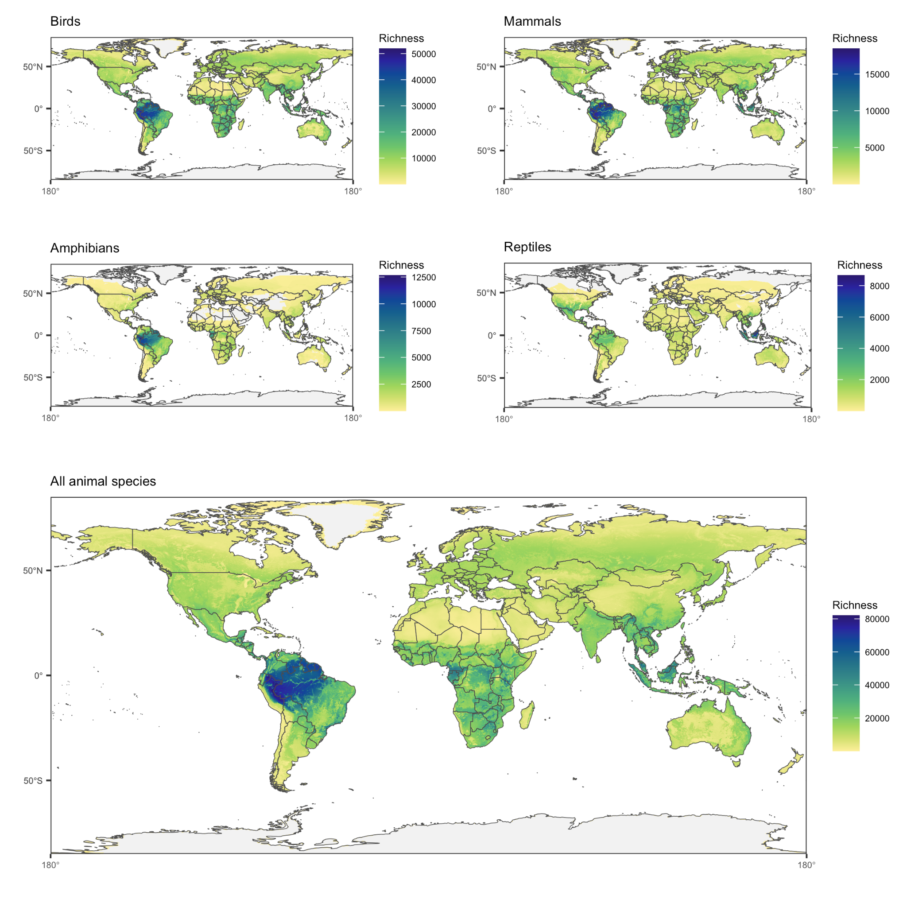
Fig. S10 Global maps of species richness using area of habitat (AOH) estimates for 10,774 birds, 5219 mammals, 4462 reptiles, and 6254 amphibians from Schuster et al., (2023). The maps are in a global 1km grid.

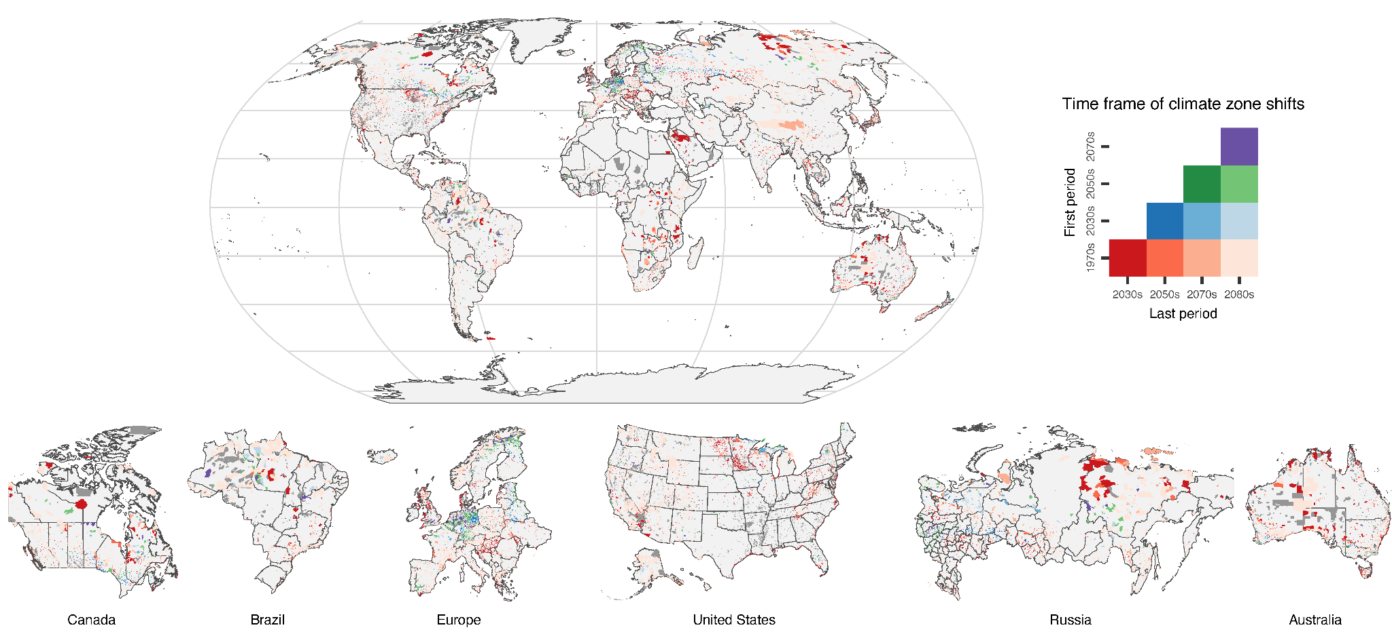
Fig. S11 Timing of projected climate zone shifts within the global terrestrial PAs (RCP8.5). Timing of climate zone shifts is estimated with a starting period and ending period from 1970-2000 (1980s), 2020-2049 (2030s), 2040-2069 (2050s), 2060-2089 (2070s), and 2070-2099 (2080s). Most PAs experienced their first climate zone shift during the baseline period (1970-2000) as evidenced by the red-coloring of the PA.
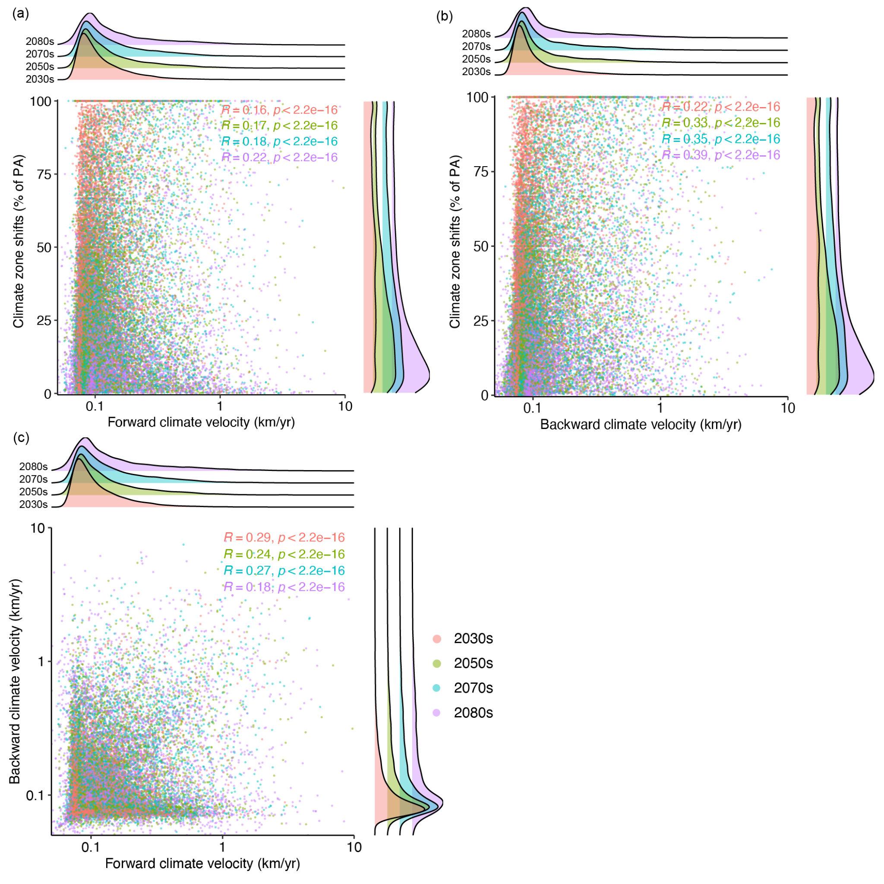
Fig. S12 Correlations between velocities and shifts. (a) Forward and (b) backward climate zone velocity with the percent of PA expected to experience climate zone shifts (RCP8.5), and (c) the correlation between forward and backward climate velocities.

Table S1 Recent studies applying local climate velocity or climate analog velocity with the associated spatial coverage, resolution, data, time period, and representative concentration pathway (RCP) scenario(s).
Reference | Velocity algorithm | Research topic | Spatial coverage | Res. | Data | Time periods | Scenario
Dobrowski et al., 2013 | Local climate velocity | Species exposure to climate change | North America | 5km | 12 CMIP5 GCMs | 1981-2010, 2071-2100 | RCP8.5
Burrows et al., 2014 | Local climate velocity | Climate velocity trajectory and climate connectivity | Global land and ocean | 1º | HadISST, CRU, CSIRO ACCESS1.0 | 1960-2009, 2006-2100 | RCP4.5, RCP8.5
Ordonez et al., 2014 | Local climate velocity | Species exposure to climate change | US | 10km | CMIP5 GCMs | 2001-2011, 2041-2051 | RCP2.6, RCP6.0, RCP8.5
Batllori et al., 2017 | Climate analog velocity | PA exposure to climate change | US PA network | 1km | MPI-ESM-LR | 1981-2010, 2071-2100 | RCP8.5
Carroll et al., 2018 | Climate analog velocity | Climate connectivity | North America | 5km | 15 CMIP5 GCMs | 1981-2010, 2071-2100 | RCP8.5
Heikkinen et al., 2020 | Climate analog velocity | PA exposure to climate change | Finland PA network | 50m, 1km | ECA&D, 23 CMIP5 GCMs | 1981-2010, 2077-2099 | RCP2.6, RCP4.5, RCP8.5

Table S2 Summary of climate zone velocities (left) and the percent of Protected Area (PA) areas experiencing climate zone shifts (right) for each of the four epochs under the four Representative Concentration Pathway (RCP) scenarios. Results are also separated by IUCN Category for RCP8.5.
 | Climate zone velocity (Median (IQR)) (km yr-1) |  |  |  |  |  |  |  | Climate zone changes (% of PA)
 | 1980s to 2030s |  | 2030s to 2050s |  | 2050s to 2070s |  | 2070s to 2080s |  | 1980s to 2030s | 2030s to 2050s | 2050s to 2070s | 2070s to 2080s
 | Forward | Backward | Forward | Backward | Forward | Backward | Forward | Backward | Climate zone | Climate zone | Climate zone | Climate zone
RCP2.6 | 0.2 (0.59) | 0.2 (0.75) | 0.1 (0.19) | 0.12 (0.25) | 0.12 (0.22) | 0.11 (0.21) | 0.15 (0.39) | 0.13 (0.38) | 17.6% | 3.3% | 2.6% | 2.3%
RCP4.5 | 0.19 (0.55) | 0.19 (0.64) | 0.17 (0.48) | 0.22 (0.76) | 0.14 (0.35) | 0.16 (0.43) | 0.13 (0.37) | 0.15 (0.45) | 18.3% | 6.9% | 5.4% | 2.5%
RCP6.0 | 0.2 (0.59) | 0.19 (0.7) | 0.15 (0.37) | 0.16 (0.52) | 0.2 (0.56) | 0.27 (0.92) | 0.19 (0.63) | 0.24 (0.93) | 17.7% | 6.7% | 8.8% | 5.0%
RCP8.5 | 0.21 (0.57) | 0.21 (0.68) | 0.23 (0.67) | 0.28 (0.99) | 0.23 (0.6) | 0.3 (0.92) | 0.25 (0.88) | 0.31 (1.17) | 20.2% | 11.8% | 12.1% | 6.3%
IUCN categories (RCP8.5)
• I-II | 0.19 (0.58) | 0.19 (0.58) | 0.22 (0.76) | 0.22 (0.76) | 0.19 (0.5) | 0.19 (0.5) | 0.19 (0.62) | 0.19 (0.62) | 22.0% | 13.8% | 13.6% | 6.8%
• III-VI | 0.22 (0.56) | 0.22 (0.56) | 0.24 (0.61) | 0.24 (0.61) | 0.28 (0.69) | 0.28 (0.69) | 0.31 (1.11) | 0.31 (1.11) | 18.9% | 10.3% | 10.9% | 5.9%

Table S3 Summary of the timing of protected areas projected to climate zone shifts for each of the four RCP scenarios including the number (and percent) of protected areas that are projected to experience climate zone shifts. If a PA has pixel changes across multiple time periods, then the time frame will be identified using the first and last period.
Scenario | Changes begin in the 1980s |  |  |  | Changes begin in the 2030s |  |  | Changes begin in the 2050s |  | Changes begin in the 2070s
Scenario | 1980s-2030s | 1980s-2050s | 1980s-2070s | 1980s-2080s | 2030s-2050s | 2030s-2070s | 2030s-2080s | 2050s-2070s | 2050s-2080s | 2070s-2090s
RCP 2.6 | 4,126 (18%) | 530 (2%) | 918 (4%) | 6,214 (27%) | 48 (0%) | 124 (1%) | 238 (1%) | 23 (0%) | 101 (0%) | 77 (0%)
RCP 4.5 | 3,840 (17%) | 1,067 (5%) | 1,358 (6%) | 5,824 (26%) | 317 (1%) | 353 (2%) | 467 (2%) | 237 (1%) | 551 (2%) | 179 (1%)
RCP 6.0 | 3,253 (14%) | 875 (4%) | 1,139 (5%) | 6,524 (29%) | 334 (1%) | 421 (2%) | 455 (2%) | 528 (2%) | 905 (4%) | 523 (2%)
RCP 8.5 | 2,905 (13%) | 1,430 (6%) | 1,612 (7%) | 6,484 (28%) | 792 (3%) | 610 (3%) | 759 (3%) | 705 (3%) | 1,103 (5%) | 745 (3%)

Table S4 Summary of forward and backward climate zone velocities for ten global regions for each time period (left) and climate zone changes (right) within global PAs by region for RCP 8.5
Region | Climate zone velocity (Median (IQR)) (km yr⁻¹) |  |  |  |  |  |  |  | Climate zone changes (% of regional PA area (% of global PA area))
Region | 1980s to 2030s |  | 2030s to 2050s |  | 2050s to 2070s |  | 2070s to 2080s |  | 1980s to 2030s | 2030s to 2050s | 2050s to 2070s | 2070s to 2080s
Region | Forward | Backward | Forward | Backward | Forward | Backward | Forward | Backward | Climate | Climate | Climate | Climate
Africa | 0.37 (0.92) | 0.34 (0.9) | 0.46 (1.38) | 0.41 (1.11) | 0.25 (0.53) | 0.22 (0.41) | 0.31 (0.88) | 0.28 (0.69) | 15% (3%) | 6% (1%) | 5% (1%) | 3% (0%)
Asia | 0.12 (0.17) | 0.13 (0.39) | 0.14 (0.3) | 0.14 (0.48) | 0.14 (0.34) | 0.16 (0.62) | 0.17 (0.52) | 0.2 (0.81) | 19% (2%) | 11% (1%) | 11% (1%) | 6% (1%)
Russia | 0.47 (1.33) | 0.61 (1.47) | 0.32 (0.78) | 0.44 (1.08) | 0.43 (1.15) | 0.57 (1.39) | 0.53 (2.1) | 0.7 (2.23) | 39% (4%) | 20% (2%) | 22% (3%) | 12% (1%)
Europe | 0.29 (0.94) | 0.32 (1.15) | 0.25 (0.63) | 0.32 (0.95) | 0.29 (0.79) | 0.41 (1.12) | 0.35 (1.39) | 0.48 (1.73) | 36% (6%) | 20% (3%) | 23% (4%) | 13% (2%)
North America | 0.15 (0.36) | 0.15 (0.44) | 0.23 (0.87) | 0.36 (1.59) | 0.23 (0.59) | 0.29 (1.01) | 0.19 (0.58) | 0.21 (0.9) | 30% (5%) | 21% (4%) | 21% (4%) | 9% (2%)
United States | 0.12 (0.2) | 0.12 (0.25) | 0.15 (0.34) | 0.17 (0.54) | 0.19 (0.48) | 0.24 (1.09) | 0.11 (0.28) | 0.14 (0.5) | 30% (3%) | 22% (2%) | 23% (2%) | 9% (1%)
Canada | 0.27 (0.82) | 0.26 (1.16) | 0.61 (1.95) | 1.19 (3.1) | 0.33 (0.8) | 0.4 (1) | 0.4 (1.11) | 0.45 (1.81) | 32% (2%) | 25% (2%) | 23% (2%) | 10% (1%)
Oceania | 0.22 (0.46) | 0.34 (0.77) | 0.39 (0.93) | 0.26 (0.56) | 0.25 (0.45) | 0.27 (0.6) | 0.22 (0.55) | 0.21 (0.5) | 16% (2%) | 7% (1%) | 5% (1%) | 2% (0%)
South America | 0.17 (0.36) | 0.14 (0.27) | 0.17 (0.37) | 0.16 (0.37) | 0.2 (0.43) | 0.24 (0.65) | 0.22 (0.58) | 0.28 (0.84) | 10% (2%) | 5% (1%) | 6% (1%) | 4% (1%)
Brazil | 0.17 (0.22) | 0.21 (0.35) | 0.24 (0.45) | 0.22 (0.46) | 0.28 (0.5) | 0.35 (0.76) | 0.39 (0.93) | 0.58 (1.52) | 7% (1%) | 4% (1%) | 5% (1%) | 4% (1%)

Table S5 Summary of climate zone velocities (left) and climate zone changes (right) within global PAs by IUCN category for RCP8.5
IUCN Categories | Climate zone velocity (Median (IQR)) (km yr⁻¹) |  |  |  |  |  |  |  | Climate zone changes (% of PA area (% of global PA area))
IUCN Categories | 1980s to 2030s |  | 2030s to 2050s |  | 2050s to 2070s |  | 2070s to 2080s |  | 1980s to 2030s | 2030s to 2050s | 2050s to 2070s | 2070s to 2080s
IUCN Categories | Forward | Backward | Forward | Backward | Forward | Backward | Forward | Backward | Climate | Climate | Climate | Climate
I-II | 0.19 (0.58) | 0.19 (0.58) | 0.22 (0.76) | 0.22 (0.76) | 0.19 (0.5) | 0.19 (0.5) | 0.19 (0.62) | 0.19 (0.62) | 22% (9%) | 14% (6%) | 14% (6%) | 7% (3%)
Ia | 0.53 (1.67) | 0.49 (1.48) | 0.2 (0.54) | 0.3 (0.78) | 0.21 (0.48) | 0.48 (1.42) | 0.2 (0.5) | 0.31 (1.17) | 21% (1%) | 12% (1%) | 14% (1%) | 7% (0%)
Ib | 0.14 (0.38) | 0.18 (0.68) | 0.23 (0.77) | 0.44 (1.88) | 0.18 (0.41) | 0.18 (0.63) | 0.17 (0.48) | 0.2 (0.82) | 31% (3%) | 22% (2%) | 19% (2%) | 9% (1%)
II | 0.17 (0.43) | 0.15 (0.4) | 0.22 (0.8) | 0.24 (1.01) | 0.2 (0.56) | 0.24 (0.76) | 0.21 (0.76) | 0.27 (1.17) | 19% (5%) | 11% (3%) | 12% (3%) | 6% (2%)
III-VI | 0.22 (0.56) | 0.22 (0.56) | 0.24 (0.61) | 0.24 (0.61) | 0.28 (0.69) | 0.28 (0.69) | 0.31 (1.11) | 0.31 (1.11) | 19% (11%) | 10% (6%) | 11% (6%) | 6% (3%)
III | 0.1 (0.09) | 0.08 (0.1) | 0.16 (0.25) | 0.12 (0.2) | 0.15 (0.25) | 0.11 (0.22) | 0.2 (0.48) | 0.19 (0.4) | 16% (0%) | 7% (0%) | 6% (0%) | 3% (0%)
IV | 0.19 (0.41) | 0.23 (0.63) | 0.22 (0.5) | 0.25 (0.72) | 0.27 (0.61) | 0.41 (1.26) | 0.22 (0.66) | 0.37 (1.3) | 20% (3%) | 15% (2%) | 16% (2%) | 7% (1%)
V | 0.16 (0.22) | 0.15 (0.3) | 0.19 (0.42) | 0.21 (0.63) | 0.19 (0.38) | 0.25 (0.68) | 0.2 (0.55) | 0.22 (0.73) | 22% (2%) | 14% (1%) | 15% (2%) | 8% (1%)
VI | 0.36 (0.97) | 0.41 (1.15) | 0.34 (0.88) | 0.33 (0.89) | 0.41 (1.12) | 0.42 (1.06) | 0.62 (2.07) | 0.5 (1.6) | 17% (5%) | 7% (2%) | 7% (2%) | 5% (1%)

Table S6 Summary of the median (interquartile range; IQR) forward and backward climate zone velocities within global Protected Areas (PAs) for each of the four RCP scenarios and major Koppen-Geiger climate zones (reported for RCP 8.5 only)

 | Climate zone velocity (Median (IQR)) (km yr⁻¹)
 | 1980s to 2030s |  | 2030s to 2050s |  | 2050s to 2070s |  | 2070s to 2080s
 | Forward | Backward | Forward | Backward | Forward | Backward | Forward | Backward
RCP2.6 | 0.2 (0.59) | 0.2 (0.75) | 0.1 (0.19) | 0.12 (0.25) | 0.12 (0.22) | 0.11 (0.21) | 0.15 (0.39) | 0.13 (0.38)
RCP4.5 | 0.19 (0.55) | 0.19 (0.64) | 0.17 (0.48) | 0.22 (0.76) | 0.14 (0.35) | 0.16 (0.43) | 0.13 (0.37) | 0.15 (0.45)
RCP6.0 | 0.2 (0.59) | 0.19 (0.7) | 0.15 (0.37) | 0.16 (0.52) | 0.2 (0.56) | 0.27 (0.92) | 0.19 (0.63) | 0.24 (0.93)
RCP8.5 | 0.21 (0.57) | 0.21 (0.68) | 0.23 (0.67) | 0.28 (0.99) | 0.23 (0.6) | 0.3 (0.92) | 0.25 (0.88) | 0.31 (1.17)
Major climate zones (RCP8.5)
Tropical | 0.15 (0.18) | 0.19 (0.4) | 0.19 (0.34) | 0.22 (0.65) | 0.24 (0.45) | 0.23 (0.56) | 0.29 (0.69) | 0.22 (0.63)
Arid | 0.25 (0.55) | 0.28 (0.68) | 0.35 (0.93) | 0.27 (0.6) | 0.26 (0.53) | 0.27 (0.62) | 0.34 (0.9) | 0.34 (0.92)
Temperate | 0.15 (0.28) | 0.1 (0.17) | 0.17 (0.44) | 0.13 (0.39) | 0.16 (0.32) | 0.17 (0.53) | 0.18 (0.48) | 0.19 (0.66)
Boreal | 0.25 (0.71) | 0.28 (1.07) | 0.29 (0.91) | 0.44 (1.47) | 0.27 (0.73) | 0.41 (1.27) | 0.29 (1.23) | 0.42 (1.69)
Polar | 0.21 (1) | 0.09 (0.06) | 0.13 (0.32) | 0.08 (0.07) | 0.24 (0.89) | 0.1 (0.09) | 0.1 (0.33) | 0.06 (0.08)

Table S7 Summary of climate zone velocities (left) and the percent of global protected area (PA) undergoing climate zone change (right) for both forward and backward velocities under the four RCP scenarios by 2100 using the baseline period of 1970-2000
 | Climate zone velocity (km yr-1) |  |  |  | Climate zone change (% of global PA area)
 | Forward |  | Backward
Scenarios | Mean | Median | Mean | Median | Within | Outside | Into | Among | Disturbed | Disappearing | Novel
RCP2.6 | 0.45 | 0.16 | 0.70 | 0.16 | 12.5% | 3.8% | 1.2% | 1.6% | 2.9% | 3.0% | 3.7%
RCP4.5 | 0.50 | 0.17 | 0.62 | 0.19 | 17.3% | 4.8% | 2.1% | 2.3% | 3.2% | 3.9% | 4.6%
RCP6.0 | 0.57 | 0.19 | 0.72 | 0.21 | 19.8% | 5.5% | 2.6% | 2.9% | 4.1% | 4.0% | 5.1%
RCP8.5 | 0.64 | 0.22 | 0.79 | 0.25 | 25.0% | 7.6% | 2.9% | 3.9% | 6.7% | 6.6% | 8.3%

Table S8 Summary of the total area of protected areas projected to undergo the seven types of spatial patterns for forward and (backward in parentheses) climate zone velocities for each of the four RCP scenarios
Scenario | Type | Total area (% of PA area) |  |  |  | PA level (% of PAs)
Scenario | Type | 1980s to 2030s | 2030s to 2050s | 2050s to 2070s | 2070s to 2080s | 1980s to 2030s | 2030s to 2050s | 2050s to 2070s | 2070s to 2080s
RCP2.6 | Within | 9.9% (9.8%) | 2.7% (2.5%) | 2.2% (2.0%) | 2.0% (1.8%) | 34% (31%) | 29% (27%) | 27% (25%) | 26% (24%)
RCP2.6 | Outside | 3.6% (3.3%) | 0.4% (0.4%) | 0.3% (0.3%) | 0.2% (0.2%) | 33% (32%) | 23% (21%) | 20% (19%) | 18% (17%)
RCP2.6 | Into | 4.0% (2.8%) | 0.4% (0.5%) | 0.3% (0.3%) | 0.3% (0.3%) | 28% (29%) | 20% (22%) | 20% (17%) | 17% (16%)
RCP2.6 | Among | 0.6% (0.5%) | 0.1% (0.1%) | 0% (0.1%) | 0% (0%) | 11% (11%) | 6% (6%) | 5% (5%) | 4% (5%)
RCP2.6 | Disturbed | 5.6% | 0.7% | 0.6% | 0.5% | 69% | 43% | 39% | 36%
RCP2.6 | Novel | 3.7% | 0.1% | 0% | 0% | 16% | 2% | 2% | 1%
RCP2.6 | Disappearing | 3.0% | 0% | 0% | 0% | 22% | 2% | 1% | 1%
RCP4.5 | Within | 10.2% (10.1%) | 5.1% (4.8%) | 4.2% (3.9%) | 2.0% (1.9%) | 34% (31%) | 32% (30%) | 31% (30%) | 27% (26%)
RCP4.5 | Outside | 3.8% (3.2%) | 1.1% (1.0%) | 0.7% (0.7%) | 0.3% (0.3%) | 33% (32%) | 28% (27%) | 27% (30%) | 20% (25%)
RCP4.5 | Into | 4.4% (2.9%) | 1.1% (1.2%) | 0.8% (0.8%) | 0.3% (0.3%) | 28% (30%) | 25% (27%) | 23% (260%) | 18% (18%)
RCP4.5 | Among | 0.5% (0.5%) | 0.1% (0.2%) | 0.1% (0.1%) | 0% (0.1%) | 11% (11%) | 8% (8%) | 7% (7%) | 5% (5%)
RCP4.5 | Disturbed | 6.4% | 1.9% | 1.3% | 0.5% | 76% | 62% | 55% | 41%
RCP4.5 | Novel | 4.0% | 0.5% | 0.3% | 0% | 18% | 6% | 4% | 1%
RCP4.5 | Disappearing | 3.5% | 0.3% | 0.2% | 0% | 23% | 5% | 4% | 1%
RCP6.0 | Within | 10.0% (9.8%) | 4.9% (4.7%) | 6.1% (5.7%) | 4.0% (3.7%) | 34% (31%) | 31% (31%) | 32% (31%) | 31% (30%)
RCP6.0 | Outside | 3.6% (2.9%) | 1.0% (0.9%) | 1.4% (1.4%) | 0.7% (0.6%) | 33% (32%) | 29% (27%) | 30% (30%) | 27% (25%)
RCP6.0 | Into | 4.1% (2.7%) | 1.1% (1.1%) | 1.6% (1.5%) | 0.7% (0.7%) | 28% (29%) | 24% (27%) | 26% (28%) | 24% (25%)
RCP6.0 | Among | 0.4% (0.3%) | 0.1% (0.1%) | 0.2% (0.1%) | 0.1% (0.1%) | 11% (9%) | 8% (6%) | 9% (7%) | 7% (6%)
RCP6.0 | Disturbed | 5.2% | 1.8% | 1.9% | 1.0% | 66% | 53% | 51% | 41%
RCP6.0 | Novel | 3.7% | 0.6% | 0.9% | 0.2% | 16% | 6% | 8% | 3%
RCP6.0 | Disappearing | 3.3% | 0.3% | 0.5% | 0.2% | 22% | 5% | 7% | 4%
RCP8.5 | Within | 10.5% (11.3%) | 7.2% (7.0%) | 7.6% (7.8%) | 4.9% (4.6%) | 34% (31%) | 32% (31%) | 32% (31%) | 32% (30%)
RCP8.5 | Outside | 4.4% (3.5%) | 2.0% (2.0%) | 2.3% 2.0%) | 1.0% (1.0%) | 33% (32%) | 31% (30%) | 31% (31%) | 29% (27%)
RCP8.5 | Into | 5.2% (4.6%) | 2.2% (2.1%) | 2.3% (2.2%) | 1.0% (1.0%) | 29% (30%) | 26% (29%) | 26% (29%) | 25% (26%)
RCP8.5 | Among | 0.6% (0.5%) | 0.4% (0.3%) | 0.3% (0.3%) | 0.2% (0.2%) | 11% (11%) | 10% (10%) | 11% (10%) | 9% (8%)
RCP8.5 | Disturbed | 7.3% | 3.2% | 3.6% | 1.4% | 77% | 67% | 67% | 59%
RCP8.5 | Novel | 5.0% | 2.2% | 1.9% | 0.3% | 20% | 13% | 13% | 5%
RCP8.5 | Disappearing | 4.0% | 1.6% | 1.4% | 0.3% | 25% | 12% | 13% | 6%

Table S9 Details of the datasets used in the analyses
Data | Name | Reference | Res. | Temporal span | Scenarios
Climate classification maps | Historical and future Köppen-Geiger climate classification maps (KGClim) | Cui et al., 2021 | 1km | 1970-2000  2020-2049  2040-2069  2060-2079  2070-2099 | RCP2.6  RCP4.5  RCP6.0  RCP8.5
Land use | Land-Use Harmonization (LUH2) v2f | Hurtt et al., 2020 | 0.25º | 2020-2100 | RCP2.6  RCP4.5  RCP6.0  RCP8.5
Terrestrial protected areas | World Database on Protected Area (WDPA) | UNEP-WCMC and IUCN, 2021 | Polygon | Present
Elevation and terrain ruggedness | Global 1km topography | Amatulli et al., 2018 | 1km | Present
Human footprint | Global terrestrial Human Footprint maps for 1993 and 2009 | Venter et al., 2016 | 1km | 1993-2009
Biodiversity | Area of habitat (AOH) estimates for 10,774 birds, 5219 mammals, 4462 reptiles, and 6254 amphibians | Schuster et al., 2023 | 1km | 1970-2020

Table S10 PA terrestrial coverage and number of PAs by region and IUCN category
 | PA coverage (% of land) | Number of PAs | Total area of PAs (1000 km²)
Region
Africa | 8.9% | 1,984 | 2,588
Asia | 12.3% | 3,773 | 3,710
Russia | 9.4% | 1,922 | 1,536
Europe | 11.6% | 8,201 | 2,563
North America | 13.3% | 7,756 | 3,120
United States | 17.5% | 5,308 | 1,596
Canada | 12.2% | 1,605 | 1,162
Oceania | 20.6% | 2,602 | 1,697
South America | 18.7% | 1,903 | 3,192
Brazil | 19.6% | 779 | 1,611
IUCN Category
• Ia | 0.6% | 1,390 | 738
• Ib | 1.0% | 2,062 | 1,296
• II | 3.0% | 3,589 | 3,981
• III | 0.1% | 1,355 | 177
• IV | 1.5% | 5,869 | 2,012
• V | 1.1% | 6,125 | 1,440
• VI | 3.2% | 2,324 | 4,290

Table S11 CMIP5 GCMs used to conduct sensitivity analysis
Model | Institute
BCC-CSM1.1 | Beijing Climate Center, China Meteorological Administration
BCC-CSM1.1(m) | Beijing Climate Center, China Meteorological Administration
CCCMA-CanESM2 | Canadian Centre for Climate Modeling and Analysis
CESM1-CAM5 | National Science Foundation, Department of Energy, National Center for Atmospheric Research
CSIRO-Mk3.6.0 | Queensland Climate Change Centre of Excellence and Commonwealth Scientific and Industrial Research Organization
FIO-ESM | The First Institute of Oceanography, State Oceanic Administration, China
GFDL-CM3 | NOAA Geophysical Fluid Dynamics Laboratory
GFDL-ESM2G | NOAA Geophysical Fluid Dynamics Laboratory
GISS-E2R | NASA Goddard Institute for Space Studies USA
IPSL-CM5A-LR | Institut Pierre Simon Laplace
MIROC-MIROC5 | University of Tokyo, National Institute for Environmental Studies and Japan Agency for Marine-Earth Science and Technology
MOHC-HadGEM2-ES | UK Met Office Hadley Centre
MRI-CGCM3 | Meteorological Research Institute
NCAR-CCSM4 | US National Centre for Atmospheric Research
NCC-NorESM1-M | Norwegian Climate Centre
NIMR-HadGEM2-AO | National Institute of Meteorological Research and Korea Meteorological Administration

References
Amatulli, G. et al. A suite of global, cross-scale topographic variables for environmental and biodiversity modeling. Scientific data 5, 180040 (2018).
Batllori, E., Parisien, M.-A., Parks, S. A., Moritz, M. A. & Miller, C. Potential relocation of climatic environments suggests high rates of climate displacement within the North American protection network. Global Change Biology 23, 3219–3230 (2017).
Burrows, M. T. et al. Geographical limits to species-range shifts are suggested by climate velocity. Nature 507, 492–495 (2014).
Carroll, C., Parks, S. A., Dobrowski, S. Z. & Roberts, D. R. Climatic, topographic, and anthropogenic factors determine connectivity between current and future climate analogs in North America. Glob Change Biol 24, 5318–5331 (2018).
Cui, D., Liang, S., Wang, D. & Liu, Z. A 1 km global dataset of historical (1979–2013) and future (2020–2100) Köppen–Geiger climate classification and bioclimatic variables. Earth Syst. Sci. Data 13, 5087–5114 (2021).
Dobrowski, S. Z. et al. The climate velocity of the contiguous United States during the 20th century. Glob Change Biol 19, 241–251 (2013).
Heikkinen, R. K. et al. Fine-grained climate velocities reveal vulnerability of protected areas to climate change. Sci Rep 10, 1678 (2020).
Hurtt, G. C. et al. Harmonization of global land use change and management for the period 850–2100 (LUH2) for CMIP6. Geosci. Model Dev. 13, 5425–5464 (2020).
Ordonez, A., Martinuzzi, S., Radeloff, V. C. & Williams, J. W. Combined speeds of climate and land-use change of the conterminous US until 2050. Nature Clim Change 4, 811–816 (2014).
Schuster, R. et al. Protected area planning to conserve biodiversity in an uncertain future. Conservation Biology e14048 (2023) doi:10.1111/cobi.14048.
UNEP-WCMC and IUCN. Protected Planet: The World Database on Protected Areas (WDPA)/The Global Database on Protected Areas Management Effectiveness (GD-PAME). (2021).
Venter, O. et al. Global terrestrial Human Footprint maps for 1993 and 2009. Sci Data 3, 160067 (2016).

