Supplementary Information

Supplemental Table 1. B. anthracis strains, MIC (µg/mL)
Strain | TXB | AMX | IPM | CIP | LVX | DOX
Ames | 0.25 | 1 | 0.03 | 0.5 | 1 | 0.25
Ames C^{R}4-2 | 0.12 | 0.25 | 0.06 | 16 | 8 | 8
Kruger B | 0.25 | 0.5 | 0.12 | 2 | 4 | 0.25
Vollum | 0.12 | 0.5 | 0.06 | 1 | 1 | 4
V770-NP1-R | 0.25 | 0.25 | 0.03 | 0.5 | 0.5 | 0.12
CNEVA 9066 | 0.25 | 0.12 | 0.03 | 2 | 4 | 0.12
WNA | 0.25 | 1 | 0.03 | 0.5 | 0.5 | 0.12
Davis | 0.06 | 0.5 | 1 | 8 | 8 | 0.12
Graves | 0.25 | 0.5 | 0.06 | 4 | 4 | 0.12
Pasteur Vaccine No. 1 | 0.12 | 0.12 | 0.03 | 0.06 | 1 | 0.06
A0906 | 0.12 | 0.5 | 0.06 | 2 | 2 | 0.03
A0103 | 0.25 | 0.5 | 0.06 | 1 | 1 | 0.12
A0384 | 0.25 | 0.25 | 0.06 | 0.5 | 1 | 0.12
A0471 | 0.25 | 1 | 0.03 | 0.5 | 1 | 0.12
A0901 | 0.25 | 1 | 0.06 | 4 | 4 | 0.12
ASC-10 (NCTC 2620) | 0.5 | 0.5 | 0.03 | 2 | 2 | 0.12
NRS 1013 | 0.25 | 0.5 | 0.06 | 2 | 2 | 0.03
46-PY-5 | 0.25 | 0.25 | 0.12 | 0.5 | 2 | 0.12
SDR-44 | 0.12 | 0.12 | 0.03 | 0.5 | 2 | 8
ASC-32 | 0.25 | >16 | 16 | 2 | 2 | 16
C2374 | 0.25 | 0.12 | 0.06 | 1 | 2 | 0.25
AMC1 | 0.25 | 0.25 | 0.03 | 2 | 4 | 0.12
NRS-1014 | 0.25 | 0.5 | 0.06 | 0.25 | 0.5 | 0.25
A0008 | 0.25 | 0.5 | 0.03 | 4 | 4 | 4
ASC-512 | 0.12 | 0.5 | 0.06 | 0.5 | 0.5 | 0.12
A0485 (STI-89) | 0.25 | 0.25 | 0.03 | 0.25 | 0.5 | 0.12
C2371 | 0.25 | 1 | 0.03 | 0.5 | 0.5 | 0.06
ASC-50 | 0.5 | 1 | 0.25 | 1 | 4 | 0.03
C2391 | 0.12 | 0.5 | 0.03 | 0.5 | 0.5 | 0.12
C2401 | 0.12 | 0.5 | 0.03 | 1 | 1 | 0.06
TXB; Teixobactin, AMX; Amoxicillin/clavulanic acid (2:1), IPM; Imipenem, CIP; Ciprofloxacin, LVX; Levofloxacin, DOX; Doxycycline. All strains were obtained from BEI resources.

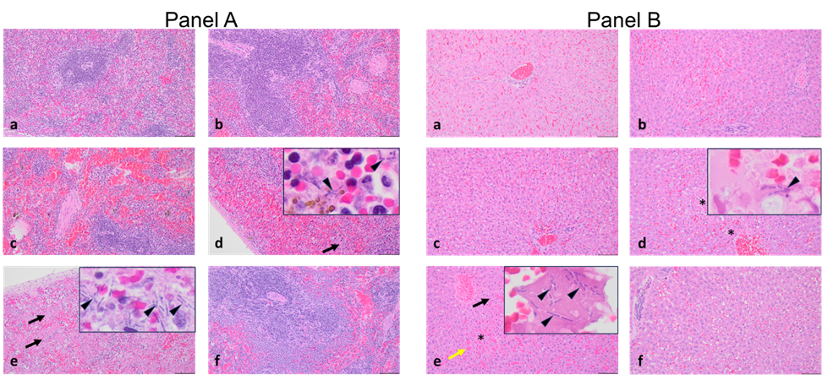Supplemental Fig. 1. Histopathology of infected tissues treated with teixobactin. Panel A, a-f, Representative H&E-stained sections of spleen tissue from rabbits challenged with a lethal dose of B. anthracis spores followed by treatment. a, 3.0 mg/kg teixobactin treatment. b, 1.0 mg/kg teixobactin treatment. c, 0.3 mg/kg teixobactin treatment. d, 0.1 mg/kg teixobactin treatment (black arrow indicates necrosis of red and white pulp and arrowhead indicates bacilli). e, Untreated (black arrows indicate necrosis of red and white pulp and arrowheads indicate bacilli). f, 12.5 mg/kg levofloxacin treatment. Scale bars in a-f, 50 µm; scale bars for inserts in d and e, 10 µm. Panel B, a-f, Representative H&E-stained sections of liver tissue from rabbits challenged with a lethal dose of B. anthracis spores followed by treatment. a, 3.0 mg/kg teixobactin treatment. b, 1.0 mg/kg teixobactin treatment. c, .0.3 mg/kg teixobactin treatment. d, 0.1 mg/kg teixobactin treatment (asterisks indicate areas of hepatocellular necrosis and arrowhead indicates bacilli). e, Untreated (black arrow indicates inflammatory infiltrate, yellow arrow indicates hemorrhage, asterisk indicates area of hepatocellular necrosis, and arrowhead indicates bacilli). f, 12.5 mg/kg levofloxacin treatment. Scale bars in a-f, 50 µm; scale bars for inserts in d and e, 10 µm.

Supplemental Table 2. Summary of DMPK & Safety Findings Including IND-enabling Studies
In vitro Safety | Species | Dose/Conc Tested | Results
hERG¹ | - | 10, 30 μM | Not significant
MNT² | - | 7.81-500 μg/mL | Not significant
Ames³ | - | 0.1-50 μg/plate | Not significant
Hemolysis | - | 1.56-200 μM | Not significant
In vitro DMPK
Metabolism⁴ | - | 10 μM | No major teixobactin metabolites; no unique human metabolites
CypP450⁵ | - | 10, 30 μM | Not significant
In vivo Safety Pharmacology
CV/respiratory | Monkey | 5, 10, 15 mg/kg | Transient, non-adverse histamine response⁶. Significant changes in arterial pressures only at mid & high dose. Single dose NOAEL⁷ was 5 mg/kg
Renal | Rat | 4.3, 6.8, or 10.2 mg/kg (males); 2.8, 5.0, or 9.7 mg/kg (females) | No adverse clinical observations at any dose. Elevated serum creatinine in males at 10.2 mg/kg. Single dose NOAELs were 6.8 mg/kg for males and 9.7 mg/kg for females.
In vivo Toxicology
14-day tox/TK with 28-day recovery⁸ | Rat | 2.5, 7.5, 20 mg/kg/day | Kidney is only adverse target organ (at high dose). 14-day NOAEL was 7.5 mg/kg/day. Serum drug levels suggest good safety margin.
7-day tox/TK | Monkey | 5, 15, 25, 37.5 mg/kg/day | Kidney is only adverse target organ (at 3 highest doses). 7-day NOAEL was 5 mg/kg/day. Serum drug levels suggest good safety margin.
¹hERG: Human ether-à-go-go-related gene, potassium channels expressed in human embryonic kidney cells (GLP); ²MNT: micronuclease test (GLP) in TK6 cells for genotoxicity; ³Ames bacterial mutagenicity test +/- S9 (GLP); ⁴Metabolism study conducted in the presence of liver microsomes and hepatocytes from mice, rats, dogs, rabbits, monkeys and humans; ⁵CypP450: Cytochrome P450 enzymes 1A2, Cyp2C9, Cyp2C19, Cyp2D6, Cyp3A4 (pooled substrates) incubated in liver microsomes; ⁶Transient, non-adverse histamine response (e.g., red ears, itching) observed in most teixobactin treated animals; ⁷NOAEL: No Observed Adverse Effect Level; ⁸GLP study.

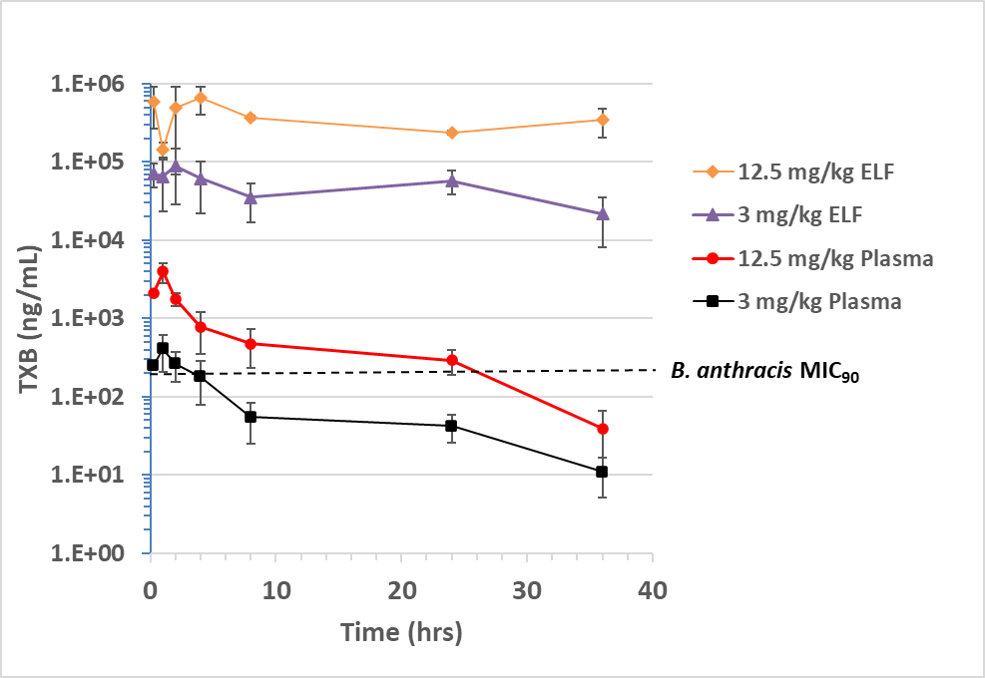

Supplemental Fig. 2. PK of teixobactin in plasma and epithelial lining fluid (ELF) delivered intranasally to mice. Teixobactin was formulated in 5% dextrose and delivered as single IN doses at 3 mg/kg and 12.5 mg/kg. Plasma and bronchoalveolar lavage fluid (BALF) were sampled at various time points and measured for teixobactin and urea. BALF was collected through two consecutive 0.5 mL saline flushes of the lungs. Teixobactin concentrations in the ELF were calculated based on the dilution factor from normalizing urea concentrations in plasma and BALF.

