Supplementary Material

Supplementary Figures:
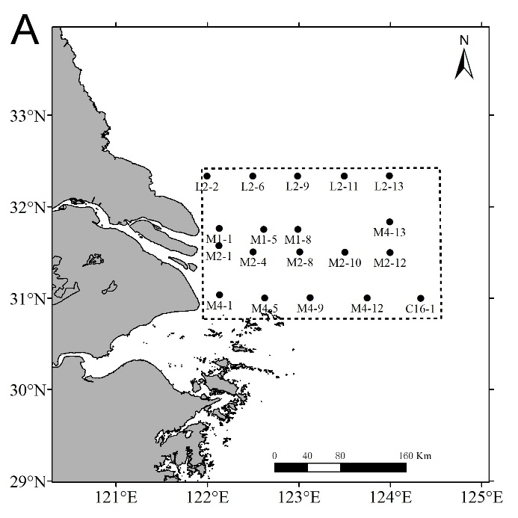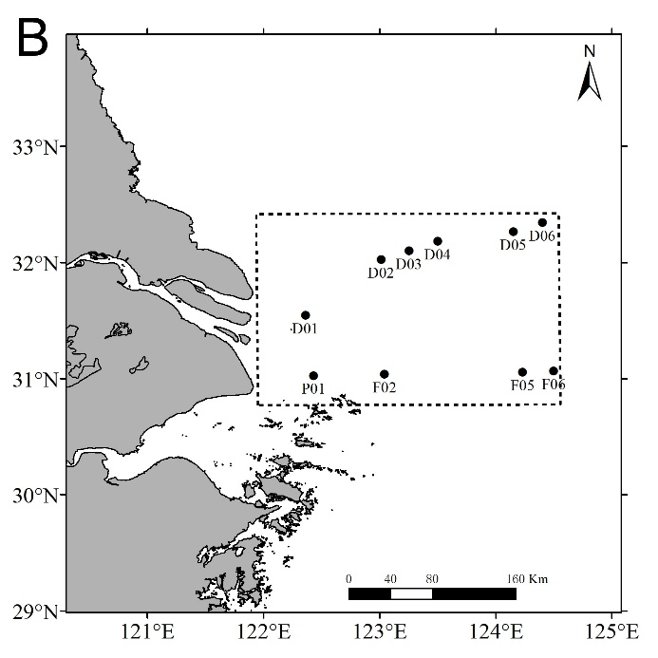
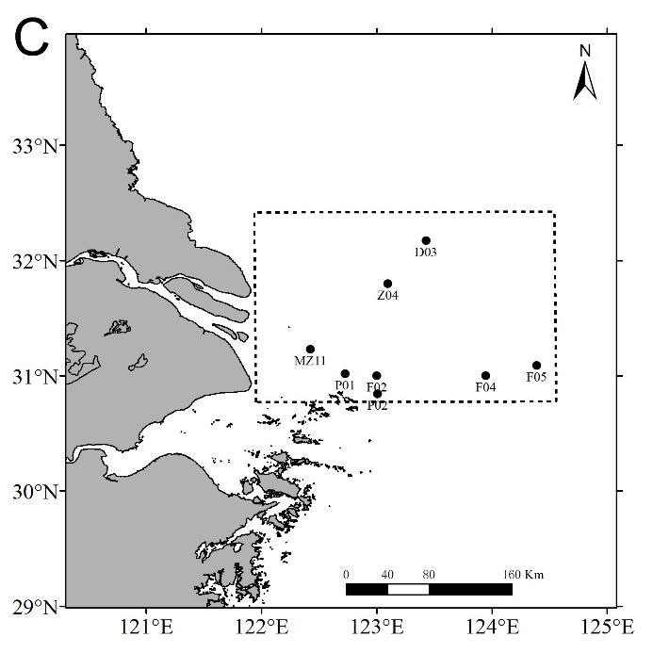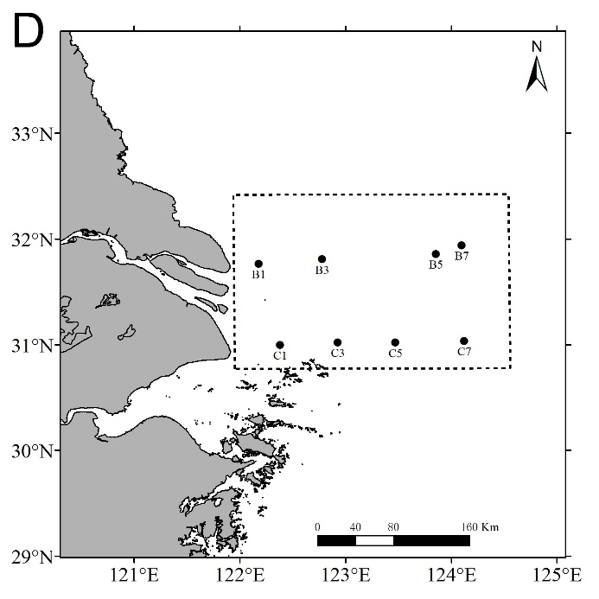
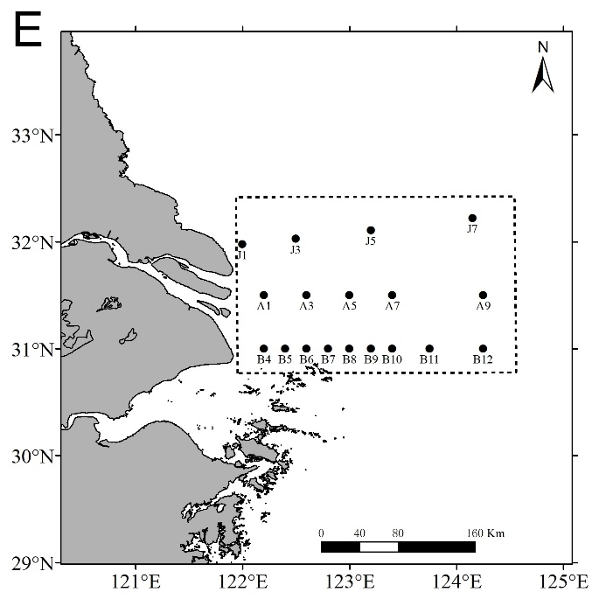
Figure 1. Sampling sites of the cruises during (A) July, 2006, (B) July, 2011, (C) July, 2013, (D), August 2014, and (E) August 2016-2021.

Supplementary Tables:
Table 1. Mann-Kendall test (S) and the Sen’s slope estimate (Q) results of abundance and biomass of benthic macroinvertebrates in summer in the Changjiang Estuary during different years. *: p<0.05, **: p<0.01.
Time series | Years | n | S | Significance | Q
Abundance | 2006-2014 | 4 | 6 | * | 129.56
Abundance | 2014-2021 | 6 | -19 | ** | -106.96
Biomass | 2006-2014 | 4 | 6 | * | 2.19
Biomass | 2014-2021 | 6 | -15 | * | -3.24

Table 2. Mann-Kendall test (S) and the Sen’s slope estimate (Q) results of H’, J’, and d of benthic macroinvertebrates in summer in the Changjiang Estuary during different years. NS: not significant, *: p<0.05, **: p<0.01.
Time series | Years | n | S | Significance | Q
H’ | 2006-2017 | 6 | -9 | NS | -1.16
H’ | 2017-2021 | 4 | 4 | NS | 0.70
J’ | 2006-2017 | 6 | -11 | * | -0.02
J’ | 2017-2021 | 4 | 4 | NS | 0.02
d | 2006-2017 | 6 | -3 | NS | -0.09
d | 2017-2021 | 4 | 8 | * | 0.10

