Manuscript – Supplementary Material

Crithmum maritimum restores the lipid and metabolic profiles of liver cancer cells to a normal phenotype

Davide Gnocchi¹, Dragana Nikolic¹, Rita Rosa Paparella¹, Carlo Sabbà¹, Antonio Mazzocca¹

¹ Interdisciplinary Department of Medicine, University of Bari School of Medicine,
Piazza G. Cesare, 11 - 70124 Bari, Italy

Correspondence:
Antonio Mazzocca, M.D., Ph.D., Interdisciplinary Department of Medicine, University of Bari School of Medicine, Piazza G. Cesare, 11 I-70124 Bari, Italy
Tel.: +39 080 5593593
Email: antonio.mazzocca@uniba.it

Materials and Methods

Cell lines and culturing
HepG2, Huh7 and HLE cell lines were obtained from the JCRB cell bank [cat. # JCRB1371, cat. # JCRB0404, cat. # JCRB1054]. HepaRG cell lines was obtained through a Material Transfer Agreement from Bio-Predic International. HepG2 and Huh7 were grown in Dulbecco's modified Eagle's medium (DMEM) with 1 g/L glucose, 4 mM glutamine, and 1 mM sodium pyruvate [Corning cat. #10-014-CVR], supplemented with 10% Foetal Bovine Serum (FBS) [Corning cat. # 35-079-CV], 1X MEM-Nonessential Amino Acids [Corning cat. # 25-025-CIR], 20 mM Hepes Buffer [Aurogene cat. # AU-L0180-500], 1X Antibiotic-Antimycotic solution [Corning cat. # 30-004-CI]. HLE was grown in RPMI [Corning cat. # -CVR] supplemented with 10% FBS. HepaRG was grown in Williams E medium [Sigma-Aldrich cat. # W1878] supplemented with 10% FBS, 5 μg/mL insulin [Sigma-Aldrich cat. #I9278], 50 μM hydrocortisone succinate. Cells were kept under standard conditions (humidified atmosphere, 37°C and 5% CO₂).
HepG2 and HepaRG have been treated with oleic acid [Sigma-Aldrich cat. # O1383] using volumes not exceeding 1% volume of the cell culture media. Treatment with Crithmum maritimum extract has been performed with volumes not exceeding 1% volume of the cell culture media. Ethanol and DMSO respectively were used as vehicle control at 0.5% or 1% volume of cell culture media. Cells were treated 24 h after plating for all of the experiments reported.

Oil Red O (ORO) staining
Cells were initially fixed with paraformaldehyde 4% for at least 1 h at room temperature. After two washes with PBS, cells were incubated with ORO solution for a minimum of 1 h at room temperature. After two PBS washes, pictures were taken using a Nikon TMS (model DS-Fi1) associated with a “Nikon Digital Sight” digital camera and with “NIS-Elements F3.0” software. A quantitative assessment of staining was performed by eluting the color with isopropanol and reading absorbance at λ=510 nm.
For hematoxylin counterstaining, after ORO staining, cells were washed twice with PBS and once with distilled water, and then incubated with hematoxylin for 5 minutes. After two water washes, cells were imaged.

Quantitative Real-Time PCR (q-RT-PCR)
RNA was extracted using the “Aurum Total RNA Mini Kit" [Bio-Rad cat. #732-6820] following the producer's directions of use. The amount and the quality of the extracted RNA were determined by using an “IMPLEN N50” Nanophotometer. 1 μg RNA was used for cDNA synthesis, which has been performed with the “iScript Advanced cDNA Synthesis Kit” [Bio-Rad cat. #1725038]. qRT-PCR was performed using a “SsoAdvanced Universal SYBR Green Supermix” using 500 nM primers. Fluorescence was detected using an “Applied Biosystems 7300 Real-Time PCR System”. Primer sequences are available upon request from the corresponding author.

Immunoblotting analyses
Cell lysates were made with Cell Signaling lysis buffer [Cell Signaling cat. #9803] added with protease and phosphatase inhibitors [Roche cat. #04693159001 and 04906837001]. Samples were prepared with Laemmli Sample Buffer [BioRad cat. #161-0737] complemented with 5% β-mercaptoethanol. Proteins were separated by SDS-PAGE and then blotted onto nitrocellulose membranes. Primary antibody incubation was performed overnight at 4°C with gentle shaking using the antibodies reported below. Membranes were developed using Licor c-Digit. Each panel of the reported blots was obtained by stripping the same membrane two times and re-probing it with the indicated antibodies.
Antibodies employed: Phospho-AMPKα (Thr172) Antibody [Cell Signaling cat. #2531]; AMPKα Antibody [Cell Signaling cat. #2532]; Phospho-Akt (Ser473) Rabbit mAb [Cell Signaling cat. #4058]; Akt Antibody [Cell Signaling cat. #9272]; Actin [Santa Cruz cat. # sc-7210]; Secondary antibody: Anti-rabbit IgG, HRP-linked [Cell Signaling cat. #7074].

Statistical analyses
The normality of data was verified with D'Agostino-Pearson's Omnibus K2 test. One-Way ANOVA followed by Dunnett's post-hoc test was used to determine statistical significance when data were normally distributed.

Supplementary Figures

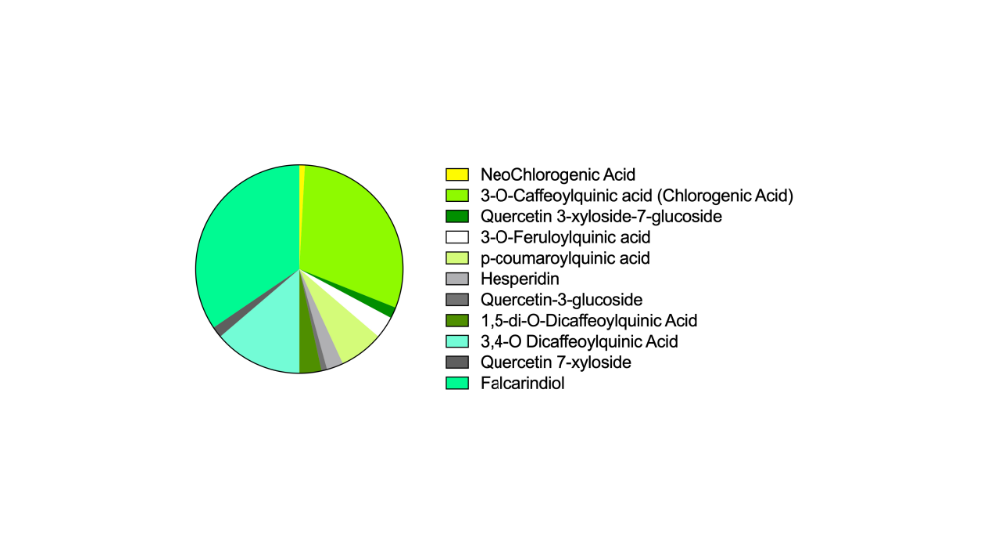

Fig. S1 Graphical representation of the main metabolites found in the Crithmum maritimum employed in the present study [see also Ref. 14].

