Supplementary Results

Regardless of bioinoculation rapid colonization of axenic beet plants by rhizosphere bacteria takes place in two phases

Marcin Gołębiewski^{1,2*}, Marcin Sikora², Justyna Mazur², Sonia Szymańska³, Jarosław Tyburski¹, Katarzyna Hrynkiewicz³, Werner Ulrich⁴

Soils of contrasting physico-chemical characteristics were used in experiments

Soil S1 was more abundant in silt/clay and less abundant in nutrients than S2, which was more sandy (Table SR1).

Table SR1. Soils characteristics
 | S1 | S2
Sand (%) | 60 | 74
Silt (%) | 31 | 19
Clay (%) | 9 | 7
pH (H₂O) | 7.450 | 7.560
Total carbon (TC) (%) | 0.987 | 1.698
Total organic carbon (TOC) (%) | 0.945 | 1.600
Total inorganic carbon (TIC) (%) | 0.043 | 0.099
Total nitrogen (TN) (%) | 0.220 | 0.269
P (g/kg) | 0.662 | 0.700
K (g/kg) | 3.299 | 2.101
Na (g/kg) | 0.396 | 0.206
Ca (g/kg) | 2.944 | 7.848
Mg (g/kg) | 2.243 | 2.351

Bacterial counts in surface-sterilized beet seeds are below detection limit

Primer pair B335f-B769r (see Table SM1 and SM6a in Supplementary Methods) did not amplify plastidic nor mitochondrial sequences. Reactions were run as described in SM6a, but using 100 ng of a 27f-1492r amplicon generated on Escherichia coli DH10B as well as beet mitochondrial and chloroplastic 16S rRNA genes cloned into pCR4TOPO as templates. The reactions were run on a 1.5% agarose gel and visualized under UV illumination (Fig. SR1).
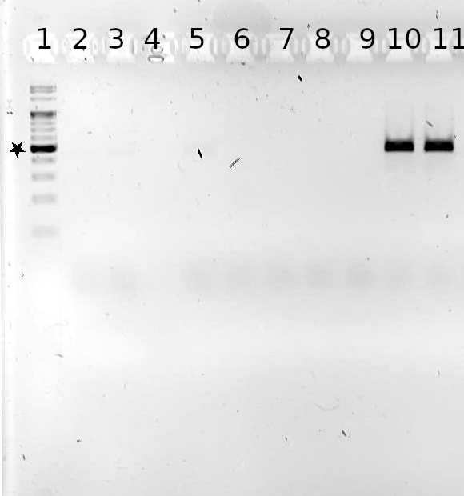

Fig. SR1. B335f-B769r primer pair does not amplify beet mitochondrial nor plastidic 16S rRNA gene fragments. 1.5% agarose gel, lanes: 1 – GeneRuler 100 bp Plus DNA ladder (ThermoFisher) (500 bp band is marked with a star), 2 – negative control (water), 3-5 – plastidic 16S rRNA gene, 6 – no template control (water), 7-9 – mitochondrial 16S rRNA gene, 10-11 – positive control (E. coli DH10B 16S rRNA gene).

Detection limit of the qPCR analysis was 1000 16S rRNA copies/ng of DNA, as it was the number of copies in the most diluted standard used. The standard had C_{t} = 45.385, while negative controls had C_{t} of over 50. Parameters of a standard curve: 62.491 intercept, -5.544 slope, 0.999 adjusted R². The fit was significant, ANOVA F_{1,4} = 5218, p = 2.201e-07. Calculated efficiency was 1.515. Analyses were performed in quadruplicate (technical replicates), for seeds there was one biological replicate (DNA isolated from 10-15 seeds), while for seedlings there were at least three biological replicates (seedlings) per variant.
Samples whose counts are 0 on Fig. SR2 had indeterminable C_{t} values, as the ‘second-derivative’ algorithm of LC480 software was unable to determine their C_{t} value after 55 cycles.

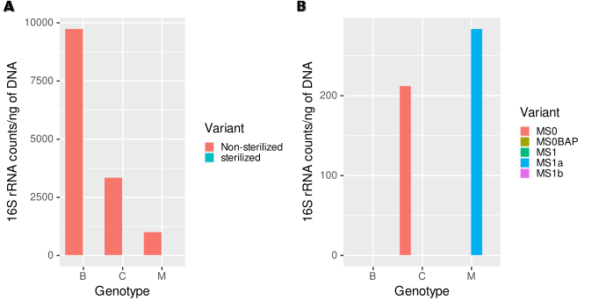
Fig. SR2. Surface sterilization of beet seeds causes decrease of the number of non-plastidic, non-mitochondrial 16S rRNA sequences below the detection limit, regardless of genotype (A). Regardless of growth medium variant, seedlings emerging from surface-sterilized seeds have 16S rRNA counts below detection limit (B). Media used for germination were: MS0 – standard Murashige and Skoog, MS0BAP – Murashige and Skoog with BAP, MS1 – Murashige and Skoog with cefotaxime and vancomycin, MS1a – Murashige and Skoog with cefotaxime, vancomycin and tetracyclin, MS1b – Murashige and Skoog with cefotaxime, vancomycin and chloramphenicol.

Sequencing statistics

Table SR2. Sequencing statistics. Means and SD values were rounded to the nearest integer. Total number of ASVs is not the sum of numbers found in all pools, as there are ones found in more than one pool.
 | No. samples | Raw reads | Final seqs# | Raw reads mean ± SD | Final reads mean ± SD | No. ASVs
Soils | 782 | 20 387 303 | 8 714 779 | 26 070 ± 10 918 | 11 144 ± 4 883 | 35 992
Roots | 782 | 11 662 884 | 8 210 732 | 14 914 ± 6 242 | 10 500 ± 4 377 | 11 874
Leaves | 778 | 12 318 975 | 10 516 589 | 15 834 ± 4 435 | 13 517 ± 3 939 | 25 893
Inoculant$ | 21 | 192 641 | 129 554 | 9 173 ± 2 142 | 6 169 ± 1 605 | 1 224
Total | 2 363 | 44 561 803 | 27 571 654 | 18 858 ± 7 158 | 11 668 ± 4 376 | 70 605
# - the number of denoised, merged and non-chimeric sequences; $ - apart from inoculant, there were mock community, root and leaf samples in this pool

Positive control (staggered mock community HM-283D from BEI Resources) was sequenced along with inoculant samples. 18 amplicons, out of 20 that should be present, were recovered. The missing ones were those of the lowest concentration (Actinomyces baumanii and Streptococcus pneumoniae), showing that sequencing coverage was low for this sample. No additional ASVs were found in mock community, which suggested that stringency of reads processing was adequate.
Negative controls (libraries generated from C6 (elution) buffer) were sequenced with each pool of samples. As they contained no or only a few reads, likely due to barcodes misassignment, they were excluded from analysis. Consistently, no systematic batch effect was detected, e.g. leaf samples sequenced along with inoculant clustered with other libraries derived from leaves.
In spite of the use of blocking primers numbers of mitochondrial and plastidic sequences was high in libraries derived from plant tissues, particularly in leaves (in the range of 20-90%). Removal of such sequences reduced the number of ASVs to 62 289, and sequences to 10 847 891 (4 618 ± 5 208 per sample). Rarefying to 900 sequences per sample further decreased the number of samples to 1 496. There were 1 322 087 sequences from 26 963 ASVs in the final, rarefied dataset.

Abundances of a differentially abundant ASV measured by amplicon sequencing and qPCR are significantly correlated

Primers specific for ASV10 (classified as Pseudomonas) were designed using DECIPHER as described in SM7m. Standard curve was constructed using purified amplicon generated on mixed roots and leaves DNA. Detection limit was 1000 copies/ng of DNA, the number of molecules in the most dilute standard. Negative controls had C_{t} over 35. Parameters of the standard curve: 37.18 intercept, -3.49 slope, 0.9999 adjusted R². The fit was highly significant: ANOVA F_{1,4} = 50 040, p = 2.4e-09. Calculated efficiency was 1.93.
ASV10 abundances were extracted from rarefied sequencing data (for roots and leaves separately) and their Spearman’s correlation with qPCR results was highly significant in both cases (leaves: p = 9.8e-06, roots: p = 0). However, correlation was much weaker in leaves, probably due to the ASV10 abundance being below detection limits of qPCR (Fig. SR3A). Significant correlations corroborate the sequencing results.

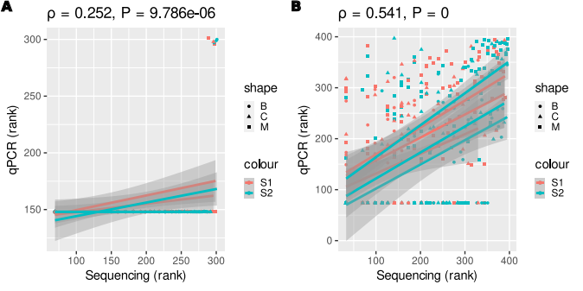
Fig. SR3. Spearman’s correlation of ASV10 abundance measured by qPCR and amplicon sequencing. A - leaves B - roots

There is no significant influence of sequencing run and pot on both alpha and beta-diversity

To assess influence of random factors (sequencing run and pot, which represent technical variance) we used variance partitioning. As sequencing run was almost identical to material (soil, leaf, root and inoculant libraries were sequenced in different MiSeq runs) estimation of run influence was restricted to leaves and roots samples that were sequenced with inoculant ones (n = 14)

PICRUSt2 results are of medium quality

Weighted nearest sequenced taxon index (NSTI), a measure of PICRUSt2 predictions quality, was relatively high for analyzed communities (Fig. SR4), with mean values of 0.115, 0.099, and 0.093 for leaves, roots and soils, respectively. The differences between groups were significant, as assessed by robust ANOVA (overall test for location shift: n = 1493, F_{3,1490} = 80.562, p = 0). Such a high NSTI value is indicative of large proportion of taxa with unsequenced genomes in analyzed communities and suggests that the results need to be interpreted with caution.

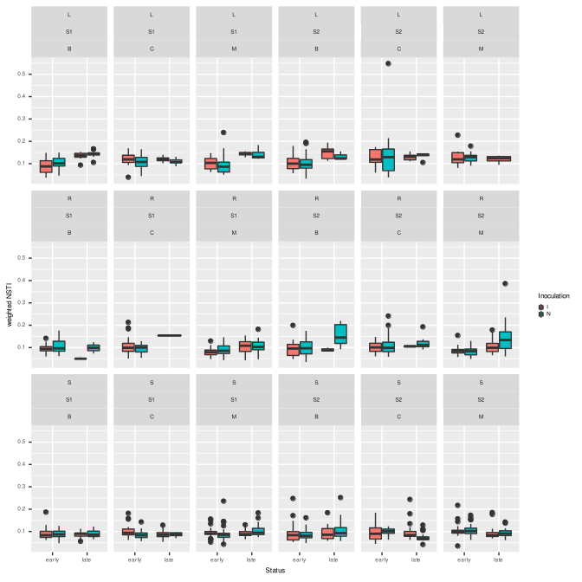
Fig. SR4. NSTI (Nearest Sequenced Taxon Indes) values in experimental variants. Values > 0.03 indicate large proportion of unsequenced taxa.

Soils differ in bacterial community structure, alpha-diversity and functional potential

Soils used as growth substrate (T0 samples – before inoculation, but after four weeks of axenic plants’ growth) differed in bacterial community structure (Fig. SR5A; permutational test of a dbRDA model: n = 89, F₁ = 10.87, p = 0.001, betadisper permutational test: F₁ = 20.00, p = 2.33e-5, explained variance: 10.49%). The same applied to PICRUSt2-predicted functional potential (Fig. SR5B; permutational test of a dbRDA model: F₁ = 11.21, p = 0.001, betadisper permutational test: F₁ = 2.59, p = 0.11, explained variance: 10.79%). Diversity (Shannon’s H’), evenness and richness were lower in S2 than in S1 (Fig. SR5C; Wilcoxon test: H’ – W = 1292, p = 0.013, E – W = 1252, p = 0.031, observed number of ASVs – W = 1397.5, p = 8.35e-4). Functional diversity was similar in both soils, but richness was lower, and evenness higher in S2 (Fig. SR5D; Wilcoxon test: H’ – W = 760, p = 0.059, E – W = 572 p = 5.00e-4, observed number of functions – W = 1454.5, p = 1.40e-4). Libraries generated from S1 samples were more abundant in sequences affiliated with Bacillus and rare taxa, while Brevundimonas, Delftia and Pseudoxanthomonas were more frequent in S2 (Fig. SR5E).
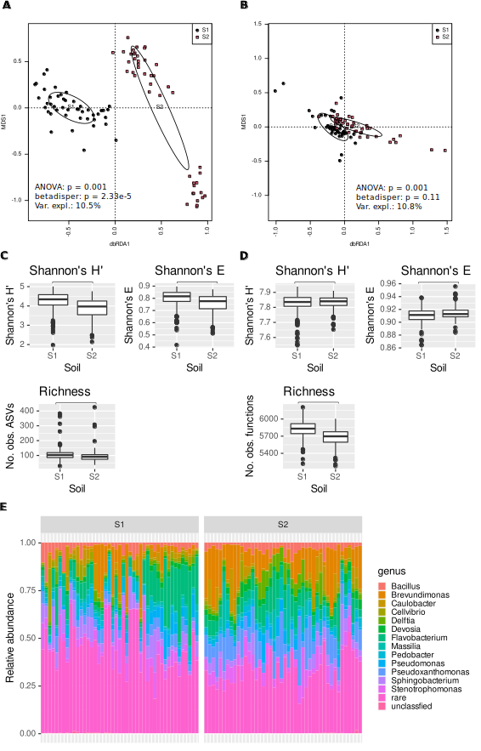

Fig. SR5. Microbiomes of S1 and S2 soils differ in terms of structure (A), functional potential (B), alpha-diversity of ASVs (C), functional diversity (D), and taxonomic compostion (E).
Communities in leaves, roots and soils differ

Table SR3. ASVs characteristic for leaves, soils and roots. Rows containing ASVs characteristic for plant tissues were written in boldface font, while those containing ASVs characteristic for soils were underlined.
ASV | Comparison¹ | Fold change² | DESeq2 q³ | ALDEx2 q⁴ | Taxonomy | Material⁵
ASV13 | LR | 2.12 | 2.55e-91 | 5.17e-69 | Sphingobacterium | L
ASV23 | LR | 1.22 | 7.63e-24 | 9.56e-176 | Chryseobacterium | P
ASV57 | LR | 1.16 | 1.15e-23 | 7.35e-24 | Azospirillum | L
ASV22 | LR | -1.11 | 7.15-28 | 0.00018 | Comamonas | R
ASV76 | LR | -1.12 | 7.69e-28 | 0.00016 | Chitinophagaceae | R
ASV16 | LR | -1.49 | 1.46e-38 | 7.52e-18 | Stenotrophomonas | R
ASV18 | LR | -2.10 | 2.31e-76 | 0.0015 | Pseudoxanthomonas
ASV20 | LR | -2.59 | 9.95e-142 | 7.72e-33 | Fluviicola
ASV7 | LR | -3.00 | 7.53e-149 | 9.13e-28 | Cellvibrio | R
ASV23 | LS | 6.24 | 0 | 9.56e-176 | Chryseobacterium | P
ASV80 | LS | 2.06 | 7.32e-95 | 2.39e-09 | Achromobacter | P
ASV57 | LS | 2.05 | 1.39e-72 | 7.35e-24 | Azospirillum | L
ASV15 | LS | 1.77 | 7.02e-43 | 2.74e-106 | Flavobacterium | P
ASV4 | LS | 1.59 | 1.09e-50 | 3.17e-45 | Flavobacterium | P
ASV11 | LS | 1.55 | 5.72e-51 | 1.33e-08 | Caulobacter
ASV522 | LS | 1.33 | 7.46e-50 | 4.43e-16 | Bacillus
ASV7 | LS | -1.07 | 2.31e-20 | 9.13e-28 | Cellvibrio
ASV10 | LS | -1.09 | 1.02e-20 | 2.54e-15 | Pseudomonas
ASV29 | LS | -1.17 | 1.36e-25 | 1.46e-05 | Pseudomonas
ASV6 | LS | -1.29 | 1.41e-39 | 9.75e-10 | Brevundimonas | S
ASV44 | LS | -1.62 | 1.71e-92 | 9.77e-54 | Reyranella | S
ASV18 | LS | -1.74 | 7.24e-54 | 0.0015 | Pseudoxanthomonas
ASV14 | LS | -1.83 | 7.36e-96 | 6.01e-52 | Devosia | S
ASV9 | LS | -1.94 | 3.27e-77 | 0.00060 | Stenotrophomonas | S
ASV20 | LS | -2.04 | 4.56e-90 | 7.72e-33 | Fluviicola
ASV33 | LS | -2.43 | 3.15e-137 | 1.39e-34 | Micropepsaceae
ASV24 | LS | -2.50 | 4.62e-208 | 9.38e-98 | Pseudohongiellaceae - BIyi10 | S
ASV27 | LS | -2.69 | 5.73e-190 | 1.50e-102 | Pedobacter | S
ASV3 | LS | -3.07 | 6.75e-201 | 1.76e-32 | Pseudoxanthomonas | S
ASV21 | LS | -3.60 | 2.86e-225 | 3.04e-36 | Sphingopyxis | S
ASV27 | SR | 3.60 | 0 | 1.50e-102 | Pedobacter | S
ASV21 | SR | 3.30 | 3.58e-198 | 3.04e-36 | Sphingopyxis | S
ASV3 | SR | 2.86 | 2.20e-176 | 6.75e-201 | Pseudoxanthomonas | S
ASV33 | SR | 2.77 | 3.79e-178 | 1.39e-34 | Micropepsaceae | S
ASV13 | SR | 2.73 | 5.48e-154 | 5.17e-69 | Sphingobacterium | S,L
ASV24 | SR | 2.65 | 1.80e-241 | 9.38e-98 | BIyi10 | S
ASV44 | SR | 1.76 | 4.42e-112 | 9.77e-54 | Reyranella | S
ASV19 | SR | 1.76 | 2.45e-60 | 0.0039 | Caulobacter
ASV9 | SR | 1.59 | 8.83e-54 | 0.00060 | Stenotropho  monas | S
ASV6 | SR | 1.25 | 2.26e-37 | 9.75e-10 | Brevundimonas | S
ASV14 | SR | 1.03 | 1.05e-32 | 6.01e-52 | Devosia | S
ASV4 | SR | -1.48 | 1.76e-44 | 3.17e-45 | Flavobacterium | P
ASV15 | SR | -1.66 | 1.44e-37 | 2.74e-106 | Flavobacterium | P
ASV80 | SR | -1.90 | 4.46e-81 | 2.39e-09 | Achromobacter | P
ASV7 | SR | -1.94 | 1.63e-66 | 9.13e-28 | Cellvibrio | R
ASV16 | SR | -1.98 | 2.14e-69 | 7.52e-18 | Stenotrophomonas | R
ASV23 | SR | -5.03 | 0 | 9.56e-176 | Chryseobacterium | P
1 - LR – leaves vs. roots (positive FC – higher abundance in leaves), LS – leaves vs. soils, SR – soils vs. roots
2 – log₂ fold change (FC) reported by DESeq2
3 – Benjamini-Hochberg corrected p-value of Wald test reported by DESeq2
4 – Benjamini-Hochberg corrected p-value of Kruskal-Wallis test reported by ALDEx2
5 – Material for which a given ASV is characteristic – S – soil, R – roots, L – leaves, P – plant (roots + leaves)

Table SR4. PICRUSt2-predicted functions characteristic for soils, roots and leaves. Ten KO functions with largest absolute values of log₂ fold change per comparison are shown.
Function | Comp. | Fold change | DESeq2 q | ALDEx2 q | Description | Pathway | Process
K16638 | LR | 2,44 | 0 |  | K16638, exoU; exoenzyme U | - | Plant pathogenicity
K15502 | LR | 2,44 | 0 |  | ANKRD28; serine/threonine-protein phosphatase 6 regulatory ankyrin repeat subunit A | - | DNA repair and recombination
K10921 | LR | 2,29 | 0 |  | toxR; cholera toxin transcriptional activator | - | Biofilm formation
K06931 | LR | 2,2 | 0 |  | K06931; uncharacterized protein | - | -
K08651 | LR | 2,19 | 0 |  | E3.4.21.66; thermitase [EC:3.4.21.66] | - | Protein folding
K19278 | LR | -2,66 | 0 |  | aac6-Ib; aminoglycoside 6'-N-acetyltransferase Ib [EC:2.3.1.82] | - | Inter-organismal interactions (antibiotic resistance)
K12997 | LR | -2,71 | 0 |  | rgpB; rhamnosyltransferase [EC:2.4.1.-] | - | Lipopolysaccharide biosynthesis, inter-organismal interactions
K19301 | LR | -2,72 | 0 |  | aac6-II; aminoglycoside 6'-N-acetyltransferase II [EC:2.3.1.82] | - | Inter-organismal interactions
K13243 | LR | -2,88 | 0 |  | dos; c-di-GMP-specific phosphodiesterase [EC:3.1.4.52] | - | Regulation
K12516 | LR | -3,04 | 0 |  | bigA; putative surface-exposed virulence protein | - | Pathogenicity
K19694 | LS | 3,86 | 0 |  | chiS; two-component system, sensor histidine kinase ChiS | - | Regulation of natural competence
K18642 | LS | 3,23 | 0 |  | creS; crescentin |  | Regulation of cell shape
K07257 | LS | 3,09 | 0 |  | spsF; spore coat polysaccharide biosynthesis protein SpsF |  | Spore formation
K15894 | LS | 2,72 | 0 |  | pseB; UDP-N-acetylglucosamine 4,6-dehydratase [EC:4.2.1.115] | Amino sugar and nucleotide sugar metabolism | Inter-organismal interactions (cell wall antigen biosynthesis)
K06931 | LS | 2,69 | 0 |  | K06931; uncharacterized protein | - | -
K05709 | LS | -1,78 | 0 |  | hcaF, hcaA2; 3-phenylpropionate/trans-cinnamate dioxygenase subunit beta [EC:1.14.12.19] | Phenylalanine metabolism | Degradation of aromatic compounds
K01822 | LS | -1,78 | 0 |  | E5.3.3.1; steroid Delta-isomerase [EC:5.3.3.1] | Steroid degradation | Xenobiotics biodegradation and metabolism
K02638 | LS | -1,83 | 0 |  | petE; plastocyanin | Photosynthesis | Photosynthesis
K07505 | LS | -1,97 | 0 |  | repA; regulatory protein RepA | - | DNA replication
K14439 | LS | -2,14 | 0 |  | SMARCAD1; SWI/SNF-related matrix-associated actin-dependent regulator of chromatin subfamily A containing DEAD/H box 1 [EC:3.6.4.12] | Artefact – eukaryotic function, should not be present in PICRUSt2 results
K07505 | SR | 3,12 | 0 |  | repA; regulatory protein RepA | - | DNA replication
K19170 | SR | 2,81 | 0 |  | dndC; DNA sulfur modification protein DndC | - | Prokaryotic defense against phages
K19171 | SR | 2,69 | 0 |  | dndD; DNA sulfur modification protein DndD | - | Prokaryotic defense against phages
K14439 | SR | 2,69 | 0 |  | SMARCAD1; SWI/SNF-related matrix-associated actin-dependent regulator of chromatin subfamily A containing DEAD/H box 1 [EC:3.6.4.12] | Artefact – eukaryotic function, should not be present in PICRUSt2 results
K03395 | SR | 2,59 | 0 |  | aac3-I; aminoglycoside 3-N-acetyltransferase I [EC:2.3.1.60] | - | Inter-organismal interactions (antibiotic resistance)
K13552 | SR | -2,32 | 0 |  | btrQ; paromamine 6'-oxidase [EC:1.1.3.43] | Neomycin, kanamycin and gentamycin biosynthesis | Inter-organismal interactions (antibiotic biosynthesis)
K18642 | SR | -2,35 | 0 |  | creS; crescentin |  | Regulation of cell shape
K12516 | SR | -2,36 | 0 |  | bigA; putative surface-exposed virulence protein | - | Pathogenicity
K18336 | SR | -2,46 | 0 | 3,70060888642378E-25 | K18336; 2,4-diketo-3-deoxy-L-fuconate hydrolase [EC:3.7.1.-] | Fructose and mannose metabolism | Carbohydrate metabolism
K19694 | SR | -2,73 | 0 | 2,10751808638163E-84 | chiS; two-component system, sensor histidine kinase ChiS | - | Regulation of natural competence
Table SR5. Variables’ influence on bacterial communities, assessed based on d05 generalized UniFrac distance matrix. Means of variance explained for two models (one involving time, and the other status) are given. Time and status were not tested together.
Variable | Total var. expl.¹ | Unique var. expl.² | R sq. | p-value³
Material | 12.1 | 9.6 | 92.82 | 0.001
Time | 8.2 | 5.8 | 28.37 | 0.001
Status | 6.9 | 4.7 | 90.27 | 0.001
Soil | 2.9 | 2.7 | 54.75 | 0.001
Genotype | 1.8 | 1.7 | 17.72 | 0.001
Inoculation | 0.28 | 0.15 | 3.54 | 0.001
1 – total variance explained, 2 – variance explained solely by a variable in question (i.e. with other variables conditioned out), 3 – p-value of a permutational test of unique variation fraction significance in a dbRDA model

Samples cluster into ‘late’ and ‘early’ groups regardless of material, soil and plant genotype

Grouping according to status was significant in each experimental variant apart from roots of genotype C grown in S1, where there were only one late sample and, consequently, there was no possibility of conducting tests. However, tests for homogeneity of multidimensional dispersion showed significant differences of variance between early and late groups, which suggested possibility of the permutational tests of dbRDA models yielding significant p-value not because of difference in location but in spread. Nevertheless, it seems unlikely, as separation of clusters is obvious in each ordination plot generated.
Interestingly, percent of variance explained by status was drastically lower in roots than in soils and leaves and consistently lower in S2 than in S1.
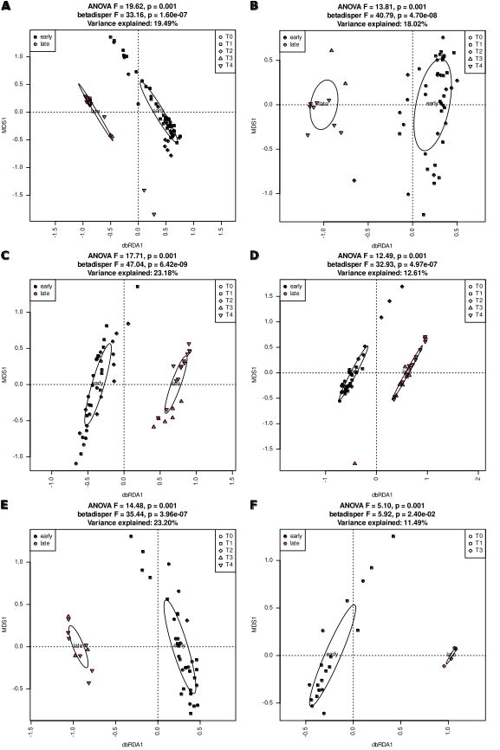

Fig. SR6. Leaf samples form ‘early’ and ‘late’ clusters regardless of soil and plant genotype. dbRDA analysis based on d05 generalized UniFrac distance matrix. AB – genotype B, CD - genotype C, EF – genotype M; ACE – soil S1, BDF – soil S2.

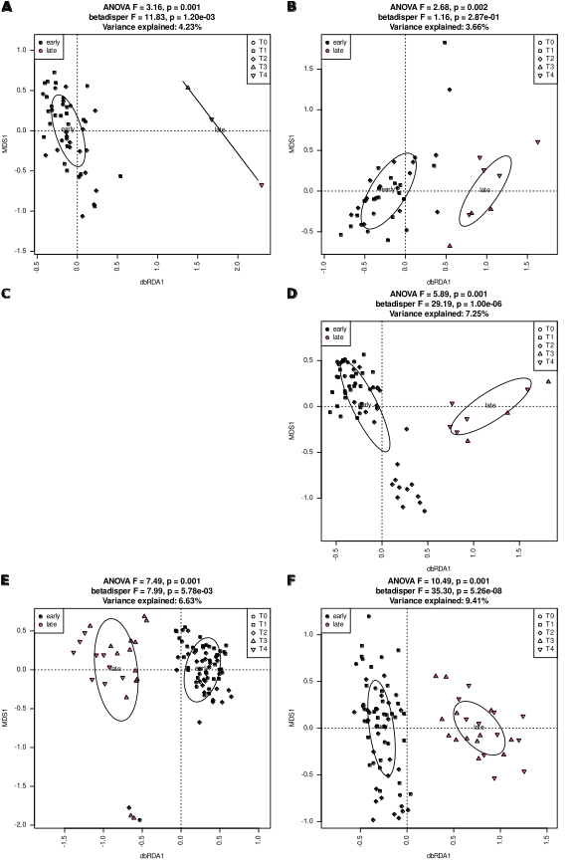

Fig. SR7. Root samples form ‘early’ and ‘late’ clusters regardless of soil and plant genotype. dbRDA analysis based on d05 generalized UniFrac distance matrix. AB – genotype B, CD - genotype C, EF – genotype M; ACE – soil S1, BDF – soil S2.

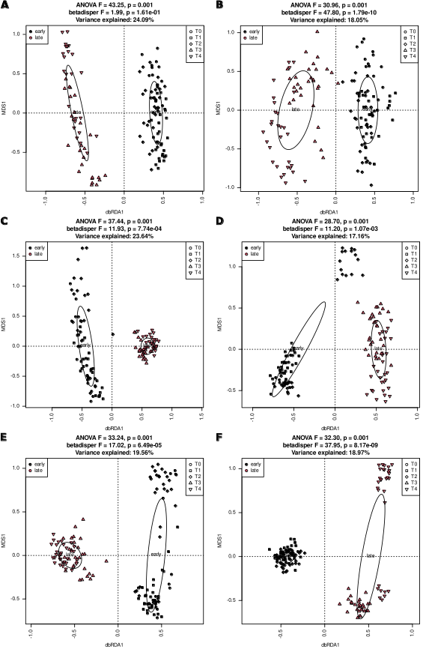

Fig. SR8. Soil samples form ‘early’ and ‘late’ clusters regardless of soil and plant genotype. dbRDA analysis based on d05 generalized UniFrac distance matrix. AB – genotype B, CD - genotype C, EF – genotype M; ACE – soil S1, BDF – soil S2.

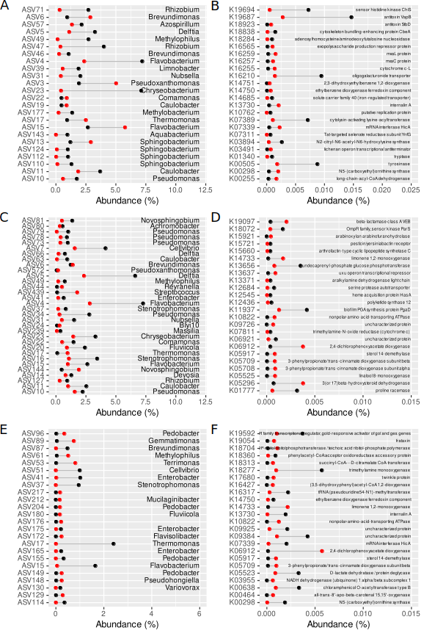

Fig. SR9. Organisms (ACE) and functions (BDF) characteristic for early and late samples are different in leaves (AB), roots (CD) and soils (EF). Black dots denote abundance in early samples, red dots abundance in late ones. Twenty-four features of greatest fold-change are shown on each panel
Nestedness decreases over time and is significantly higher in early samples than in late ones

Table SR6. Significance testing of differences in mean weighted NODF values in early and late samples in different experimental variants. Wilcoxon test was used. Significant p-value is given in boldface font.
Variant | Test statistics (W) | p-value
S1 B | 218 | 6.85e-4
S1 C | 86 | 7.65e-2
S1 M | 293 | 5.51e-4
S2 B | 152 | 2.12e-3
S2 C | 410 | 1.57e-10
S2 M | 74 | 2.98e-2

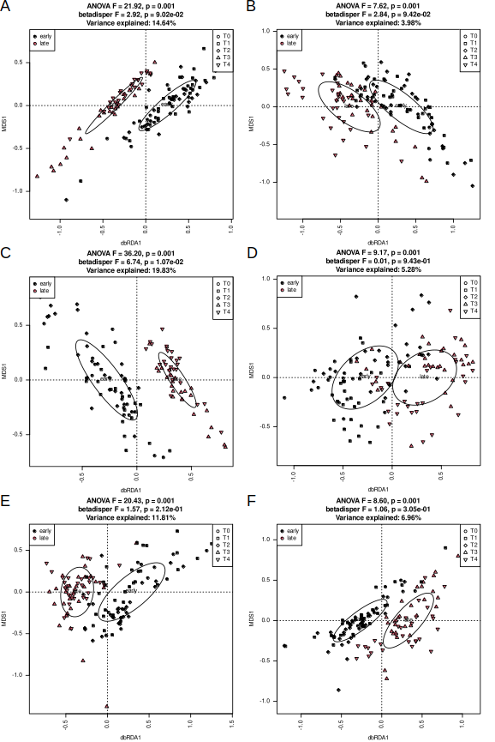

Fig. SR10. Functional potential of bacterial communities living in early and late soil samples differ, but variance does not. Results of dbRDA analysis of Morisita-Horn distance matrices derived from PICRUSt2-predicted KO abundance tables are shown for soil S1 (ACE) and S2 (BDF) and genotype B (AB), C (CD) and M (EF). dbRDA and betadisper models were tested with permutational tests.

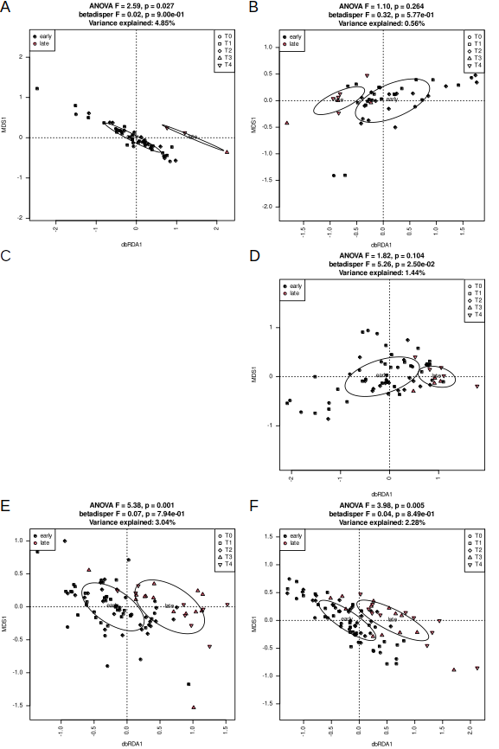

Fig. SR11. Functional potential of bacterial communities living in early and late root samples differ, but variance does not. Results of dbRDA analysis of Morisita-Horn distance matrices derived from PICRUSt2-predicted KO abundance tables are shown for soil S1 (ACE) and S2 (BDF) and genotype B (AB), C (CD) and M (EF). dbRDA and betadisper models were tested with permutational tests.

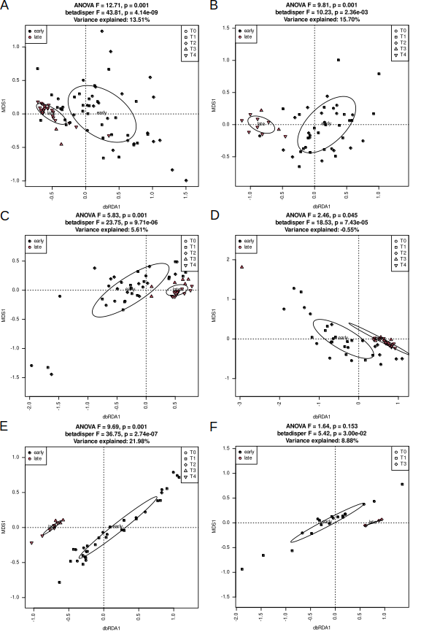

Fig. SR12. Functional potential of bacterial communities living in early and late leaf samples differ, and variance does not. Results of dbRDA analysis of Morisita-Horn distance matrices derived from PICRUSt2-predicted KO abundance tables are shown for soil S1 (ACE) and S2 (BDF) and genotype B (AB), C (CD) and M (EF). dbRDA and betadisper models were tested with permutational tests.

Genotype influenced bacterial communities in soils and beet plants regardless of soil type and status

Genotype influences both soil and endophytic bacterial communities regardless of status

Bacterial communities and sets of imputed KO functions clustered according to genotype regardless of material, soil as well as status (Figs. SR13, SR16, SR19 and SR22, SR25, SR28 for ASVs and KO functions, respectively). Genotype influence was strongest (i.e. percent of variance explained was highest) in soils and stronger at the level of ASVs than of KO functions.
Alpha-diversity varied depending on material, soil and status at the level of ASVs. Bacterial load differed only in early root samples, where it was highest in genotype M (Figs. SR14, SR17 and SR20). In general, in soil S1 diversity was highest in genotype B samples, regardless of material, in soil S2, the same was true for genotype M. The functional diversity pattern was essentially the same (Figs. SR23, SR26 and SR29). In all materials and regardless of status ASVs classified as Gammaproteobacteria were characteristic for sea beet (genotype M), while Alphaproteobacteria and Bacteroidia were typical for cultivated beets (genotypes B and C) (Figs. SR15, SR18 and SR21). Sets of KO functions characteristic for particular genotypes also depended on soil and status, and the number of differentially represented functions was highest in soils and lowest in leaves. Moreover, endophytic bacterial communities were functionally more diverse in early samples than in late ones regardless of genotype.
Regardless of soil and status the degree of nestedness was higher in sea beet than in sugar beet varieties, however in late samples grown in soil S1 this difference was not significant (Fig. SR31). Genotypes did not differ clearly in shares of community assembly mechanisms, regardless of the stage (Fig. 10).

Bacterial community structure differed in the three analyzed genotypes, regardless of material, soil and status (Figs. SR13 (soils), SR16 (roots) and SR19 (leaves)). Genotype influence was greater in soils than in planta and in early samples than in late ones. The influence at the level of functional potential was smaller than at ASVs level, but the general pattern was the same (Figs. SR22, SR25 and SR28). Alpha-diversity was

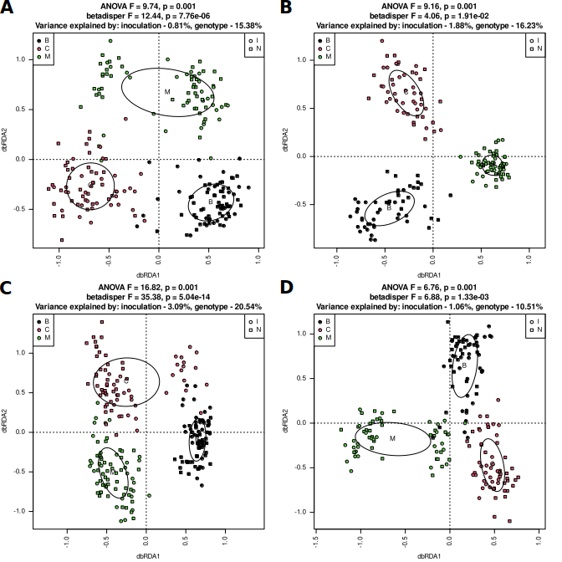
Fig. SR13. Soil samples group according to genotype regardless of soil and status. Early samples (AC), late (BD), soil S1 (AB), S2 (CD). dbRDA models based on d05 generalized UniFrac distance matrices were tested with permutational test (999 permutations). Homogeneity of multi-dimensional variance was tested with betadisper test, and percentage of explained variance was assessed with varpart.

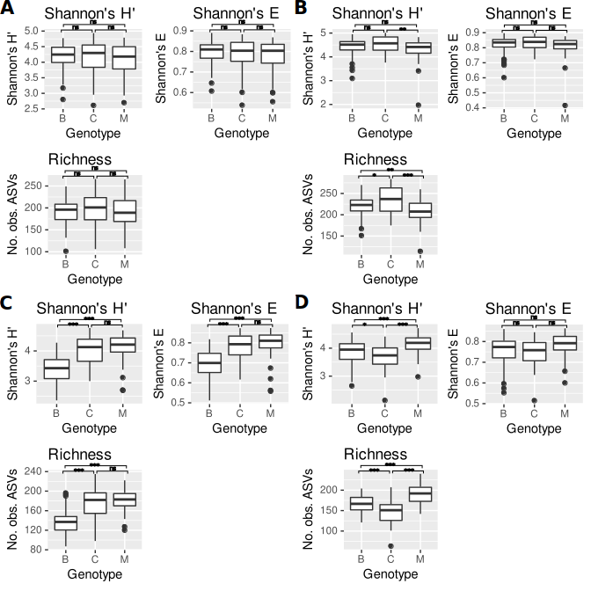
Fig. SR14. Alpha-diversity measures are higher in samples of soil S2 in which genotype M was grown than in soils in which genotypes B and C were grown, regardless of status. AB – soil S1, CD – soil S2, AC – early samples, BD – late samples. Means ± SD of Shannon’s diversity (H’), Shannon’s evennes (E) and observed number of ASVs are shown. Significance of difference between genotypes (Kruskal-Wallis test with Dunn’s post-hoc procedure using Benjamini-Hochberg FDR) is shown over the plots: *** - p < 0.001, ** - p < 0.01, * - p < 0.05, ns – not significant.

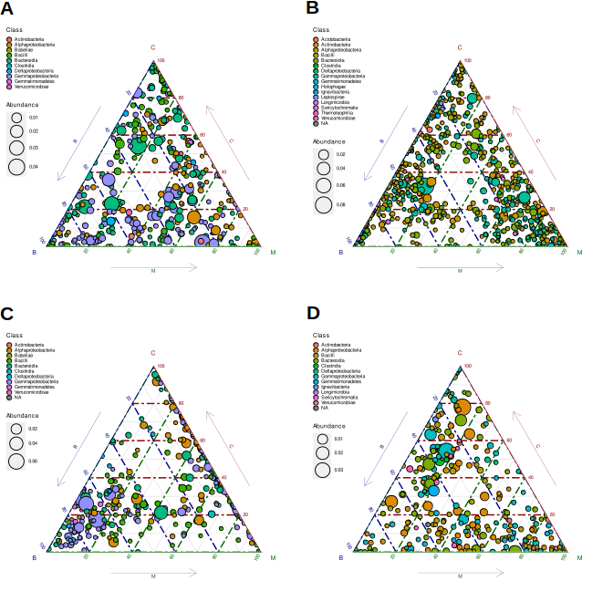
Fig. SR15. Sets of organisms characteristic for soil in which different genotypes were grown are different depending on soil and status. Ternary plots of differentially abundant ASVs identified with DESeq2 are shown. AB – soil S1, CD – soil S2, AC – early samples, BD – late samples. Note differeces between panels’ legends.

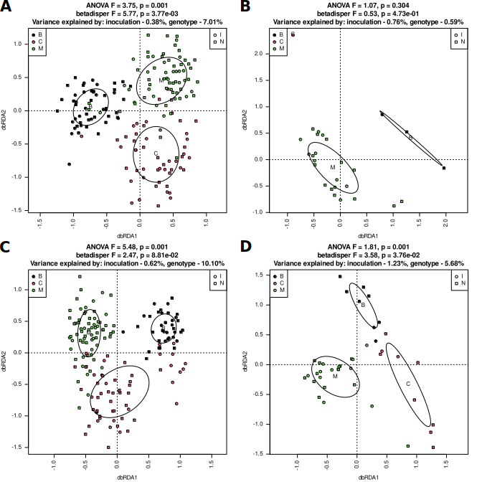
Fig. SR16. Root samples group according to genotype regardless of soil and status. Early samples (AB), late (CD), soil S1 (AC), S2 (BD). dbRDA models based on d05 generalized UniFrac distance matrices were tested with permutational test (999 permutations). Homogeneity of multi-dimensional variance was tested with betadisper test, and percentage of explained variance was assessed with varpart.

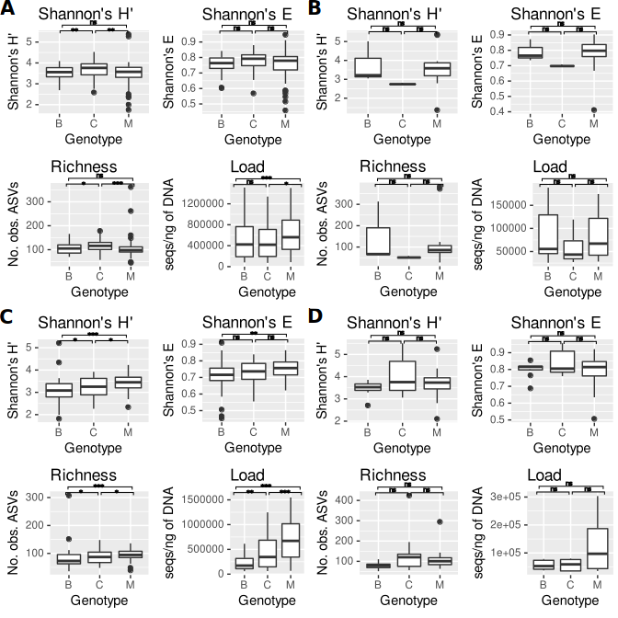
Fig. SR17. Alpha-diversity measures and bacterial load are highest in root samples of genotype M grown in S2 soil , regardless of status, while the same is true for early root samples of genotype C grown in S1. AB – soil S1, CD – soil S2, AC – early samples, BD – late samples. Means ± SD of Shannon’s diversity (H’), Shannon’s evennes (E) and observed number of ASVs are shown. Significance of difference between genotypes (Kruskal-Wallis test with Dunn’s post-hoc procedure using Benjamini-Hochberg FDR) is shown over the plots: *** - p < 0.001, ** - p < 0.01, * - p < 0.05, ns – not significant.

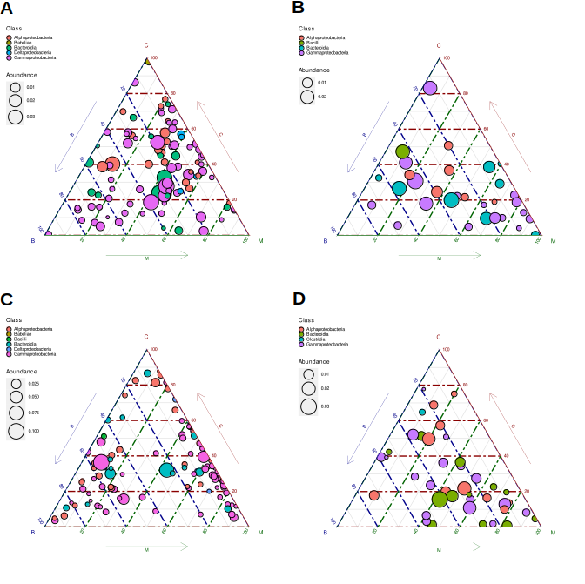
Fig. SR18. Sets of organisms characteristic for roots of different genotypes are different depending on soil and status. Ternary plots of differentially abundant ASVs identified with DESeq2 are shown. AB – soil S1, CD – soil S2, AC – early samples, BD – late samples. Note differeces between panels’ legends.

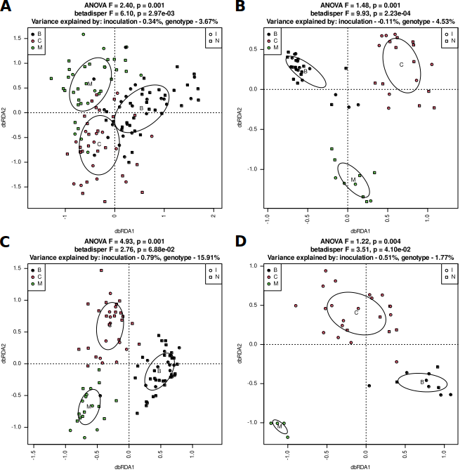
Fig. SR19. Leaf samples group according to genotype regardless of soil and status. Early samples (AB), late (CD), soil S1 (AC), S2 (BD). dbRDA models based on d05 generalized UniFrac distance matrices were tested with permutational test (999 permutations). Homogeneity of multi-dimensional variance was tested with betadisper test, and percentage of explained variance was assessed with varpart.

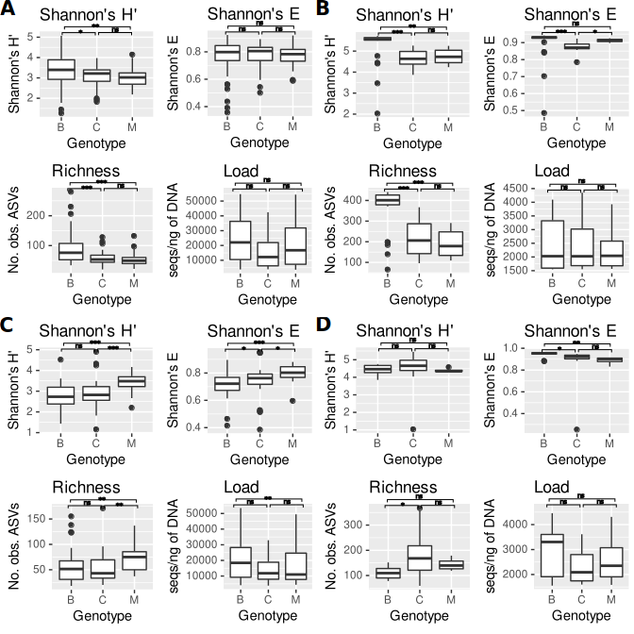
Fig. SR20. Alpha-diversity measures but not bacterial load are higher in early leaf samples of genotype M grown in S2 soil while the same is true for genotype B in S1 soil. AB – soil S1, CD – soil S2, AC – early samples, BD – late samples. Means ± SD of Shannon’s diversity (H’), Shannon’s evennes (E) and observed number of ASVs are shown. Significance of difference between genotypes (Kruskal-Wallis test with Dunn’s post-hoc procedure using Benjamini-Hochberg FDR) is shown over the plots: *** - p < 0.001, ** - p < 0.01, * - p < 0.05, ns – not significant.

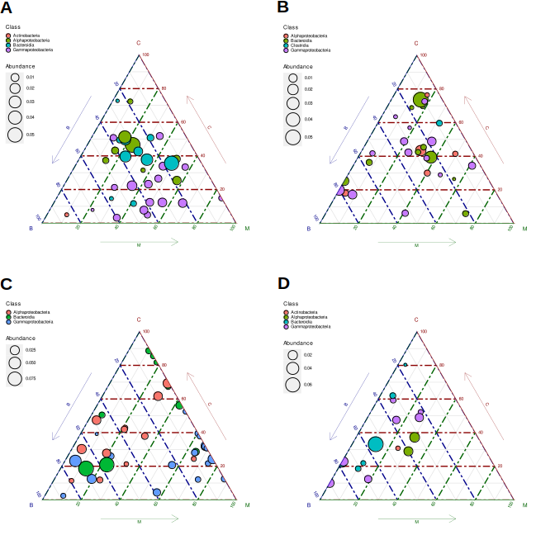
Fig. SR21. Sets of organisms characteristic for leaves of different genotypes are different depending on soil and status. Ternary plots of differentially abundant ASVs identified with DESeq2 are shown. AB – soil S1, CD – soil S2, AC – early samples, BD – late samples. Note differeces between panels’ legends.

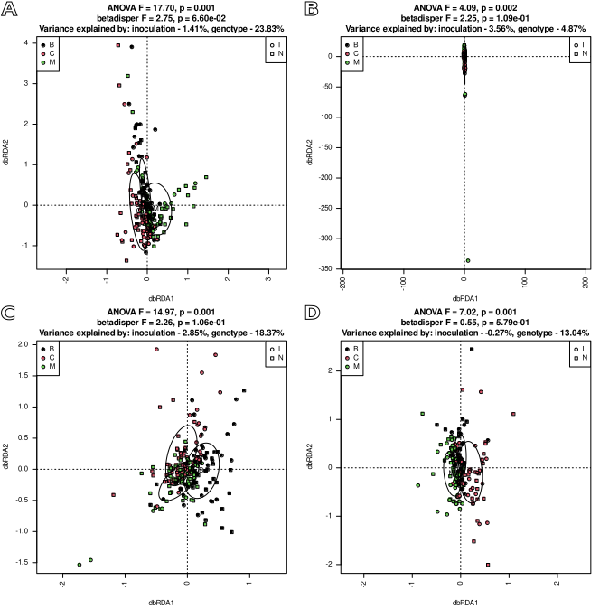
Fig. SR22. Sets of KO functions predicted to be encoded by organisms living in soil samples group according to genotype regardless of soil and status. Early samples (AB), late (CD), soil S1 (AC), S2 (BD). dbRDA models based on Morisita-Horn distance matrices were tested with permutational test (999 permutations). Homogeneity of multi-dimensional variance was tested with betadisper test, and percentage of explained variance was assessed with varpart.

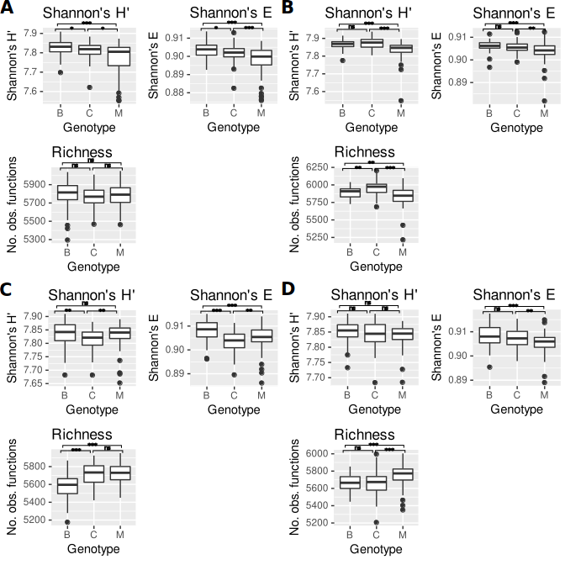
Fig. SR23. Functional diversity of soil samples’ bacterial communities depends genotype. AB – soil S1, CD – soil S2, AC – early samples, BD – late samples. Means ± SD of Shannon’s diversity (H’), Shannon’s evennes (E) and observed number of KO functions predicted by PICRUSt2 to be encoded by genomes of organisms thriving in the samples are shown. Significance of difference between genotypes (Kruskal-Wallis test with Dunn’s post-hoc procedure using Benjamini-Hochberg FDR) is shown over the plots: *** - p < 0.001, ** - p < 0.01, * - p < 0.05, ns – not significant.

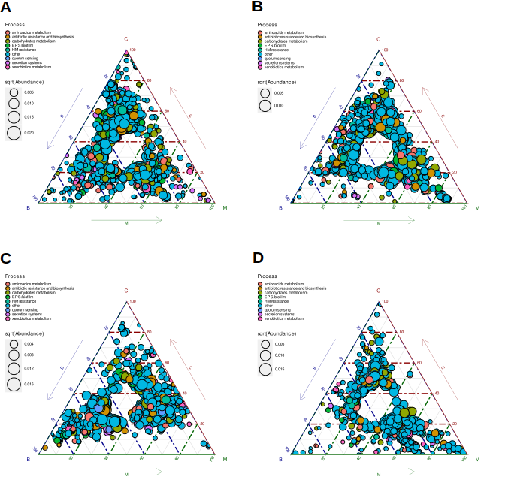
Fig. SR24. Sets of KO functions characteristic for soils in which different genotypes grew were different depending on soil and status. Ternary plots of differentially abundant PICRUSt2-predicted KOs identified with DESeq2 are shown. AB – soil S1, CD – soil S2, AC – early samples, BD – late samples. Note differeces between panels’ legends.

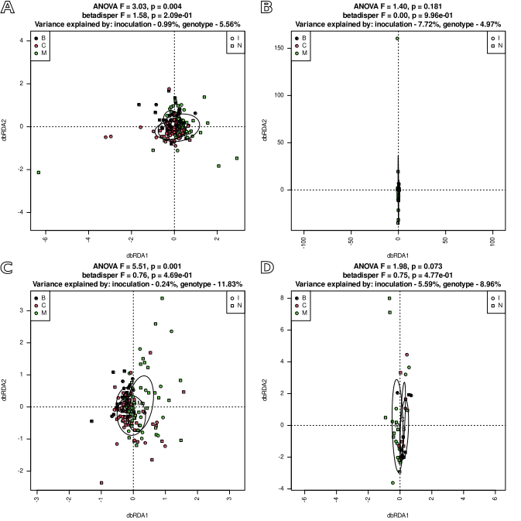
Fig. SR25. Sets of KO functions predicted to be encoded by organisms living in root samples group according to genotype regardless of soil and status. Early samples (AB), late (CD), soil S1 (AC), S2 (BD). dbRDA models based on Morisita-Horn distance matrices were tested with permutational test (999 permutations). Homogeneity of multi-dimensional variance was tested with betadisper test, and percentage of explained variance was assessed with varpart.

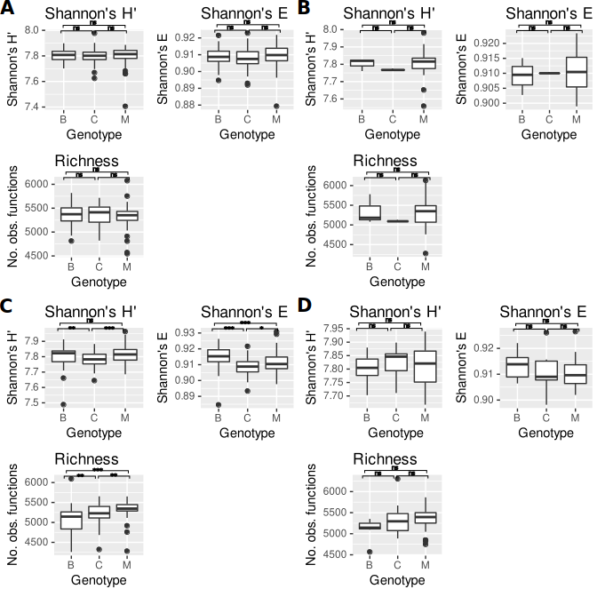
Fig. SR26. Functional diversity of root samples’ bacterial communities depends genotype. AB – soil S1, CD – soil S2, AC – early samples, BD – late samples. Means ± SD of Shannon’s diversity (H’), Shannon’s evennes (E) and observed number of KO functions predicted by PICRUSt2 to be encoded by genomes of organisms thriving in the samples are shown. Significance of difference between genotypes (Kruskal-Wallis test with Dunn’s post-hoc procedure using Benjamini-Hochberg FDR) is shown over the plots: *** - p < 0.001, ** - p < 0.01, * - p < 0.05, ns – not significant.

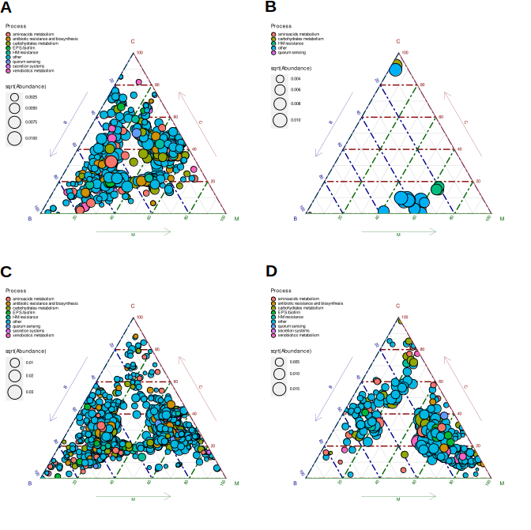
Fig. SR27. Sets of KO functions characteristic for roots of different genotypes are different depending on soil and status. Ternary plots of differentially abundant PICRUSt2-predicted KOs identified with DESeq2 are shown. AB – soil S1, CD – soil S2, AC – early samples, BD – late samples. Note differeces between panels’ legends.

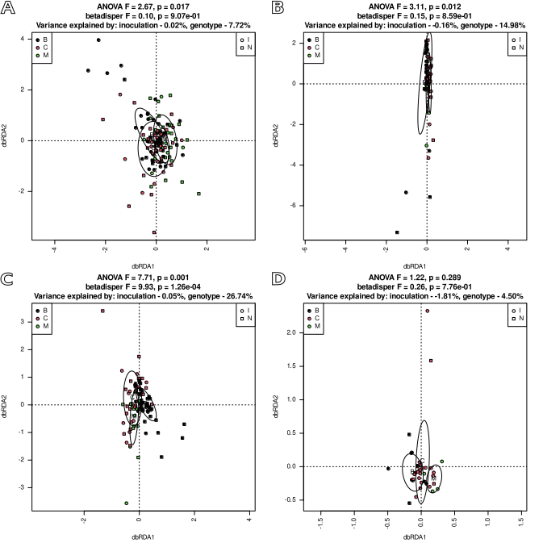
Fig. SR28. Sets of KO functions predicted to be encoded by organisms living in leaf samples group according to genotype regardless of soil and status. Early samples (AB), late (CD), soil S1 (AC), S2 (BD). dbRDA models based on Morisita-Horn distance matrices were tested with permutational test (999 permutations). Homogeneity of multi-dimensional variance was tested with betadisper test, and percentage of explained variance was assessed with varpart.

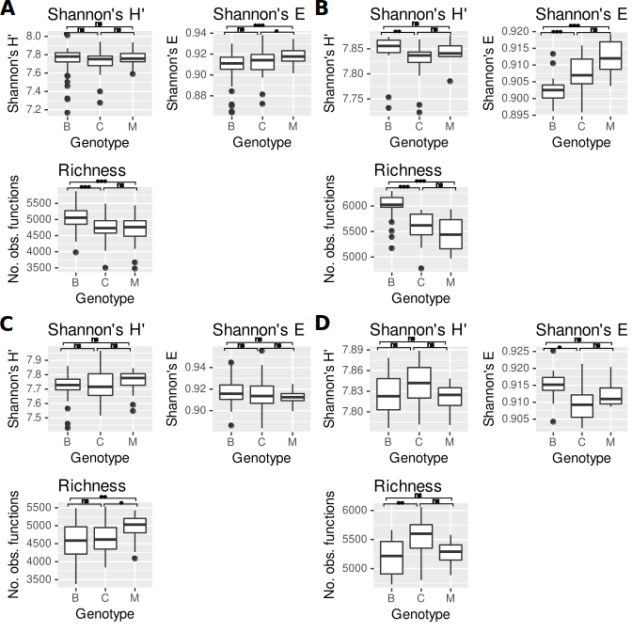
Fig. SR29. Functional diversity of leaf samples’ bacterial communities depends genotype. AB – soil S1, CD – soil S2, AC – early samples, BD – late samples. Means ± SD of Shannon’s diversity (H’), Shannon’s evennes (E) and observed number of KO functions predicted by PICRUSt2 to be encoded by genomes of organisms thriving in the samples are shown. Significance of difference between genotypes (Kruskal-Wallis test with Dunn’s post-hoc procedure using Benjamini-Hochberg FDR) is shown over the plots: *** - p < 0.001, ** - p < 0.01, * - p < 0.05, ns – not significant.

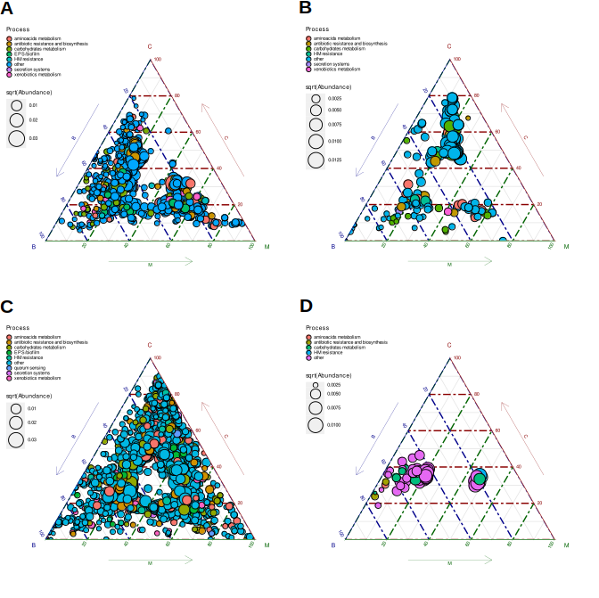
Fig. SR30. Sets of KO functions characteristic for leaves of different genotypes are different depending on soil and status. Ternary plots of differentially abundant PICRUSt2-predicted KOs identified with DESeq2 are shown. AB – soil S1, CD – soil S2, AC – early samples, BD – late samples. Note differeces between panels’ legends.

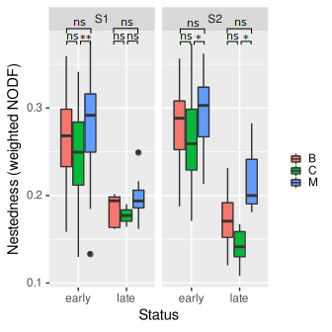

Fig. SR31. Nestedness is higher in genotype M than in B and C. Means of weighted NODF index are shown. Significance of difference between genotypes (Kruskal-Wallis test with Dunn’s post-hoc procedure using Benjamini-Hochberg FDR) is shown over the plots: *** - p < 0.001, ** - p < 0.01, * - p < 0.05, ns – not significant.

Community structure in inoculated and non-inoculated samples differs significantly and the differing ASVs depend on compartment, soil and genotype

Table SR7. Results of permutational tests of dbRDA models based on d05 generalized UniFrac (ASVs) and Morisita-Horn (KOs) distance matrices and involving inoculation.
Material | Soil | Genotype | Status | Df¹ | ASVs |  | KOs
 |  |  |  |  | F | p | F | p
S | S1 | B | early | 73 | 2.388 | 0.001 | 1.291 | 0.258
S | S1 | B | late | 49 | 5.869 | 0.001 | 6.612 | 0.002
S | S1 | C | early | 65 | 2.292 | 0.007 | 3.764 | 0.010
S | S1 | C | late | 48 | 1.959 | 0.014 | 1.321 | 0.227
S | S1 | M | early | 73 | 2.326 | 0.019 | 4.420 | 0.013
S | S1 | M | late | 58 | 2.873 | 0.001 | 1.743 | 0.175
S | S2 | B | early | 73 | 4.429 | 0.001 | 1.944 | 0.074
S | S2 | B | late | 58 | 3.463 | 0.001 | 3.217 | 0.009
S | S2 | C | early | 69 | 11.085 | 0.001 | 8.902 | 0.001
S | S2 | C | late | 57 | 5.106 | 0.001 | 1.891 | 0.113
S | S2 | M | early | 72 | 4.532 | 0.001 | 4.230 | 0.011
S | S2 | M | late | 58 | 1.912 | 0.049 | 0.509 | 0.584
R | S1 | B | early | 46 | 1.606 | 0.040 | 1.215 | 0.299
R | S1 | B | late | - | - | - | - | -
R | S1 | C | early | 50 | 1.384 | 0.058 | 1.820 | 0.116
R | S1 | C | late | - | - | - | - | -
R | S1 | M | early | 68 | 1.031 | 0.410 | 0.639 | 0.602
R | S1 | M | late | 21 | 1.040 | 0.383 | 1.952 | 0.138
R | S2 | B | early | 36 | 1.396 | 0.077 | 0.944 | 0.435
R | S2 | B | late | 6 | 2.519 | 0.018 | 0.625 | 0.609
R | S2 | C | early | 56 | 3.319 | 0.001 | 1.166 | 0.283
R | S2 | C | late | 7 | 1.441 | 0.161 | 3.099 | 0.086
R | S2 | M | early | 66 | 1.289 | 0.122 | 0.687 | 0.561
R | S2 | M | late | 22 | 0.939 | 0.541 | 1.967 | 0.137
L | S1 | B | early | 52 | 2.355 | 0.001 | 1.505 | 0.236
L | S1 | B | late | 24 | 0.872 | 0.884 | 0.804 | 0.451
L | S1 | C | early | 36 | 1.057 | 0.373 | 0.207 | 0.935
L | S1 | C | late | 17 | 0.995 | 0.447 | 2.232 | 0.160
L | S1 | M | early | 34 | 1.733 | 0.013 | 0.578 | 0.695
L | S1 | M | late | 8 | 1.091 | 0.138 | 1.976 | 0.114
L | S2 | B | early | 42 | 1.492 | 0.069 | 0.901 | 0.402
L | S2 | B | late | 8 | 0.877 | 0.912 | 0.630 | 0.698
L | S2 | C | early | 29 | 1.620 | 0.033 | 0.578 | 0.743
L | S2 | C | late | 21 | 1.199 | 0.099 | 0.740 | 0.504
L | S2 | M | early | 17 | 1.579 | 0.026 | 1.294 | 0.271
L | S2 | M | late | -
1 – degrees of freedom in the denominator of the pseudo-F distribution used by anova.cca

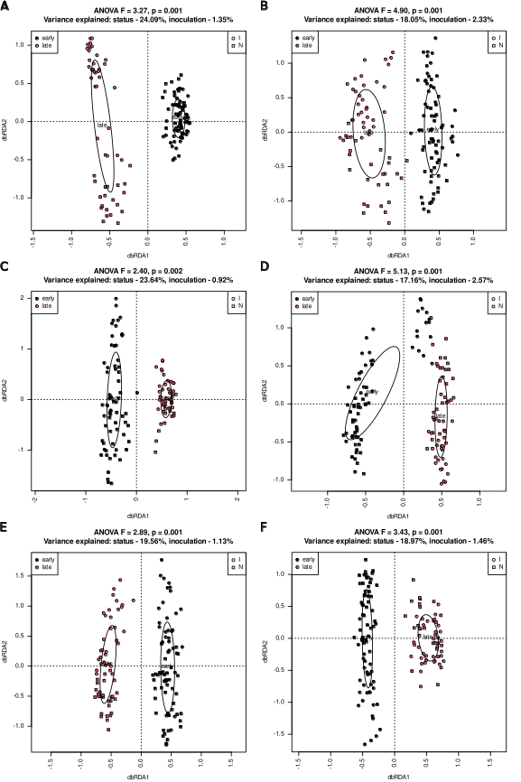

Fig. SR32. Bacterial communities in inoculated (squares) and non-inoculated (circles) soil samples differ regardless of an experimental variant and status. dbRDA models based on d05 generalized UniFrac distance matrices and involving inoculation and status are shown for soil S1 (ACE) and S2 (BDF) and genotypes B (AB), C (CD) and M (EF). P-value of a dbRDA model involving inoculation and with status conditioned out is given
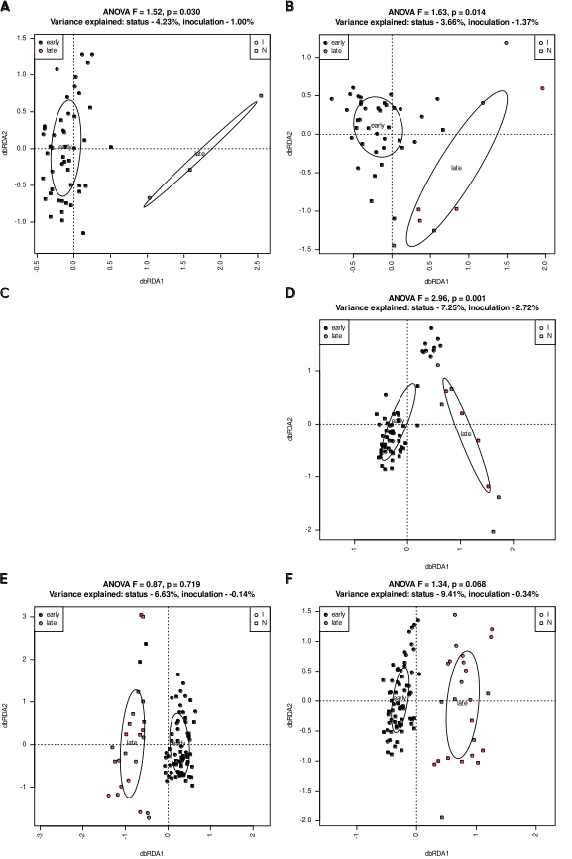

Fig. SR33. Bacterial communities in inoculated (squares) and non-inoculated (circles) root samples differ more in late than in early ones regardless of an experimental variant. dbRDA models based on d05 generalized UniFrac distance matrices are shown for soil S1 (ACE) and S2 (BDF) and genotypes B (AB), C (CD) and M (EF). P-value of a dbRDA model involving inoculation and with status conditioned out is given

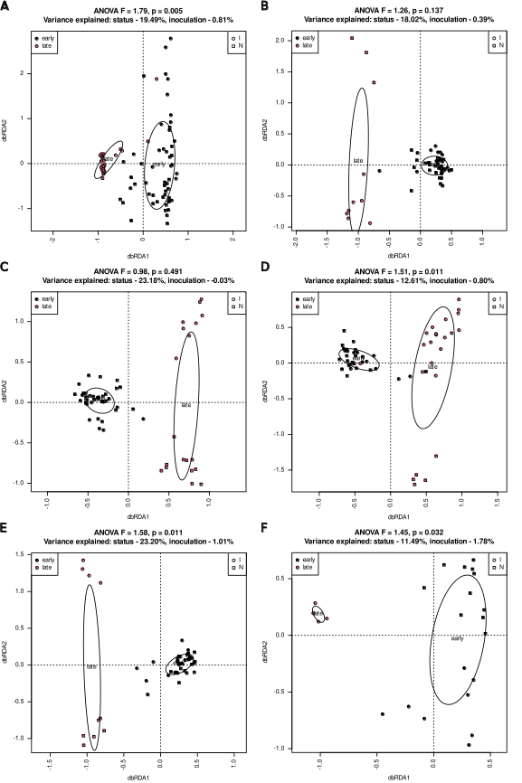

Fig. SR34. Bacterial communities in inoculated (squares) and non-inoculated (circles) late but not early leaf samples differ regardless of an experimental variant. dbRDA models based on d05 generalized UniFrac distance matrices are shown for soil S1 (ACE) and S2 (BDF) and genotypes B (AB), C (CD) and M (EF). P-value of a dbRDA model involving inoculation and with status conditioned out is given

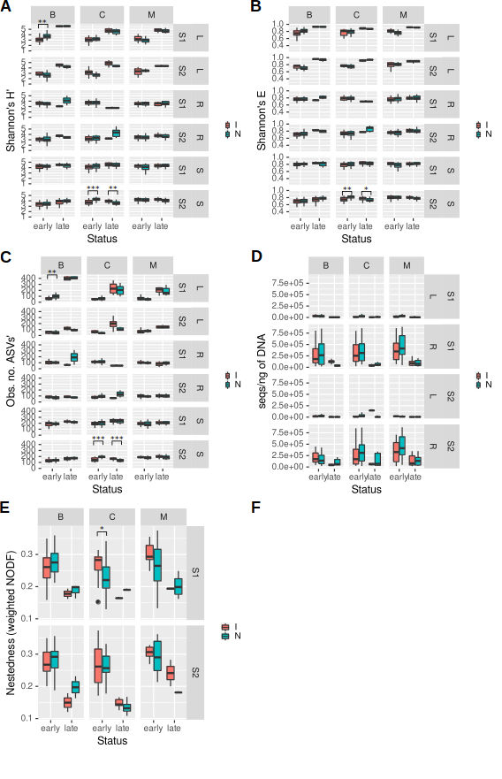

Fig. SR35. Alpha-diversity measures, bacterial load and nestedness are not influenced by inoculation regardless of an experimental variant. A – Shannon’s diversity index (H’), B – Shannon’s evenness (E), C – observed number of ASVs, D – bacterial load measured as number of 16S rRNA gene fragments per ng of DNA, E – nestedness measured as weighted NODF index. Statistical significance was assessed with Wilcoxon test and p-value was corrected for multiple comparisons using Benjamini-Hochberg FDR. Significant p-values are shown over the plots: *** - p < 0.001, ** - p < 0.01, * - p < 0.05.

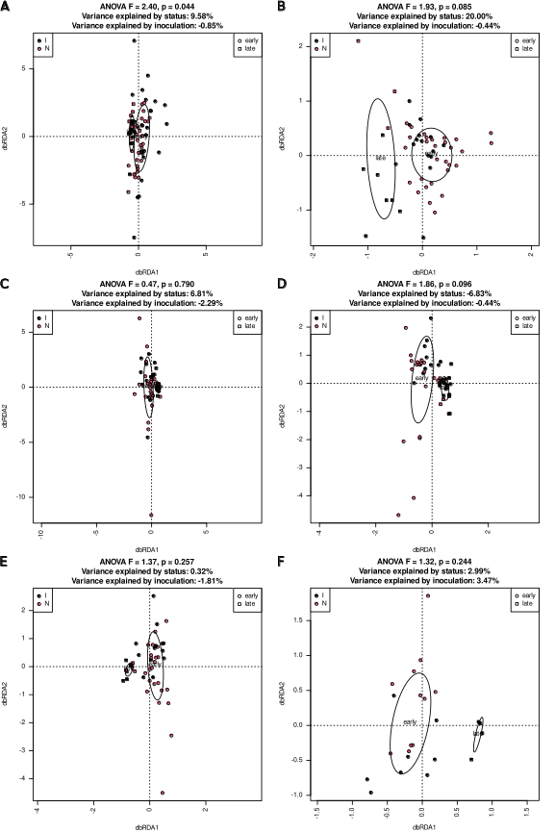

Fig. SR36. Functional potential of bacterial communities in inoculated and non-inoculated leaf samples do not differ significantly. dbRDA models based on Morisita-Horn distance matrices and involving status and inoculation are shown for soil S1 (ACE) and S2 (BDF) and genotypes B (AB), C (CD) and M (EF). Negative values of variance explained should be interpreted as zero. P-value of a dbRDA model involving inoculation and with status conditioned out is given

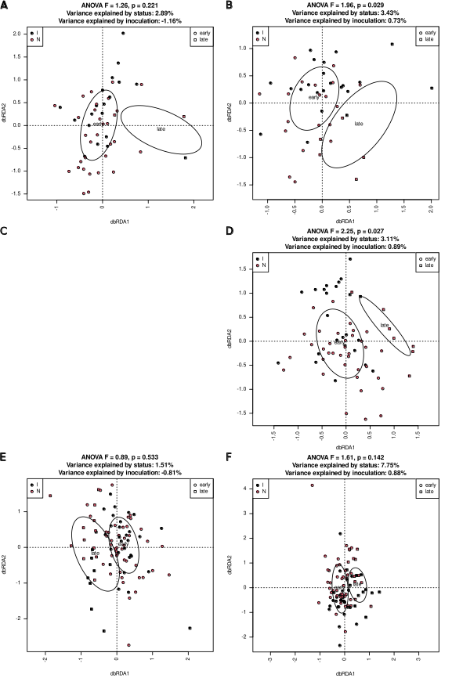

Fig. SR37. Functional potential of bacterial communities in inoculated and non-inoculated root samples does not differ significantly. dbRDA models based on Morisita-Horn distance matrices and involving status and inoculation are shown for soil S1 (ACE) and S2 (BDF) and genotypes B (AB), C (CD) and M (EF). Negative values of variance explained should be interpreted as zero. P-value of a dbRDA model involving inoculation and with status conditioned out is given.

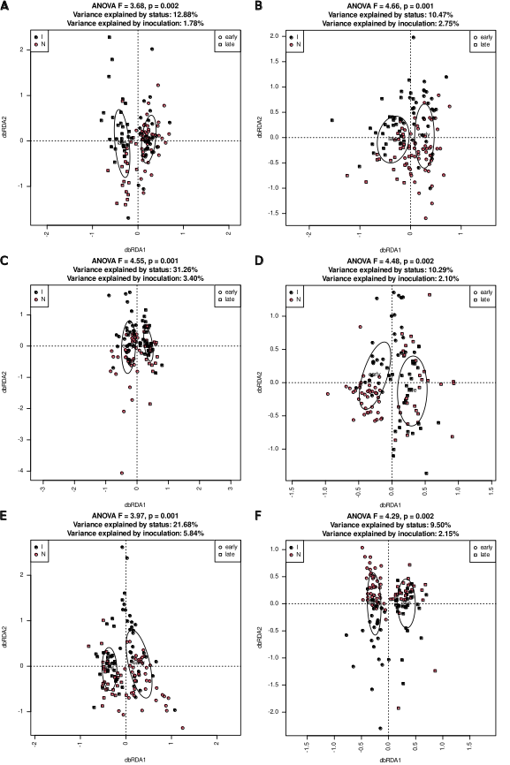

Fig. SR38. Functional potential of bacterial communities in inoculated and non-inoculated soil samples does not differ significantly. dbRDA models based on Morisita-Horn distance matrices and involving status and inoculation are shown for soil S1 (ACE) and S2 (BDF) and genotypes B (AB), C (CD) and M (EF). Negative values of variance explained should be interpreted as zero. P-value of a dbRDA model involving inoculation and with status conditioned out is given
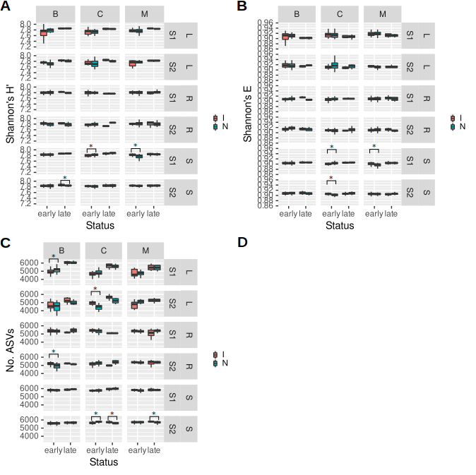
Fig. SR39.

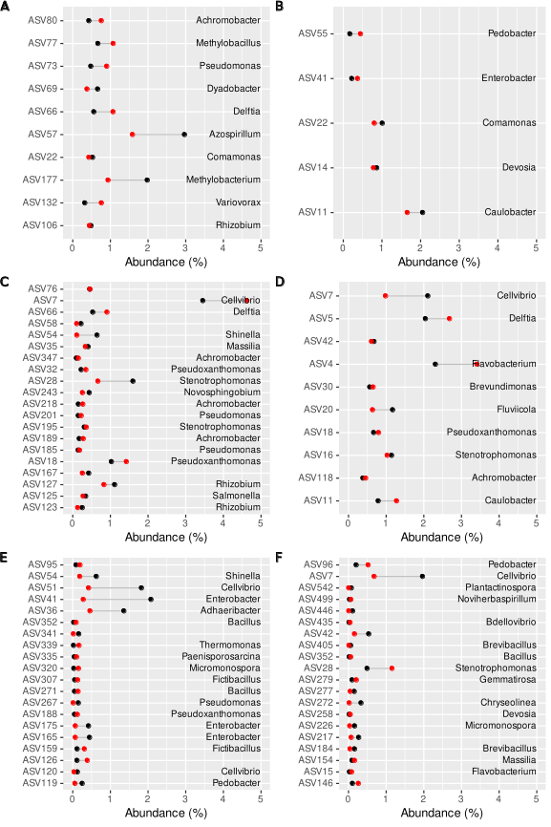

Fig. SR40. ASVs differentially represented in inoculated and non-inoculated early (ACE) and late (BDF) leaf (AB), root (CD) and soil (EF) samples. Red circles represent non-inoculated samples, black circles – inoculated ones. At most 24 features of greatest fold-change are shown.

Complete sets of differentially represented ASVs and higher taxa can be found in SupplementaryResultsF1, and sets of differentially represented KO functions are in SupplementaryResultsF2.

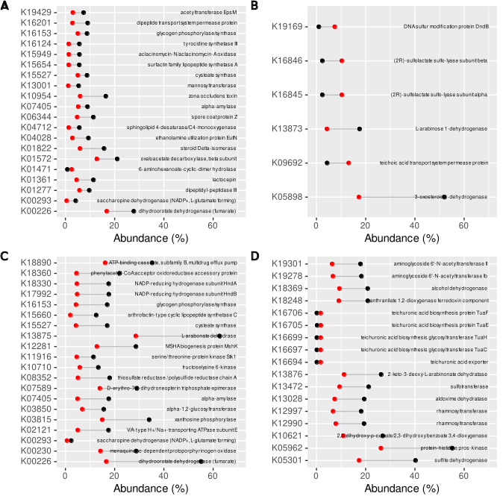
Fig. SR41. Functions differentially represented in inoculated and non-inoculated early (AC) and late (BD) root (AB) and soil (CD) samples. Red circles represent non-inoculated samples, black circles – inoculated ones. At most 24 features of greatest fold-change are shown. There were no differentially represented functions in leaf samples.

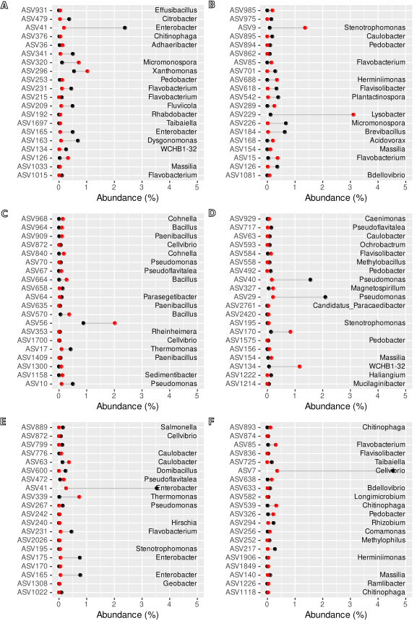

Fig. SR42. ASVs differentially represented in inoculated and non-inoculated S1 soil samples. Early samples (ACE) and late ones (BDF), genotype B (AB), C (CD) and M (EF). At most 10 ASVs with greatest and lowest fold change are shown Red circles represent non-inoculated samples, black circles – inoculated ones. Differential abundance analysis was carried out using DESeq2.

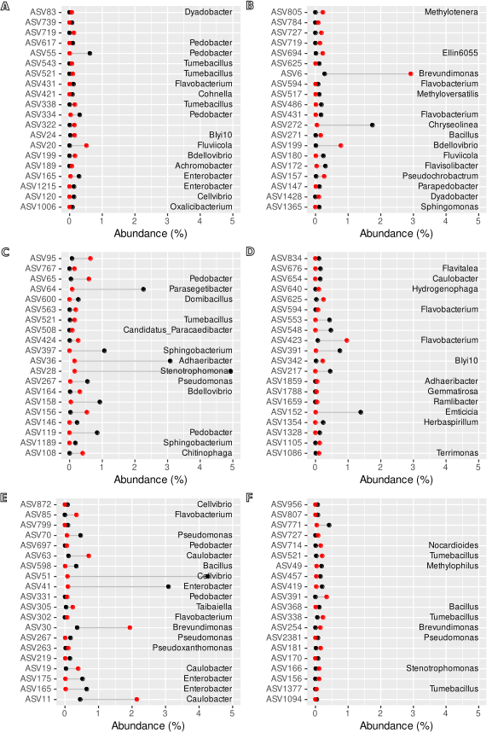

Fig. SR43. ASVs differentially represented in inoculated and non-inoculated S2 soil samples. Early samples (ACE) and late ones (BDF), genotype B (AB), C (CD) and M (EF). At most 10 ASVs with greatest and lowest fold change are shown. Red circles represent non-inoculated samples, black circles – inoculated ones. Differential abundance analysis was carried out using DESeq2.

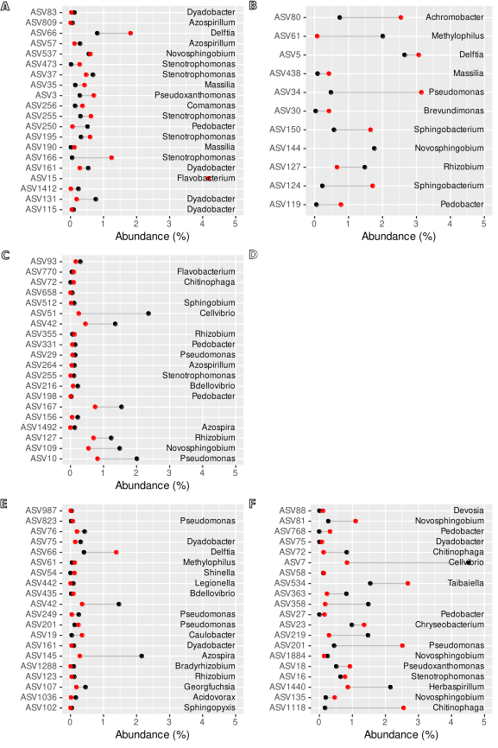

Fig. SR44. ASVs differentially represented in inoculated and non-inoculated S1 root samples. Early samples (ACE) and late ones (BDF), genotype B (AB), C (CD) and M (EF). At most 10 ASVs with greatest and lowest fold change are shown. Red circles represent non-inoculated samples, black circles – inoculated ones. Differential abundance analysis was carried out using DESeq2.

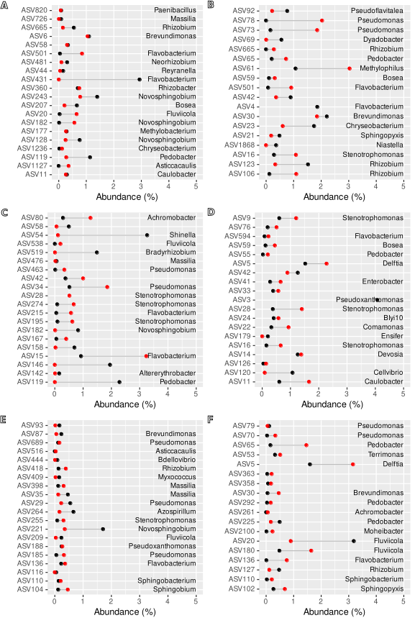

Fig. SR45. ASVs differentially represented in inoculated and non-inoculated S2 root samples. Early samples (ACE) and late ones (BDF), genotype B (AB), C (CD) and M (EF). At most 10 ASVs with greatest and lowest fold change are shown. Red circles represent non-inoculated samples, black circles – inoculated ones. Differential abundance analysis was carried out using DESeq2.

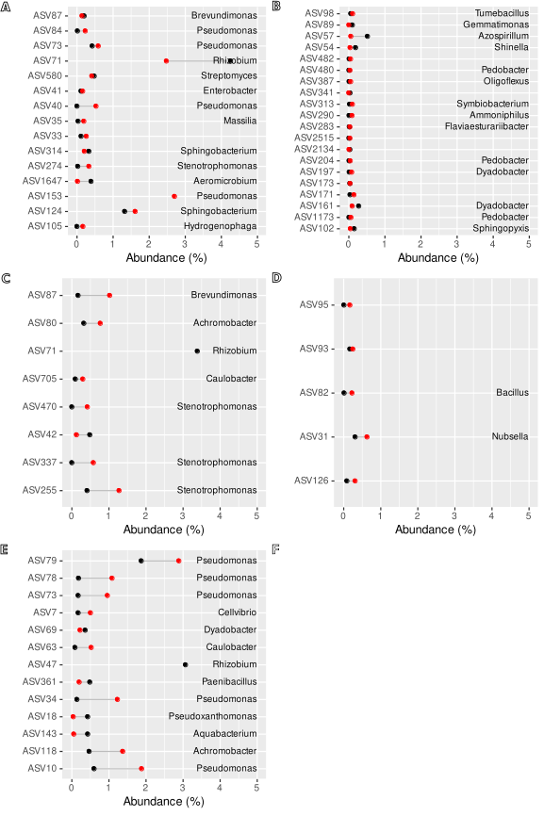

Fig. SR46. ASVs differentially represented in inoculated and non-inoculated S1 leaf samples. Early samples (ACE) and late ones (BDF), genotype B (AB), C (CD) and M (EF). At most 10 ASVs with greatest and lowest fold change are shown. Red circles represent non-inoculated samples, black circles – inoculated ones. Differential abundance analysis was carried out using DESeq2.

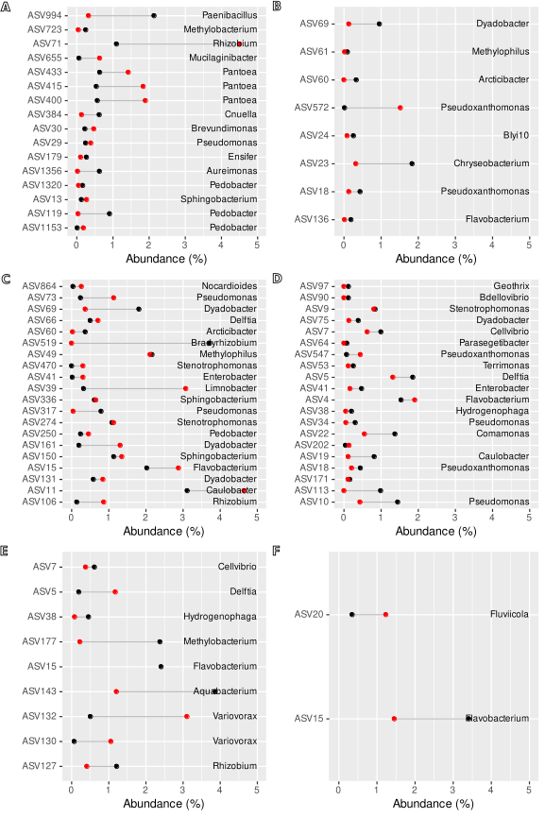

Fig. SR47. ASVs differentially represented in inoculated and non-inoculated S2 leaf samples. Early samples (ACE) and late ones (BDF), genotype B (AB), C (CD) and M (EF). At most 10 ASVs with greatest and lowest fold change are shown. Red circles represent non-inoculated samples, black circles – inoculated ones. Differential abundance analysis was carried out using DESeq2.

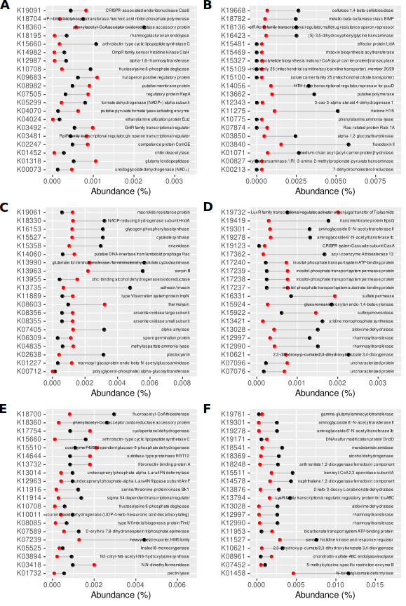

Fig. SR48. KO functions differentially represented in genomes of organisms thriving in inoculated and non-inoculated S1 soil samples. Early samples (ACE) and late ones (BDF), genotype B (AB), C (CD) and M (EF). At most 10 functions with greatest and lowest fold change are shown. Red circles represent non-inoculated samples, black circles – inoculated ones. Differential abundance analysis was carried out using DESeq2.

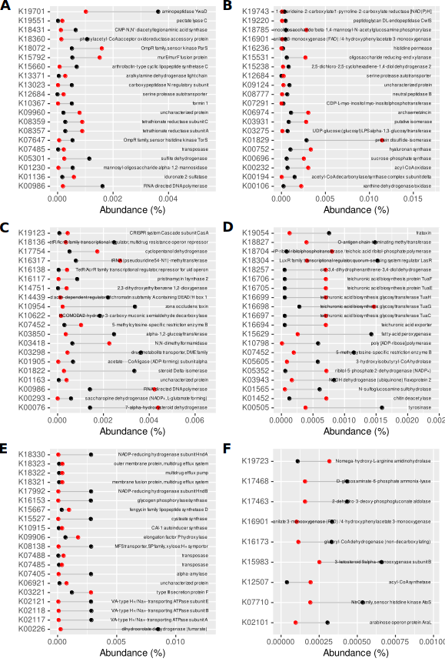

Fig. SR49. KO functions differentially represented in genomes of organisms thriving in inoculated and non-inoculated S2 soil samples. Early samples (ACE) and late ones (BDF), genotype B (AB), C (CD) and M (EF). At most 10 functions with greatest and lowest fold change are shown. Red circles represent non-inoculated samples, black circles – inoculated ones. Differential abundance analysis was carried out using DESeq2.

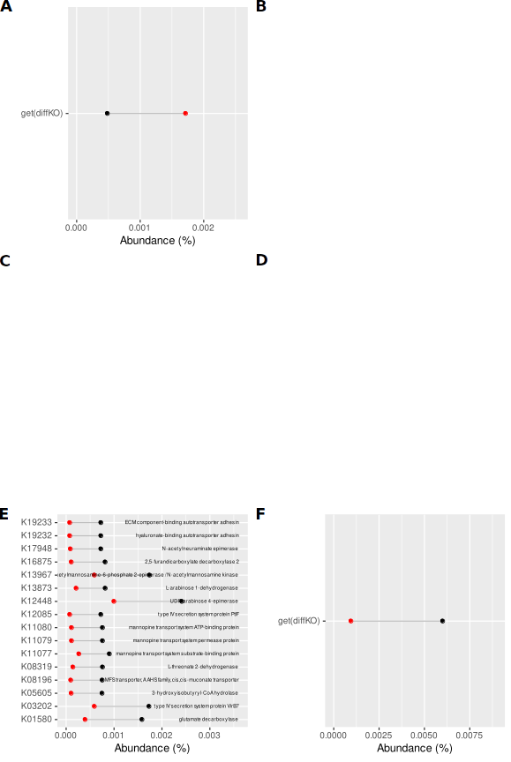

Fig. SR50. KO functions differentially represented in genomes of organisms thriving in inoculated and non-inoculated S1 root samples. Early samples (ACE) and late ones (BDF), genotype B (AB), C (CD) and M (EF). At most 10 functions with greatest and lowest fold change are shown. Red circles represent non-inoculated samples, black circles – inoculated ones. Differential abundance analysis was carried out using DESeq2. The lack of a graph means that there were no differentially represented functions.

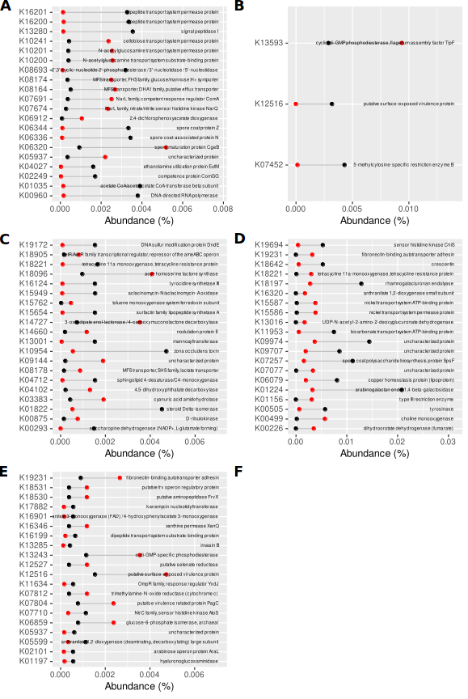

Fig. SR51. KO functions differentially represented in genomes of organisms thriving in inoculated and non-inoculated S2 root samples. Early samples (ACE) and late ones (BDF), genotype B (AB), C (CD) and M (EF). At most 10 functions with greatest and lowest fold change are shown. Red circles represent non-inoculated samples, black circles – inoculated ones. Differential abundance analysis was carried out using DESeq2. The lack of a graph means that there were no differentially represented functions.

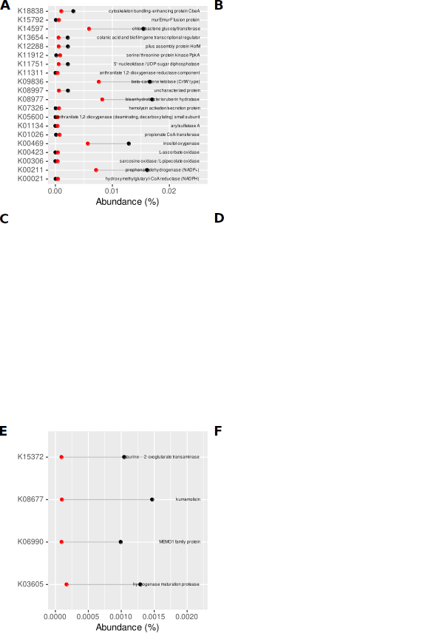

Fig. SR52. KO functions differentially represented in genomes of organisms thriving in inoculated and non-inoculated S1 leaf samples. Early samples (ACE) and late ones (BDF), genotype B (AB), C (CD) and M (EF). At most 10 functions with greatest and 10 with lowest fold change are shown. Red circles represent non-inoculated samples, black circles – inoculated ones. Differential abundance analysis was carried out using DESeq2. The lack of a graph means that there were no differentially represented functions.

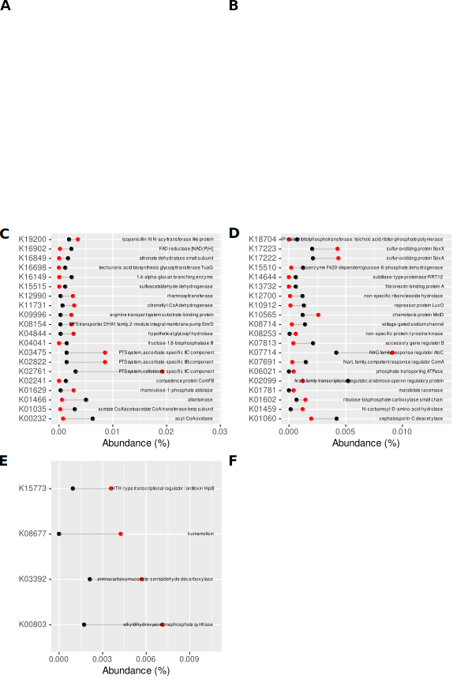

Fig. SR53. KO functions differentially represented in genomes of organisms thriving in inoculated and non-inoculated S2 leaf samples. Early samples (ACE) and late ones (BDF), genotype B (AB), C (CD) and M (EF). At most 20 functions with greatest and lowest fold change are shown. Red circles represent non-inoculated samples, black circles – inoculated ones. Differential abundance analysis was carried out using DESeq2. The lack of a graph means that there were no differentially represented functions.

Table SR8. ASVs constituting signature of inoculated samples identified with biosigner.
ASV | Taxonomy
ASV3 | Pseudoxanthomonas
ASV4 | Flavobacterium
ASV5 | Delftia
ASV6 | Brevundimonas
ASV7 | Cellvibrio
ASV10 | Pseudomonas
ASV11 | Caulobacter
ASV14 | Devosia
ASV16 | Stenotrophomonas
ASV20 | Fluviicola
ASV31 | Nubsella
ASV41 | Enterobacter
ASV66 | Delftia
ASV70 | Pseudomonas
ASV77 | Methylobacillus
ASV119 | Pedobacter
ASV159 | Fictibacillus
ASV165 | Enterobacter
ASV175 | Enterobacter
ASV217 | Memeber of Sphigobacteriaceae
ASV273 | Tumebacillus
ASV307 | Fictibacillus
ASV542 | Plantactinospora
ASV603 | Fictibacillus
ASV617 | Pedobacter
ASV656 | Galbitalea
ASV799 | Member of Enterobacteriaceae
ASV872 | Cellvibrio

Table SR9. ASVs present in inoculant and inoculated samples, but absent from non-inoculated ones.
ASV | Taxonomy
ASV1254 | Cellvibrio
ASV2212 | Devosia
ASV2539 | Member of Moraxellaceae
ASV3930 | Brevibacillus
ASV4420 | Nocardioides
ASV4847 | Brevundimonas
ASV4848 | Pedobacter
ASV4949 | Member of Paenibacillaceae
ASV5743 | Member of Paenibacillaceae
ASV5988 | Member of Burkholderiaceae
ASV7103 | Algoriphagus
ASV8922 | Terrimonas
ASV9530 | Member of Gammproteobacterial order PLTA13
ASV11034 | Member of Chitinophagaceae
ASV12901 | Herbinix

