Isolation, Characterization, and Herbicidal Activity of Streptomyces spp. from Diseased Potato Scab Tubers
Zhong-di HUANG ^{1#}, Shu-ping SHI^{1#}, Yi ZHANG¹, Cai-ping YIN¹ , Shu-xiang ZHANG¹ and Ying-lao ZHANG^{1*}
¹School of Life Sciences, Anhui Agricultural University, Hefei 230036, China

*Corresponding author: Yinglao Zhang, School of Life Sciences, Anhui Agricultural

University, Hefei, Anhui 230036, China. E-mail: zhangyl@ahau.edu.cn; Tel.: +86

0551-6578-6129.

# These authors contributed to the work equally and should be regarded as co-first

authors.

Supplementary Material
Table S1. Media used for isolation and cultivation in this study.
Table S2. Identification results of cultivable actinomycetes of potato common scab.
Table S3. Inhibitory effects of the fermentation broth on the growth of radish seedlings and weeds roots (%).
Figure S1. The ¹H NMR spectrum of compound 1 in DMSO-d₆ (600 MHz).
Figure S2. The ¹³C NMR spectrum of compound 1 in DMSO-d₆ (150 MHz).
Figure S3. The DEPT spectrum of compound 1 in DMSO-d₆ (150 MHz).
Figure S4. The ¹H-¹H COSY spectrum of compound 1 in DMSO-d₆ (600 MHz).
Figure S5. The HSQC spectrum of compound 1 in DMSO-d₆ (600 MHz).
Figure S6. The HMBC spectrum of compound 1 in DMSO-d₆ (600 MHz).
Figure S7. The ESI⁺ spectrum of compound 1.

Table S1. Media used for isolation and cultivation in this study.
Usage | Media | Components
Isolation | CCM (cellulose-casamino acid) | Microcrystalline cellulose 1.0 g, casein amino acids 1.0 g, KNO₃ 0.2 g, Na₂HPO₄ 0.5 g, MgSO₄·7H₂O 0.05 g, FeSO₄·7H₂O 0.01 g, agar 18 g, H₂O 1000 mL, pH 7.2
Isolation | ISP2 (ISP medium No.2) | Yeast extract 4.0 g, malt extract 10.0 g, dextrose 4.0 g, agar 15.0-20.0 g, H₂O 1000 mL, pH 7.2
Isolation | ISP4 (ISP medium No.4) | Soluble starch 20.0 g, K₂HPO₄ 1.0 g, MgSO₄·7H₂O 1.0 g, NaCl 1.0 g, (NH₄)₂SO₄ 2.0 g, CaCO₃ 2.0 g, FeSO₄·7H₂O 0.01 g, MnCl₂·4H₂O 0.01 g, ZnSO₄·7H₂O 0.01 g, agar 15-20 g, H₂O 1000 mL
Isolation | LB (luria bertani) | Yeast extract 5.0 g, NaCl 10.0 g, peptone 10.0 g, agar 18.0 g, H₂O 1000 mL
Isolation | B4 medium | Calcium acetate 2.5 g, yeast extract 2.0 g, glucose 1.0 g, agar 15-20.0 g, H₂O 1000 mL
Isolation | OMA (oatmeal agar) | Oatmeal 20.0 g, trace salt solution 1.0 mL, agar 15.0-20.0 g, H₂O 1000 mL, pH 7.2
Isolation | MM (minimal medium) | Glucose 0.5 g, yeast extract 0.5 g, K₂HPO₄ 1.0 g, MgSO₄·7H₂O 0.5 g, NaCl 0.5 g, agar 18 g, H₂O 1000 mL, pH 7.5
Isolation | SCA (starch casein agar) | Soluble starch 10.0 g, casein 0.3 g, KNO₃ 2.0 g, NaCl 2.0 g, K₂HPO₄ 2.0 g, MgSO₄·7H₂O 0.05 g, CaCO₃ 0.02 g, FeSO₄·7H₂O 0.01 g, Vitamins (0.5 mg each of thiamine-HCl, riboflavin, niacin, pyridoxin-HCl, inositol, Ca-pantothenat, p-aminobenzoic acid, and 0.25 mg of biotin), agar 18.0 g, H₂O 1000 mL, pH 7.5
Isolation | R2A (Reasoner’s 2A agar) | Yeast extract 0.5 g, peptone 0.5 g, casamino acid 0.5 g, glucose 0.5 g, soluble starch 0.5 g, K₂HPO₄ 0.3 g, MgSO₄·7H₂O 0.05 g, Na-pyruvate 0.3 g, Vitamins (0.5 mg each of thiamine-HCl, riboflavin, niacin, pyridoxin-HCl, inositol, Ca-pantothenat, p-aminobenzoic acid, and 0.25 mg of biotin), agar 18.0 g, H₂O 1000 mL, pH 7.5
Isolation | G1 (Gause’s No. 1) | Soluble starch 20 g, KNO₃ 1.0 g, K₂HPO₄·3H₂O 0.5 g, MgSO₄·7H₂O 0.5 g, NaCl 0.5 g, FeSO₄·7H₂O 0.01 g, agar 18 g, H₂O 1000 mL, pH 7.4-7.6
Isolation | GYM (glucose-yeast-malt) | Glucose 4.0 g, yeast extract 4.0 g, malt extract 10.0 g, CaCO₃ 2.0 g, agar 18.0 g, H₂O 1000 mL, pH 7.2
Isolation | AIA (actinobacteria isolation agar) | Sodium propionate 4.0 g, sodium caseinate 2.0 g, K₂HPO₄ 0.5 g, L-Asparagine 0.1 g, MgSO₄·7H₂O 0.1 g, FeSO₄·7H₂O 0.001 g, Vitamins (0.5 mg each of thiamine-HCl, riboflavin, niacin, pyridoxin-HCl, inositol, Ca-pantothenat, p-aminobenzoic acid, and 0.25 mg of biotin), agar 18.0 g, H₂O 1000 mL, pH 8.1
Cultivation | G1 (Gause’s No. 1) | Soluble starch 20 g, KNO₃ 1.0 g, K₂HPO₄·3H₂O 0.5 g, MgSO₄·7H₂O 0.5 g, NaCl 0.5 g, FeSO₄·7H₂O 0.01 g, agar 18 g, H₂O 1000 mL, pH 7.4-7.6

Table S2. Identification results of cultivable actinomycetes of potato common scab.
Isolate | Accession numbers | Closest Type Strain and Similarity | Identity | Medium | GenBank accession number
L7-2 | JQ806215 | Streptomyces pratensis ch24(T) | 99.93% | G1 | OR186221
L7-7 | AY999737 | Streptomyces violascens ISP 5183(T) | 98.93% | G1 | OR186222
L7-12  NKY-N | AY999737  KF682161 | Streptomyces violascens ISP 5183(T)  Streptomyces colonosanans MUSC 93J(T) | 99.22%  98.75% | G1  G1 | OR186223  OR186224
NKY-4 | AY999783 | Streptomyces badius NRRL B-2567(T) | 100.00% | G1 | OR186225
NKY-11 | AB184687 | Streptomyces tricolor NBRC 15461(T) | 99.02% | G1 | OR186226
NKY-12 | DQ334781 | Streptomyces geldanamycininus NRRLB-3602(T) | 99.22% | G1 | OR186227
NKY-15 | MH718844 | Streptomyces aquilus GGCR-6(T) | 98.42% | G1 | OR186228
NKY-17 | MH718844 | Streptomyces aquilus GGCR-6(T) | 97.85% | G1 | OR186229
NKY-24 | DSM 44293 | Streptomyces thermocarboxydus U94490 | 98.88% | G1 | OR186230
NKY-26 | ISP 5185 | Streptomyces bellus AJ399476 | 98.79% | G1 | OR186231
NKY-29 | JQ806215 | Streptomyces pratensis ch24(T) | 99.93% | G1 | OR186232
NKY-30 | JQ806215 | Streptomyces pratensis ch24(T) | 100.00% | G1 | OR186233
GYM-31 | MUNB01000146 | Streptomyces setonii NRRL ISP-5322(T) | 100.00% | GYM | OR186234
GYM-34 | Z76676 | Streptomyces albidoflavus DSM 40455(T) | 99.71% | GYM | OR186235
GYM-35 | AB184284 | Streptomyces microflavus NBRC 13062(T) | 100.00% | GYM | OR186236
B4-38 | Z76676 | Streptomyces albidoflavus DSM 40455(T) | 99.71% | B4 | OR186237
B4-40 | Z76676 | Streptomyces albidoflavus DSM 40455(T) | 99.71% | B4 | OR186238
B4-42 | Z76676 | Streptomyces albidoflavus DSM 40455(T) | 99.71% | B4 | OR186239
B4-46 | Z76676 | Streptomyces albidoflavus DSM 40455(T) | 99.71% | B4 | OR186240
GS-36 | MUNB01000146 | Streptomyces setonii NRRL ISP-5322(T) | 100.00% | G1 | OR186241
GS-47 | JQ806215 | Streptomyces pratensis ch24(T) | 100.00% | G1 | OR186242
GS-49 | AY999737 | Streptomyces violascens ISP 5183(T) | 99.15% | G1 | OR186243
GS-55 | JQ806215 | Streptomyces pratensis ch24(T) | 99.93% | G1 | OR186244
GS-56 | JQ806215 | Streptomyces pratensis ch24(T) | 99.93% | G1 | OR186245
GS-63 | AY999737 | Streptomyces violascens ISP 5183(T) | 99.29% | G1 | OR186246
GS-64 | AY999737 | Streptomyces violascens ISP 5183(T) | 99.15% | G1 | OR186247
GS-65 | JQ806215 | Streptomyces pratensis ch24(T) | 100.00% | G1 | OR186248
GS-66 | AY999737 | Streptomyces violascens ISP 5183(T) | 99.00% | G1 | OR186249
GS-67 | AY999737 | Streptomyces violascens ISP 5183(T) | 99.29% | G1 | OR186250
GS-68 | AY999737 | Streptomyces violascens ISP 5183(T) | 99.00% | G1 | OR186251
SCA2 | AY999737 | Streptomyces violascens ISP 5183(T) | 99.36% | SCA | OR186252
SCA3 | MUNB01000146 | Streptomyces setonii NRRL ISP-5322(T) | 100.00% | SCA | OR186253
SCA4 | AY999737 | Streptomyces violascens ISP 5183(T) | 99.00% | SCA | OR186254
SCA5 | JQ806215 | Streptomyces pratensis ch24(T) | 100.00% | SCA | OR186255
SCA6 | AY999737 | Streptomyces violascens ISP 5183(T) | 99.00% | SCA | OR186256
SCA7 | AY999737 | Streptomyces violascens ISP 5183(T) | 99.22% | SCA | OR186257
SCA9 | JQ806215 | Streptomyces pratensis ch24(T) | 100.00% | SCA | OR186258
SCA10 | Z76676 | Streptomyces albidoflavus DSM 40455(T) | 99.50% | SCA | OR186259
SCA11 | JQ806215 | Streptomyces pratensis ch24(T) | 99.93% | SCA | OR186260
SCA12 | MUNB01000146 | Streptomyces setonii NRRL ISP-5322(T) | 100.00% | SCA | OR186261
AIA1 | JQ806215 | Streptomyces pratensis ch24(T) | 99.93% | AIA | OR186262
AIA2 | JQ806215 | Streptomyces pratensis ch24(T) | 100.00% | AIA | OR186263
AIA3 | JQ806215 | Streptomyces pratensis ch24(T) | 100.00% | AIA | OR186264
AIA4 | JQ806215 | Streptomyces pratensis ch24(T) | 100.00% | AIA | OR186265
CCM2 | AB184284 | Streptomyces microflavus NBRC 13062(T) | 100.00% | CCM | OR186266
CCM3 | JQ806215 | Streptomyces pratensis ch24(T) | 99.78% | CCM | OR186267
R2A2 | MUNB01000146 | Streptomyces setonii NRRL ISP-5322(T) | 100.00% | R2A | OR186268
R2A3 | MUNB01000146 | Streptomyces setonii NRRL ISP-5322(T) | 100.00% | R2A | OR186269
MM3 | JQ806215 | Streptomyces pratensis ch24(T) | 99.27% | MM | OR186270
AMCC400023 | KB911581 | Streptomyces bottropensis ATCC 25435(T) | 100.00% | -

Table S3. Inhibitory effects of the fermentation broth on the growth of radish seedlings and weeds roots (%).
Strain No. |  | Radish seedlings | E. crusgalli | D. sanguinalis |  | A. theophrasti
L7-2 |  | 64.0±2.9 | NI | NI |  | 58.0±7.7
L7-7 |  | 66.2±3.1 | 50.9±8.3 | 43.1±6.7 |  | 50.9±6.7
L7-12 |  | 12.5±5.4 | 44.0±6.7 | 61.0±6.6 |  | 66.2±4.6
NKY-N |  | 37.0±5.5 | 50.2±9.7 | 91.5±9.1 |  | 43.8±6.5
NKY-4 |  | 68.5±1.9 | 40.0±8.3 | 18.5±7.9 |  | 43.3±7.8
NKY-11 | NI |  | NT | NT | NT
NKY-12 |  | 48.7±5.0 | 100.0±0.0 | 84.2±3.5 |  | 81.0±6.3
NKY-15 |  | 19.9±7.9 | 28.6±6.4 | NI |  | 60.0±6.7
NKY-17 |  | NI | NT | NT |  | NT
NKY-24 |  | NI | NT | NT |  | NT
NKY-26 |  | NI | NT | NT |  | NT
NKY-29 |  | 12.3±6.7 | 35.3±7.1 | 28.75±9.4 |  | 70.4±8.1
NKY-30 |  | 11.7±7.1 | 53.0±4.9 | NI |  | 71.6±3.8
GYM-31 |  | NI | NT | NT |  | NT
GYM-34 |  | NI | NT | NT |  | NT
GYM-35 |  | 62.2±5.0 | 40.3±7.9 | 22.1±5.6 |  | 45.2±6.9
B4-38 |  | NI | NT | NT |  | NT
B4-40 |  | NI | NT | NT |  | NT
B4-42 |  | NI | NT | NT |  | NT
B4-46 |  | 12.2±5.9 | 49.0±5.4 | NI |  | 67.3±5.6
GS-36 |  | NI | NT | NT |  | NT
GS-47 |  | NI | NT | NT |  | NT
GS-49 |  | 31.6±6.6 | 62.4±5.8 | 62.5±8.7 |  | 53.5±7.1
GS-55 |  | 24.6±6.3 | NI | NI |  | 44.5±5.0
GS-56 |  | NI | NT | NT |  | NT
GS-63 |  | 12.2±9.7 | 42.4±9.4 | 44.7±9.0 |  | 45.7±9.1
GS-64 |  | 10.8±6.7 | 12.1±9.7 | 26.7±8.5 |  | 37.3±4.9
GS-65 |  | NI | NT | NT |  | NT
GS-66 |  | NI | NT | NT |  | NT
GS-67 |  | 68.8±3.1 | 72.4±9.2 | 100.0±0.0 |  | 64.3±9.4
GS-68 |  | 33.2±6.8 | 41.4±9.6 | 18.9±9.75 |  | 32.2±7.3
SCA2 |  | 16.0±7.0 | 100.0±0.0 | 100.0±0.0 |  | 59.5±7.9
SCA3 |  | NI | NT | NT |  | NT
SCA4 |  | 14.1±9.6 | 38.2±7.4 | 66.8±8.7 |  | 54.3±4.8
SCA5 |  | NI | NT | NT |  | NT
SCA6 |  | 25.7±6.6 | 44.6±8.4 | 36.3±9.0 |  | 57.8±7.3
SCA7 |  | 16.8±5.9 | 49.6±7.6 | 61.4±4.8 |  | 46.7±8.1
SCA9 |  | NI | NT | NT |  | NT
SCA10 |  | 43.3±4.5 | 100.0±0.0 | 100.0±0.0 |  | 35.5±7.4
SCA11 |  | 22.3±5.3 | 22.7±7.3 | NI |  | NI
SCA12 |  | NI | NT | NT |  | NT
AIA1 |  | 35.7±6.1 | 13.1±9.1 | NI |  | 29.8±4.8
AIA2 |  | 10.8±7.8 | NI | NI |  | 10.4±6.0
AIA3 |  | 42.0±6.8 | NI | NI |  | NI
AIA4 |  | 26.1±8.9 | 16.6±7.6 | NI |  | 34.5±6.6
R2A2 |  | NI | NT | NT |  | NT
R2A3 |  | 30.7±6.9 | NI | NI |  | 33.7±9.8
CCM2 |  | 45.3±6.5 | NI | NI |  | 21.1±7.1
CCM3 |  | 24.5±4.9 | NI | NI |  | 21.3±7.4
MM3 |  | 40.6±8.4 | NI | NI |  | 35.9±8.4
AMCC40023 |  | 70.7±2.8 | 69.3±1.5 | 84.8±1.6 |  | 72.6±5.6
2,4-D |  | 100.0±0.0 | 100.0±0.0 | 100.0±0.0 |  | 100.0±0.0
Results are presented as the mean ± standard; “NI” means not inhibited; “NT” means not tested; 2,4-D was the positive control. For the bio-herbicidal assay on tested seeds, each treatment was composed of 30 seeds with three replicates of 10 seeds.

Figure S1. Actinomycetes were isolated in different isolation media.

Figure S2. The phylogenetic analysis of NKY-15, NKY-17, L7-2 and NKY-4 using 16S rRNA gene sequences. Neighbor-Joining phylogenetic tree was constructed with 1000 bootstraps.
Streptomyces angustmyceticus JCM 4053
Streptomyces koyangensis JCM 14915
Streptomyces venezuelae ATCC 10712
Streptomyces fradiae ATCC 10745
Streptomyces ambofaciens ATCC 23877
Streptomyces aquilus GGCR-6
Streptomyces deccanensis KCTC 19241
Streptomyces qaidamensis S10
Streptomyces collinus CGMCC 4.1623
Streptomyces alboniger ATCC 12461
Streptomyces californicus FDAARGOS 1209
L7-2
NKY-4
Streptomyces bacillaris ATCC 15855
Streptomyces aureocirculatus NBRC 13018
Streptomyces novaecaesareae NBRC 13368
NKY-17
NKY-15
30
49
100
98
99
99
99
99
96
74
88
54
32
18
23
0.1

Figure S3. The phylogenetic analysis of NKY-15, NKY-17, L7-2 and NKY-4 using the trpB and rpoB gene sequences. Neighbor-Joining phylogenetic tree was constructed with 1000 bootstraps.
Streptomyces ambofaciens ATCC 23877
Streptomyces galilaeus ATCC 14969
NKY-15
Streptomyces aquilus GGCR-6
Streptomyces deccanensis KCTC 19241
Streptomyces qaidamensis S10
Streptomyces collinus CGMCC 4.1623
Streptomyces alboniger ATCC 12461
Streptomyces fradiae ATCC 10745
Streptomyces venezuelae ATCC 10712
Streptomyces angustmyceticus JCM 4053
Streptomyces koyangensis JCM 14915
Streptomyces californicus FDAARGOS 1209
L7-2
NKY-17
NKY-4
Streptomyces bacillaris ATCC 15855
Streptomyces griseofuscus DSM 40191
100
79
39
100
100
100
100
80
96
68
75
28
32
20
88
0.05

Figure S4. The ¹H NMR spectrum of compound 1 in DMSO-d₆ (600 MHz).

Figure S5. The ¹³C NMR spectrum of compound 1 in DMSO-d₆ (150 MHz).

Figure S6. The DEPT spectrum of compound 1 in DMSO-d₆ (150 MHz).

Figure S7. The ¹H-¹H COSY spectrum of compound 1 in DMSO-d₆ (600 MHz).

Figure S8. The HSQC spectrum of compound 1 in DMSO-d₆ (600 MHz).

Figure S9. The HMBC spectrum of compound 1 in DMSO-d₆ (600 MHz).

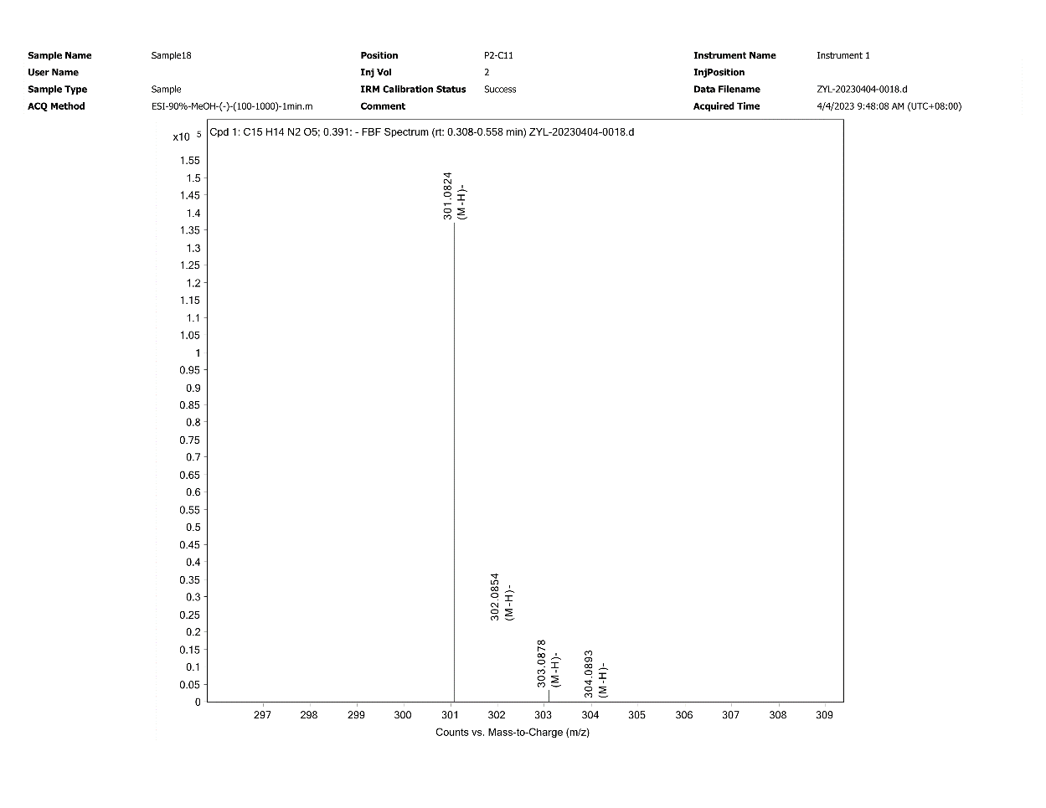
Figure S10. The ESI⁺ spectrum of compound 1.

