Supplementary
Text S1 Solid-phase extraction methods
First, ~ 3-5 ml methanol (ULC-MS grade) and acidified Milli-Q water (pH = 2.0) were utilized to rinse and activate the PPL cartridges (500mg, 6ml). Subsequently, the acidified DOM filtered samples (pH = 2.0) was continuously passed through the cartridges (2 ml min⁻¹). Then, cartridges were rinsed with at least 20 ml acidified Milli-Q water to completely remove salts. The cartridges were air dried and immediately extracted with 5 mL of methanol (ULC-MS grade). Finally, the eluted samples were stored at ‒20°C away from light.

Text S2 FT-ICR MS analysis
The formula assignments were performed using Bruker Compass DataAnalysis software, which required that a mass error of < 0.5 ppm between the measured mass and the calculated mass for a given chemical formula and a signal-to-noise ratio (S/N) of >5. Briefly described, potential formulae were preselected from a theoretical framework with elemental combinations of C₁₋₈₀H₂₋₂₀₀O₀₋₄₀N₀₋₃S₀₋₂. P-containing molecules typically do not vary systematically and were excluded from further discussion (Kellerman et al., 2015). The elemental ratios of 0.333 < H/C < 2.25, O/C < 1.2, and O ≤ C+2 were set as stringent restrictions for further analysis. After removing unreasonable formulas, the one that had the lowest deviation was chosen if several chemically and mathematically legitimate elemental formulas remained. The formulas above 500 Da were assigned through the detection of CH₂- homologous series.

Table S1. The concentration of amino sugar and lignin phenol of different ecosystems in Tibetan Plateau from published data.
Ecosystem | SOC  (mg/g) | Amino sugar  (mean,  mg/g soil) | Lignin phenol  (mean,  mg/g soil) | Amino sugars (mean,  mg /g SOC) | Lignin phenol (mean,  mg/g SOC) | References
Desert | 2.95 | 0.19 | 0.10 | 57.71 | 27.90 | Ma et al., 2018
Desert Steppe | 8.46 | 0.72 | 0.11 | 7.83 | 11.40 | Ma et al., 2018
Typical Steppe | 29.57 | 2.49 | 0.23 | 84.66 | 8.50 | Ma et al., 2018
Meadow Steppe | 17.12 | 1.18 | 0.16 | 71.81 | 10.00 | Ma et al., 2018
Alpine grassland | 1.27 | NA | 0.35 | NA | 15.88 | Ma et al., 2019
Grassland | 42.06 | NA | 0.15 | NA | 3.67 | Feng et al., 2007
Grassland | 18.08 | NA | 0.20 | NA | 12.65 | Zhao et al., 2014
Grassland | 29.73 | NA | 0.29 | NA | 11.01 | Zhu et al., 2019
Grassland | 31.90 | 1.94 | NA | 60.90 | NA | Ding et al., 2013
Grassland | 41.16 | 3.08 | NA | 84.33 | NA | Guan et al., 2018
Grassland | 70.90 | 4.78 | NA | 67.44 | NA | Jia et al., 2017
Grassland | 11.27 | 0.45 | NA | 40.80 | NA | Liang and Blaser, 2012
Grassland | 17.60 | 0.79 | NA | 46.04 | NA | Liang et al., 2013
Grassland | 66.70 | 5.30 | NA | 79.40 | NA | Luo et al., 2020
Grassland | 9.30 | 0.64 | NA | 68.64 | NA | Liang et al., 2015
Grassland | 14.98 | 1.18 | NA | 71.84 | NA | Ma et al., 2018
Grassland | 21.40 | 1.75 | NA | 81.66 | NA | Shao et al., 2018
Grassland | 22.17 | 1.20 | NA | 53.33 | NA | Zhang et al., 2021

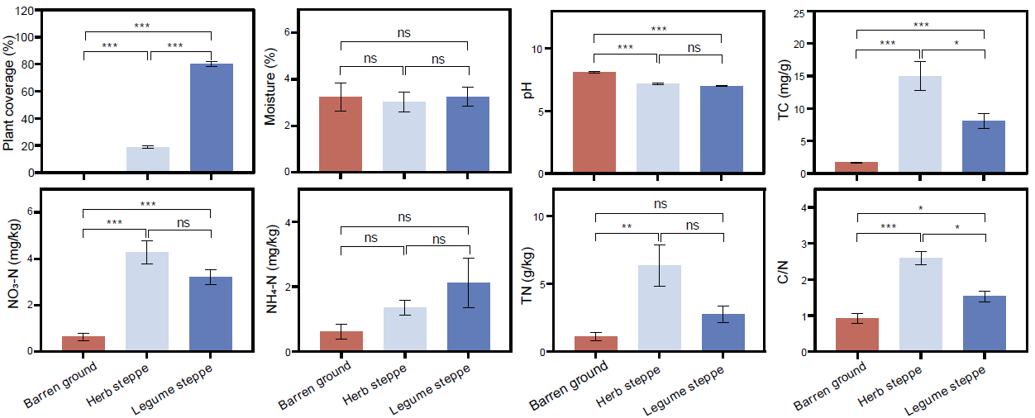
Fig. S1 Soil physicochemical properties among different succession stages.
Statistical significance is based on One-way ANOVA with LSD post hoc analysis. *** stands for P < 0.001; ** stands for P < 0.01; * stands for P < 0.05; ns stands for not significant.

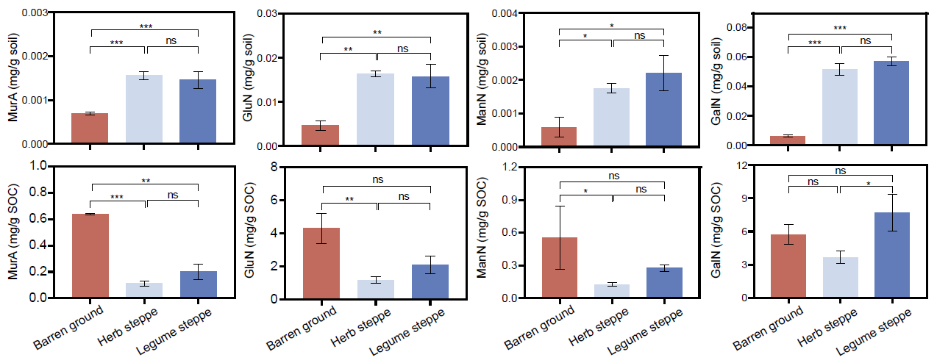
Fig. S2 Concentration of different microbial residues types and their contribution to SOC.
Statistical significance is based on One-way ANOVA with LSD post hoc analysis. *** stands for P < 0.001; ** stands for P < 0.01; * stands for P < 0.05; ns stands for not significant.

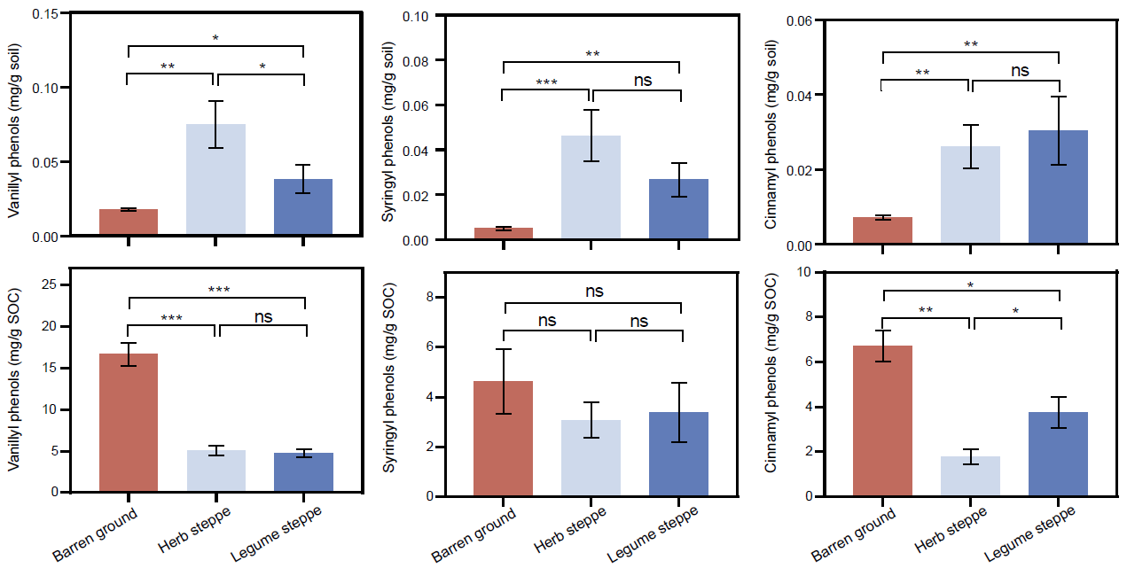
Fig. S3 Concentration of different lignin phenols monomers and their contribution to SOC.
Statistical significance is based on One-way ANOVA with LSD post hoc analysis. *** stands for P < 0.001; ** stands for P < 0.01; * stands for P < 0.05; ns stands for not significant.

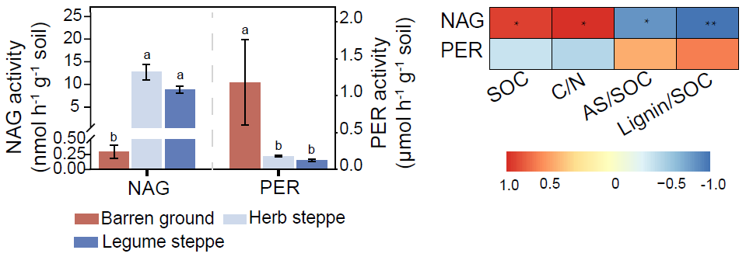
Fig. S4 Enzyme activities and correlations between them and environmental factors.
Statistical significance is based on One-way ANOVA with LSD post hoc analysis. ** stands for P < 0.01; * stands for P < 0.05. Different letters indicate significant differences among different succession stages. NAG: β-N-acetyl-glucosaminidase; PER: peroxidase; SOC: soil organic carbon; C/N: C-to-N ratio; AS/SOC: AS-to-SOC ratio; Lignin/SOC: lignin-to-SOC ration.

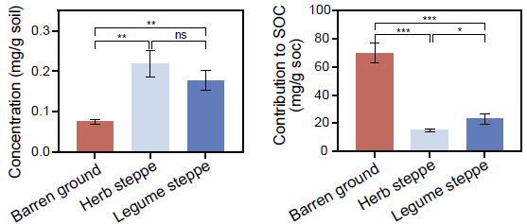
Fig. S5 Total concentration of amino sugar and lignin sugar and their total contribution to SOC.
Statistical significance is based on One-way ANOVA with LSD post hoc analysis. *** stands for P < 0.001; ** stands for P < 0.01; * stands for P < 0.05.

References
Kellerman, A.M., Kothawala, D.N., Dittmar, T., Tranvik, L.J., 2015. Persistence of dissolved organic matter in lakes related to its molecular characteristics. Nature Geoscience 8, 454-U452.
Ma, T., Zhu, S., Wang, Z., Chen, D., Dai, G., Feng, B., Su, X., Hu, H., Li, K., Han, W., Liang, C., Bai, Y., Feng, X., 2018. Divergent accumulation of microbial necromass and plant lignin components in grassland soils. Nature Communications 9, 3480.
Feng, X., Simpson, M.J., 2007. The distribution and degradation of biomarkers in Alberta grassland soil profiles. Organic Geochemistry 38(9), 1558-1570.
Zhao, L., Wu, W., Xu, X., Xu, Y., 2014. Soil organic matter dynamics under different land use in grasslands in Inner Mongolia (northern China). Biogeosciences 11, 5103-5113.
Zhu, S., Dai, G., Ma, T., Chen, L., Chen, D., Lü, X., Wang, X., Zhu, J., Zhang, Y., Bai, Y., Han, X., He, J.-S., Feng, X., 2019. Distribution of lignin phenols in comparison with plant-derived lipids in the alpine versus temperate grassland soils. Plant and Soil
Ding, X., Han, X., Zhang, X., Qiao Y., 2013. Effects of contrasting agricultural management on microbial residues in a Mollosol in China. Soil and Tillage Research 130, 13-17.
Guan, Z., Li, X., Wang, L., Mou, X., Kuzyakov, Y., 2018. Conversion of Tibetan grasslands to croplands decreases accumulation of microbially synthesized compounds in soil. Soil Biology and Biochemistry 123, 10-20.
Jia, J., Feng, X., He, J., He, H., Lin, L., Liu, Z., 2017. Comparing microbial carbon sequestration and priming in the subsoil versus topsoil of a Qinghai-Tibetan alpine grassland. Soil Biology and Biochemistry 104, 141-151.
Liang, C., Balser, T.C., 2012. Warming and nitrogen deposition lessen microbial residue contribution to soil carbon pool. Nature Communications 3, 1222
Liang, C., Duncan, D. S., Balser, T. C., Tiedje, J. M., Jackson, R. D., 2013. Soil microbial residue storage linked to soil legacy under biofuel cropping systems in southern Wisconsin, USA. Soil Biology and Biochemistry 57, 939-942.
Luo, R., Kuzyakov, Y., Liu, D., Fan, J., Luo, J., Lindsey, S., He, J.-S., Ding, W., 2020. Nutrient addition reduces carbon sequestration in a Tibetan grassland soil: Disentangling microbial and physical controls. Soil Biology and Biochemistry 144, 107764.
Liang, C., Gutknecht, J. L. M., Balser, T., 2015. Microbial lipid and amino sugar responses to log-term simulated global environmental changes in a California annual grassland. Frontiers in Microbiology 6, 385.
Shao, P., He, H., Zhang, X., Xie, G., Bao, X., Liang, C., 2018. Responses of microbial residues to simulated climate change in a semiarid grassland. Science of the Total Environment 644, 1286-1291.
Zhang, X., Jia, J., Chen, L., Chu, H., He, J.-S., Zhang, Y., Feng, X., 2021. Aridity and NPP constrain contribution of microbial necromass to soil organic carbon in the Qinghai-Tibet alpine grasslands. Soil Biology and Biochemistry, 156, 108213.

