SUPPLEMENTARY DATA
S1
Methods: Pharmacology data was generated from 16 QPatch runs. Transfection efficiency was assessed from the number of whole-cell recordings per QPatch run expressing large (>300 pA), slowly-activating, Ani9-sensitive current. This definition of ‘transfected’ vs ‘untransfected’ was established by comparing transfected cell recordings with ‘sham’ transfects, i.e. cells that had undergone the same transfection process but with the omission of plasmid DNA (Supplementary Figure S1). The ‘sham’ transfects, like untransfected HEK cells, had a small background chloride current generally <300 pA in size (equating to 21.5±3.5 pA/pF (n=14); Figure S1a). These currents were rapidly-activating and inactivating, with a time-constant of 16.2±2.4 ms (n=14), showed voltage-sensitivity but were insensitive to block by 10 µM Ani9. Interestingly, they were blocked by 100 µM CaCCinh-A01. In QPatch experiments using transfected cells, approximately 45 % displayed a distinctively large current (1-2 nA or 114.5±25 pA/pF (n=11)) which activated/inactivated slowly with a time-constant of 88.3±8.2 ms (n=11; Figure S1b). This current showed outward rectification at positive potentials and sensitivity to block by both 10 µM Ani9 and 100 µM CaCCinh-A01, matching characteristics ascribed to human TMEM16A. Cells with these characteristics were deemed to be expressing X. tropicalis Tmem16a, and only recordings from successfully-transfected cells which additionally passed seal/series resistance and capacitance quality control criteria, were used in analysis of X. tropicalis Tmem16a currents.

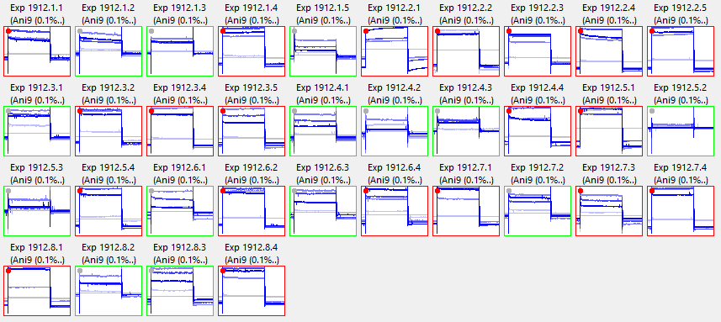
a.
b.
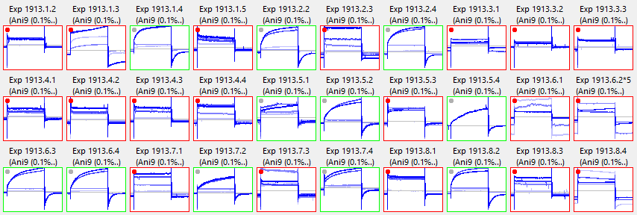
c.
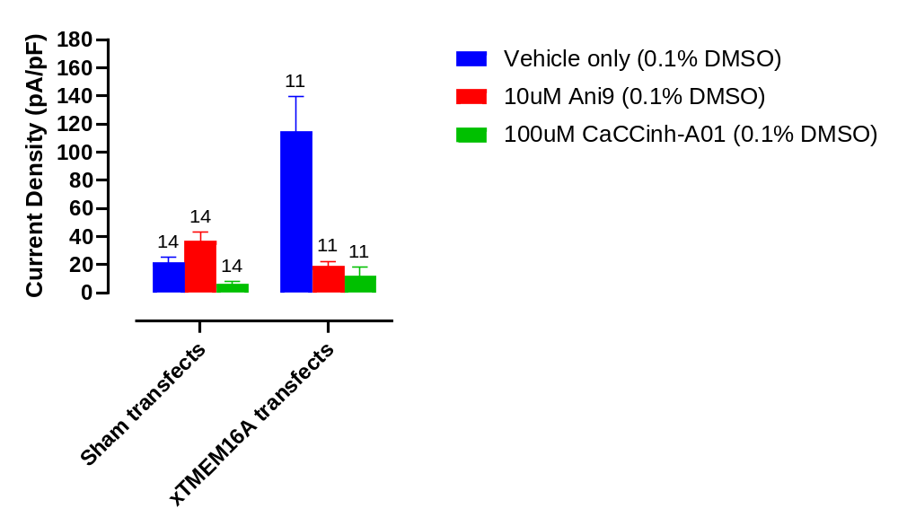Supplementary Figure S1. Identification of successfully-transfected cells
a-b. Snapshot of QPatch runs using sham transfects (a) and cells transfected with tmem16a (b). Wells highlighted in green passed quality control assessment and were used in analysis, those in red were rejected (see text for full definitions). c. Current levels and Ani9-sensitivity in sham and tmem16a transfects which passed quality control assessment.

S2
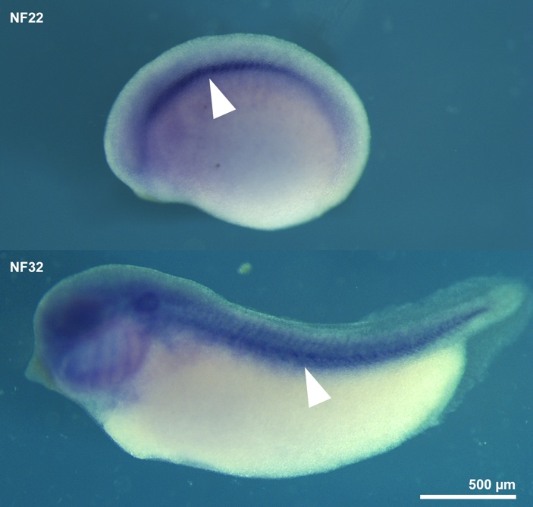
Supplementary Figure S2. Expression of cftr at NF22 (upper) and NF32 (lower)
In situ hybridisation to detect expression of cftr in the developing tadpole. Expression was not detected in the skin. However, arrowheads indicate expression in the notochord.

