Supplementary Table 1. qRT-PCR primer sequence
primer name | primer sequence (5’-3’) | product length (bp) | annealing temperature(℃)
β-actin Forward | AGGGAAATCGTGCGTGAC | 192 | 58.0
β-actin Reverse | CATACCCAAGAAGGAAGGCT | 192 | 58.0
FGF23 Forward | CGCTGGAGAATGGCTATGAC | 166 | 59.2
FGF23 Reverse | GGGCGAACAGTGTAGAAATGC | 166 | 59.2
FGFR4 Forward | CAAGGGAAACCTTCGGGAAT | 170 | 57.8
FGFR4 Reverse | GGTGGATGCACTTCCGAG | 170 | 57.8
MHC Forward | CACCACCAACCCATACGACTA | 125 | 58.8
MHC Reverse | CATCAGAAGTGAAGCCCAGAATA | 125 | 58.8
MyoD Forward | TGGCTACGACACCGCCTACT | 220 | 61.5
MyoD Reverse | GGTCTGGGTTCCCTGTTCTG | 220 | 61.5
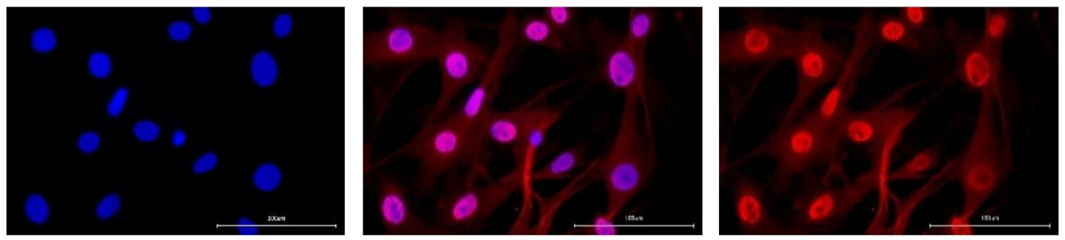
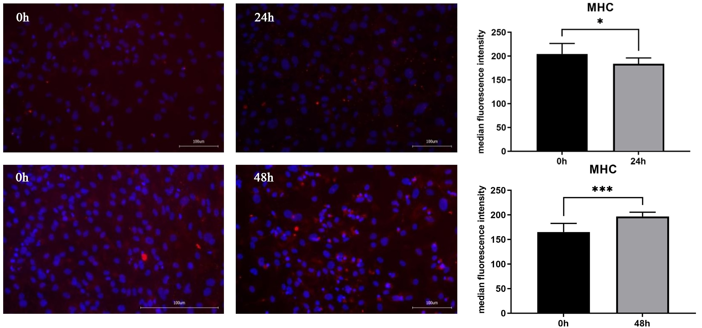
Supplementary Figure 1. Immunofluorescence labeling of muscle satellite cell marker protein Pax7, scale bar: 100μm.

Supplementary Figure 2. Immunofluorescence labeling and statistical analysis of MHC 24h and 48h after induction of muscle satellite cell differentiation, scale bar: 100μm.

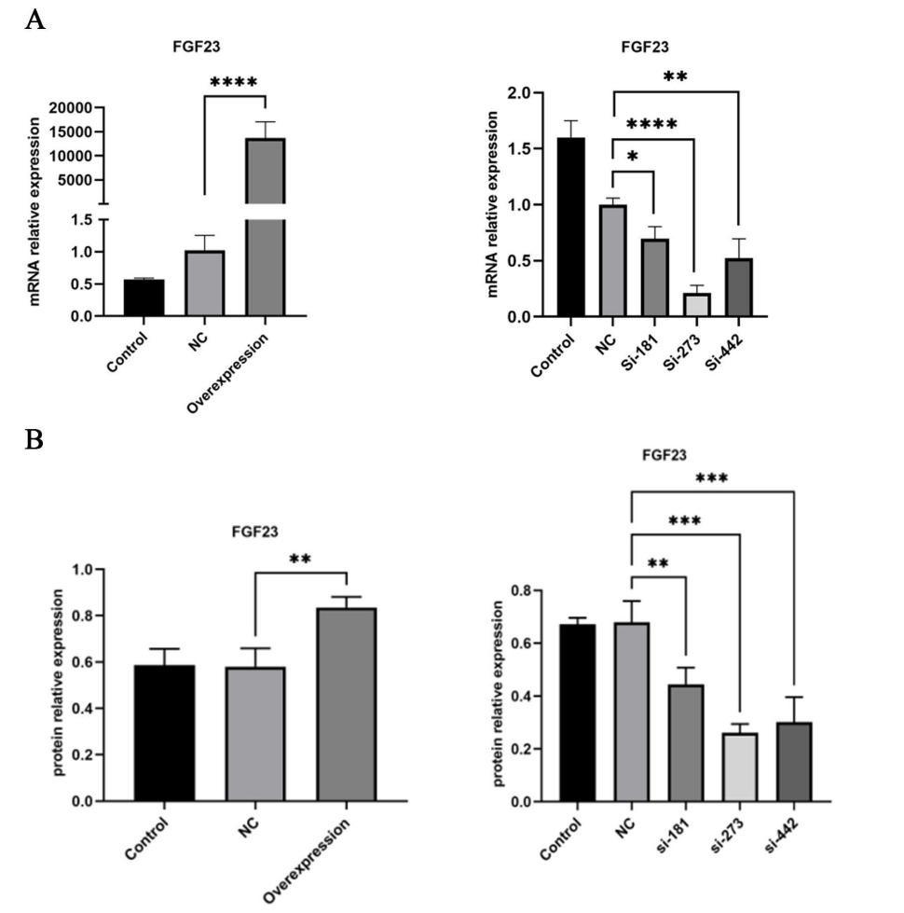
Supplementary Figure 3. The mRNA (A) and protein (B) expression of FGF23 after transfection of muscle satellite cells with FGF23 overexpression vector and FGF23 siRNA, respectively.
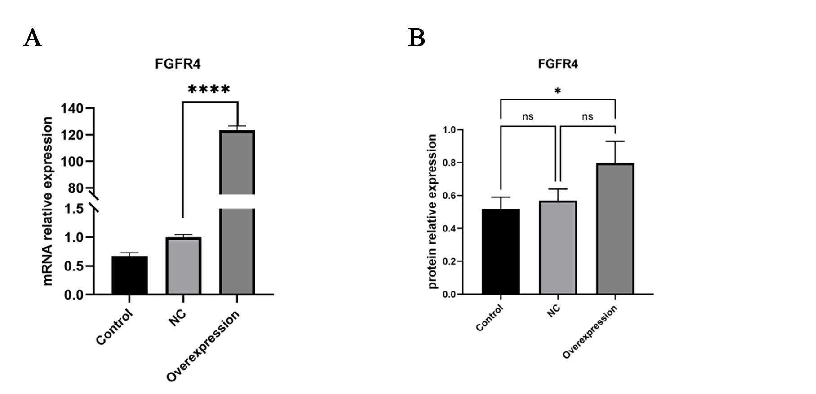
The control represents the blank control group, NC represents the FGF23 overexpression empty vector group or the FGF23 interference empty vector group, overexpression represents the FGF23 overexpression group, and siRNA-181, siRNA-273 and siRNA-442 represent different FGF23 interference groups.

Supplementary Figure 4. The mRNA (A) and protein (B) expression of FGFR4 after transfection of muscle satellite cells with FGFR4 overexpression vector.
The control represents the blank control group, NC represents the FGFR4 overexpression empty vector group, and overexpression represents the FGFR4 overexpression group.

