Supplement

Supporting Information
Long lists are provided as metadata on https://github.com/vollkorrn/ElbeEstuarineZander
S1_Table Relative abundance (%) of sequences belonging to phyla in gill microbiome and bacterioplankton.
S1_List Full list of ASVs with taxonomy, sequence data, relative abundance and counts per sample. Abundance filtered (0.005% overall abundance)
S2_List Core ASVs with taxonomy, sequence data, relative abundance (rel) and counts per sample. Abundance filtered (0.005% overall abundance).
S3_List Differential abundant ASVs from pairwise comparisons joined in heatmap clusters with taxonomy, sequence data, relative abundance (rel) and counts per sample. Abundance filtered (0.005% overall abundance).
S4_List Bacterial abundance correlated (r > 0.4) to fish immune response module (Gill-RNA-7) eigengene with taxonomy, sequence data, and counts per sample. Abundance filtered (0.005% overall abundance).
S5_List Bacterial abundance correlated (r > 0.4) to fish immune response module (Gill-RNA-11) eigengene with taxonomy, sequence data, and counts per sample. Abundance filtered (0.005% overall abundance).
S1 Figure Bacterial ASV accumulation over number of sampled specimen for unfiltered data (A) and 0.005% overall abundance filtered data (B). Compositional barplot showing relative abundance of bacteria at genus level from Sander lucioperca gill swab core ASVs (n = 47) (C) and relative proportions of genera within the core microbiome along the course of the estuary.
S2 Figure Cluster heatmap of differential abundant genes in gill tissue tested by DESEq2 (significance when LFC > 0.05 & p.adjust < 0.05) in pairwise comparison of sampling groups, joined and clustered via pam algorithm into four clusters (A). Genes are filtered for TPM > 1 (n = 4519) in at least three samples. Depicted are Z-score values with red = high and blue = low. Individual gene names with LFC > 1 (n = 21) are shown on the right side of the heatmap. Cluster-genes were tested for functional enrichment via ClusterProfiler against the KEGG-database, top 10 pathways by significance per cluster are shown as well as number of genes involved (X-axis) (B).
S3 Figure Cluster heatmap of differential abundant genes in liver tissue tested by DESEq2 (significance when LFC > 0.05 & p.adjust < 0.05) in pairwise comparison of sampling groups, joined and clustered via pam algorithm into four clusters (A). Genes are filtered for TPM > 1 (n = 2775) in at least three samples. Depicted are Z-score values with red = high and blue = low. Individual gene names with LFC > 1 (n = 21) are shown on the right side of the heatmap. Cluster-genes were tested for functional enrichment via ClusterProfiler against the KEGG-database, top 10 pathways by significance per cluster are shown as well as number of genes involved (X-axis) (B).

S.1_Table Relative abundance (%) of sequences belonging to phyla in gill microbiome and bacterioplankton.
 | WF | MG - 711 | BB - 692 | SS - 665 | ML - 633
Phylum
Proteobacteria | 38 | 62 | 53 | 54 | 78
Bacteroidota | 15 | 21 | 20 | 32 | 14
Actinobacteriota | 24 | 3 | 2 | 6 | 2
Verrucomicrobiota | 8 | 3 |  | 2 | 3
Firmicutes |  | 6 | 22
Deinococcota |  |  |  | 3
Desulfobacterota |  | 1
Acidobacteriota | 2
Cyanobacteria | 4
Nitrospirota | 3
Planctomycetota | 1

S.2_Table Differences in community structure between fish and bacterioplankton as well as fish sampling groups via PERMANOVA and post hoc pairwise t-test.
Test
 | Pairs | DF | SumsOfSqs | F.Model | p.adjust
PERMANOVA | Kind | 1 | 28212 | 7.57 | 0.001
PERMANOVA | Location | 3 | 29011 | 3.55 | 0.001
Permutation for homogeneits of multivariate dispersions | Location | 3 | 98.55 | 1.16 | 0.34
post hoc pairwise t-test | MG vs BB | 1 | 4108.69 | 1.44 | 0.042
 | MG vs SS | 1 | 10402.21 | 3.64 | 0.006
 | MG vs ML | 1 | 15061.55 | 5.27 | 0.012
 | BB vs SS | 1 | 7298.86 | 2.82 | 0.024
 | BB vs ML | 1 | 12716.63 | 4.91 | 0.006
 | SS vs ML | 1 | 8434.26 | 3.26 | 0.012

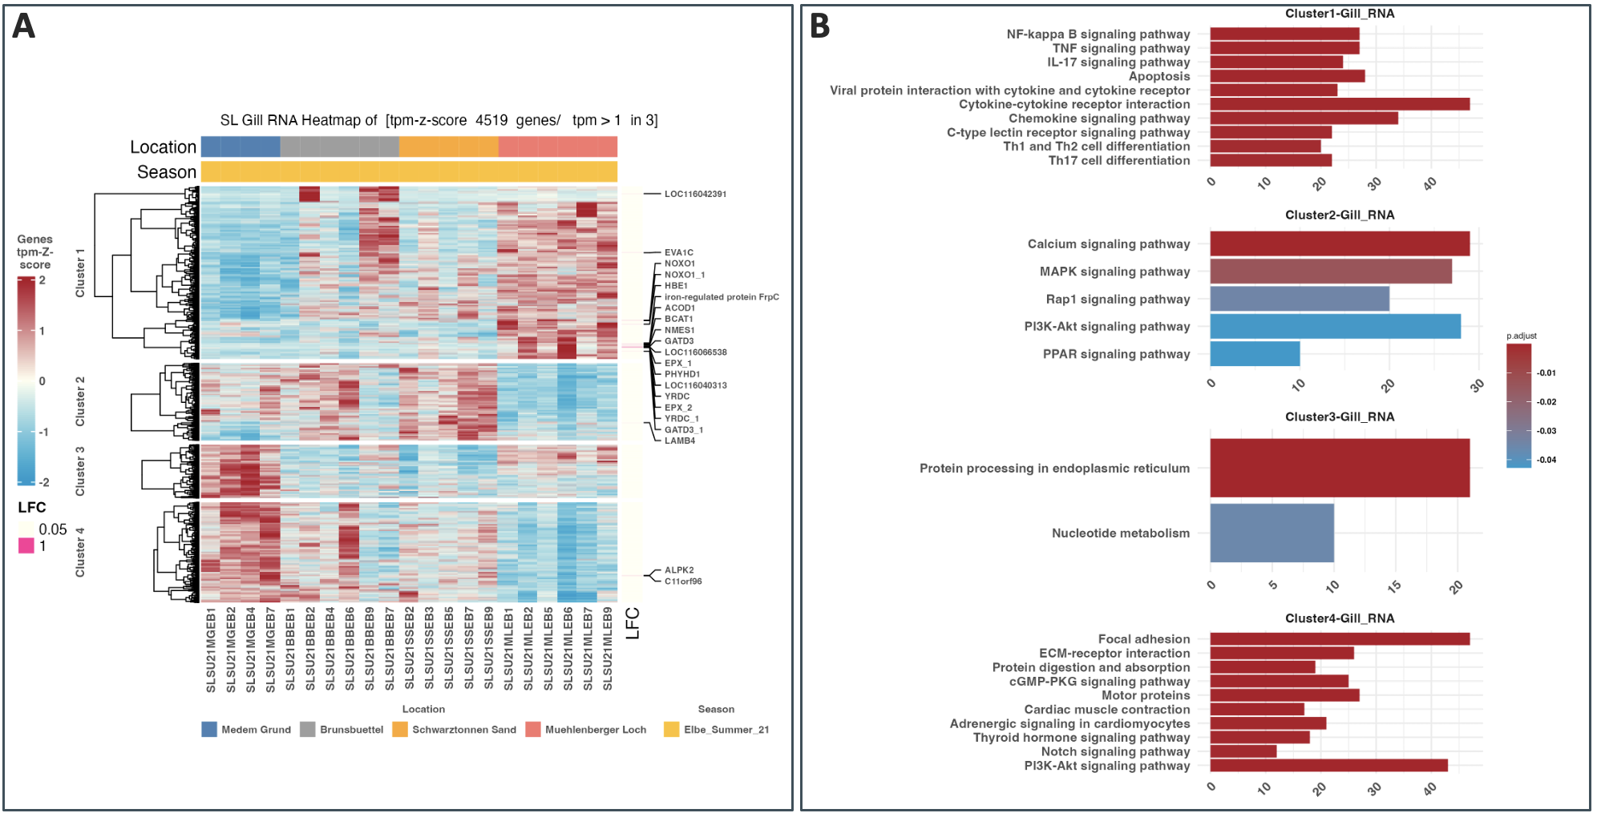
S2 Figure Cluster heatmap of differential abundant genes in gill tissue tested by DESEq2 (significance when LFC > 0.05 & p.adjust < 0.05) in pairwise comparison of sampling groups, joined and clustered via pam algorithm into four clusters (A). Genes are filtered for TPM > 1 (n = 4519) in at least three samples. Depicted are Z-score values with red = high and blue = low. Individual gene names with LFC > 1 (n = 21) are shown on the right side of the heatmap. Cluster-genes were tested for functional enrichment via ClusterProfiler against the KEGG-database, top 10 pathways by significance per cluster are shown as well as number of genes involved (X-axis) (B).

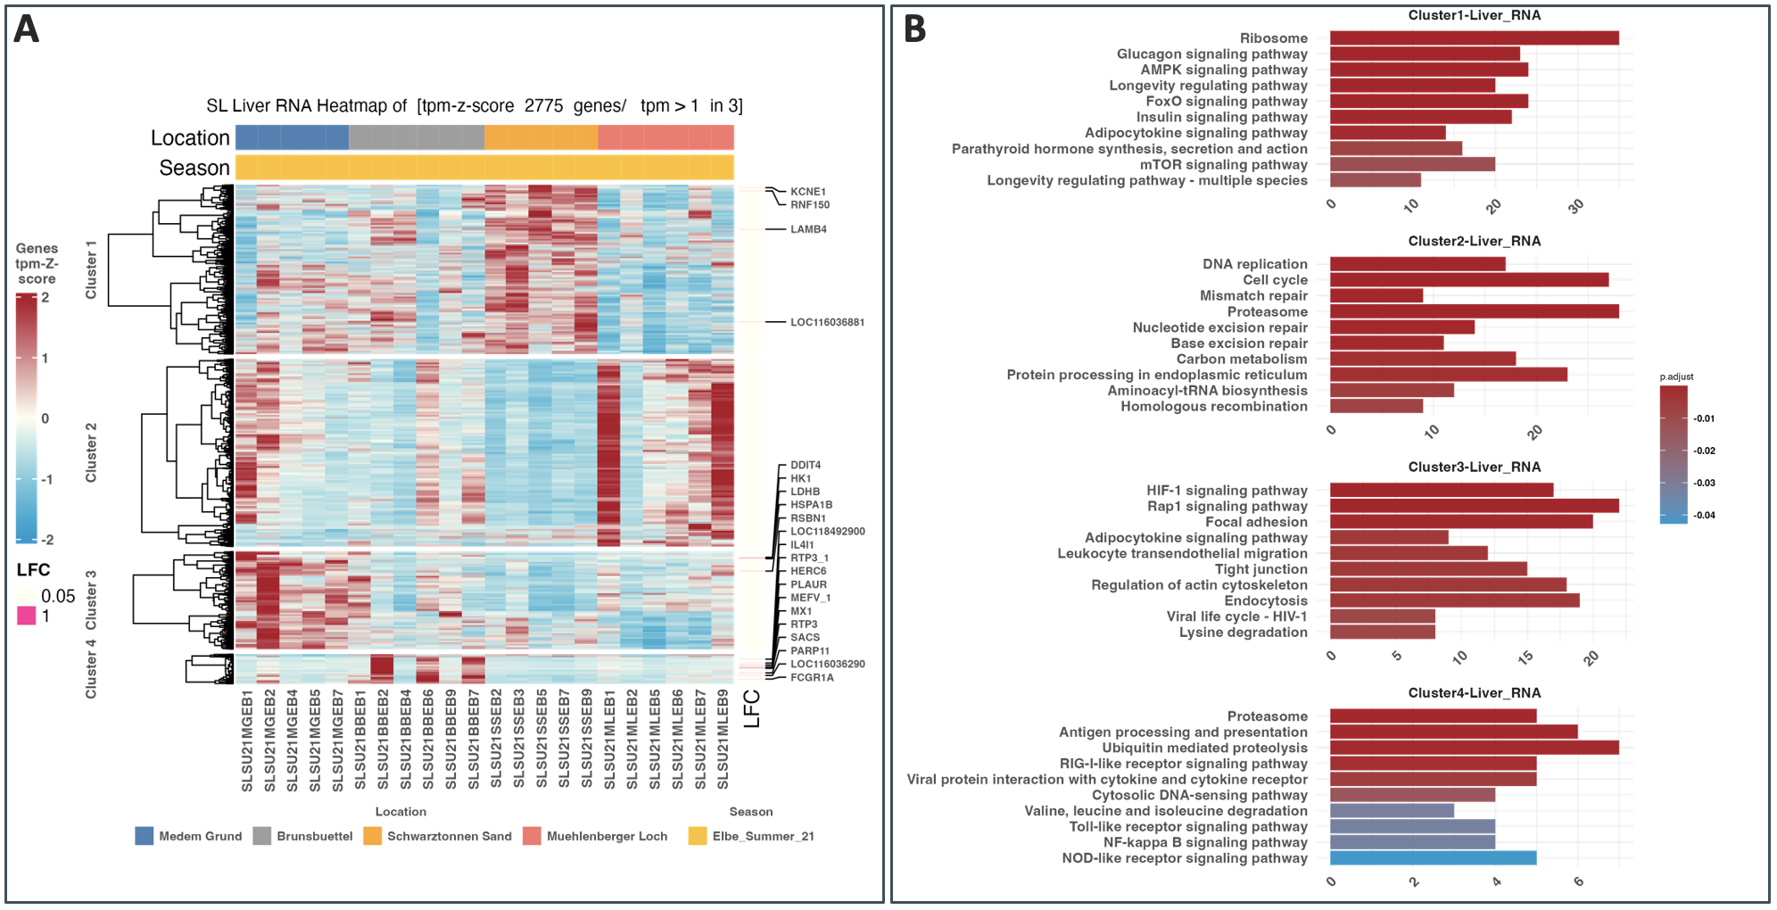
S3 Figure Cluster heatmap of differential abundant genes in liver tissue tested by DESEq2 (significance when LFC > 0.05 & p.adjust < 0.05) in pairwise comparison of sampling groups, joined and clustered via pam algorithm into four clusters (A). Genes are filtered for TPM > 1 (n = 2775) in at least three samples. Depicted are Z-score values with red = high and blue = low. Individual gene names with LFC > 1 (n = 21) are shown on the right side of the heatmap. Cluster-genes were tested for functional enrichment via ClusterProfiler against the KEGG-database, top 10 pathways by significance per cluster are shown as well as number of genes involved (X-axis) (B).

