Energy production through enhanced organic matter recovery in high-rate contact stabilization with Klebsiella pneumoniae

Minsu Song ª, Jihye Park ^{b}, Sanghyun Jeong ^{b}, Daehee Choi ^{c}, Yong-Uk Shin ª,
Hyokwan Bae ^{a, d,} *

ª Department of Civil, Urban, Earth and Environmental Engineering, Ulsan National Institute of Science and Technology, 50 UNIST-gil, Eonyang-eup, Ulju-gun, Ulsan 44919, Republic of Korea
^{b} Department of Civil and Environmental Engineering, Pusan National University, 63 Busandeahak-ro, Geumjeong-Gu, Busan 46241, Republic of Korea
^{c} Department of Environmental Engineering, Yeungnam University, 280 Daehak-Ro, Gyeongsan-Si, Gyeongbuk 38541, South Korea
^{d} Graduate School of Carbon Neutrality, Ulsan National Institute of Science and Technology (UNIST), 50 UNIST-gil, Eonyang-eup, Ulju-gun, Ulsan 44919, Republic of Korea

*Corresponding author: Hyokwan Bae, Ph.D.
Department of Urban and Environmental Engineering, Ulsan National Institute of Science and Technology (UNIST), 50 UNIST-gil, Eonyang-eup, Ulju-gun, Ulsan 44919, Republic of Korea
E-mail: hyokwan.bae@unist.ac.kr
Tel: +82-52-217-2801
Fax: +82-52-217-2859
ORCID: 0000-0002-2422-9411

Table S1. Identification of microorganisms isolated from HRCS sludge by 16S rDNA analysis.
Sequence | Most match | similarity (%) | NCBI Accession #
GCA·····CTA | Bacillus sp. GD0706 | 99.72 | DQ084540.1
GTC·····CTA | Klebsiella pneumoniae | 100 | CP052262.1
GAG·····GGG | Klebsiella pneumoniae | 86.6 | MT037171.1
GCA·····TTG | Klebsiella pneumoniae | 99.93 | CP052262.1
TGC·····AGT | Exiguobacterium acetylicum | 99.93 | KP191982.1
TAC·····CTA | Klebsiella pneumoniae | 99.93 | CP052262.1
GCA·····ACT | Klebsiella pneumoniae | 99.86 | MG890348.1
TCT·····CTC | Exiguobacterium sp. ZWU0009 | 92.74 | CP018057.1

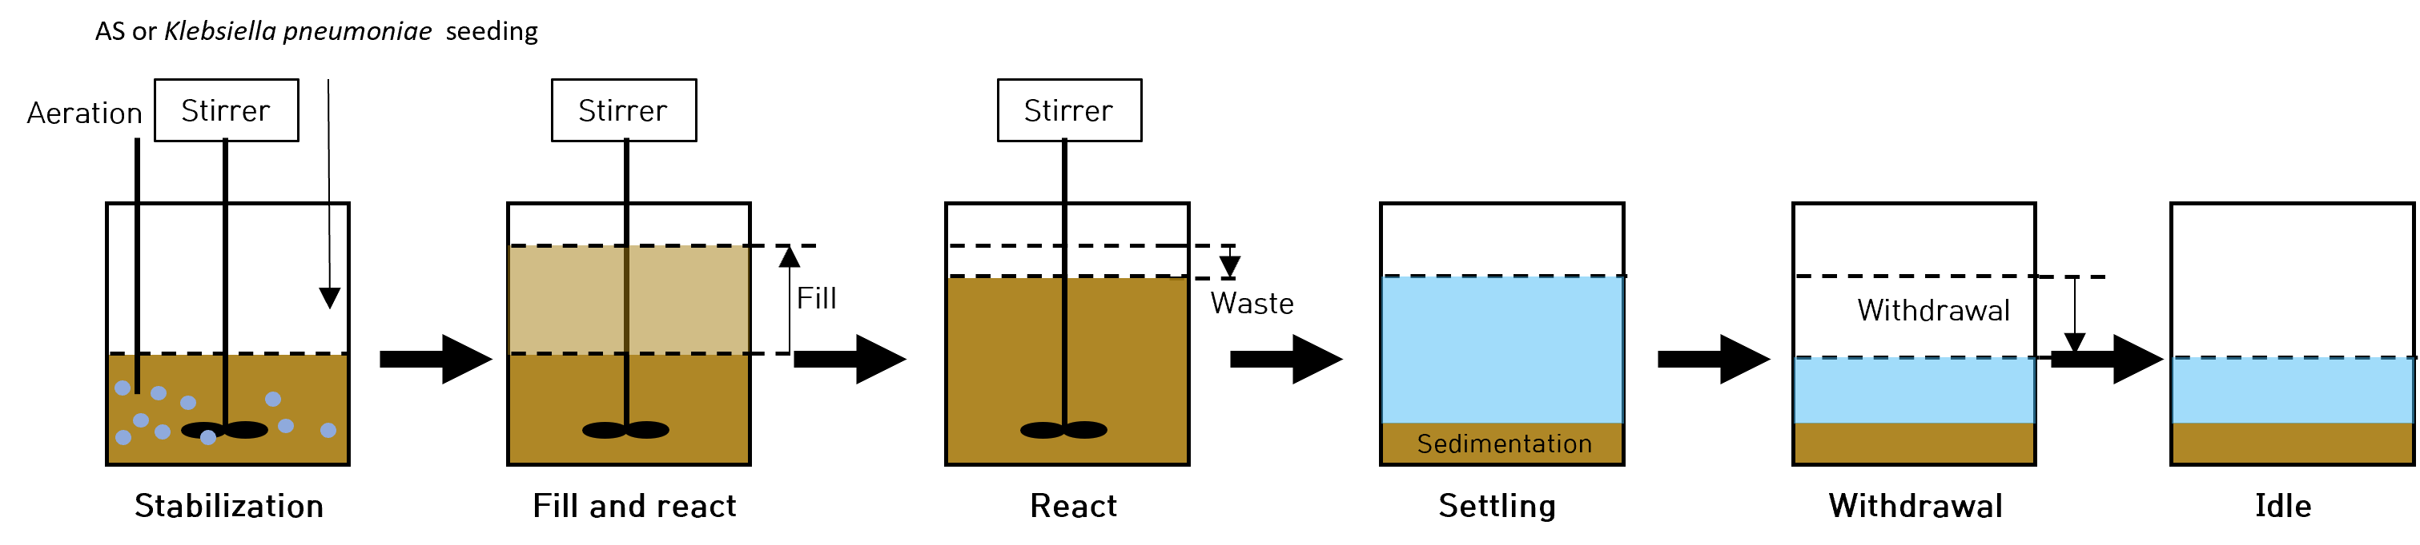
Figure. S1. flow diagram of the HRCS reactor in SBR configuration with inoculation of AS or Klebsiella pneumoniae.

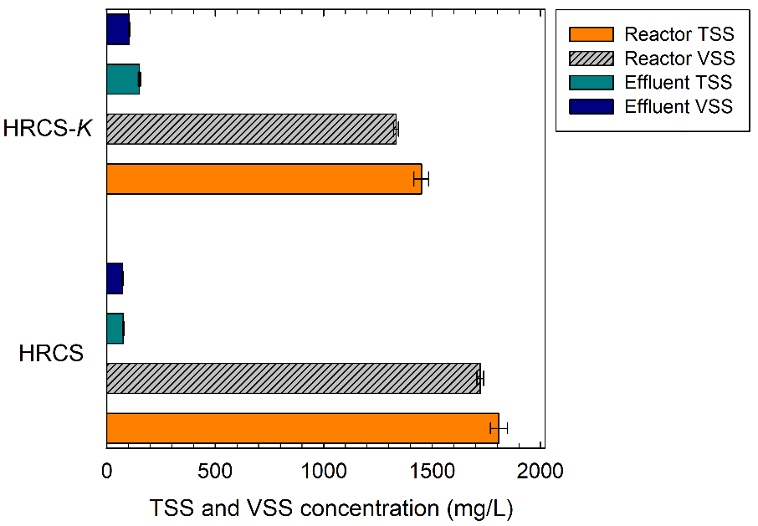
Figure. S2. TSS and VSS concentrations in the reactor interior and effluent for HRCS and HRCS-K systems.

