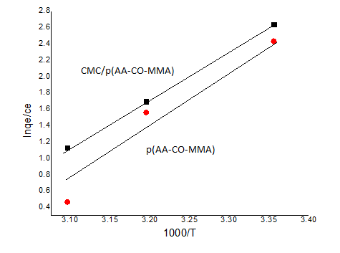

Fig. S3: thermodynamic plot for p(AA-co-MMA) and CMC/ p(AA-co-MMA)

