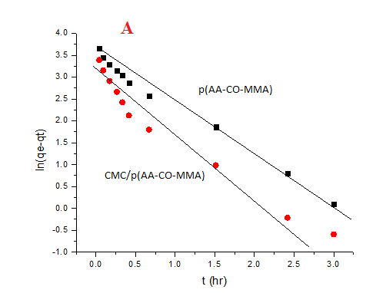 | 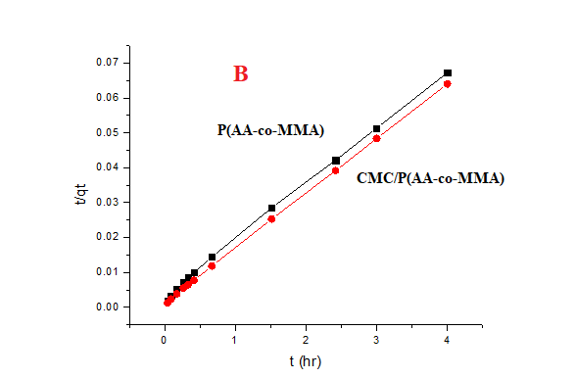
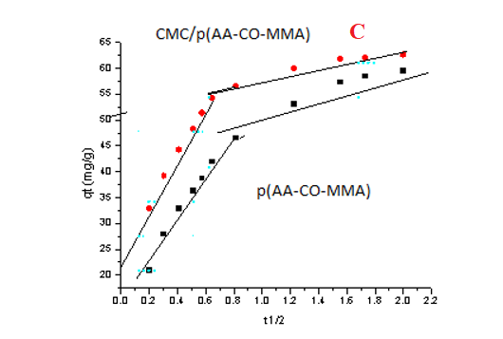
Fig. S2: (A) pseudo-first order plot for p(AA-co-MMA) and CMC/ p(AA-co-MMA) (B) pseudo-second order plot for p(AA-co-MMA) and CMC/ p(AA-co-MMA) (C) intra particle diffusion plot for p(AA-co-MMA) and CMC/ p(AA-co-MMA)

