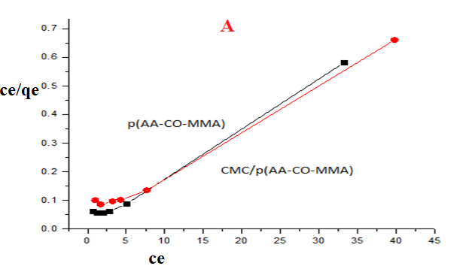 | 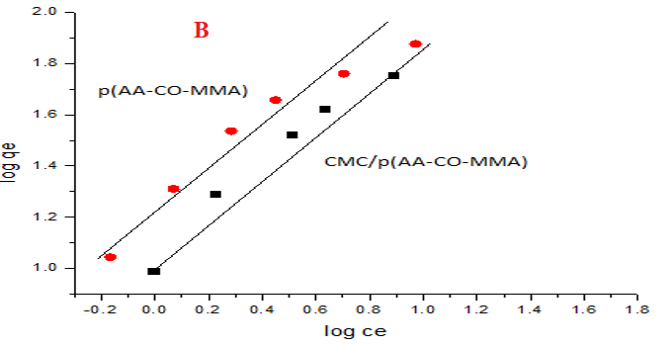
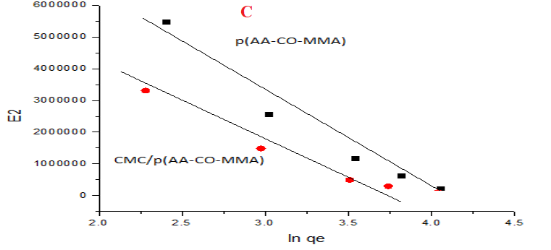
Fig. S1: (A) Langmuir plot for p(AA-co-MMA) and CMC/ p(AA-co-MMA) (B) Freundlich plot for p(AA-co-MMA) and CMC/ p(AA-co-MMA) (C) Dubinin–Radushkevich equilibrium plot for p(AA-co-MMA) and CMC/ p(AA-co-MMA)

