Supplementary Data
Table S1: Details of primer sequence used for the study.
Gene | Primer sequences
SERPINA3 | Fw: 5’CGCACCCTCAATCAGTCCAG3’  Rv: 5’CAAAGGCCTCGGAGCCATAC3’
L19 | Fw: 5’GCGGAGAGGGTACAGCCAAT3’  Rv: 5’GCAGCCGGCGCAAA3’

Table S2: The score values given for intensity (I) and percentage positivity (P).
Staining intensity | Intensity score  (I) | Number of positive cells/Area positivity | Positive cells score (P)
Negative | 0 | <25% | 1
Weak | 1+ | 25-50% | 2
Moderate | 2+ | 50-75% | 3
Strong | 3+ | ≥75% | 4

Calculations for scoring:
Quickscore (H-score) = I × P
Minimum H-score = 0, Maximum H-score = 12
H-score 0-3: SERPINA3 Low-expression group
H-score 4-12: SERPINA3 High-expression group

Values were assigned based on the quantity of positive cells (P) and intensity of staining (I) as shown in the table above.

Table S3: Reads obtained from mRNA sequencing of tumor and matched normal biopsies.
Sample | Platform | Type of reads | Total number of raw reads  (in million) | Total number of processed Reads  (in million)
Normal | NextSeq 500 | 2*Paired end (75bp) | 28704935 | 27905573
Tumor | NextSeq 500 | 2*Paired end (75bp) | 24777597 | 24083677

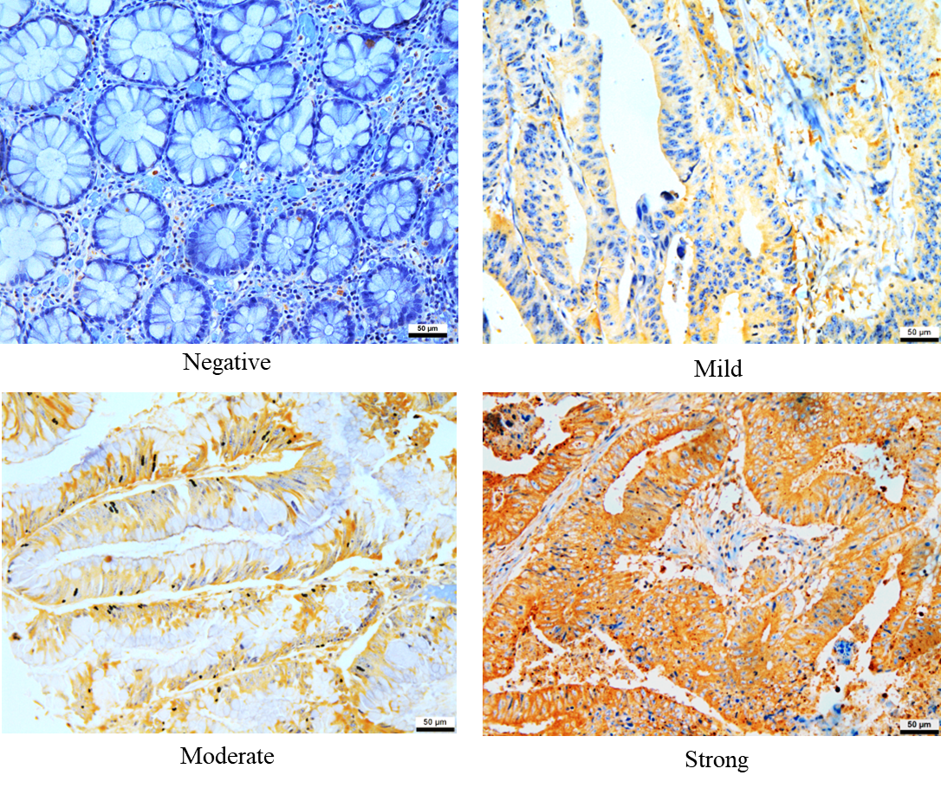

.

Figure S1: Representative images for SERPINA3 staining intensities.

Figure S2: SERPINA3 staining in rectal tissue types.

