Table 4: Promoter analysis of hub proteins
Motif | logo | width | Gene ontology
MAZ_HUMAN.H11MO.0.A | 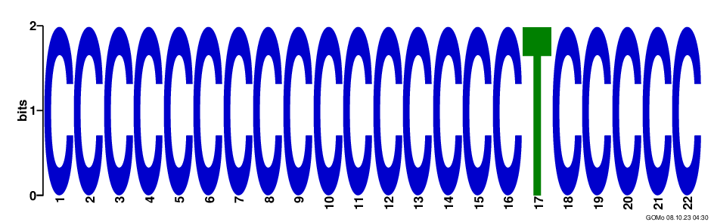 | 22 | CC transcription factor complex  BP negative regulation of signal transduction  MF protein heterodimerization activity  MF protein homodimerization activity  CC dendrite
MXI1_HUMAN.H11MO.0.A | 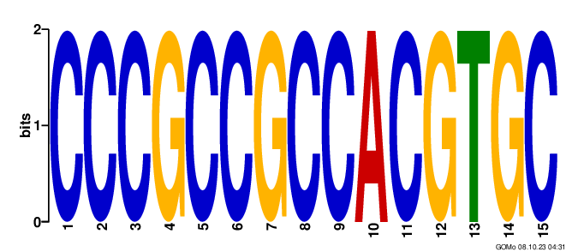 | 15 | CC transcription factor complex  MF ATP binding  CC nucleolus  BP anterior/posterior pattern formation  CC cytosol
SP1_HUMAN.H11MO.0.A | 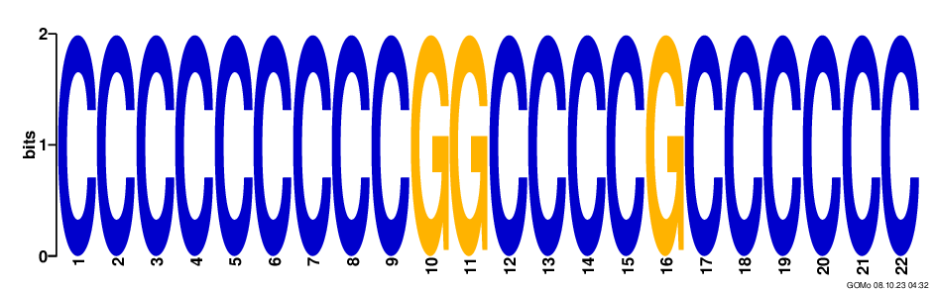 | 22 | CC transcription factor complex  BP negative regulation of signal transduction  MF potassium ion binding  BP negative regulation of neuron apoptosis  BP potassium ion transport
SP2_HUMAN.H11MO.0.A | 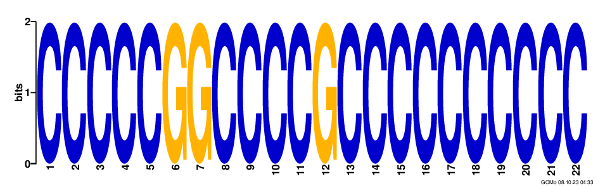 | 22 | CC transcription factor complex  BP negative regulation of signal transduction  MF protein heterodimerization activity  BP neuron fate commitment  MF chromatin binding
SP3_HUMAN.H11MO.0.B | 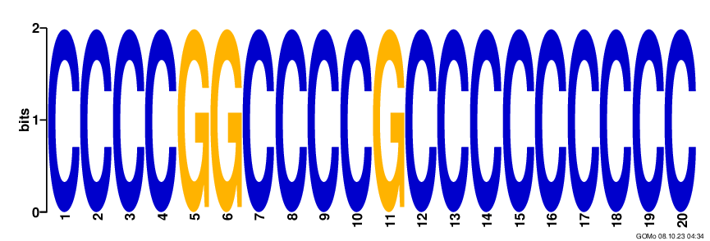 | 20 | CC transcription factor complex  BP negative regulation of signal transduction  MF protein heterodimerization activity  MF protein homodimerization activity  MF chromatin binding
VEZF1_HUMAN.H11MO.0.C | 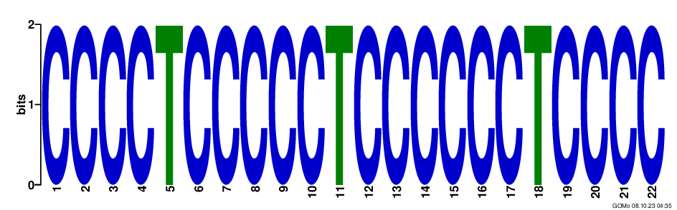 | 22 | CC transcription factor complex  CC dendrite  MF transcription activator activity  MF protein heterodimerization activity  BP negative regulation of signal transduction
WT1_HUMAN.H11MO.0.C | 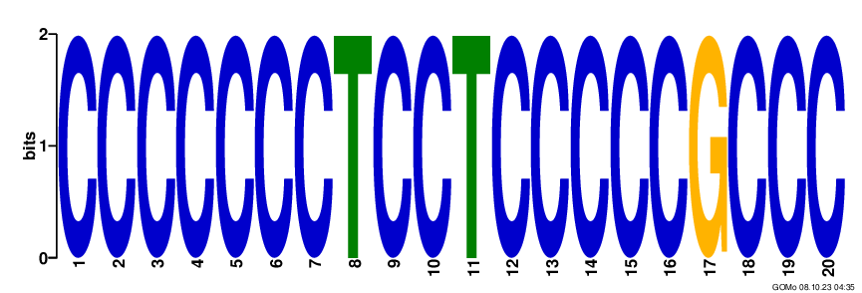 | 20 | CC transcription factor complex  MF protein heterodimerization activity  BP negative regulation of signal transduction  CC dendrite  MF potassium ion binding
ZN263_HUMAN.H11MO.0.A | 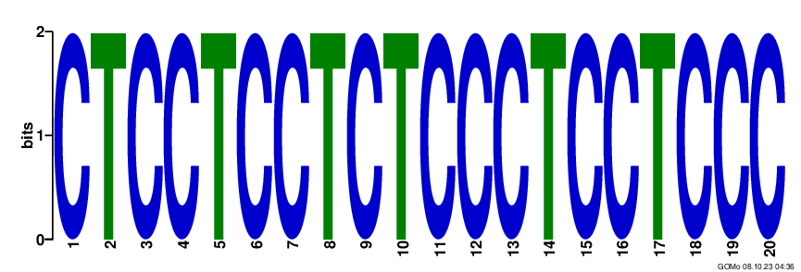 | 20 | BP negative regulation of transcription from RNA polymerase II promoter  BP signal transduction  MF protein heterodimerization activity  CC transcription factor complex  BP inner ear morphogenesis
ZN341_HUMAN.H11MO.0.C | 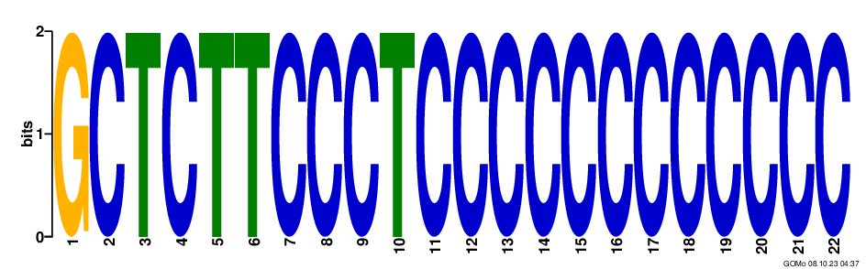 | 22 | CC transcription factor complex  MF potassium ion binding  BP potassium ion transport  BP spleen development  BP inner ear morphogenesis
ZN467_HUMAN.H11MO.0.C | 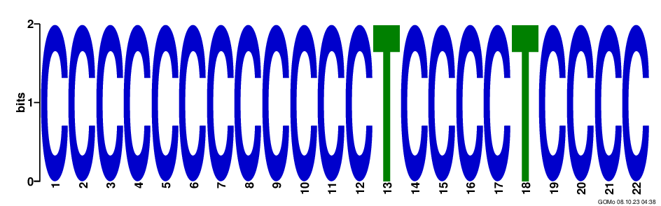 | 22 | CC transcription factor complex  BP negative regulation of signal transduction  MF protein heterodimerization activity  MF protein homodimerization activity  BP inner ear morphogenesis

