Supplementary file:
Druglikeness rule and Toxicity range for phytochemical molecules
Compound | Structure | PubChem CID | Lipinski rule | Pfizer rule | GSK rule | Golden Triangle
9-Octadecenamide | 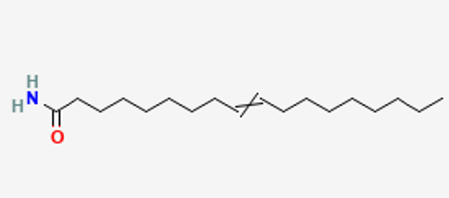 | 1930 | Accepted | Rejected | Rejected | Accepted
7-Nonenamide | 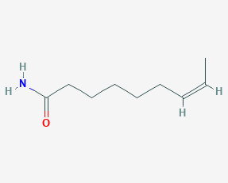 | 5365368 | Accepted | Accepted | Accepted | Rejected
13-Docosenamide | 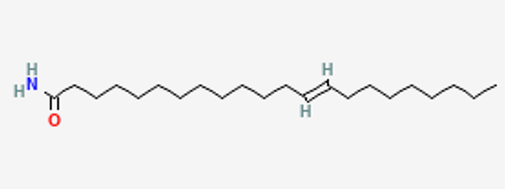 | 5365369 | Accepted | Rejected | Rejected | Accepted
Hexadecanamide | 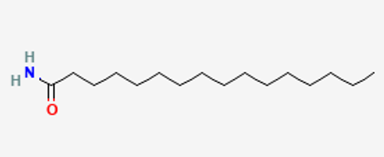 | 69421 | Accepted | Rejected | Rejected | Accepted
Pentadecanamide | 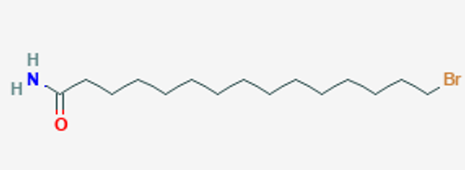 | 547888 | Accepted | Rejected | Rejected | Accepted
8,11,14-Eicosatrienoic acid | 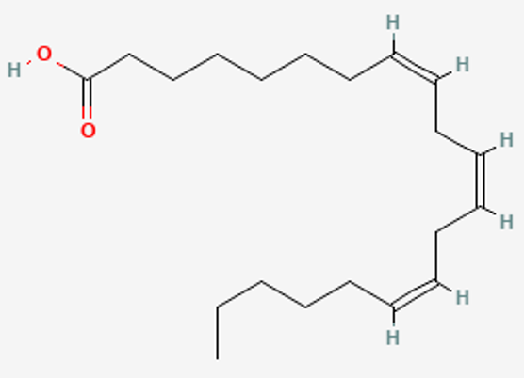 | 5280581 | Accepted | Rejected | Rejected | Accepted
Akuammilan-17-ol | 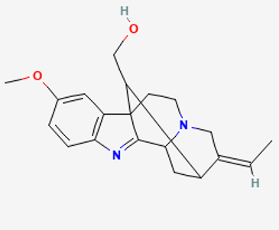 | 5363104 | Accepted | Accepted | Accepted | Accepted
Octadecanoic acid | 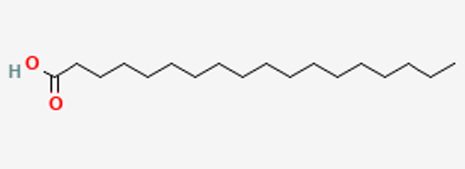 | 5281 | Accepted | Rejected | Rejected | Accepted
Eicosanoic acid | 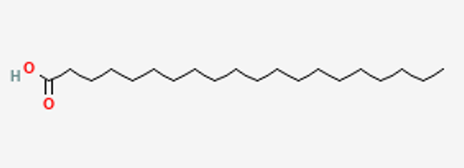 | 10467 | Accepted | Rejected | Rejected | Accepted
Docosanoic acid | 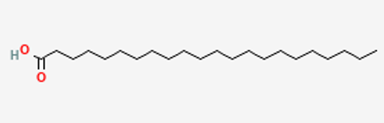 | 8215 | Accepted | Rejected | Rejected | Accepted
Nor-diazepam | 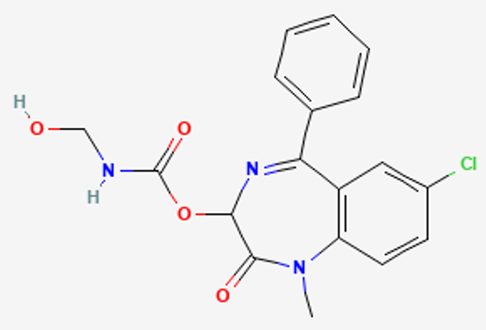 | 541761 | Accepted | Accepted | Accepted | Accepted
8-Quinolinedione | 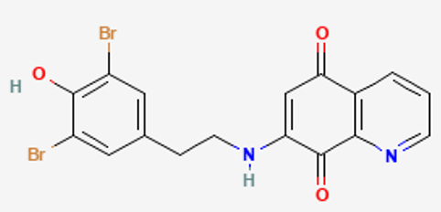 | 381594 | Accepted | Accepted | Rejected | Accepted
Phthalic acid | 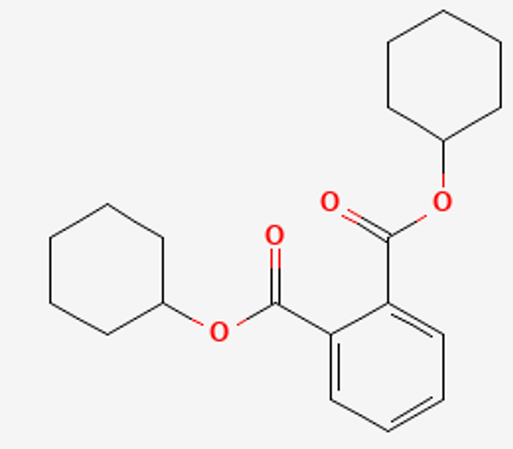 | 6777 | Accepted | Rejected | Rejected | Accepted
1,2-Benzenedicarboxylic acid | 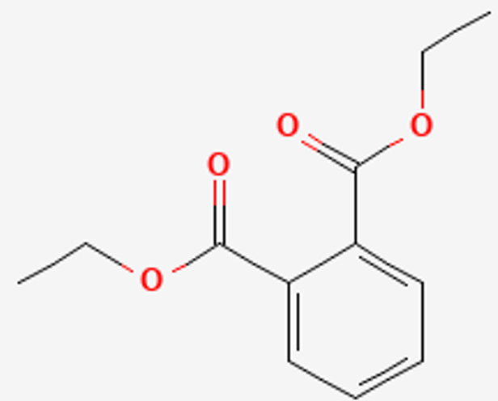 | 6721 | Accepted | Accepted | Accepted | Accepted
1,3-diethyl 2-cyclohexylpropanedioate | 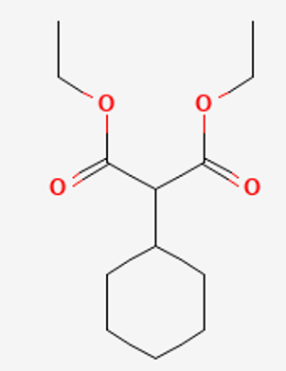 | 240541 | Accepted | Rejected | Accepted | Accepted
2,4,6,8,10-Tetradecapentaenoic acid | 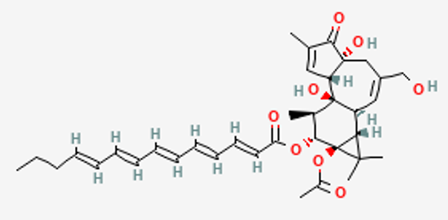 | 6443104 | Accepted | Accepted | Rejected | Rejected

