Supplemental Material
Development and evaluation of a deep learning framework for detection and diagnosis of peri-ampullary tumor in MRI images

Contents
SI Details of datasets……………………………………………...…………………2
SI Figure 1…………………………………………………………...………………2
SI Figure 2………………………………………………………………...…………3
SI Figure 3…………………………………………………………………………...4
SI Figure 4……………………………………………....…………………...………5
SI Figure 5……………………………………………………………………...……6
SI Table 1 ………………………………………………………...…………………7
SI Table 2 ………………………………………………………...…………………8
SI Table 3 ………………………………………………………...…………………9

SI Details of datasets
In preparing the training, validation, test datasets, we divided the initial dataset based on patients. As a result, for T1WI images (n = 9,182), first, we classify NPA and PSOL cases: The training set (n=7,718 images) from 442 patients with NPA and 340 with PSOL cases. The validation (n=761 images) set from 36 patients with NPA and 36 with PSOL cases. The test set (n=703 images) set from 36 patients with NPA and 36 with PSOL cases. Next, we classify non-PATL and PAT: Training set (n=2,943 images) from 196 patients with non-PATL and 144 with PAT. Validation set (n=384 images) 18 patients with non-PATL and 18 with PAT. Test set (n=324 images) 18 patients with non-PATL and 18 with PAT. For T2WI images (n = 5,121), first, we classify NPA and PSOL cases: The training set (n=7,718 images) from 462 patients with NPA and 382 with PSOL cases. The validation (n=443 images) set from 44 patients with NPA and 44 with PSOL cases. The test set (n=434 images) set from 44 patients with NPA and 44 with PSOL case. Next, we classify non-PATL and PAT: Training set (n=1,915 images) from 202 patients with non-PATL and 180 with PAT. Validation set (n=223 images) 22 patients with non-PATL and 22 with PAT. Test set (n=230 images) 22 patients with non-PATL and 22 with PAT.

Supplemental Figure 1

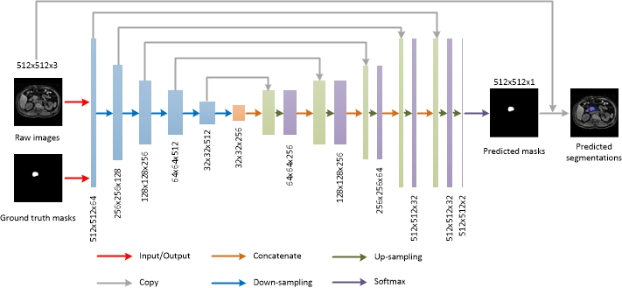
Supplemental Figure 1: Schematic of the UNet16 architecture used to obtain segmentations of PA regions in the first step of the DL framework.

Supplementary Figure 2
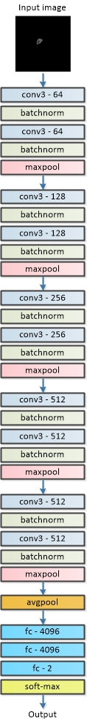

Supplementary Figure 2: Schematic of the VGG13 architecture used to classify NPA and PSOL cases in the second step of the DL framework.

Supplementary Figure 3
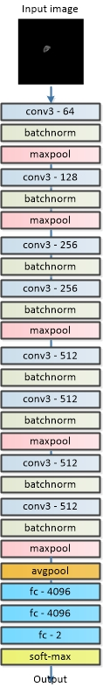

Supplementary Figure 3: Schematic of the VGG11 architecture used to classify PAT and non-PATL cases in the third step of the DL framework.

Supplementary Figure 4
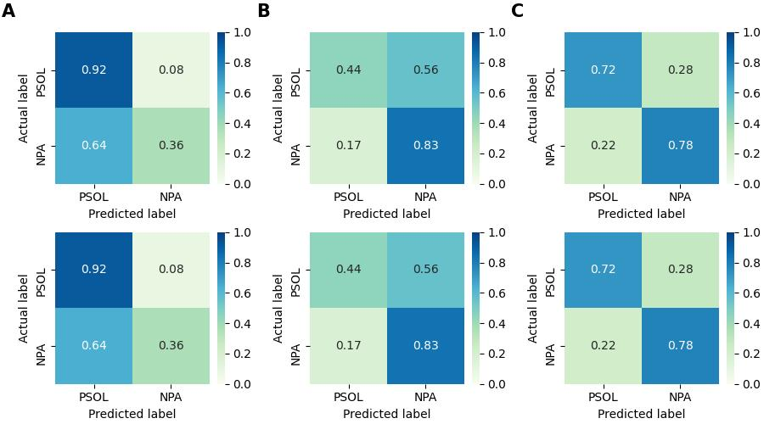

Supplementary Figure 4: Confusion matrices of patient-based classification of NPA and PSOL cases in the second step of the DL framework. Columns A, B, C were results obtained by the one case-based, vote-based, and weight-based strategies, respectively. The first and second rows are MRI images of T1WI and T2WI, respectively.

Supplementary Figure 5
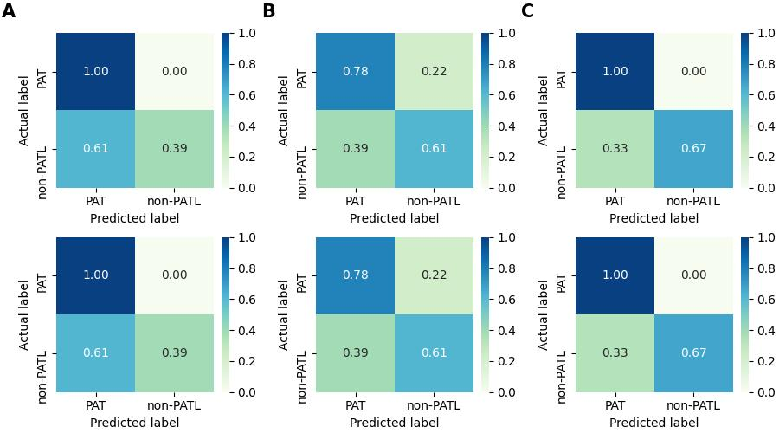

Supplementary Figure 5: Confusion matrices of patient-based classification of PAT and non-PATL in PSOL cases in the second step of the DL framework. Columns A, B, C were results obtained by the one case-based, vote-based, and weight-based strategies, respectively. The first and second rows are MRI images of T1WI and T2WI, respectively.

Supplementary Table 1
Images of one patient | Classification probability |  | Image  -based | Patient  -based | Strategies
 |  |  |  |  | One case | Vote-based | Weight-based
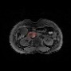 | Positive | 0·7 | Positive | Negative | Positive | Negative | Negative
 | Negative | 0·3
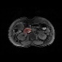 | Positive | 0·2 | Negative
 | Negative | 0·8
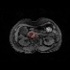 | Positive | 0·1 | Negative
 | Negative | 0·9
Result |  |  |  |  | Incorrect | Correct | Correct

Supplementary Table 1. Calculation examples of three strategies.

Supplementary Table 2
 | NPA | Non-PATL | PAT
Sample | 555 | 255 | 228
Age (years), median (IQR) | 58(15-89) | 57(11-90) | 71(18-87)
Gender
Female (%) | 259(46·7%) | 145(57·3%) | 84(36·8%)
Male (%) | 296(53·3%) | 110(42·7%) | 144(63·2%)
BMI(Kg/m2), median (IQR) | 19·80(19·00-20·35) | 20·05(19·65-20·37) | 18·31(17·49-19·22)
TB (μmol/L), mean ± SD | 65·59±17·77 | 63·84±16·00 | 47·82±16·53
DB (μmol/L), mean ± SD | 17·01±6·90 | 17·47±6·60 | 15·02±6·02
AFP (ng/ml), mean ± SD | 10·62±2·01 | 10·01±1·76 | 8·31±1·33
CA19-9(U/ml), mean ± SD | 37·16±3·16 | 36·56±2·84 | 98·02±23·93
CA12-5(U/ml), mean ± SD | 12·57±3·13 | 12·19±2·72 | 13·49±4·42
CEA (ng/ml), mean ± SD | 9·92±3·31 | 9·95±2·28 | 10·05±2·48
TB: Total Bilirubin; DB: Direct Bilirubin; AFP: Alpha Fetoprotein; CA19-9: Carbohydrate Antigen19-9; CA12-5: Carbohydrate Antigen 12-5; CEA: Carcinoembryonic Antigen; IQR: Interquartile range; SD: standard deviation.

Supplementary Table 2. Clinical characteristics findings of enrolled patients with PSOL case.

Supplementary Table 3.
 | Type | Sample (%)
PAT | Lower segment carcinoma of the bile duct | 64(28·1%)
PAT | Duodenal papillary carcinoma | 24(10·5%)
PAT | Ampullary carcinoma | 60(26·3%)
PAT | Pancreatic head carcinoma | 80(35·1%)
Non-PATL | Lower segment stone of the bile duct | 209(82·0%)
Non-PATL | Common bile duct inflammation stenosis | 46(18·0%)
Normal PA | Liver lesions | 259(46·7%)
Normal PA | Gallbladder disease | 218(39·3%)
Normal PA | Other normal PA | 78(14%)

Supplementary Table 3. Types of PAT, Non-PATL, Normal PA.

