Appendix A

Here, the complete results of buildings design (stories’ stiffness, stories’ yielding force, and Bouc-Wen α parameter) described in sections 2 and 3 are presented elaborately.

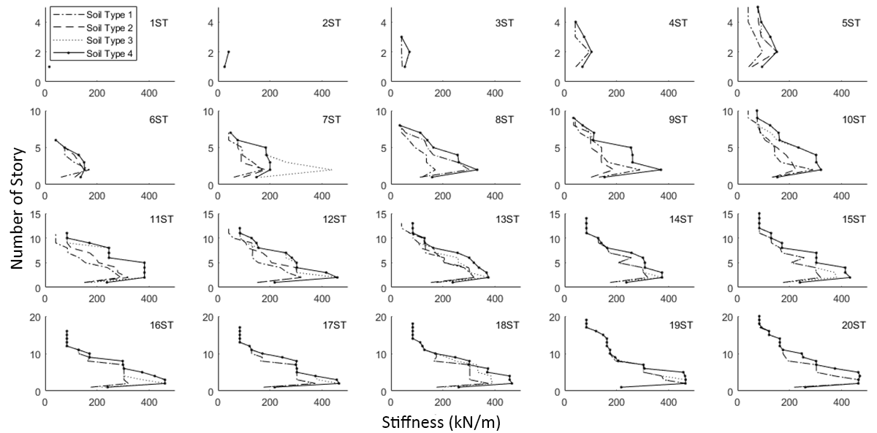
Figure A.1. Stiffness of each story of all the building models for all different soil types.

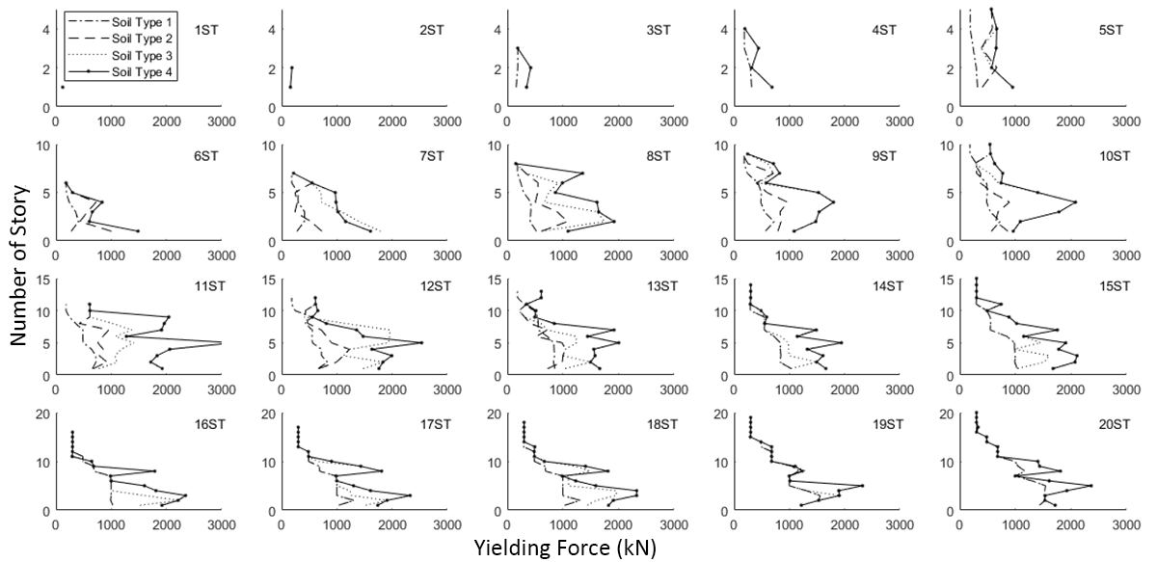
Figure A.2. Yielding force of each story of all the building models for all different soil types.

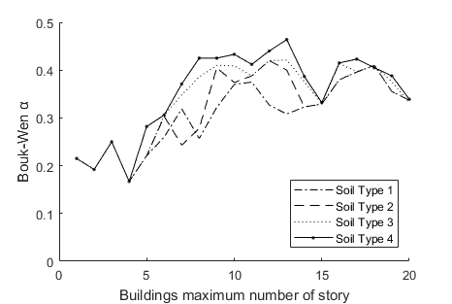
Figure A.3. Bouc-Wen α parameter of each building model for all different soil types.

Appendix B
This appendix presents a glossary of important terms in this paper.

Table B.1. Glossary.
Term | Definition
Accelerogram | The recording of ground acceleration as a function of time during a seismic event.
Active Vibration Control System | A system that mitigate the building undesired vibration due to input noises (earthquake excitation) via an online procedure using an external power source.
Broad-band Signal | Earthquake signals which covers a wide range of frequency and here is used as a representative of far-field earthquakes.
Content Damage | All damages occurred to the equipments, staffs, and indoor appliance existed in the building due to earthquake.
Cumulative Damage | Damages caused by sequential earthquakes which are added to the damages from the previous event.
Earthquake Scenario | A scenario which includes probable mainshocks and aftershocks in a specific time range.
Fragility Curve | A curve which shows the probability of facing different levels of damages in a building based on the hazard intensity or building responses to that hazard.
Life-cycle Cost | The estimated probable damage cost of building due to life time seismic hazard.
Lifetime | 50 years as a period of buildings life span.
Loss Curve | The curve showing the probability of exceedance of different ranges of building losses due to seismic hazard.
MA Sequence | Sequences of the mainshock and aftershock.
MDOF | Multi degree of freedom systems.
Multi-Objective Optimization | A method of optimizing a problem with more than one optimization target.
Pareto Front | All the optimal results of a multi-objective optimization problem in the method of Pareto.
Pulse-like Signal | An earthquake record which its velocity time series contains a pulse due to forward directivity phenomenon.
Realization | Generated sample of a random variable.
Seismic Risk | The estimated probable loss of buildings due to the future earthquakes.
Story Stiffness | The resistance of each building story against a unit deformation.
Story Yielding Force | The force level that causes a story of building enters its nonlinear behavior phase.

