Supplementary materials

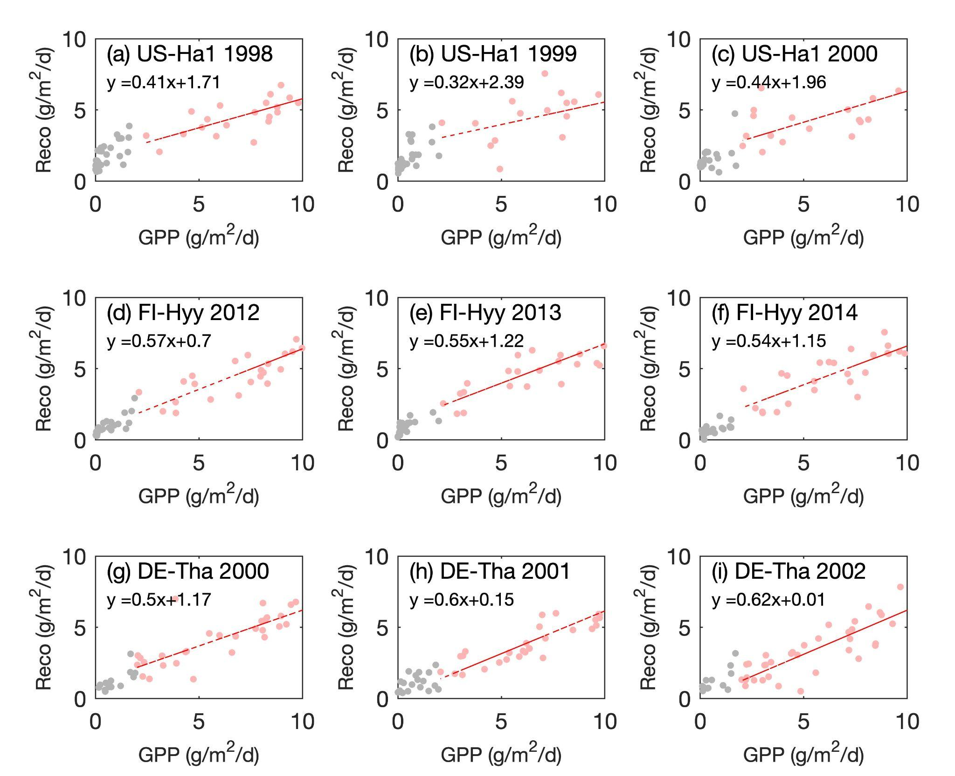
Figure S1. The coupling between GPP and Reco at the weekly time scale for several exemplary site-years, and the changes in the slopes of regression are relevant to the variation in CUE.

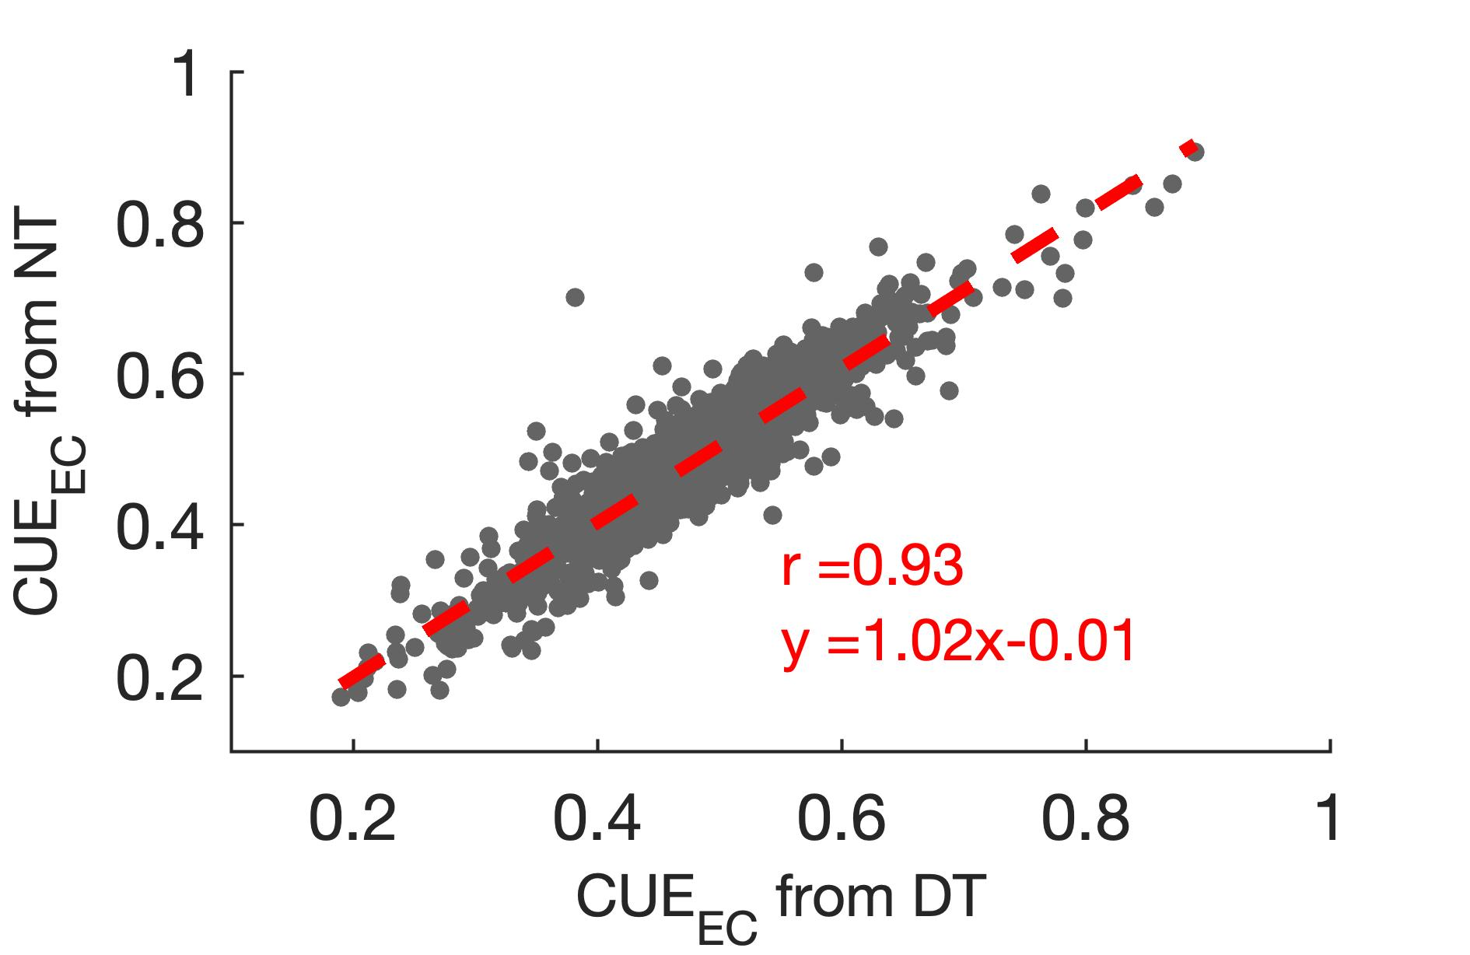

Figure S2. CUE_{EC} estimated based on the GPP and Reco derived from daytime partition method and nighttime partition method, respectively.

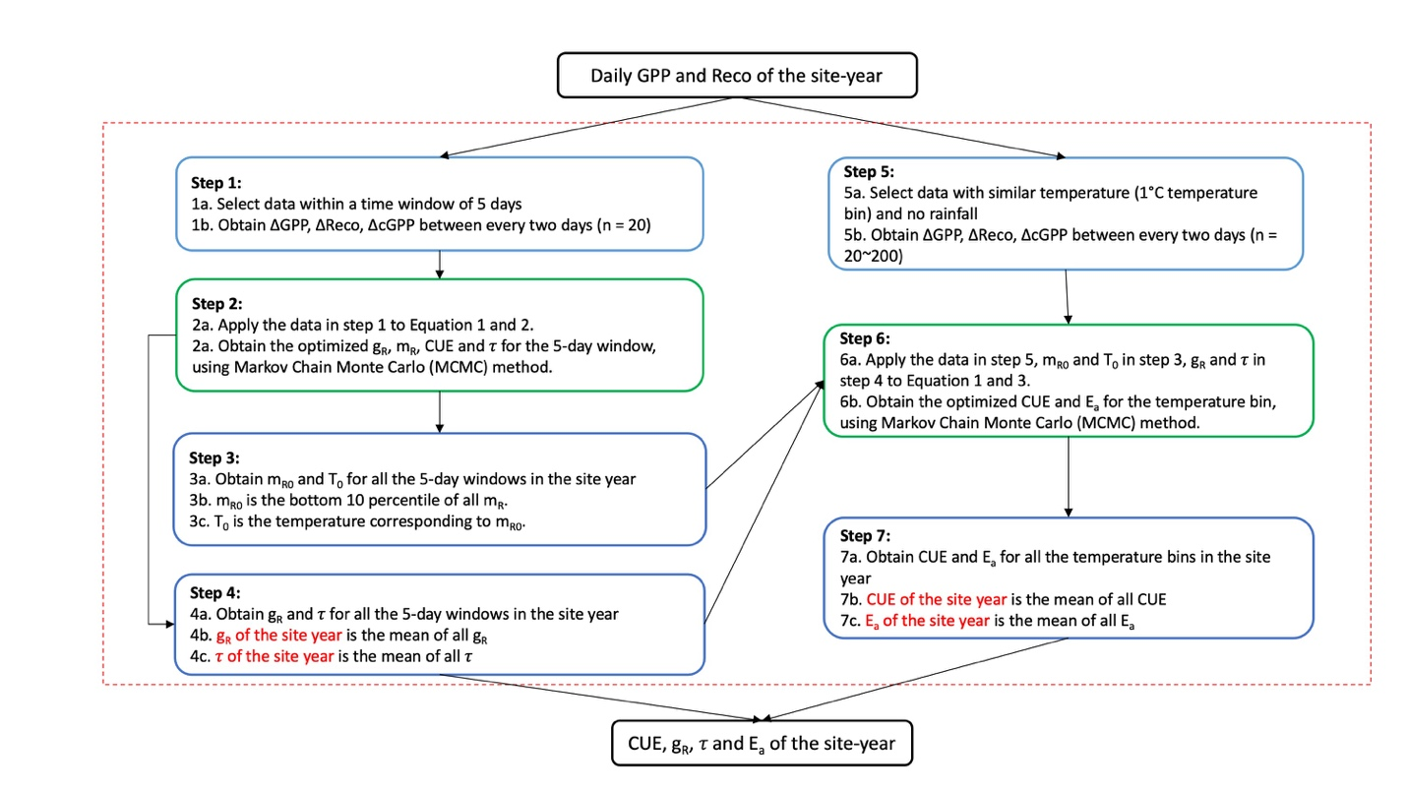
Figure S3. The workflow to estimate carbon use efficiency (CUE) for each site-year from daily flux data. ΔGPP, ΔReco, ΔcGPP refer to the difference in GPP, Reco and cumulative GPP between two timestamps. g_{R} and m_{R} are the respiration coefficients for growth and maintenance respiration, respectively. m_{R0} is the baseline m_{R} of the ecosystem, T₀ is the air temperature corresponding to the baseline. 𝜏 represents the fraction of live biomass changed to non-respiratory biomass. E_{a} is the Arrhenius activation energy for respiration (i.e., the temperature sensitivity of maintenance respiration).

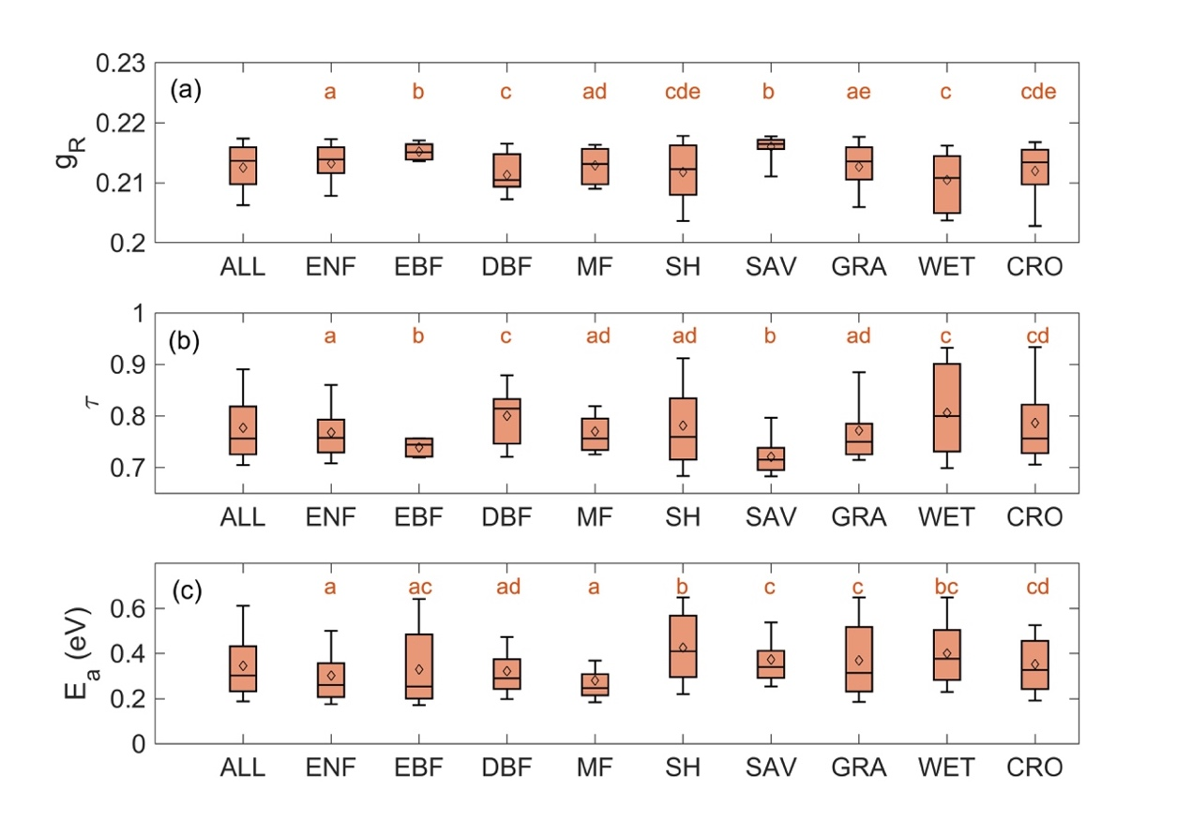
Figure S4. The estimated g_{R}, 𝜏 and E_{a} for each PFT. ALL indicates all PFTs. PFTs include EBF (evergreen broadleaf forests), ENF (evergreen needleleaf forests), DBF (deciduous broadleaf forests), MF (mixed forests), SH (shrublands), SAV (savannas), GRA (grasslands), WET (wetlands) and CRO (croplands). The letters above indicate the significance of the difference between different groups (p < 0.05, one-way ANOVA).

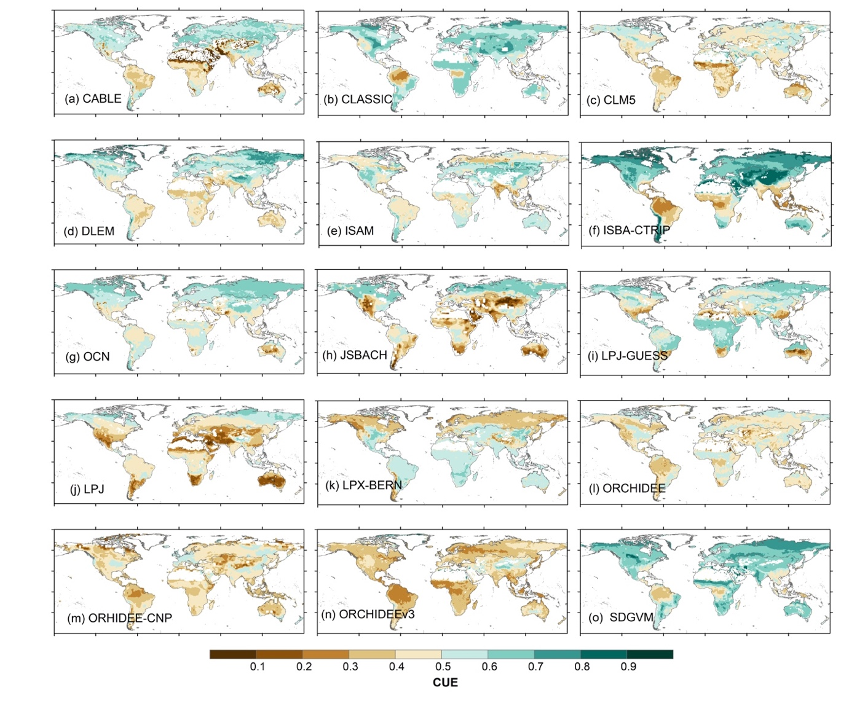
Figure S5. The global distribution of carbon use efficiency (CUE) estimated by 15 Dynamic Global Vegetation Models (DGVMs).

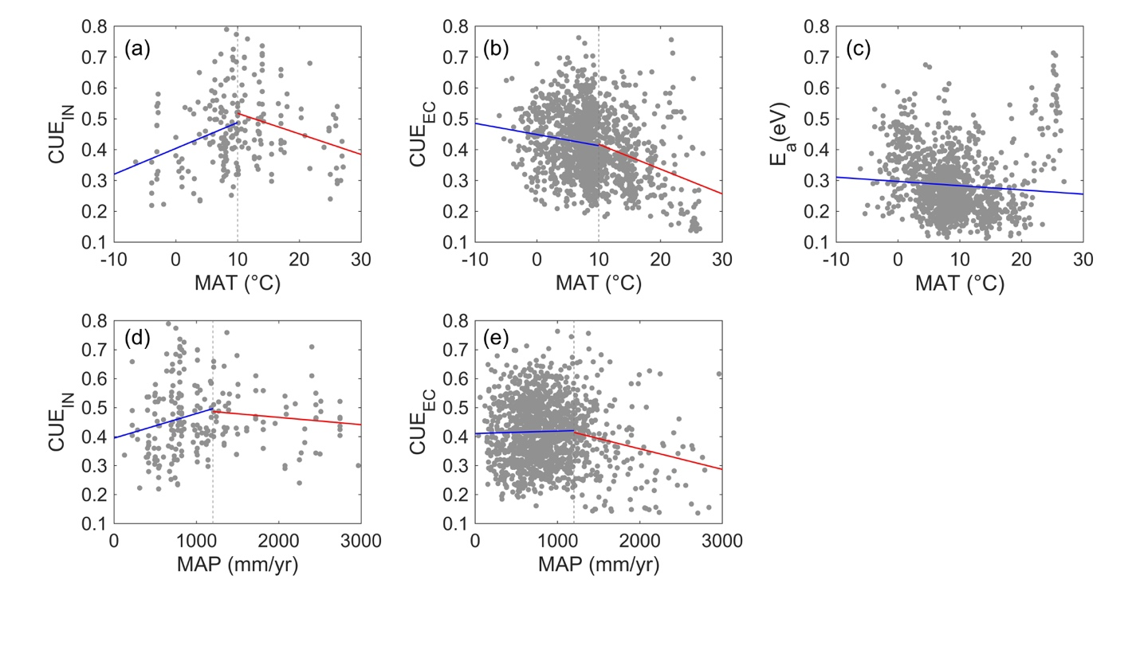
Figure S6. (a-c) The relationships between CUE_{IN}, CUE_{EC} and E_{a} and mean annual temperature (MAT). (d-e) The relationships between CUE_{IN}, CUE_{EC} and E_{a} and mean annual precipitation (MAP).

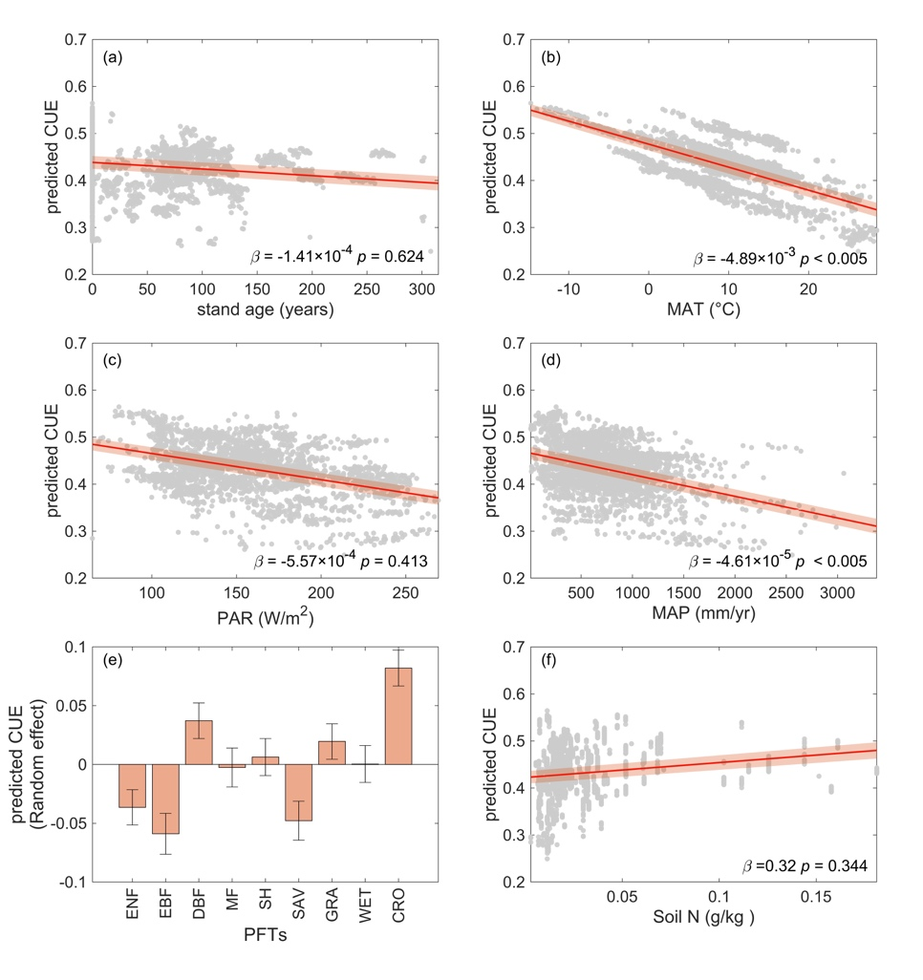
Figure S7. The responses of CUE to abiotic and biotic factors. The biotic factors include (a) stand age and (e) plant functional types. The abiotic factors include (b) mean annual temperature (MAT; unit: °C), (c) mean annual photosynthetically active radiation (PAR; unit: W/m²), (d) mean annual precipitation (MAP; unit: mm/yr) and (f) soil N content (unit: g/kg).

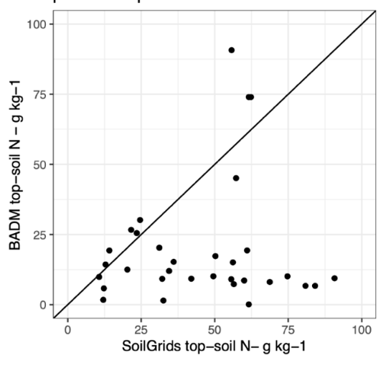
Figure S8. The comparison of soil nitrogen content extracted from soil grids and from Ameriflux Biological, Ancillary, Disturbance and Metadata (BADM).

Table S1. The statistical performance of the liner mixed effect model (LME) when considering different explanatory variables. AIC is Akaike information criterion and BIC is Bayesian information criterion. We used the LME 57 in the main analysis, as the model demonstrated one of the strongest statistical performances and includes all major factors from previous studies.
ID | Linear mixed effect model (LME) | R² | AIC | BIC
1 | CUE ~ MAT | 0.101 | -4398.57 | -4380.81
2 | CUE ~ PAR | 0.045 | -4231.36 | -4213.60
3 | CUE ~ MAP | 0.034 | -4199.72 | -4181.96
4 | CUE ~ stand age | 0.009 | -4076.15 | -4058.44
5 | CUE ~ soil N | 0.007 | -3950.02 | -3932.39
6 | CUE ~ MAT + PAR | 0.101 | -4397.36 | -4373.68
7 | CUE ~ MAT + MAP | 0.111 | -4427.54 | -4403.86
8 | CUE ~ MAT + stand age | 0.116 | -4383.77 | -4360.15
9 | CUE ~ MAT + soil N | 0.105 | -4219.64 | -4196.14
10 | CUE ~ MAT + (1|pft) | 0.236 | -4809.40 | -4785.72
11 | CUE ~ PAR + MAP | 0.082 | -4339.75 | -4316.07
12 | CUE ~ PAR + stand age | 0.062 | -4222.05 | -4198.44
13 | CUE ~ PAR + soil N | 0.046 | -4051.57 | -4028.07
14 | CUE ~ PAR + (1|pft) | 0.185 | -4629.99 | -4606.32
15 | CUE ~ MAP + stand age | 0.038 | -4154.97 | -4131.36
16 | CUE ~ MAP + soil N | 0.035 | -4022.50 | -3999.00
17 | CUE ~ MAP + (1|pft) | 0.176 | -4599.03 | -4575.36
18 | CUE ~ stand age + soil N | 0.014 | -3914.03 | -3890.59
19 | CUE ~ stand age + (1|pft) | 0.153 | -4465.34 | -4441.73
20 | CUE ~ soil N + (1|pft) | 0.163 | -4359.13 | -4335.63
21 | CUE ~ MAT + PAR + MAP | 0.112 | -4426.81 | -4397.21
22 | CUE ~ MAT + PAR + stand age | 0.116 | -4381.96 | -4352.44
23 | CUE ~ MAT + PAR + soil N | 0.105 | -4217.72 | -4188.35
24 | CUE ~ MAT + PAR + (1|pft) | 0.237 | -4810.90 | -4781.30
25 | CUE ~ MAT + MAP + stand age | 0.121 | -4394.91 | -4365.40
26 | CUE ~ MAT + MAP + soil N | 0.113 | -4242.67 | -4213.30
27 | CUE ~ MAT + MAP + (1|pft) | 0.239 | -4820.87 | -4791.27
28 | CUE ~ MAT + stand age + soil N | 0.117 | -4197.73 | -4168.44
29 | CUE ~ MAT + stand age + (1|pft) | 0.229 | -4722.00 | -4692.49
30 | CUE ~ MAT + soil N + (1|pft) | 0.232 | -4589.30 | -4559.92
31 | CUE ~ PAR + MAP + stand age | 0.090 | -4301.72 | -4272.21
32 | CUE ~ PAR + MAP + soil N | 0.081 | -4149.93 | -4120.56
33 | CUE ~ PAR + MAP + (1|pft) | 0.203 | -4691.88 | -4662.28
34 | CUE ~ PAR + stand age + soil N | 0.059 | -4033.47 | -4004.18
35 | CUE ~ PAR + stand age + (1|pft) | 0.178 | -4545.88 | -4516.37
36 | CUE ~ PAR + soil N + (1|pft) | 0.182 | -4419.05 | -4389.68
37 | CUE ~ MAP + stand age + soil N | 0.038 | -3977.33 | -3948.03
38 | CUE ~ MAP + stand age + (1|pft) | 0.172 | -4524.87 | -4495.35
39 | CUE ~ MAP + soil N + (1|pft) | 0.178 | -4404.63 | -4375.26
40 | CUE ~ stand age + soil N + (1|pft) | 0.156 | -4283.66 | -4254.37
41 | CUE ~ MAT + PAR + MAP + stand age | 0.122 | -4395.58 | -4360.16
42 | CUE ~ MAT + PAR + MAP + soil N | 0.114 | -4243.33 | -4208.08
43 | CUE ~ MAT + PAR + MAP + (1|pft) | 0.240 | -4819.56 | -4784.05
44 | CUE ~ MAT + PAR + stand age + soil N | 0.117 | -4196.57 | -4161.42
45 | CUE ~ MAT + PAR + stand age + (1|pft) | 0.230 | -4722.63 | -4687.21
46 | CUE ~ MAT + PAR + soil N + (1|pft) | 0.233 | -4591.30 | -4556.05
47 | CUE ~ MAT + MAP + stand age + soil N | 0.121 | -4207.26 | -4172.11
48 | CUE ~ MAT + MAP + stand age + (1|pft) | 0.233 | -4732.15 | -4696.73
49 | CUE ~ MAT + MAP + soil N + (1|pft) | 0.236 | -4600.71 | -4565.46
50 | CUE ~ MAT + stand age + soil N + (1|pft) | 0.225 | -4506.09 | -4470.93
51 | CUE ~ PAR + MAP + stand age + soil N | 0.087 | -4110.22 | -4075.07
52 | CUE ~ PAR + MAP + stand age + (1|pft) | 0.197 | -4608.31 | -4572.89
53 | CUE ~ PAR + MAP + soil N + (1|pft) | 0.200 | -4476.33 | -4441.09
54 | CUE ~ PAR + stand age + soil N + (1|pft) | 0.174 | -4339.96 | -4304.80
55 | CUE ~ MAP + stand age + soil N + (1|pft) | 0.172 | -4333.32 | -4298.17
56 | CUE ~ MAT + PAR + MAP + stand age + soil N | 0.122 | -4209.75 | -4168.73
57 | CUE ~ MAT + PAR + MAP + stand age + (1|pft) | 0.233 | -4730.65 | -4689.32
58 | CUE ~ MAT + PAR + MAP + soil N + (1|pft) | 0.236 | -4599.57 | -4558.45
59 | CUE ~ MAT + PAR + stand age + soil N + (1|pft) | 0.226 | -4507.27 | -4466.26
60 | CUE ~ MAT + MAP + stand age + soil N + (1|pft) | 0.229 | -4516.43 | -4475.41
61 | CUE ~ PAR + MAP + stand age + soil N + (1|pft) | 0.193 | -4397.38 | -4356.37
62 | CUE ~ MAT + PAR + MAP + stand age + soil N + (1|pft) | 0.229 | -4515.10 | -4468.23

Table S2. Average CUE_{EC}, g_{R}, 𝜏 and E_{a} for each flux site in the FLUXNET2015, ICOS and Ameriflux Fluxnet datasets (n = 358).
Site_ID | CUE_{EC} | g_{R} | 𝜏 | E_{a} (eV)
AR_SLu | 0.51 | 0.21 | 0.79 | 0.15
AR-TF1 | 0.22 | 0.22 | 0.70 | 0.28
AR-Vir | 0.53 | 0.21 | 0.78 | 0.32
AT-Neu | 0.43 | 0.21 | 0.77 | 0.25
AU-ASM | 0.40 | 0.22 | 0.70 | 0.50
AU-Ade | 0.40 | 0.22 | 0.72 | 0.41
AU-Cpr | 0.34 | 0.22 | 0.70 | 0.38
AU-Cum | 0.25 | 0.22 | 0.72 | 0.37
AU-DaP | 0.51 | 0.22 | 0.75 | 0.58
AU-DaS | 0.18 | 0.22 | 0.72 | 0.47
AU-Dry | 0.24 | 0.22 | 0.71 | 0.35
AU-Emr | 0.52 | 0.21 | 0.81 | 0.51
AU-Fog | 0.55 | 0.22 | 0.71 | 0.34
AU-GWW | 0.28 | 0.22 | 0.68 | 0.41
AU-Gin | 0.30 | 0.22 | 0.70 | 0.26
AU-How | 0.28 | 0.22 | 0.73 | 0.37
AU-Lox | 0.60 | 0.21 | 0.75 | 0.37
AU-RDF | 0.47 | 0.22 | 0.72 | 0.51
AU-Rig | 0.40 | 0.22 | 0.72 | 0.32
AU-Rob | 0.16 | 0.22 | 0.72 | 0.52
AU-Stp | 0.48 | 0.22 | 0.71 | 0.65
AU-TTE | 0.53 | 0.21 | 0.78 | 0.65
AU-Tum | 0.34 | 0.21 | 0.76 | 0.26
AU-Wac | 0.38 | 0.22 | 0.73 | 0.21
AU-Whr | 0.34 | 0.22 | 0.71 | 0.27
AU-Wom | 0.39 | 0.21 | 0.76 | 0.21
AU-Ync | 0.54 | 0.21 | 0.82 | 0.62
BE-Bra | 0.44 | 0.22 | 0.73 | 0.30
BE-Dor | 0.39 | 0.21 | 0.74 | 0.20
BE-Lcr | 0.37 | 0.21 | 0.75 | 0.21
BE-Lon | 0.54 | 0.21 | 0.80 | 0.40
BE-Maa | 0.27 | 0.22 | 0.68 | 0.31
BE-Vie | 0.35 | 0.22 | 0.73 | 0.22
BR-CST | 0.33 | 0.21 | 0.70 | 0.34
BR-Npw | 0.31 | 0.21 | 0.74 | 0.34
BR-Sa1 | 0.23 | 0.22 | 0.76 | 0.55
BR-Sa3 | 0.16 | 0.22 | 0.74 | 0.55
CA-ARB | 0.40 | 0.21 | 0.87 | 0.45
CA-ARF | 0.46 | 0.21 | 0.83 | 0.38
CA-Ca1 | 0.37 | 0.21 | 0.73 | 0.29
CA-Ca2 | 0.29 | 0.21 | 0.73 | 0.40
CA-Cbo | 0.42 | 0.21 | 0.85 | 0.34
CA-DB2 | 0.34 | 0.22 | 0.67 | 0.48
CA-DBB | 0.35 | 0.21 | 0.74 | 0.44
CA-ER1 | 0.51 | 0.21 | 0.78 | 0.28
CA-Gro | 0.47 | 0.21 | 0.89 | 0.29
CA-LP1 | 0.35 | 0.22 | 0.68 | 0.43
CA-MA1 | 0.47 | 0.21 | 0.88 | 0.53
CA-MA2 | 0.58 | 0.21 | 0.85 | 0.50
CA-MA3 | 0.48 | 0.21 | 0.77 | 0.27
CA-Man | 0.45 | 0.21 | 0.87 | 0.44
CA-NS1 | 0.52 | 0.21 | 0.85 | 0.36
CA-NS2 | 0.49 | 0.21 | 0.83 | 0.26
CA-NS3 | 0.44 | 0.21 | 0.87 | 0.33
CA-NS4 | 0.41 | 0.21 | 0.77 | 0.48
CA-NS5 | 0.48 | 0.21 | 0.86 | 0.33
CA-NS6 | 0.50 | 0.21 | 0.89 | 0.39
CA-NS7 | 0.46 | 0.21 | 0.89 | 0.45
CA-Oas | 0.56 | 0.20 | 0.97 | 0.48
CA-Obs | 0.39 | 0.21 | 0.87 | 0.44
CA-Qfo | 0.42 | 0.20 | 0.90 | 0.43
CA-SF1 | 0.33 | 0.21 | 0.78 | 0.36
CA-SF2 | 0.35 | 0.22 | 0.68 | 0.41
CA-SF3 | 0.33 | 0.22 | 0.72 | 0.37
CA-TP1 | 0.45 | 0.21 | 0.79 | 0.32
CA-TP2 | 0.60 | 0.21 | 0.82 | 0.28
CA-TP3 | 0.41 | 0.21 | 0.80 | 0.28
CA-TP4 | 0.36 | 0.21 | 0.83 | 0.29
CA-TPD | 0.41 | 0.21 | 0.79 | 0.27
CG-Tch | 0.48 | 0.21 | 0.80 | 0.49
CH-Aws | 0.48 | 0.21 | 0.78 | 0.31
CH-Cha | 0.37 | 0.22 | 0.73 | 0.21
CH-Dav | 0.40 | 0.21 | 0.76 | 0.29
CH-Fru | 0.43 | 0.22 | 0.76 | 0.24
CH-Lae | 0.45 | 0.21 | 0.76 | 0.27
CH-Oe1 | 0.41 | 0.22 | 0.73 | 0.21
CH-Oe2 | 0.47 | 0.21 | 0.73 | 0.25
CN-Cha | 0.25 | 0.21 | 0.69 | 0.22
CN-Cng | 0.29 | 0.22 | 0.69 | 0.28
CN-Dan | 0.28 | 0.22 | 0.70 | 0.48
CN-Din | 0.24 | 0.22 | 0.71 | 0.27
CN-Du2 | 0.52 | 0.21 | 0.90 | 0.59
CN-Du3 | 0.57 | 0.21 | 0.69 | 0.53
CN-Ha2 | 0.28 | 0.22 | 0.69 | 0.38
CN-HaM | 0.51 | 0.21 | 0.81 | 0.43
CN-Qia | 0.30 | 0.22 | 0.73 | 0.18
CN-Sw2 | 0.47 | 0.20 | 0.71 | 0.65
CZ-BK1 | 0.44 | 0.21 | 0.76 | 0.22
CZ-BK2 | 0.46 | 0.21 | 0.77 | 0.35
CZ-KrP | 0.50 | 0.21 | 0.80 | 0.30
CZ-Lnz | 0.43 | 0.21 | 0.82 | 0.34
CZ-RAJ | 0.39 | 0.21 | 0.76 | 0.20
CZ-Stn | 0.50 | 0.21 | 0.81 | 0.33
CZ-wet | 0.43 | 0.21 | 0.80 | 0.33
DE-Akm | 0.42 | 0.21 | 0.72 | 0.30
DE-Geb | 0.52 | 0.21 | 0.80 | 0.48
DE-Gri | 0.40 | 0.22 | 0.74 | 0.20
DE-Hai | 0.52 | 0.21 | 0.81 | 0.36
DE-HoH | 0.44 | 0.21 | 0.79 | 0.36
DE-Hte | 0.40 | 0.21 | 0.70 | 0.30
DE-Hzd | 0.34 | 0.22 | 0.72 | 0.27
DE-Kli | 0.53 | 0.21 | 0.75 | 0.29
DE-Lkb | 0.39 | 0.22 | 0.76 | 0.42
DE-Lnf | 0.56 | 0.21 | 0.84 | 0.44
DE-Obe | 0.36 | 0.21 | 0.74 | 0.23
DE-RuR | 0.34 | 0.22 | 0.72 | 0.22
DE-RuS | 0.46 | 0.22 | 0.73 | 0.34
DE-RuW | 0.38 | 0.22 | 0.75 | 0.26
DE-Seh | 0.52 | 0.21 | 0.74 | 0.34
DE-SfN | 0.26 | 0.22 | 0.71 | 0.26
DE-Spw | 0.36 | 0.21 | 0.73 | 0.23
DE-Tha | 0.30 | 0.22 | 0.73 | 0.22
DE-Zrk | 0.33 | 0.22 | 0.75 | 0.37
DK-Eng | 0.45 | 0.21 | 0.73 | 0.33
DK-Fou | 0.42 | 0.21 | 0.72 | 0.24
DK-Gds | 0.50 | 0.22 | 0.76 | 0.26
DK-NuF | 0.52 | 0.21 | 0.81 | 0.51
DK-Sor | 0.36 | 0.22 | 0.72 | 0.24
DK-ZaF | 0.59 | 0.20 | 1.00 | 0.65
DK-ZaH | 0.55 | 0.20 | 1.00 | 0.62
ES-Abr | 0.31 | 0.22 | 0.71 | 0.28
ES-Agu | 0.41 | 0.21 | 0.74 | 0.41
ES-Amo | 0.50 | 0.21 | 0.78 | 0.64
ES-Cnd | 0.35 | 0.22 | 0.70 | 0.27
ES-LJu | 0.44 | 0.21 | 0.72 | 0.48
ES-LM1 | 0.31 | 0.22 | 0.72 | 0.25
ES-LM2 | 0.29 | 0.22 | 0.71 | 0.23
ES-LgS | 0.30 | 0.22 | 0.66 | 0.31
ES-Ln2 | 0.50 | 0.20 | 1.00 | 0.65
FI-Hyy | 0.42 | 0.21 | 0.76 | 0.24
FI-Jok | 0.54 | 0.20 | 0.95 | 0.50
FI-Ken | 0.54 | 0.21 | 0.93 | 0.43
FI-Let | 0.44 | 0.21 | 0.80 | 0.29
FI-Lom | 0.60 | 0.20 | 0.99 | 0.59
FI-Qvd | 0.45 | 0.21 | 0.72 | 0.19
FI-Sii | 0.44 | 0.21 | 0.88 | 0.44
FI-Sod | 0.47 | 0.21 | 0.89 | 0.45
FI-Var | 0.53 | 0.20 | 0.93 | 0.49
FR-Aur | 0.49 | 0.22 | 0.70 | 0.32
FR-Bil | 0.43 | 0.21 | 0.75 | 0.15
FR-EM2 | 0.55 | 0.21 | 0.75 | 0.23
FR-FBn | 0.32 | 0.22 | 0.73 | 0.19
FR-Fon | 0.43 | 0.21 | 0.75 | 0.29
FR-Gri | 0.51 | 0.22 | 0.72 | 0.28
FR-Hes | 0.55 | 0.21 | 0.84 | 0.36
FR-LBr | 0.38 | 0.22 | 0.74 | 0.22
FR-LGt | 0.21 | 0.22 | 0.68 | 0.27
FR-Lam | 0.46 | 0.21 | 0.76 | 0.28
FR-Pue | 0.33 | 0.21 | 0.72 | 0.21
FR-Tou | 0.39 | 0.21 | 0.73 | 0.29
GF-Guy | 0.15 | 0.22 | 0.74 | 0.57
GH-Ank | 0.42 | 0.21 | 0.77 | 0.48
IE-Cra | 0.25 | 0.22 | 0.69 | 0.36
IL-Yat | 0.36 | 0.22 | 0.70 | 0.25
IT-BCi | 0.50 | 0.21 | 0.75 | 0.33
IT-BFt | 0.37 | 0.22 | 0.73 | 0.26
IT-CA1 | 0.37 | 0.22 | 0.73 | 0.21
IT-CA2 | 0.51 | 0.22 | 0.69 | 0.27
IT-CA3 | 0.28 | 0.22 | 0.71 | 0.23
IT-Col | 0.58 | 0.21 | 0.81 | 0.29
IT-Cp2 | 0.38 | 0.22 | 0.75 | 0.20
IT-Cpz | 0.40 | 0.22 | 0.74 | 0.35
IT-Isp | 0.33 | 0.22 | 0.73 | 0.29
IT-La2 | 0.46 | 0.22 | 0.75 | 0.20
IT-Lav | 0.45 | 0.21 | 0.76 | 0.18
IT-Lsn | 0.26 | 0.22 | 0.72 | 0.25
IT-MBo | 0.45 | 0.21 | 0.77 | 0.28
IT-Noe | 0.46 | 0.22 | 0.73 | 0.19
IT-PT1 | 0.45 | 0.22 | 0.76 | 0.33
IT-Ren | 0.48 | 0.21 | 0.78 | 0.32
IT-Ro1 | 0.35 | 0.22 | 0.73 | 0.21
IT-Ro2 | 0.51 | 0.21 | 0.79 | 0.33
IT-SR2 | 0.27 | 0.21 | 0.75 | 0.22
IT-SRo | 0.32 | 0.21 | 0.74 | 0.20
IT-Tor | 0.54 | 0.21 | 0.88 | 0.38
JP-MBF | 0.52 | 0.21 | 0.82 | 0.39
JP-SMF | 0.31 | 0.21 | 0.74 | 0.27
MX-Tes | 0.24 | 0.22 | 0.67 | 0.46
MY-PSO | 0.15 | 0.22 | 0.75 | 0.61
NL-Hor | 0.41 | 0.22 | 0.73 | 0.24
NL-Loo | 0.37 | 0.22 | 0.74 | 0.22
NO-Adv | 0.53 | 0.20 | 1.00 | 0.64
NO-Blv | 0.50 | 0.20 | 1.00 | 0.67
PA-SPn | 0.18 | 0.22 | 0.73 | 0.62
PA-SPs | 0.25 | 0.22 | 0.73 | 0.41
PE-QFR | 0.18 | 0.22 | 0.73 | 0.48
RU-Che | 0.52 | 0.21 | 0.78 | 0.37
RU-Cok | 0.67 | 0.21 | 0.83 | 0.18
RU-Fy2 | 0.34 | 0.22 | 0.74 | 0.28
RU-Fyo | 0.34 | 0.21 | 0.79 | 0.27
RU-Ha1 | 0.34 | 0.22 | 0.70 | 0.23
RU-Sam | 0.58 | 0.20 | 0.89 | 0.31
RU-SkP | 0.45 | 0.22 | 0.67 | 0.24
RU-Tks | 0.53 | 0.20 | 0.97 | 0.41
RU-Vrk | 0.30 | 0.22 | 0.75 | 0.24
SD-Dem | 0.34 | 0.21 | 0.72 | 0.41
SE-Deg | 0.50 | 0.20 | 0.90 | 0.51
SE-Htm | 0.45 | 0.22 | 0.71 | 0.20
SE-Lnn | 0.53 | 0.21 | 0.83 | 0.31
SE-Nor | 0.44 | 0.22 | 0.76 | 0.26
SE-Ros | 0.43 | 0.22 | 0.71 | 0.24
SE-St1 | 0.66 | 0.21 | 0.75 | 0.24
SE-Svb | 0.57 | 0.21 | 0.83 | 0.34
SN-Dhr | 0.30 | 0.22 | 0.70 | 0.34
US-A32 | 0.37 | 0.22 | 0.75 | 0.20
US-A74 | 0.40 | 0.21 | 0.83 | 0.42
US-ALQ | 0.30 | 0.22 | 0.67 | 0.36
US-AR1 | 0.39 | 0.21 | 0.72 | 0.36
US-AR2 | 0.37 | 0.21 | 0.74 | 0.41
US-ARM | 0.37 | 0.22 | 0.71 | 0.27
US-ARb | 0.48 | 0.21 | 0.81 | 0.42
US-ARc | 0.51 | 0.21 | 0.89 | 0.44
US-Atq | 0.53 | 0.20 | 0.92 | 0.42
US-BRG | 0.34 | 0.22 | 0.72 | 0.30
US-BZB | 0.42 | 0.21 | 0.82 | 0.36
US-BZF | 0.52 | 0.20 | 0.91 | 0.43
US-BZS | 0.34 | 0.21 | 0.75 | 0.37
US-BZo | 0.36 | 0.21 | 0.86 | 0.46
US-Bar | 0.48 | 0.21 | 0.83 | 0.27
US-Bi1 | 0.53 | 0.22 | 0.78 | 0.18
US-Bi2 | 0.47 | 0.21 | 0.76 | 0.47
US-Blo | 0.28 | 0.22 | 0.71 | 0.23
US-CF1 | 0.53 | 0.21 | 0.75 | 0.31
US-CF2 | 0.38 | 0.22 | 0.71 | 0.32
US-CF3 | 0.49 | 0.22 | 0.72 | 0.32
US-CF4 | 0.62 | 0.21 | 0.84 | 0.49
US-CRT | 0.54 | 0.20 | 0.93 | 0.58
US-CS1 | 0.63 | 0.21 | 0.76 | 0.26
US-CS2 | 0.39 | 0.22 | 0.73 | 0.22
US-CS3 | 0.40 | 0.22 | 0.72 | 0.32
US-CS4 | 0.43 | 0.21 | 0.68 | 0.39
US-Cop | 0.49 | 0.21 | 0.75 | 0.54
US-DFC | 0.34 | 0.22 | 0.69 | 0.25
US-EDN | 0.38 | 0.22 | 0.68 | 0.30
US-EML | 0.50 | 0.21 | 0.85 | 0.47
US-Fcr | 0.50 | 0.21 | 0.90 | 0.56
US-Fmf | 0.26 | 0.22 | 0.71 | 0.29
US-Fuf | 0.28 | 0.22 | 0.70 | 0.27
US-GBT | 0.49 | 0.21 | 0.86 | 0.61
US-GLE | 0.43 | 0.21 | 0.76 | 0.32
US-Goo | 0.37 | 0.22 | 0.73 | 0.29
US-HB1 | 0.35 | 0.22 | 0.71 | 0.27
US-HWB | 0.39 | 0.21 | 0.70 | 0.20
US-Ha1 | 0.48 | 0.21 | 0.83 | 0.27
US-Hn2 | 0.49 | 0.20 | 0.94 | 0.65
US-Hn3 | 0.31 | 0.22 | 0.68 | 0.27
US-Ho2 | 0.48 | 0.21 | 0.79 | 0.41
US-IB2 | 0.44 | 0.21 | 0.77 | 0.28
US-ICh | 0.51 | 0.20 | 0.91 | 0.54
US-ICs | 0.56 | 0.20 | 0.93 | 0.57
US-ICt | 0.54 | 0.20 | 0.95 | 0.61
US-Ivo | 0.64 | 0.20 | 0.97 | 0.52
US-Jo1 | 0.33 | 0.22 | 0.68 | 0.33
US-Jo2 | 0.41 | 0.22 | 0.69 | 0.46
US-KFS | 0.40 | 0.21 | 0.73 | 0.35
US-KLS | 0.40 | 0.22 | 0.72 | 0.24
US-KS1 | 0.22 | 0.22 | 0.74 | 0.33
US-KS2 | 0.22 | 0.22 | 0.72 | 0.30
US-KS3 | 0.23 | 0.22 | 0.72 | 0.27
US-LWW | 0.48 | 0.21 | 0.94 | 0.57
US-Lin | 0.23 | 0.22 | 0.70 | 0.32
US-Los | 0.55 | 0.21 | 0.83 | 0.38
US-MMS | 0.49 | 0.21 | 0.88 | 0.41
US-MOz | 0.34 | 0.22 | 0.72 | 0.22
US-Me1 | 0.34 | 0.22 | 0.70 | 0.27
US-Me2 | 0.37 | 0.22 | 0.72 | 0.20
US-Me3 | 0.36 | 0.22 | 0.68 | 0.48
US-Me4 | 0.40 | 0.22 | 0.71 | 0.34
US-Me5 | 0.26 | 0.22 | 0.70 | 0.26
US-Me6 | 0.34 | 0.22 | 0.69 | 0.26
US-Mpj | 0.23 | 0.22 | 0.69 | 0.34
US-Myb | 0.46 | 0.21 | 0.76 | 0.34
US-NC1 | 0.28 | 0.22 | 0.73 | 0.23
US-NC4 | 0.45 | 0.21 | 0.73 | 0.43
US-NGB | 0.62 | 0.20 | 0.96 | 0.53
US-NGC | 0.66 | 0.21 | 0.75 | 0.30
US-NR1 | 0.38 | 0.21 | 0.85 | 0.41
US-Ne1 | 0.58 | 0.20 | 0.95 | 0.44
US-Ne2 | 0.52 | 0.20 | 0.92 | 0.48
US-Ne3 | 0.54 | 0.20 | 0.93 | 0.46
US-ONA | 0.30 | 0.22 | 0.75 | 0.37
US-ORv | 0.40 | 0.22 | 0.72 | 0.22
US-OWC | 0.42 | 0.21 | 0.66 | 0.46
US-Oho | 0.45 | 0.21 | 0.75 | 0.28
US-PFa | 0.43 | 0.21 | 0.82 | 0.31
US-Prr | 0.44 | 0.21 | 0.87 | 0.49
US-Rms | 0.48 | 0.21 | 0.76 | 0.28
US-Ro1 | 0.51 | 0.21 | 0.82 | 0.42
US-Ro4 | 0.40 | 0.22 | 0.70 | 0.27
US-Ro5 | 0.46 | 0.21 | 0.82 | 0.31
US-Ro6 | 0.47 | 0.22 | 0.76 | 0.24
US-Rwe | 0.42 | 0.21 | 0.81 | 0.34
US-Rwf | 0.46 | 0.21 | 0.78 | 0.23
US-Rws | 0.34 | 0.22 | 0.68 | 0.37
US-SRC | 0.33 | 0.22 | 0.68 | 0.35
US-SRG | 0.40 | 0.22 | 0.74 | 0.38
US-SRM | 0.41 | 0.21 | 0.80 | 0.46
US-Seg | 0.42 | 0.21 | 0.79 | 0.48
US-Ses | 0.39 | 0.21 | 0.73 | 0.45
US-Sne | 0.38 | 0.21 | 0.73 | 0.34
US-Snf | 0.40 | 0.22 | 0.74 | 0.18
US-Sta | 0.47 | 0.21 | 0.67 | 0.35
US-Syv | 0.46 | 0.21 | 0.78 | 0.36
US-Ton | 0.36 | 0.22 | 0.71 | 0.28
US-Tw1 | 0.40 | 0.22 | 0.74 | 0.26
US-Tw2 | 0.56 | 0.21 | 0.69 | 0.30
US-Tw3 | 0.53 | 0.22 | 0.77 | 0.21
US-Tw4 | 0.48 | 0.22 | 0.70 | 0.44
US-Tw5 | 0.31 | 0.21 | 0.71 | 0.30
US-Twt | 0.57 | 0.21 | 0.83 | 0.42
US-UM3 | 0.54 | 0.22 | 0.71 | 0.64
US-UMB | 0.42 | 0.21 | 0.83 | 0.26
US-UMd | 0.46 | 0.21 | 0.82 | 0.29
US-Var | 0.52 | 0.21 | 0.71 | 0.53
US-WCr | 0.53 | 0.20 | 0.93 | 0.46
US-WPT | 0.48 | 0.20 | 0.98 | 0.58
US-Whs | 0.48 | 0.21 | 0.83 | 0.60
US-Wi0 | 0.52 | 0.22 | 0.68 | 0.22
US-Wi1 | 0.32 | 0.22 | 0.68 | 0.21
US-Wi2 | 0.37 | 0.22 | 0.74 | 0.27
US-Wi3 | 0.49 | 0.22 | 0.70 | 0.40
US-Wi4 | 0.44 | 0.22 | 0.72 | 0.18
US-Wi5 | 0.38 | 0.22 | 0.72 | 0.29
US-Wi6 | 0.57 | 0.21 | 0.81 | 0.38
US-Wi7 | 0.35 | 0.21 | 0.69 | 0.26
US-Wi8 | 0.27 | 0.22 | 0.68 | 0.31
US-Wi9 | 0.55 | 0.22 | 0.73 | 0.43
US-Wjs | 0.23 | 0.22 | 0.68 | 0.31
US-Wkg | 0.48 | 0.21 | 0.81 | 0.58
US-xAE | 0.42 | 0.22 | 0.70 | 0.45
US-xBR | 0.38 | 0.21 | 0.81 | 0.27
US-xCL | 0.48 | 0.22 | 0.75 | 0.28
US-xCP | 0.48 | 0.21 | 0.79 | 0.59
US-xDC | 0.40 | 0.21 | 0.83 | 0.32
US-xDL | 0.35 | 0.22 | 0.73 | 0.31
US-xDS | 0.38 | 0.22 | 0.72 | 0.42
US-xGR | 0.45 | 0.21 | 0.74 | 0.30
US-xHA | 0.57 | 0.21 | 0.78 | 0.23
US-xHE | 0.51 | 0.21 | 0.82 | 0.43
US-xJE | 0.31 | 0.21 | 0.76 | 0.18
US-xKA | 0.43 | 0.22 | 0.71 | 0.32
US-xKZ | 0.48 | 0.21 | 0.81 | 0.38
US-xMB | 0.48 | 0.21 | 0.83 | 0.58
US-xML | 0.46 | 0.21 | 0.75 | 0.46
US-xNG | 0.35 | 0.21 | 0.80 | 0.37
US-xNQ | 0.53 | 0.21 | 0.80 | 0.59
US-xRM | 0.37 | 0.21 | 0.76 | 0.34
US-xSB | 0.37 | 0.22 | 0.72 | 0.42
US-xSE | 0.47 | 0.21 | 0.76 | 0.26
US-xSR | 0.42 | 0.22 | 0.71 | 0.55
US-xST | 0.52 | 0.21 | 0.83 | 0.22
US-xTA | 0.39 | 0.21 | 0.74 | 0.26
US-xTR | 0.52 | 0.21 | 0.84 | 0.26
US-xUK | 0.47 | 0.21 | 0.75 | 0.24
US-xUN | 0.59 | 0.21 | 0.80 | 0.28
US-xYE | 0.36 | 0.21 | 0.83 | 0.46
ZA-Kru | 0.46 | 0.22 | 0.74 | 0.45
ZM-Mon | 0.50 | 0.22 | 0.74 | 0.57

