Anti-PD-1 therapy-induced aGvHD is associated with abnormal IL-1β and NKG2A level in AML patients with relapse post-UCBT

Dongyao Wang ^{1,2,3,4,13*}, Ping Qiang ^{1,4,13}, Xiaokang Dai ^{5,13}, Peidong Yan ^{3,6}, Jin Xu ⁷, Yuting Wang ⁸, Siping Zhang ⁹, Jiajia Xie ⁹, Guangyu Sun ^{1,4}, Bo Pan ¹⁰, Jianbo Yang ¹¹, Chi Zhang ¹², Li Xu ^{7*} and Xiaoyu Zhu ^{1,4*}

1. Department of Hematology, the First Affiliated Hospital of USTC, Division of Life Sciences and Medicine, University of Science and Technology of China, Hefei, Anhui, 230001, China.
2. Center for Cancer Immunology and Cutaneous Biology Research Center, Department of Dermatology and Center for Cancer Research, Massachusetts General Hospital and Harvard Medical School, Boston, Massachusetts, 02129, USA.
3. Institute of Immunology, School of Basic Medicine and Medical Center, University of Science and Technology of China, Hefei, Anhui, 230001, China.
4. Blood and Cell Therapy Institute, Anhui Provincial Key Laboratory of Blood Research and Applications, University of Science and Technology of China, Hefei, Anhui, 230001, China.
5. Department of Emergency, the First Affiliated Hospital of Anhui Medical University, Hefei, Anhui, 230027, China.
6. The CAS Key Laboratory of Innate Immunity and Chronic Disease, School of Basic Medicine and Medical Center, University of Science and Technology of China, Hefei, Anhui, 230001, China.
7. Department of Hematology, Anhui No. 2 Provincial People's Hospital, Hefei, Anhui 230041, China.
8. Department of Pathology, the First Affiliated Hospital of USTC, Division of Life Sciences and Medicine, University of Science and Technology of China, Hefei, Anhui, 230001, China.
9. Department of Dermatology, the First Affiliated Hospital of USTC, Division of Life Sciences and Medicine, University of Science and Technology of China, Hefei, Anhui, 230001, China.
10. Division of PET/CT, Department of Nuclear Medicine, the First Affiliated Hospital of USTC, Division of Life Sciences and Medicine, University of Science and Technology of China, Hefei, Anhui, 230001, China.
11. Department of General Surgery, the First Affiliated Hospital of USTC, Division of Life Sciences and Medicine, University of Science and Technology of China, Hefei, Anhui, 230001, China.
12. Department of Infectious Disease, Center for Liver Disease, Peking University First Hospital, Beijing, 100034, China.
13. These authors contributed equally
*Correspondence: dywsn@ustc.edu.cn (D.W.) or xuli943119@163.com (L.X.) or xiaoyuz@ustc.edu.cn (X.Z.). University of Science and Technology of China, 443 Huangshan Road, Hefei city, 230027, Anhui, China; Tel: 86-551-228-3347; Fax: 86-551-3228-3347.

Supplementary Figures and Figure Legends

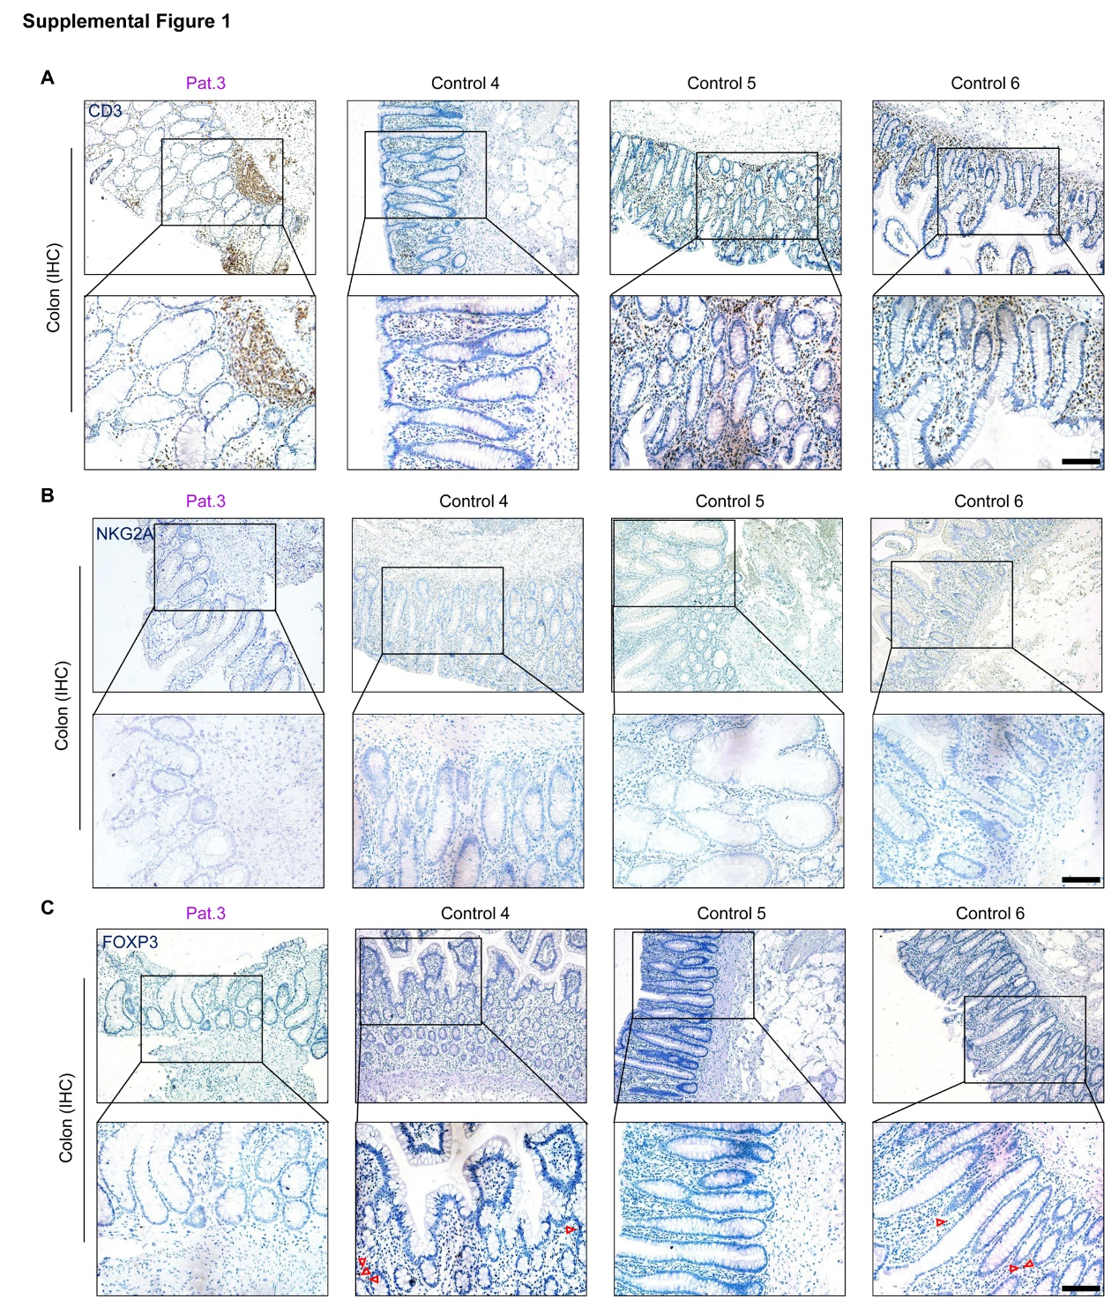
Supplemental Figure 1. The patient with aGvHD after sequential anti-PD-1 therapy had low expression of FOXP3 in the colon. (A–C) Serial sections prepared from the colon-biopsy samples of a patient with aGvHD after sequential anti-PD-1 therapy and in HCs. Serial sections were stained (as indicated) with antibodies directed against CD3 (A), NKG2A (B), and FOXP3 (C). Scale bars, 50 μm.

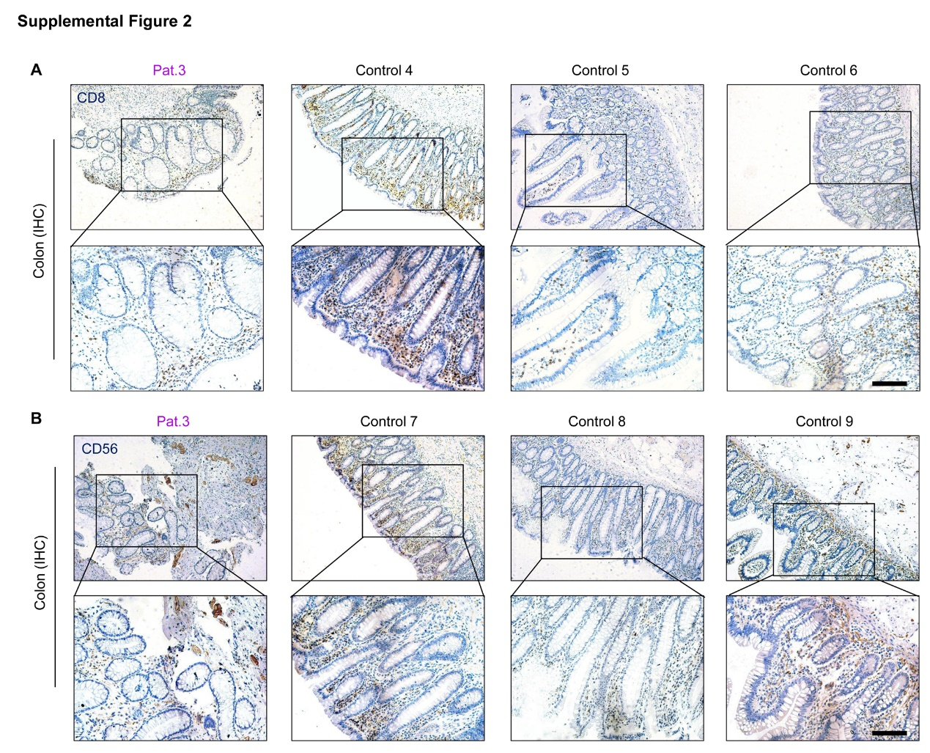
Supplemental Figure 2. The patient with aGvHD after sequential anti-PD-1 therapy had few CD8⁺ T cells and CD56⁺ NK cells in the colon. (A and B) Serial sections prepared from the colon-biopsy samples of a patient with aGvHD after sequential anti-PD-1 therapy and in HCs. Serial sections were stained with antibodies directed against CD8 (A) and CD56 (B) as indicated. Scale bars, 50 μm.

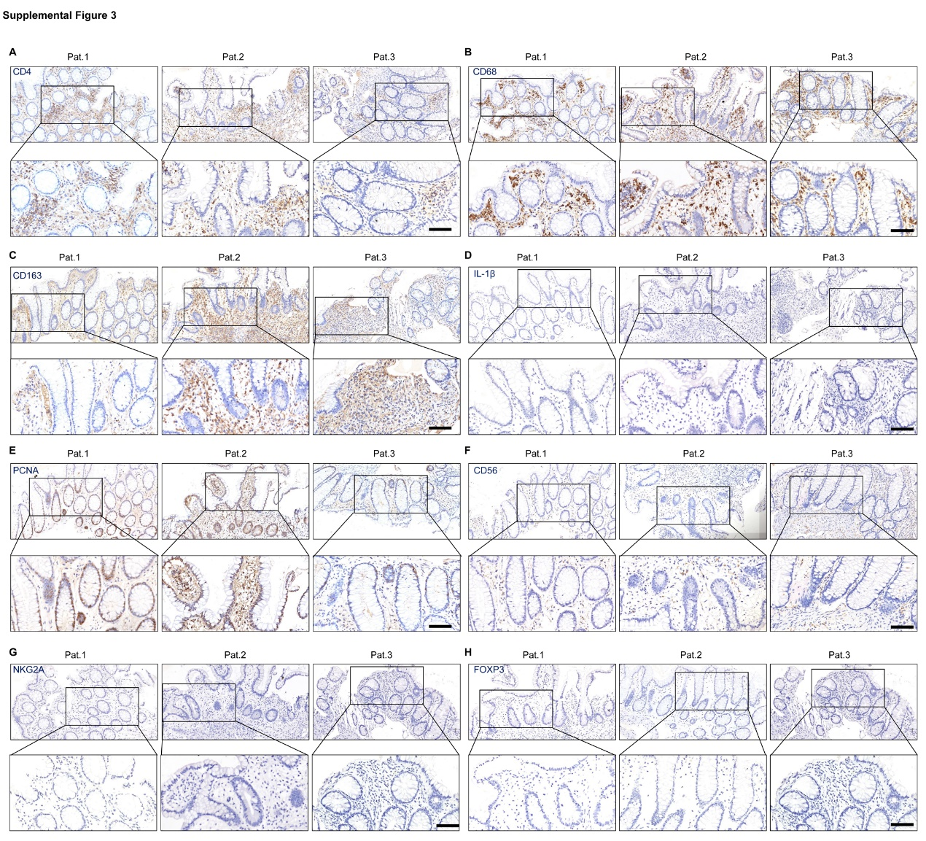
Supplemental Figure 3. Representative images of immunohistochemical staining of immune-cell infiltration in the colon samples of patients who relapsed before anti-PD-1 therapy. (A–H) Sections were prepared from the colon-biopsy samples of three patients who relapsed before anti-PD-1 therapy. Sections were stained (as indicated) with antibodies directed against CD4 (A), CD68 (B), CD163 (C), IL-1β (D), PCNA (E), CD56 (F), NKG2A (G), and FOXP3 (H). Scale bars, 50 μm.
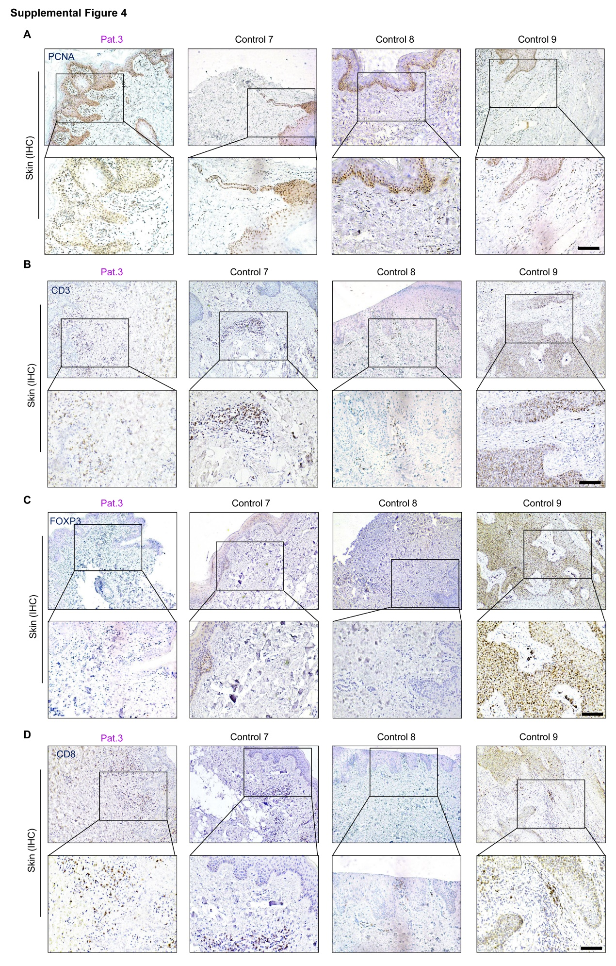
Supplemental Figure 4. The patient with aGvHD after sequential anti-PD-1 therapy had low expression of FOXP3 in skin. (A–D) Serial sections prepared from the skin-biopsy samples of a patient with aGvHD after sequential anti-PD-1 therapy and in HCs. Serial sections were stained with antibodies directed against PCNA (A), CD3 (B), CD8 (C), and FOXP3 (D) as indicated. Scale bars, 50 μm.

