Supplementary Material

- Ultrasound evaluation of kidney and liver involvement in Bardet-Biedl syndrome
- Metin Cetiner, Ilja Finkelberg, Felix Schiepek, Raphael Hirtz, Anja K. Büscher

Outline
Supplementary Methods - Testing of statistical assumptions
Supplementary Results - Table 1 | Covariate Selection Process by FWDselect – ATI
Supplementary Results - Table 2 | Covariate Selection Process by FWDselect – SWD
Supplementary Results - Table 3 | Covariate Selection Process by FWDselect – SWE
Supplementary Results - Figure 1 | Heterogeneity of Regression Slopes

Supplementary Methods - Testing of statistical assumptions
Descriptive Statistics
Normality of the data was assessed by the Kolmogorov-Smirnov test. Equality of variances was tested by Levene's test. When this assumption was not met, a Welch test was performed. In case of non-normally distrusted data or the presence of outliers, a median test was performed.

Multiple Regression
Normality of the residuals of the multiple regression analyses regarding the outcome measures ATI, SWE, and SWD levels were assessed by the Kolmogorov-Smirnov test. Outlier detection relied on standardized residuals exceeding ± 3 SD. Multicollinearity was defined by variance inflation factors exceeding 10 and homoscedasticity was evaluated by the Breusch-Pagan test. Autocorrelations of residuals were excluded by the Durbin-Watson test. Linearity was checked by visual inspection of (partial) bivariate scatter plots between the DV of interest and all IVs as well as all pairs of IVs.

ANCOVA
The normality of studentized residuals and the identification of outliers were evaluated using the methods detailed previously in the context of multiple regression analysis. Equality of variances was tested by Levene's test (based on the median). In the presence of heteroscedasticity, a robust standard error estimator for regression coefficients according to Davidson-McKinnan (HC3) was applied. Homogeneity of regression was investigated by separate ANCOVAs testing for the significance of the interaction between the independent (grouping) variable and the considered covariates (1). In the presence of heterogeneity of regression slopes, a Neyman-Johnson analysis was performed. This statistical technique identifies ranges of values for a moderator variable (e.g., age) where the effect of a predictor variable (e.g., group) on an outcome variable (e.g., ATI) is significant. In contexts of heterogeneity of regression slopes, it specifies the range within the moderator variable for which the effect is statistically significant, thus delineating clear boundaries for the influence of the predictor (26).

Supplementary Table 1 - Covariate Selection Process by FWDselect – ATI
 | covariate
q | age | sex | height-SDS | BMI-SDS | weight-SDS | abdominal wall | liver size (%) | liver echogenicity | liver margin | fasting duration | cooperation | AIC | p-value
1 |  |  |  |  |  |  |  | x |  |  |  | -108.62 | .02
2 |  |  |  |  |  |  | x | x |  |  |  | -122.29 | .16
3 |  |  | x |  |  |  | x | x |  |  |  | -126.03
4 | x |  | x |  |  |  | x | x |  |  |  | -131.99
5 | x |  | x |  |  | x | x | x |  |  |  | -134.63
6 | x |  | x |  |  | x | x | x |  | x |  | -135.00
7 | x |  | x |  |  | x | x | x | x | x |  | -136.35
8 | x |  | x | x |  | x | x | x | x | x |  | -135.04
9 | x | x | x | x |  | x | x | x | x | x |  | -133.25
10 | x | x | x | x | x | x | x | x | x | x |  | -131.37
ATI FWDselect results. q = size of the considered covariate subset; x = covariate selected by the FWDselect algorithm at size q; AIC = Akaike information criterion; p-value = p-value regarding the hypothesis H1(q): the model fit improves including additional covariates.

Supplementary Table 2 - Covariate Selection Process by FWDselect – SWE
 | covariate
q | age | sex | height-SDS | BMI-SDS | weight-SDS | abdominal wall | liver size (%) | liver echogenicity | liver margin | fasting duration | cooperation | AIC | p-value
1 |  |  |  |  |  | x |  |  |  |  |  | -62.61 | .52
2 | x |  |  |  |  | x |  |  |  |  |  | -63.71
3 | x |  |  | x |  | x |  |  | x |  |  | -63.79
4 | x |  |  | x |  | x |  |  | x |  |  | -63.16
5 | x |  |  | x |  | x |  |  | x |  | x | -62.03
6 | x |  |  | x |  | x | x |  | x |  | x | -60.60
7 | x |  |  | x |  | x | x | x | x |  | x | -59.32
8 | x |  |  | x | x | x | x | x | x |  | x | -57.77
9 | x | x |  | x | x | x | x | x | x |  | x | -56.20
10 | x | x |  | x | x | x | x | x | x | x | x | -54.38
SWE (ms) FWDselect results. q = size of the considered covariate subset; x = covariate selected by the FWDselect algorithm at size q; AIC = Akaike information criterion; p-value = p-value regarding the hypothesis H1(q): the model fit improves including additional covariates.

Supplementary Table 3 - Covariate Selection Process by FWDselect – SWD
 | covariate
q | age | sex | height-SDS | BMI-SDS | weight-SDS | abdominal wall | liver size (%) | liver echogenicity | liver margin | fasting duration | cooperation | AIC | p-value
1 |  | x |  |  |  |  |  |  |  |  |  | 170.14 | .91
2 |  | x |  |  |  |  |  |  |  |  | x | 170.00
3 |  | x |  |  | x |  |  |  |  |  | x | 170.77
4 |  | x |  | x | x |  |  |  |  |  | x | 170.31
5 | x | x |  | x | x |  |  |  |  |  | x | 171.08
6 | x | x |  | x | x |  | x |  |  |  | x | 171.55
7 | x | x | x | x | x |  | x |  |  |  | x | 172.80
8 | x | x | x | x | x |  | x |  | x |  | x | 174.62
9 | x | x | x | x | x |  | x | x | x |  | x | 176.48
10 | x | x | x | x | x |  | x | x | x | x | x | 178.40
SWD FWDselect results. q = size of the considered covariate subset; x = covariate selected by the FWDselect algorithm at size q; AIC = Akaike information criterion; p-value = p-value regarding the hypothesis H1(q): the model fit improves including additional covariates.

Supplementary Results - Figure 1 | Heterogeneity of Regression Slopes
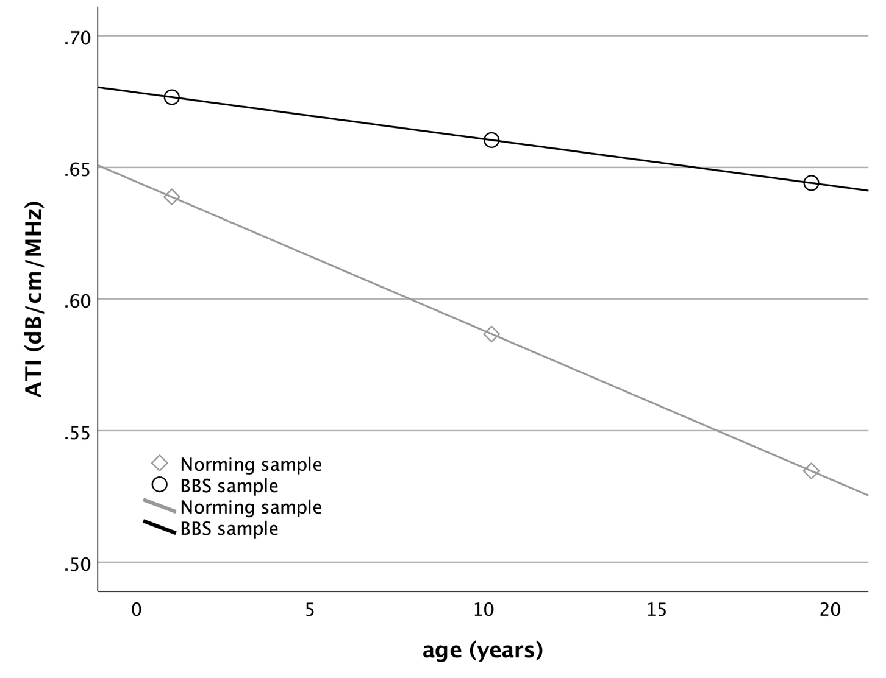
Relationship between ATI level (attenuation imaging coefficient; y-axis) in BBS patients versus the norming sample, with age (x-axis) analyzed at exemplary ages (-1 SD [14th percentile], the mean, and +1 SD [86th percentile]) as a moderator, and liver size (as a percentage), liver echogenicity, and BMI standard deviation scores (BMI-SDS) as covariates. Further details and the statistical significance of these relationships are discussed in the manuscript.

