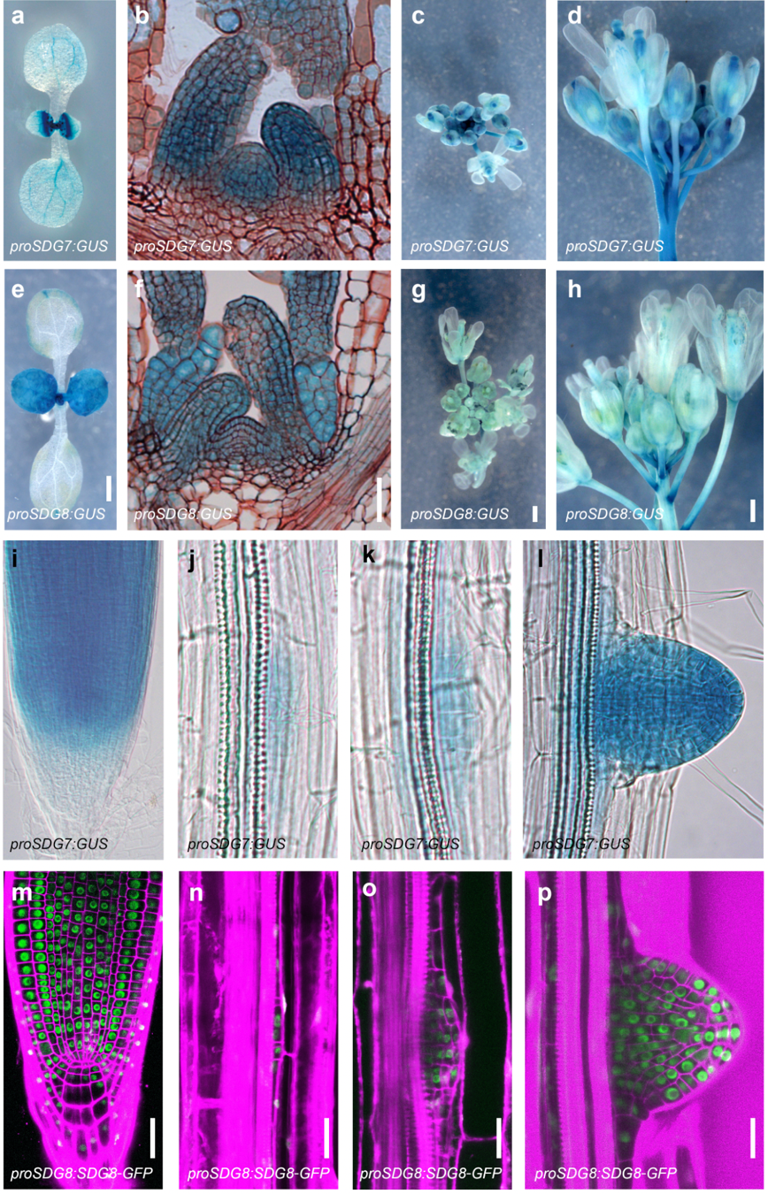
Fig. S1 | Overlapping expression patterns of SDG7 and SDG8 in Arabidopsis thaliana.
a–h, Expression pattern of SDG7 and SDG8 using proSDG7:SDG7-GUS (a-d) and proSDG8:GUS (e-h) transgenic lines in cotyledons (a,e), shoot apical meristems (b,f), top and side views of primary inflorescences (c,g and d,h, respectively). Scale bars, 500 µm (e, g, h) or 50 µm (f). i–p, Expression pattern of SDG7 and SDG8 using proSDG7:SDG7-GUS (i-l) and proSDG8:SDG8-GFP (m-p) transgenic lines in primary root tips (i,m), stage II lateral roots (j,n), stage IV lateral roots (k,o) and emerged lateral roots (l,p). Scale bars, 50 µm (m-p).

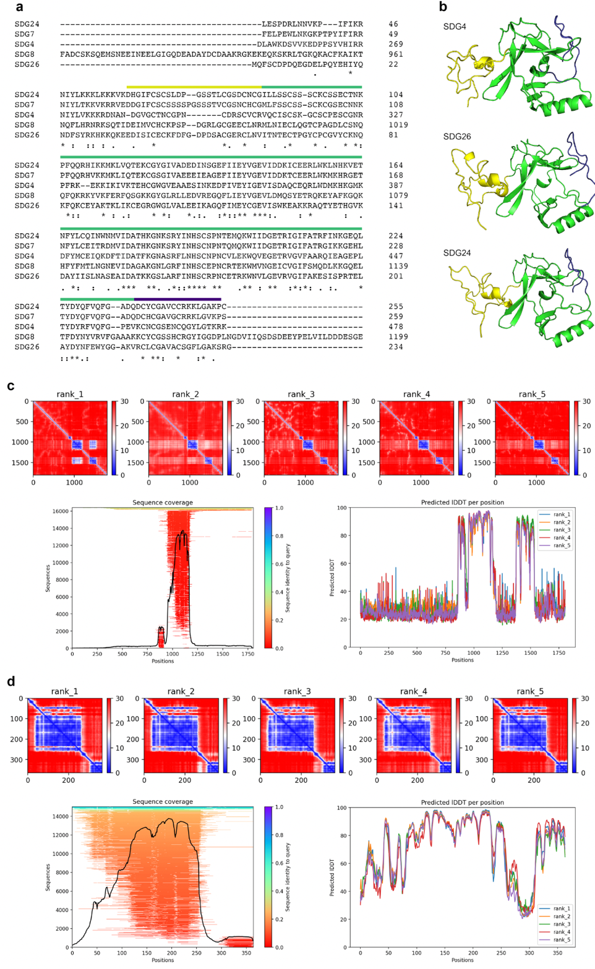
Fig. S2 | Structural prediction of class II SDG family proteins.
a, Sequence alignment of the conserved domains in SDG7, SDG8 and other SDG members. Blue, green and red lines indicate the AWS, SET and post-SET domains, respectively. Asterisks show conserved amino acids. b, 3D structure prediction of the conserved domains of SDG4, SDG26 and SDG24 by AlphaFold 2. Blue, green and red lines indicate the AWS, SET and post-SET domains, respectively. c,d, Structure prediction of full-length SDG8 and SDG7 by AlphaFold 2. Top, Inter-chain predicted aligned error (PAE) plot for the best-ranked model structures of SDG7 (c) and SDG8 (d) by AlphaFold 2. Bottom left, Multiple Sequence Alignment (MSA) sequence coverage by AlphaFold 2. Bottom right, Predicted local distance difference test (LDDT) per position of the five models by AlphaFold 2.
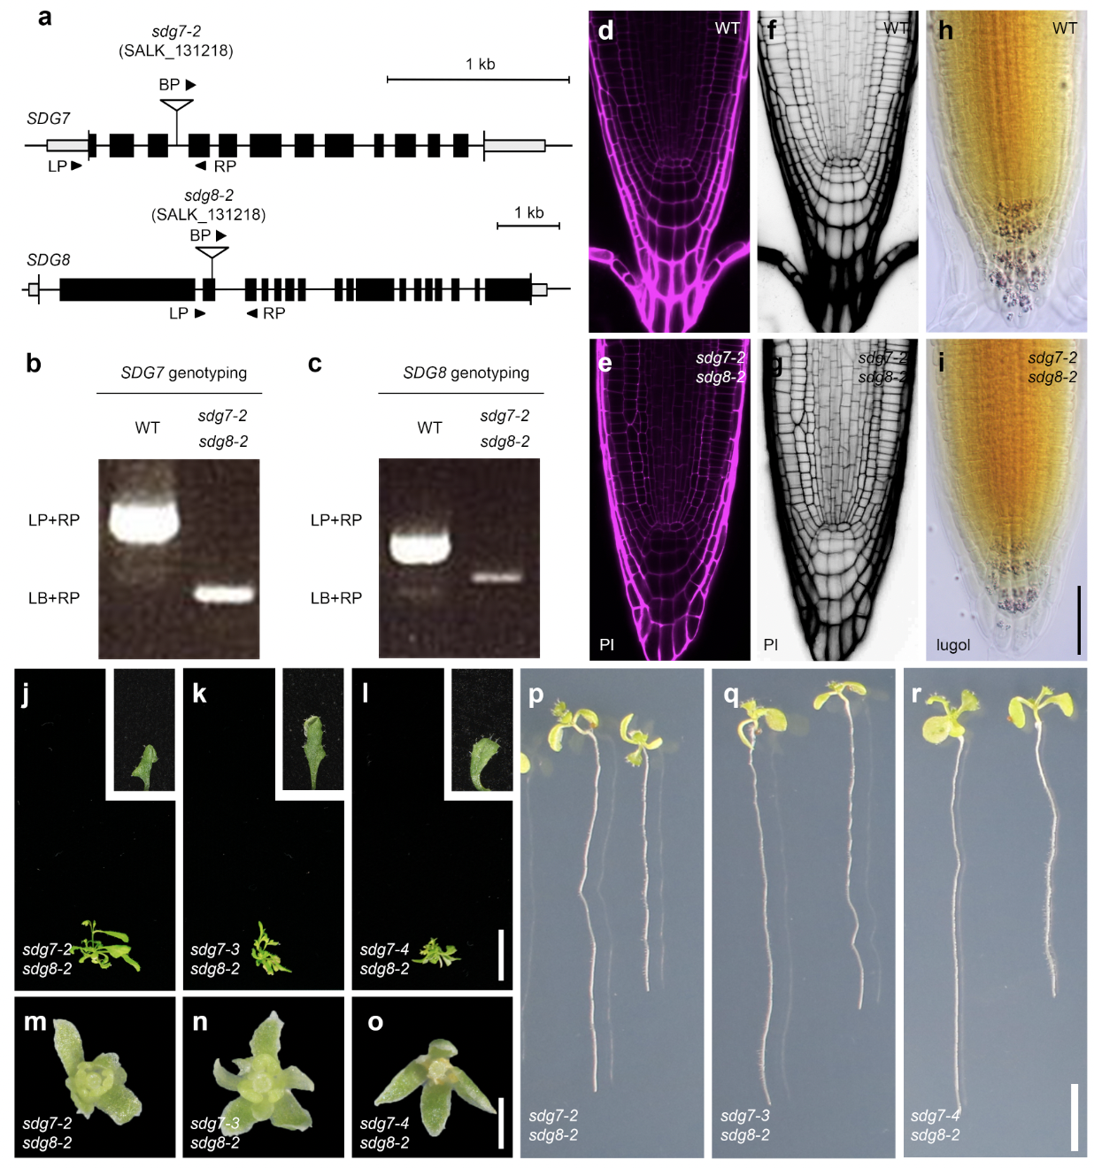Fig. S3 | Isolation of sdg7 sdg8 double mutants.
a, Diagram of the SDG7 and SDG8 loci. The black boxes, gray boxes and short lines inside gene bodies indicate exons, untranslated regions, introns and qPCR-amplified regions, respectively. White triangles indicate the position of T-DNA insertions; black arrowheads denote genotyping primers (sdg7-2 LP, sdg7-2 RP, sdg8-2 LP and sdg8-2 RP); and white arrowheads denote RT-PCR primer pairs. b, c, Genotyping results of WT and sdg7-2 sdg8-2 double mutant. b. SDG7 genotyping. c. SDG8 genotyping. d–g, Cellular organization of the root meristem, as visualized by propidium iodide (PI) staining in wild type (WT; d, f) and sdg7 sdg8 (e, g). h,i, Cellular organization of the columella root cap, as visualized by Lugol staining in WT (h) and sdg7 sdg8 (i). Scale bar, 50 µm. j–l, Representative photographs of the sdg7-2 sdg8-2 (j), sdg7-3 sdg8-2 (k) and sdg7-4 sdg8-2 (l) double mutants at 25 days after germination. Insets: top view of 1st true leaves. Scale bar, 1 cm. m–o, Top view of stage 14 flowers from soil-grown sdg7-2 sdg8-2 (m), sdg7-3 sdg8-2 (n) and sdg7-4 sdg8-2 (o). Scale bar, 0.5 mm. p–r, Representative photograph of the roots from the sdg7-2 sdg8-2 (p), sdg7-3 sdg8-2 (q) and sdg7-4 sdg8-2 (r) double mutants. Scale bar, 1 cm.

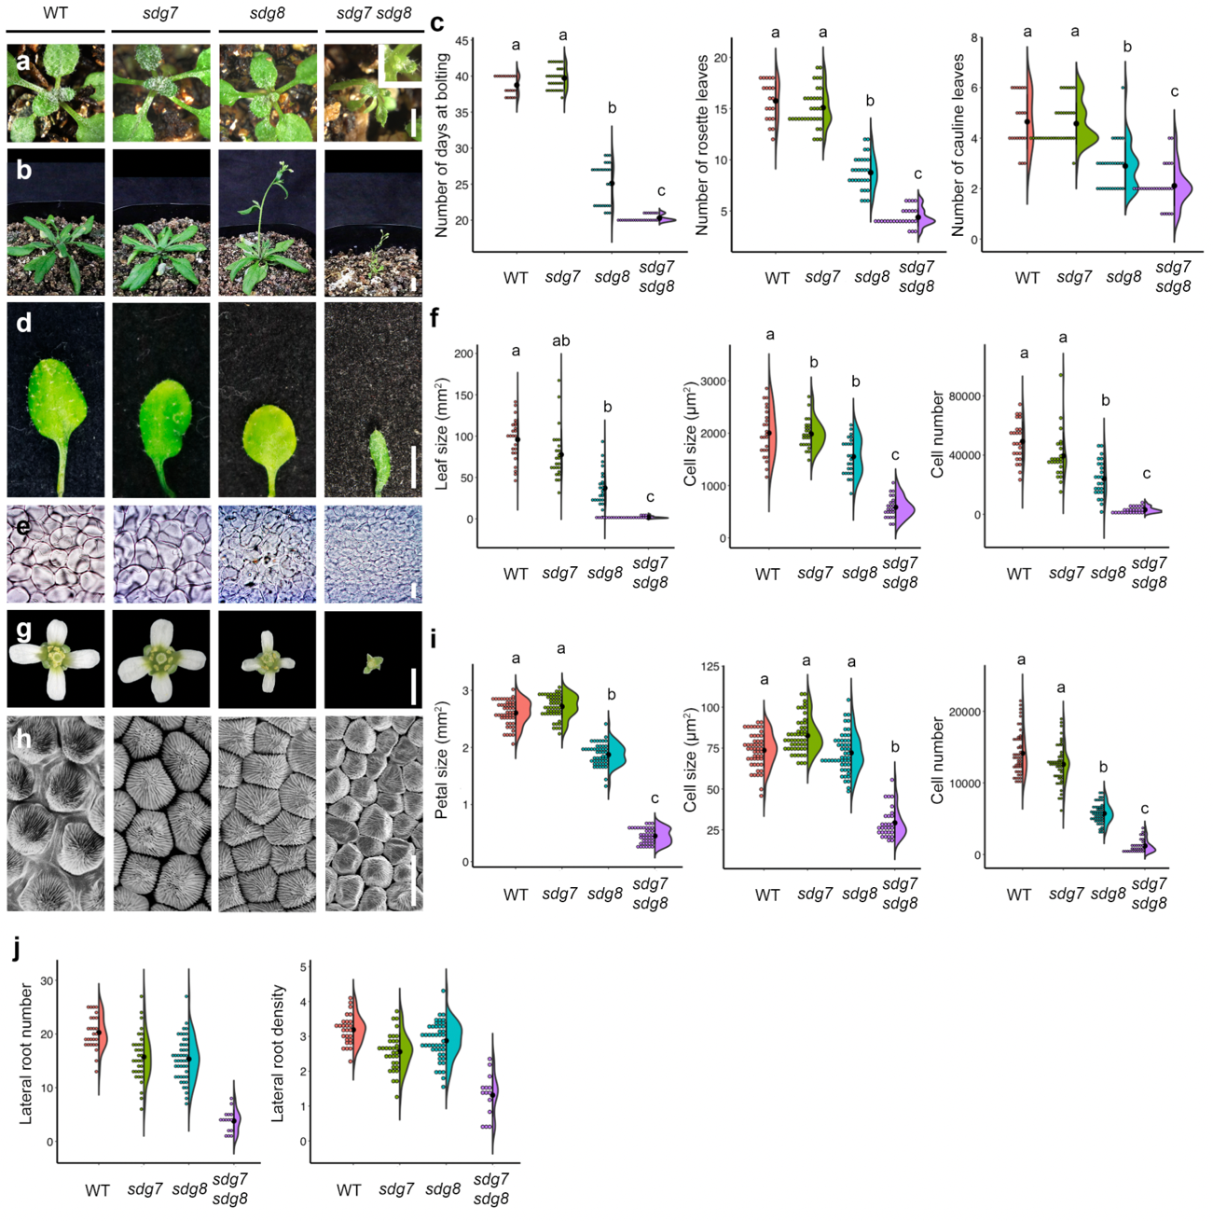Fig. S4 | Phenotypes of the sdg7 sdg8 double mutant.
a, Top views of the wild type (WT), sdg7, sdg8 and sdg7 sdg8 at 10 days after germination. b, Side views of the WT, sdg7, sdg8 and sdg7 sdg8 at 25 days after germination. c, Number of rosette leaves (left) and cauline leaves (middle), and days to bolting (right) in the WT, sdg7, sdg8 and sdg7 sdg8 (WT: n = 20; sdg7: n = 34; sdg8: n = 28; sdg7 sdg8: n = 26). d, Top view of 5th true leaf in the WT, sdg7, sdg8 and sdg7 sdg8. Scale bars (a, b, d), 1 cm. e, Appearance of palisade cells from 5th true leaves in the WT, sdg7, sdg8 and sdg7 sdg8. Scale bar, 20 µm. f, Leaf size (left), cell size (middle), and cell number (right) in the WT, sdg7, sdg8 and sdg7 sdg8 (WT: n = 24; sdg7: n = 24; sdg8: n = 24; sdg7 sdg8: n = 24). g, Top view of stage 14 flowers from soil-grown WT, sdg7, sdg8 and sdg7 sdg8. Scale bar, 0.5 mm. h, Petal epidermal cells in the WT, sdg7, sdg8 and sdg7 sdg8. Scale bar, 10 µm. i, Petal area (left), petal cell number (middle), and petal cell size (right) in the WT, sdg7, sdg8, and sdg7 sdg8 (WT: n = 50; sdg7: n = 50; sdg8: n = 50; sdg7 sdg8: n = 40). j, Lateral root number (left) and lateral root density (right) in the WT, sdg7, sdg8 and sdg7 sdg8 at 7 days after germination (WT: n = 27; sdg7: n = 33; sdg8: n = 46; sdg7 sdg8: n = 15). Significant differences were calculated based on one-way ANOVA tests (p = 1.1 x 10⁻¹⁶). Different letters indicate significant differences based on post-hoc Tukey’s HSD test (p < 0.05: See the Data Source file for all combinations of the exact p-values).

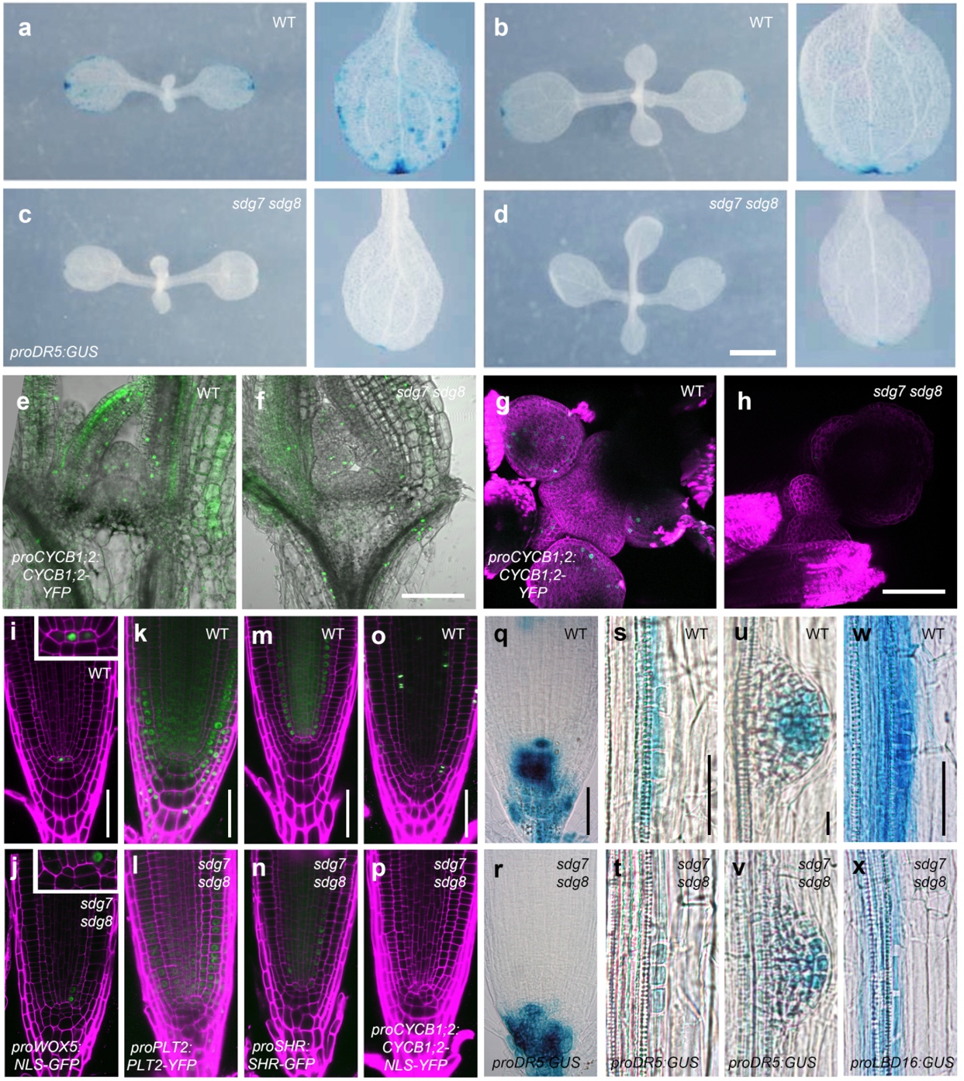
Fig. S5 | Molecular defects of the sdg7 sdg8 double mutants.
a–d, GUS staining pattern from the DR5:GUS reporter construct in the WT (a, b) and sdg7 sdg8 (c, d). Seven-day-old (a, c) and 13-day-old (b, d) seedlings are shown. Left, top views of seedlings. Right, Close-up views of cotyledons. Scale bar, 3 mm. e,f, YFP fluorescence pattern from the proCYCB1;2:CYCB1;2-YFP transgene in the shoot apical meristems from WT (e) and sdg7 sdg8 (f). Scale bar, 50 µm. g,h, YFP fluorescence pattern from the proCYCB1;2:CYCB1;2-YFP transgene in the inflorescence meristems of WT (g) and sdg7 sdg8 (h). Scale bar, 100 µm. i-r, GFP fluorescence or GUS staining pattern from the indicated cell markers in the primary roots of WT (i, k, m, o, q) and sdg7 sdg8 (j, l, n, p, r). proWOX5:NLS-GFP (i, j), proPLT2:PLT2-YFP (k, l), proSHR:SHR-GFP (m, n), proCYCB1;2:CYCB1;2-NLS-YFP (o, p) and DR5:GUS (q, r). s-x GUS staining pattern from the indicated cell markers in lateral roots of WT (s, u, w) and sdg7 sdg8 (t, v, x). DR5:GUS (s-v) and proLBD16:GUS (w, x). Stage II (s, t, w, x) and Stage IV (u, v). Scale bars, 50 µm.

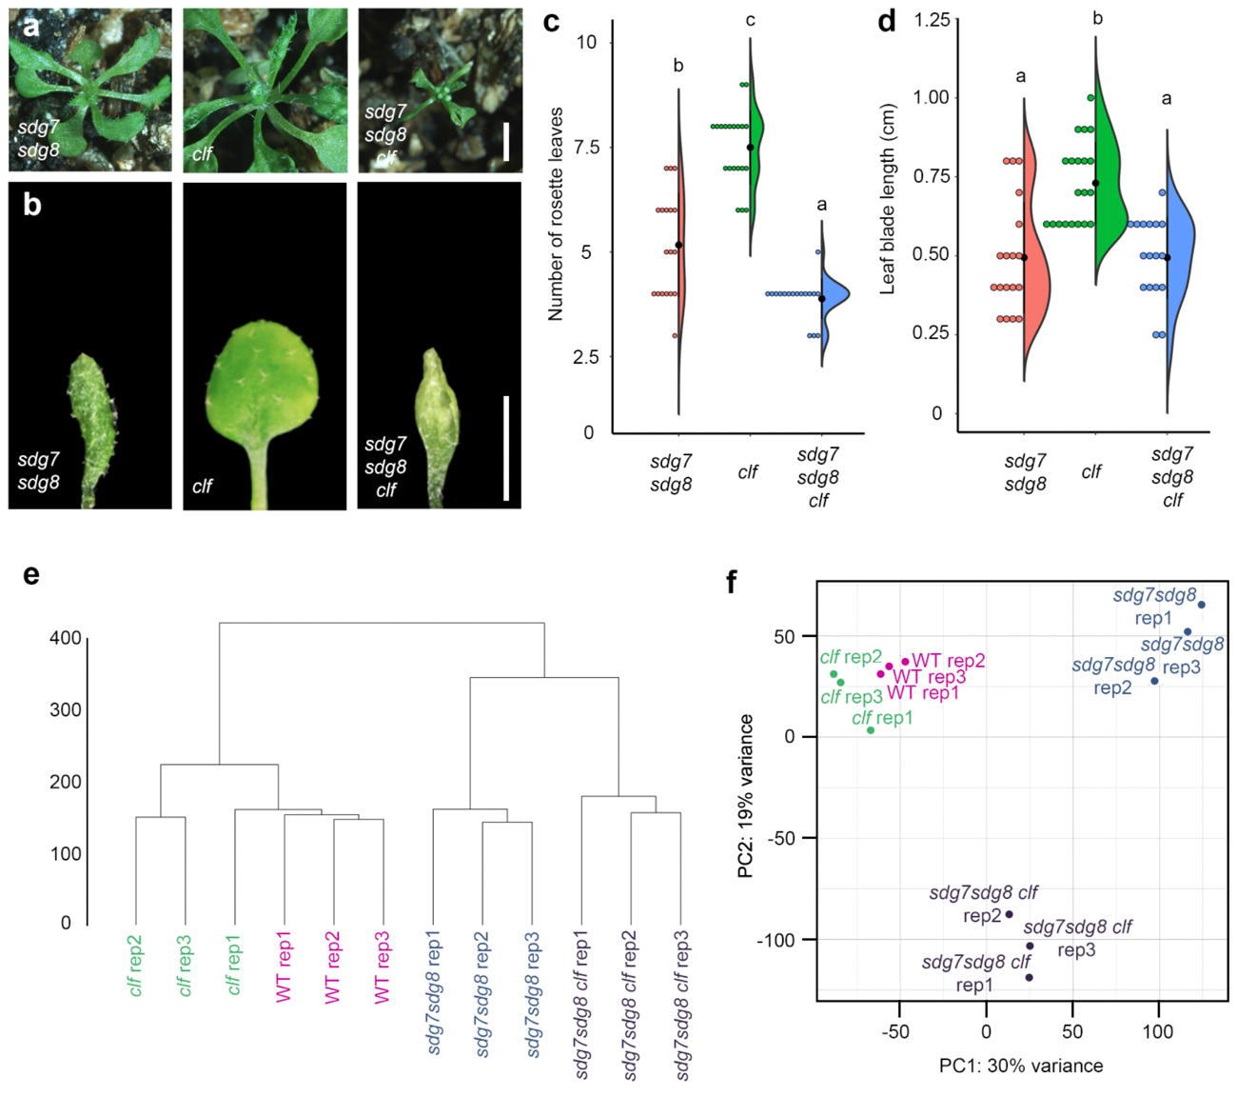
Fig. S6 | Phenotypic and molecular defects in the clf sdg7 sdg8 triple mutants.
a, Top views of the sdg7 sdg8, clf and sdg7 sdg8 clf at 20 days after germination. Scale bar, 1 cm. b, Top views of the 1st leaf in the sdg7 sdg8, clf and sdg7 sdg8 clf at 20 days after germination. Scale bar, 1 cm. c, d, Leaf number at flowering and size of 1st true leaf in the sdg7 sdg8, clf and sdg7 sdg8 clf (sdg7 sdg8: n = 18; clf: n = 20; sdg7 sdg8 clf: n = 17). Significant differences were calculated based on one-way ANOVA tests (p = 1.1 x 10⁻¹⁶). Different letters indicate significant differences based on post-hoc Tukey’s HSD test (p < 0.05: See the Data Source file for all combinations of the exact p-values). e, Hierarchical clustering. The dendrogram of all RNA-seq samples obtained with the R package stat is shown with the bootstrap values on each node. f, Principal component analysis (PCA). The PCA plot illustrates all twelve RNA-seq samples, with replicates represented by the same color.

