Understanding the degradation process of polyhydroxyalkanoate (PHA)/ poly(butylene adipate-co-terephthalate) (PBAT) biocomposite mulch films and the effects of stabilizers under accelerated aging test
Yuchuan Tianª, Bing Zhouª, and James H. Wangª
ª Sinopec Shanghai Research Institute of Petrochemical Technology, Shanghai 201028, PR China

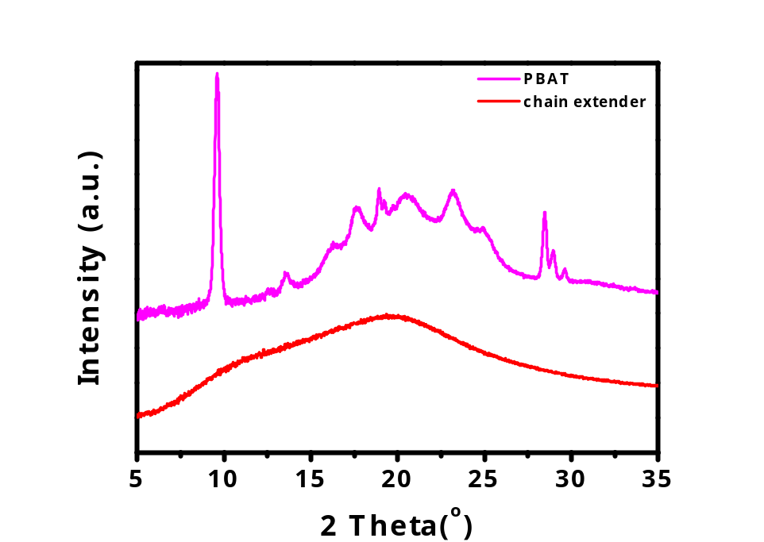
Fig. S1 The XRD information of different ingredients of neat PHA-PBAT films

Table S1 The parameters for PHA-PABT melt blending

Samples |  | PHA/PBAT | PHA/PBAT-UVA | PHA/PBAT-AO | PHA/PBAT-HRA
Composition  (Mass fraction)ª | PBAT | 80 | 80 | 80 | 80
Composition  (Mass fraction)ª | PHA | 20 | 20 | 20 | 20
Composition  (Mass fraction)ª | ADR | 0.5 | 0.5 | 0.5 | 0.5
Composition  (Mass fraction)ª | UVA | 0 | 0.3 | 0 | 0
Composition  (Mass fraction)ª | HRA | 0 | 0 | 0 | 0.6
Composition  (Mass fraction)ª | AO | 0 | 0 | 0.3 | 0
Composition  (Mass fraction)ª | OA* | 10.5 | 10.5 | 10.5 | 10.5
Screw Speed (rpm) |  | 200 | 200 | 200 | 200
Melt Temprature (℃) |  | 175 | 172 | 168 | 177
Melt Pressure (bar) |  | 49 | 30 | 51 | 44
Feeding speed (kg/h) |  | 8.3 | 8.4 | 8.4 | 8.4

* OA is the abbreviation for other additives including lubricants, opening agents etc.
a The mass fraction is the relative parts by weight based on 100 parts by weight of polymer.

Table S2 The parameters of different PHA-PABT films
Additives | Amount (wt%) | Screw speed (rpm) | Drawing  Speed (m/s) |  | Blow-up Ratio | Melt  Pressure  (bar) | Thickness (μm)
None | - | 30 | 6 | 2.35 |  | - | 13.4
None | - | 30 | 6 | 2.94 |  | - | 19.7
UVA | 0.3 | 30 | 6 | 2.69 |  | 0.3 | 17.5
AO | 0.3 | 30 | 6 | 2.35 |  | 0.3 | 18.8
HRA | 0.6 | 30 | 6 | 2.65 |  | 0.6 | 18.8

Table S3 Detailed information of fitted peaks of C 1s of PHA-PBAT and PHA-PBAT-UV327 before and after aging
XPS Deconvolution |  |  | sp2 | sp3 | C-O | C=O
PBAT-PHA | 0 h | Position (eV) | 284.5 | 285 | 286.4 | 288.9
PBAT-PHA | 0 h | Area (%) | 26.7 | 53.1 | 13.6 | 6.5
PBAT-PHA | 0 h | FWHM (eV) | 1 | 1.2 | 1.2 | 1
PBAT-PHA | 0 h | %GL | 80% | 80% | 80% | 80%
PBAT-PHA | 50 h | Position (eV) | 284.5 | 285 | 286.4 | 288.9
PBAT-PHA | 50 h | Area (%) | 36.3 | 41.1 | 12.4 | 10
PBAT-PHA | 50 h | FWHM (eV) | 1 | 1.2 | 1.2 | 1
PBAT-PHA | 50 h | %GL | 80% | 80% | 80% | 80%
PHA-PBAT-UV327 | 0 h | Position (eV) | 284.5 | 285 | 286.3 | 288.9
PHA-PBAT-UV327 | 0 h | Area (%) | 22.4 | 47.4 | 20.1 | 9.4
PHA-PBAT-UV327 | 0 h | FWHM (eV) | 1 | 1.2 | 1.2 | 1
PHA-PBAT-UV327 | 0 h | %GL | 80% | 80% | 80% | 80%
PHA-PBAT-UV327 | 50 h | Position (eV) | 284.5 | 285 | 286.3 | 288.9
PHA-PBAT-UV327 | 50 h | Area (%) | 27.1 | 46.7 | 13.7 | 12.5
PHA-PBAT-UV327 | 50 h | FWHM (eV) | 1 | 1.2 | 1.2 | 1
PHA-PBAT-UV327 | 50 h | %GL | 80% | 80% | 80% | 80%

To whom correspondence should be addressed. JamesWang.sshy@sinopec.com.

