Fine mapping of LrN3B, one of two complementary genes for adult plant leaf rust resistance on wheat chromosome arm 3BS

Wang et al.

Supplementary Figures

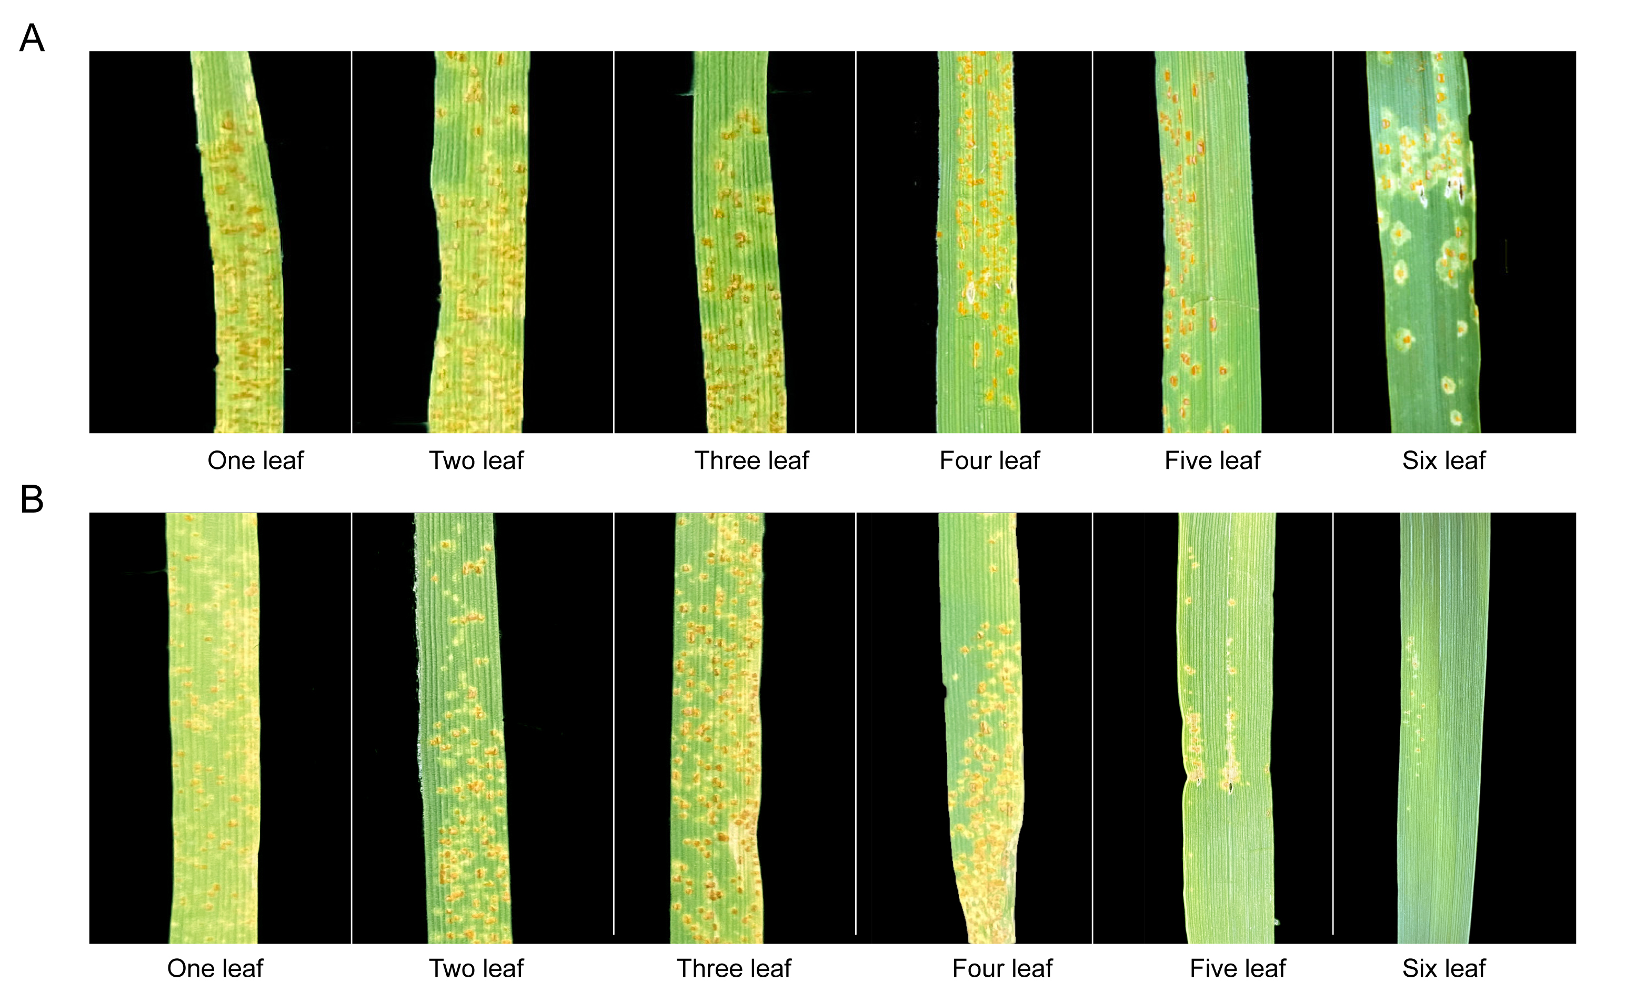

Fig. S1 Reactions to Pt PHT of 4N0461 at different temperture. (A) Wheat pants were infected with Pt PHT at 20 ℃. (B) Wheat pants were infected with Pt PHT at 30 ℃.

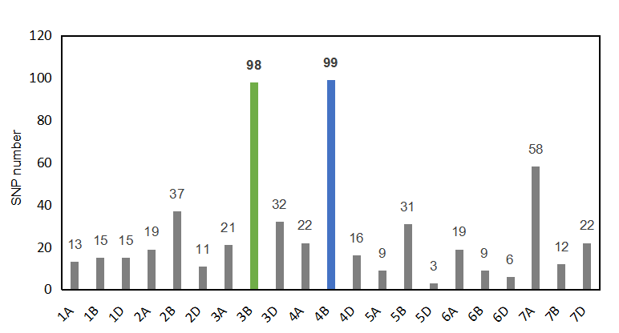
Fig. S2 Total single nucleotide polymorphisms (SNPs) numbers between the resistant and susceptible pools from gwm251-segregating and gwm533-segregating F_{2:3} families.

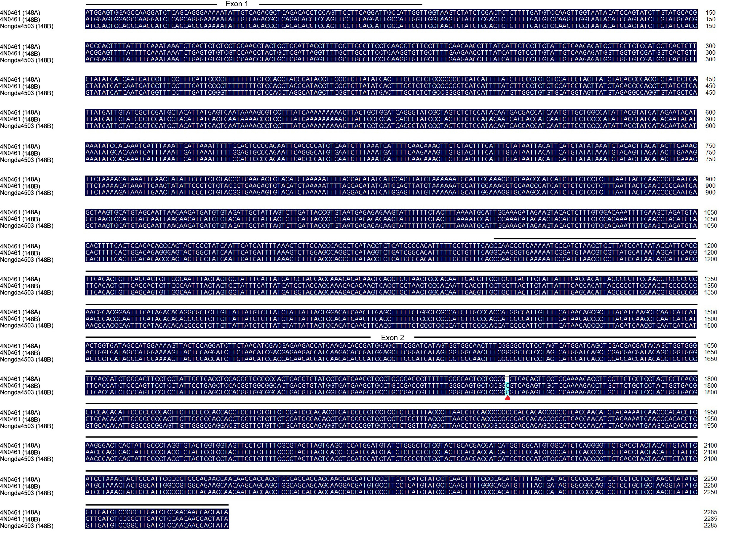
Fig. S3 Nucleotide sequence alignment of 148A and 148B. Red triangle indicates the SNP between 148A and 148B.

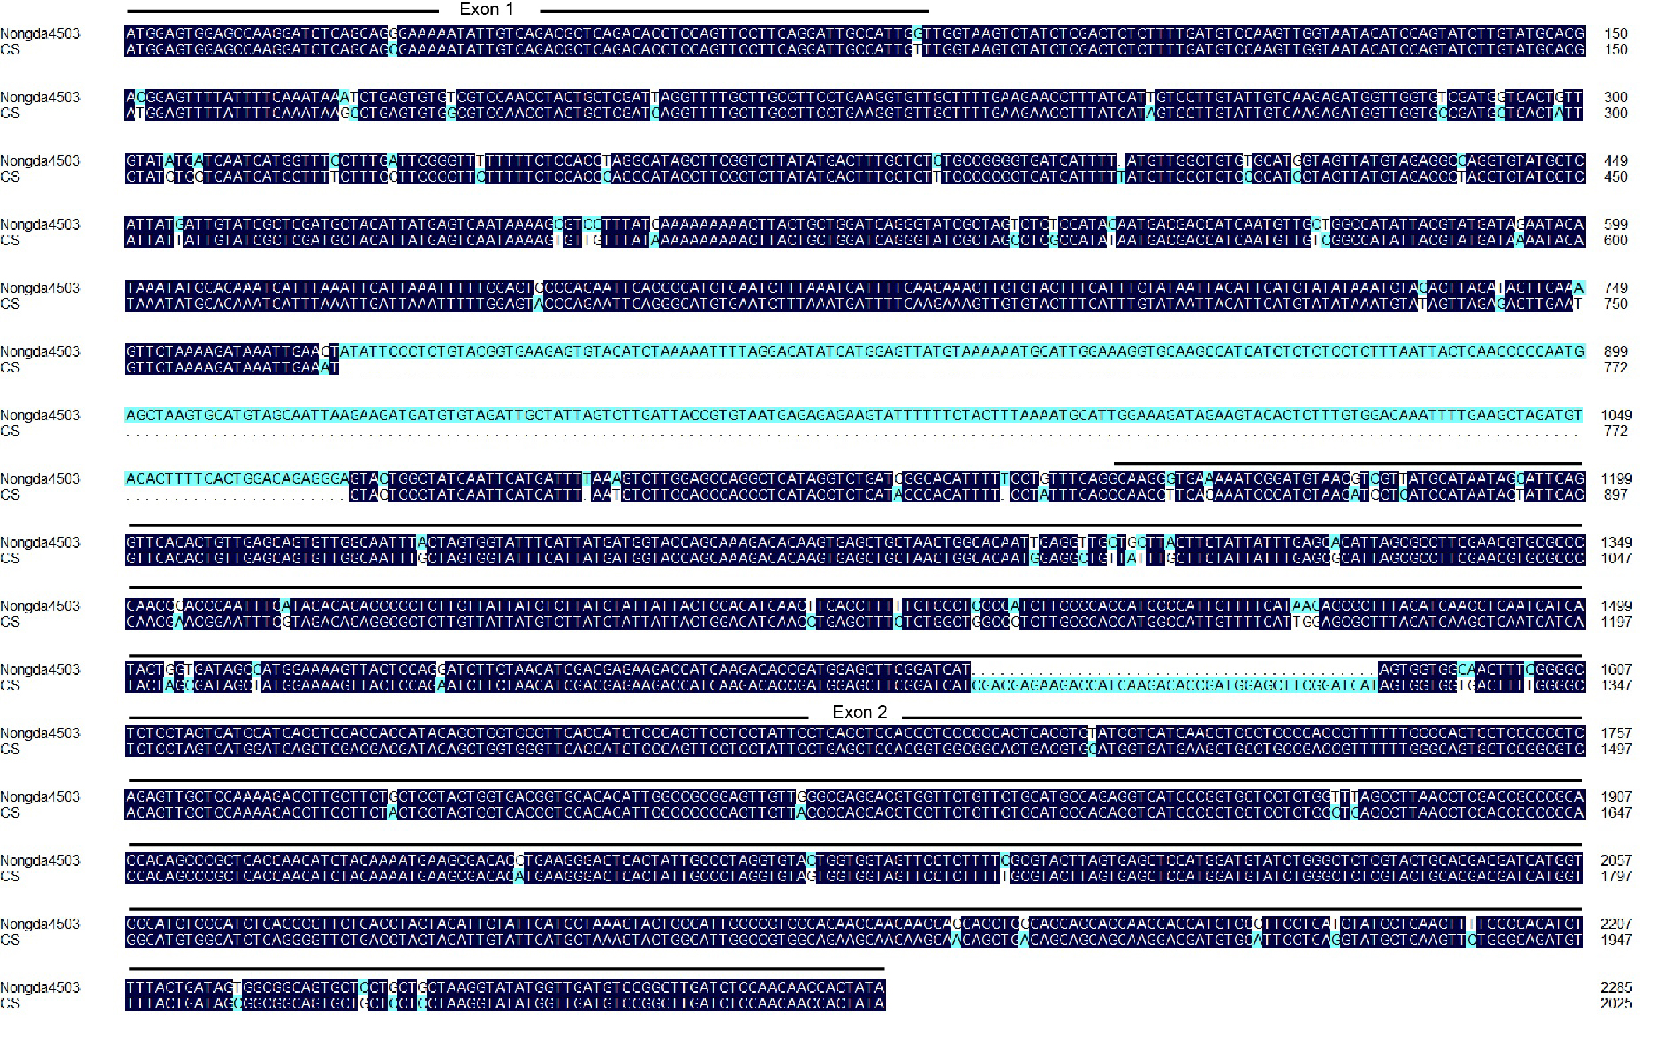
Fig. S4 Nucleotide sequence alignment of TraesCS3B02G014800 alleles in Nongda4503 and Chinese Spring. The full length of TraesCS3B02G014800 alleles in Nongda4503 and CS are 2286 and 2026 bp, respectively.
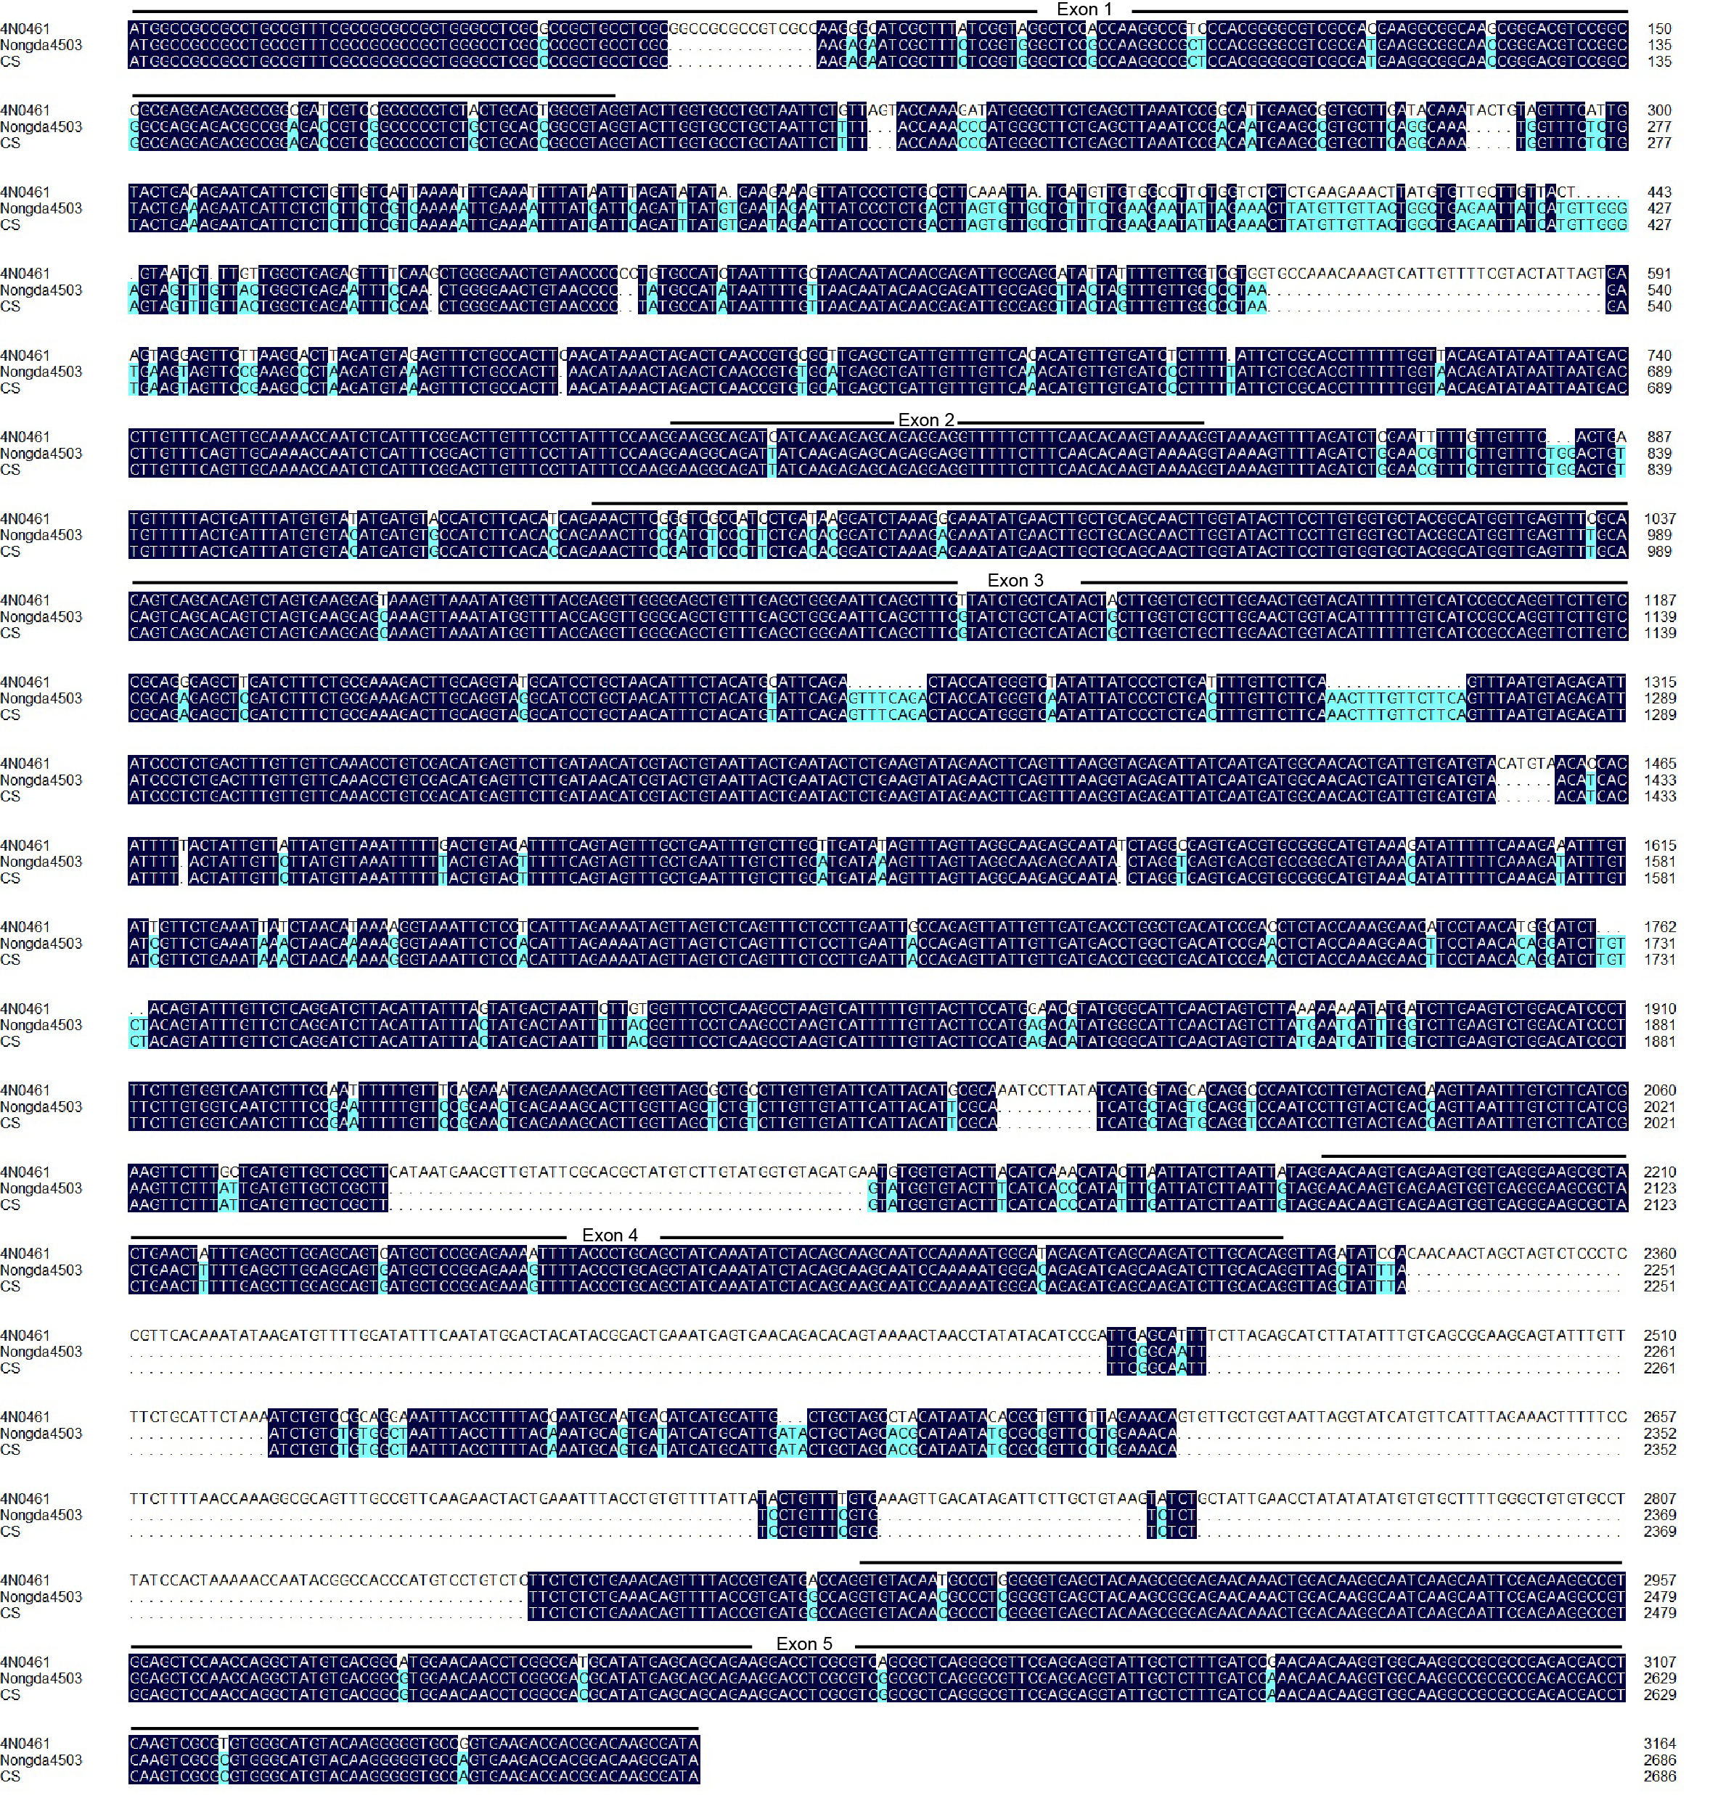
Fig. S5 Nucleotide sequence alignment of TraesCS3B02G014900 alleles in 4N0461, Nongda4503 and CS. The full length of TraesCS3B02G014900 alleles are 3165, 2687 and 2687 bp in 4N0461, Nongda4503 and CS, respectively.

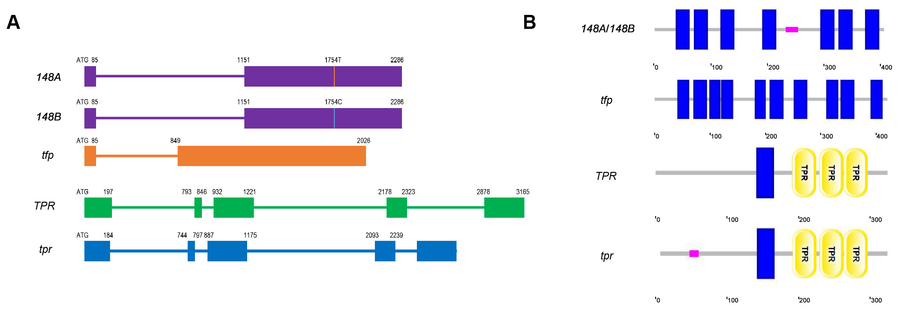
Fig. S6 Analysis of gene structure and domain of TraesCS3B02G014800 and TraesCS3B02G014900 alleles. (A) Gene structures. Rectangle: exons; horizontal lines: introns; vertical bar: the SNP between 148A and 148B. (B) Domains analysis. Blue rectangles: transmembrane region; yellow ovals: TPR motif; pink rectangle: low complexity domain.

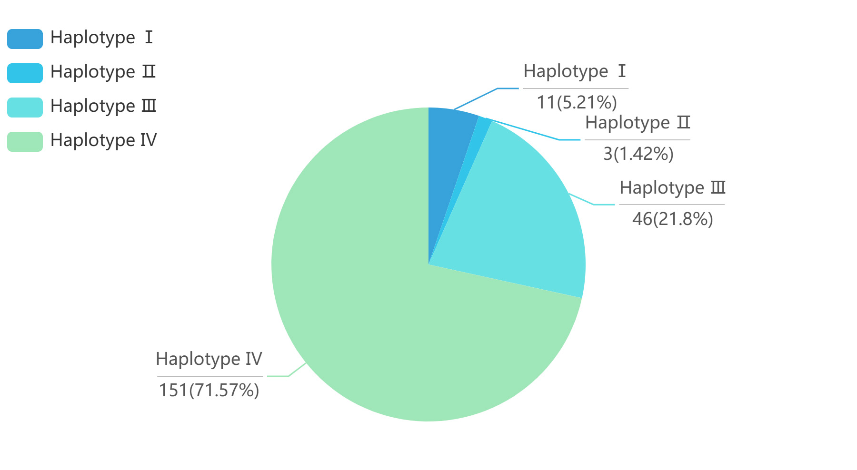
Fig. S7 Distribution of haplotypes of LrN3B in 211 wheat lines. There were 4 haplotypes of LrN3B in 211 materials. Haplotype Ⅰ: 148A+148B+TPR; haplotype Ⅱ: 148B+TPR; haplotype Ⅲ: 148B+tpr; haplotype Ⅳ: tfp+tpr.

