Supplementary Materials & Methods
The Digital Imaging and Communications in Medicine (DICOM) CECT images were scanned by 640-slice CT scanner (Aquilion One, Toshiba Medical Systems), dual-source CT scanner (SOMATOM Force) and the SOMATOM Definition Flash scanner (both by Siemens AG, Forchheim, Germany). An automatic tube current modulation technique was used and the tube voltage was set to 120 kVp. Prior to scanning, patients were instructed to hold their breath to avoid motion artefacts. The first series was a non-enhanced CT study of the chest (helical scan type, 100 kV and automatic mAs, rotation time of 0.6 s, slice thickness and spacing of 1.375:1 per 5 mm, scan field of view (SFOV) of 50 cm, and matrix of 512*512); the scanning area ranged from the thoracic inlet to the level of the diaphragm. A total of 50 to 120 mL (1 mL/kg weight) of contrast agent (iohexol, 300 mg/mL, iodine) was injected at a rate of 3.0 mL/s with a pump syringe.
The imaging data of 134 patients were retrospectively collected from the picture archiving and communication systems (PACS) of Shandong Provincial Hospital Affiliated to Shandong First Medical University, Qilu hospital of Shandong University, Shandong Cancer Hospital and Shandong Provincial Qianfoshan Hospital.

Parameters of Linear Discriminant Analysis in combined radiomics model:
solver: svd
shrink age: None

Supplementary Results
The calculation formula of the RS:
0.9118 * Non_enhanced_original_shape_Maximum3DDiameter + 0.7778 * Enhanced_squareroot_firstorder_90Percentile + 0.3946 * Non_enhanced_log-sigma-3-0-mm-3D_glszm_SmallAreaLowGrayLevelEmphasis + -0.144 * Non_enhanced_lbp-3D-m2_firstorder_RootMeanSquared + 1.117 * Non_enhanced_log-sigma-3-0-mm-3D_gldm_DependenceEntropy + 1.0408 * Enhanced_log-sigma-1-0-mm-3D_glrlm_ShortRunLowGrayLevelEmphasis + -0.0343 * Non_enhanced_wavelet-HL_glszm_ZoneEntropy + -0.8436 * Non_enhanced_wavelet-LH_glszm_ZoneEntropy + 0.3036 * Non_enhanced_log-sigma-2-0-mm-3D_glszm_GrayLevelNonUniformityNormalized + -0.2562 * Enhanced_wavelet-HH_glszm_GrayLevelNonUniformityNormalized + -1.699 * Non_enhanced_wavelet-HL_glcm_MCC + 1.1953 * Non_enhanced_log-sigma-4-0-mm-3D_firstorder_Range + -2.2662 * Non_enhanced_wavelet-HL_glcm_Imc1 + 1.2617 * Enhanced_log-sigma-1-0-mm-3D_firstorder_Skewness + 0.1562 * Non_enhanced_log-sigma-5-0-mm-3D_firstorder_Maximum + -0.3325 * Non_enhanced_lbp-3D-k_firstorder_Minimum + -0.7048 * Non_enhanced_exponential_glszm_SizeZoneNonUniformity + -0.1317 * Enhanced_lbp-3D-k_firstorder_Minimum + -1.2695 * Enhanced_exponential_glszm_SmallAreaEmphasis + -1.075 * Non_enhanced_wavelet-HH_glrlm_RunVariance + 0.4167 * Enhanced_exponential_glszm_SizeZoneNonUniformity

Supplementary Figures and Tables
Table S1 Performances of different machine learning classifiers in the validation set
 | Logistic regression | Decision tree | Random Forest | SVM | Xgboost | LinearSVC
ACC | 0.659 | 0.610 | 0.512 | 0.707 | 0.707 | 0.634
AUC | 0.785 | 0.638 | 0.589 | 0.722 | 0.708 | 0.676
F1-score | 0.72 | 0.636 | 0.583 | 0.76 | 0.769 | 0.681
AUC: Area under the curve; ACC: Accuracy; SVM: Support vector machines;
Xgboost: eXtreme gradient boosting; LinearSVC: Linear support vector classification;
TP: True positive; FP: False positive; TN: True negative; FN: False negative;
Accuracy = (TP + TN) / (TP + FP + TN + FN);
Precision= TP / (TP + FP);
Recall=TP/(TP+FN);
F1-Score = 2 × Precision × Recall / (Precision + Recall).

Table S2 Characteristics of patients with TC in each cohort
Variables | Training cohort (n = 93) |  | Internal validation cohort (n = 41)
Variables | n | % | n | %
Gender
Male | 62 | 66.7 | 25 | 61
Female | 31 | 33.3 | 16 | 39
Age (years), median (interquartile range) | 58(50-56) |  | 56(49-63)
BMI, median (interquartile range) | 23.4(21.5-26.6) |  | 23.4(22.1-27.7)
CK5/6
Positive | 89 | 95.7 | 40 | 97.6
Negative | 4 | 4.3 | 1 | 2.4
Ki-67
>60% | 9 | 9.7 | 5 | 12.2
≤60% | 84 | 90.3 | 36 | 87.8
CD5
Positive | 63 | 67.7 | 28 | 68.3
Negative | 30 | 32.3 | 13 | 31.7
CD117
Positive | 82 | 88.2 | 40 | 97.6
Negative | 11 | 11.8 | 1 | 2.4
Depth of invasion
T1 | 3 | 3.2 | 0 | 0
T2 | 9 | 9.7 | 3 | 7.3
T3 | 15 | 16.1 | 2 | 4.9
T4 | 66 | 71 | 36 | 87.8
Lymph node metastasis
N0 | 42 | 45.1 | 15 | 36.6
N1 | 13 | 14 | 14 | 34.1
N2 | 38 | 40.9 | 12 | 29.3
Distant metastasis
M(−) | 56 | 60.2 | 27 | 65.9
M(+) | 37 | 39.8 | 14 | 34.1
TNM stage
I | 1 | 1.1 | 0 | 0
II | 8 | 8.6 | 3 | 7.3
III | 24 | 25.8 | 10 | 24.4
IV | 60 | 64.5 | 28 | 68.3
LDH
Elevated | 25 | 26.9 | 8 | 19.5
Normal | 68 | 73.1 | 33 | 80.5
CEA
Elevated | 8 | 8.6 | 10 | 24.4
Normal | 85 | 91.4 | 31 | 75.6
NSE
Elevated | 47 | 50.5 | 19 | 46.3
Normal | 46 | 49.5 | 22 | 53.7
NE
Elevated | 22 | 23.7 | 8 | 19.5
Normal | 71 | 76.3 | 33 | 80.5
Lym
Normal | 53 | 57 | 25 | 61
Declined | 40 | 43 | 16 | 39
NLR, median (interquartile range) | 4(2.6-6.5) |  | 3.6(2.4-4.5)
Clinical Manifestation
Y | 67 | 72 | 28 | 68.3
N | 26 | 28 | 13 | 31.7
LDH, lactate dehydrogenase; CEA, carcinoembryonic antigen; NSE, neuron-specific enolase; NE, neutrophils; Lym, lymphocytes; NLR, neutrophil-to-lymphocyte ratio

Table S3 IDI assessment of the combined radiomics model
 | Results | 95% CI | P value
Training
IDI | 27% | 17.3%-36.9% | ＜0.001
Validation
IDI | 0.4% | -0.9%-8.9% | 0.108
IDI: integrated discrimination improvement

Table S4 ROC curve comparison between each model
 | AUC | Z score* | P value
Combined radiomics model vs. AJCC 8th TNM stage model
Training set | 0.937 vs. 0.799 | 3.086 | 0.002
Validation set | 0.899 vs. 0.754 | 1.634 | 0.102
Combined radiomics model vs. Clinical model
Training set | 0.937 vs. 0.799 | 3.58 | ＜0.001
Validation set | 0.899 vs. 0.879 | 0.633 | 0.572
Combined radiomics model vs. Radiomics model
Training set | 0.937 vs. 0.911 | 1.345 | 0.179
Validation set | 0.899 vs. 0.785 | 1.783 | 0.075
Radiomics model vs. Clinical model
Training set | 0.911 vs. 0.799 | 2.196 | 0.028
Validation set | 0.785 vs. 0.879 | -1.783 | 0.075
* by Delong test

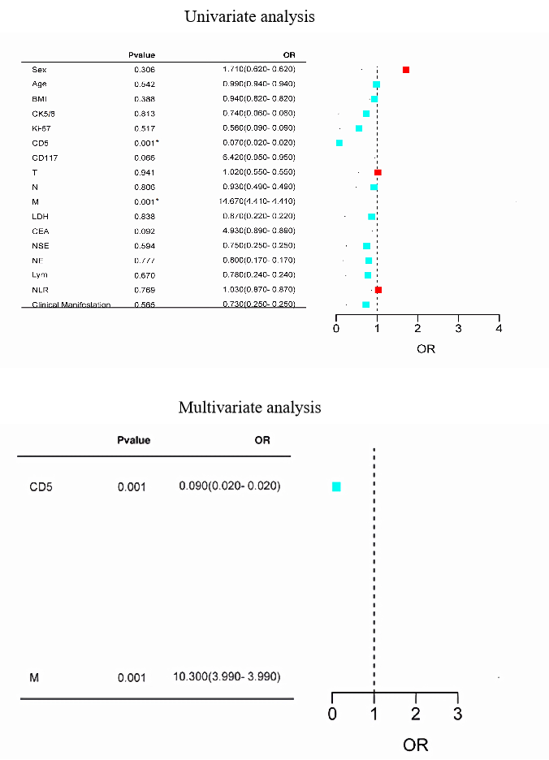

Fig. S1 Univariable and multivariable logistic analyses for predicting PD in the training set
* Statistically significant results from logistic regression analysis

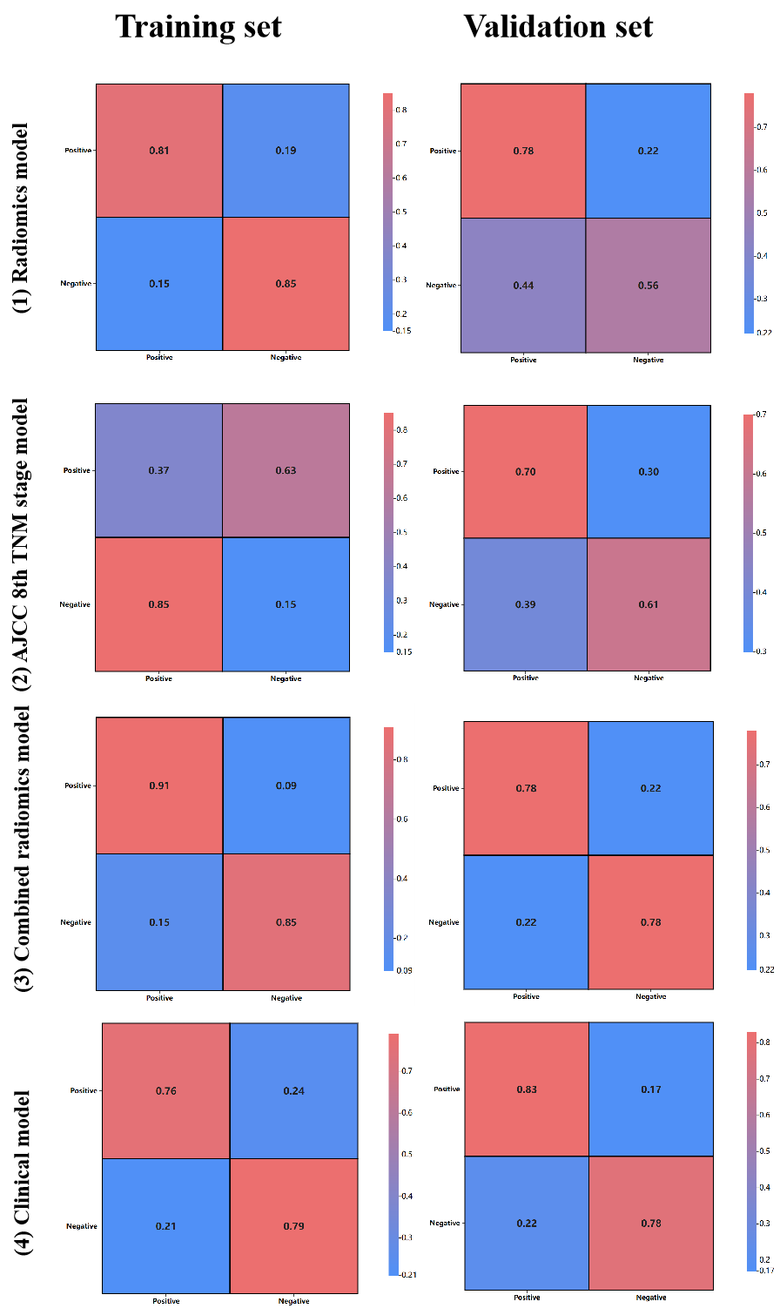
Fig. S2 Confusion matrices for (1) Radiomics model, (2) AJCC 8th TNM stage model, (3) Combined radiomics model and (4) Clinical model in the training and validation sets. The figures in the grid express the values of the probabilities derived from the calculation of the number of people in each set

