Effect of Compositions and Heat Treatments of Polypropylene/PP-g-MAH/CuO-TiO₂ composites on Thermal, Crystallization and Antimicrobial Properties

G Ambarasan Govindasamy¹, Srimala Sreekantan^{2,*)}, Khairul Arifah Saharudin³, Ming Thong Ong⁴, Priscilla Jayanthi Thavamany⁴, Geethaa Sahgal⁵, Tan Aik Aun⁶

¹Ann Joo Integrated Steel Sdn Bhd, Lot 1236, Prai Industrial Estate, 13600 Prai, Penang, Malaysia
²School of Materials and Mineral Resources Engineering, Engineering Campus, Universiti Sains Malaysia, 14300 Nibong Tebal, Penang, Malaysia
³Qdos Interconnect Sdn Bhd, PMT 743, Persiaran Cassia Selatan 4, Batu Kawan Industrial Park, 14110 Batu Kawan, Pulau Pinang, Malaysia
⁴Institute for Research in Molecular Medicine (INFORMM), Universiti Sains Malaysia, 11800 Pulau Pinang, Malaysia
⁵Faculty of Pharmacy, AIMST University, Bedong, 08100 Semeling, Kedah, Malaysia
⁶B. Braun Medical Industries Sdn Bhd, P.O. Box 880,10810 Pulau Pinang, Malaysia

^{*)} Address all correspondence to this author. e-mail: srimala@usm.my

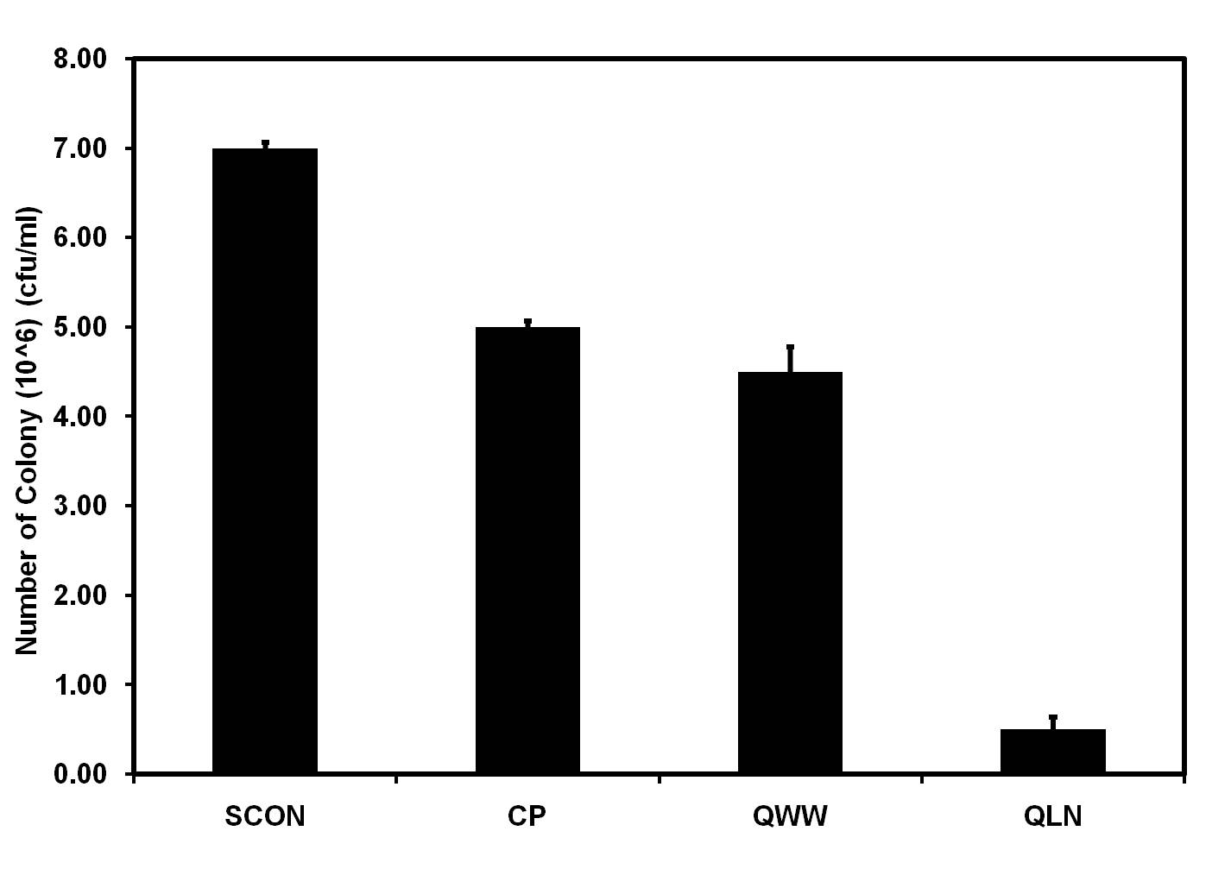
Figure 1. Colony count of various heat-treated CuO-TiO₂-PP composites.
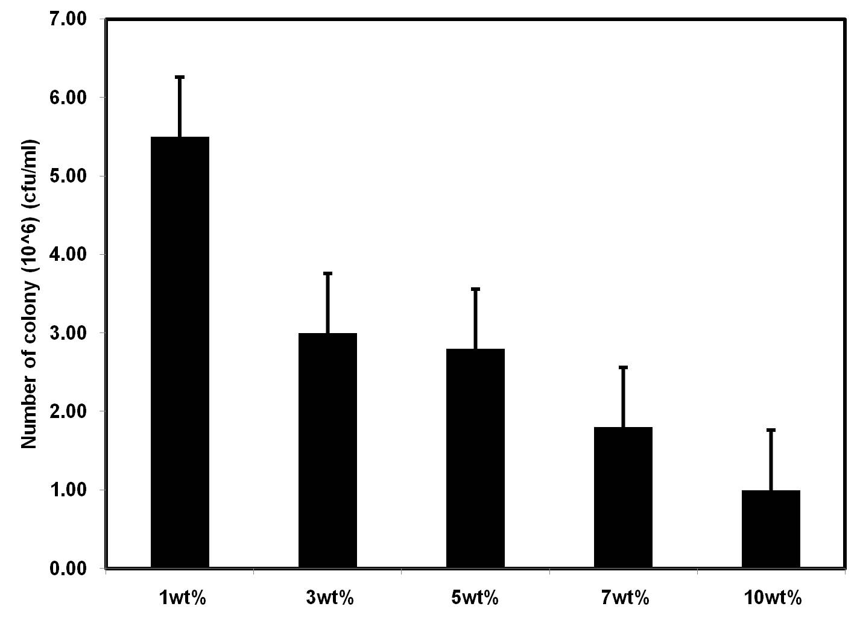
Figure 2. Colony count of CuO-TiO₂-PP composites with different contents of binary mixed oxide (CuO/TiO₂) particles.

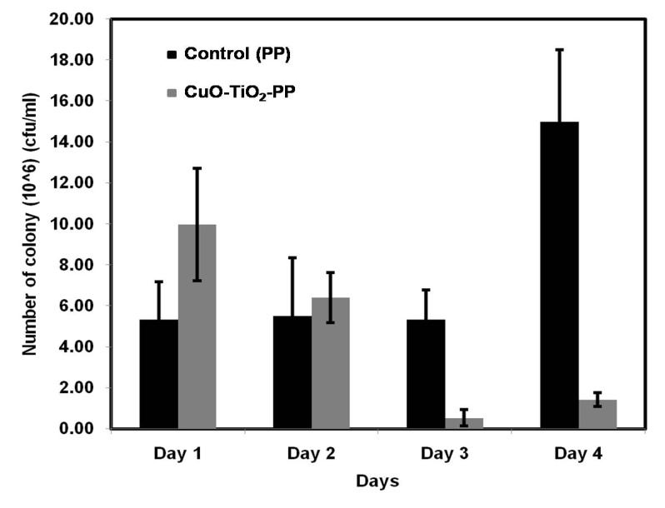

Figure 3. Attachment of E. coli on control pellet PP and CuO-TiO₂-PP pellet for 4 days of exposure.

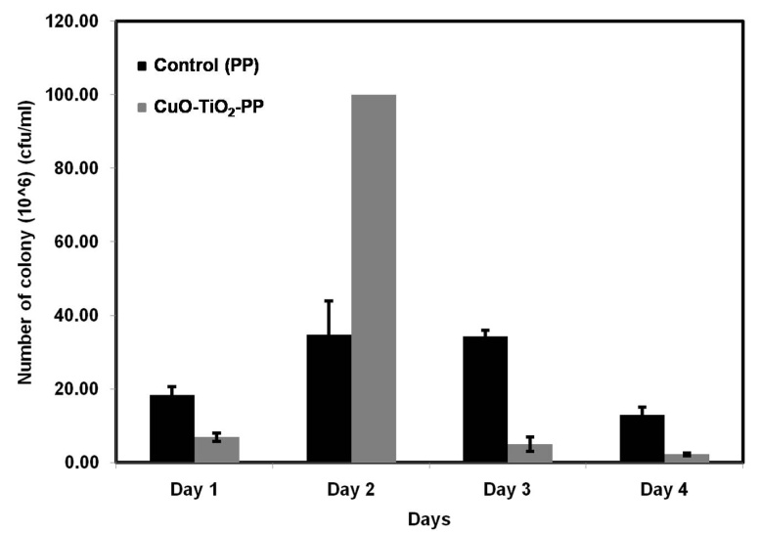

Figure 4. Attachment of S. aureus on control pellet PP and CuO-TiO₂-PP pellet for 4 days of exposure.

