Supplementary Figure 1. Sensitivity and specificity of NP-IgG assay. a. Specificity of NP-IgG assay in contemporaneous patients with respiratory illnesses who tested negative for SARS-CoV-2 by PCR. b. Sensitivity of NP-IgG assay in SARS-CoV-2 PCR-positive patients. Color dots represent patients with renal transplant on immunosuppression (red), aplastic anemia (blue), rituximab treatment (green) or lupus on immunosuppression (yellow). The sensitivity numbers shown in the insert table are calculated with the immunosuppressed patients excluded.

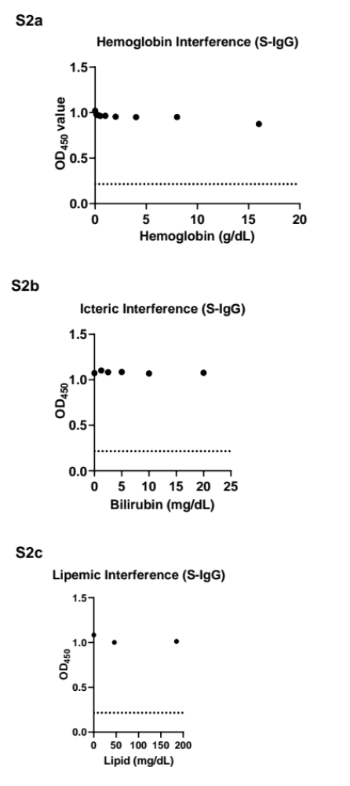

Supplementary Figure 2. Standard interference studies of S-IgG ELISA. Control serum specimens were spiked with specified concentrations of a. hemoglobin, b. bilirubin, and c. intralipid (Sigma-Aldrich) and tested by ELISA.

S3
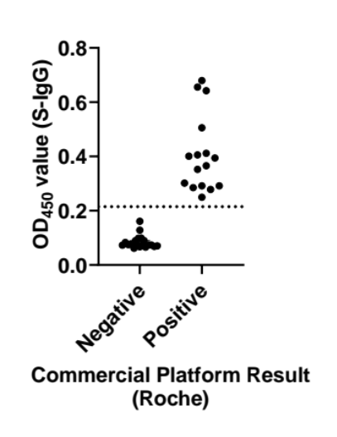

Supplementary Figure 3. Comparison of S-IgG ELISA to commercial Anti-SARS-CoV-2 assay. Patient serum samples spanning the range of ELISA optical density values (N=35) were tested using the S-IgG ELISA and the commercial anti-SARS-CoV-2 test (Roche). Dotted line represents cutoff for S-IgG ELISA.

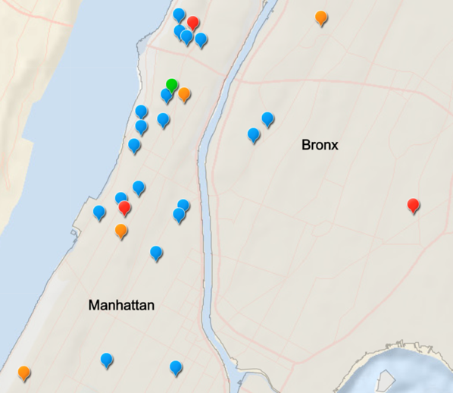
Supplementary Figure 4. Geographic distribution of identified SARS-CoV-2 seropositive patients. Cases 1-3 depicted in red, 4-7 in orange, and later cases in blue around CUIMC (green). Note that an additional 14 cases reside outside the area depicted in this map.

