FINANCIAL LITERACY STUDY
CONSENT – INFORMATION DOCUMENT
Study title: The impact of financial literacy on risk and time preferences and financial behavioural intentions
Time and Risk Preferences: An Economics experiment
Greeting: Thank you for taking the time to come to the venue today and to listen to an explanation of the research study we will be conducting today.

Introduction: We, researchers from the Department of Economics at the University of the Free State, are doing research on time and risk preferences in humans.

Invitation to participate: We are inviting you to participate in this research study.

What is involved in the study: In this study, we want to investigate discount rate and risk parameter on time and risk preferences of students. An important component of this work is to conduct experiments. You have been selected to be part of this experiment. In an experiment, subjects such as yourself, is typically asked to complete various tasks or games in addition to completing a questionnaire(s) as well as a knowledge test.The experiment will take approximately 120 minutes.

A similar follow up experiment will be carried on the same participants in October 2016 (week 24-28 October 2016)

Risks of being involved in the study: There are no risks to taking part in the study.
Benefits of being in the study: You will receive a show-up fee of R50. If you agree to take part in the study you may earn more money if you happen to be one of the luck 10% of the participants, depending on the specific tasks you will be required to complete as part of the experiment.

Participation is voluntary, and refusal to participate will involve no penalty. If you do not agree to take part you may terminate the interview at any time and you have the right to decline to answer any questions you might not want to respond to.

Confidentiality: Your answers will be confidential. The answers will be put together with information collected from other people and the data will be safely stored. Results of the study may be published or presented at a meeting in an anonymous aggregated form.

The R50 appearance fee will be paid in cash and all other payments will via FNB ewallet. Contact details of researcher(s): Mr Calvin Mudzingiri at 058 718 5069.
Contact details of Secretariat and Chair: Ethics Committee Faculty of Economic & Management Sciences, University of the Free State – for reporting of complaints and problems and for questions regarding your rights as a research subject: Telephone number 051 - 401 2310.

PLEASE DO NOT TURN THE PAGE UNTIL INSTRUCTED TO DO SO

FINANCIAL LITERACY STUDY CONSENT FORM: DECISION-MAKING EXPERIMENT
RESPONDENT:

I,

_

[FULL NAME OF RESPONDENT IN BLOCK LETTERS]

- have read and understood all the above information; | Yes | No
- was given the opportunity to discuss this information and ask questions; | Yes | No
- volunteer to take part in this study;  - gave the investigator permission to access and use my matric AP as well as mathematics proficiency score. The investigator undertakes to ensure anonymity, data collected will be aggregated for analysis purposes. | Yes | No
- Confirm that I have received a copy of this consent form. | Yes | No
 | Yes | No
Signature of respondent: Date:

RESEARCH ASSISTANT:

I,

[FULL NAME OF RESEARCH ASSISTANT IN BLOCK LETTERS]

- have explained the study to the respondent; and | Yes | No
- have given the respondent a copy of this consent form. | Yes | No
Signature of Research Assistant: Date:

BEFORE WE CONTINUE PLEASE NOTE THE FOLLOWING:

!! Please make sure your cell phone is switched off!!

During the experiment, please remain silent and do not communicate with other subjects.

If you should have any question(s), please raise your hand so the experimenter and/or an assistant can attend to your question in person.

Importantly, please closely follow the experimenter’s instructions to the letter and do not turn the page until you are instructed to do so by the experimenter.

When on each page, please fill in the unique ID number on your recruitment flyer in the space provided at the top right hand side of the page – make sure you fill in the number on each page.

PLEASE DO NOT TURN THE PAGE UNTIL INSTRUCTED TO DO SO

PAYMENT

As mentioned before, you stand to earn real money by participating in this experiment.

As part of this experiment, you will complete a total of TWO tasks or games. In each of these TWO tasks, as will be explained below, you stand to earn real money. For each task, we will explain how the task works and how payment is calculated for each task. At the end of the experiment we will randomly select 10 percent of the participants and ONLY one of these tasks for payment.

[Experimenter: Illustrate use of 10-sided dice.]

The number on the 10-sided dice will pay out the following tasks, each of which we will now explain and play in turn:

1-4 | = | TIME PREFERENCES
5-8 | = | RISK ATTITUDES
9-10 | = | roll the dice again

PLEASE DO NOT TURN THE PAGE UNTIL INSTRUCTED TO DO SO

TIME PREFERENCES
For this task, let us first explain how the game works using the example below:
PRACTICE TABLE:
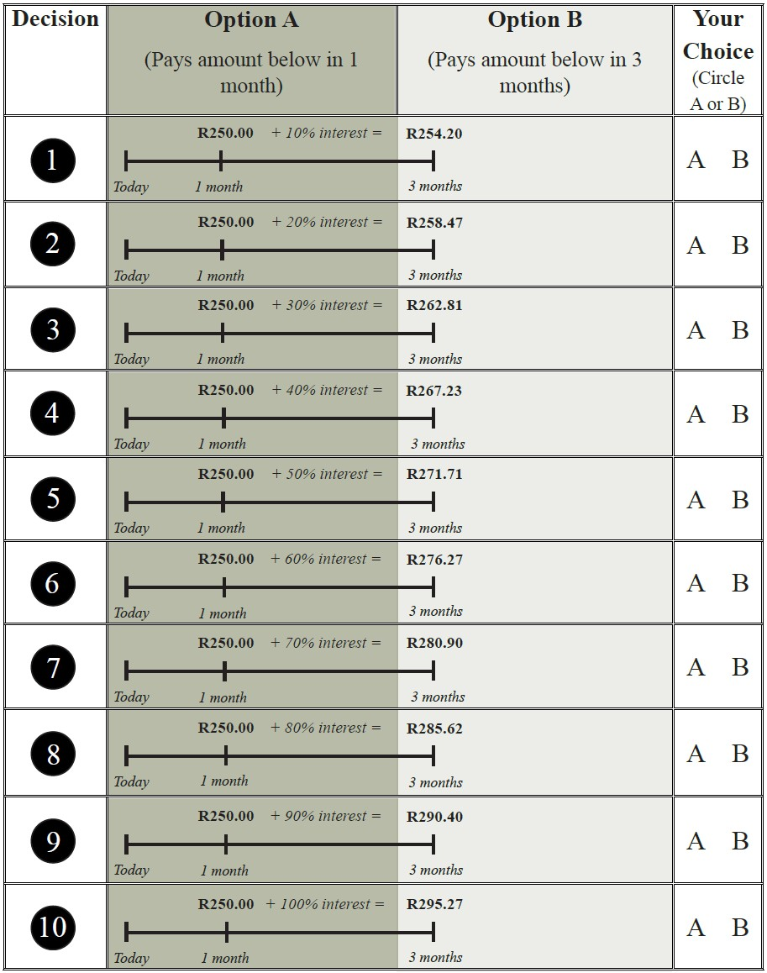 9
Decision row selected:
Roll 10-sided dice
Number on dice (1-10)
Choice (A/B)
Payment (R):

How do I play the table?
- Please look at the above ‘Practice Table’.
- On the left of the table there are 10 rows.
- You will need to play A or B on EVERY ROW.
- You will play by marking A or B on the right of the table for each row under ‘Your Choice’.

5
PLEASE DO NOT TURN THE PAGE UNTIL INSTRUCTED TO DO SO

How does the timeline work?
- On every row there is a timeline that starts with ‘Today’.
- You will be playing today so you are at the start of the timeline.
- As you can see, with A you win R250 in 1 month from today. That is why R250 is 1 month from today on the timeline.
- Look at the calendar to see the date 1 month from today.
- With B you win money that is paid 3 months from today. That is why B is 3 months from today on the timeline.
- Look at the calendar to see the date 3 months from today.
How is the amount in option B calculated?
- As you can see, the B money increases as you move down the table from row 1 to row 10.
- On row 1, with B you win R254.20 in 3 months from today. On row 10, with B you win R295.27 in 3 months from today.
- B money increases as you move down the table because we are adding more interest to A money on every row.
- On row 1 we add 10% interest to R250 in 1 month from today (A) and this gives us R254.20 in 3 months from today (B). On row 10 we add 100% interest to R250 in 1 month from today (A) and this gives us R295.27 in 3 months from today (B).
- Note that interest represents the price of money. If you leave money in a bank account the bank pays you interest. The bank basically pays you for borrowing your money until you need it.
- These tables use the same idea. If you play B then you have to wait 3 months to win B. If you play A you have to wait only 1 month to win A. So B money is bigger than A money because of interest that is added to A money over 2 months (the difference between 1 month and 3 months).
- Please note that interest is usually calculated over 12 months. On this table, you win A after 1 month and you win B after 3 months. So with B money you only get interest for 2 months, i.e. the difference between 1 month (when you win A) and 3 months (when you win B).

How do I know whether to play A or B?
- Now, you need to play A or B on every row of the table.
- For row 1, you need to decide if you want R250 in 1 month from today (A) or R254.20 in 3 months from today (B).3. If you play A then you want R250 in 1 month from today.
- If you play B then you want R254.20 in 3 months from today.
- On row 2 you need to decide if you want R250 in 1 month from today (A) or R258.47 in 3 months from today (B).
- If you play A then you want R250 in 1 month from today.
- If you play B then you want R258.47 in 3 months from today.
- So all that you need to do is mark A if you want to play A and mark B if you want to play B.
- There is no right or wrong answer in this game. Please just play A if you want A and play B if you want B on every row of the table.
- Do you have any questions?
It’s now time for you to play the practice table (see table above)
- Now it’s time for you to play ‘D Practice Table’.
- Please note that you will not win money for playing this table.
- It’s important that you play the ‘Practice Table’ so that you know how to play the other tables and so that you can ask any questions if you have them.
How does payment work again?
- We will roll the 10-sided dice to see your winning row in the table.
- Look at if you played A or B on that row.
- You will win what you played (A or B) when it’s time to win what you played (in this case, in 1 month from today or 3 months from today, depending on whether you played option A or option B).
Do you have any other questions?
It’s now time for you to start the game
- Please play the next tables in the game pack (Table A-D).
- You win A and B at different times.
- So please look at the table carefully so that you can decide whether to play A or B.
- Please take your time to play the tables and remember that there is no right or wrong answer in this game. Please just play A if you want A and play B if you want B on each row of every table.

STUDENT NUMBER:

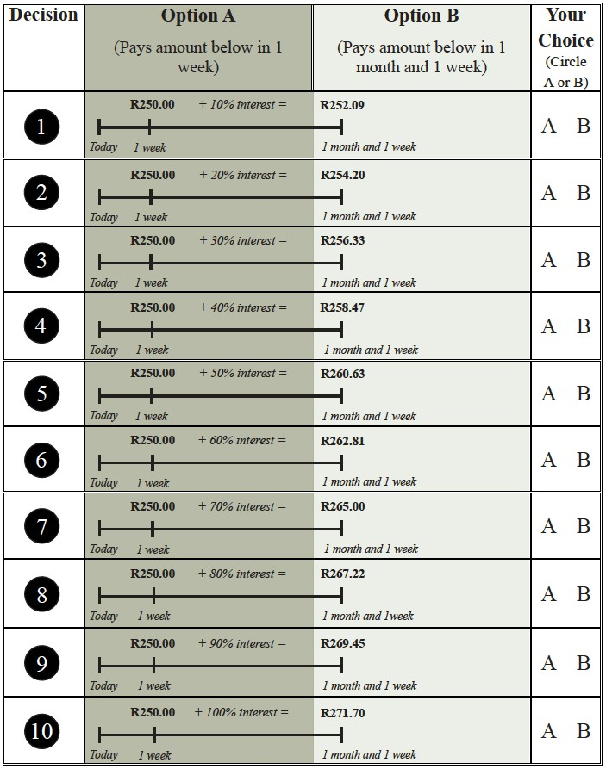
Please play the table below:
TIME PREFERENCES (continued) TABLE A

STUDENT NUMBER:

TIME PREFERENCES (continued)
Please play the table below:TABLE B
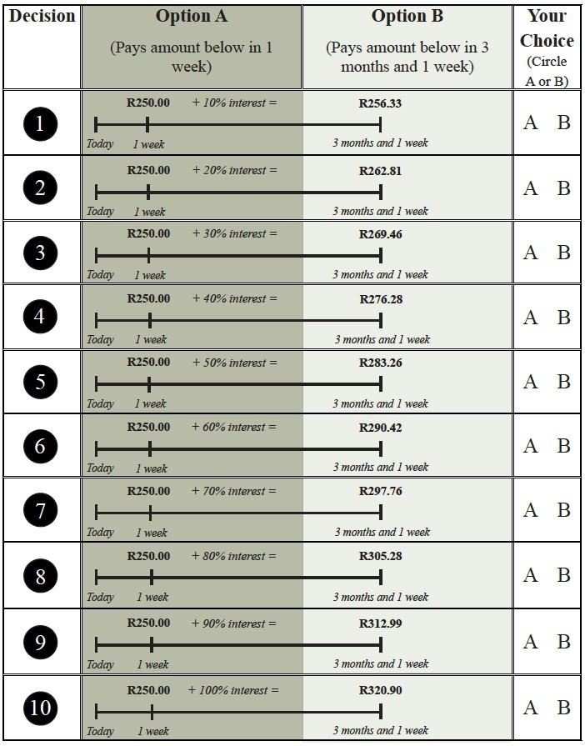

STUDENT NUMBER:
TIME PREFERENCES (continued)
Please play the table below:TABLE C
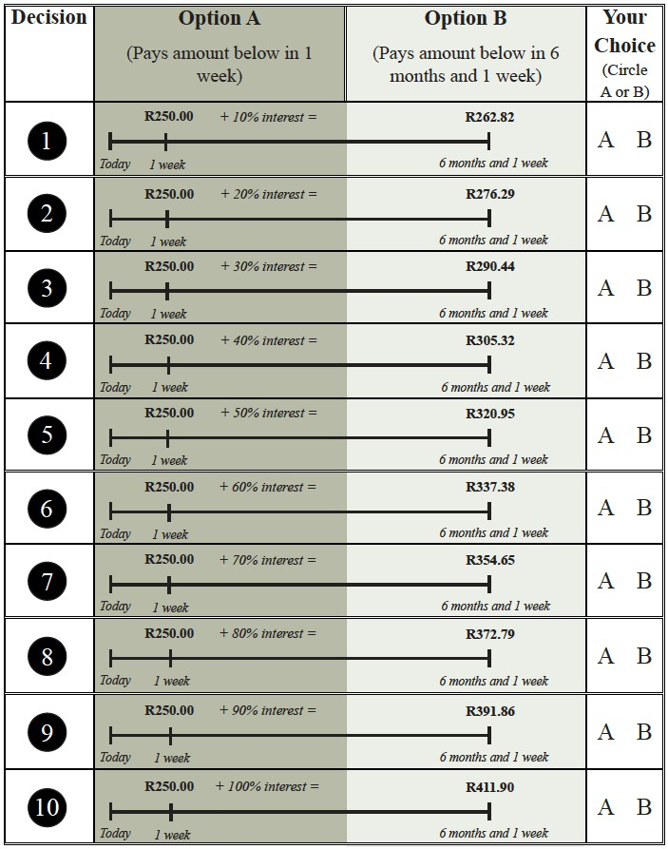

STUDENT NUMBER:
TIME PREFERENCES (continued)
Please play the table below: TABLE D
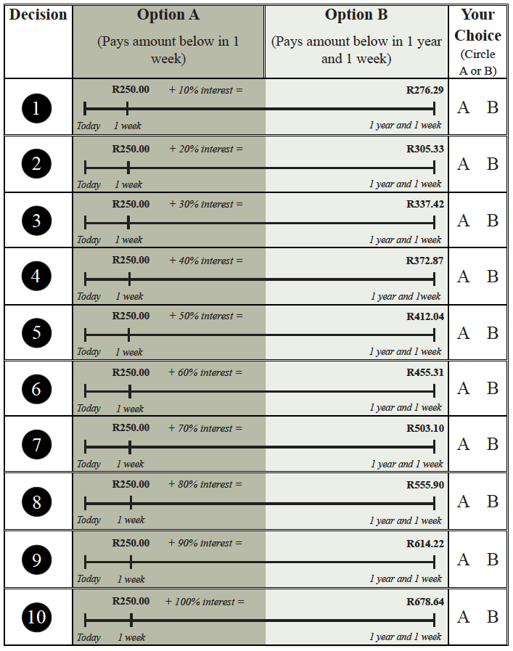

RISK ATTITUDES
STUDENT NUMBER:

For this task, let us explain how the game works using the example below:
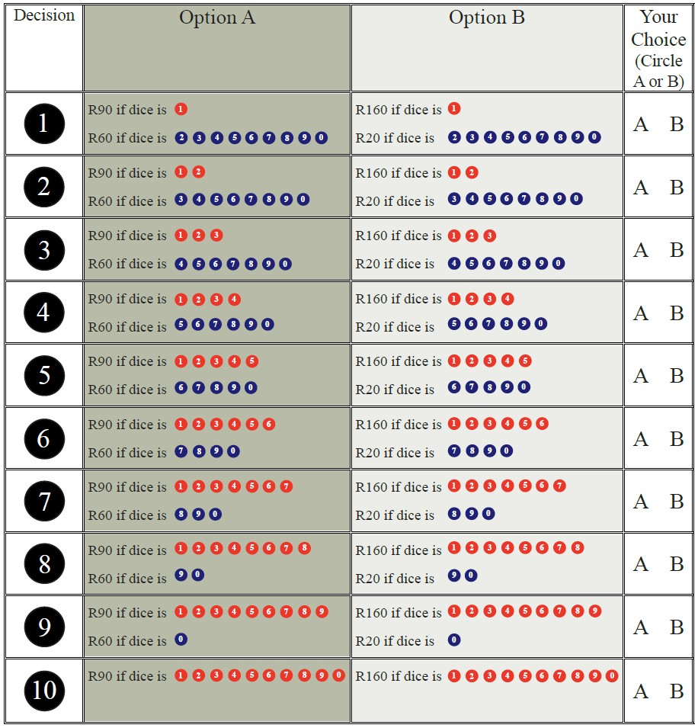
PRACTICE TABLE:

PLEASE DO NOT TURN THE PAGE UNTIL INSTRUCTED TO
Roll 10-sided dice
Number on dice (1-10)
Choice (A/B)
Payment (R):

How do I play the table?
- Please look at the above ‘Practice Table’.
- On the left of the table there are 10 rows.
- You will need to play A or B on every row.
- You will play by marking A or B on the right of the table under ‘Your Choice’
How do A and B change on the table?
- Please look at row 1 at the top of the ‘Practice Table’.
- With A you win R90 if you roll 1 on the 10-sided dice and you win R60 if you roll the number 2, 3, 4, 5, 6, 7, 8, 9 or 10.
- With B you win R160 if you roll 1 on the 10-sided dice and you win R20 if you roll the number 2, 3, 4, 5, 6, 7, 8, 9, or 10.
- On every row in this table the money under A is R90 or R60 and the money under B is R160 or R20.
- Please look at the table at the top of the page. As you move down the table from row 1 to row 10, you will see that there are more numbers next to R90 under A. What this means is that the chance of winning R90 under A gets bigger as you move down the table.
- As you move down the table, there are less numbers next to R60 under A. What this means is that the chance of winning R60 under A is smaller as you move down the table.
- As you move down the table from row 1 to row 10, you will see that there are more numbers next to R160 under B. What this means is that the chance of winning R160 under B gets bigger as you move down the table.
- As you move down the table, there are less numbers next to R20 under B. What this means is that the chance of winning R20 under B is smaller as you move down the table.
- Please look at row 2 on the ‘Practice Table’. With A you win R90 if you roll 1 or 2 and you win R60 if you roll 3, 4, 5, 6, 7, 8, 9 or 10. So now you can roll 1 or 2 to win R90 under A on row 2. On row 1 you could only roll 1 to win R90 under A.
- On row 2, with B you win R160 if you roll 1 or 2 and you win R20 if you roll 3, 4, 5, 6, 7, 8, 9 or
- So now you can roll 1 or 2 to win R160 under B on row 2. On row 1 you could only roll 1 to win R160 under B.
- Please look at row 5. With A you win R90 if you roll 1, 2, 3, 4 or 5 and you win R60 if you roll 6, 7, 8, 9 or 10. So now you can roll 1, 2, 3, 4 or 5 to win R90 under A on row 5. On row 1 you could only roll 1 to win R90 under A.

- On row 5, with B you win R160 if you roll 1, 2, 3, 4 or 5 and you win R20 if you roll 6, 7, 8, 9 or
10. So now you can roll 1, 2, 3, 4 or 5 to win R160 under B on row 5. On row 1 you could only roll 1 to win R160 under B.
13. Finally, look at row 10. With A you win R90 if you roll 1, 2, 3, 4, 5, 6, 7, 8, 9 or 10. With B you win R160 if you roll 1, 2, 3, 4, 5, 6, 7, 8, 9 or 10. So, on row 10, you can roll any number on the 10- sided dice and you will win R90 if you played A. If you played B on row 10, you can roll any number on the 10-sided dice and you will win R160. So, on row 10, you need to choose between R90 (A) and R160 (B).
How do I know whether to play A or B?
- Now, you need to play A or B on every row of the table.
- For row 1 you need to decide if you want to play A or B. In A, the big money is R90 and the small money is R60. In B, the big money is R160 and the small money is R20.
- So as you can see the big money in B (R160) is always more than the big money in A (R90).
- But the small money in A (R60) is always more than the small money in B (R20).
- So if you play A on row 1, there is a low chance of winning R90 and a high chance of winning R60.
- If you play B on row 1, there is a low chance of winning R160 and a high chance of winning R20.
- On row 5, if you play A then there is a 50:50 chance of winning R90 or R60.
- On row 5, if you play B then there is a 50:50 chance of winning R160 or R20.
- So all that you need to do is mark A if you want to play A and mark B if you want to play B.
- There is no right or wrong answer in this game. Please just play A if you want A and play B if you want B on every row of the table.
- Do you have any questions?

It’s now time for you to play the practice table
- Now it’s time for you to play the ‘Practice Table’.
- Please note that you will not win money for playing this table.
- Its important that you play ‘R Practice Table’ so that you know how to play the other tables and so that you can ask any questions if you have them.
How does payment work again?
- Roll the 10-sided dice to see your winning row in the table.
- Look at if you played A or B on that row.
- Now roll the 10-sided dice once more to see which amount of money you win.

Do you have any other questions?
It’s now time for you to start the game
- Please play Tables E-H in the game pack.
- The money under A and B is different on every table.
- So please look at the tables carefully so that you can decide whether to play A or B.
- Please take your time to play the tables and remember that there is no right or wrong answer in this game. Please just play A if you want A and play B if you want B on each row of every table.

STUDENT NUMBER:
RISK ATTITUDES (continued)
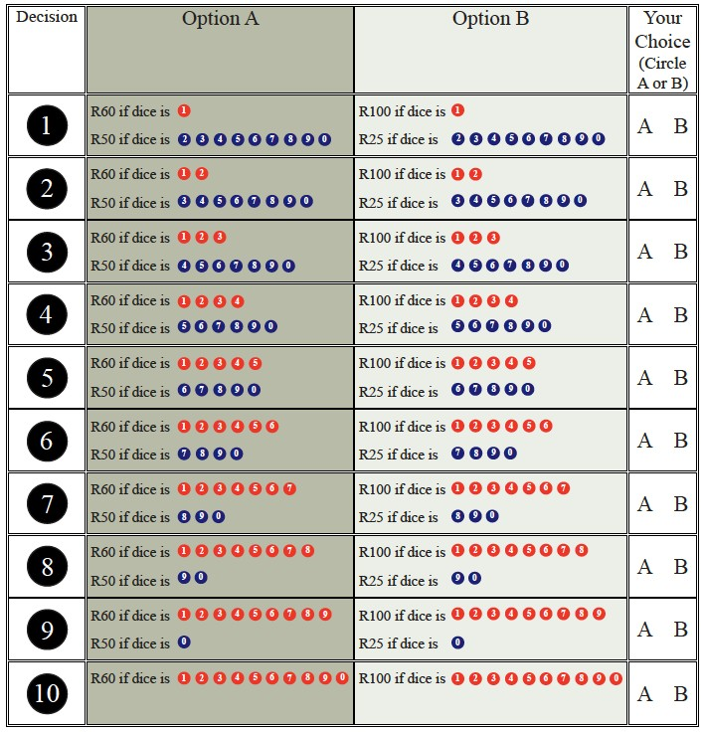
Now play the table below:TABLE E

Decision row selected:
Roll 10-sided dice
Number on dice (1-10)
Choice (A/B)
Payment (R):

STUDENT NUMBER:
RISK ATTITUDES (continued)
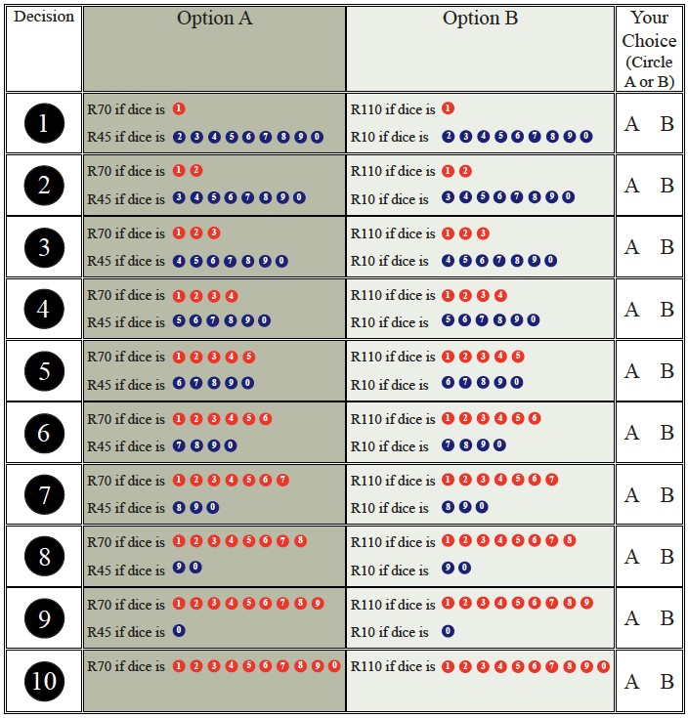
Now play the table below:TABLE F

Decision row selected:
Roll 10-sided dice
Number on dice (1-10)
Choice (A/B)
Payment (R):

STUDENT NUMBER:
RISK ATTITUDES (continued)
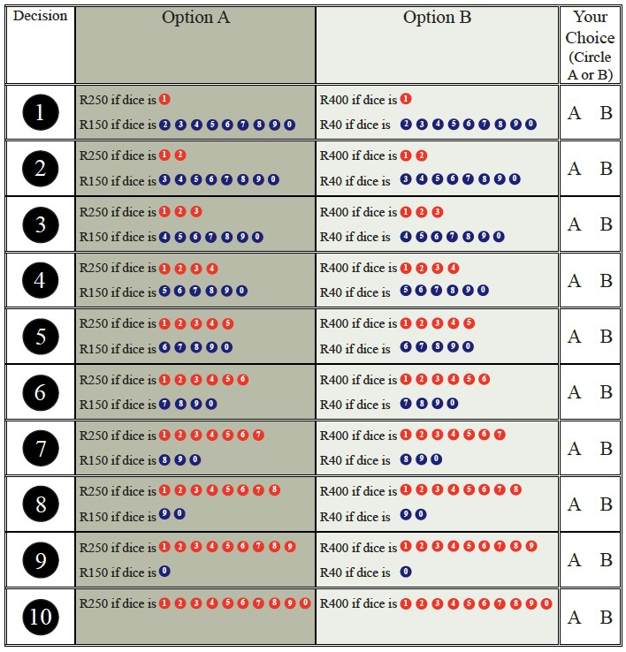
Now play the table below:TABLE G

Decision row selected:
Roll 10-sided dice
Number on dice (1-10)
Choice (A/B)
Payment (R):

RISK ATTITUDES (continued)
STUDENT NUMBER:

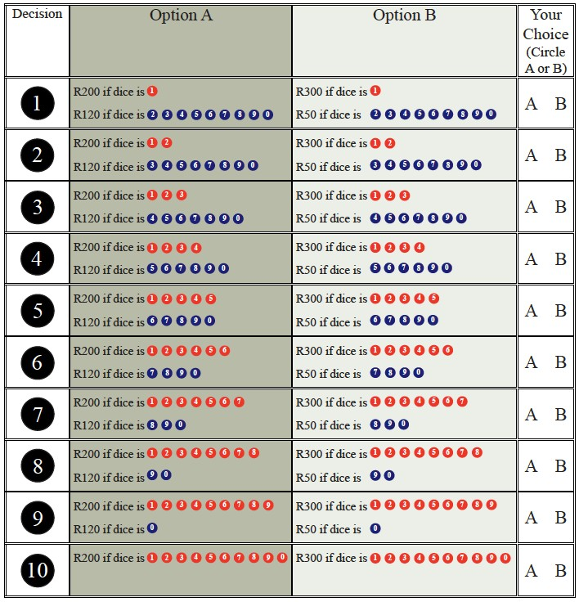
Now play the tables below:TABLE H

Decision row selected:
Roll 10-sided dice
Number on dice (1-10)
Choice (A/B)
Payment (R):

