DEVELOPMENT OF A BIODEGRADABLE POLYMER-BASED IMPLANT TO RELEASE DUAL DRUGS FOR POST-OPERATIVE MANAGEMENT OF CATARACT SURGERY
Nayana E Subhash¹, Soumya Nair², Srilatha Parampalli Srinivas³, Nagarajan Theruveethi⁴, Sulatha V Bhandary*², BharathRaja Guru*¹

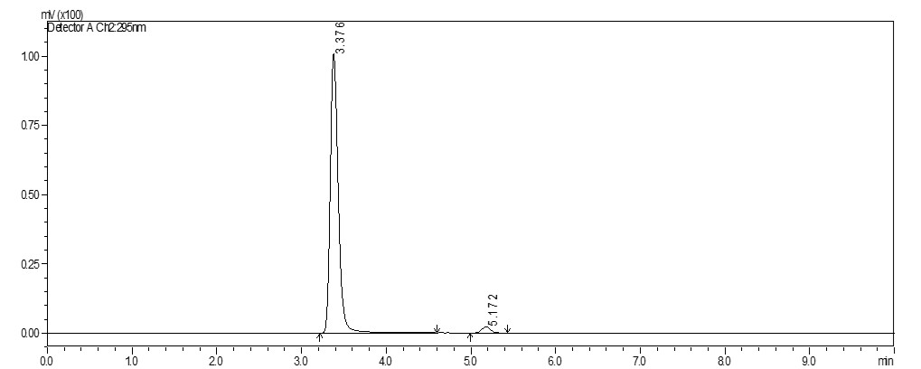
Fig S1: HPLC chromatogram for MOX (3.3min) at 295nm wavelength, run in 50:50 acetonitrile: buffer
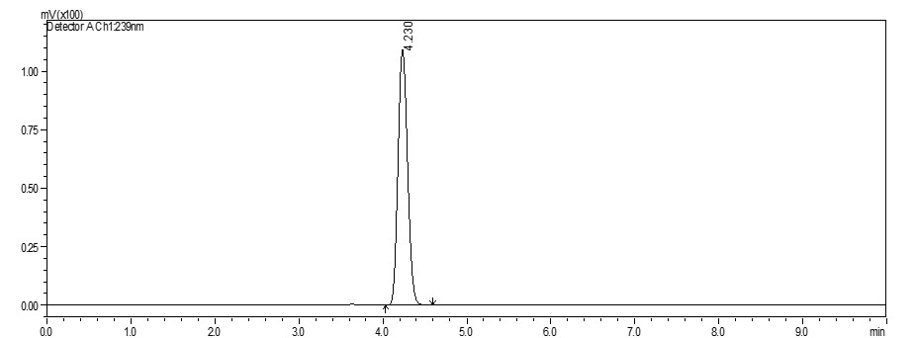
Fig S2: HPLC chromatogram for DEX (4.2min) at 239nm wavelength, run in 60:40 acetonitrile: water
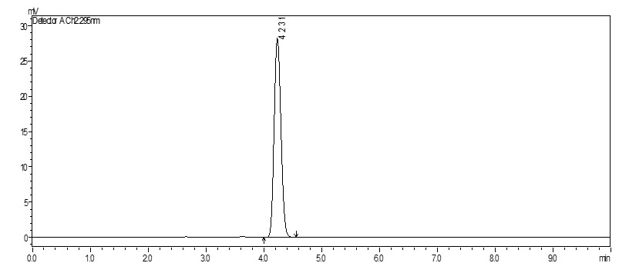
Fig S3: HPLC chromatogram for MOX (4.2min) at 295nm wavelength, run in 35:65 acetonitrile: buffer
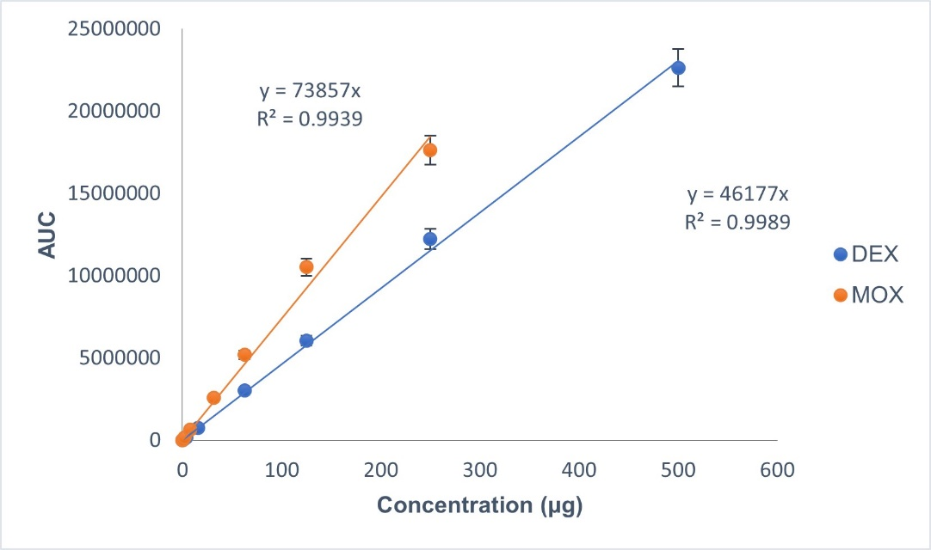
Fig S4: Standard graph for simultaneous estimation of DEX and MOX
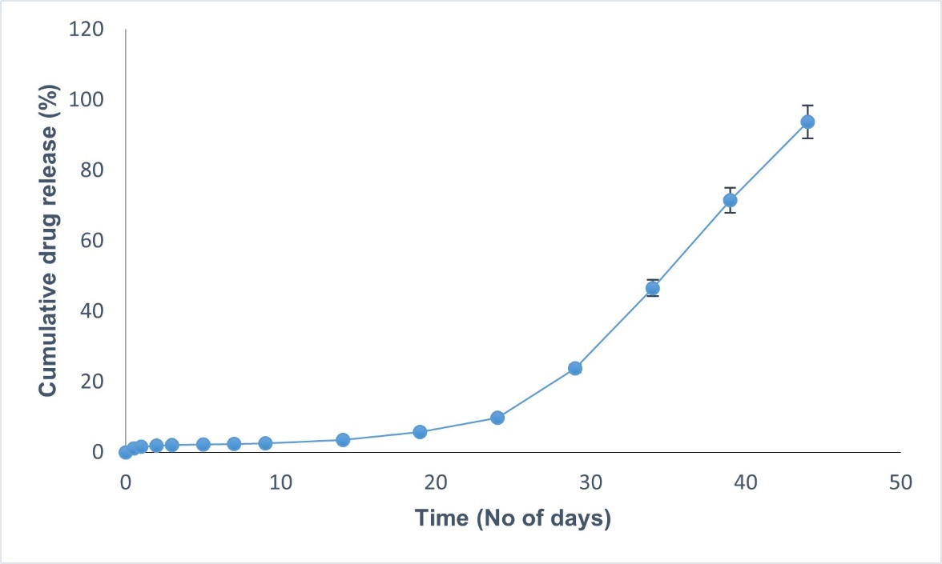
Fig S5: Release profile of dexamethasone in DEX only implant
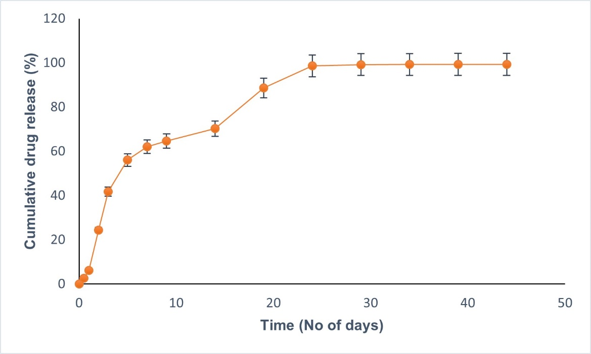
Fig S6: Release profile of moxifloxacin in MOX only implant
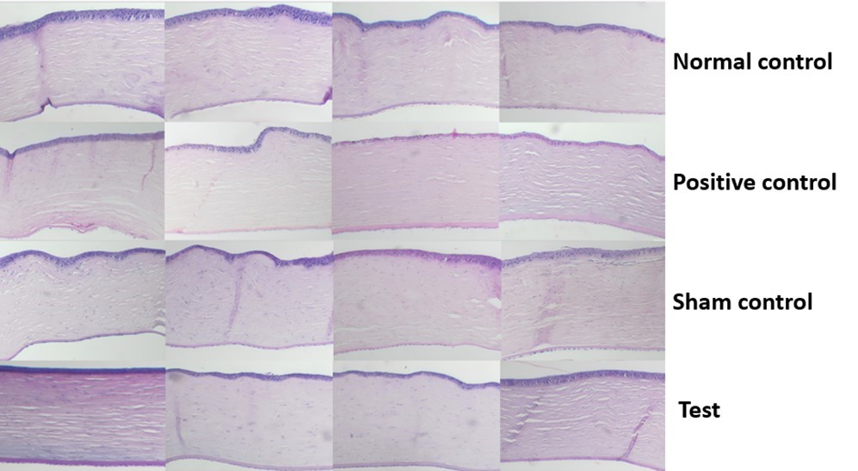
Fig S7a: Histology of cornea at 6 weeks (n=4)
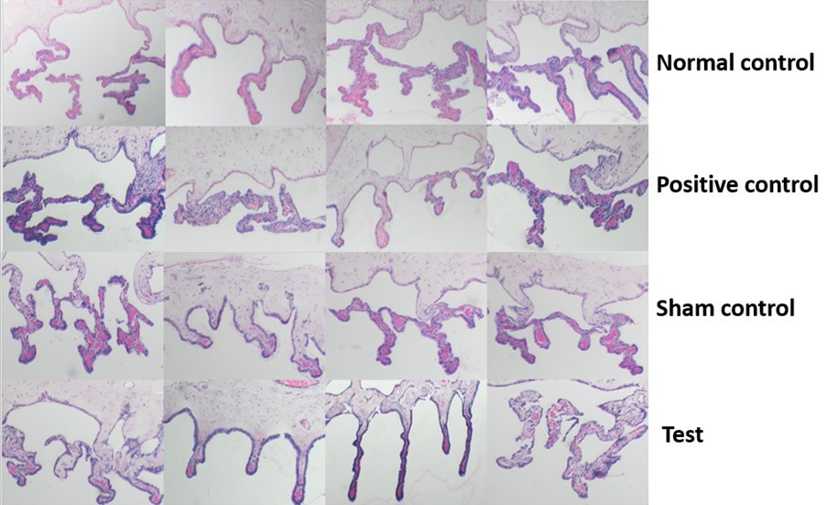
Fig S7b: Histology of ciliary body at 6 weeks (n=4)

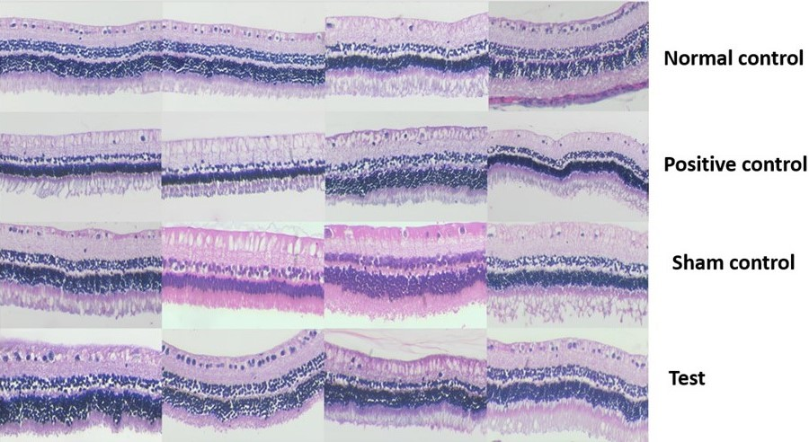
Fig S7c: Histology of retina at 6 weeks (n=4)

