Supplementary Material

Table S1 Basic properties of biochar

material | Origin | raw material | surface area （m²/g) | pH | ash content（%） | C （%） | N （%） | P （%） | K （%） | CEC (cmol/kg) | Acidic functional groups（cmol/kg) | Alkaline functional groups（cmol/kg)
Biochar | Liaoning | Corn stalks | 7.29 | 9.46 | 27.9 | 55.31 | 1.35 | 0.243 | 1.18 | 24.6 | 215.6 | 108.9

Figure S1 Mycorrhizal infection rate of switchgrass
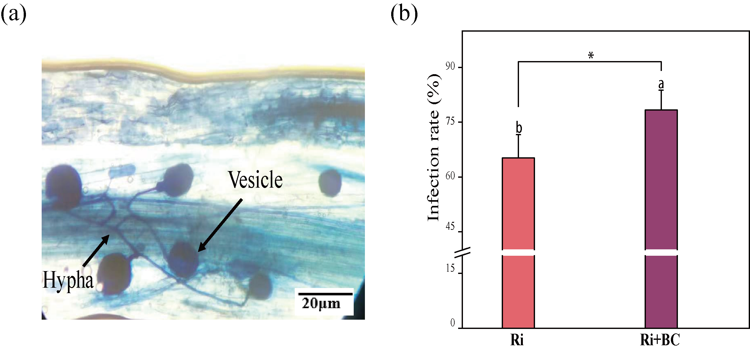
Note: (a) The Ri infection in switchgrass root under the microscope in the Ri+BC treatment group (400x), and (b) the Ri infection rate in switchgrass root under Ri and Ri+BC treatment. Different letters indicated that the difference between treatments was statistically significant (P< 0.05).

Figure S2. Ion content and steady-state change amplitude of switchgrass leaves and roots under different treatments
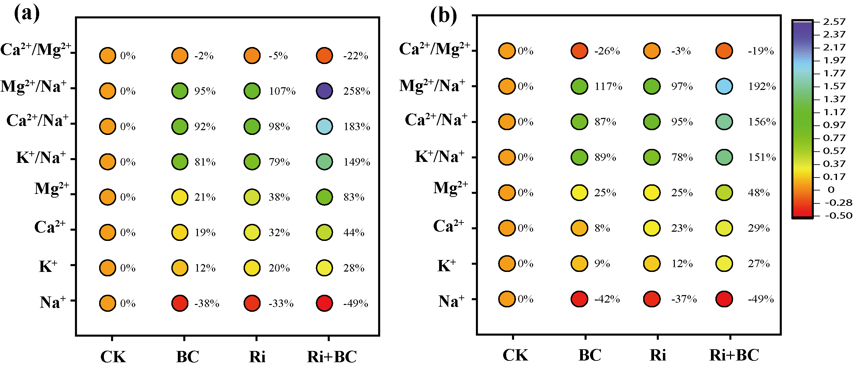
Note: (a) leaves; (b) root. The result is three repeated mean ± standard deviations. Different letters indicated that the difference between treatments was statistically significant (P< 0.05).

Table S2 Saline-alkali resistance-related genes and corresponding primer sequences of switchgrass
Gene name | Primer sequence | Annealing Temp. (℃) | Reference
PvNAC1 | For (5'-CTGAACCTGAACCACCGCTAA) | 60 | Wang, J. PvNAC1 increases biomass and enhances salt tolerance by decreasing Na⁺ accumulation and promoting ROS scavenging in switchgrass (Panicum virgatum L.). Plant Science 280:66-76 (2019).
PvNAC1 | Rev (5'-TCATCACTCGCTTCCTCTTCA) | 60
PvNHX1 | For (5'-TGTAGCCGTCGTGCTGAAGTT) | 58
PvNHX1 | Rev (5'-CAGTGGAGTGCCTTCCGATGT) | 58
PvDREB1B | For (5'-GACGGACCAAGTTCAAGGAGACG) | 58
PvDREB1B | Rev (5'-CGGCGAGTCGGCGAAGTTGAGGC) | 58
PvDREB2A | For (5'-GCCAAGGGTTCCAAGAAAGGGTG) | 56
PvDREB2A | Rev (5'-CGGAGTTGGCATCAGGAGAGTTC) | 56
PvP5CS1 | For (5'-CCTTCCTGACAGTGTTGGTAAAA) | 60
PvP5CS1 | Rev (5'-GCCCTCCATAAATAGAAACTCCT) | 60
PvSOS1 | For (5'-TGGAAATACACCAAATAAAGAGA) | 58
PvSOS1 | Rev (5'-CTGACGGCAAGAGTGAGTGAAAT) | 58
PvHKT | For (5'-AATGCTGATTGGTAGCGAGGTAT) | 60
PvHKT | Rev (5'-CATACCCAATCCCCTTCCTCTTC) | 60
PvPOD | For (5'-GGGCTGCAGATGGATTTCTACAG) | 56
PvPOD | Rev (5'-GGTTGGGCTTGGCGTCCTTCTCC) | 56
PvCAT | For (5'-GACCAACGACATCTCCCACCTCA) | 56
PvCAT | Rev (5'-GGTTGACGAGCGTGTAGGTGTTG) | 56
PvCesA4 | For (5'-TTTTGTCAAGGAGCGTAGGGC) | 58
PvCesA4 | Rev (5'-CAGGGTGGTCACGAGGATTAT) | 58
PvActin | For (5'-CGAACCCAGCCTTCACCATAC) | 60
PvActin | Rev (5'-CCCCGATGGGCAGGTAATA) | 60

