Active Hydrogen Free, Z-isomer selective isatin derived “Turn on” fluorescent dual anions sensor
Muthumanickam Shenbagapushpamª, Bosco Christin Maria Arputham Ashwin^{b}, Paulpandian Muthu Mareeswaran^{c}, Paneerselvam Yuvaraj^{d} , Selvakumar Kodirajan^{a*}
ªDepartment of Chemistry, Thiagarajar College (Affiliated to Madurai Kamaraj University), Madurai, Tamilnadu, India.
^{b}Department of Chemistry, Pioneer Kumarasamy College, Nagercoil, Tamil Nadu, India.
^{c}Department of Chemistry, College of Engineering, Anna University, Chennai, Tamil Nadu, India.
^{d}Advanced Materials Group, Materials Sciences and Technology Division, CSIR-North East Institute of Science & Technology, Jorhat, Assam 785006, India

Supporting Information
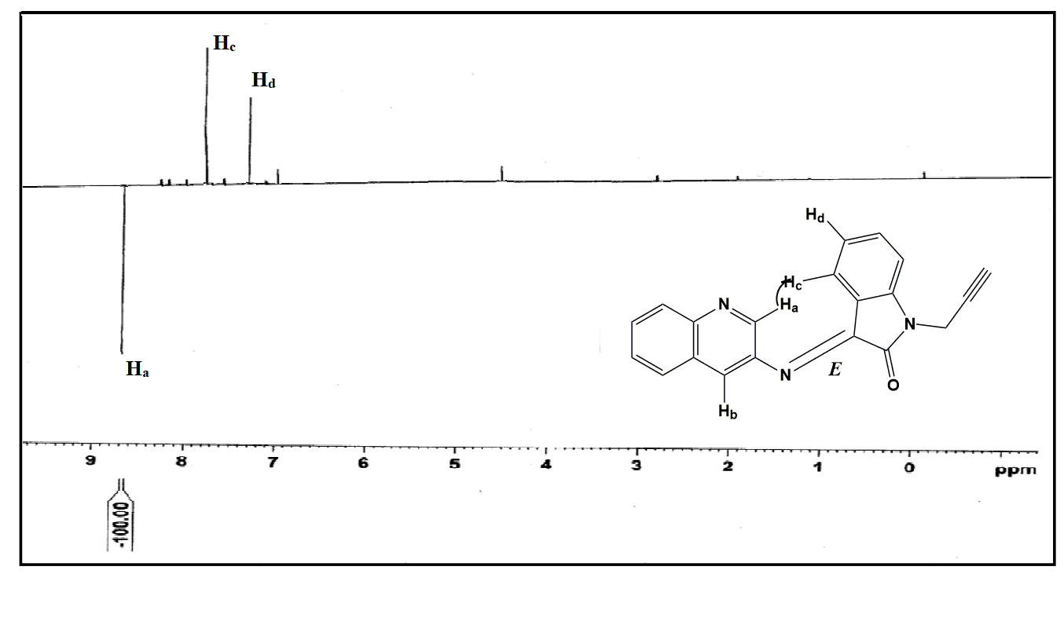
Fig. S1. NOE spectrum of E-PQI.
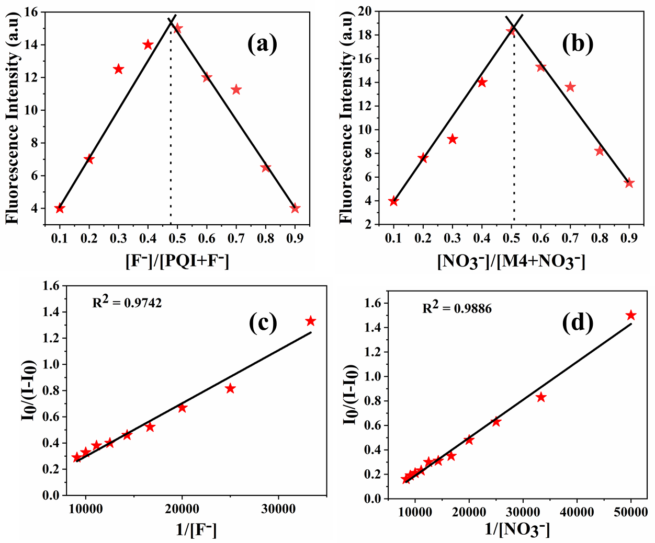
Fig. S2. (a) Jobs plot of PQI probe with F⁻ ion for predict stoichiometric ratio. (b) Jobs plot of PQI probe with NO₃⁻ ion for predict stoichiometric ratio. (c) Benesi – Hildebrand plot of PQI with F⁻ ion. (d) Benesi – Hildebrand plot of PQI with NO₃⁻ ion.

