Table 1 Average age, experience in neurosurgery and microneurosurgical management of MCA aneurysms of participants (n = 22)
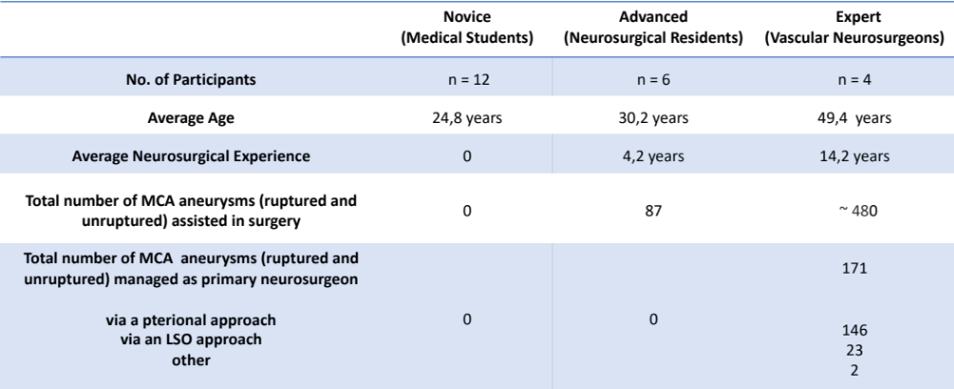

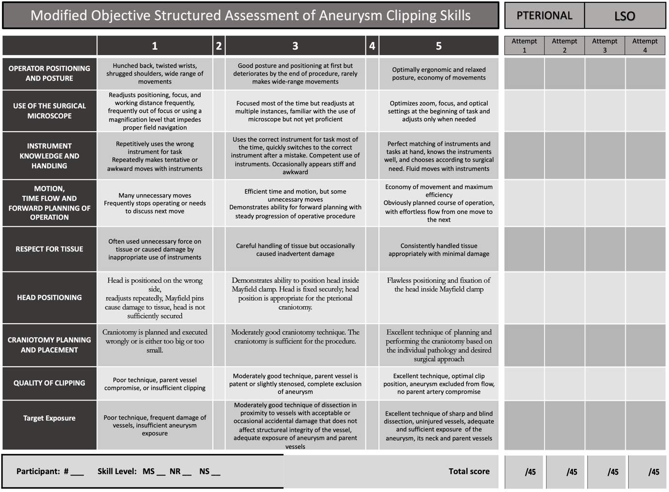
Table 2 Modified Objective Structured Assessment of Aneurysm Clipping Skills (OSAACS)

