Supplementary Content 1

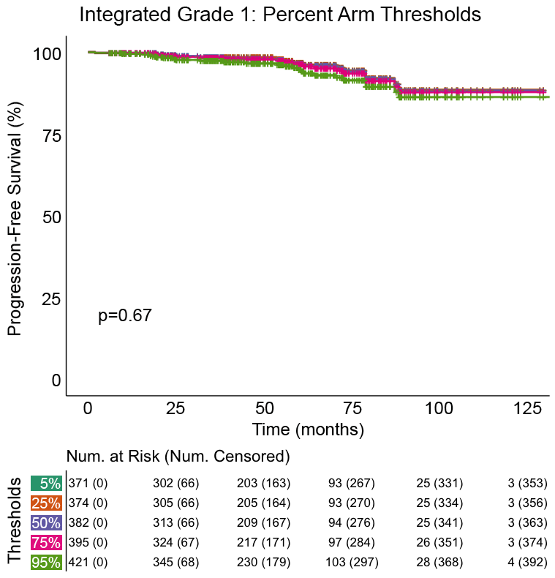

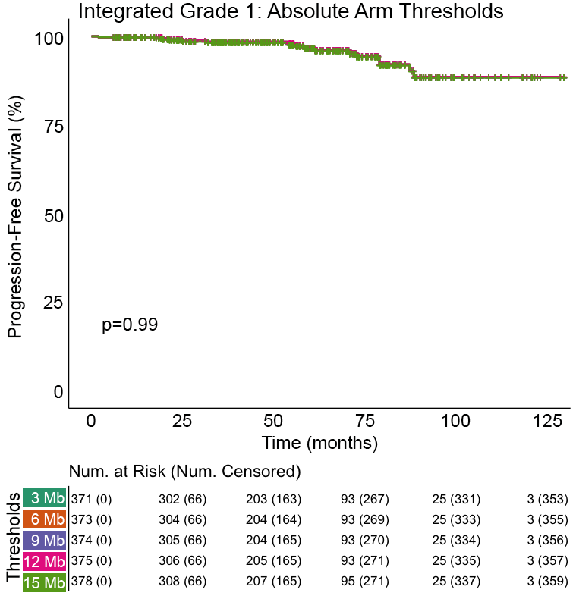

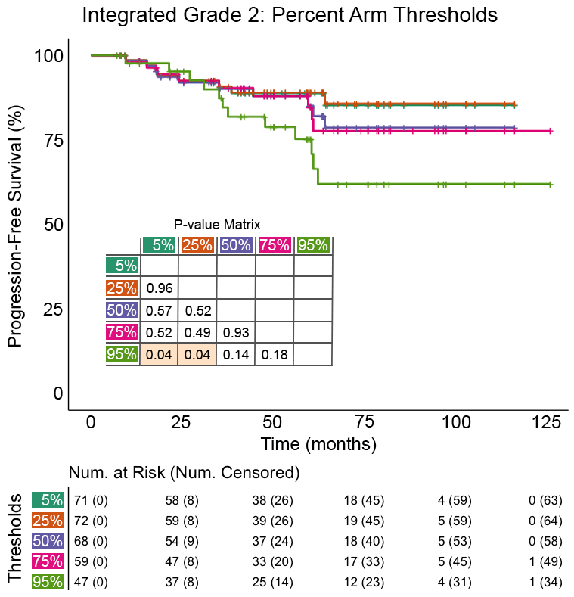

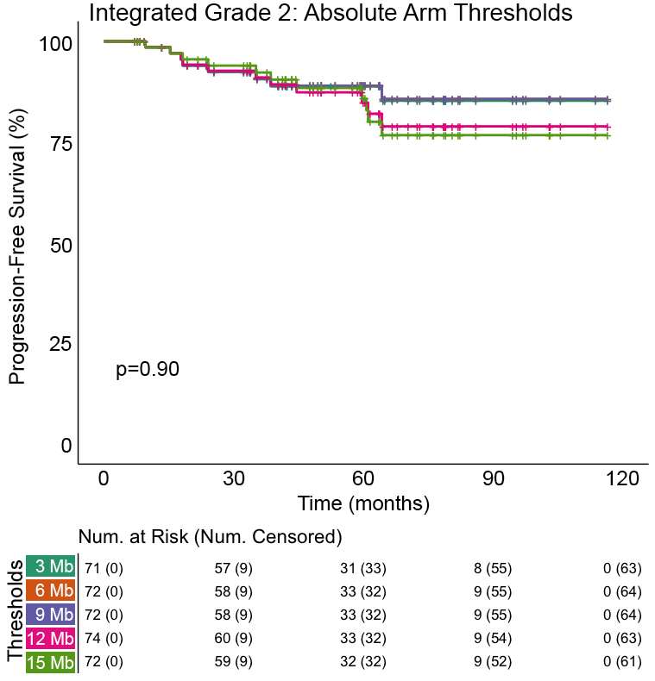

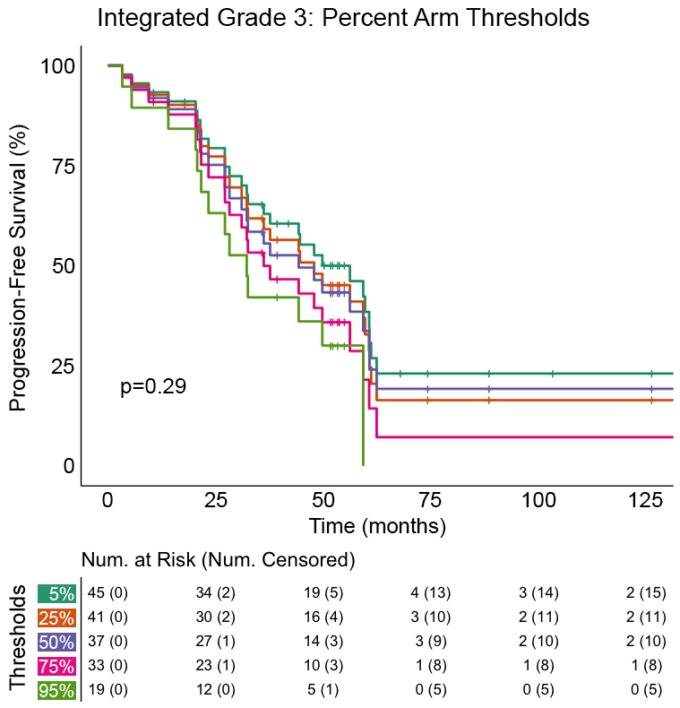

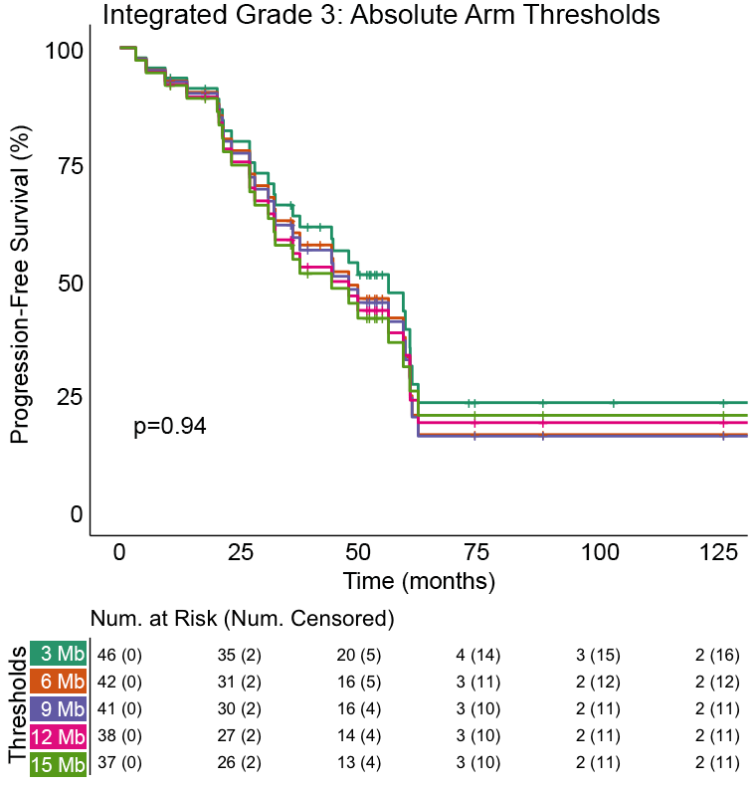

Supplement 1: Kaplan-Meier curves for meningioma recurrence stratified by integrated grade designation and tested arm call thresholds. Arm call thresholds were tested as a percent lost/gained of a chromosome arm or as an absolute base-pair length of the chromosome gained/lost. Mb: Megabases.

Supplementary Content 2

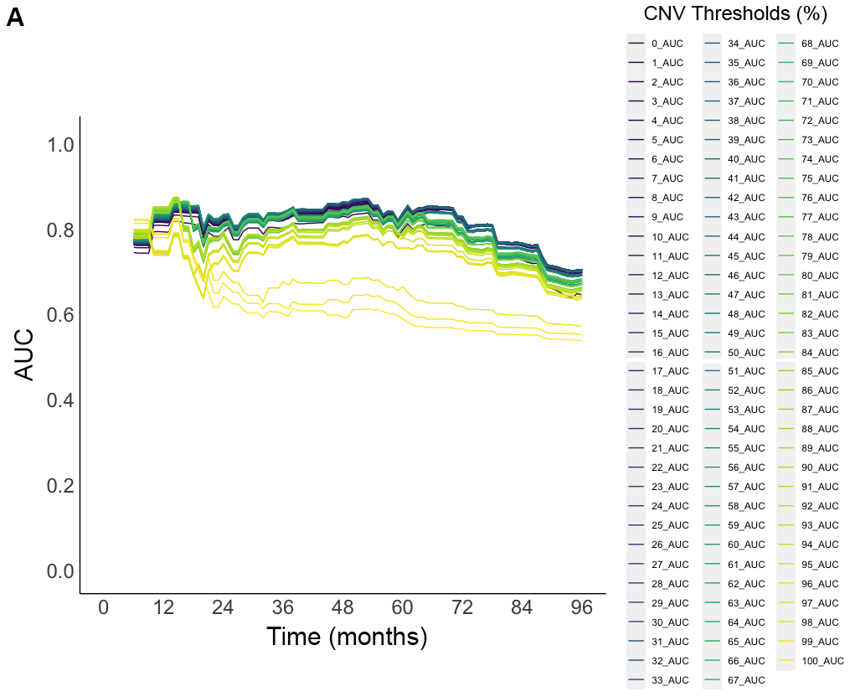

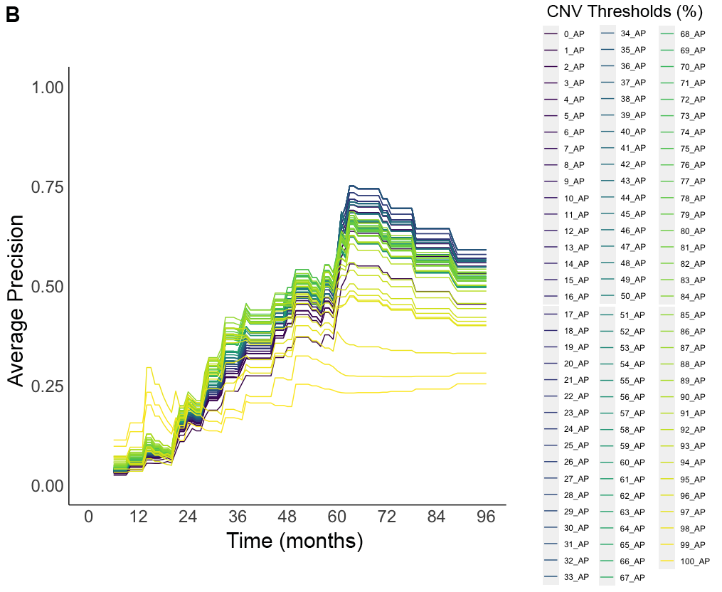
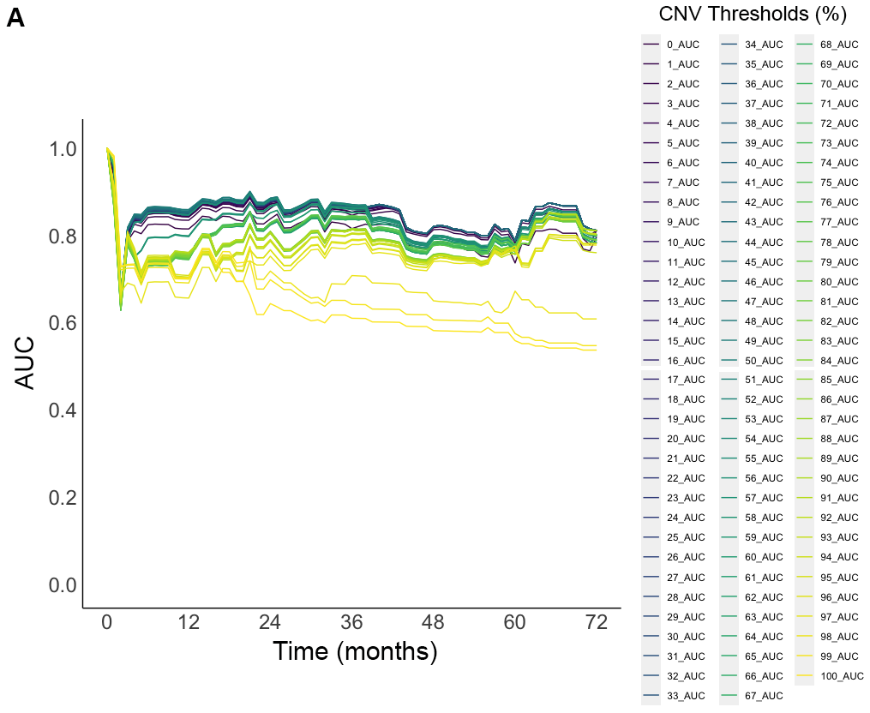

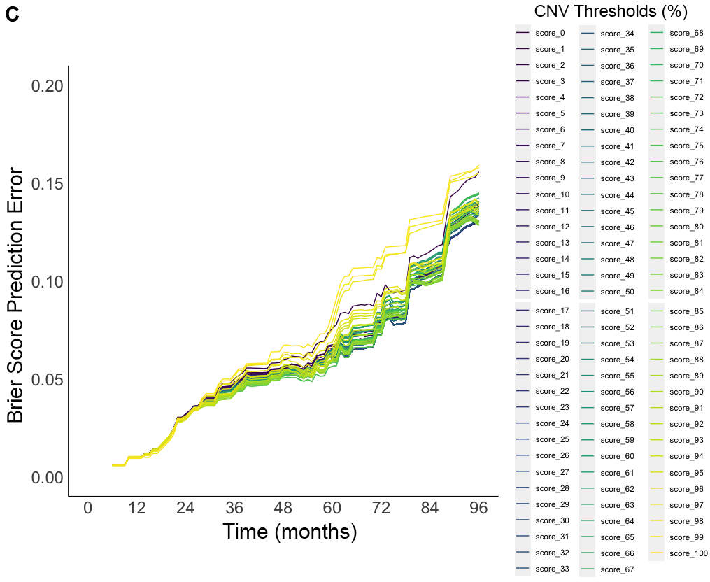

Supplement 2: Assessment of Integrated Grade prediction of meningioma progression free survival using (A) time-dependent receiver-operating curves, (B) time-dependent average precision, and (C) Brier scores over time. Each CNV arm call threshold from 0% to 100% was tested in increments of 1%.

Supplementary Content 3

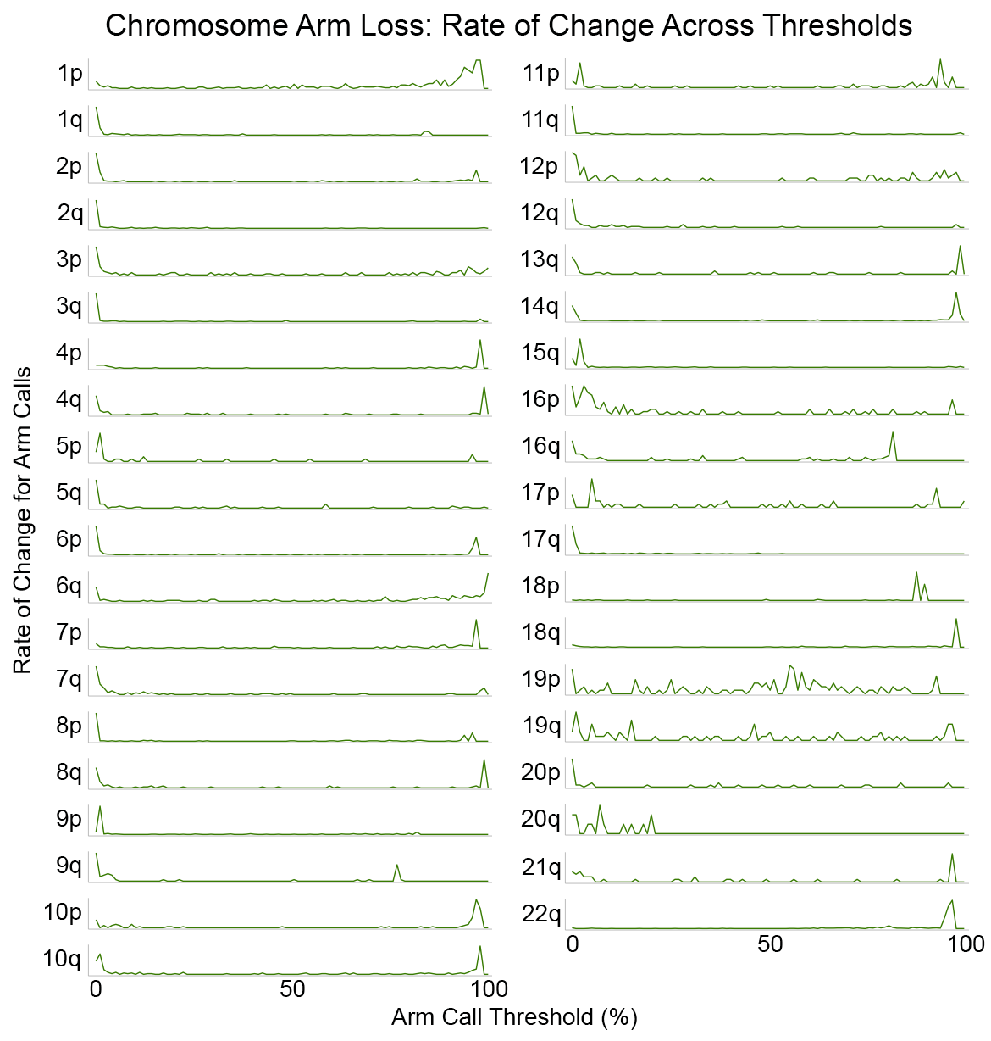

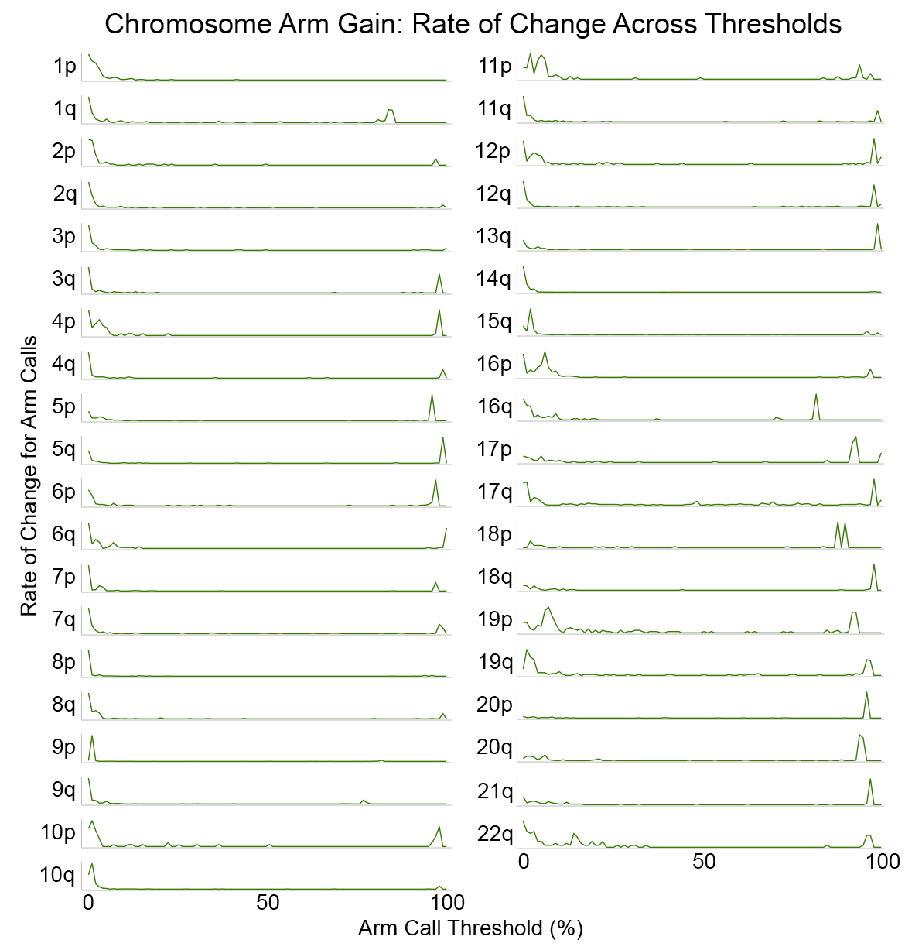
Supplement 3: Rate of change of chromosome arm loss and gain calls as CNV arm call thresholds were increased from 0 to 100%.

Supplementary Content 4

 | Copy Number Losses |  |  | Copy Number Gains
Chr Arm | Associated With Recurrence | Optimal Threshold | Range of Significant Thresholds | Associated With Recurrence | Optimal Threshold | Range of Significant Thresholds
1p | Yes | 46% | 0-97% | Yes | 20% | 0-11, 16-23%
1q | Yes | 84% | 0-84% | Yes | 32% | 0-84%
2p | Yes | 19% | 5-55%, 94% | Yes | 17% | 0-96%
2q | No | - | - | Yes | 2% | 0-2, 10-98%
3p | Yes | 4% | 0-100% | No | - | -
3q | Yes | 1% | 0-3% | No | - | -
4p | Yes | 64% | 0-97% | No | - | -
4q | Yes | 96% | 0-98% | No | - | -
5p | No | - | - | Yes | 1% | 1-2%
5q | No | - | - | No | - | -
6p | Yes | 96% | 0-97% | No | - | -
6q | Yes | 98% | 0-100% | No | - | -
7p | Yes | 1% | 0-96% | No | - | -
7q | No | - | - | No | - | -
8p | Yes | 93% | 0-95% | Yes | 8% | 1-12, 91-95%
8q | Yes | 62% | 1-99% | Yes | 11% | 0-80%
9p | Yes | 3% | 0-3% | No | - | -
9q | Yes | 4% | 0-21% | Yes | 1% | 0-3%
10p | Yes | 10% | 0-97% | Yes | 2% | 0-3%
10q | Yes | 23% | 0-97% | Yes | 2% | 0-2%
11p | Yes | 94% | 0-85%, 94% | Yes | 94% | 0-1, 3-6, 94-96%
11q | No | - | - | Yes | 3% | 0-3%
12p | Yes | 4% | 1, 4-9% | No | - | -
12q | No | - | - | No | - | -
13q | Yes | 2% | 0-98% | No | - | -
14q | Yes | 98% | 0-98% | No | - | -
15q | Yes | 96% | 4-20, 96% | Yes | 96% | 0-50, 72-98%
16p | No | - | - | No | - | -
16q | Yes | 76% | 2-81% | No | - | -
17p | Yes | 12% | 0-58% | No | - | -
17q | Yes | 2% | 1-3% | Yes | 1% | 0-20%
18p | Yes | 63% | 0-89% | No | - | -
18q | Yes | 87% | 0-97% | No | - | -
19p | Yes | 73% | 0-56, 65-76% | Yes | 0% | 0-1%
19q | Yes | 50% | 0-84% | No | - | -
20p | Yes | 31% | 1-37% | Yes | 0% | 0-1%
20q | No | - | - | Yes | 1% | 0-3, 5%
21q | No | - | - | Yes | 2% | 0-62%
22q | Yes | 7% | 0-65, 79-94% | Yes | 23% | 15-31, 35-94%

Supplement 4: Optimal CNV arm call thresholds which maximize the odds ratio for meningioma recurrence per chromosome arm on univariate testing. Significant thresholds are those at which the odds ratio reached statistical significance for increased odds of meningioma recurrence at p<0.05.
Supplementary Content 5

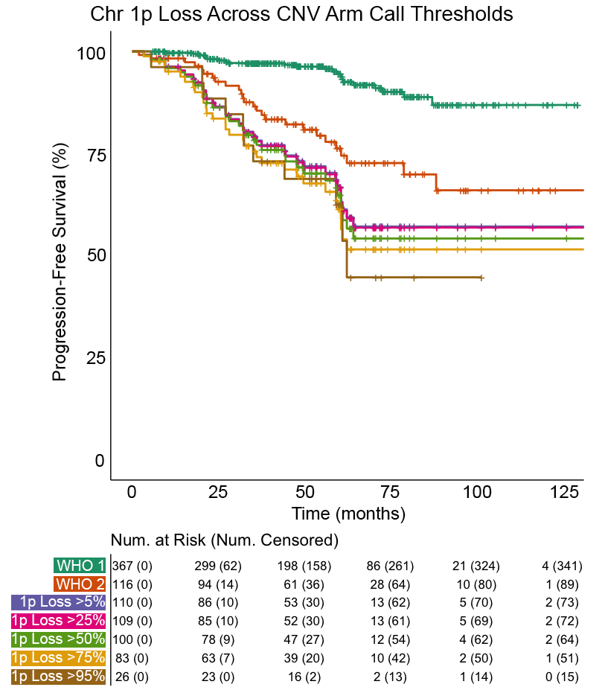

Supplement 5: Kaplan-Meier curves for meningioma recurrence stratified by WHO grade and CNV threshold applied to chromosome 1p loss. All chromosome 1p loss curves had significantly shorter median time to meningioma recurrence compared to WHO grade 1 meningiomas (p<0.001). Chromosome 1p loss defined at the 50% and 75% had significantly shorter median time to meningioma recurrence compared to WHO grade 2 meningiomas (p<0.05). There was no significant difference in median time to recurrence across various 1p loss CNV threshold curves.

Supplementary Content 6

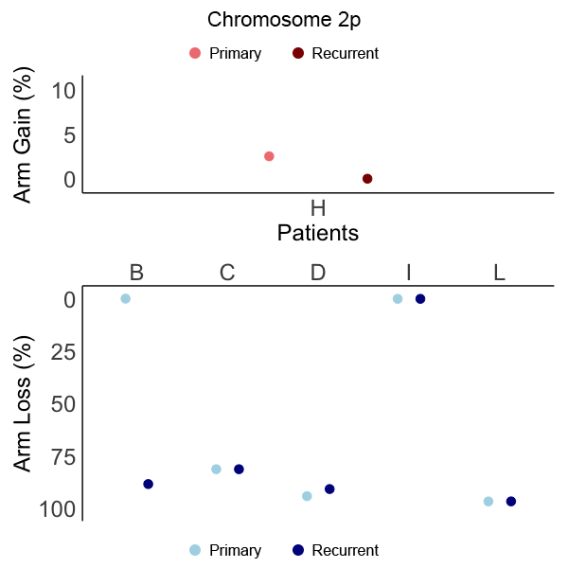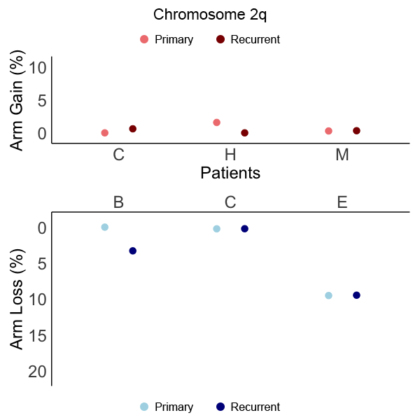

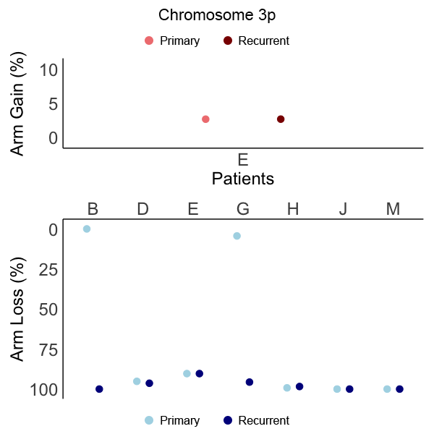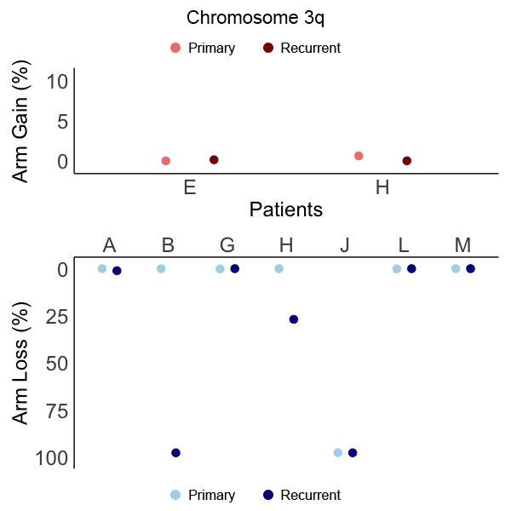

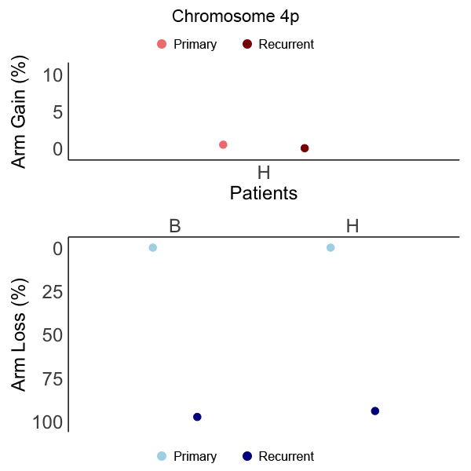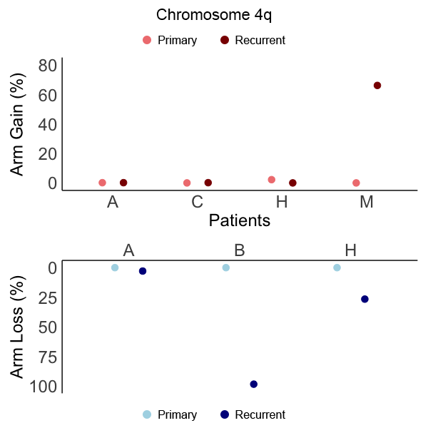

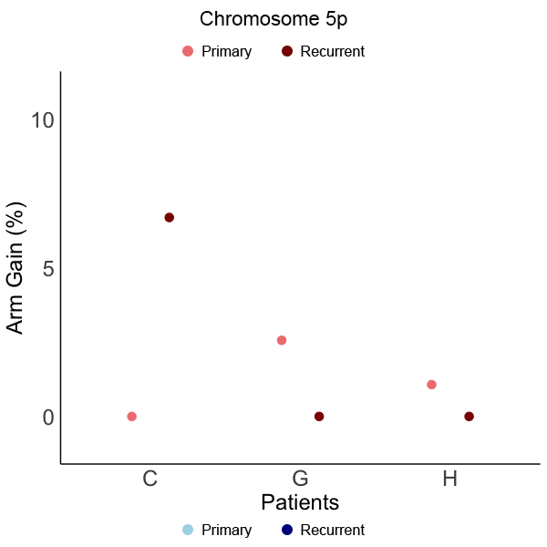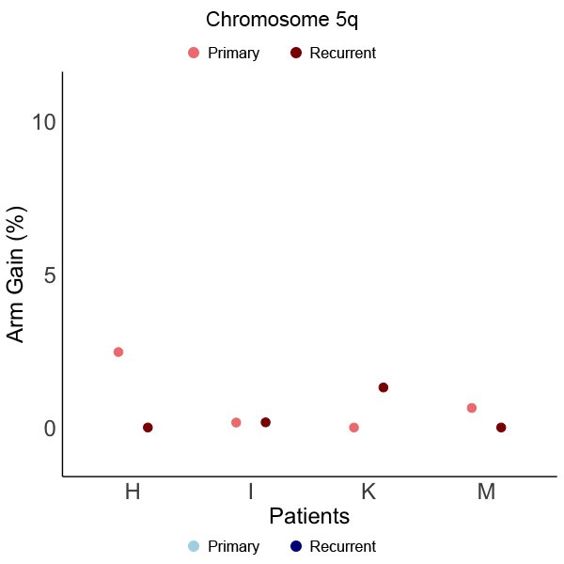

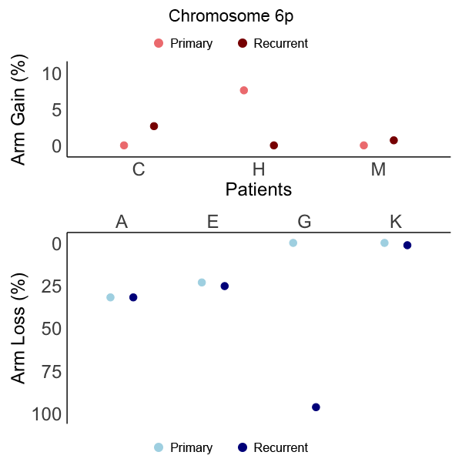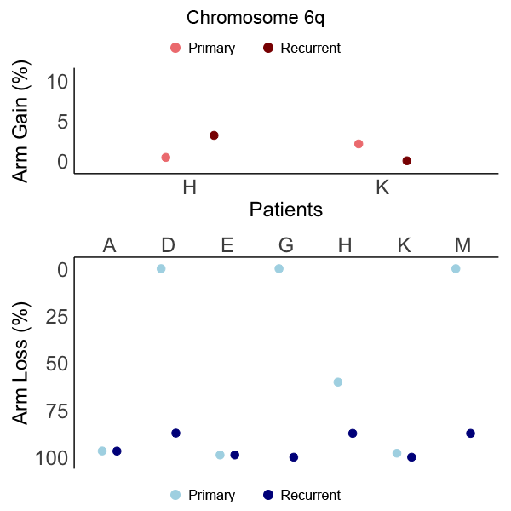

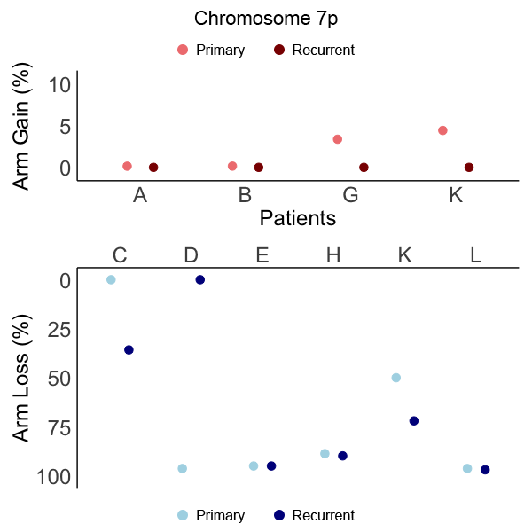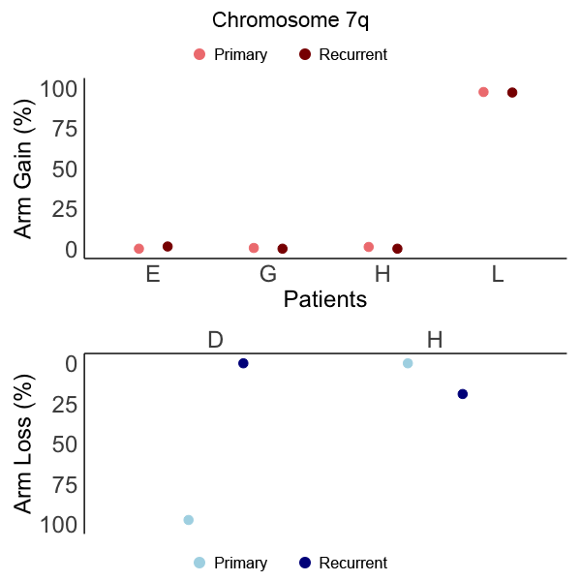

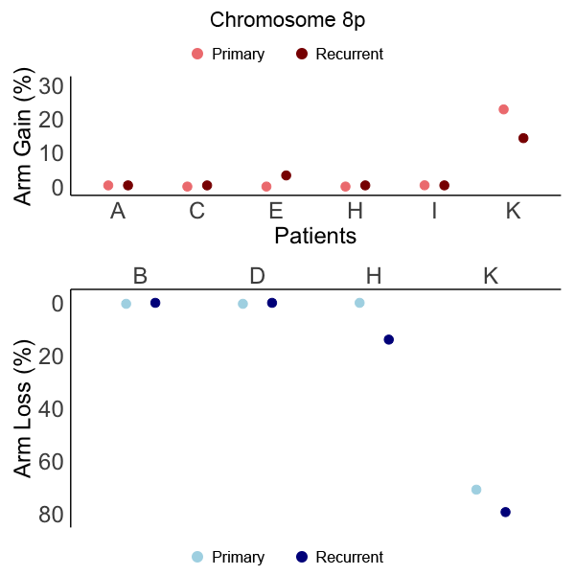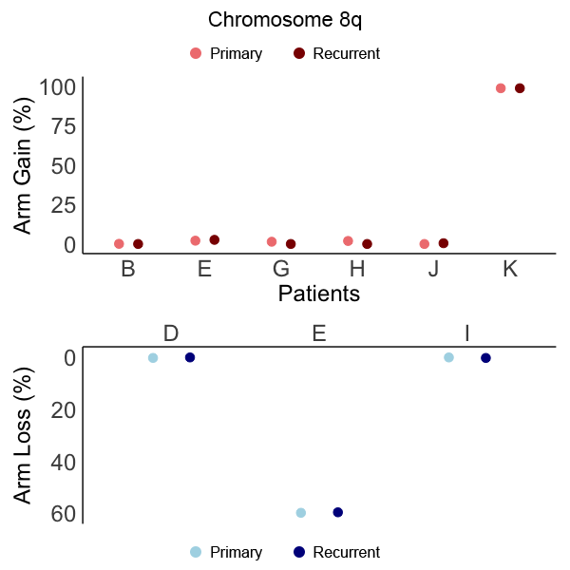

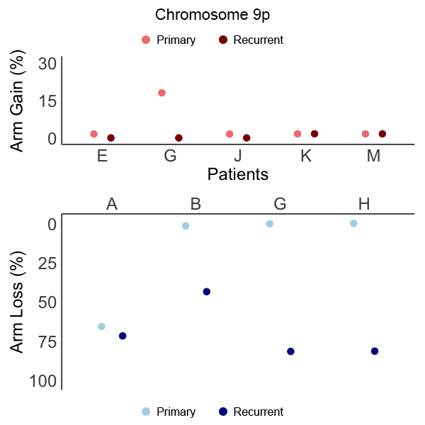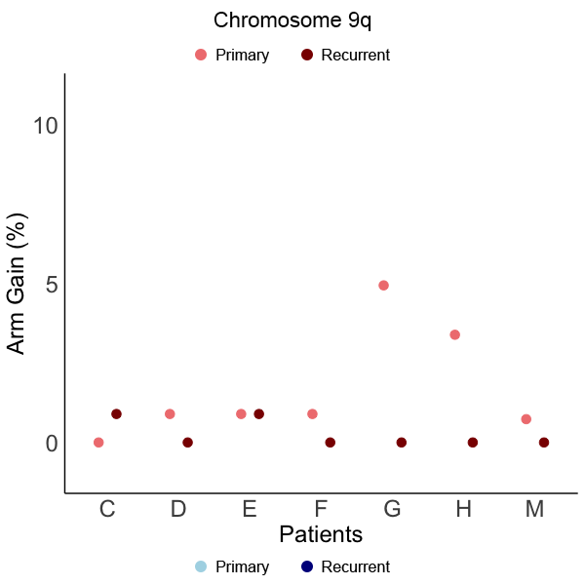

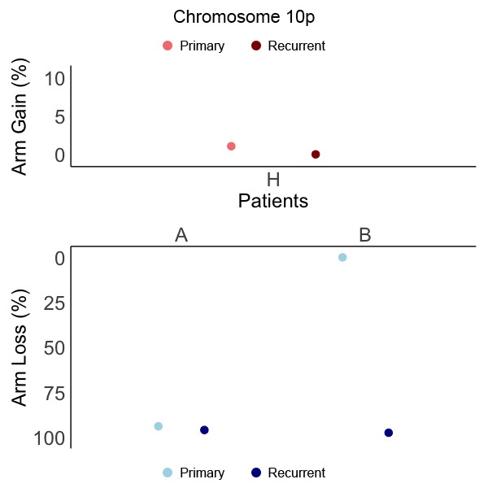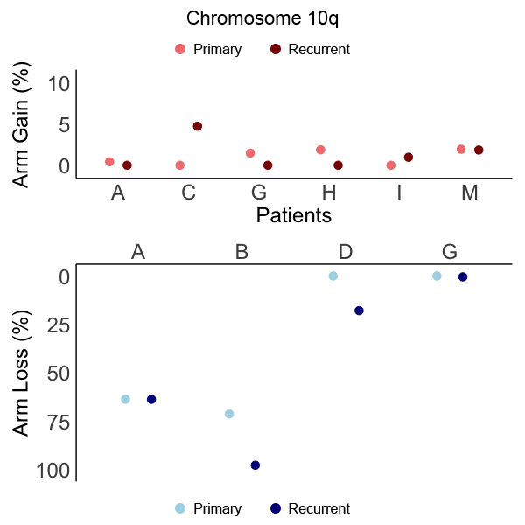

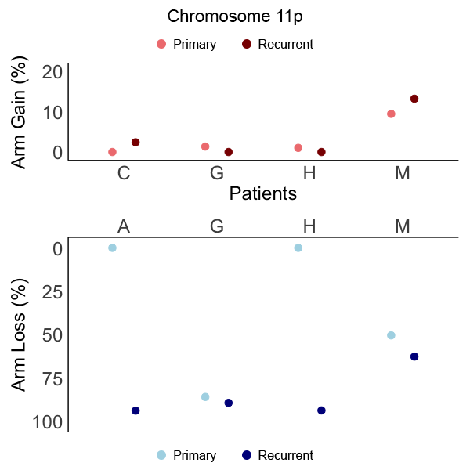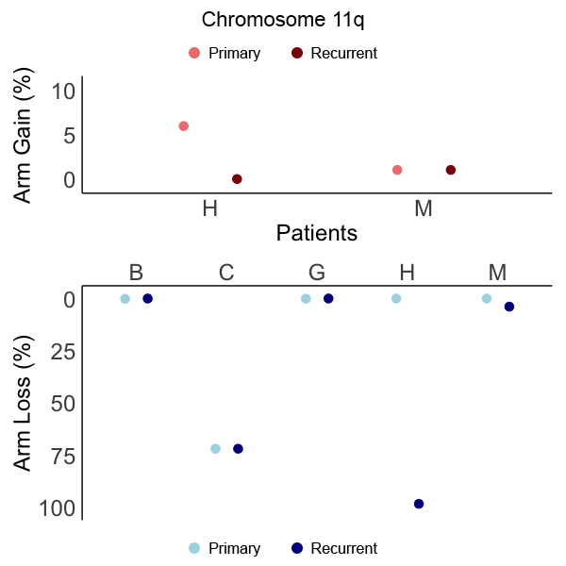

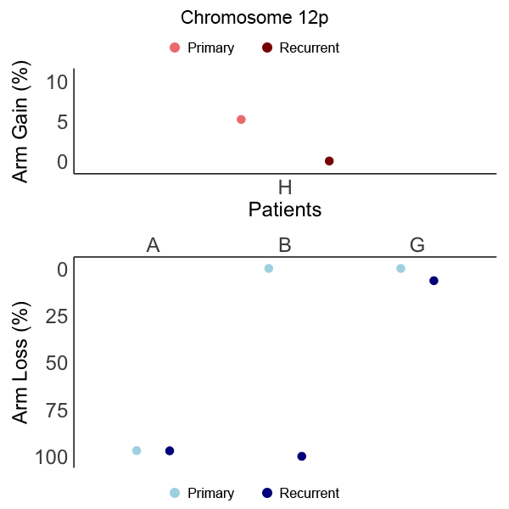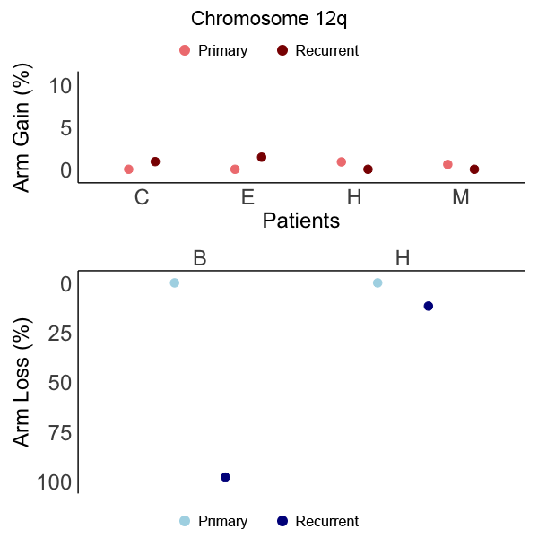

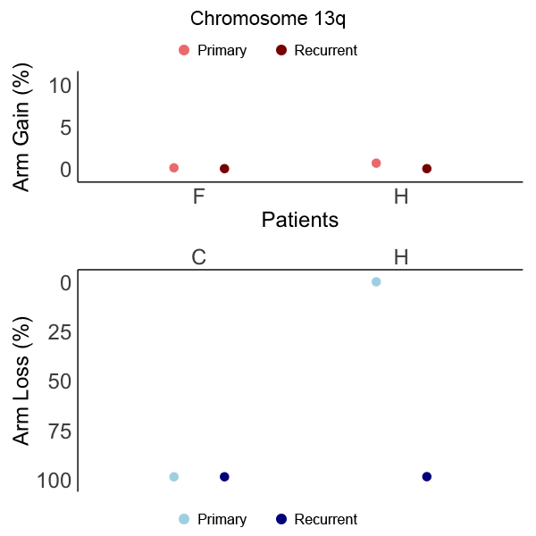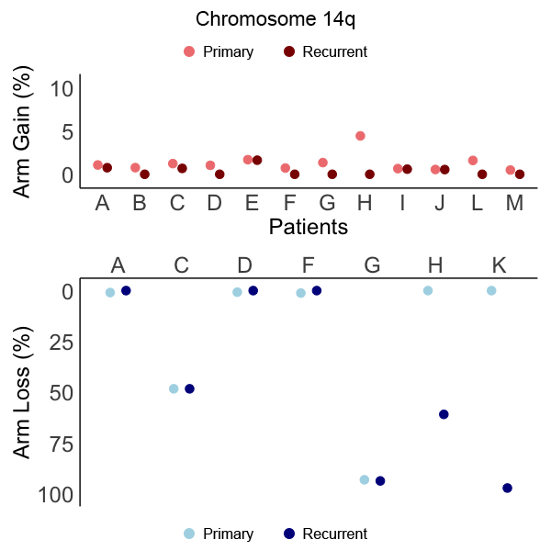

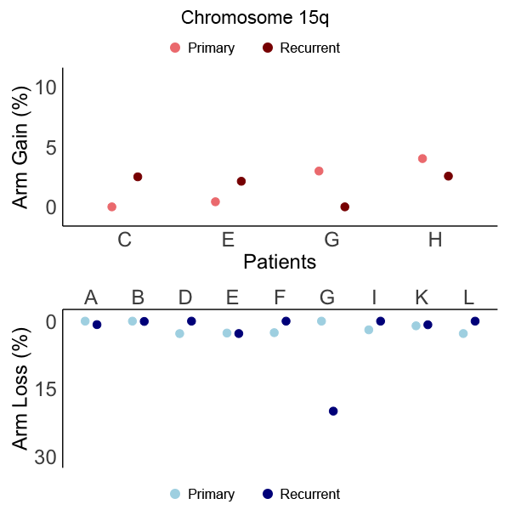

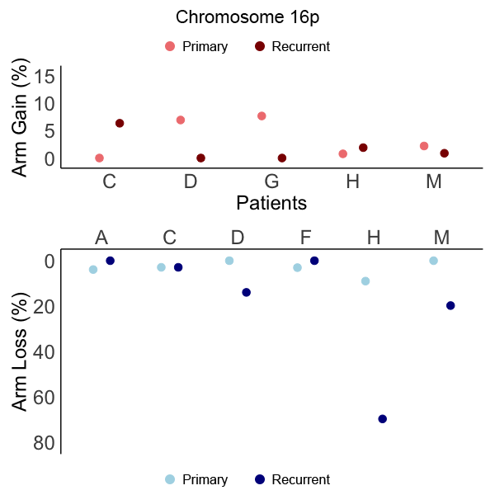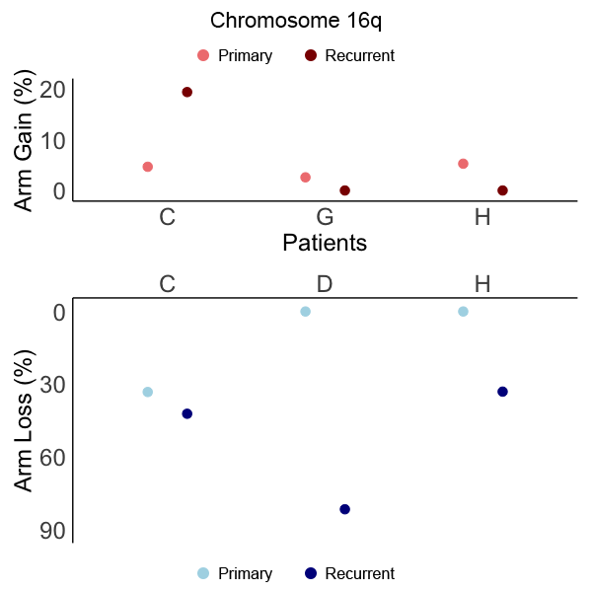

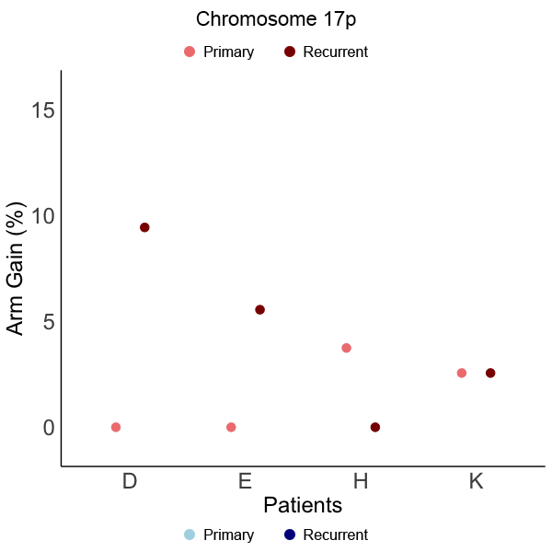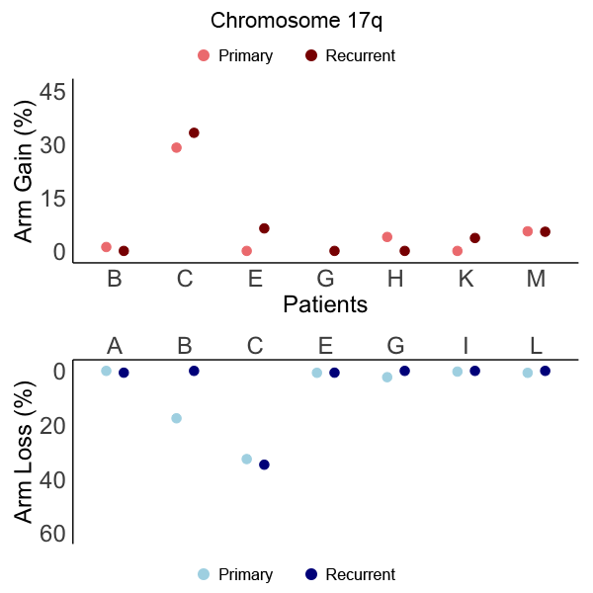

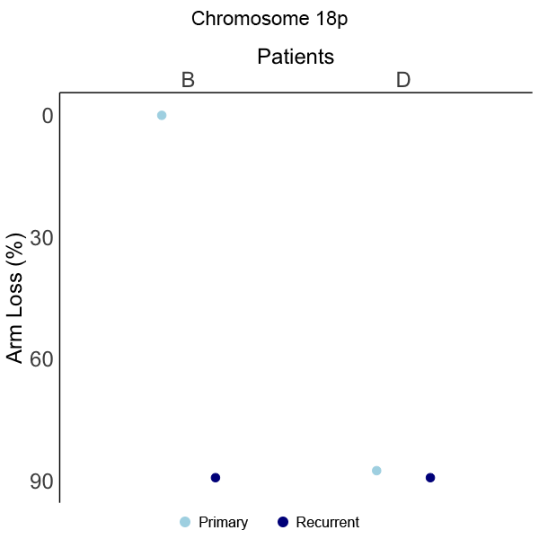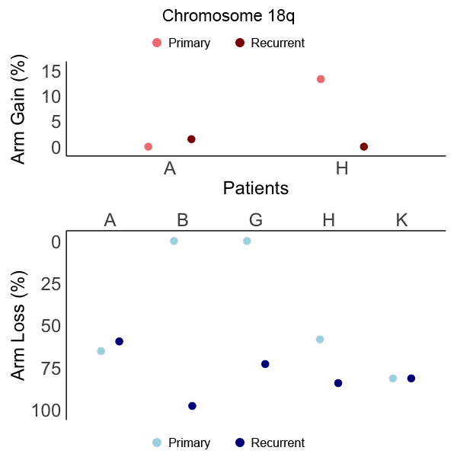

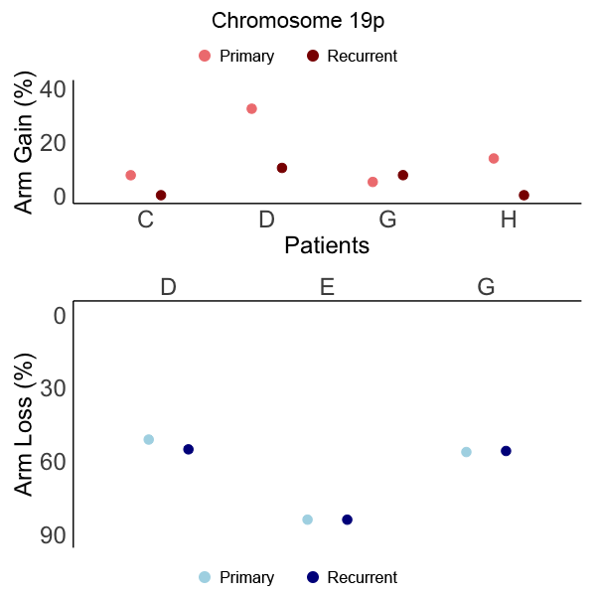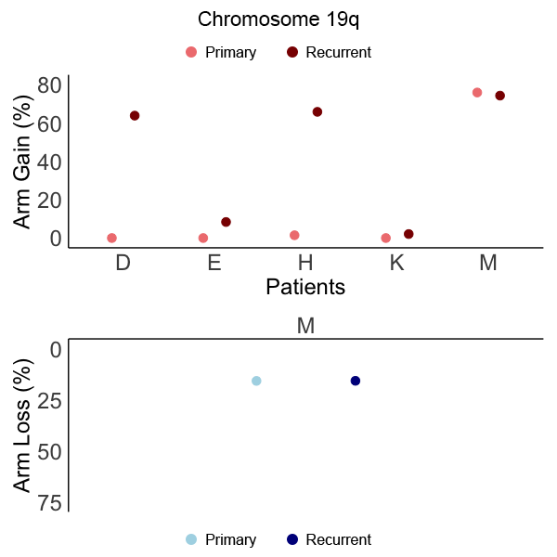
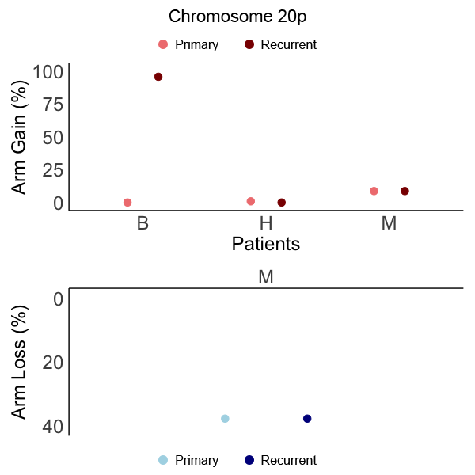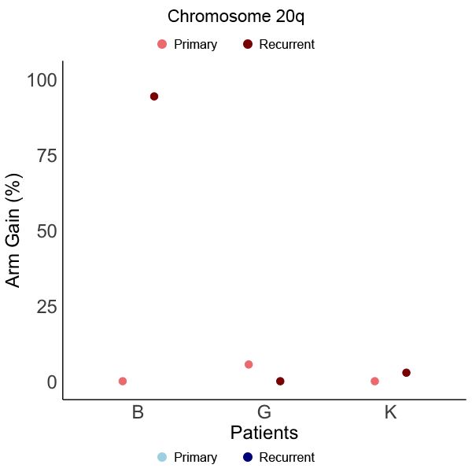

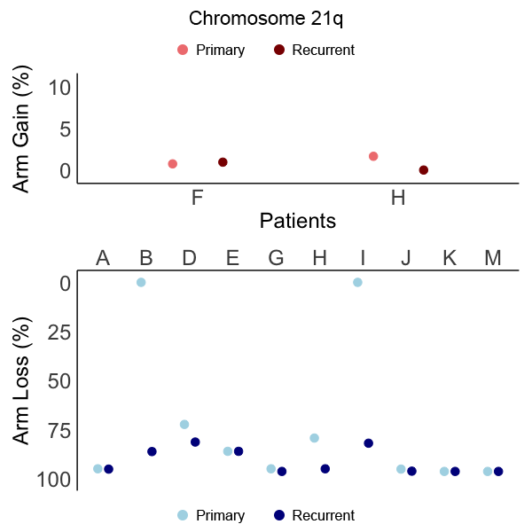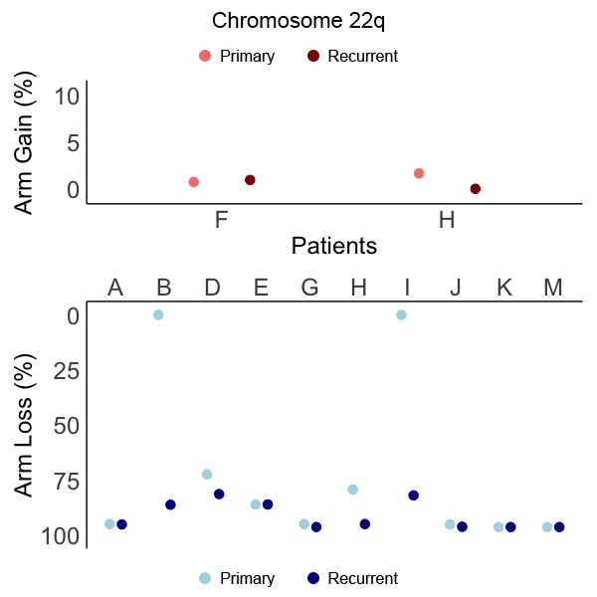

Supplement 6: Distribution of chromosome arm copy number gains and losses in paired primary and recurrent meningiomas. Dots are paired for each patient, corresponding to their primary or recurrent tumor sample respectively.

Supplementary Content 7

Copy Number Losses: Percent Change in Size Between Primary and Recurrent Meningiomas
 | A | A’ | B | B’ | C | C’ | D | D’ | E | E’ | F | F’ | G | G’ | H | H’ | I | I’ | J | J’ | K | K’ | L | L’ | M | M’
WHO | 2 | 2 | 1 | 3 | 2 | 2 | 2 | 2 | 1 | 1 | 1 | 1 | 2 | 2 | 1 | 2 | 1 | 2 | 1 | 1 | 1 | 2 | 1 | 1 | 1 | 1
IG | 3 | 3 | 1 | 3 | 2 | 2 | 3 | 3 | 3 | 3 | 1 | 1 | 3 | 3 | 3 | 3 | 1 | 1 | 1 | 1 | 2 | 3 | 1 | 1 | 2 | 2
Sex | M |  | M |  | F |  | F |  | M |  | F |  | M |  | F |  | F |  | F |  | M |  | M |  | M
1p | 0.03% |  | 66.7% |  | -0.1% |  | 4.5% |  | -1.1% |  |  |  | 1.7% |  | -0.1% |  |  |  |  |  | -0.02% |  | -0.01% |  | -0.1%
1q |  |  |  |  |  |  |  |  |  |  | -1.1% |  | -0.1% |  | 0.3%
2p |  |  | 88.5% |  | 0% |  | -3.4% |  |  |  |  |  |  |  |  |  | 0% |  |  |  |  |  | -0.02%
2q |  |  | 3.3% |  | -0.1% |  |  |  | -0.04%
3p |  |  | 100% |  |  |  | 1.2% |  | 0% |  |  |  | 91.2% |  | -0.8% |  |  |  | 0% |  |  |  |  |  | 0%
3q | 1.1% |  | 97.6% |  |  |  |  |  |  |  |  |  | -0.1% |  | 26.9% |  |  |  | 0.1% |  |  |  | -0.1% |  | 0%
4p |  |  | 97.4% |  |  |  |  |  |  |  |  |  |  |  | 94.0%
4q | 2.9% |  | 98.4% |  |  |  |  |  |  |  |  |  |  |  | 26.6%
5p
5q
6p | -0.01% |  |  |  |  |  |  |  | 2.1% |  |  |  | 96.3% |  |  |  |  |  |  |  | 1.4%
6q | 0.1% |  |  |  |  |  | 87.2% |  | -0.01% |  |  |  | 100% |  | 27.2% |  |  |  |  |  | 2.1% |  |  |  | 87.3%
7p |  |  |  |  | 35.8% |  | -96.2% |  | 0% |  |  |  |  |  | 1.1% |  |  |  |  |  | 22.0% |  | 0.7%
7q |  |  |  |  |  |  | -97.4% |  |  |  |  |  |  |  | 19.1%
8p |  |  | -0.4% |  |  |  | -0.4% |  |  |  |  |  |  |  | 13.9% |  |  |  |  |  | 8.5%
8q |  |  |  |  |  |  | -0.2% |  | -0.2% |  |  |  |  |  |  |  | 0.2%
9p | 6.0% |  | 42.0% |  |  |  |  |  |  |  |  |  | 81.4% |  | 81.4%
9q
10p | 2.1% |  | 97.4%
10q | 0.01% |  | 26.5% |  |  |  | 17.9% |  |  |  |  |  | 0.5%
11p | 93.8% |  |  |  |  |  |  |  |  |  |  |  | 3.4% |  | 93.7% |  |  |  |  |  |  |  |  |  | 12.2%
11q |  |  | -0.1% |  | 0% |  |  |  |  |  |  |  | -0.1% |  | 98.3% |  |  |  |  |  |  |  |  |  | 3.9%
12p | 0.1% |  | 100% |  |  |  |  |  |  |  |  |  | 6.5%
12q |  |  | 97.9% |  |  |  |  |  |  |  |  |  |  |  | 11.7%
13q |  |  |  |  | 0% |  |  |  |  |  |  |  |  |  | 98.5%
14q | -1.0% |  |  |  | 0.01% |  | -0.8% |  |  |  | -1.2% |  | 0.5% |  | 60.9% |  |  |  |  |  | 97.1%
15q | 0.8% |  | 0.1% |  |  |  | -2.8% |  | 0.1% |  | -2.6% |  | 20.0% |  |  |  | -1.9% |  |  |  | -0.2% |  | -2.8%
16p | -3.9% |  |  |  | 0% |  | 13.9% |  |  |  | -3.1% |  |  |  | 60.6% |  |  |  |  |  |  |  |  |  | 19.8%
16q |  |  |  |  | 9.0% |  | 81.7% |  |  |  |  |  |  |  | 33.1%
17p
17q | 0.7% |  | -17.6% |  | 2.1% |  |  |  | -0.04% |  |  |  | -2.3% |  |  |  | -0.3% |  |  |  |  |  | -0.8%
18p |  |  | 89.4% |  |  |  | 1.7% |  |  |  |  |  | 72.9%
18q | -5.7% |  | 97.8% |  |  |  |  |  |  |  |  |  |  |  | 25.9% |  |  |  |  |  | 0%
19p |  |  |  |  |  |  | 4.0% |  | 0.02% |  |  |  | -0.4%
19q |  |  |  |  |  |  |  |  |  |  |  |  |  |  |  |  |  |  |  |  |  |  |  |  | -0.05%
20p |  |  |  |  |  |  |  |  |  |  |  |  |  |  |  |  |  |  |  |  |  |  |  |  | 0%
20q
21q
22q | 0.2% |  | 86.2% |  |  |  | 9.0% |  | 0% |  |  |  | 1.3% |  | 15.7% |  | 81.9% |  | 1.0% |  | 0% |  |  |  | 0%

Copy Number Gains: Percent Change in Size Between Primary and Recurrent Meningiomas
 | A | A’ | B | B’ | C | C’ | D | D’ | E | E’ | F | F’ | G | G’ | H | H’ | I | I’ | J | J’ | K | K’ | L | L’ | M | M’
WHO | 2 | 2 | 1 | 3 | 2 | 2 | 2 | 2 | 1 | 1 | 1 | 1 | 2 | 2 | 1 | 2 | 1 | 2 | 1 | 1 | 1 | 2 | 1 | 1 | 1 | 1
IG | 3 | 3 | 1 | 3 | 2 | 2 | 3 | 3 | 3 | 3 | 1 | 1 | 3 | 3 | 3 | 3 | 1 | 1 | 1 | 1 | 2 | 3 | 1 | 1 | 2 | 2
Sex | M |  | M |  | F |  | F |  | M |  | F |  | M |  | F |  | F |  | F |  | M |  | M |  | M
1p | 0.5% |  |  |  |  |  | -3.9% |  | -0.02% |  |  |  | -1.3% |  |  |  |  |  |  |  | 0%
1q | 0.8% |  |  |  | 1.1% |  | 31.7% |  | 0.2% |  |  |  | -84.6% |  | -2.6% |  |  |  |  |  | 0% |  |  |  | -0.1%
2p |  |  |  |  |  |  |  |  |  |  |  |  |  |  | -2.5%
2q |  |  |  |  | 0.6% |  |  |  |  |  |  |  |  |  | -1.6% |  |  |  |  |  |  |  |  |  | 0.04%
3p |  |  |  |  |  |  |  |  | 0.01%
3q |  |  |  |  |  |  |  |  | 0.1% |  |  |  |  |  | -0.6%
4p |  |  |  |  | 0.2% |  |  |  |  |  |  |  |  |  | -0.5%
4q | 0.02% |  |  |  |  |  |  |  |  |  |  |  |  |  | -2.2% |  |  |  |  |  |  |  |  |  | 66.2%
5p |  |  |  |  | 6.7% |  |  |  |  |  |  |  | -2.6% |  | -1.1%
5q |  |  |  |  |  |  |  |  |  |  |  |  |  |  | -2.5% |  | 0.01% |  |  |  | 1.3% |  |  |  | -0.6%
6p |  |  |  |  | 2.6% |  |  |  |  |  |  |  |  |  | -7.6% |  |  |  |  |  |  |  |  |  | 0.7%
6q |  |  |  |  |  |  |  |  |  |  |  |  |  |  | 2.7% |  |  |  |  |  | -2.1%
7p | -0.1% |  | -0.1% |  |  |  |  |  |  |  |  |  | -3.4% |  |  |  |  |  |  |  | -4.4%
7q |  |  |  |  |  |  |  |  | 1.4% |  |  |  | -0.5% |  | -1.1% |  |  |  |  |  |  |  | -0.3%
8p | 0.01% |  |  |  | 0.3% |  |  |  | 3.3% |  |  |  |  |  | 0.3% |  | -0.03% |  |  |  | -8.5%
8q |  |  | -0.1% |  |  |  |  |  | 0.5% |  |  |  | -1.4% |  | -1.9% |  |  |  | 0.5% |  | 0%
9p |  |  |  |  |  |  |  |  | -1.5% |  |  |  | -18.0% |  |  |  |  |  | -1.5% |  | 0% |  |  |  | 0%
9q |  |  |  |  | 0.9% |  | -0.9% |  | 0% |  | -0.9% |  | -4.9% |  | -3.4% |  |  |  |  |  |  |  |  |  | -0.7%
10p |  |  |  |  |  |  |  |  |  |  |  |  |  |  | -1.1%
10q | -0.4% |  |  |  | 4.7% |  |  |  |  |  |  |  | -1.5% |  | -1.9% |  | 1.0% |  |  |  |  |  |  |  | -0.1%
11p |  |  |  |  | 2.4% |  |  |  |  |  |  |  | -1.4% |  | -1.0% |  |  |  |  |  |  |  |  |  | 3.8%
11q |  |  |  |  |  |  |  |  |  |  |  |  |  |  | -6.0% |  |  |  |  |  |  |  |  |  | 0%
12p |  |  |  |  |  |  |  |  |  |  |  |  |  |  | -5.2%
12q |  |  |  |  | 0.9% |  |  |  | 1.4% |  |  |  |  |  | -0.9% |  |  |  |  |  |  |  |  |  | -0.6%
13q |  |  |  |  |  |  |  |  |  |  | -0.1% |  |  |  | -0.7%
14q | -0.3% |  | -0.8% |  | -0.5% |  | -1.0% |  | -0.1% |  | -0.7% |  | -1.4% |  | -4.4% |  | -0.06% |  | 0.01% |  |  |  | -1.6% |  | -0.5%
15q |  |  |  |  | 2.5% |  |  |  | 1.7% |  |  |  | -3.0% |  | -1.5%
16p |  |  |  |  | 6.3% |  | -6.9% |  |  |  |  |  | -7.7% |  | 1.1% |  |  |  |  |  |  |  |  |  | -1.3%
16q |  |  |  |  | 14.7% |  |  |  |  |  |  |  | -2.6% |  | -5.3%
17p |  |  |  |  |  |  |  |  | 5.5% |  |  |  |  |  | -3.7% |  |  |  |  |  | 0%
17q |  |  | -1.1% |  | 4.2% |  | 9.4% |  | 6.3% |  |  |  | -57.1% |  | -3.9% |  |  |  |  |  | 3.6% |  |  |  | -0.1%
18p
18q | 1.5% |  |  |  |  |  |  |  |  |  |  |  |  |  | -13.4%
19p |  |  |  |  | -7.5% |  | -22.2% |  |  |  |  |  | 2.5% |  | -13.8%
19q |  |  |  |  |  |  | 63.8% |  | 8.4% |  |  |  |  |  | 64.4% |  |  |  |  |  | 2.1% |  |  |  | -1.6%
20p |  |  | 95.7% |  |  |  |  |  |  |  |  |  |  |  | -0.9% |  |  |  |  |  |  |  |  |  | 0%
20q |  |  | 94.3% |  |  |  |  |  |  |  |  |  | -5.5% |  |  |  |  |  |  |  | 2.8%
21q |  |  |  |  |  |  |  |  |  |  |  |  |  |  | 92.4%
22q |  |  |  |  |  |  |  |  |  |  | 0.2% |  |  |  | -1.6%

Supplement 7: Change in CNV size between paired primary and recurrent meningiomas for copy number losses and gains. IG grade defined from copy number calls at a 50% arm call threshold. ‘ symbol denotes paired recurrent tumor for each patient.

Supplementary Content 8

Patient 3
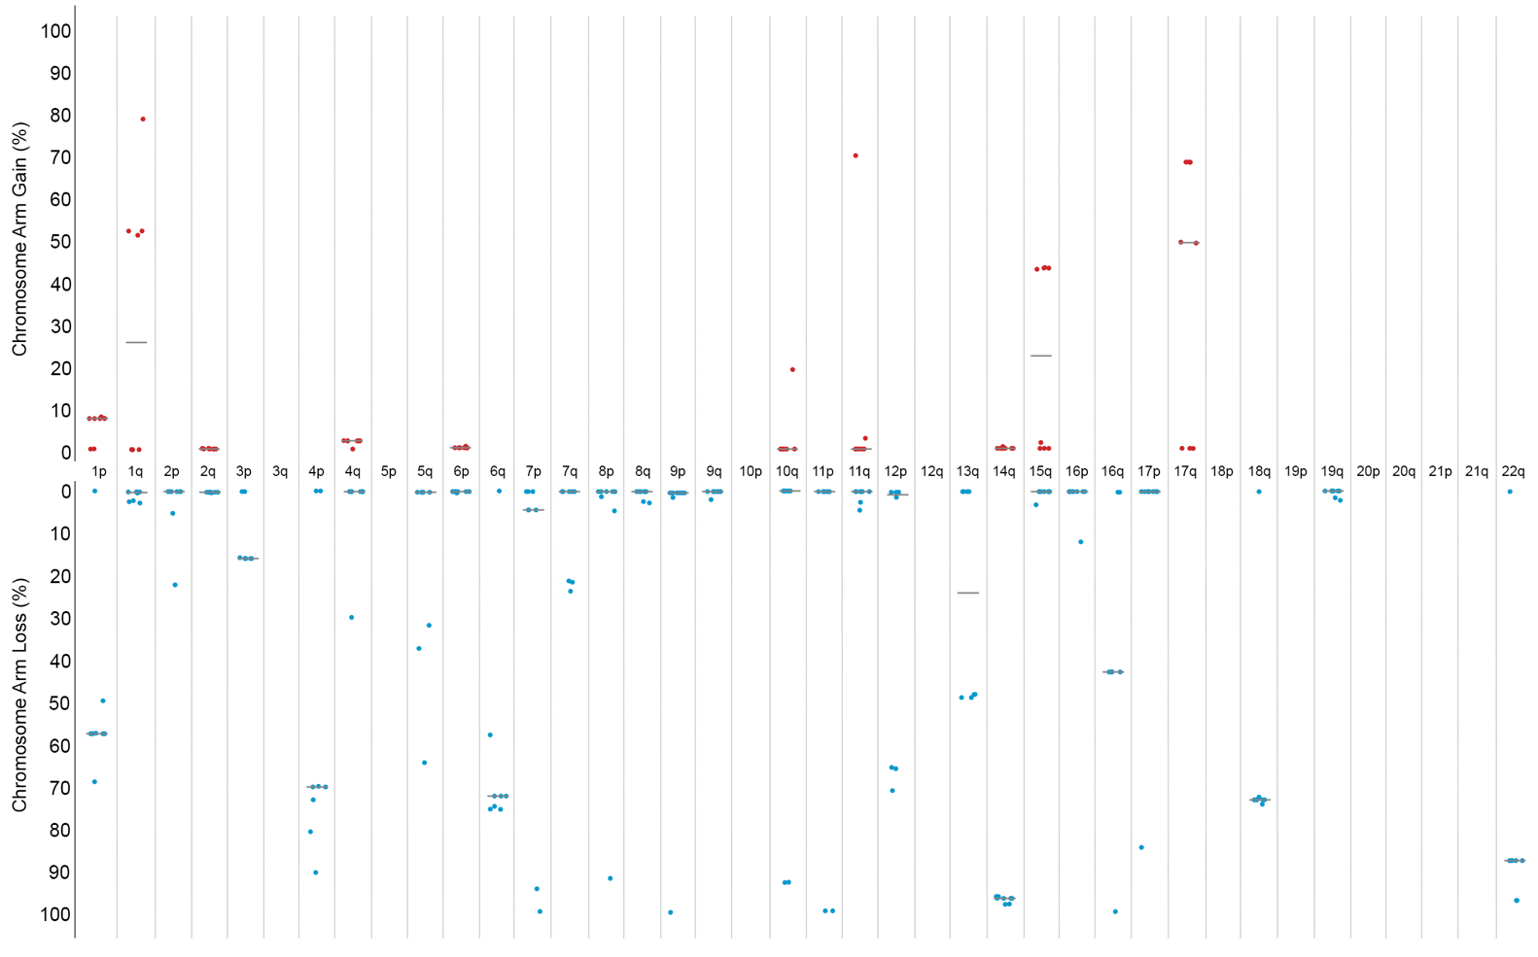

Patient 4
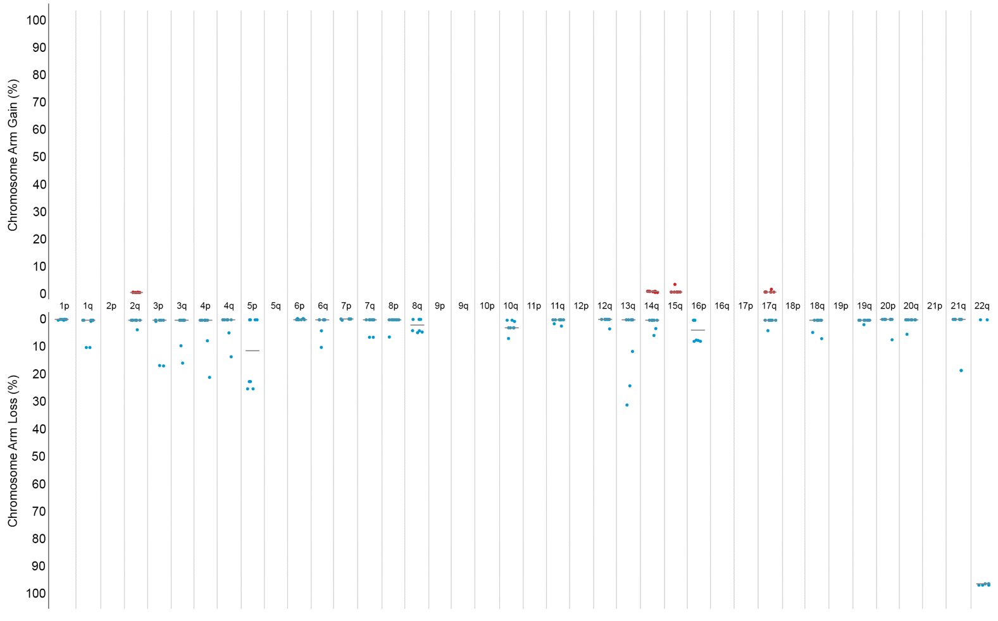

Patient 5
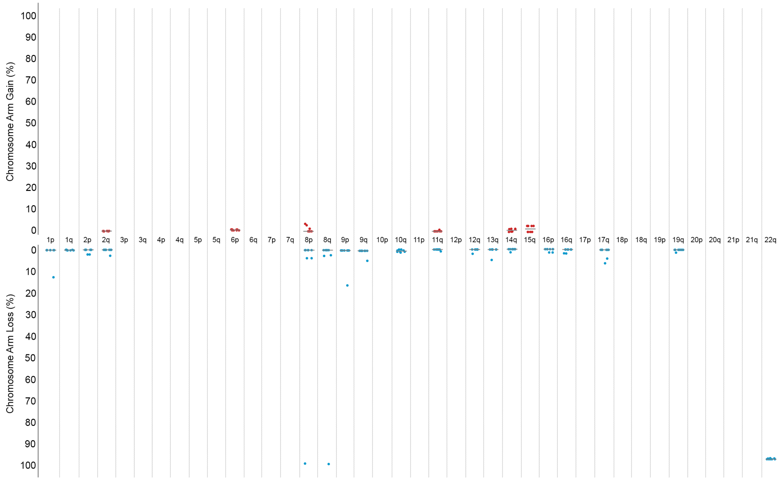

Patient 6
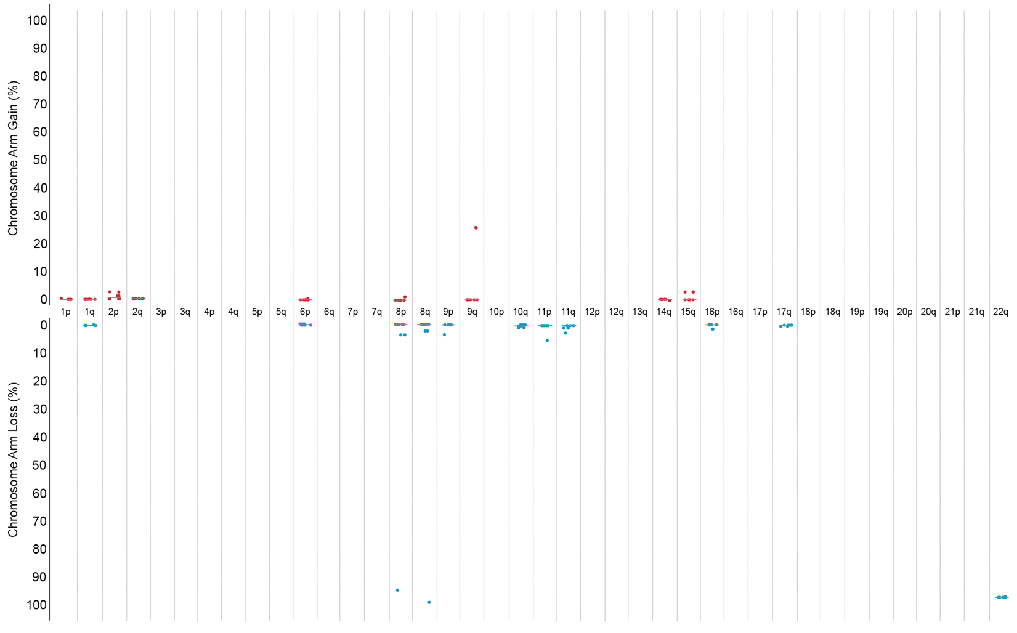
Patient 7
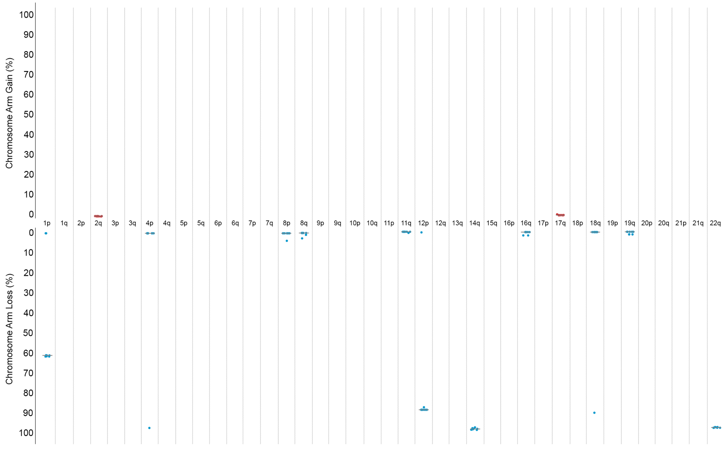

Patient 8
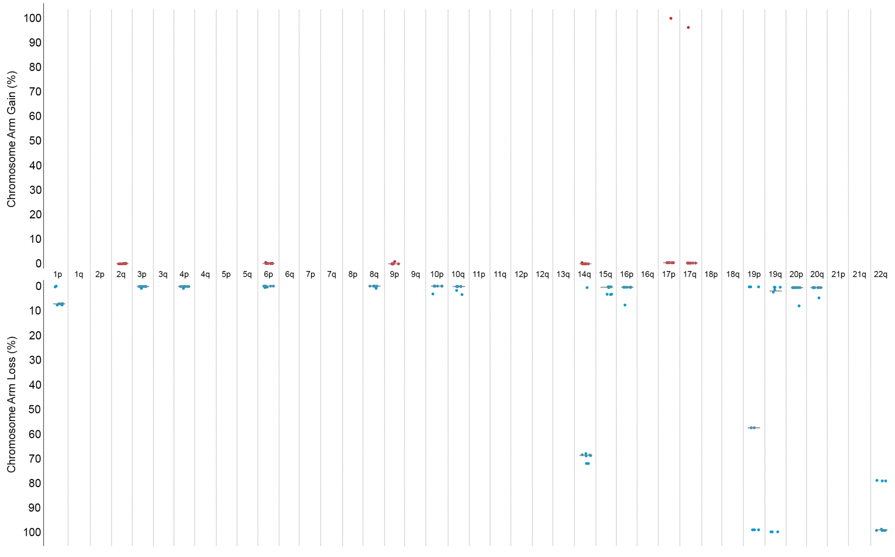
Patient 9
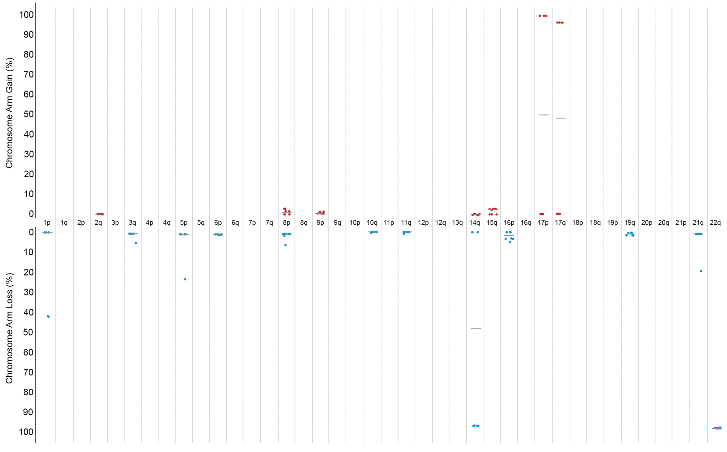

Patient 10
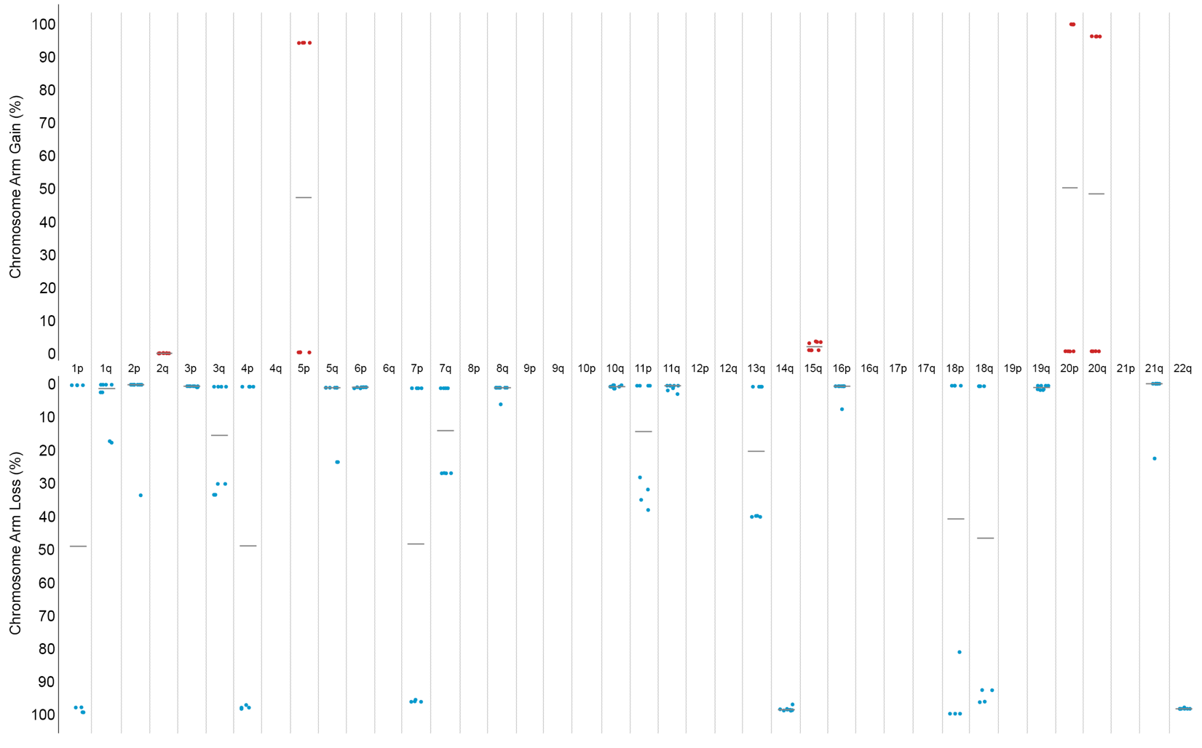
Patient 11
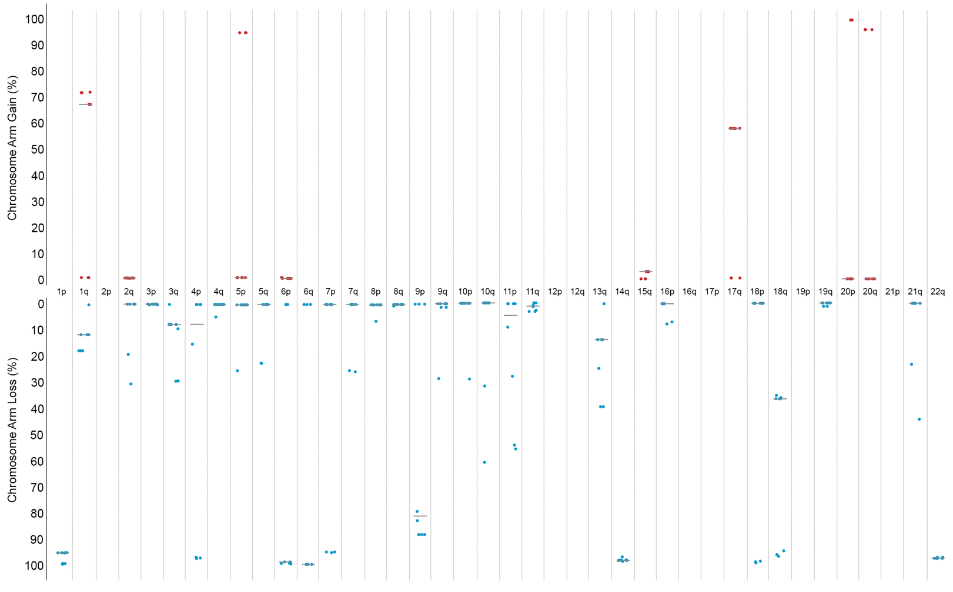

Patient 12
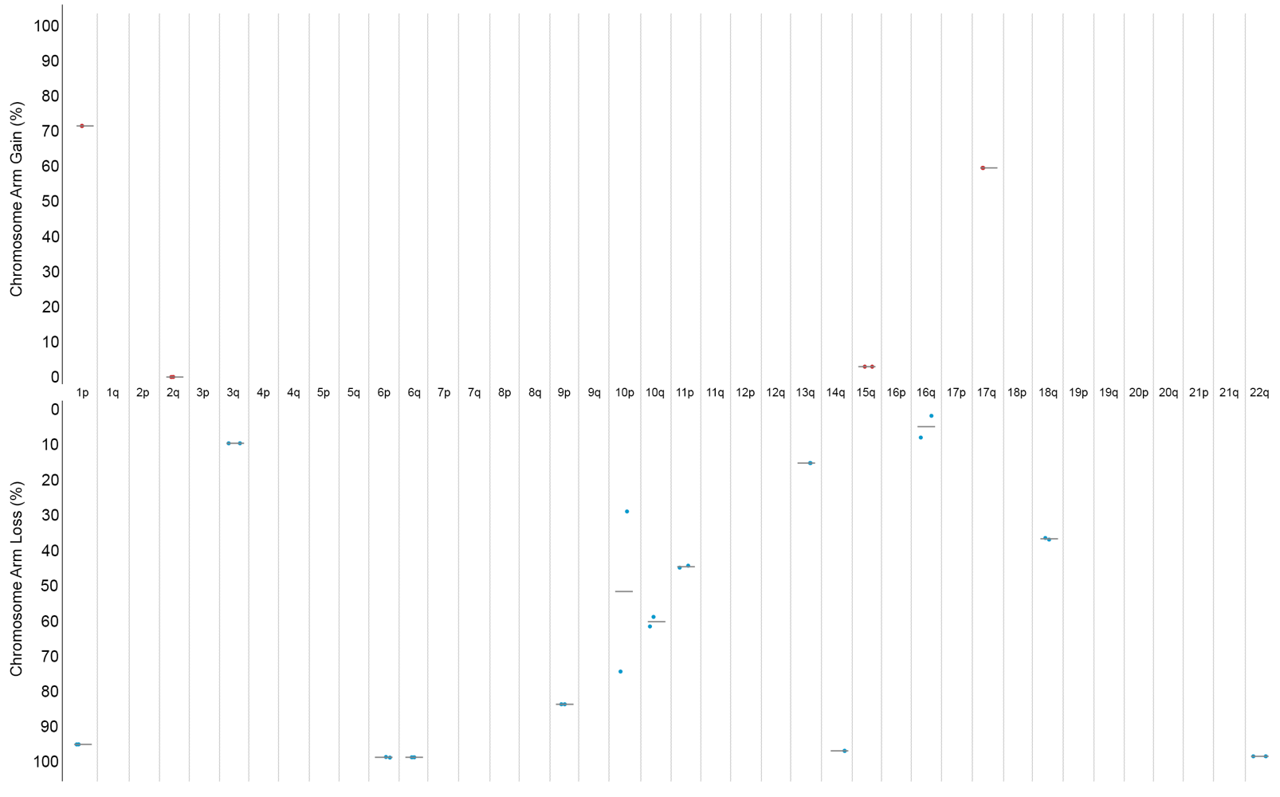
Supplement 8: CNV gains and losses in additional patients with multifocal sampled meningioma. Each dot reflects a different spatially distinct sample taken per patient.

