Table 1. The structures of selected phytoconstituents.
ID. | Name | Structure | ID | Name | Structure
P_1 | CBDA | 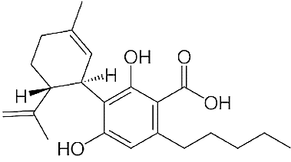 | P_26 | Geraniol
P_2 | CBGA | 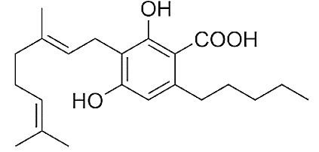 | P_27 | β-Caryophyllene
P_3 | CBG | 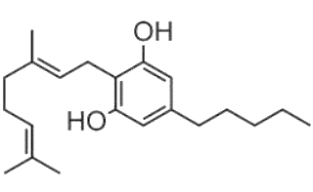 | P_28 | α-Humulene | 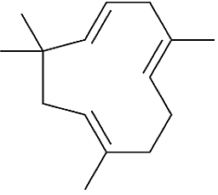
P_4 | CBD |  | P_29 | Nerolidol
P_5 | THCV |  | P_30 | (−)-Guaiol
P_6 | CBN |  | P_31 | (−)-α-Bisabolol
P_7 | Δ-9-THC |  | P_32 | Cineol
P_8 | Δ-8-THC |  | P_33 | Fenchol
P_9 | CBL |  | P_34 | Borneol
P_10 | CBC |  | P_35 | α-Terpineol
P_11 | THCA |  | P_36 | γ-Elemene
P_12 | CBCA |  | P_37 | α-Bergomotene
P_13 | α-Pinene |  | P_38 | β- Farnesene
P_14 | Camphene |  | P_39 | β- Eudesmene
P_15 | β-Pinene |  | P_40 | Valencene
P_16 | β-Myrcene |  | P_41 | α-Bulnesene
P_17 | δ-3-Carene |  | P_42 | Farnesene
P_18 | α-Terpinene |  | P_43 | β-Gurjunene
P_19 | p-Cymene |  | P_44 | Eudesma-3,7(11)-diene
P_20 | d-Limonene |  | P_45 | Seychellene
P_21 | Ocimene |  | P_46 | δ-Selinene
P_22 | γ-Terpinene |  | P_47 | γ-Eudesmol
P_23 | Terpinolene |  | P_48 | α-Eudesmol
P_24 | Linalool |  | P_49 | Bulnesol
P_25 | (−)-Isopulegol

