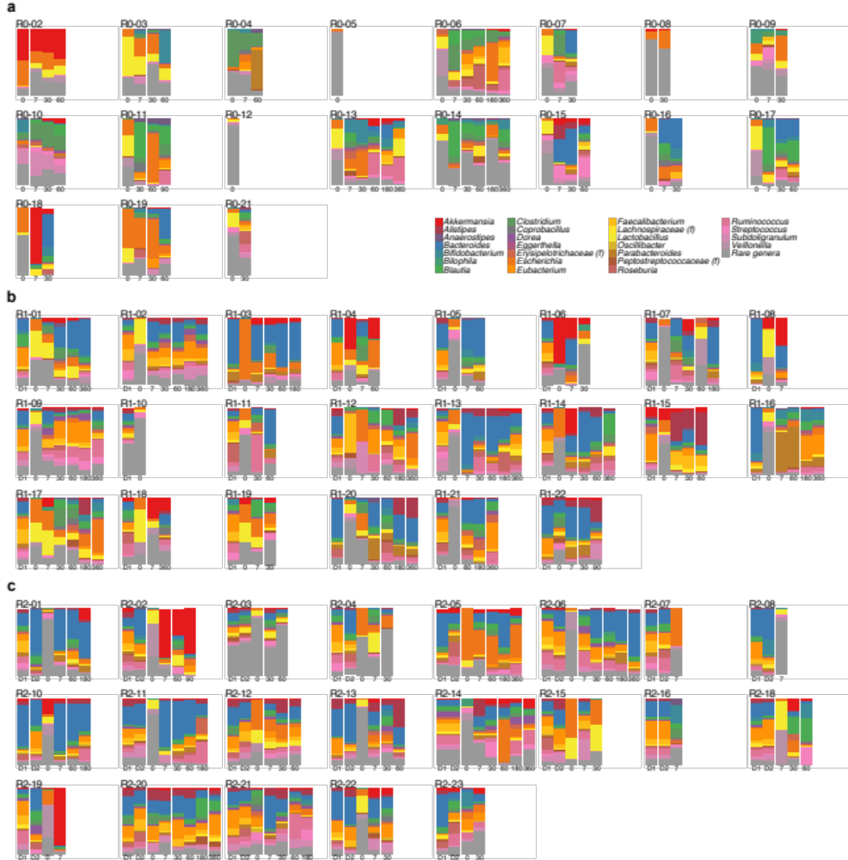
Figure S1. Taxonomic overview of patient stool samples at the genus level. Genus composition of RBX2660 products was added to the corresponding recipient. a Patients who received 2 doses of placebo. b Patients who received 1 dose RBX2660 and 1 dose of placebo. c Patients who received 2 doses of RBX2660. Patients R0-01, R0-20, and R2-09, who had only the baseline specimen (due to early rCDI) that exhibited insufficient sequencing depth for the analysis of taxonomic structure after decontamination of human reads, were omitted. Patient R2-17 was also omitted from this analysis due to incomplete donor RBX2660 information.

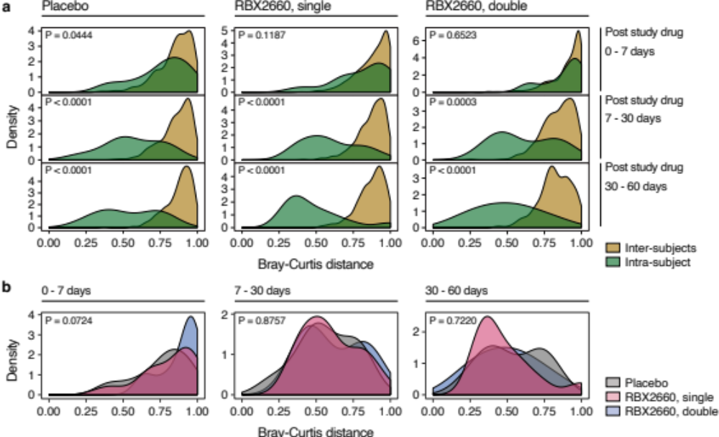
Figure S2. Taxonomic shift by treatments (related Fig. 2). a Distribution of inter-subjects Bray-Curtis dissimilarities (yellow) and intra-subject dissimilarities (green) regarding taxonomic structures by treatment groups (column) and by time frames (rows). The similar distribution of inter-subjects and intra-subject dissimilarities during the first week in all conditions suggests significant taxonomic shifts in early stage regardless of the dose of RBX2660. Wilcoxon rank sum tests were performed to compare inter-subjects and intra-subject dissimilarities of each treatment group during each time frame. b Comparison of intra-subject dissimilarities of placebo (grey), single (red), and double RBX2660 recipients (blue) during each time frame with Kruskal-Wallis rank sum tests.

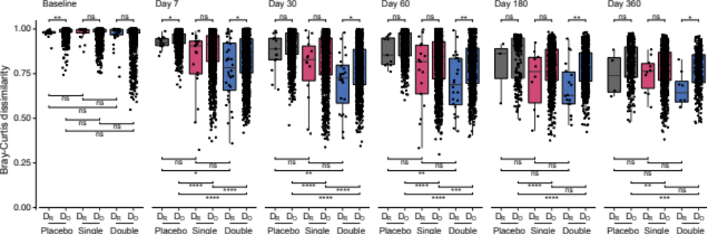
Figure S3. Bray-Curtis dissimilarities between patients and respective RBX2660 (D_{R}) or other random RBX2660 (D_{O}). Pairwise comparisons of all D_{R}s and D_{O}s of placebo (gray), single dose (red), and double dose recipients (blue) in each time point were simultaneously performed (Wilcoxon signed-rank test with Benjamini-Hochberg FDR correction, FDR < 0.05). Dissimilarities of double dose recipients include both dissimilarities to the first and second RBX2660 doses. *P ≤ 0.05, **P ≤ 0.01, ***P ≤ 0.001, ****P ≤ 0.0001.

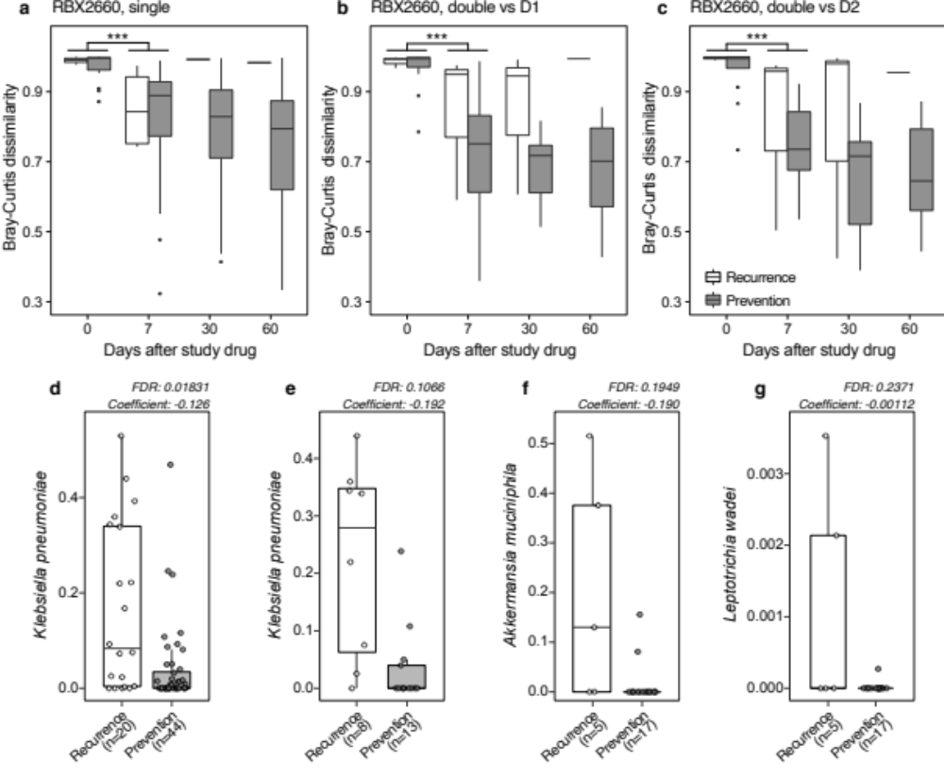
Figure S4. Changes in the Bray-Curtis dissimilarities between a patient and corresponding donor after a single RBX2660 and b-c double RBX2660 treatments. Changes in taxonomic structures of gut microbiota were significant for the first week after treatments (Kruskal-Wallis test, ***P < 0.001). There were no statistically significant differences between patients who experienced recurrent Clostridioides difficile infection (rCDI, white) and other successful patients (gray) at all time points (Wilcoxon signed-rank test with Benjamini-Hochberg FDR correction, FDR < 0.05). D1, the first dose; D2, the second dose. d Relative abundance of Klebsiella pneumoniae in all patients. Patients who experienced rCDI (white) exhibited significantly higher K. pneumoniae abundance than treatment-success patients (gray). e Relative abundance comparison of K. pneumoniae between treatment-failture and -success patients in placebo recipients. Relative abundance comparison of d Akkermansia muciniphila and e Leptotrichia wadei that were identified by MaAsLin2 as features associated with treatment-failures of single RBX2660 dose recipients. MaAsLin2 could not identify any taxonomic feature associated with treatment outcome from double RBX2660 recipients.

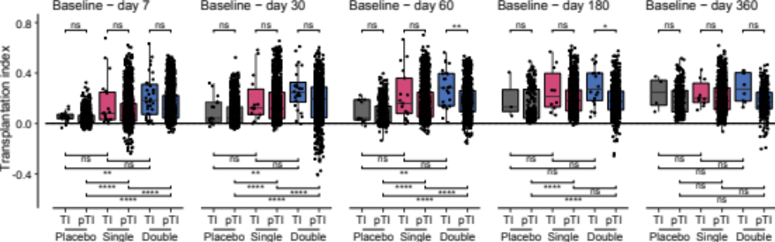
Figure S5. Transplantation indices (TIs) and pseudo transplantation indices (pTIs). Pairwise comparisons of all TIs and pTIs of placebo (gray), single dose (red), and double dose recipients (blue) in each time frame were simultaneously performed (Wilcoxon signed-rank test with Benjamini-Hochberg FDR correction, FDR < 0.05). Indices of double dose recipients include both indices for the first and second RBX2660 doses. *P ≤ 0.05, **P ≤ 0.01, ***P ≤ 0.001, ****P ≤ 0.0001.

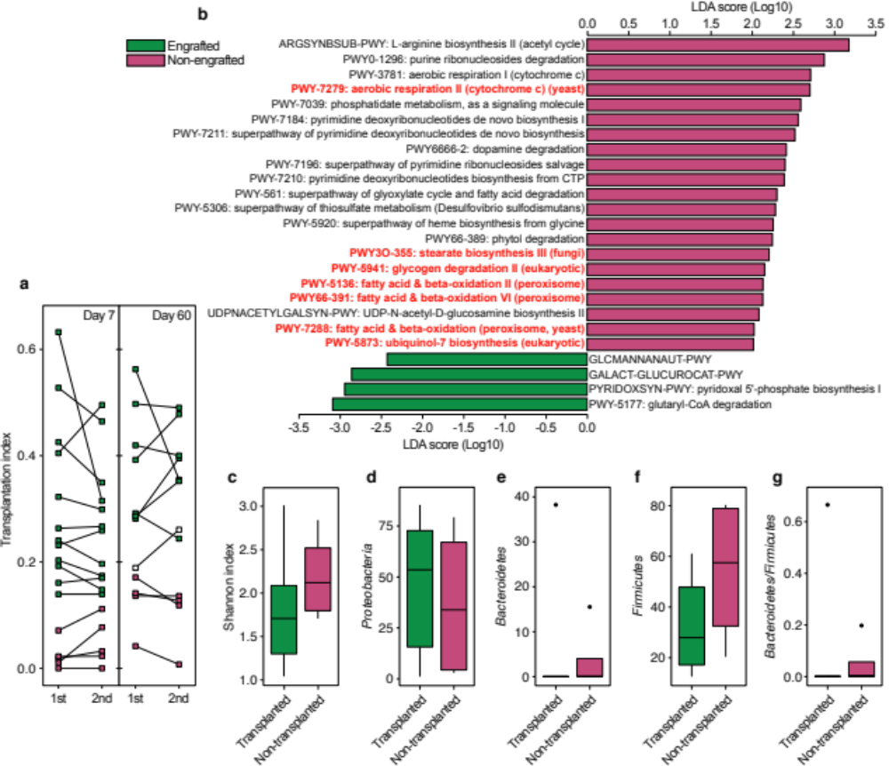
Figure S6. Additional discriminative features of the obstinate patients (related Fig. 3). a Comparison of transplantation indices of double RBX2660 recipients for the first and the second RBX2660 at day 7 and day 60. R2-21 exhibited lower engraftment index for the first dose but higher engraftment index for the second dose of RBX2660 than placebo patients at day 60 (white square). b Metabolic pathway features of the double RBX2660 recipients whose taxonomic structures were engrafted and maintained until day 60 (green) and other non-engrafted patients (purple). Yeast-specific metabolic pathways were marked in red. GLCMANNANAUT-PWY, superpathway of N-acetylglucosamine, N-acetylmannosamine and N-acetylneuraminate degradation; GALACT-GLUCUROCAT-PWY, superpathway of hexuronide and hexuronate degradation. At baseline, c Shannon index (Wilcoxon signed-rank test, P = 0.41), d Proteobacteria (P = 0.79), e Bacteroidetes (P = 0.92), f Firmicutes (P = 0.32), and g the ratio between Bacteroidetes and Firmicutes (P = 0.92) were not significantly different between the engrafted and non-engrafted double RBX2660 recipients.

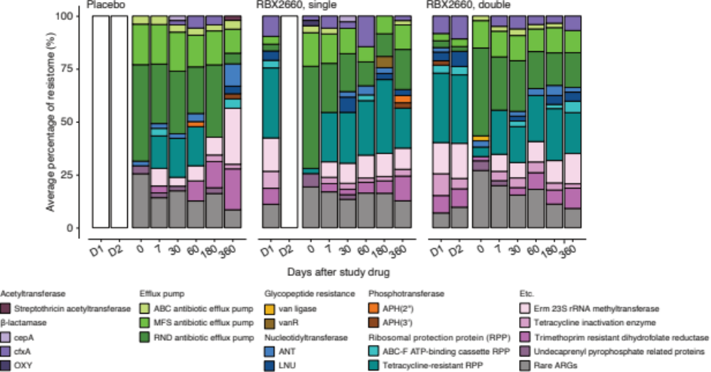Figure S7. Comparison of resistome compositions. Individual loads of an antibiotic resistant gene (ARG) in a treatment arm were averaged. ARGs whose average portion in the treatment arm was smaller than 2% were combined as “Rare ARGs.”
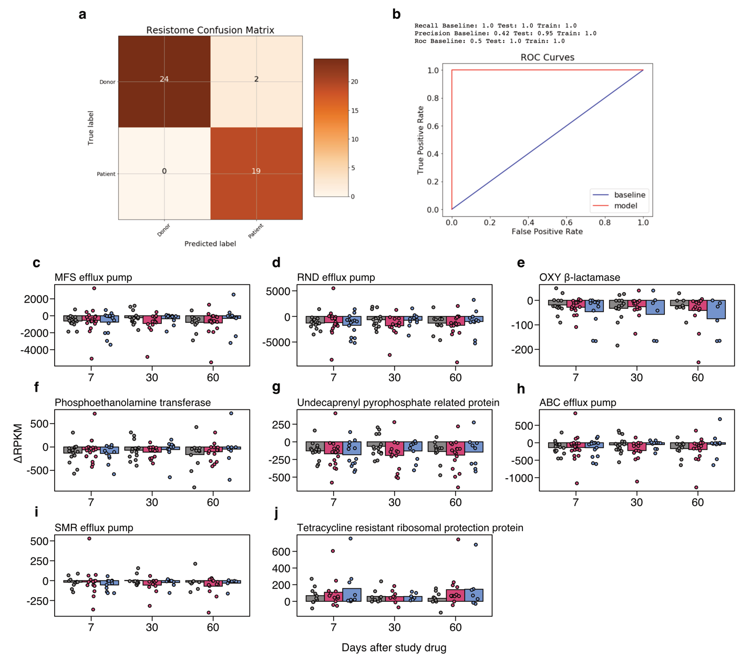
Figure S8. Random forest classifier successfully distinguished between donor and patient baseline resistomes (related Fig. 5). a Resistome confusion matrix depicting predicted and true labels for the test set (n = 45). All but 2 samples were correctly categorized. b A receiver operating characteristic (ROC) curve showed high recall, precision, and area under curve (AUC) for the model. c–j Individual changes in abundance (reads per kilobase per million sample reads, RPKM) of selected antibiotic resistant genes from baseline were similar among patients in the three treatment groups. Individual changes of the two RBX2660-origin beta-lactamases, whose baseline abundances were near-zero, were described in Fig. 5i and 5j.

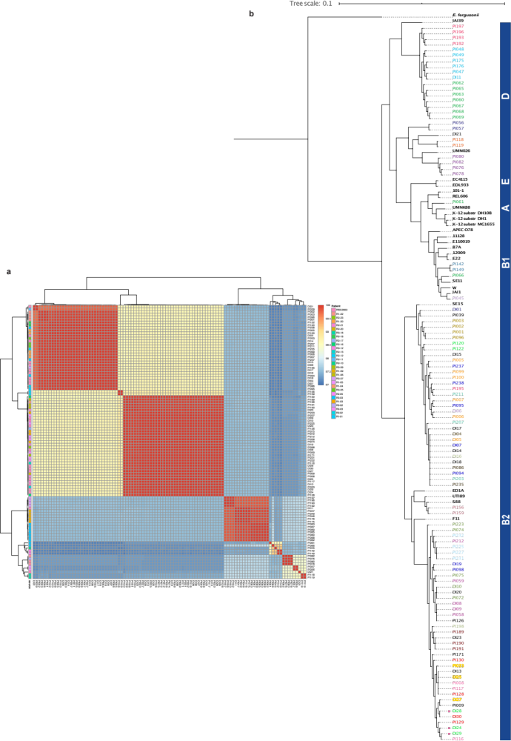
Figure S9. Average nucleotide identity (ANI) and core genome phylogeny of E. coli isolates. a ANI for all E. coli isolates pairwise comparisons. All isolates show at least 97% pairwise identity. b Core genome phylogeny of E. coli isolates with 24 NCBI reference strains and E. fergusonii as outgroup. Right panel indicates E. coli phylogroup. Isolates originated from the same patient or donor were labelled in the same color. Reference strains were marked in black and bold. Small colored squares indicate isolates from donor product that was administered to multiple patients, where the color of the text and squares correspond to the different patients.

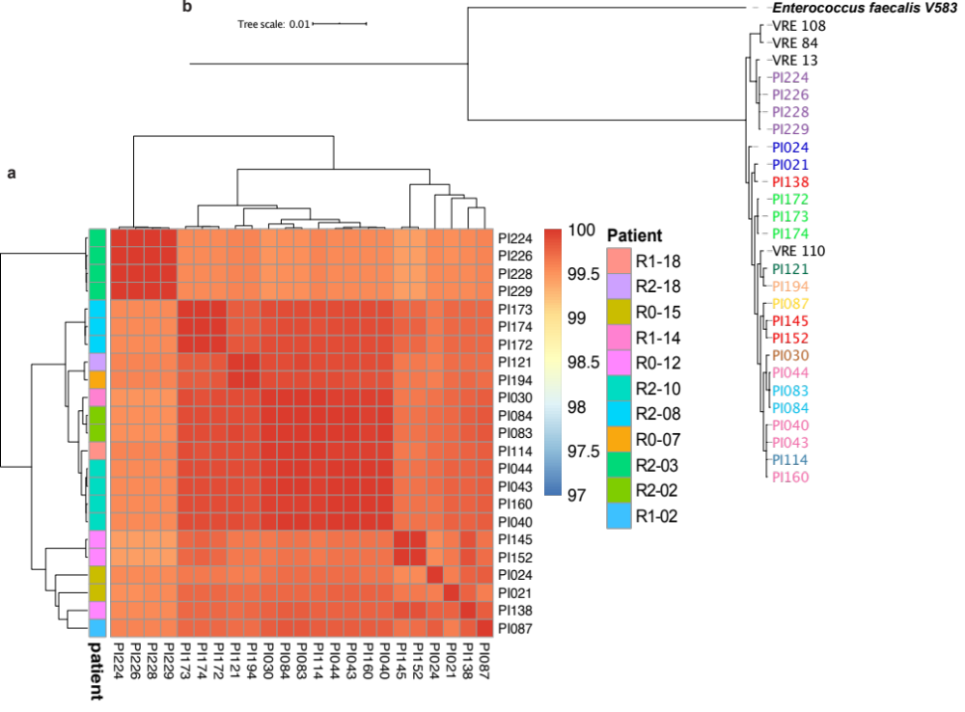
Figure S10. Average nucleotide identity (ANI) and core genome phylogeny of VRE isolates. a ANI for all VRE isolates pairwise comparisons. All isolates show at least 99.43% pairwise identity. b Core genome phylogeny of VRE isolates, with 4 NCBI reference VRE strains and V583 Enterococcus faecalis as outgroup. Isolates originated from the same patient were labelled in the same color. Reference strain names were marked in black.
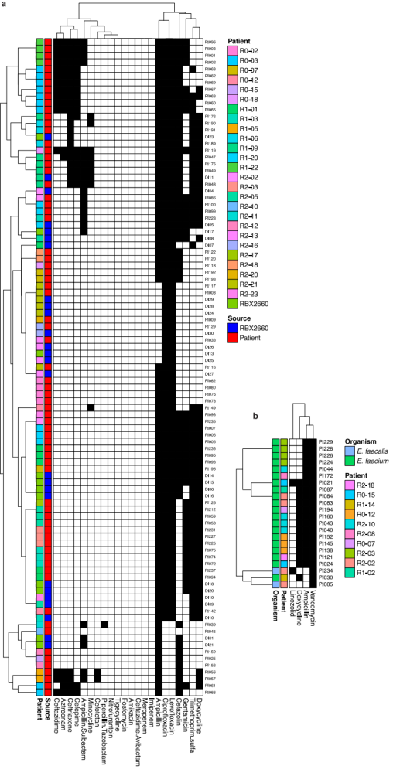
Figure S11. Antibiotic susceptibility testing (AST). a E. coli and b VRE isolates. AST showed whether isolates are susceptible (white) or intermediate/resistant (black) to a variety of antibiotics. Source of isolate and specific patient of origin were depicted in the sidebars. RBX2660-derived antibiotic resistant organisms engrafted in patients were colored as their corresponding patient. RBX2660 samples without a corresponding patient are otherwise denoted as “RBX2660.”

