Extended data figures and tables

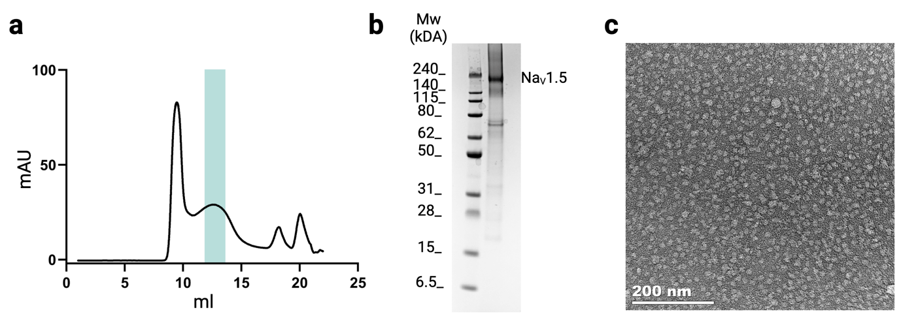
Extended Data Fig. 1. Purification of hNa_{v}1.5 and negative stain microscopy. a, Size exclusion profile (Superose 6 increase 10/300 gl column) of hNa_{v}1.5 shows the peak fractions (green) used for cryo-EM studies. b, SDS-PAGE analysis of hNa_{v}1.5 (~220 kDa). c, Representative negative stain micrograph. Scale bar: 200 nm.

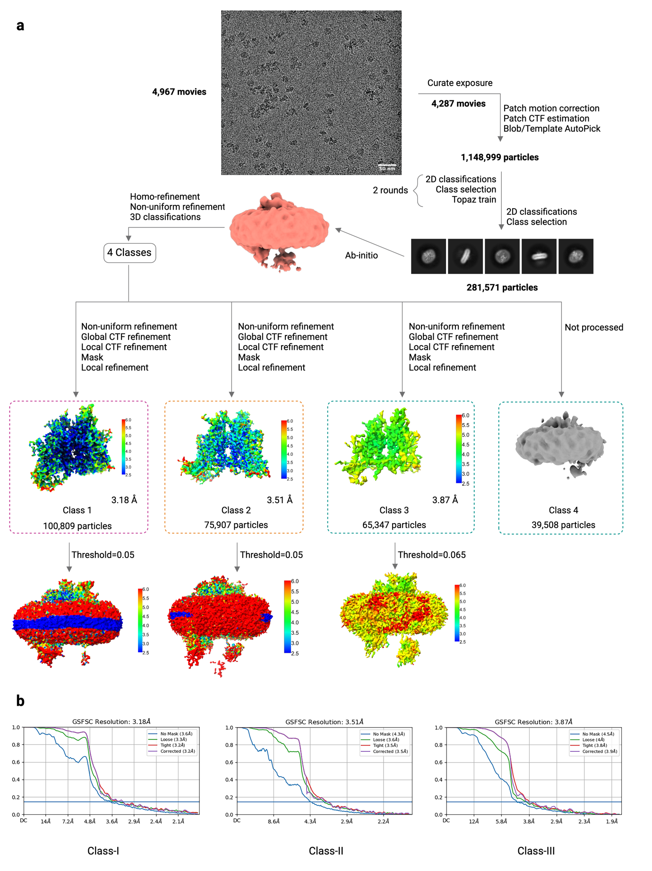
Extended Data Fig. 2. Cryo-EM data processing for hNa_{v}1.5. a, Cryo-EM data processing workflow that led to the density map of three distinct classes (Materials and Methods). b, FSCs of Class-I (3.18 Å at FSC=0.143), Class-II (3.51 Å at FSC=0.143), and Class-III (3.87 Å at FSC=0.143).

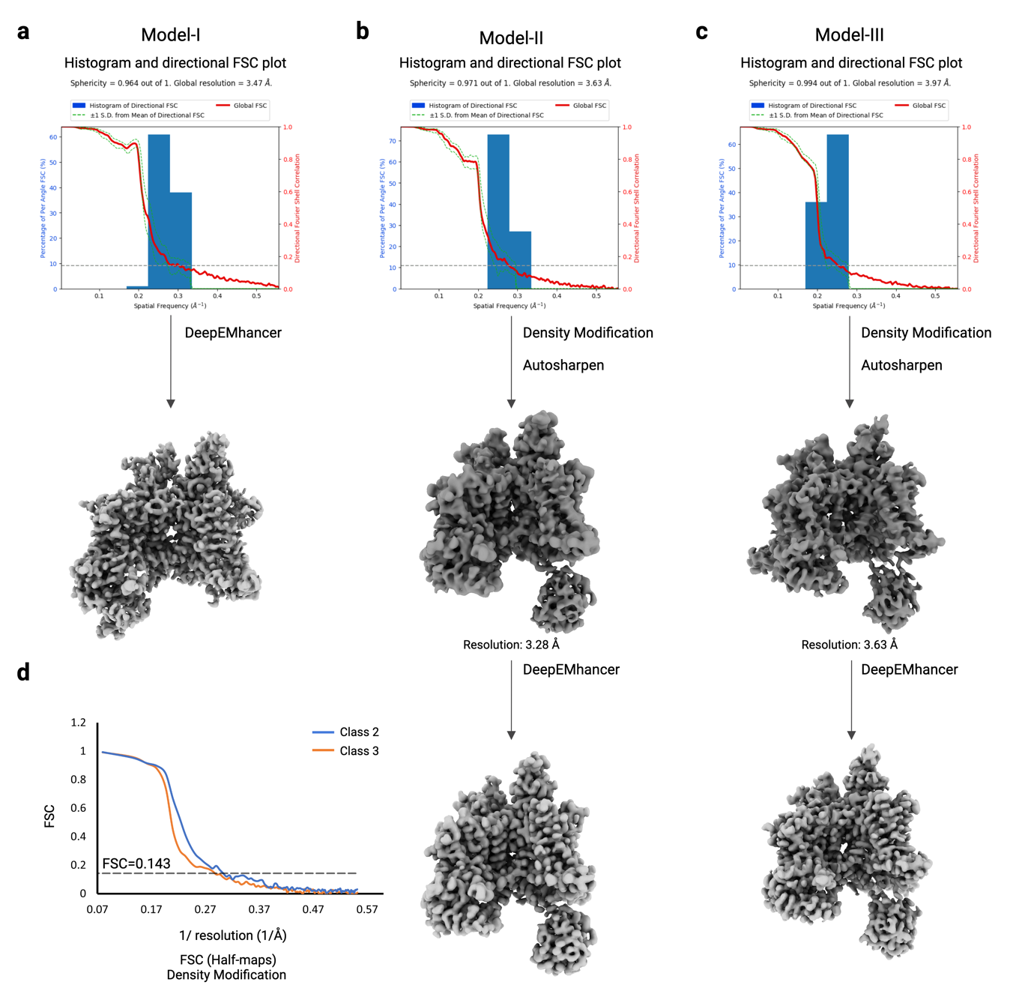
Extended Data Fig. 3. Postprocessing and structure validation. a, 3D Fourier shell correlation calculated using the 3D-FSC server. The map of Class-I has a sphericity value of 0.964 and a global resolution of 3.47 Å. The map was postprocessed by DeepEMhancer. b, The map of Class-II has a sphericity value of 0.971 and a global resolution of 3.63 Å. c, The map of Class-III has a sphericity value of 0.994 and a global resolution of 3.97 Å. d, Postprocessing improved the map resolutions of Class-II and Class-II to 3.28 Å and 3.63 Å, respectively.

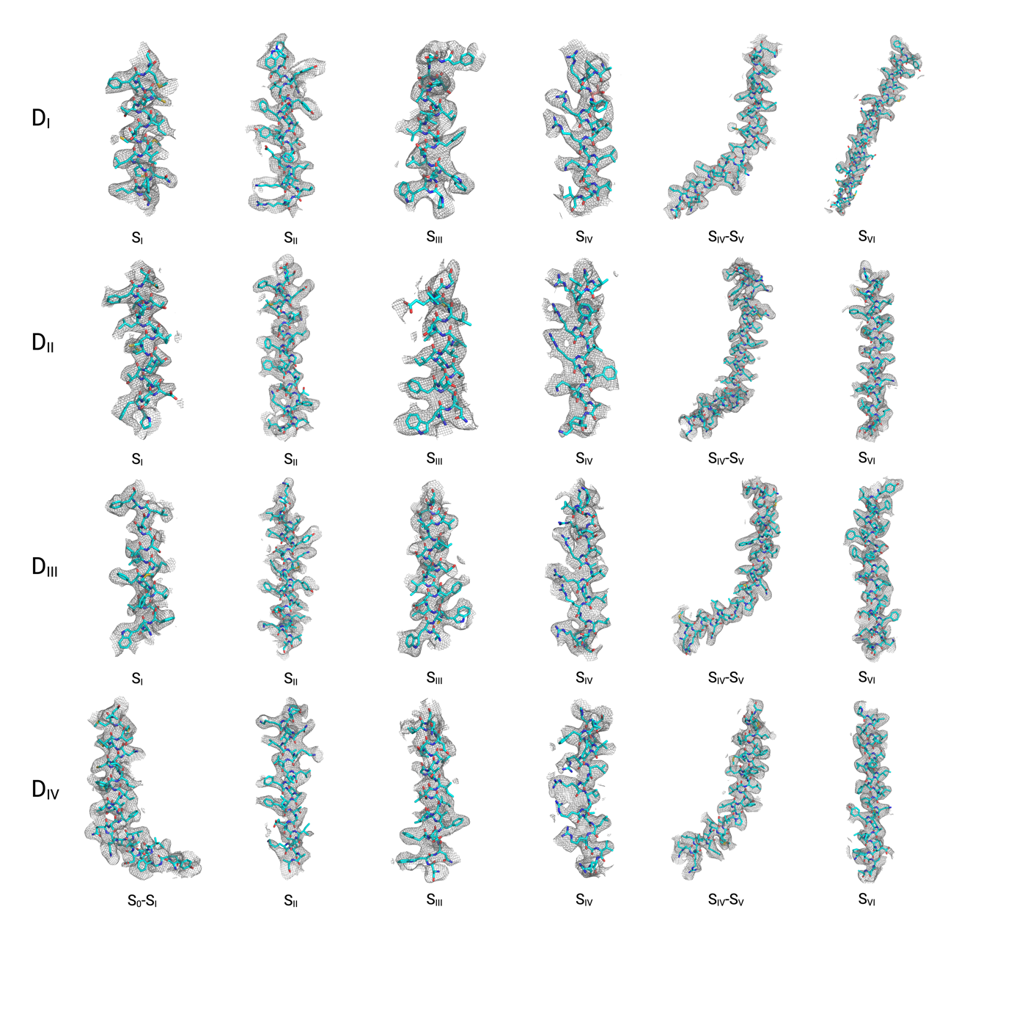
Extended Data Fig. 4. Representative cryo-EM densities and corresponding models in Model-I. The cryo-EM density (mesh representation) of all segments in the VSD and PD of D_{I}, D_{II}, D_{III}, and D_{IV} are shown. Main chain and side chains of the residues are shown in stick representation.

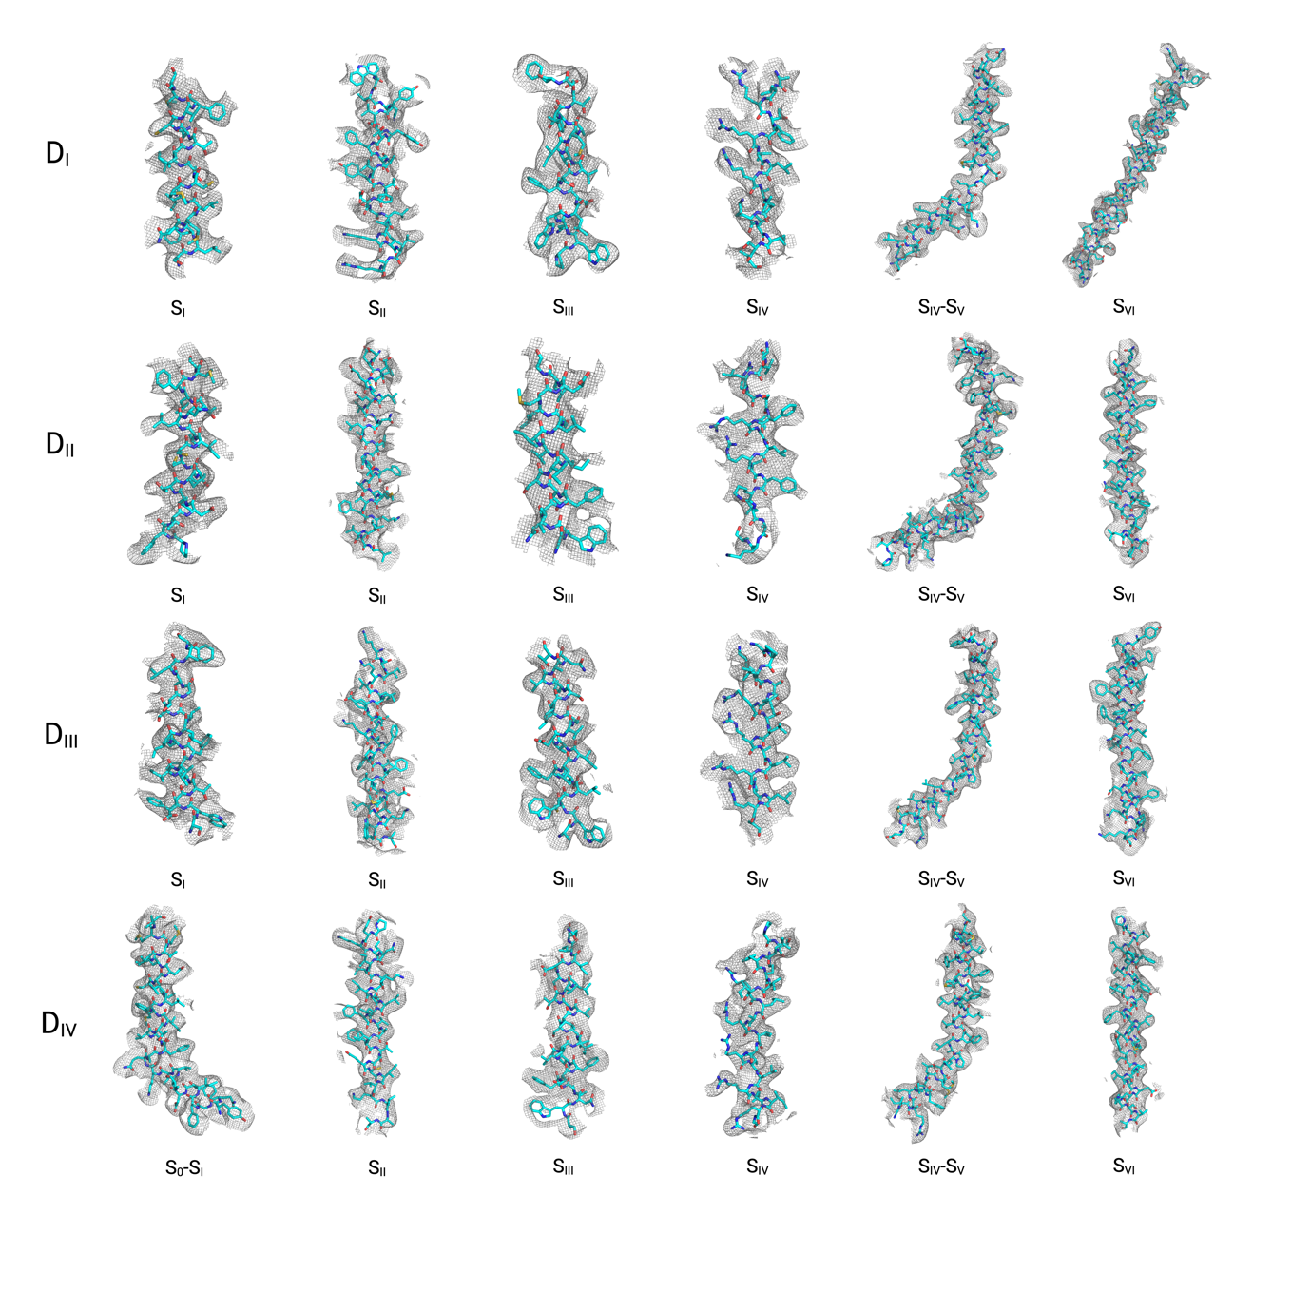
Extended Data Fig. 5. Representative cryo-EM densities and corresponding models in Model-II. The cryo-EM density (mesh representation) of all segments in the VSD and PD of D_{I}, D_{II}, D_{III}, and D_{IV} are shown. Main chain and side chains of the residues are shown in stick representation.

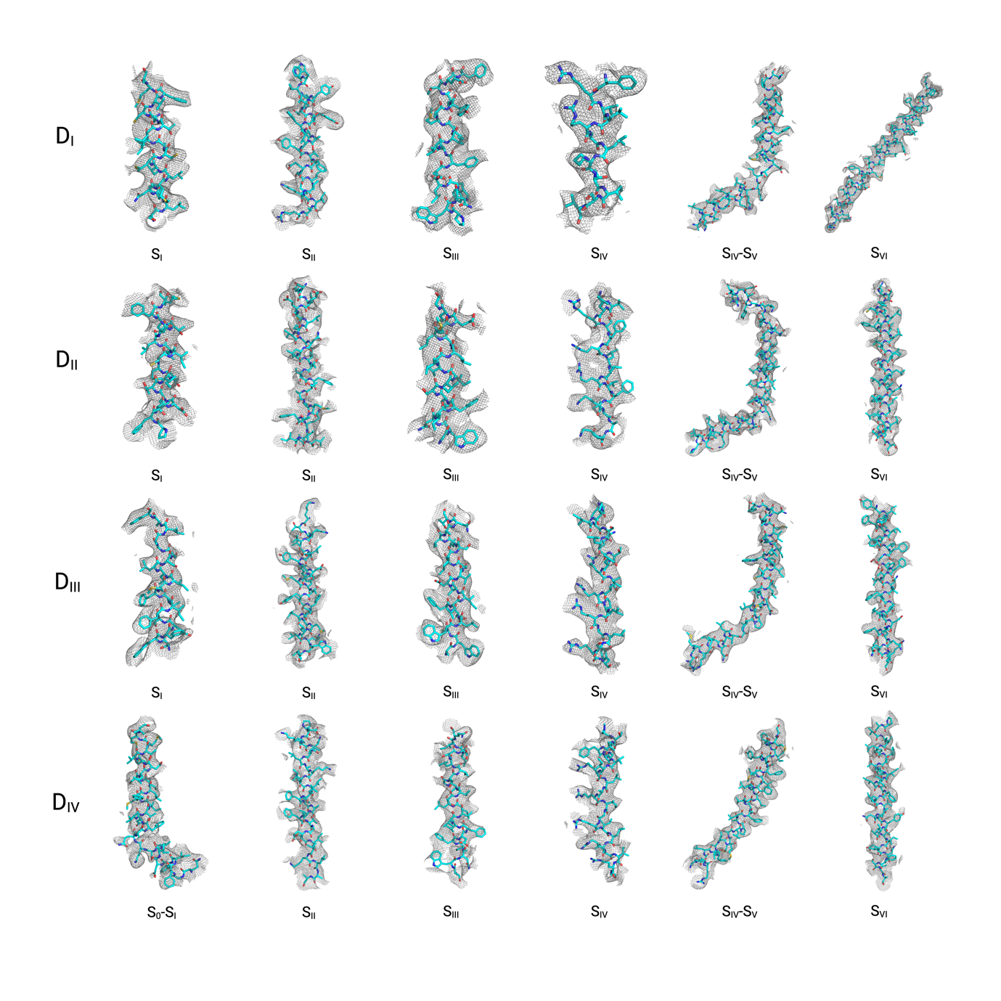
Extended Data Fig. 6. Representative cryo-EM densities and corresponding models in Model-III. The cryo-EM density (mesh representation) of all segments in the VSD and PD of D_{I}, D_{II}, D_{III}, and D_{IV} are shown. Main chain and side chains of the residues are shown in stick representation.

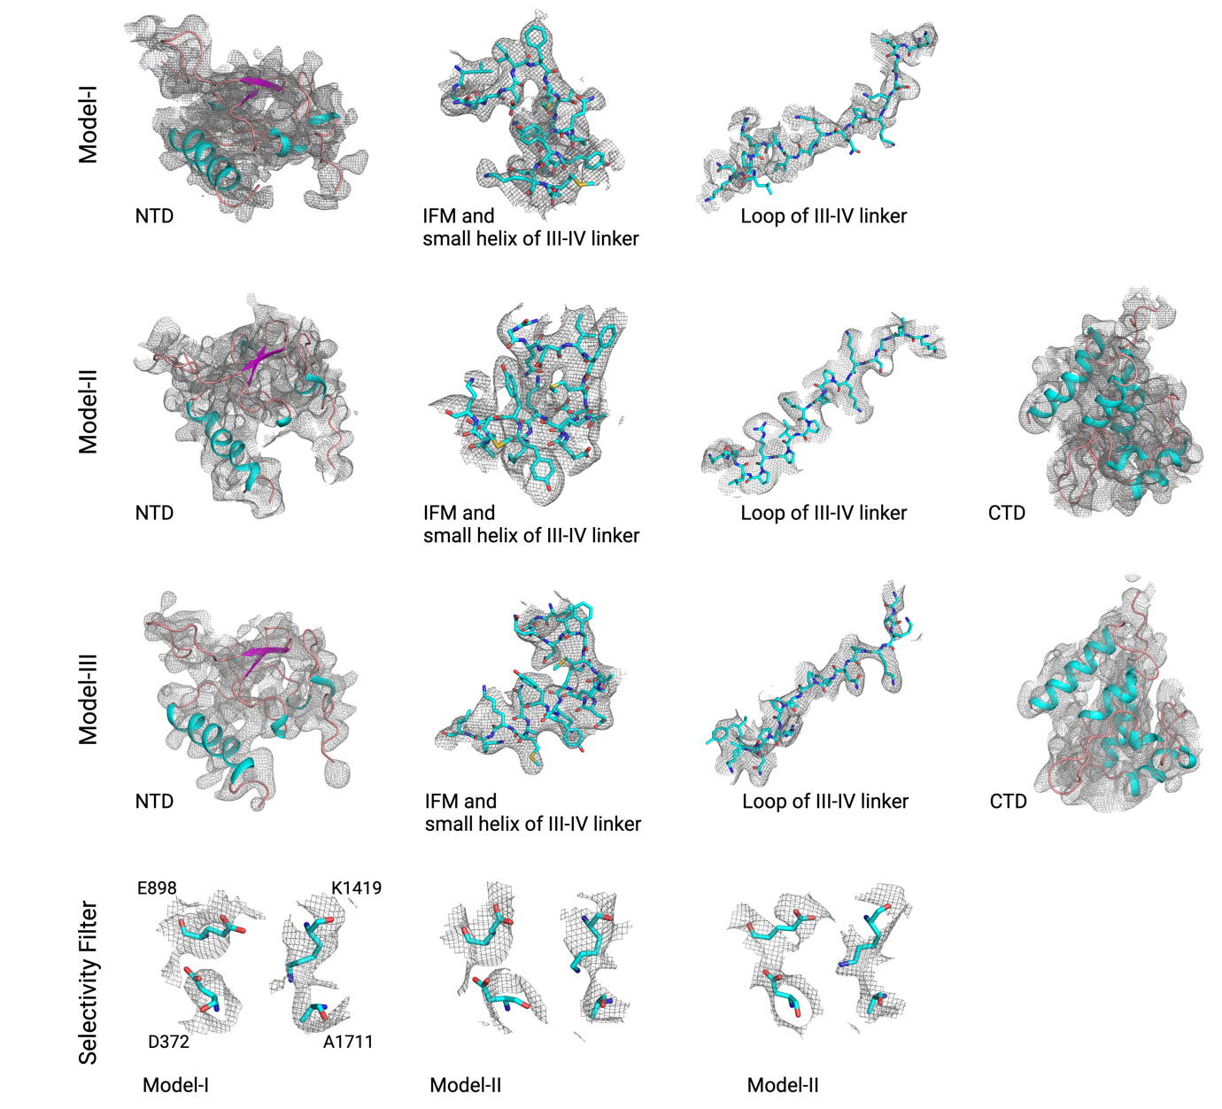
Extended Data Fig. 7. Representative cryo-EM densities and corresponding models of Model-I, Model-II and Model-III. The cryo-EM density (mesh representation) for NTD, IFM motif, III-IV linker, CTD, and selectivity filters. Main chain of NTD and CTD are shown in cartoon representation. The main chain and side chains of residues of the IFM motif and III-IV linker are shown in stick representation. The side chains of the residues of the selectivity filter are shown in stick representation.

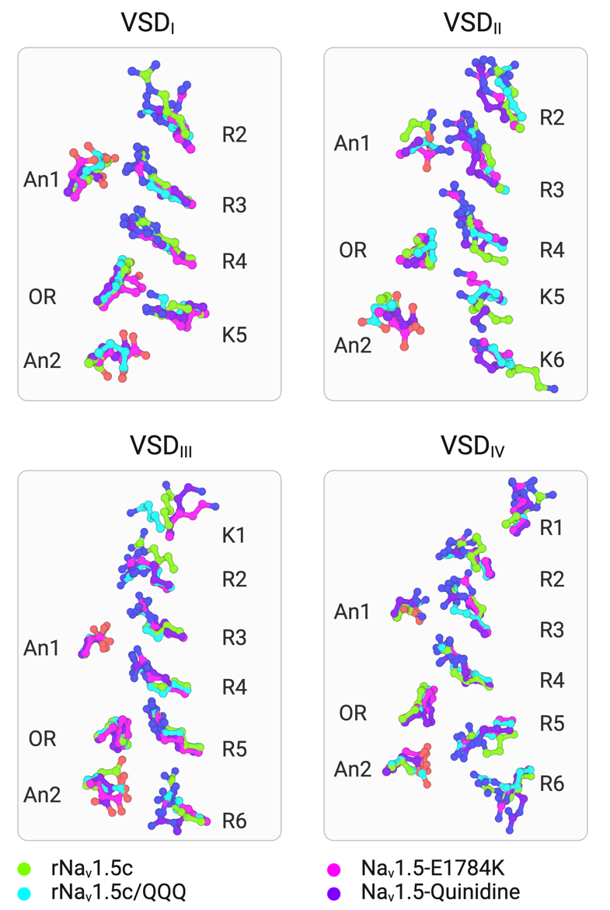

Extended Data Fig. 8. Structural alignment of Gating Charges (GCs) residues of VSDs. The sidechain of GCs in rNa_{v}1.5c (PDB ID: 6UZ3; green), rNa_{v}1.5c/QQQ (PDB ID: 7FBS; cyan), Na_{v}1.5-E1784K (PDB ID: 7DTC; magenta), Na_{v}1.5-Quinidine (PDB ID: 6LQA; purple) are shown in stick representation.

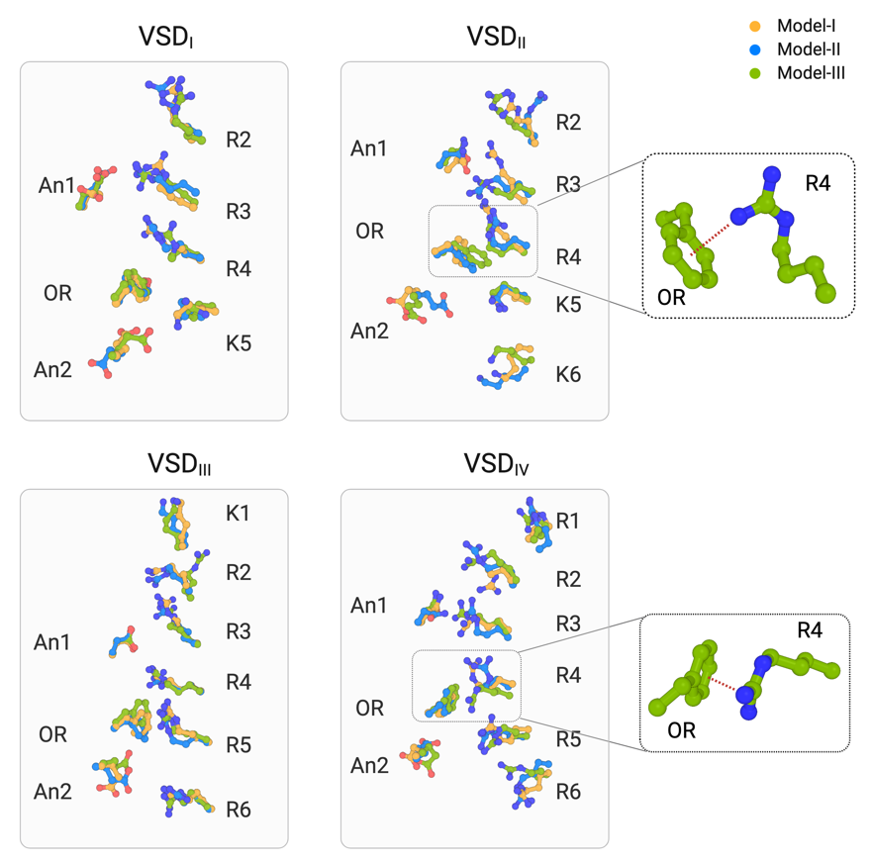

Extended Data Fig. 9. Structural alignment of gating charge (GC) residues. Comparative analysis of the conformation of GC residues of individual VSDs between Models-I, -II and -III. The π-cation interactions between R4 and OR in VSD_{II} and VSD_{IV} of Model-III are shown in the inset.

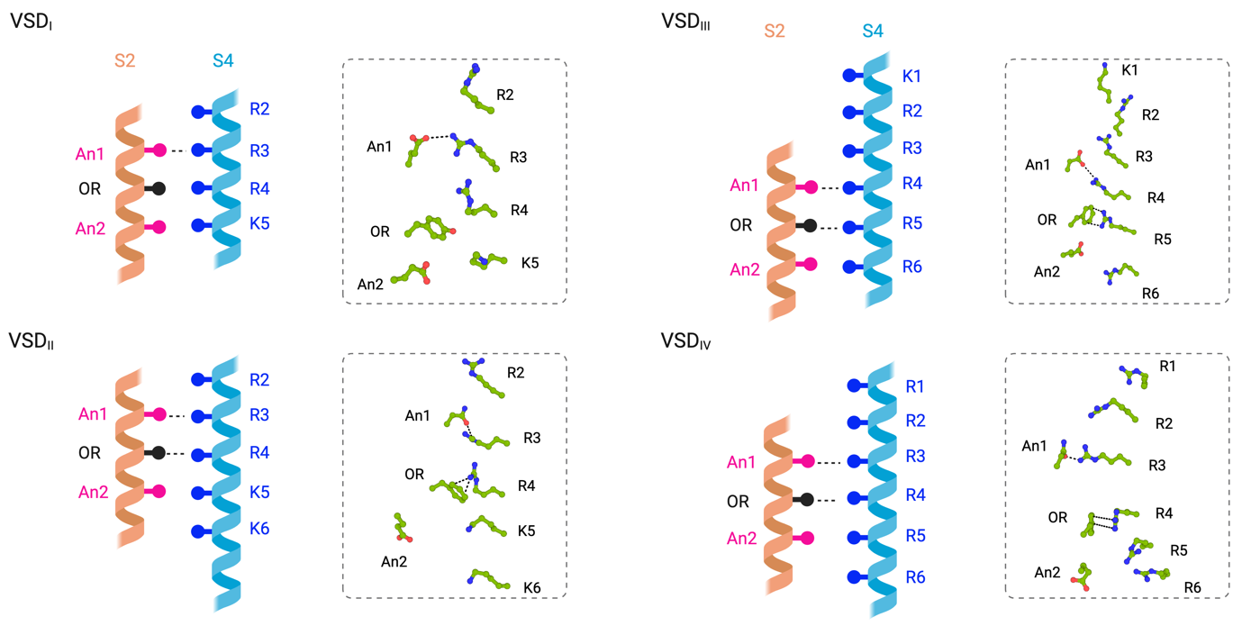

Extended Data Fig. 10. Schematic representation of GC residues of each VSD of Model-III. GC residues are shown with side chains as sticks. The salt-bridge and π-cation interactions are represented with a black dashed line.

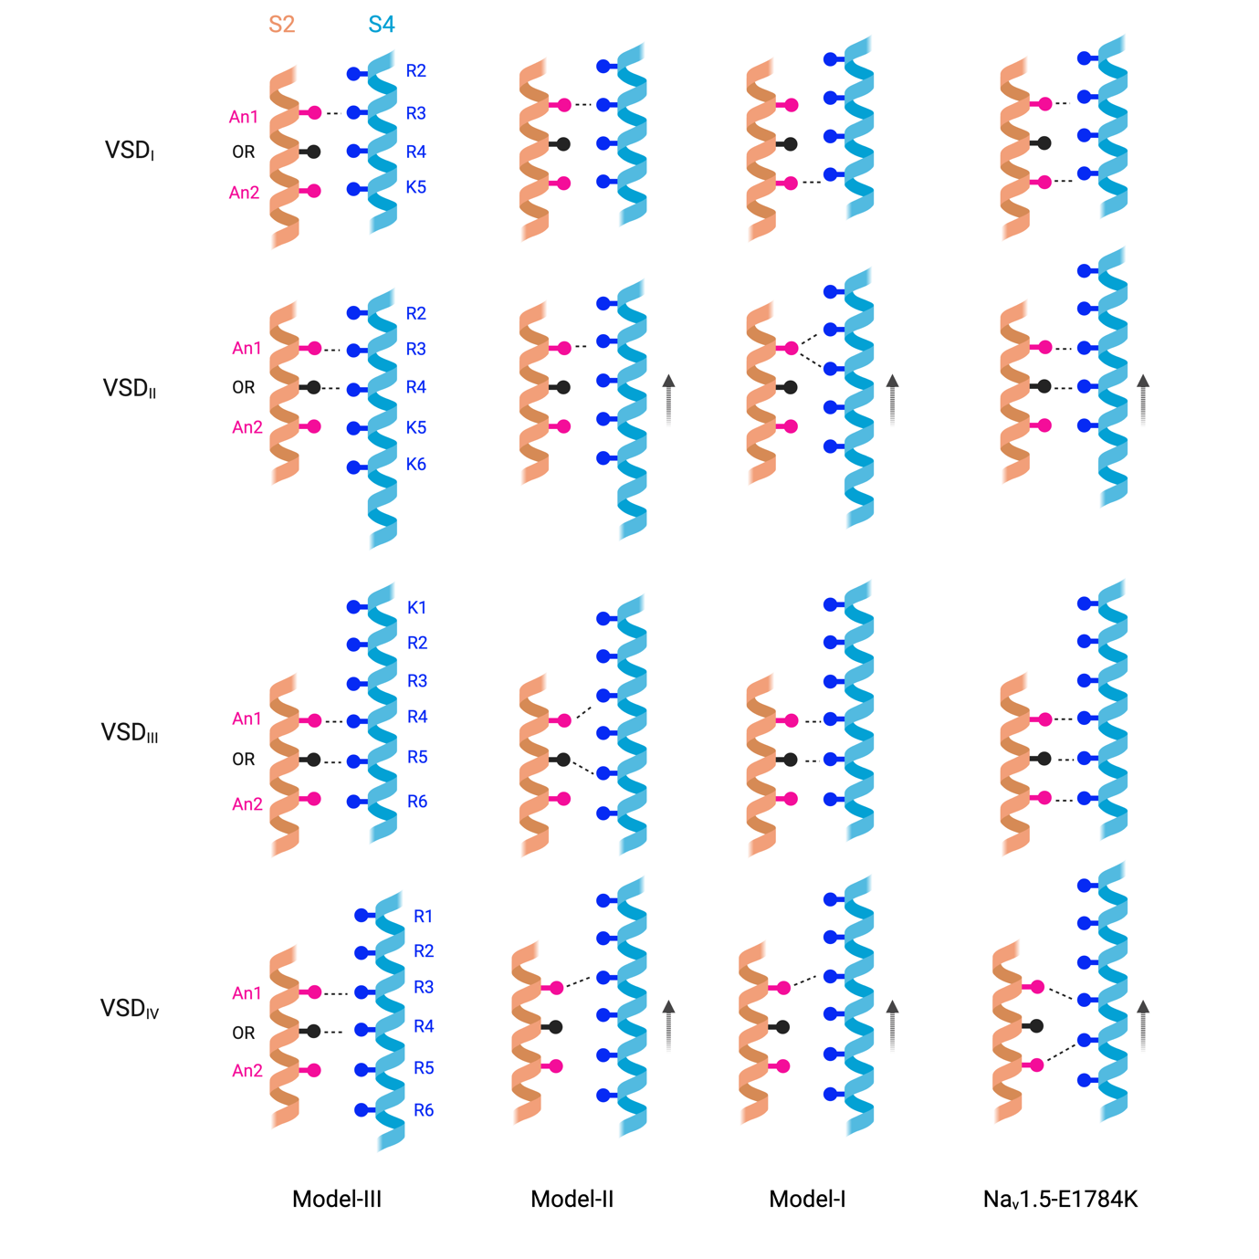

Extended Data Fig. 11. Schematic representation of GC conformational changes and movement. The GCs of VSD_{II} and VSD_{IV} are displaced upward in the order of Model-III > Model-II > Model-I > Na_{v}1.5-E1784K. Rearranged salt-bridge and p-cation interactions are represented with a black dashed line.
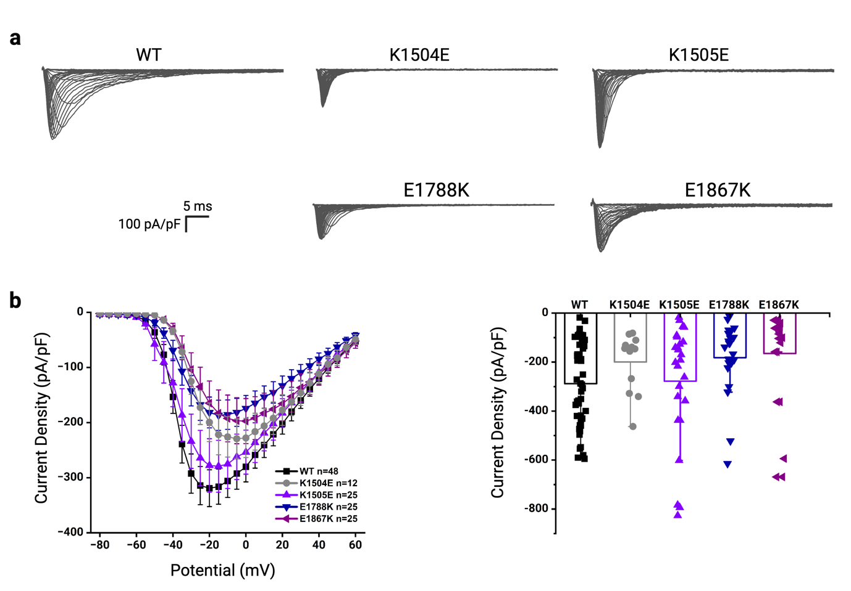
Extended Data Fig. 12. Current-Voltage relationships of III-IV linker and CTD mutants. a, Representative current traces of Na_{v} 1.5-WT, Na_{v} 1.5-K1504E, Na_{v} 1.5-K1505E, Na_{v} 1.5-E1788K, and Na_{v} 1.5-E1867K. b, I-V relationship (left) and dot chart of current densities (right) for all four mutants and wild type. No significant changes in current densities were observed.

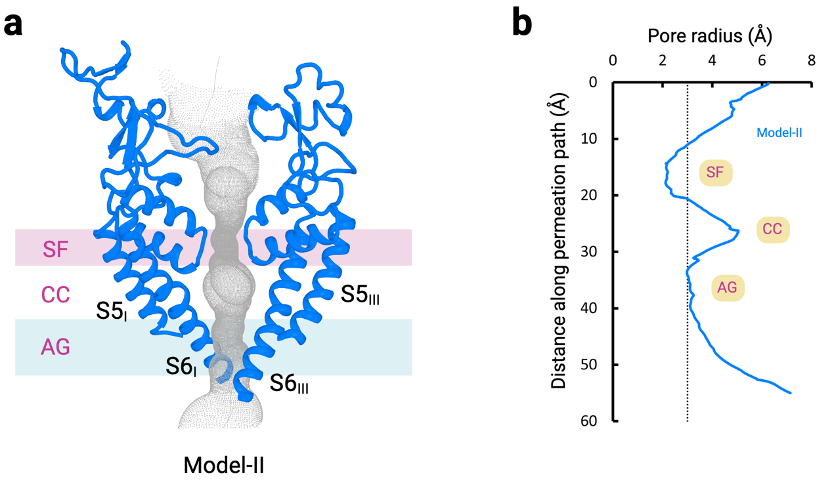
Extended Data Fig. 13. Permeation path of Model-II. a, The permeation path in Model-II is illustrated as grey dots. SF: selectivity filter, CC: central cavity, and AG: activation gate. b, Pore radius in Model-II. SF: selectivity filter, CC: central cavity, and AG: activation gate.

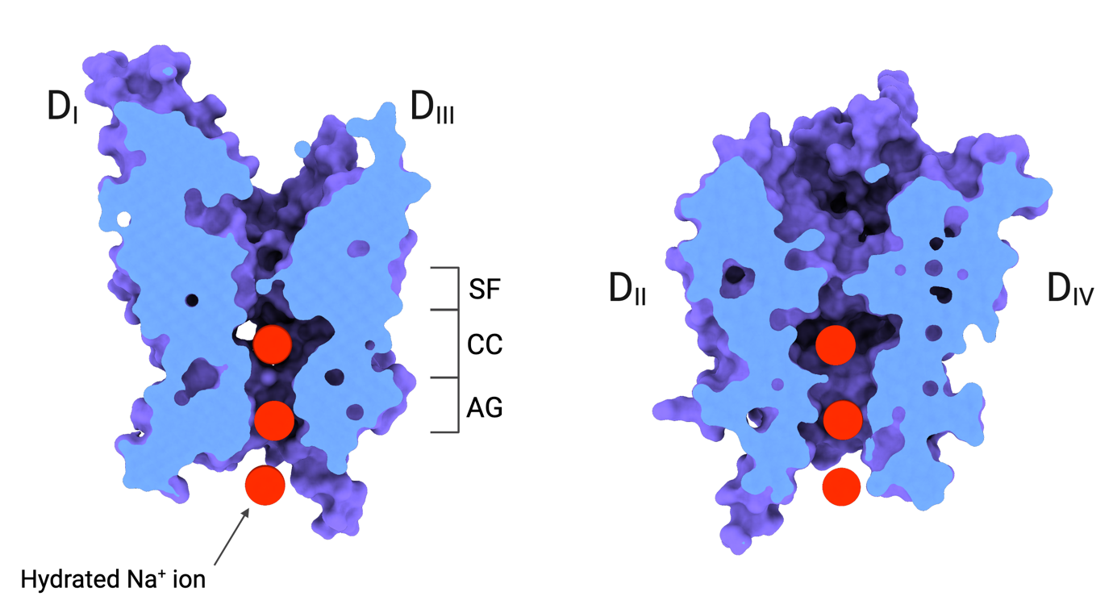

Extended Data Fig. 14. Hydrated Na⁺ inside the open activation gate. Surface representation and slice view of Model-I. A van der Waals space-filling model of hydrated Na⁺ ion (7.2 Å, red) is shown in the activation gate (AG). SF: selectivity filer, CC: central cavity, and AG: activation gate.

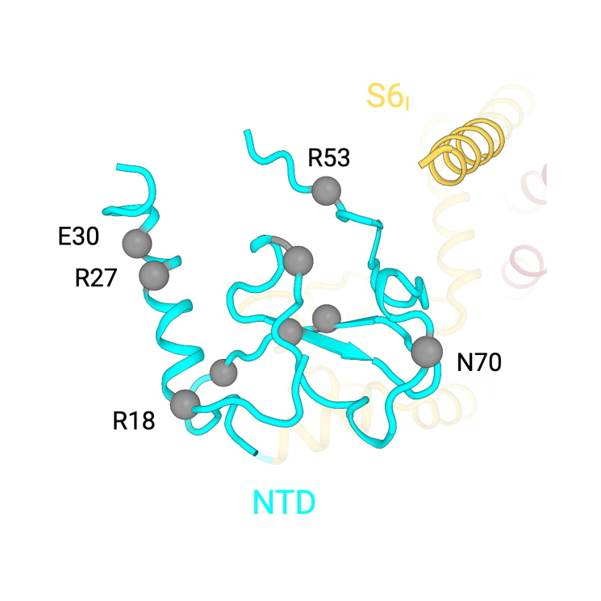

Extended Data Fig. 15. Location of BrS and LQT3-associated mutations in the NTD. Select BrS and LQT3-associated mutations in the NTD are shown as Cα spheres.

Extended Data Table 1. Cryo-EM data collection, refinement and validation statistics

 | Model-I  (EMDB-43661)  (PDB 8VYI) | Model-II (EMDB-43662)  (PDB 8VYJ) | Model-III  (EMDB-43663)  (PDB 8VYK)
Data collection and processing
Magnification | 81,000 | 81,000 | 81,000
Voltage (kV) | 300 | 300 | 300
Electron exposure (e–/Å²) | 60 | 60 | 60
Defocus range (μm) | –0.5 to –2.5 | –0.5 to –2.5 | –0.5 to –2.5
Pixel size (Å) | 0.899 | 0.899 | 0.899
Symmetry imposed | C1 | C1 | C1
Initial particle images (no.) | 1,148,999 | 1,148,999 | 1,148,999
Final particle images (no.) | 100,809 | 75,907 | 65,347
Map resolution (Å)  FSC threshold | 3.18  0.143 | 3.28  0.143 | 3.63  0.143
Map resolution range (Å) | 2.5~6.0 | 3.0~6.0 | 3.5~6.0
Refinement
Initial model used (PDB code) | AlphaFold2 | AlphaFold2 | AlphaFold2
Model resolution (Å)  FSC threshold | 3.9  0.5 | 4.1  0.5 | 4.6  0.5
Map sharpening B factor (Å²) | -80.6 | -47.6 | -58.9
Model composition  Non-hydrogen atoms  Protein residues  Ligands | 11249  1327  26 | 11715  1395  23 | 11715  1395  23
B factors (Å²)  Protein  Ligand | 163.87  127.95 | 228.01  142.63 | 155.11  116.27
R.m.s. deviations  Bond lengths (Å)  Bond angles (°) | 0.006  0.770 | 0.006  0.922 | 0.004  0.773
Validation  MolProbity score  Clashscore  Poor rotamers (%) | 2.20  8  2.65 | 2.42  11.71  2.68 | 2.10  7.99  1.95
Ramachandran plot  Favored (%)  Allowed (%)  Disallowed (%) | 93.92  5.62  0.46 | 91.2  8.51  0.29 | 93.01  6.56  0.43

Extended Data Table 2. Biophysical parameters of Nav1.5 mutants from electro-physiological recordings.

hNa_{v}1.5 | Conductance V_{1/2} (mV) | Steady-State Inactivation  V_{1/2} (mV) | Recovery from Inactivation  t (ms)
WT | -30.52±0.60 | -75.92±0.59 | 4.37±0.67
K1504E | -27.68±0.42* | -92.19±0.51* | 3.81±0.48
K1505E | -30.08±0.40 | -83.87±0.74* | 3.75±0.60
E1788K | -29.10±0.62 | -85.88±0.64* | 8.90±1.23*
E1867K | -24.66±0.78* | -98.30±0.42* | 2.96±0.31

p<0.05 compared to WT

Supplementary information

Supplementary Video 1
Structural insights into Model-III and comparison with Na_{v}1.5-E1784K.

Supplementary Video 2
Structural comparison of Model-II and Model-III.

Supplementary Video 3
Normal mode analysis of Model-II and Model-III.

