Supplementary material of
Association between regional monsoon onset in South Asia and Tibetan Plateau thermal forcing

Die Hu^{1, 2}, Anmin Duan^{1, 2,3*}, Ping Zhang^{1, 2}
¹State Key Laboratory of Numerical Modeling for Atmospheric Sciences and Geophysical Fluid Dynamics, Institute of Atmospheric Physics, Chinese Academy of Sciences, Beijing 100029, China
²College of Earth Science, University of Chinese Academy of Sciences, Beijing, 100049, China
³CAS Center for Excellence in Tibetan Plateau Earth Sciences, Chinese Academy of Sciences (CAS), Beijing 100101, China.
*Corresponding author. Email: amduan@lasg.iap.ac.cn

List of Table Captions
Table S1 Correlation coefficients (first and third row) and partial correlation coefficients (second and fourth row) during 1979–2016 between the monsoon onset date (over the AS and India, separately) and the SST index, including the IPO index (first column), Niño3.4 index (second column), and SID index (third column), in May, having removed the influence from the seesaw pattern of the diabatic heating over the TP (PC1) in May. Statistical significance is shown by superscript asterisks: * p < 0.1, ** p < 0.05 and *** p < 0.01.

List of Figure Captions
Fig. S1 Correlation patterns between SST and Indian summer monsoon onset from November of the previous year to May of the current year (a–g). Black dotted areas in (a–c) indicate statistical significance at or above the 95% confidence level
Fig. S2 Composite evolution of (a–c) meridionally averaged (5°–15 °N) OLR (shading, units: W m⁻²) and (d–f) zonally averaged (50º–90 ºE) temperature, vertically averaged over 500–200 hPa (shading, unit: K) for (a, d) PC > 0. 5 standard deviation years, (b, e) PC < −0.5 standard deviation years and (c, d) the climatological mean. The green curves in (a–c) indicate the 14280 geopotential height at 20ºN, and in (d–f) denote the maximum ridge line. The light pink line denotes 20 ºN

Fig. S3 Composite seesaw pattern of diabatic heating index over the TP from the leading 6th pentad to the onset date of the monsoon over India (upper panel) and the AS (lower panel). The small and large dots indicate that these results reached statistical significance at the 85% and 90% confidence level, respectively. The blue, red and black curves indicate advanced years, delayed years and their differences, respectively (units: W m⁻²). The seesaw pattern of diabatic heating index over the TP is defined as the difference between the diabatic heating averaged over the southeastern TP (25°–30°N, 80°–105°E) and over the northwestern TP (32°–40°N, 70°–85°E).

Table S1 Correlation coefficients (first and third row) and partial correlation coefficients (second and fourth row) during 1979–2016 between the monsoon onset date (over the AS and India, separately) and the SST index, including the IPO index (first column), Niño3.4 index (second column), and SID index (third column), in May, having removed the influence from the seesaw pattern of the diabatic heating over the TP (PC1) in May. Statistical significance is shown by superscript asterisks: * p < 0.1, ** p < 0.05 and *** p < 0.01.
 | IPO | Niño 3.4 | SID
Arabian Sea | 0.41** | 0.41** | −0.03
Arabian Sea (no PC1) | 0.12 | 0.11 | −0.03
India | 0.27* | 0.32** | −0.13
India (no PC1) | −0.01 | 0.06 | −0.14

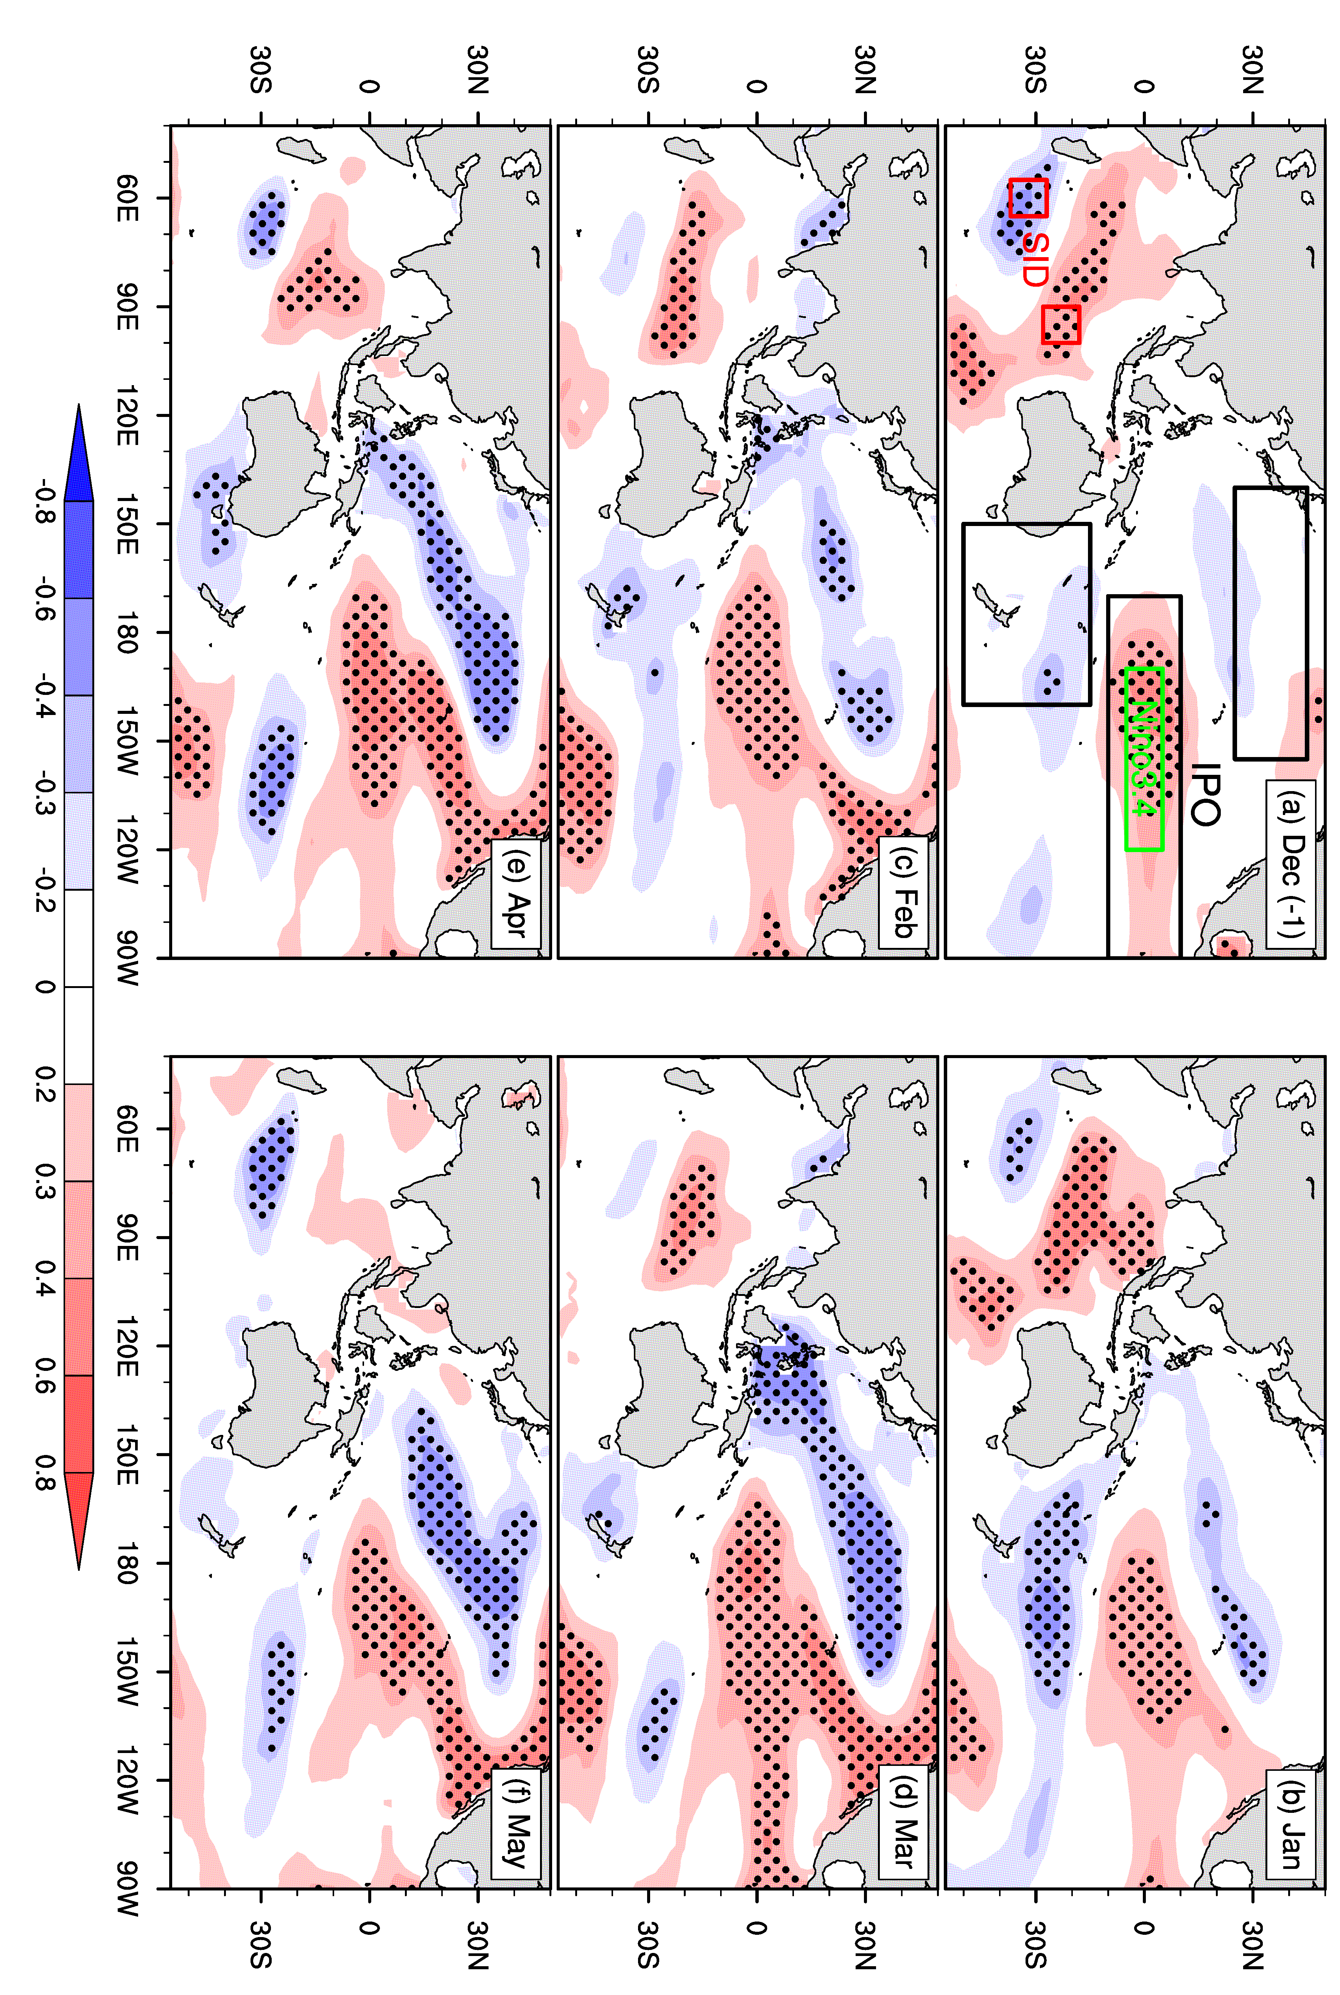
Fig. S1 Correlation patterns between SST and Indian summer monsoon onset from November of the previous year to May of the current year (a–g). Black dotted areas in (a–c) indicate statistical significance at or above the 95% confidence level

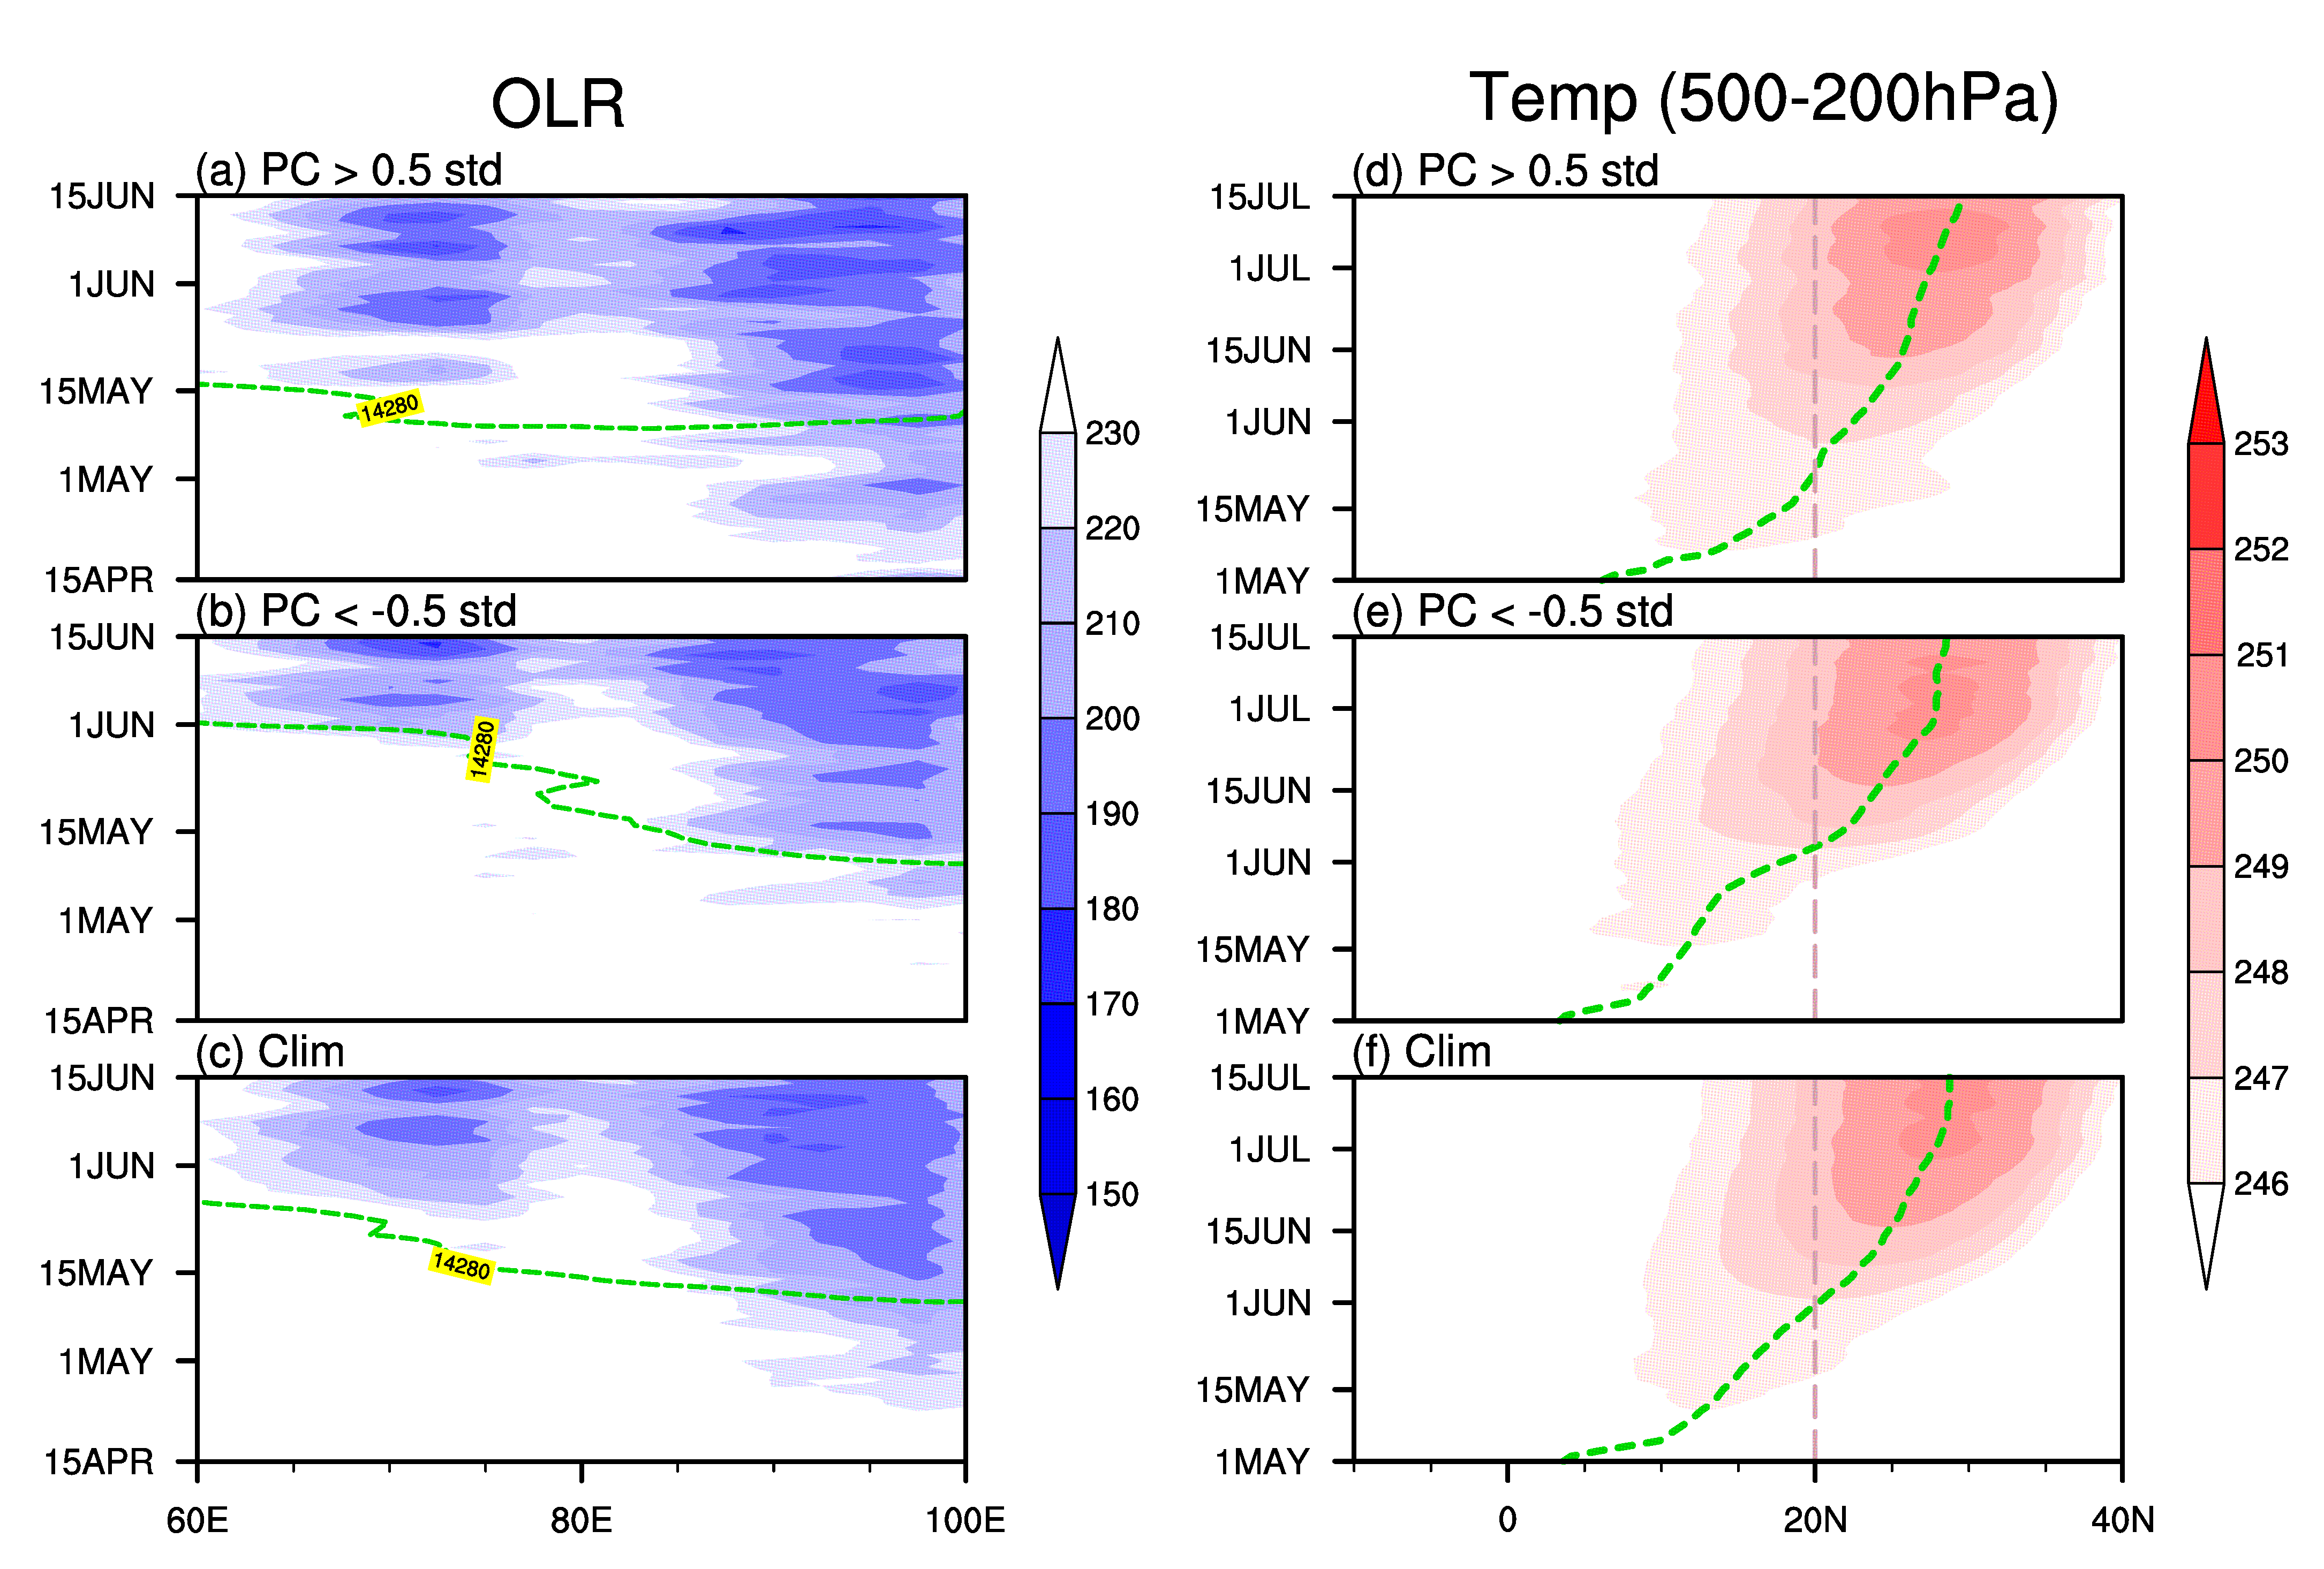
Fig. S2 Composite evolution of (a–c) meridionally averaged (5°–15 °N) OLR (shading, units: W m⁻²) and (d–f) zonally averaged (50º–90 ºE) temperature, vertically averaged over 500–200 hPa (shading, unit: K) for (a, d) PC > 0. 5 standard deviation years, (b, e) PC < −0.5 standard deviation years and (c, d) the climatological mean. The green curves in (a–c) indicate the 14280 geopotential height at 20ºN, and in (d–f) denote the maximum ridge line. The light pink line denotes 20 ºN

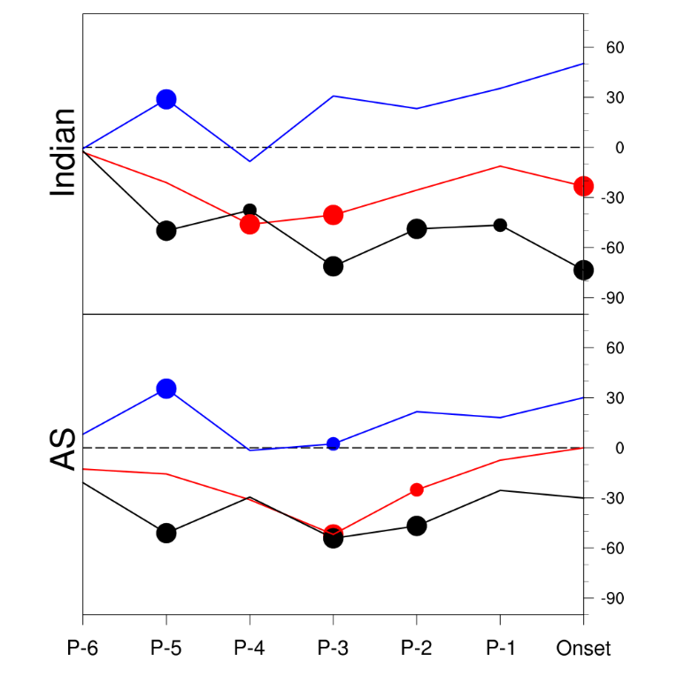
Fig. S3 Composite seesaw pattern of diabatic heating index over the TP from the leading 6th pentad to the onset date of the monsoon over India (upper panel) and the AS (lower panel). The small and large dots indicate that these results reached statistical significance at the 85% and 90% confidence level, respectively. The blue, red and black curves indicate advanced years, delayed years and their differences, respectively (units: W m⁻²). The seesaw pattern of diabatic heating index over the TP is defined as the difference between the diabatic heating averaged over the southeastern TP (25°–30°N, 80°–105°E) and over the northwestern TP (32°–40°N, 70°–85°E).

