Assessing the Therapeutic Efficacy of Artemether-Lumefantrine for Uncomplicated Malaria in Lagos, Nigeria: A Comprehensive Study on Treatment Response and Resistance Markers
Kolapo M. Oyebola^{1,2}, Funmilayo C. Ligali^{1,2}, Afolabi J. Owoloye^{1,2}, Oluwagbemiga O. Aina², Yetunde M. Alo¹, Blessing Erinwusi¹, Michael J. Olufemi¹, Babatunde L. Salako²

¹Centre for Genomic Research in Biomedicine, Mountain Top University, Ibafo, Nigeria
²Nigerian Institute of Medical Research, Lagos, Nigeria

Supplementary Methods
MDR1 genotyping
MDR1 genotyping involved nested polymerase chain reaction (nPCR), followed by restriction fragment length polymorphism (RFLP) analysis https://www.medschool.umaryland.edu/malaria/Protocols/. This approach facilitated the detection of point mutations in the MDR1 gene with the corresponding SNPs. In brief, PCRs were executed in a final volume of 25 μL, comprising 12.5 µL of One Taq Quick-Load 2X Master Mix with Standard Buffer (containing PCR buffer, MgCl₂, and dNTPs) from New England Biolabs, Massachusetts, USA, along with nuclease-free water and 2 μL of the extracted parasite DNA. Control DNA samples from the wild type (3D7) and multi-drug resistant laboratory strains (Dd2) of P. falciparum were used. The primer pairs and cycling conditions are presented in Additional Table S3. Digestion reactions were set up with a final volume of 15 μL, containing 8 μL of the nested PCR product, enzyme buffer, and 1 unit of the appropriate restriction enzyme (New England Biolabs, Massachusetts, USA). The mixtures underwent digestion for 4 hours at 37°C, as recommended by the manufacturer. Subsequently, a 5μL volume of the digested product was subjected to electrophoresis on 3% agarose gels, visualized under the E-Gel Power Snap Electrophoresis Device (Invitrogen™, Waltham, Massachusetts, USA) after staining with SafeViewTM Classic (ABM, Richmond, Canada). The size of DNA fragments was estimated by visual inspection using a 100 bp DNA ladder marker (New England Biolabs, Ipswich, MA, USA).

Table S1: Plasmodium falciparum 18S rRNA primer sequence
Gene/Locus | Primer Name | Primer Sequence
Plasmodium genus

Plasmodium falciparum
Plasmodium genus  Plasmodium falciparum | rPUL-5 | 5′-CCTGTTGTTGCCTTAAACTTC-3′
Plasmodium genus  Plasmodium falciparum | rPUL-6 | 5′-TTAAAATTGTTGCAGTTAAAACG-3′
Plasmodium genus  Plasmodium falciparum | rFAL-1 | 5′-TTAAACTGGTTTGGGAAAACCAAATATATT-3′
Plasmodium genus  Plasmodium falciparum | rFAL-2 | 5′-ACACAATGAACTCAATCATGACTACCCGTC-3′

Table S2: MSP1 and MSP2 primer sequences
Gene/Locus | Amplification Reaction | Primer Name | Primer Sequence
MSP1 | Primary PCR
MSP1 | MSP1 primary target | MSP1-P1 | 5′-CACATGAAAGTTATCAAGAACTTGTC-3′
MSP1 | MSP1 primary target | MSP1-P2 | 5′-GTACGTCTAATTCATTTGCAC-3′
MSP1 | Secondary PCR
MSP1 | R033 allelic family | R033-R1 | 5′-GCAAATACTCAAGTTGTTGCAAAGC-3′
MSP1 | R033 allelic family | R033-R2 | 5′-AGGATTTGCAGCACCTGGAGATCT-3′
MSP1 | K1 allelic family | K1-K1 | 5′-GAAATTACTACAAAAGGTGCAAGTG-3′
MSP1 | K1 allelic family | K1-K2 | 5′-AGATGAAGTATTTGAACGAGGTAAAGTG-3′
MSP1 | MAD20 allelic family | MAD20-M1 | 5′-GAACAAGTCGAACAGCTGTTA-3′
MSP1 | MAD20 allelic family | MAD20-M2 | 5′-TGAATTATCTGAAGGATTTGTACGTCTTGA-3′
MSP2 | Primary PCR
MSP2 | MSP2 primary target | MSP2-1 | 5′-ATGAAGGTAATTAAAACATTGTCTATTATA-3′
MSP2 | MSP2 primary target | MSP2-4 | 5′-ATATGGCAAAAGATAAAACAAGTG-3′
MSP2 | Secondary PCR
MSP2 | FC27 allelic family | FC27-B1 | 5′-GCAAATGAAGGTTCTAATACTAATAG-3′
MSP2 | FC27 allelic family | FC27-B2 | 5′-GCTTTGGGTCCTTCTTCAGTTGATTC-3′
MSP2 | 3D7 allelic family | 3D7-A1 | 5′-GCAGAAAGTAAGCCTTCTACTGGTGCT-3′
MSP2 | 3D7 allelic family | 3D7-A2 | 5′-GATTTGTTTCGGCATTATTATGA-3′

Table S3: Primers and restriction enzymes used for MDR1 genotyping.
Genes | Mutations | Primer name | Nucleotide sequence (5'-3') | Fragment size (bp) | Restriction enzyme | Fragment size (bp)
MDR1 | N86Y | 86 F1 | ATGGGTAAAGAGCAGAAAGA | 476 | Apo I HF | 250 + 225
 |  | 86 R1 | AACGCAAGTAATACATAAAGTCA
 |  | 86 F2 | TGGTAACCTCAGTATCAAAGAA
 |  | 86 R2 | ATAAACCTAAAAAGGAACTGG
 | D1246Y | 1246 F1 | ATGACAAATTTTCAAGATTA | 295 | BglII | 113 + 90
 |  | 1246 R1 | ACTAACACGTTTAACATCTT
 |  | 1246 F2 | AATGTAAATGAATTTTCAAACC | 203
 |  | 1246 R2 | CATCTTCTCTTCCAAATTTGATA

Table S4: UBP1 primer sequences and PCR cycling parameters.
Gene/Locus | Primer Name | Primer Sequence | Size of PCR amplicon (bp) | Annealing temperature  (⁰C)
UBP1 | Primary PCR
UBP1 | Forward | 5’-CGCCCGTACTATGAAGAAGATC-3’ | 484 | 52
UBP1 | Reverse | 5’-GGCTTTTACCTGAACTGTTCAGG-3’ | 484 | 52
UBP1 | Secondary PCR
UBP1 | Forward | 5’-CGTAAACAGAATATTCAGGATTGC-3’ | 304 | 57
UBP1 | Reverse | 5’-CTAGCCCTTTATTATCATTATCG-3’ | 304 | 57

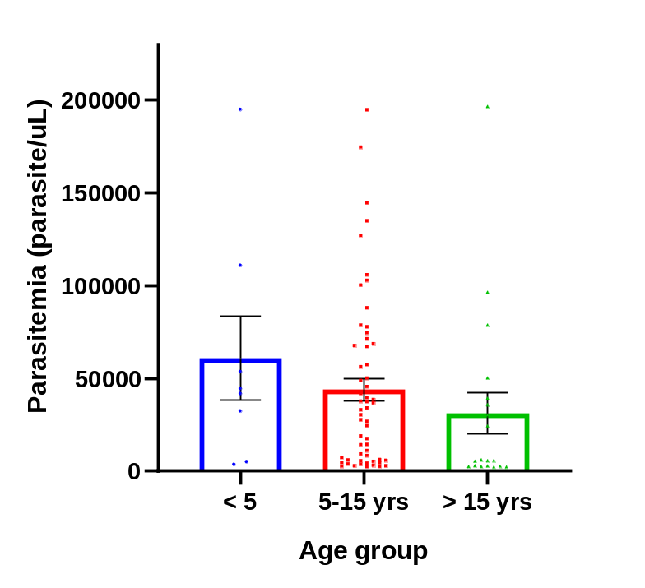
Figure S1: Age-groups and Plasmodium falciparum parasite densities
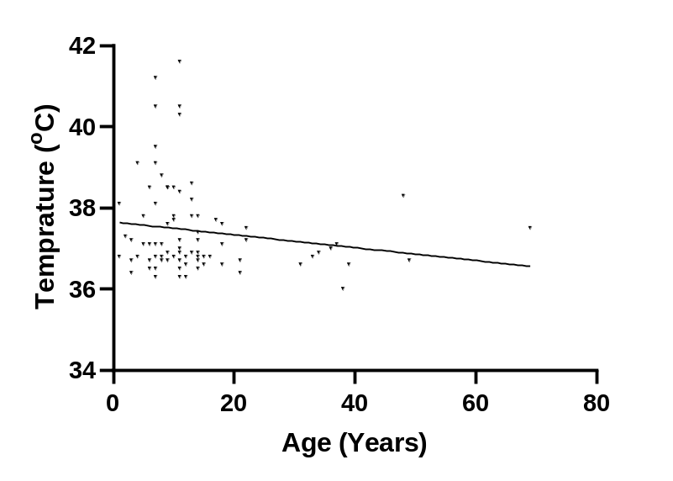
Figure S2: Relationship between temperature (^{O}C) and age (years)

Table S5: Frequencies and Multiplicity of Infection (MOI) with P. falciparum
Allelic Type | n (%) | Total Marker |  | Frequency (%) |  | Size of Allele (bp) |  |  | Average MOI |  |  | Monoclonal infections |  | Polyclonal infections
MSP1
K1 | 19 (31.1) | K1 |  | 55 (90.2) |  | 160-500 |  |  | 2.0 |  |  | 35 (57.3) |  | 26 (42.6)
MAD20 | 9 (14.8) | RO33 |  | 31 (50.8) |  | 160-600
RO33 | 7 (11.5) | MAD20 |  | 35 (57.4) |  | 160-500
K1+MAD20 | 6 (9.8)
K1+RO33 | 11 (18.0)
MAD20+RO33 | 1 (1.6)
K1+MAD20+RO33 | 8 (13.1)
Total | 61
MSP2
FC27 | 20 (44.4) | FC27 |  | 29 (64.4) |  | 400-800 |  |  | 1.2 |  |  | 37 (82.2) |  | 8 (17.8)
3D7 | 17 (37.8) | 3D7 |  | 26 (57.8) |  | 300-800
FC27+3D7 | 8 (17.8)
Total | 45

B
A

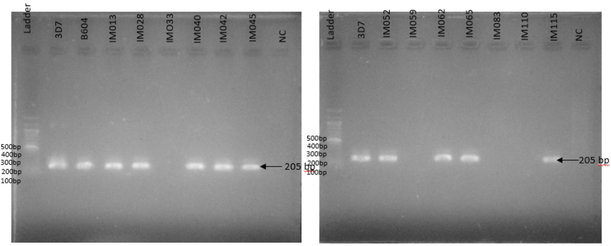

Plate S1 (A and B): Representative gel images showing the results of Plasmodium falciparum 18S PCR amplification; 3D7 and positive samples showed a band size of 205 bp, NC = negative control well. Ladder size =100 bp.

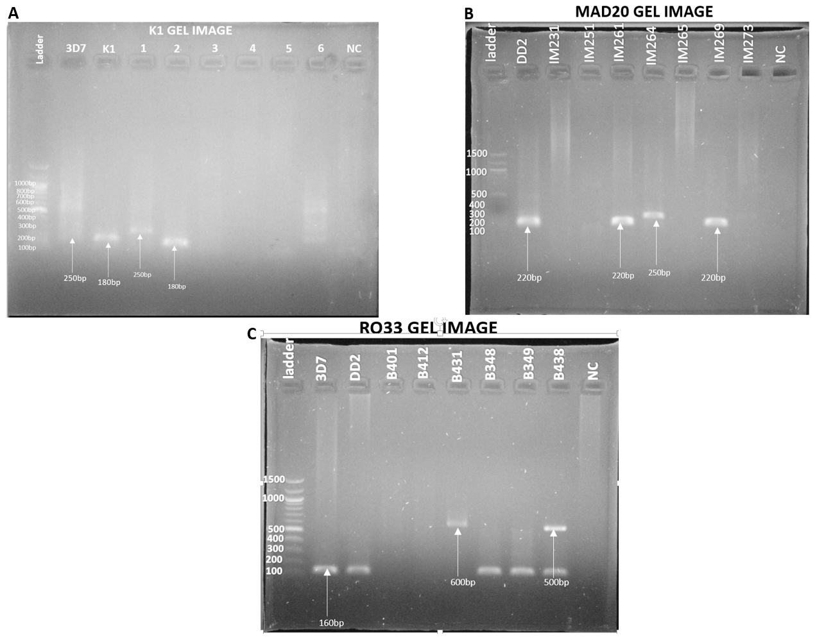

Plate S2: Representative gel images showing the results of (A) K1 (MSP1) genotyping with band size (180 and 200 bp). 3D7-Positive control 1, K1- Positive control 2, NC- Negative, Ladder size =100 bp. (B) MAD20 (MSP1) genotyping with band size (220 and 250 bp). Dd2- Positive control, NC- Negative, and ladder is 100 bp ladder, and (C) RO33 (MSP1) genotyping with band size (160 - 600). 3D7- Positive control 1, Dd2- Positive control 2, NC- Negative. Ladder size =100 bp
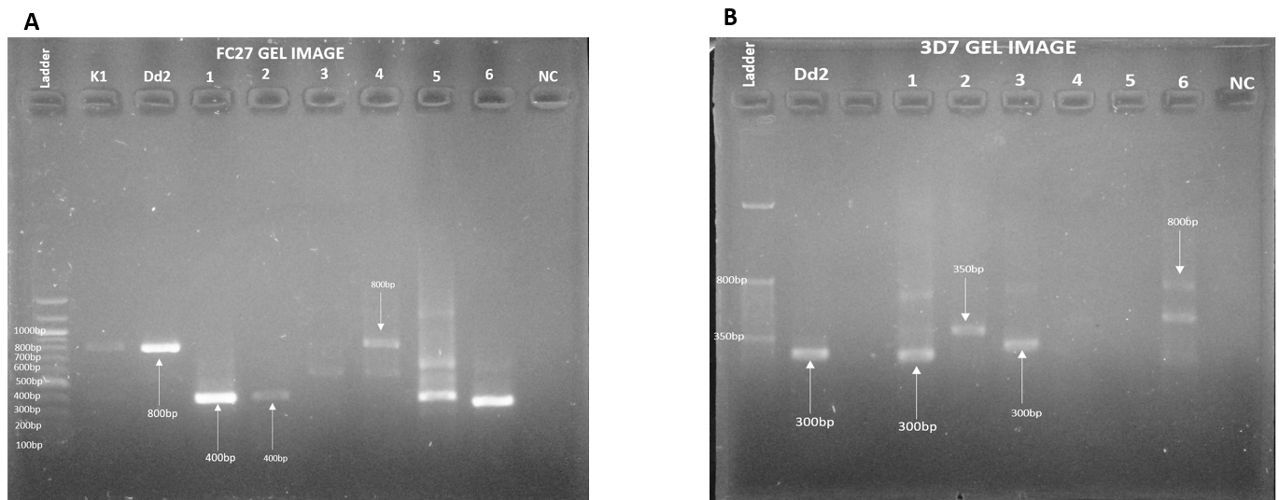

Plate S3: Representative gel images showing the results of (A) FC27 (MSP2) genotyping with band size (400 to 800 bp). K1-Positive control 1, Dd2- Positive control 2, NC- Negative. Ladder size = 100 bp, and (B) 3D7 (MSP2) genotyping with band size (300 to 800 bp). Dd2- Positive control, NC- Negative. Ladder size = 50 bp
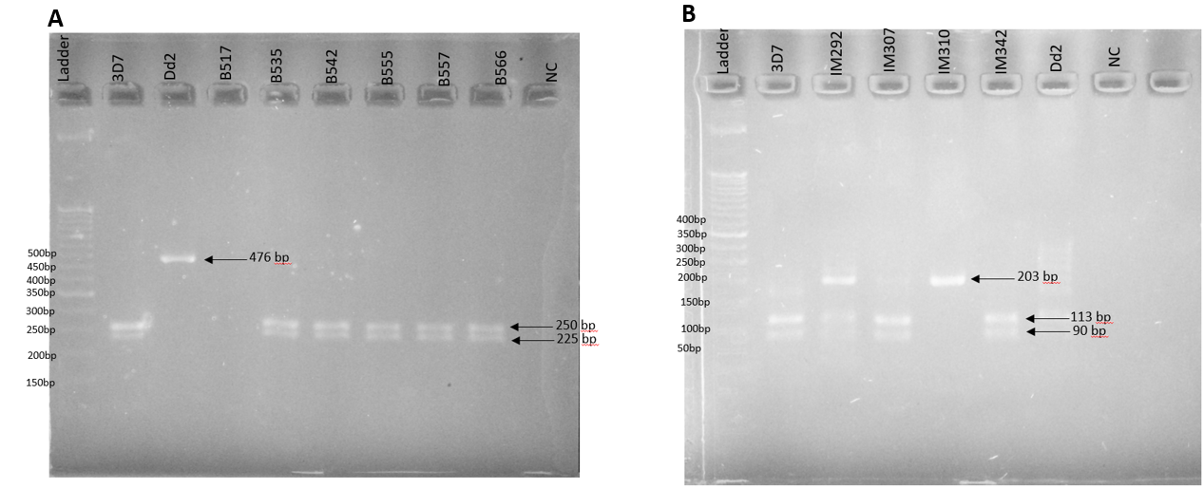

Plate S5: Representative gel images showing the results of (A) MDR1-N86Y and (B) MDR- D1246Y mutations, 3D7 and Dd2 are the positive control wells, NC is the negative control well. Ladder size =50 bp.

B
A
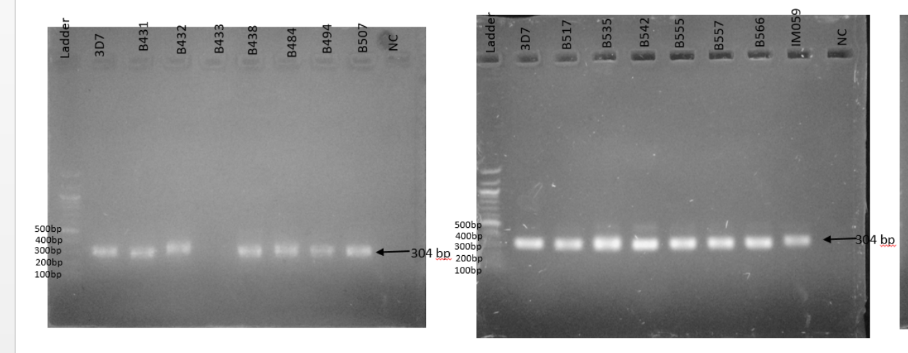
Plate S4 (A and B): Representative gel images showing the results of UBP1 PCR amplification; 3D7 and positive samples showed a band size of 304 bp, NC is the negative control well. Ladder size =100 bp.

