Additional file 1
Clinical efficacy and safety of vasopressin and its analogues in patients with septic shock: a meta-analysis and trial sequential analysis
Milan Dong^{1#}; Shaojun Li ^{2#}; Jing Jiang¹; Dandan Pi³; Jiashan Li¹; Xuehan Bai¹; Yiqi Lu⁴; Feng Xu³; Xuemei Li^{1**;} Jing Li^{3**}
¹Department of Pediatrics, Women and Children’s Hospital of Chongqing Medical University, Chongqing Health Center for Women and Children, Chongqing, China.
²Department of Emergency, Children's Hospital of Chongqing Medical University, National Clinical Research Center for Child Health and Disorders, Ministry of Education Key Laboratory of Child Development and Disorders, Chongqing Key Laboratory of Pediatric Metabolism and Inflammatory Diseases, Chongqing, China.
³Department of Critical Care Medicine, Children's Hospital of Chongqing Medical University, National Clinical Research Center for Child Health and Disorders, Ministry of Education Key Laboratory of Child Development and Disorders, Chongqing Key Laboratory of Pediatric Metabolism and Inflammatory Diseases, Chongqing, China.
⁴Yubei District Hospital of TCM, Chongqing, China.
#Contributed equally.
**Corresponding author:
Jing Li, Email: lijingwangyi@126.com
Xuemei Li, Email: 981342321@qq.com
Content
Table S1. Study search strategies. 4
Table S2 PRISMA Checklist 12
Figure S1. Sensitivity analysis on mortality. 17
Figure S2. Sensitivity analysis on ICU LOS. 17
Figure S3. Sensitivity analysis on SOFA score change. 17
Figure S4. Sensitivity analysis on lactate change. 18
Figure S5. Sensitivity analysis on NE doses change. 18
Figure S6. Sensitivity analysis on total adverse events. 19
Figure S7. Forest plot for effects of vasopressin or its analogues to catecholamines alone on ICU LOS. 19
Figure S8. Forest plot for effects of vasopressin or its analogues to catecholamines alone on Duration of mechanical ventilation. 20
Figure S9. Forest plot for effects of vasopressin or its analogues to catecholamines alone on SOFA score change. 20
Figure S10. Forest plot for effects of vasopressin or its analogues to catecholamines alone on Lactate change. 20
Figure S11. Forest plot for effects of vasopressin or its analogues to catecholamines alone on NE doses change. 20
Figure S12. Forest plot for effects of vasopressin or its analogues to catecholamines alone on Time to shock reversal. 21
Figure S13. Forest plot for effects of vasopressin or its analogues to catecholamines alone on Total adverse events. 21
Figure S14. Forest plot for effects of vasopressin or its analogues to catecholamines alone on Renal failure or injury. 21
Figure S15. Forest plot for effects of vasopressin or its analogues to catecholamines alone on Renal replacement therapy. 21
Figure S16. Forest plot for effects of vasopressin or its analogues to catecholamines alone on Arrhythmia. 22
Figure S17. Forest plot for effects of vasopressin or its analogues to catecholamines alone on Digital ischemia. 22
Figure S18. Forest plot for effects of vasopressin or its analogues to catecholamines alone on Mesenteric ischemia. 22
eAppendix. Assessment of publication biases for the inchluded studies (Funnel plot and Egger’s test) 23

Table S1. Study search strategies.
Database | Strategy
MEDLINE (via PubMed)  （N=527） | #1."randomized controlled trial"[Publication Type]  #2. "controlled clinical trial"[Publication Type]  #3. "randomized"[Title/Abstract]  #4. "randomized"[Title/Abstract]  #5. "placebo"[Title/Abstract]  #6. "drug therapy"[MeSH Subheading]  #7. "randomly"[Title/Abstract]  #8. "trial"[Title/Abstract]  #9. "groups"[Title/Abstract]  #10. OR/ #1-#9  #11. "animals"[MeSH Terms]  #12. "humans"[MeSH Terms]  #13. #10 NOT #11 NOT #12  #14. "shock, septic"[MeSH Terms]  #15. "shock, septic"[MeSH Terms]  #15. "shock"[All Fields] AND "septic"[All Fields]  #16. "septic shock"[All Fields]  #17. "septic"[All Fields] AND "shock"[All Fields]  #19. "shock, septic"[MeSH Terms]  #20. "shock"[All Fields] AND "septic"[All Fields]  #21. "septic shock"[All Fields]  #22. ("shock"[All Fields] AND "toxic"[All Fields]  #23. "shock toxic"[All Fields]  #24. ("shock, septic"[MeSH Terms]  #25. ("shock"[All Fields] AND "septic"[All Fields]  #26. "septic shock"[All Fields]  #27. ("toxic"[All Fields] AND "shock"[All Fields] AND "syndrome"[All Fields]  #28. "toxic shock syndrome"[All Fields]  #29. "shock, septic"[MeSH Terms]  #30."shock"[All Fields] AND "septic"[All Fields]  #31. "septic shock"[All Fields]  #32."shock"[All Fields] AND "syndrome"[All Fields] AND "toxic"[All Fields]  #33. "shock syndrome toxic"[All Fields]  #34."shock, septic"[MeSH Terms]  #35."shock"[All Fields] AND "septic"[All Fields]  #36. "septic shock"[All Fields]  #37."toxic"[All Fields] AND "shock"[All Fields] AND "syndromes"[All Fields]  #38. "toxic shock syndromes"[All Fields]  #39. "shock, septic"[MeSH Terms]  #40. "shock"[All Fields] AND "septic"[All Fields]  #41. "septic shock"[All Fields]  #42. "toxic"[All Fields] AND "shock"[All Fields]  #43. "toxic shock"[All Fields]  #44. "shock, septic"[MeSH Terms]  #45. "shock"[All Fields] AND "septic"[All Fields]  #46. "septic shock"[All Fields]  #47. "shock"[All Fields] AND "endotoxic"[All Fields]  #48. "shock endotoxic"[All Fields]  #49. "shock, septic"[MeSH Terms]  #50. "shock"[All Fields] AND "septic"[All Fields]  #51. "septic shock"[All Fields]  #52. "endotoxin"[All Fields] AND "shock"[All Fields]  #53. "endotoxin shock"[All Fields]  #54. "shock, septic"[MeSH Terms]  #55. "shock"[All Fields] AND "septic"[All Fields]  #56. "septic shock"[All Fields]  #57. "endotoxin"[All Fields] AND "shocks"[All Fields]  #58. "endotoxin shocks"[All Fields]  #59. "shock, septic"[MeSH Terms]  #60. "shock"[All Fields] AND "septic"[All Fields]  #61. "septic shock"[All Fields]  #62. "shock"[All Fields] AND "endotoxin"[All Fields]  #63. "shock endotoxin"[All Fields]  #64. "shock, septic"[MeSH Terms]  #65. “shock"[All Fields] AND "septic"[All Fields])  #66. "septic shock"[All Fields]  #67. ("shocks"[All Fields] AND "endotoxin"[All Fields]  #68. OR/#14-#67  #69. "pituitary hormones, posterior"[MeSH Terms]  #70. "pituitary hormones posterior"[Supplementary Concept]  #71. "pituitary hormones posterior"[All Fields]  #72. "posterior pituitary hormones"[All Fields]  #73. "pituitary hormones, posterior"[MeSH Terms]  #74. "pituitary"[All Fields] AND "hormones"[All Fields] AND "posterior"[All Fields]  #75. "posterior"[All Fields] AND "pituitary"[All Fields] AND "hormones"[All Fields]  #76. "pituitary hormones posterior"[Supplementary Concept]  #77. "pituitary hormones posterior"[All Fields]  #78. "neurohypophyseal peptides"[All Fields]  #79. "pituitary hormones, posterior"[MeSH Terms]  #80. ("pituitary"[All Fields] AND "hormones"[All Fields] AND "posterior"[All Fields]  #81. "posterior pituitary hormones"[All Fields]  #82. "neurohypophyseal"[All Fields] AND "peptides"[All Fields]  #83. "pituitary hormones posterior"[Supplementary Concept]  #84. "pituitary hormones posterior"[All Fields]  #85. "neurohypophyseal hormones"[All Fields]  #86. "pituitary hormones, posterior"[MeSH Terms]  #87. ("pituitary"[All Fields] AND "hormones"[All Fields] AND "posterior"[All Fields]  #88. "posterior pituitary hormones"[All Fields]  #89."neurohypophyseal"[All Fields] AND "hormones"[All Fields]  #90. "pituitary hormones posterior"[Supplementary Concept]  #91. "pituitary hormones posterior"[All Fields]  #92. "pituitrin"[All Fields]  #93. "pituitary hormones, posterior"[MeSH Terms]  #94. "pituitary"[All Fields] AND "hormones"[All Fields] AND "posterior"[All Fields]  #95. "posterior pituitary hormones"[All Fields]  #96. "pituitrine"[All Fields]  #97. "Terlipressin"[MeSH Terms]  #98. "Terlipressin"[Supplementary Concept]  #99. "Terlipressin"[All Fields]  #100. "glycylpressin"[All Fields]  #101. "Terlipressin"[MeSH Terms]  #102. "Terlipressin"[Supplementary Concept]  #103. "Terlipressin"[All Fields]  #104. "tglvp"[All Fields]  #105."Terlipressin"[MeSH Terms]  #106. "Terlipressin"[Supplementary Concept] OR "Terlipressin"[All Fields] OR "terlypressin"[All Fields] OR "Terlipressin"[MeSH Terms]  #107. "Terlipressin"[Supplementary Concept]  #108. "Terlipressin"[All Fields]  #109. "triglycyl lysine vasopressin"[All Fields]  #110. "Terlipressin"[MeSH Terms]  #111. "triglycyl"[All Fields] AND "lysine"[All Fields] AND "vasopressin"[All Fields]  #112. "Terlipressin"[Supplementary Concept] OR "Terlipressin"[All Fields] OR "triglycylvasopressin"[All Fields] OR "Terlipressin"[MeSH Terms]  #113. "Terlipressin"[Supplementary Concept] OR "Terlipressin"[All Fields] OR "glipressin"[All Fields] OR "Terlipressin"[MeSH Terms]  #114. "Terlipressin"[Supplementary Concept] OR "Terlipressin"[All Fields] OR "glypressin"[All Fields] OR "Terlipressin"[MeSH Terms]  #115. "triglycyl"[All Fields] AND "8-lysine"[All Fields]  #116. "vasopressin s"[All Fields]  #117. "vasopressine"[All Fields]  #118. "Vasopressins"[Supplementary Concept]  #119. "Vasopressins"[All Fields]  #120. "vasopressin"[All Fields]  #121. "avp protein human"[Supplementary Concept]  #122. "avp protein human"[All Fields]  #123. "Vasopressins"[MeSH Terms]))  #124 "antidiuretic"[All Fields] AND "hormones"[All Fields]  #125 "Selepressin"[All Fields]  #126 OR/#69-125  #127 #13 AND #68 AND #126
EMBASE  (N=424) | #1 'vasopressins':ti,ab,kw OR 'antidiuretic hormones':ti,ab,kw OR 'antidiuretic hormone':ti,ab,kw OR 'hormone, antidiuretic':ti,ab,kw OR 'beta-hypophamine':ti,ab,kw OR 'beta hypophamine':ti,ab,kw OR 'pitressin':ti,ab,kw OR 'vasopressin (usp)':ti,ab,kw OR 'vasopressin':ti,ab,kw OR 'selepressin':ti,ab,kw OR 'terlipressin':ti,ab,kw OR 'glycylpressin':ti,ab,kw OR 'tglvp':ti,ab,kw OR 'terlypressin':ti,ab,kw OR 'triglycyl lysine vasopressin':ti,ab,kw OR 'triglycylvasopressin':ti,ab,kw OR 'glipressin':ti,ab,kw OR 'glypressin':ti,ab,kw OR 'triglycyl-(8-lysine)vasopressin':ti,ab,kw OR 'gly-gly-gly-8-lys-vasopressin':ti,ab,kw OR 'gly gly gly 8 lys vasopressin':ti,ab,kw OR 'n-(alpha)-glycyl-glycyl-glycyl-8-lysine vasopressin':ti,ab,kw OR 'vasopressin, tri-gly-8-lys-':ti,ab,kw OR 'tri-gly-8-lys- vasopressin':ti,ab,kw OR 'remestyp':ti,ab,kw OR 'pituitary hormones, posterior':ti,ab,kw OR 'posterior pituitary hormones':ti,ab,kw OR 'neurohypophyseal peptides':ti,ab,kw OR ‘neurohypophyseal AND hormones’ :ti,ab,kw OR ‘pituitrin’ :ti,ab,kw  #2 'shock, septic':ti,ab,kw OR 'septic shock':ti,ab,kw OR 'shock, toxic':ti,ab,kw OR 'toxic shock syndrome':ti,ab,kw OR 'shock syndrome, toxic':ti,ab,kw OR 'toxic shock syndromes':ti,ab,kw OR 'toxic shock':ti,ab,kw OR 'shock, endotoxic':ti,ab,kw OR 'endotoxin shock':ti,ab,kw OR 'endotoxin shocks':ti,ab,kw OR 'shock, endotoxin':ti,ab,kw OR 'shocks, endotoxin':ti,ab,kw  #3 ('randomized controlled trial':ti,ab,kw OR 'controlled clinical trial':ti,ab,kw OR 'randomized':ti,ab,kw OR 'randomised':ti,ab,kw OR 'placebo':ti,ab,kw OR 'drug therapy':ti,ab,kw OR 'randomly':ti,ab,kw OR 'trial':ti,ab,kw OR 'groups':ti,ab,kw) NOT 'animals':ti,ab,kw NOT 'humans':ti,ab,kw  #1 AND #2 AND #3
Web of Science  （N=1170） | #1 (TS=(Randomized Controlled Trial) OR TS=(controlled clinical trial) OR TS=(randomized) OR TS=(randomised) OR TS=(placebo) OR TS=(drug therapy) OR TS=(randomly) OR TS=(trial) OR TS=(groups) NOT TS=(animals) NOT TS=(humans)) NOT (SILOID==("PPRN"))  #2 (TS=(shock, septic) OR TS=(septic shock) OR TS=(shock, toxic) OR TS=(toxic shock syndrome) OR TS=(shock syndrome, toxic) OR TS=(toxic shock syndromes) OR TS=(toxic shock) OR TS=(shock, endotoxic) OR TS=(endotoxin shock) OR TS=(endotoxin shocks) OR TS=(shock, endotoxin) AND TS=(shocks, endotoxin)) NOT (SILOID==("PPRN"))  #3 (TS=(Vasopressins) OR TS=(Antidiuretic Hormones) OR TS=(Antidiuretic Hormone) OR TS=(Hormone, Antidiuretic) OR TS=(beta-Hypophamine) OR TS=(beta Hypophamine) OR TS=(Pitressin) OR TS=(Vasopressin (USP)) OR TS=(Vasopressin) OR TS=(Selepressin) OR TS=(Terlipressin) OR TS=(Glycylpressin) OR TS=(TGLVP) OR TS=(Terlypressin) OR TS=(Triglycyl Lysine Vasopressin) OR TS=(Triglycylvasopressin) OR TS=(Glipressin) OR TS=(Glypressin) OR TS=(Triglycyl-(8-lysine)vasopressin) OR TS=(Gly-Gly-Gly-8-Lys-vasopressin) OR TS=(Gly Gly Gly 8 Lys vasopressin) OR TS=(N-(alpha)-glycyl-glycyl-glycyl-8-lysine vasopressin) OR TS=(Vasopressin, tri-Gly-8-Lys-) OR TS=(tri-Gly-8-Lys- Vasopressin) OR TS=(Remestyp) OR TS=(Pituitary Hormones, Posterior) OR TS=(Posterior Pituitary Hormones) OR TS=(Neurohypophyseal Peptides) OR TS=(Neurohypophyseal Hormones) OR TS=(Pituitrin)) NOT (SILOID==("PPRN"))  #4 #1 AND #2 AND #3
CENTRAL  (N=203) | #1 Shock, Septic 4127  #2 (Shock, Septic):ti,ab,kw OR (Septic Shock):ti,ab,kw OR (Shock, Toxic):ti,ab,kw OR (Toxic Shock Syndrome):ti,ab,kw OR (Shock Syndrome, Toxic):ti,ab,kw 4002  #3 (Toxic Shock Syndromes):ti,ab,kw OR (Toxic Shock):ti,ab,kw OR (Shock, Endotoxic):ti,ab,kw OR (Endotoxin Shock):ti,ab,kw OR (Endotoxin Shocks):ti,ab,kw 334  #4 (Shock, Endotoxin):ti,ab,kw OR (Shocks, Endotoxin):ti,ab,kw 151  #5 #1 OR #2 OR #3 OR #4 4275  #6 Vasopressins 588  #7 (Vasopressins):ti,ab,kw OR (Antidiuretic Hormones):ti,ab,kw OR (Antidiuretic Hormone):ti,ab,kw OR (Hormone, Antidiuretic):ti,ab,kw OR (beta-Hypophamine):ti,ab,kw 956  #8 (beta Hypophamine):ti,ab,kw OR (Pitressin):ti,ab,kw OR (Vasopressin (USP)):ti,ab,kw OR (Vasopressin):ti,ab,kw OR (Selepressin):ti,ab,kw 2729  #9 #6 OR #7 or #8 3007  #10 #5 AND #9 203

Table S2. PRISMA Checklist
Section and Topic | Item # | Checklist item | Location where item is reported
TITLE
Title | 1 | Identify the report as a systematic review. | Page 1
ABSTRACT
Abstract | 2 | See the PRISMA 2020 for Abstracts checklist. | Page 2-3
INTRODUCTION
Rationale | 3 | Describe the rationale for the review in the context of existing knowledge. | Page 4
Objectives | 4 | Provide an explicit statement of the objective(s) or question(s) the review addresses. | Page 4
METHODS
Eligibility criteria | 5 | Specify the inclusion and exclusion criteria for the review and how studies were grouped for the syntheses. | Page 5
Information sources | 6 | Specify all databases, registers, websites, organisations, reference lists and other sources searched or consulted to identify studies. Specify the date when each source was last searched or consulted. | Page 5 and additional file 1: Table S1
Search strategy | 7 | Present the full search strategies for all databases, registers and websites, including any filters and limits used. | additional file 1: Table S1
Selection process | 8 | Specify the methods used to decide whether a study met the inclusion criteria of the review, including how many reviewers screened each record and each report retrieved, whether they worked independently, and if applicable, details of automation tools used in the process. | Page 5
Data collection process | 9 | Specify the methods used to collect data from reports, including how many reviewers collected data from each report, whether they worked independently, any processes for obtaining or confirming data from study investigators, and if applicable, details of automation tools used in the process. | Page 5
Data items | 10a | List and define all outcomes for which data were sought. Specify whether all results that were compatible with each outcome domain in each study were sought (e.g. for all measures, time points, analyses), and if not, the methods used to decide which results to collect. | Page 5-6 and Table 1
Data items | 10b | List and define all other variables for which data were sought (e.g. participant and intervention characteristics, funding sources). Describe any assumptions made about any missing or unclear information. | Page 6
Study risk of bias assessment | 11 | Specify the methods used to assess risk of bias in the included studies, including details of the tool(s) used, how many reviewers assessed each study and whether they worked independently, and if applicable, details of automation tools used in the process. | Page 6 and Fig 2
Effect measures | 12 | Specify for each outcome the effect measure(s) (e.g. risk ratio, mean difference) used in the synthesis or presentation of results. | Page 6
Synthesis methods | 13a | Describe the processes used to decide which studies were eligible for each synthesis (e.g. tabulating the study intervention characteristics and comparing against the planned groups for each synthesis (item #5)). | Page 6
Synthesis methods | 13b | Describe any methods required to prepare the data for presentation or synthesis, such as handling of missing summary statistics, or data conversions. | Page 6
Synthesis methods | 13c | Describe any methods used to tabulate or visually display results of individual studies and syntheses. | Page 6
Synthesis methods | 13d | Describe any methods used to synthesize results and provide a rationale for the choice(s). If meta-analysis was performed, describe the model(s), method(s) to identify the presence and extent of statistical heterogeneity, and software package(s) used. | Page 6
Synthesis methods | 13e | Describe any methods used to explore possible causes of heterogeneity among study results (e.g. subgroup analysis, meta-regression). | Page 6
Synthesis methods | 13f | Describe any sensitivity analyses conducted to assess robustness of the synthesized results. | Page 6
Reporting bias assessment | 14 | Describe any methods used to assess risk of bias due to missing results in a synthesis (arising from reporting biases). | Page 6
Certainty assessment | 15 | Describe any methods used to assess certainty (or confidence) in the body of evidence for an outcome. | Page 6
RESULTS
Study selection | 16a | Describe the results of the search and selection process, from the number of records identified in the search to the number of studies included in the review, ideally using a flow diagram. | Page 7 and Fig 1
Study selection | 16b | Cite studies that might appear to meet the inclusion criteria, but which were excluded, and explain why they were excluded. | N/A
Study characteristics | 17 | Cite each included study and present its characteristics. | Page 7 and Table 1
Risk of bias in studies | 18 | Present assessments of risk of bias for each included study. | Page 7 and Fig 2
Results of individual studies | 19 | For all outcomes, present, for each study: (a) summary statistics for each group (where appropriate) and (b) an effect estimate and its precision (e.g. confidence/credible interval), ideally using structured tables or plots. | Page 8-12; Fig 3-6; Additional file 1: Figure S7-S18
Results of syntheses | 20a | For each synthesis, briefly summarise the characteristics and risk of bias among contributing studies. | Page 8-12; Fig 3-6; Additional file 1: Figure S7-S18
Results of syntheses | 20b | Present results of all statistical syntheses conducted. If meta-analysis was done, present for each the summary estimate and its precision (e.g. confidence/credible interval) and measures of statistical heterogeneity. If comparing groups, describe the direction of the effect. | Page 8-12; Fig 3-6; Additional file 1: Figure S7-S18
Results of syntheses | 20c | Present results of all investigations of possible causes of heterogeneity among study results. | Page 8-12; Fig 3-6; Additional file 1: Figure S7-S18
Results of syntheses | 20d | Present results of all sensitivity analyses conducted to assess the robustness of the synthesized results. | Additional file 1: Fig S1-S6
Reporting biases | 21 | Present assessments of risk of bias due to missing results (arising from reporting biases) for each synthesis assessed. | N/A
Certainty of evidence | 22 | Present assessments of certainty (or confidence) in the body of evidence for each outcome assessed. | Fig 3-6; Additional file 1: Figure S7-S18
DISCUSSION
Discussion | 23a | Provide a general interpretation of the results in the context of other evidence. | Page 12-14
Discussion | 23b | Discuss any limitations of the evidence included in the review. | Page 14
Discussion | 23c | Discuss any limitations of the review processes used. | Page 14
Discussion | 23d | Discuss implications of the results for practice, policy, and future research. | Page 12-14
OTHER INFORMATION
Registration and protocol | 24a | Provide registration information for the review, including register name and registration number, or state that the review was not registered. | Page 4
Registration and protocol | 24b | Indicate where the review protocol can be accessed, or state that a protocol was not prepared. | Page 4
Registration and protocol | 24c | Describe and explain any amendments to information provided at registration or in the protocol. | N/A
Support | 25 | Describe sources of financial or non-financial support for the review, and the role of the funders or sponsors in the review. | Page 15-16
Competing interests | 26 | Declare any competing interests of review authors. | Page 15
Availability of data, code and other materials | 27 | Report which of the following are publicly available and where they can be found: template data collection forms; data extracted from included studies; data used for all analyses; analytic code; any other materials used in the review. | Page 15

Figure S1. Sensitivity analysis on mortality.
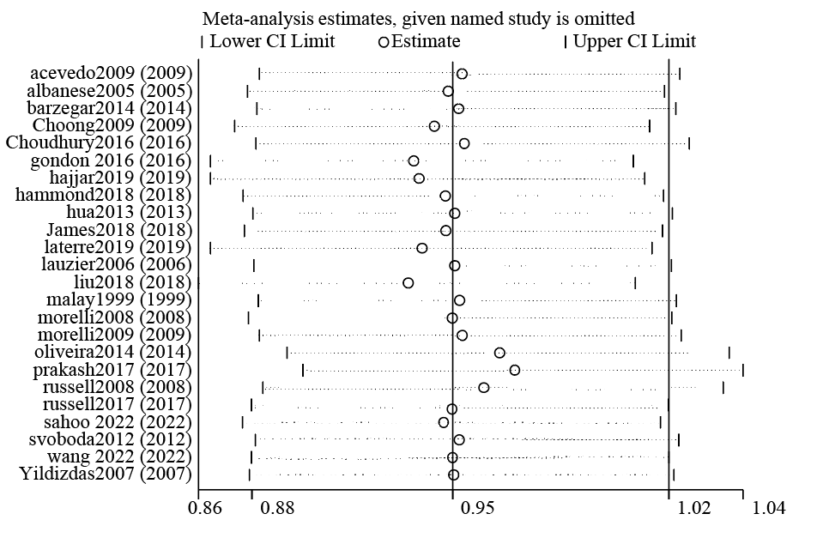

Figure S2. Sensitivity analysis on ICU LOS.
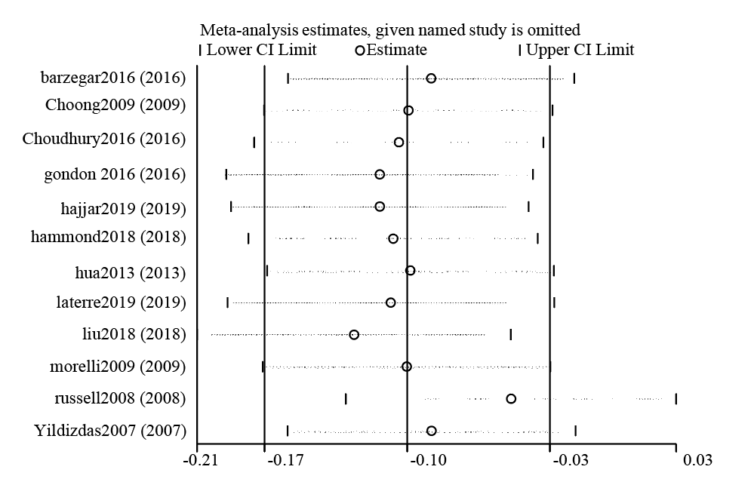

Figure S3. Sensitivity analysis on SOFA score change.
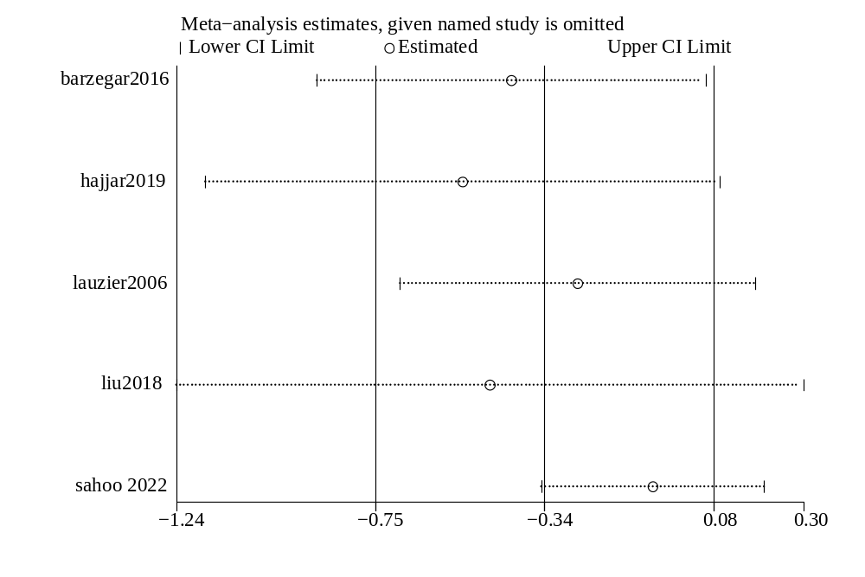

Figure S4. Sensitivity analysis on lactate change.
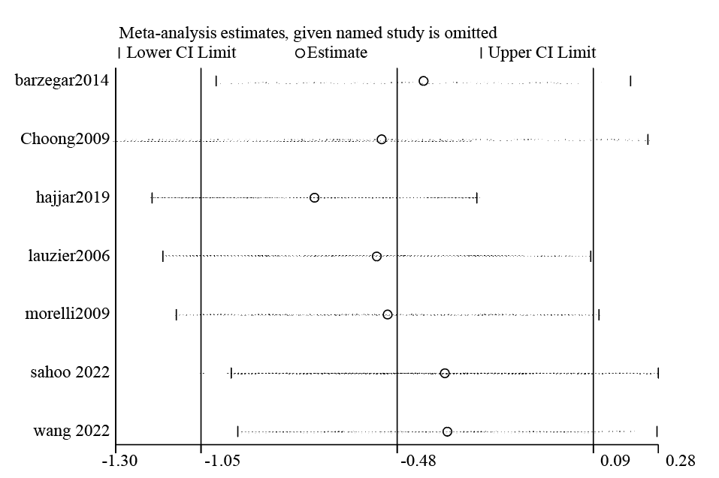

Figure S5. Sensitivity analysis on NE doses change.
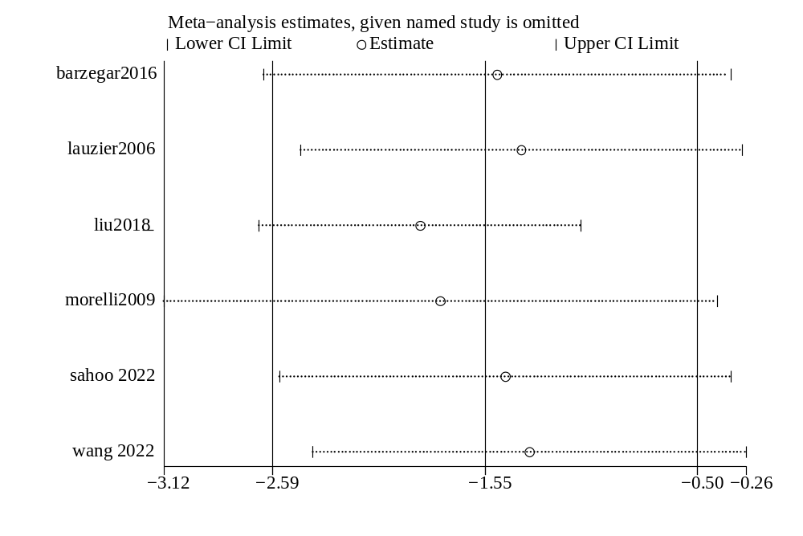

Figure S6. Sensitivity analysis on total adverse events.
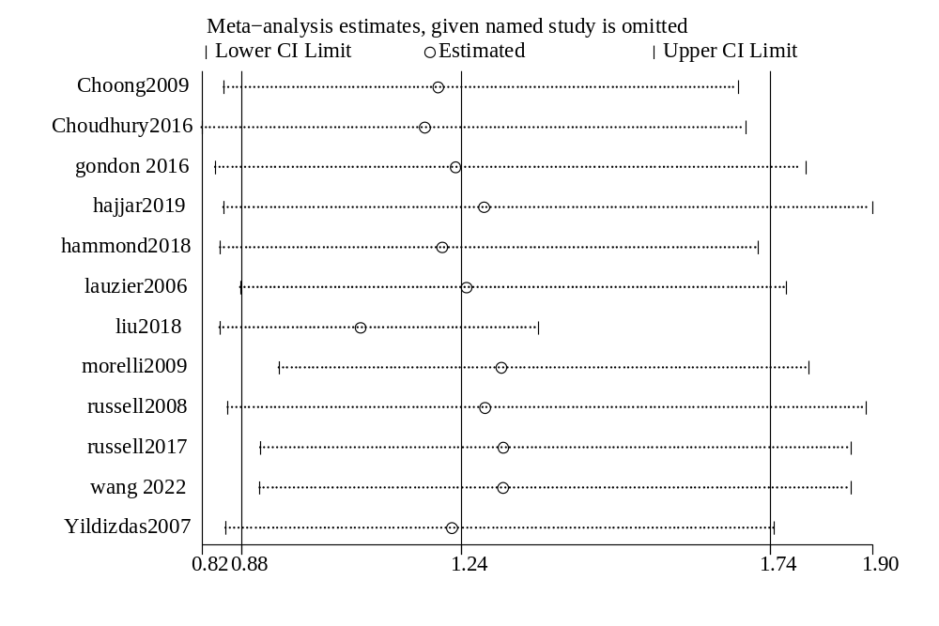

Figure S7. Forest plot for effects of vasopressin or its analogues to catecholamines alone on ICU LOS.

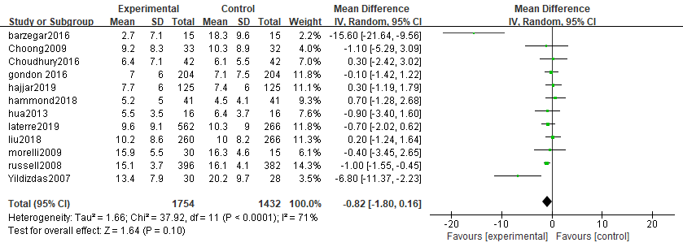

Figure S8. Forest plot for effects of vasopressin or its analogues to catecholamines alone on Duration of mechanical ventilation.
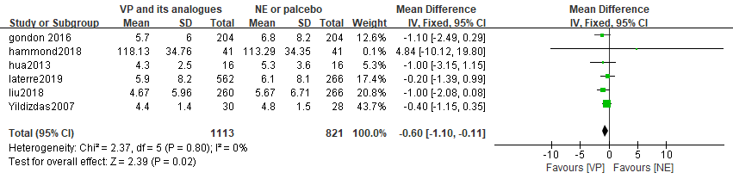

Figure S9. Forest plot for effects of vasopressin or its analogues to catecholamines alone on SOFA score change.
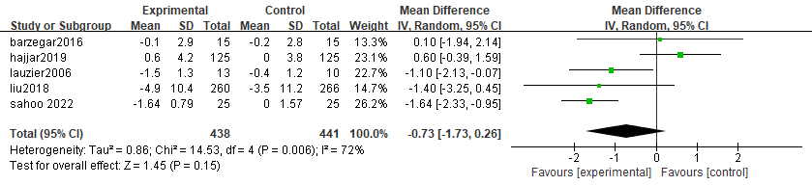

Figure S10. Forest plot for effects of vasopressin or its analogues to catecholamines alone on Lactate change.

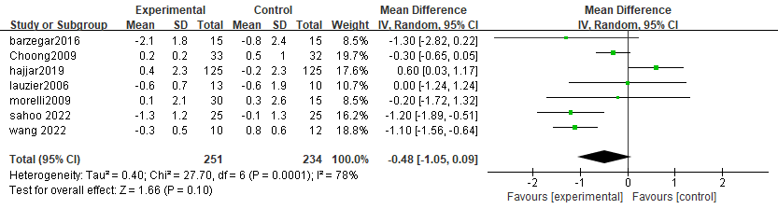

Figure S11. Forest plot for effects of vasopressin or its analogues to catecholamines alone on NE doses change.
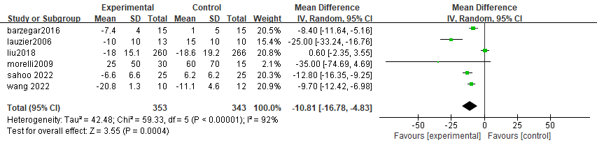

Figure S12. Forest plot for effects of vasopressin or its analogues to catecholamines alone on Time to shock reversal.
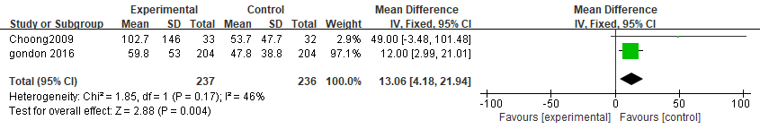

Figure S13. Forest plot for effects of vasopressin or its analogues to catecholamines alone on Total adverse events.
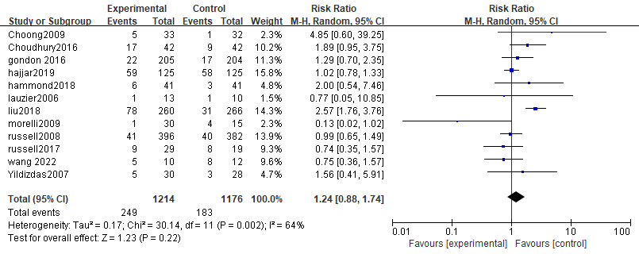

Figure S14. Forest plot for effects of vasopressin or its analogues to catecholamines alone on Renal failure or injury.
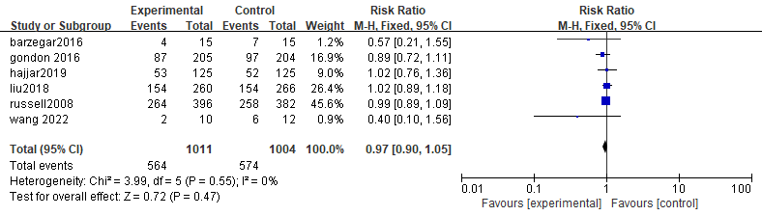

Figure S15. Forest plot for effects of vasopressin or its analogues to catecholamines alone on Renal replacement therapy.
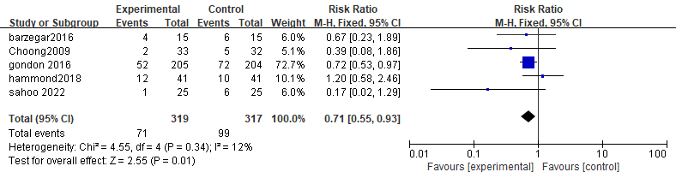

Figure S16. Forest plot for effects of vasopressin or its analogues to catecholamines alone on Arrhythmia.
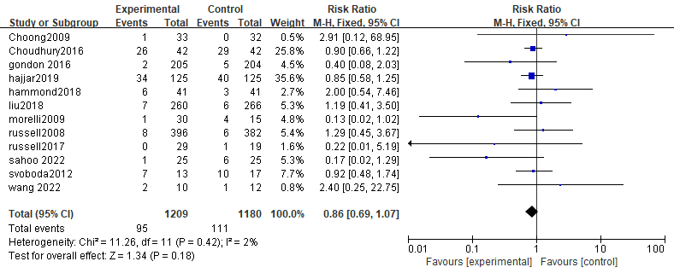

Figure S17. Forest plot for effects of vasopressin or its analogues to catecholamines alone on Digital ischemia.
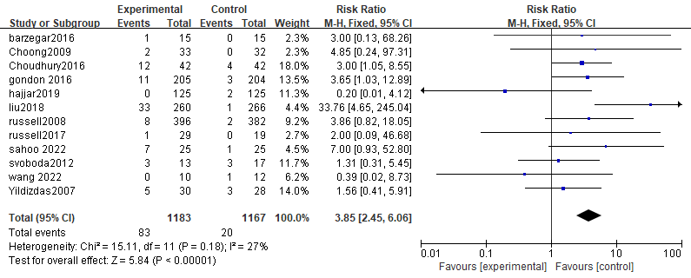

Figure S18. Forest plot for effects of vasopressin or its analogues to catecholamines alone on Mesenteric ischemia.
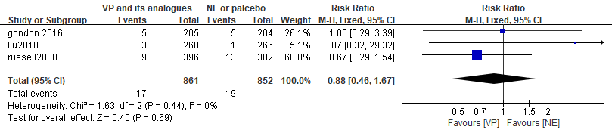

eAppendix. Assessment of publication biases for the inchluded studies (Funnel plot and Egger’s test)
- Figure (a): Funnel plot for publication bias for the primary outcome
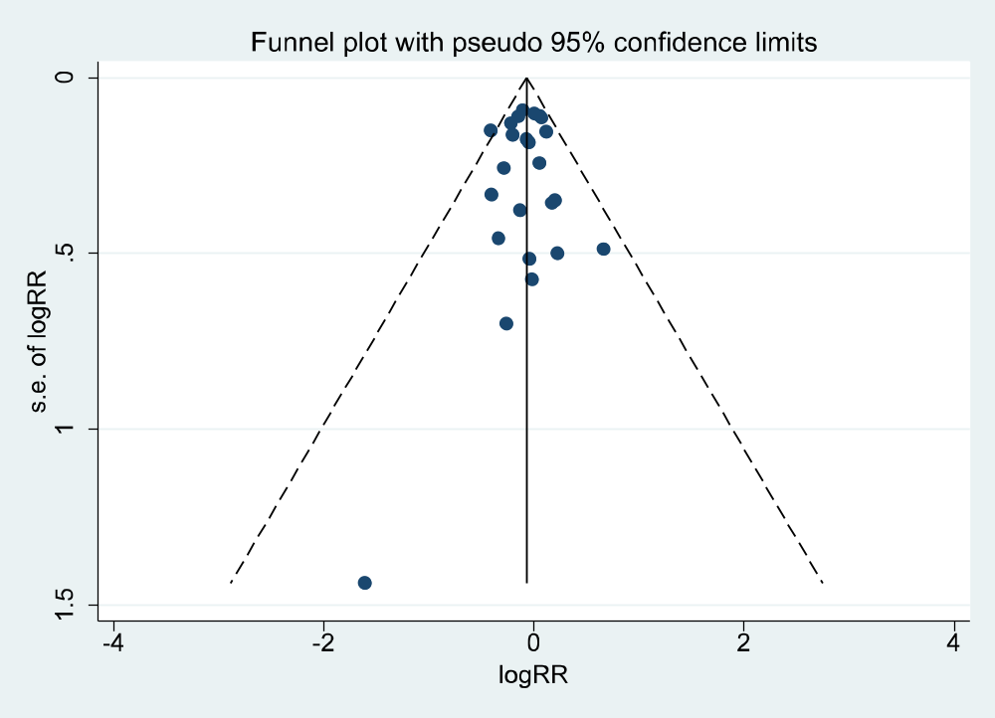
- Figure (b): Egger’s test for publication biases for the primary outcome

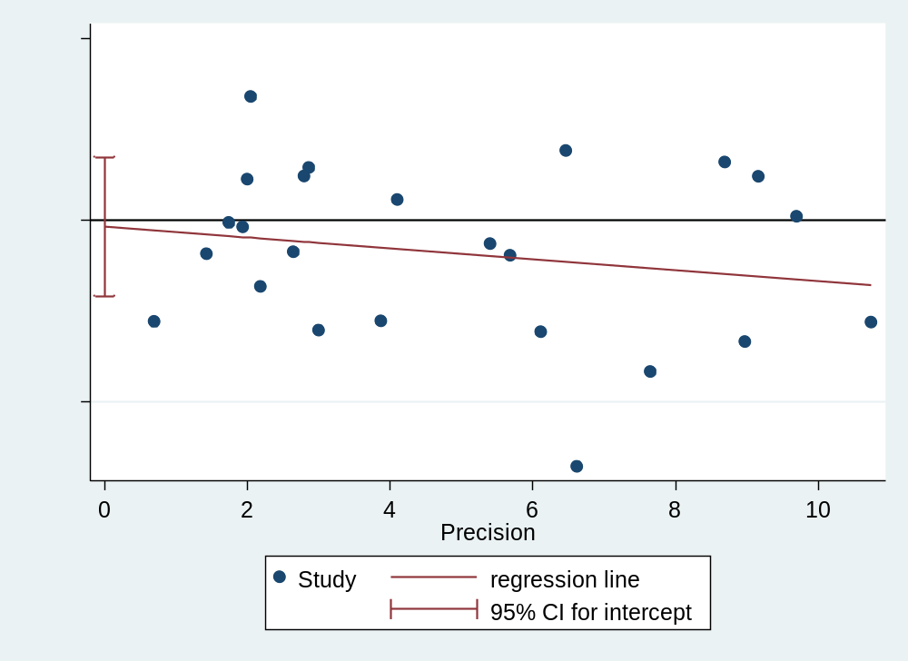
- Egger’s test for publication biases for the primary outcome

Number of studies =24; Root MSE =0.9453
Std_Eff | Coefficient | Standard Error | t | P>|t| | [95%Confidence Interval]
slope | -0.060 | 0.065 | -0.93 | 0.364 | 0.074
bias | -0.075 | 0.369 | -0.20 | 0.842 | 0.691
Test of H0: no small-study effects; P = 0.842

