Supporting Information
for
Uncovering the features of environmental burden in China’s metal extraction industries from 1995 to 2018: Evidence from MRIO assessments

Tianjiao Guoª, Hua Pan^{b,}*, Xiaoqian Song^{c}
ª School of Environmental Science and Engineering, Shanghai Jiao Tong University, Shanghai 200240, China
^{b} Key Laboratory of Pollution Exposure and Health Intervention of Zhejiang Province, College of Biological and Environment Engineering, Zhejiang Shuren University, Hangzhou 310015, China
^{c} China Institute for Urban Governance, Shanghai Jiao Tong University, Shanghai 200030, China

* Corresponding author: panhua@zjsru.edu.cn

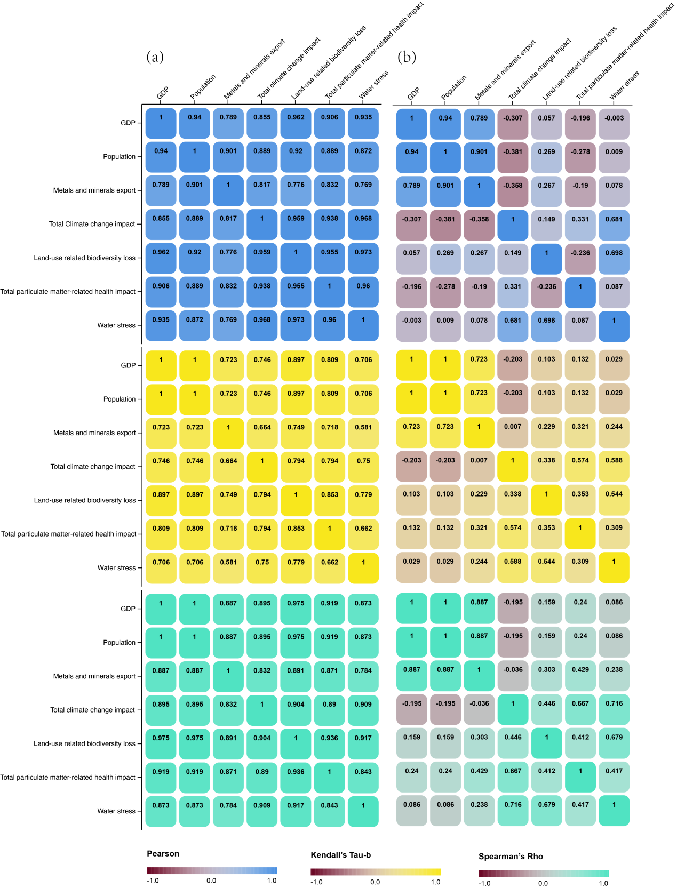
Figure S1 Correlation of national economic data (1995-2018) and four environmental burden indicators (1995-2011(2018)) in China: (a) without data treatment; (b) with Tapio decoupling index method

