Supplementary Information

Pt nanoshell with ultra-high NIR-Ⅱ photothermal conversion efficiency mediates multifunctional neuromodulation for cardiac protection
Chenlu Wang^{1,†}, Liping Zhou^{2,3,4,†}, Chengzhe Liu^{2,3,4,†}, Jiaming Qiao^{2,3,4}, Xinrui Han^{2,3,4}, Luyang Wang¹, Yaxi Liu¹, Bi Xu¹, Qinfang Qiu^{2,3,4}, Zizhuo Zhang^{2,3,4}, Jiale Wang^{2,3,4}, Xiaoya Zhou^{2,3,4*}, Mengqi Zeng¹, Lilei Yu^{2,3,4*}, Lei Fu^{1,3,4*}
¹College of Chemistry and Molecular Sciences, Wuhan University, Wuhan, China. ²Cardiovascular Hospital, Renmin Hospital of Wuhan University, Wuhan 430060, China; Hubei Key Laboratory of Autonomic Nervous System Modulation, Wuhan 430060, China; Cardiac Autonomic Nervous System Research Center of Wuhan University, Wuhan 430060, China; Hubei Key Laboratory of Cardiology, Wuhan 430060, China; Cardiovascular Research Institute, Wuhan University, Wuhan, 430060, China. ³Taikang Center for Life and Medical Sciences, Wuhan University, Wuhan 430060, China. ⁴Institute of Molecular Medicine, Renmin Hospital of Wuhan University, Wuhan 430060, China.
*E-mail: leifu@whu.edu.cn; lileiyu@whu.edu.cn; whuzhouxiaoya@whu.edu.cn
†These authors contributed equally to this work.
Table of Contents
Supplementary Fig. 1 | Characterization of intermediate products and element mapping of PtNP-shell.
Supplementary Fig. 2 | SEM image of PtNP-shell.
Supplementary Fig. 3 | Characterization of PtNP-shell surface.
Supplementary Fig. 4 | XRD spectrum of PtNP-shell prior to reacting with KOH.
Supplementary Fig. 5 | XPS spectra in the region of Ga 2p_{3/2}, Pt 4f_{5/2} and Pt 4f_{7/2}, respectively.
Supplementary Fig. 6 | ξ potential of bare PtNP-shell, PtNP-shell + KOH and PtNP-shell@PEG.
Supplementary Fig. 7 | Hydrodynamic size of PtNP-shell@PEG.
Supplementary Fig. 8 | Absorption of PtNP-shell.
Supplementary Fig. 9 | Measurement of PtNP-shell blackness.
Supplementary Fig. 10 | Temperature elevation curves of GaNPs, GaIn@Pt NPs and PtNP-shell with concentration of 50 μg·mL^{–1}.
Supplementary Fig. 11 | Temperature increase images of PtNP-shell of different concentrations at different time points.
Supplementary Fig. 12 | Temperature elevation curves of PtNP-shell with various power density of NIR-Ⅱ laser.
Supplementary Fig. 13 | Comparison of photothermal conversion efficiency.
Supplementary Fig. 14 | Photothermal stability.
Supplementary Fig. 15 | Western blotting for TRPV1 and TREK1 from canine NG and LSG tissues.
Supplementary Fig. 16 | Effect of PtNP-shell photothermal stimulation of NG.
Supplementary Fig. 17 | Visual graphical recording of NG neural activity after light activation.
Supplementary Fig. 18 | Effects of PtNP-shell photothermal activation of NG on ventricular electrophysiology.
Supplementary Fig. 19 | Statistical analysis for the density of cells after photothermal activation of NG tissues in different groups.
Supplementary Fig. 20 | Effect of photothermal activation of NG on heart rate variability.
Supplementary Fig. 21 | Effect of PtNP-shell photothermal inhibition of LSG.
Supplementary Fig. 22 | Visual graphical recording of LSG neural activity after light inhibition.
Supplementary Fig. 23 | Effects of PtNP-shell photothermal inhibition of LSG on ventricular electrophysiology.
Supplementary Fig. 24 | Statistical analysis for the density of cells after photothermal inhibition of LSG tissues in different groups.
Supplementary Fig. 25 | Statistical analysis of recorded ventricular arrhythmia events post myocardial ischemia.
Supplementary Fig. 26 | Effect of photothermal inhibition of LSG on heart rate variability.
Supplementary Fig. 27 | Long term biosafety of PtNP-shell microinjection.
Supplementary references
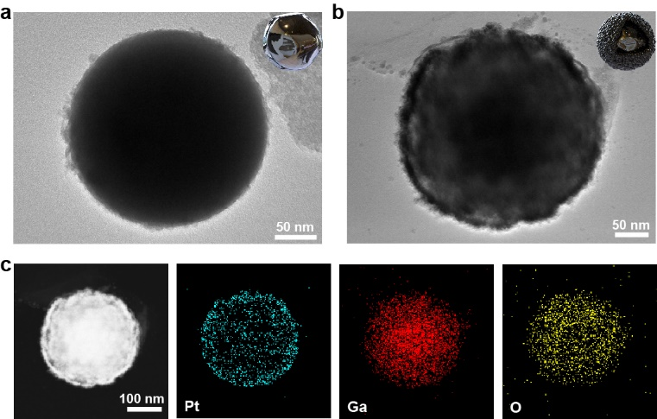
Supplementary Fig. 1 | Characterization of intermediate products and element mapping of PtNP-shell. TEM images of a, GaNPs and b, Ga@Pt NPs. c, element mapping of Ga@Pt NPs.
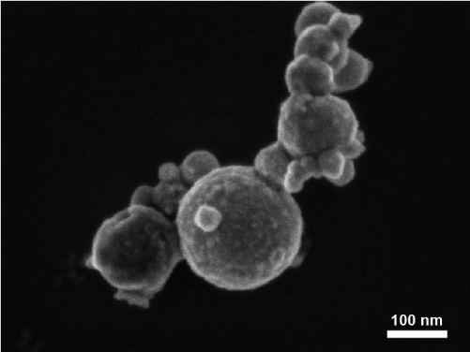

Supplementary Fig. 2 | SEM image of PtNP-shell.
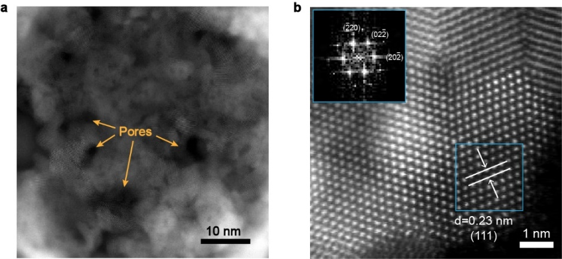
Supplementary Fig. 3 | Characterization of PtNP-shell surface. a, STEM images of PtNP-shell surface. b, HRTEM of PtNPs.
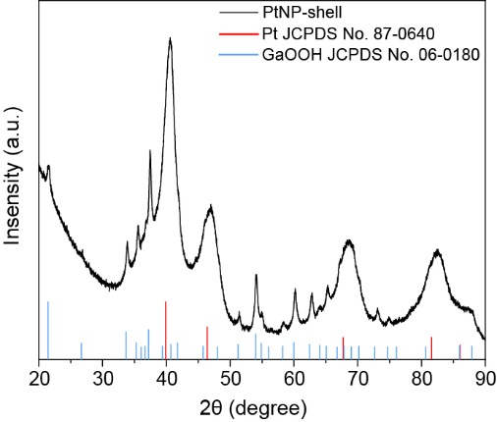

Supplementary Fig. 4 | XRD spectrum of PtNP-shell prior to reacting with KOH.
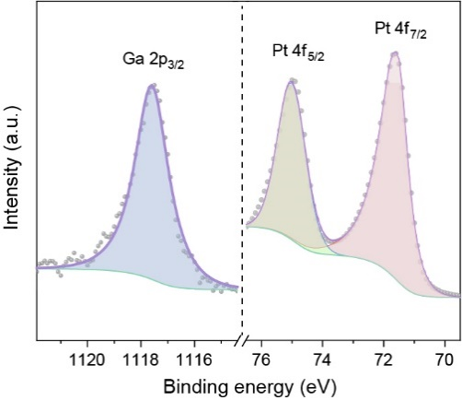

Supplementary Fig. 5 | XPS spectra in the region of Ga 2p_{3/2}, Pt 4f_{5/2} and Pt 4f_{7/2}, respectively.
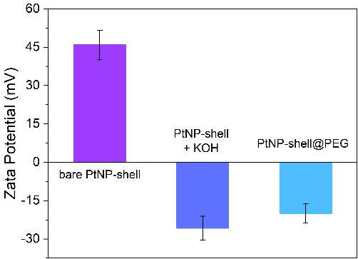
Supplementary Fig. 6 | ξ potential of bare PtNP-shell, PtNP-shell + KOH and PtNP-shell@PEG. Data are shown as the mean ± S.D.
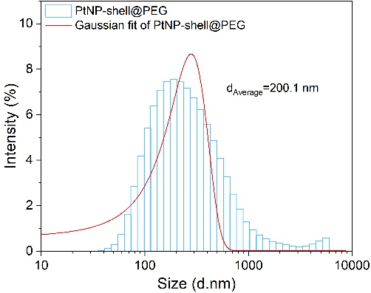

Supplementary Fig. 7 | Hydrodynamic size of PtNP-shell@PEG.
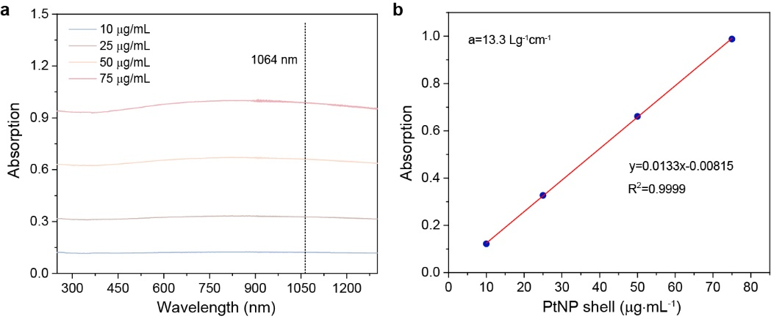
Supplementary Fig. 8 | Absorption of PtNP-shell. a, Absorption curves of PtNP-shell with different concentrations (10, 25, 50 and 75 μg·mL^{–1}). b, Mass extinction coefficient of PtNP-shell at 1064 nm. Normalized absorbance intensity at λ = 1064 nm divided by the characteristic length of the cell (A/L) at different concentrations (10, 25, 50 and 75 μg·mL^{–1}).
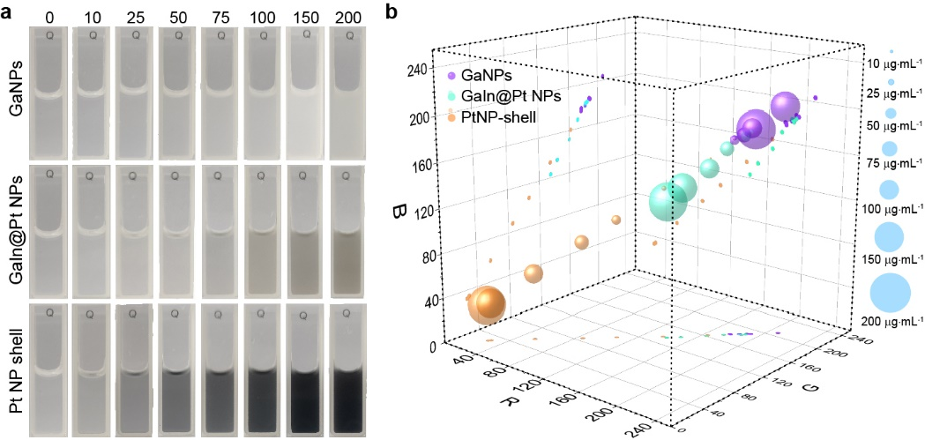
Supplementary Fig. 9 | Measurement of PtNP-shell blackness. a, Visual appearance of GaNPs, Ga@Pt NPs and PtNP-shell at different concentrations. b, Position of each color in the RGB cube, obtained by extracting the relative components of red, green and blue from Supplementary Fig. 9a.
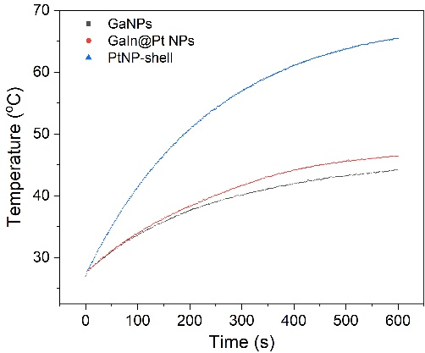

Supplementary Fig. 10 | Temperature elevation curves of GaNPs, GaIn@Pt NPs and PtNP-shell with concentration of 50 μg·mL^{–1}.
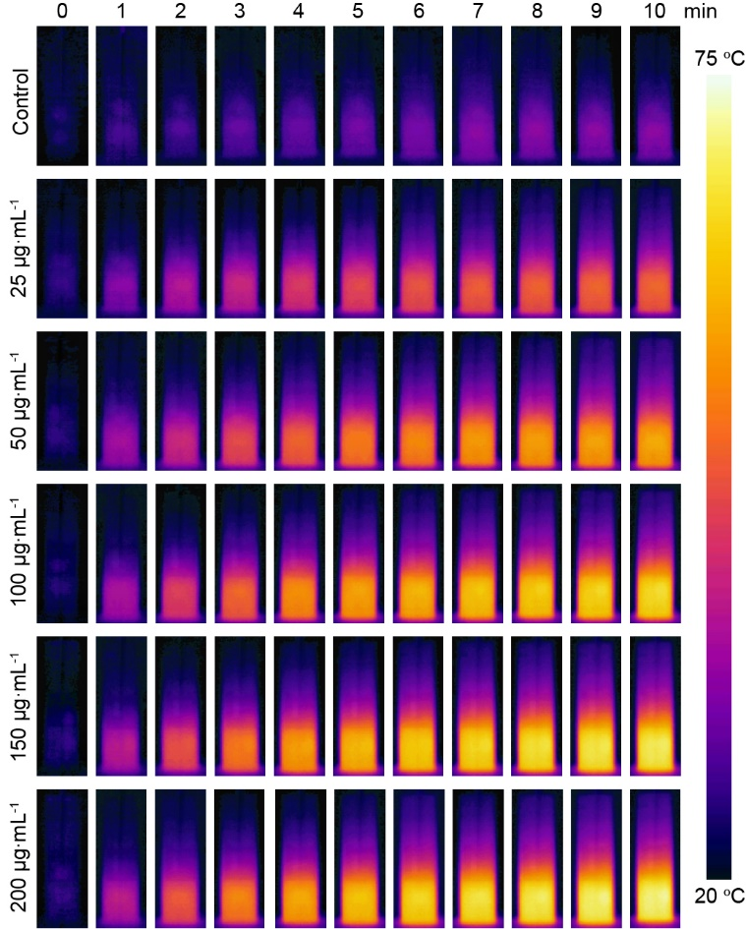
Supplementary Fig. 11 | Temperature increase images of PtNP-shell of different concentrations at different time points. Laser power density: 1 W·cm².

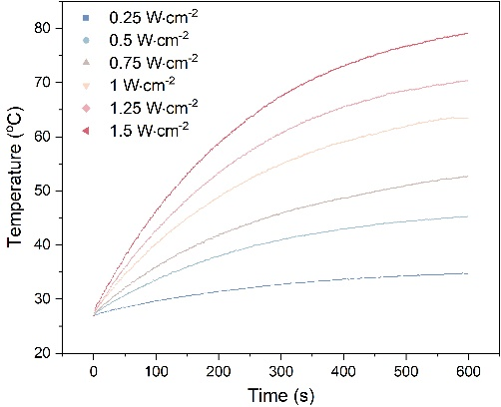

Supplementary Fig. 12 | Temperature elevation curves of PtNP-shell with various power density of NIR-Ⅱ laser.
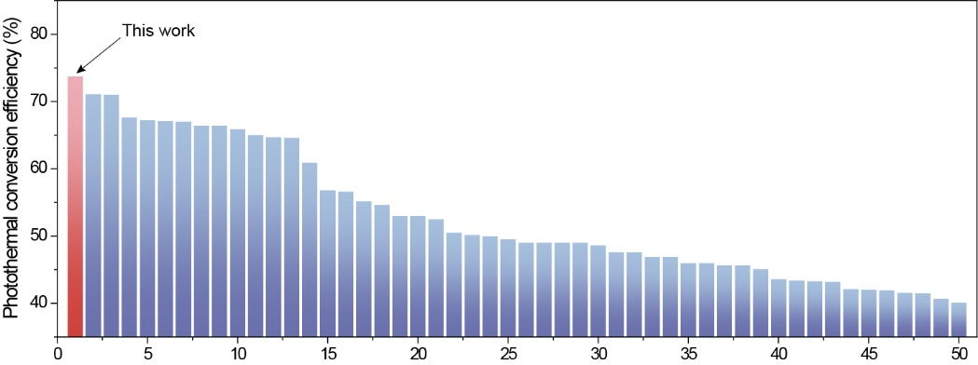
Supplementary Fig. 13 | Comparison of photothermal conversion efficiency. 1: This work, 2: PEDOT:ICG@PEG-GTA¹, 3: MINDS², 4: PTG NPs³, 5: RBC@Cu_{2-x}SeNPs⁴, 6: AuDAg₂S⁵, 7: MAPSULES⁶, 8: Fe₃O₄@PPy@GOD NCs⁷, 9: NPPBTPBF-BT⁸, 10: AS1064⁹. 11: Gold Nanoraspberry¹⁰, 12: P-Pc-HSA¹¹, 13: Ultrathin polypyrrole nanosheets¹², 14: H_{x}MoO₃¹³, 15: NiP PHNPs¹⁴, 16: FP NRs¹⁵, 17: COF¹⁶, 18: 2MPT^{.+}-CB¹⁷, 19: SPN-PT¹⁸, 20: Pdots¹⁹, 21: Pt Spirals²⁰, 22: TBDOPV-DT²¹, 23: Ti₂O₃@HA NPs²², 24: TBDOPV–DT NP²³, 25: DPP-IID-FA NPs²⁴, 26: SPN-DT¹⁸, 27: NP²⁵, 28: FTQ nanoparticles²⁶, 29: CNPs²⁷, 30: H-SiO_{x} NPs²⁸, 31: BETA NPs²⁹, 32: CN-NPs³⁰, 33: Pt-NDs³¹, 34: MoO_{3−x} nanobelts³², 35: P3 NPs³³, 36: Ni₉S₈³⁴, 37: PtAg nanosheets³⁵, 38: Nb₂C NSs³⁶, 39: V₂C-TAT@Ex-RGD³⁷, 40: PEG-TONW NRs³⁸, 41: SPNI-II³⁹, 42: 1T-MoS₂⁴⁰, 43: Bi@C NPs⁴¹, 44: Au NPL@TiO₂⁴², 55: CT NPs⁴³, 56: PPy-PEG NPs⁴⁴, 57: AuPt@CuS NSs⁴⁵, 58: Bi₁₉S₂₇I₃ nanorods⁴⁶, 59: Cu₃BiS₃ NR⁴⁷, 60: MPAE-NPS⁴⁸.
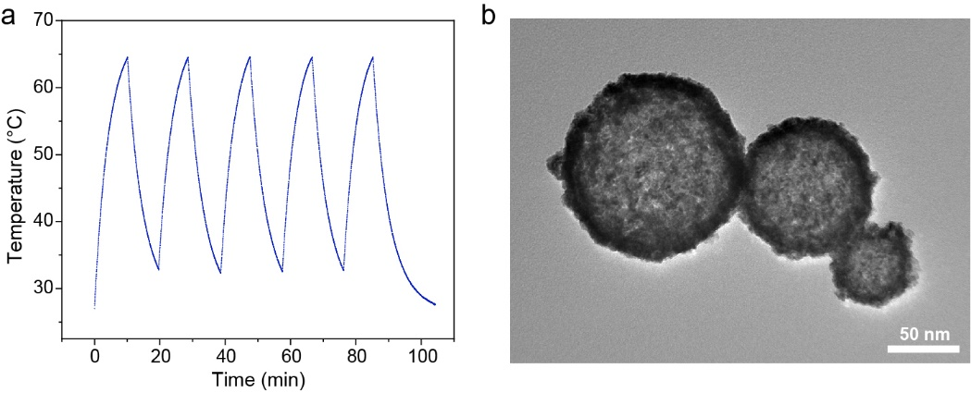
Supplementary Fig. 14 | Photothermal stability. a, Photothermal profiles of the suspension of PtNP-shell over five irradiation cycles. b, TEM image of PtNP-shell over five irradiation cycles.
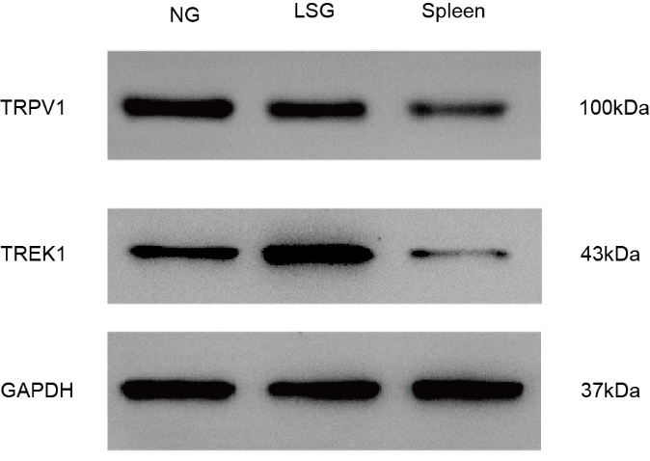
Supplementary Fig. 15 | Western blotting for TRPV1 and TREK1 from canine NG and LSG tissues. Representative western blotting bands for TRPV1, TREK1 from canine ganglion (NG and LSG) and spleen tissues.
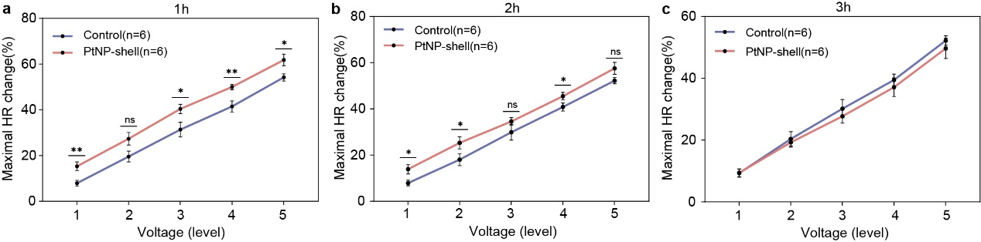
Supplementary Fig. 16 | Effect of PtNP-shell photothermal stimulation of NG. Maximal HR changes of beagles treatment with PtNP-shell or control from 1 to 3 hours after NIR irradiation, n = 6. Data are shown as the mean ± S.E.M. *P < 0.05, **P < 0.01, ns means that the difference is not statistically significant.
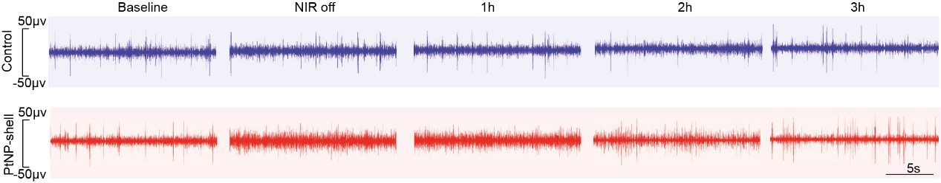
Supplementary Fig. 17 | Visual graphical recording of NG neural activity after light activation. Representative NG neural activity recordings of Beagles treatment with PtNP-shell or control at different time points.
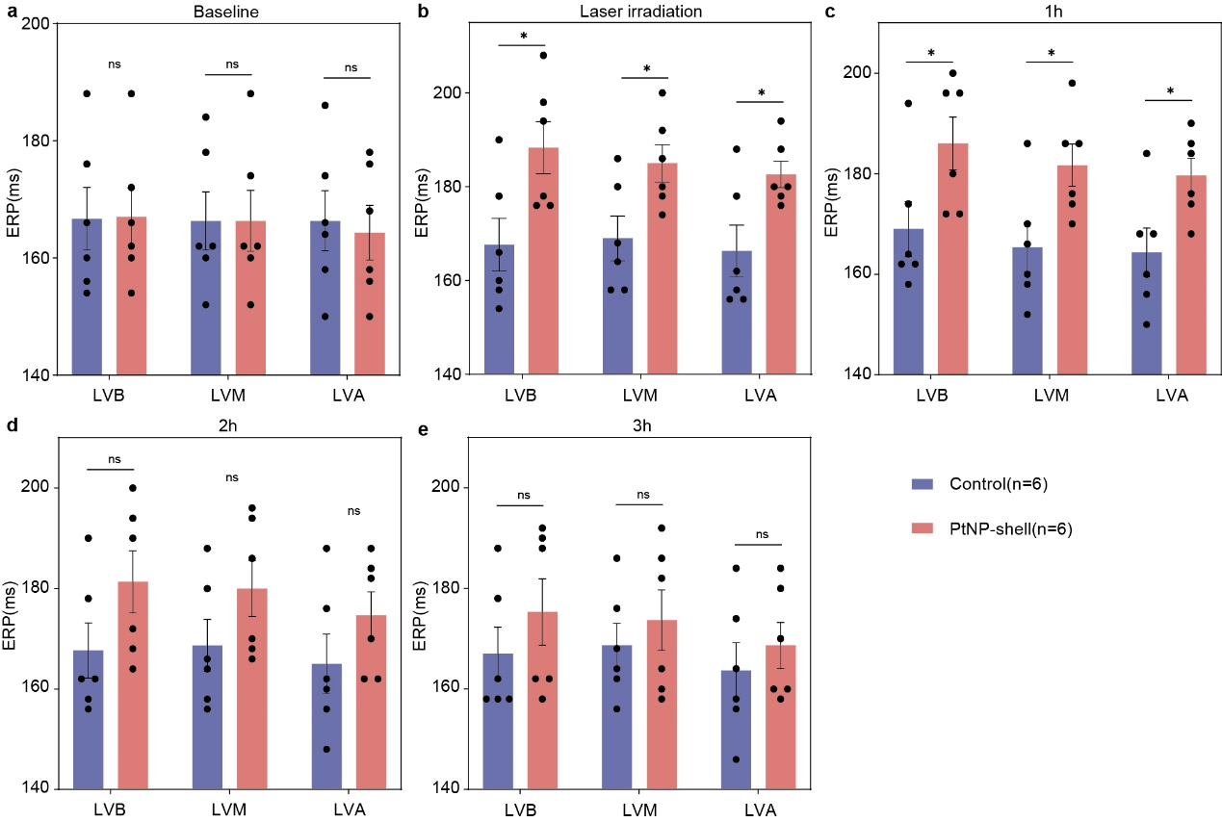
Supplementary Fig. 18 | Effects of PtNP-shell photothermal activation of NG on ventricular electrophysiology. Effects on ventricular ERP at different sites in beagles treatment with PtNP-shell or control at different time points. Data are shown as the mean ± S.E.M. *P < 0.05, **P < 0.01, ***P < 0.001, ns means that the difference is not statistically significant.
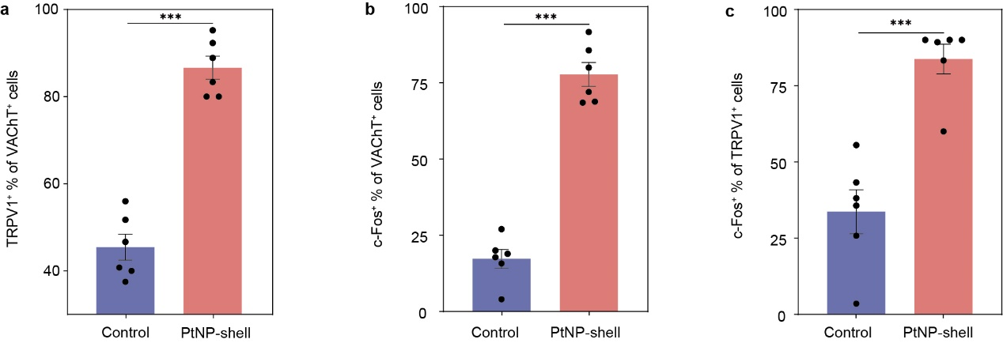
Supplementary Fig. 19 | Statistical analysis for the density of cells after photothermal activation of NG tissues in different groups. a, Percentage of TRPV1+ cells within the VAChT+ cell population. b, Percentage of c-Fos+ cells within the VAChT+ cell population. c, Percentage of c-Fos+ cells within the TRPV1+ cell population. Data are shown as the mean ± S.E.M. ***P < 0.001.
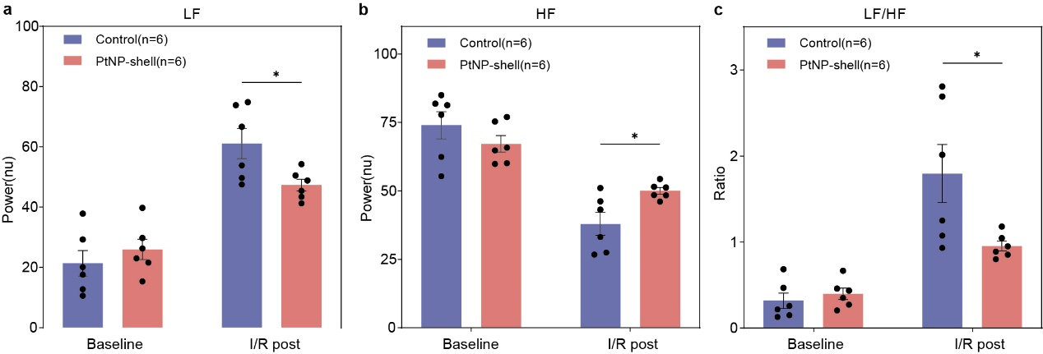
Supplementary Fig. 20 | Effect of photothermal activation of NG on heart rate variability. Changes of the a, LF, b, HF, and c, the ratio of LF/HF in the two groups at different time points. Data are shown as the mean ± S.E.M. *P < 0.05.
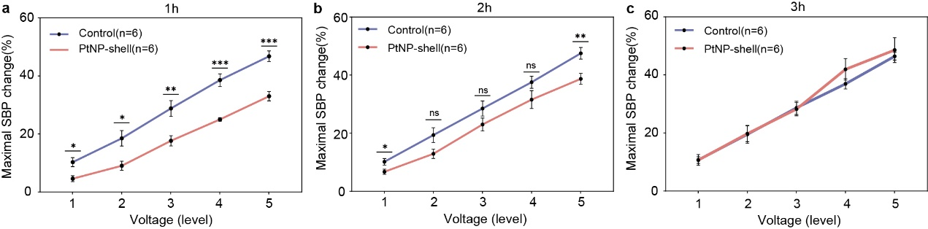
Supplementary Fig. 21 | Effect of PtNP-shell photothermal inhibition of LSG. Maximal SBP changes of beagles treatment with PtNP-shell or control from 1 to 3 hours after NIR irradiation, n = 6. Data are shown as the mean ± S.E.M. *P < 0.05, **P < 0.01, ns means that the difference is not statistically significant.
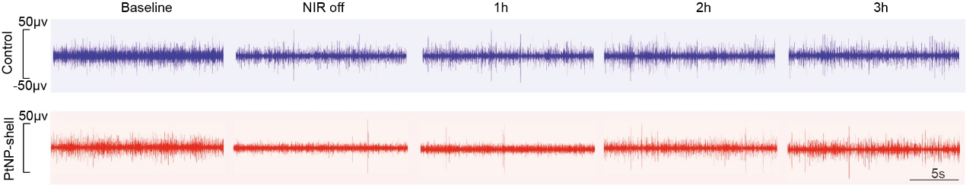
Supplementary Fig. 22 | Visual graphical recording of LSG neural activity after light inhibition. Representative LSG neural activity recordings of Beagles treatment with PtNP-shell or control at different time points.
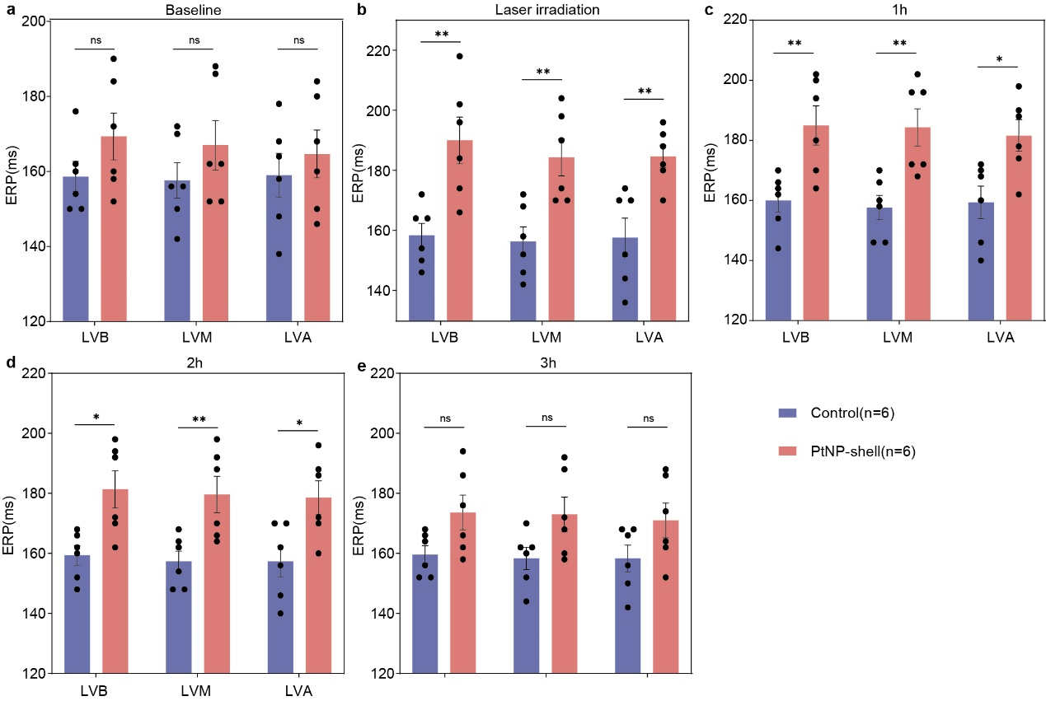
Supplementary Fig. 23 | Effects of PtNP-shell photothermal inhibition of LSG on ventricular electrophysiology. Effects on ventricular ERP at different sites in beagles treatment with PtNP-shell or control at different time points. Data are shown as the mean ± S.E.M. *P < 0.05, ns means that the difference is not statistically significant.
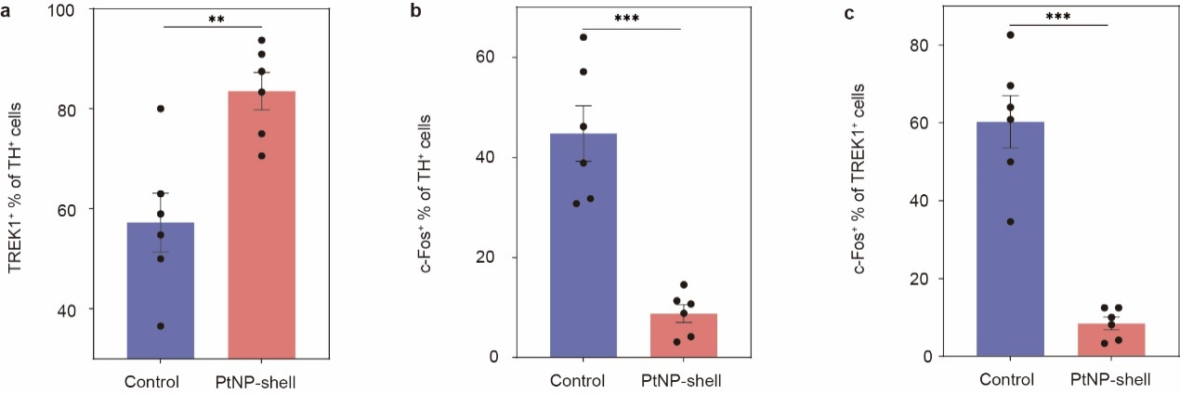
Supplementary Fig. 24 | Statistical analysis for the density of cells after photothermal inhibition of LSG tissues in different groups. a, Percentage of TREK1⁺ cells within the TH⁺ cell population. b, Percentage of c-Fos⁺ cells within the TH⁺ cell population. c, Percentage of c-Fos⁺ cells within the TREK1⁺ cell population. Data are shown as the mean ± S.E.M. **P < 0.01, ***P < 0.001.
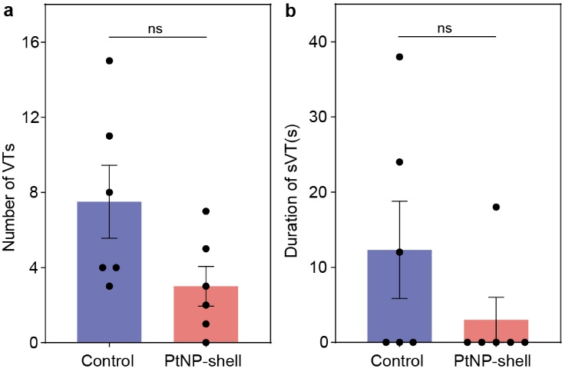
Supplementary Fig. 25 | Statistical analysis of recorded ventricular arrhythmia events post myocardial ischemia. Quantitative analysis the number of a, VTs and b, the duration of sVT of beagles with MI. Data are shown as the mean ± S.E.M. ns means that the difference is not statistically significant.
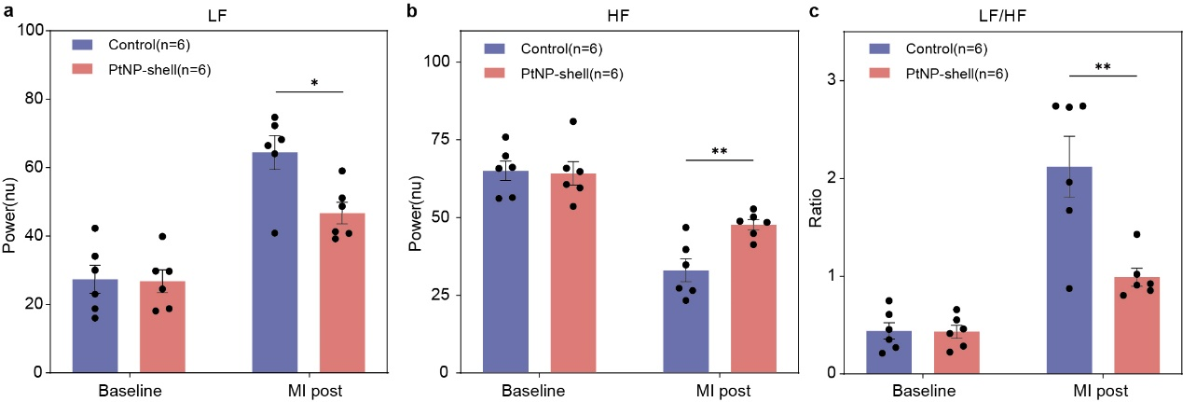
Supplementary Fig. 26 | Effect of photothermal inhibition of LSG on heart rate variability. Changes of the a, LF, b, HF, and c, the ratio of LF/HF in the two groups at different time points. Data are shown as the mean ± S.E.M. *P < 0.05.
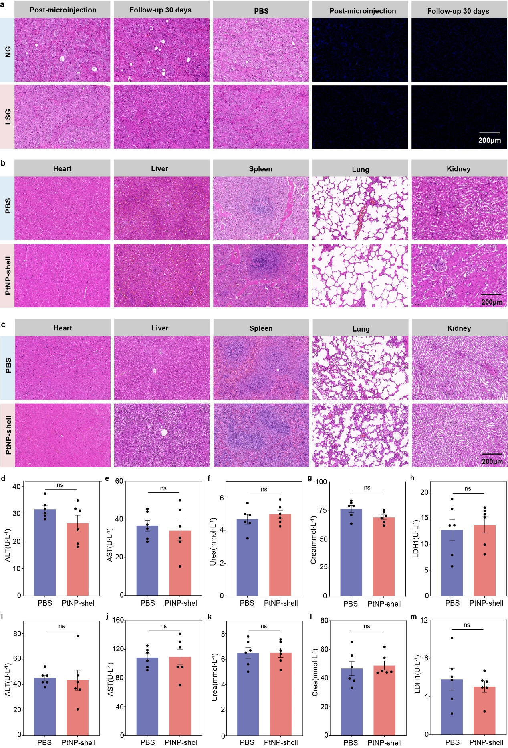
Supplementary Fig. 27 | Long term biosafety of PtNP-shell microinjection. Long-term in vivo biosafety was assessed by local injection of PtNP-shell into the NG and SG of Beagle or by injection of equal doses of PtNP-shell into the tail vein of Sprague-Dawley rats. a, Representative images of H&E and tunel staining of ganglia in Beagles from different treatment groups immediately after microinjection or after 30 days of follow-up. b, Representative H&E staining of major organs of beagles following different treatments. c, Representative H&E staining of major organs of rats following different treatments. Blood biochemical analyses including d, ALT, e, AST, f, urea, g, Crea and h, LDH1 were performed on Beagles in different treatment groups. Blood biochemical analyses including i, ALT, j, AST, k, urea, l, Crea and m, LDH1 were performed on rats in different treatment groups.
Supplementary references
1 Li, L. Y. et al. PEDOT nanocomposites mediated dual-modal photodynamic and photothermal targeted sterilization in both NIR I and II window. Biomaterials 41, 132–140 (2015).
2 Wu, X. et al. Tether-free photothermal deep-brain stimulation in freely behaving mice via wide-field illumination in the near-infrared-II window. Nat. Biomed. Eng. 6, 754–770 (2022).
3 Chen, J. et al. Atomically precise photothermal nanomachines. Nat. Mater. doi: 10.1038/s41563-023-01721-y (2023).
4 Liu, Z. et al. Fabrication of red blood cell membrane-camouflaged Cu_{2−x}Se nanoparticles for phototherapy in the second near-infrared window. Chem. Commun. 55, 6523–6526 (2019).
5 He, J. et al. SERS/NIR-II optical nanoprobes for multidimensional tumor imaging from living subjects, pathology, and single cells and guided NIR-II photothermal therapy. Adv. Funct. Mater. 32, 2208028 (2022).
6 Fluksman, A. et al. Efficient tumor eradication at ultralow drug concentration via externally controlled and boosted metallic iron magnetoplasmonic nanocapsules. ACS Nano 17, 1946–1958 (2022).
7 Feng, W. et al. Nanocatalysts-augmented and photothermal-enhanced tumor-specific sequential nanocatalytic therapy in both NIR-I and NIR-II biowindows. Adv. Mater. 31, 1805919 (2019).
8 Cao, Z. et al. Semiconducting polymer-based nanoparticles with strong absorbance in NIR-II window for in vivo photothermal therapy and photoacoustic imaging. Biomaterials 155, 103–111 (2018).
9 Dai, Y. et al. Precise tailoring of mesoporous silica-coated gold nanorods for laser ignition at 1064 nm. ACS Appl. Nano Mater. 6, 4946–4956 (2023).
10 Sangnier, A. P. et al. Raspberry-like small multicore gold nanostructures for efficient photothermal conversion in the first and second near-infrared windows. Chem. Commun. 55, 4055–4058 (2019).
11 Zhou, L. N. et al. Single-molecular phosphorus phthalocyanine-based near-infrared-II nanoagent for photothermal antitumor therapy. RSC Adv. 10, 22656–22662 (2020).
12 Wang, X., Ma, Y. C., Sheng, X., Wang, Y. C. & Xu, H. X. Ultrathin polypyrrole nanosheets via space-confined synthesis for efficient photothermal therapy in the second near-Infrared window. Nano Lett. 18, 2217–2225 (2018).
13 Zhu, Q. et al. Hydrogenated oxide material for self-targeting and automatic-degrading photothermal tumor therapy in the NIR-II bio-window. Adv. Funct. Mater. 32, 2110881 (2021).
14 Liu, Y. et al. Double switch biodegradable porous hollow trinickel monophosphide nanospheres for multimodal imaging guided photothermal therapy. Nano Lett. 19, 5093–5101 (2019).
15 Liu, Y. et al. One-dimensional Fe₂P acts as a fenton agent in response to NIR II light and ultrasound for deep tumor synergetic theranostics. Angew. Chem. Int. Ed. 58, 2407–2412 (2019).
16 Mi, Z. et al. Stable radical cation-containing covalent organic frameworks exhibiting remarkable structure-enhanced photothermal conversion. J. Am. Chem. Soc. 141, 14433–14442 (2019).
17 Tang, B. H. et al. A supramolecular radical dimer: high-efficiency NIR-II photothermal conversion and therapy. Angew. Chem. Int. Ed. 58, 15526–15531 (2019).
18 Jiang, Y. Y. et al. Metabolizable semiconducting polymer nanoparticles for second near-Infrared photoacoustic imaging. Adv. Mater. 31, 1808166 (2019).
19 Men, X. et al. Ultrasmall semiconducting polymer dots with rapid clearance for second near-infrared photoacoustic imaging and photothermal cancer therapy. Adv. Funct. Mater. 30, 1909673 (2020).
20 Wang, Q. S. et al. Plasmonic Pt superstructures with boosted near-infrared absorption and photothermal conversion efficiency in the second biowindow for cancer therapy. Adv. Mater. 31, 1904836 (2019).
21 Cao, Y. Y. et al. Highly efficient NIR-II photothermal conversion based on an organic conjugated polymer. Chem. Mater. 29, 718–725 (2017).
22 Zeng, J. et al. Facile preparation of biocompatible Ti2O3 nanoparticles for second near-infrared window photothermal therapy. J. Mater. Chem. B 6, 7889–7897 (2018).
23 Sun, T. T. et al. Second near-infrared conjugated polymer nanoparticles for photoacoustic imaging and photothermal therapy. ACS Appl. Mater. Interfaces 10, 7919–7926 (2018).
24 Wei, Z. W. et al. Semiconducting polymer-based nanoparticles for photothermal therapy at the second near-infrared window. Chem. Commun. 54, 13599–13602 (2018).
25 Yu, Y. et al. Biodegradable polymer with effective near-infrared-II absorption as a photothermal agent for deep tumor therapy. Adv. Mater. 34, 2105976 (2021).
26 Wu, Z. H. et al. A terrylene–anthraquinone dyad as a chromophore for photothermal therapy in the NIR-II window. J. Am. Chem. Soc. 145, 26487–26493 (2023).
27 Jia, W. Y. et al. Novel conjugated small molecule-based nanoparticles for NIR-II photothermal antibacterial therapy. Chem. Commun. 58, 6340–6343 (2022).
28 Yu, X. J., Yang, K., Chen, X. Y. & Li, W. W. Black hollow silicon oxide nanoparticles as highly efficient photothermal agents in the second near-infrared window for in vivo cancer therapy. Biomaterials 143, 120–129 (2017).
29 Chen, S. et al. Increasing molecular planarity through donor/side-chain engineering for improved NIR-IIa fluorescence imaging and NIR-II photothermal therapy under 1064 nm. Angew. Chem. Int. Ed. 62, e202215372 (2022).
30 Tian, Y. et al. Extended π-conjugative carbon nitride for single 1064 nm laser-activated photodynamic/photothermal synergistic therapy and photoacoustic imaging. ACS Appl. Mater. Interfaces 14, 7626–7635 (2022).
31 Tang, Y. A. et al. Albumin-coordinated assembly of clearable platinum nanodots for photo-induced cancer theranostics. Biomaterials 154, 248–260 (2018).
32 Zhou, Z. et al. Activating layered metal oxide nanomaterials via structural engineering as biodegradable nanoagents for photothermal cancer therapy. Small 17, 2007486 (2021).
33 Sun, T. T. et al. Tailor-made semiconducting polymers for second near-infrared photothermal therapy of orthotopic liver cancer. ACS Nano 13, 7345–7354 (2019).
34 Lei, Z. Y. et al. A full-spectrum-absorption from nickel sulphide nanoparticles for efficient NIR-II window photothermal therapy. Nanoscale 11, 20161–20170 (2019).
35 Zhang, Y. et al. Ultrathin two-dimensional plasmonic PtAg nanosheets for broadband phototheranostics in both NIR-I and NIR-II biowindows. Adv. Sci. 8, 2100386 (2021).
36 Lin, H., Gao, S. S., Dai, C., Chen, Y. & Shi, J. L. A two-dimensional biodegradable niobium carbide (MXene) for photothermal tumor eradication in NIR-I and NIR-II biowindows. J. Am. Chem. Soc. 139, 16235–16247 (2017).
37 Cao, Y. et al. Engineered exosome-mediated near-infrared-II region V₂C quantum dot delivery for nucleus-target low-temperature photothermal therapy. ACS Nano 13, 1499–1510 (2019).
38 Cheng, Y. R. et al. Ultrathin tellurium oxide/ammonium tungsten bronze nanoribbon for multimodality imaging and second near-infrared region photothermal therapy. Nano Lett. 19, 1179–1189 (2019).
39 Jiang, Y. Y., Li, J. C., Zhen, X., Xie, C. & Pu, K. Y. Dual-peak absorbing semiconducting copolymer nanoparticles for first and second near-infrared window photothermal therapy: a comparative study. Adv. Mater. 30, 1705980 (2018).
40 Zhou, Z. et al. Metallic 1T phase enabling MoS₂ nanodots as an efficient agent for photoacoustic imaging guided photothermal therapy in the near-Infrared-II window. Small 16, 2004173 (2020).
41 Zhen, W. Y. et al. Gram-scale fabrication of Bi@C nanoparticles through one-step hydrothermal method for dual-model imaging-guided NIR-II photothermal therapy. Nanoscale 11, 9906–9911 (2019).
42 Gao, F. L. et al. Titania-coated 2D gold nanoplates as nanoagents for synergistic photothermal/sonodynamic therapy in the second near-infrared window. Nanoscale 11, 2374–2384 (2019).
43 Tian, S. et al. Water-soluble organic nanoparticles with programable intermolecular charge transfer for NIR-II photothermal anti-bacterial therapy. Angew. Chem. Int. Ed. 60, 11758–11762 (2021).
44 Zeng, W. W. et al. Renal-clearable ultrasmall polypyrrole nanoparticles with size-regulated property for second near-infrared light-mediated photothermal therapy. Adv. Funct. Mater. 31, 2008362 (2021).
45 Cai, R. et al. Plasmonic AuPt@CuS heterostructure with enhanced synergistic efficacy for radiophotothermal therapy. J. Am. Chem. Soc. 143, 16113–16127 (2021).
46 Xiong, J. et al. Bi₁₉S₂₇I₃ nanorods: a new candidate for photothermal therapy in the first and second biological near-infrared windows. Nanoscale 13, 5369–5382 (2021).
47 Li, A. et al. Synergistic thermoradiotherapy based on PEGylated Cu₃BiS₃ ternary semiconductor nanorods with strong absorption in the second near-infrared window. Biomaterials 112, 164–175 (2017).
48 Cheng, Q. et al. Antiquenching macromolecular NIR-II probes with high-contrast brightness for imaging-guided photothermal therapy under 1064 nm irradiation. Adv. Healthc. Mater. 11, 2101697 (2021).

